Installation

You are reading this document most probably after extracting the software archive. The extracted folder contains three files this Help File named Help.pdf, evm_2_all.deb and install.sh file.

1.Right click on install.sh and choose properties
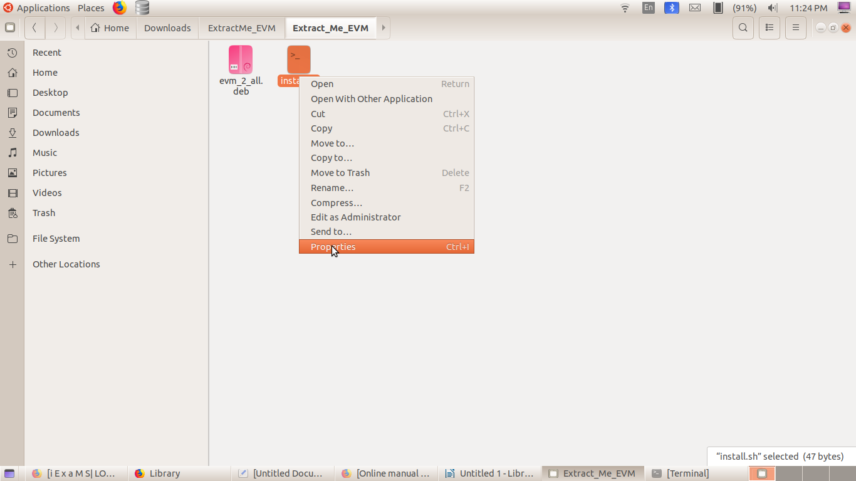

2. Take Permisson tab and check “ Allow executing file as a program” and close the dialogue box.
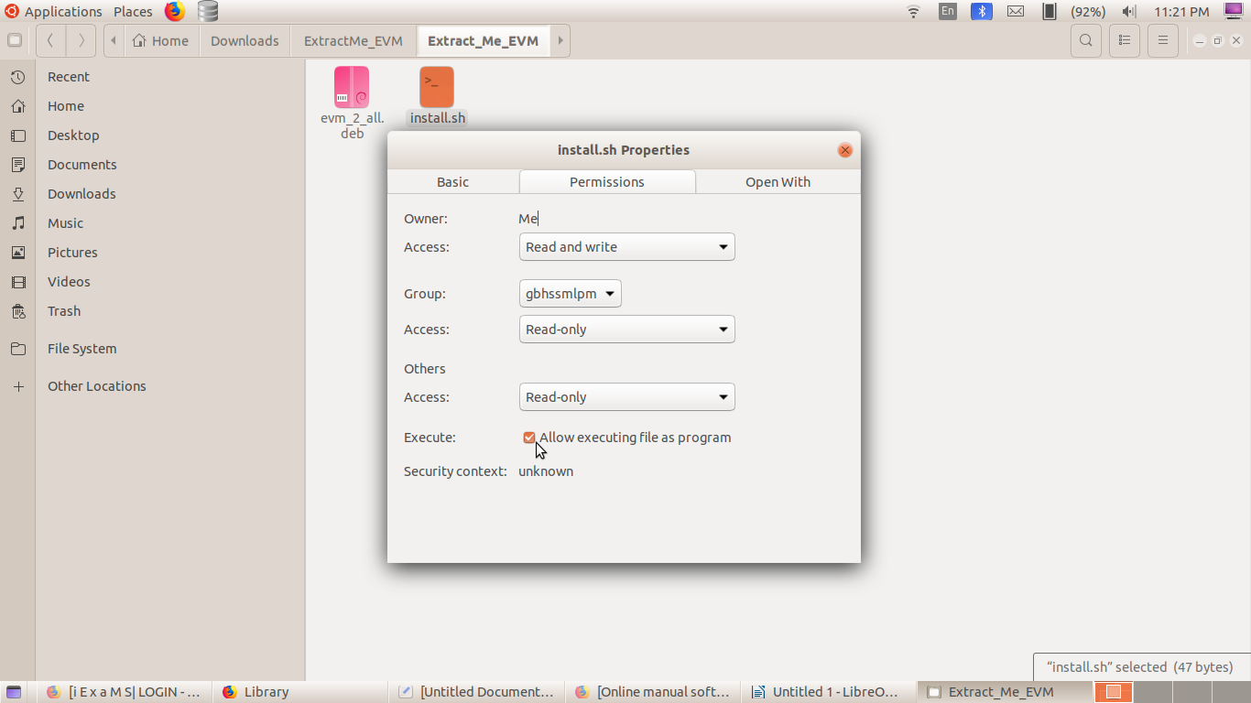
3. Double Click on install.sh and select Run in Terminal

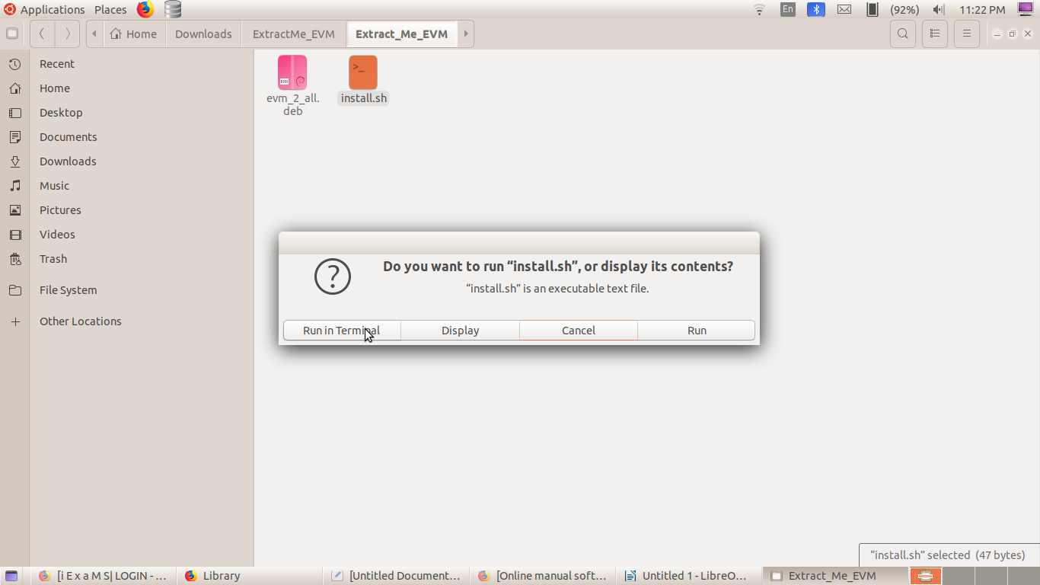

I4. n the terminal window opened, enter your administrative password( the password characters wont be displayed as you type. Don't’ worry keep typing and press Enter).

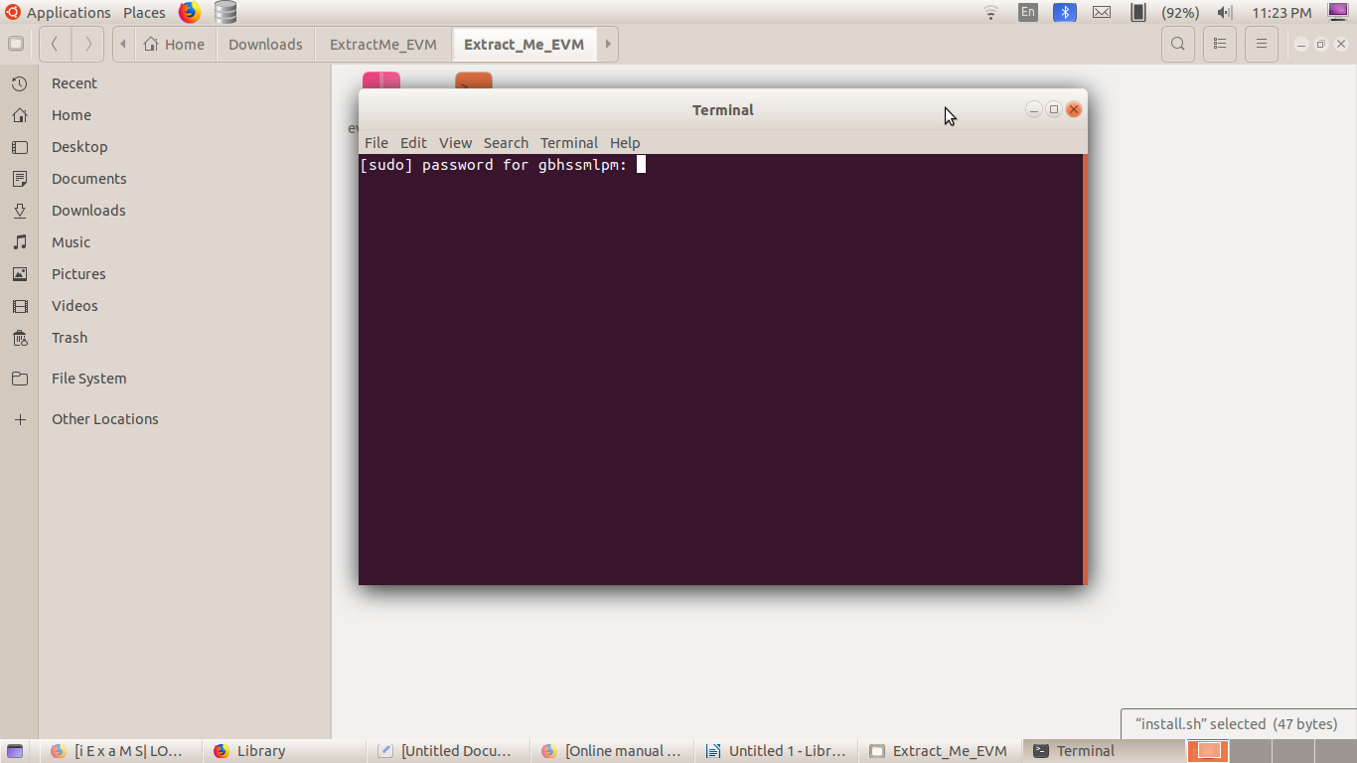

5. Done. The application is installed if everything went well. It can be opened from Application ->Education-> EVM Electronic Voting Machine

