Reproducible Research - Assignment1

Asif M Adnan

March 27, 2016

## Prepare markdown environemnt

library(knitr)

## Warning: package 'knitr' was built under R version 3.2.4

opts_chunk$set(echo = TRUE)

## Loading necessary libraries

library(ggplot2)  
library(dplyr)

##   
## Attaching package: 'dplyr'

## The following objects are masked from 'package:stats':  
##   
## filter, lag

## The following objects are masked from 'package:base':  
##   
## intersect, setdiff, setequal, union

## Precondition

Download activity.zip file and unzip the activity.csv file in the ./data directory under the current directory.

## Loading and preprocessing the data

1. Reading data from activity.csv file. Three attributes (steps, date, interval) are integer, Date and integer, respectively.

fileUrl <- "./data/activity.csv"  
attribClasses = c("integer", "Date", "integer")  
activityDataRaw <- read.csv(fileUrl, head=TRUE, colClasses=attribClasses, na.strings="NA")

1. Filter out the missing values (NA) from the activityDataRaw variable. The modified data is saved in activityDataFiltered variable.

activityDataFiltered <- activityDataRaw[complete.cases(activityDataRaw),]

## What is mean total number of steps taken per day?

1. Calculate the total number of steps taken per day

dailyTotalSteps <- tapply(activityDataFiltered$steps, activityDataFiltered$date, sum, na.rm = TRUE, simplify = T)  
  
df.dailyTotalSteps <- as.data.frame(dailyTotalSteps)

1. Ploting the bar graph for total steps per day. Here, we used ggplot.

ggplot(df.dailyTotalSteps, aes(x= df.dailyTotalSteps$dailyTotalSteps))+  
 geom_histogram(fill = "steelblue", binwidth = 1000)+  
 labs(title = "Histogram of Total Steps per day", x = "Total Steps per day", y = "Frequency")

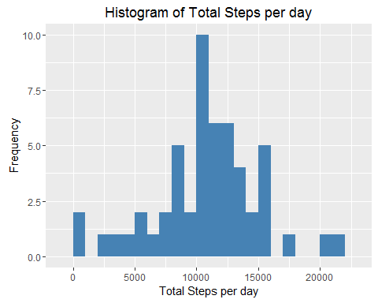

1. Calculate and report the mean and median of the total number of steps taken per day

meanSteps <- mean(dailyTotalSteps)  
medianSteps <- median(dailyTotalSteps)

Mean of total daily total steps

## [1] 10766.19

Median of total daily total steps

## [1] 10765

## What is the average daily activity pattern?

1. Calculate average steps taken in each 5-minute interval per day.

dailyAverageSteps <- tapply(activityDataFiltered$steps, activityDataFiltered$interval, mean, na.rm = TRUE, simplify = T)  
df.dailyAverageSteps <- data.frame(interval=as.integer(names(dailyAverageSteps)), avgStep=dailyAverageSteps)

Plot the time series of average steps for 5-minute interval per day. We used ggplot.

ggplot(df.dailyAverageSteps, aes(x=interval, y=avgStep)) +  
 geom_line(color = "red")+  
 labs(title = "Time series plot of average steps in different intervals", x = "5-minute interval", y = "Average steps")

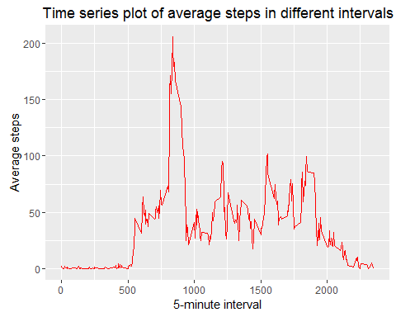

1. Interval with maximum average steps,

## interval avgStep  
## 835 835 206.1698

## Imputing missing values

1. Calculate and report the total number of missing values in the dataset

Create a new variable, activityDataModified.

activityDataModified <- activityDataRaw

Total number of missing values,

sum(is.na(activityDataModified))

## [1] 2304

1. Fill the missing values with average number of steps in the same 5-minute interval

missingRows <- is.na(activityDataModified$steps)  
  
activityDataModified$steps[missingRows] <- dailyAverageSteps[as.character(activityDataModified$interval[missingRows])]

Now, check total number of missing values,

sum(is.na(activityDataModified))

## [1] 0

1. Variable activityDataModified contains the original data along with calculated and replaced missing data.
2. Make a histogram of the total number of steps taken each day, for the modified data.

dailyTotalStepsModified <- tapply(activityDataModified$steps, activityDataModified$date, sum, na.rm = TRUE, simplify = T)  
  
df.dailyTotalStepsModified <- as.data.frame(dailyTotalStepsModified)

Plotting the histogram.

ggplot(df.dailyTotalStepsModified, aes(x= df.dailyTotalStepsModified$dailyTotalStepsModified))+  
 geom_histogram(fill = "steelblue", binwidth = 1000)+  
 labs(title = "Histogram of Total Steps per day - Modified Data", x = "Total Steps per day", y = "Frequency")

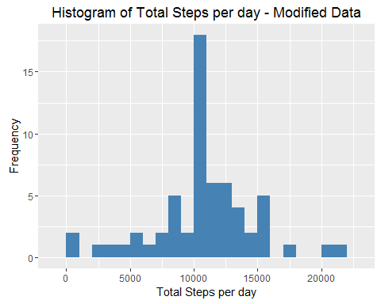

Mean of the modified total steps,

## [1] 10766.19

Median of the modified total steps,

## [1] 10766.19

The impact of imputing missing data with the average number of steps in the same 5-min interval is that both the mean and the median for the modified data are equal to the same value:

## [1] 10766.19

## Are there differences in activity patterns between weekdays and weekends?

1. User dplyr and mutate to create a new attribute/column named dayType, and assign weekend or weekday value based on the weekdays() function.

activityDataModified <- mutate(activityDataModified,   
 dayType = ifelse(weekdays(activityDataModified$date) == "Saturday" | weekdays(activityDataModified$date) == "Sunday", "weekend", "weekday"))  
  
activityDataModified$dayType <- as.factor(activityDataModified$dayType)

1. Calculate average steps in 5-minute interval per day.

dayTypeAvgSteps <- aggregate(data = activityDataModified, steps~dayType+interval, FUN = mean)  
  
df.dayTypeAvgSteps <- as.data.frame(dayTypeAvgSteps)

Plot average steps in 5-minute interval for weekend and weekday.

ggplot(df.dayTypeAvgSteps, aes(x=interval, y=steps, color = dayType)) +  
 geom_line() +  
 facet_wrap(~dayType, ncol = 1, nrow=2)+  
 labs(title = "Time series plot of average steps in different intervals", x = "5-minute interval", y = "Average steps")

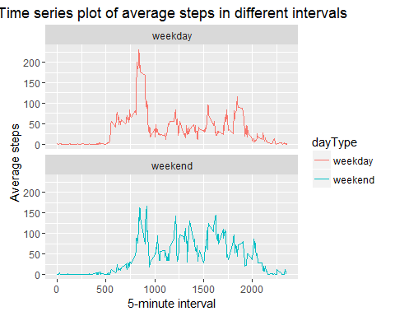

### Observation

From the two plots it seems that the test object is more active earlier in the day during weekdays compared to weekends. But, for throughout the weekend days, test object is observed more active compared with weekdays.