1. In G2 Page.
   1. We need a title “G2 Page”
   2. “Please Enter Your Details” should be displayed (H2 or H3) only if default is not True.
   3. I think it would be better if both input text and labels were on the same line.

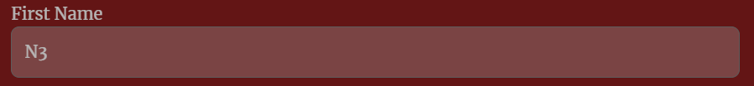

* 1. If the driver passed, comments should be aligned. Only the first line is centred now

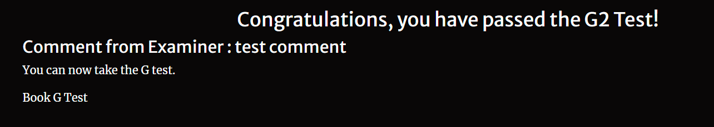

* 1. The last line, “Book G Test,” should be a link.
  2. Save button should be narrower.



* 1. We need to change the font colour when a user enters data… now both are white. If I don’t select the text, it’s not readable.

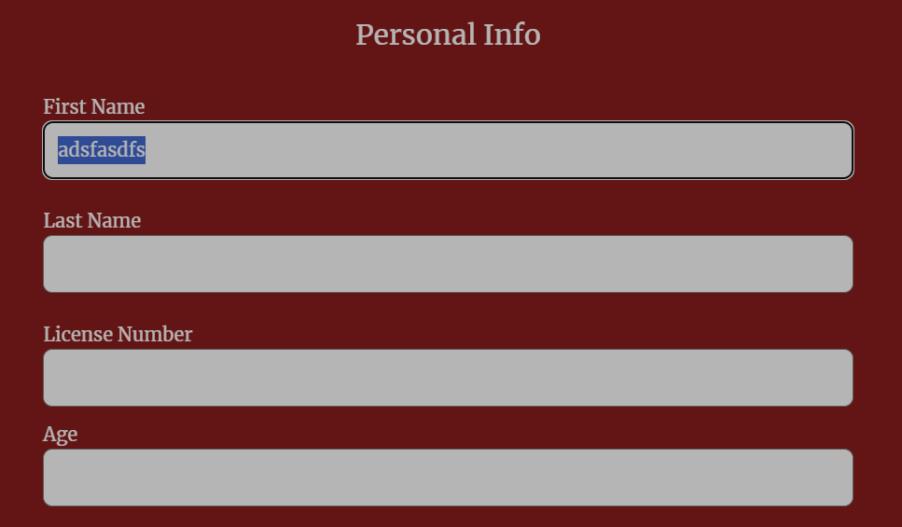

* 1. Book appointments should be centered

* 1. There should be a message “No slots available for selected date”
  2. If there are default values, the page should be shown in blank, not showing “DETAULT”, just blank.

1. In G Page
   1. Both elements (pick date & button) should be the same height

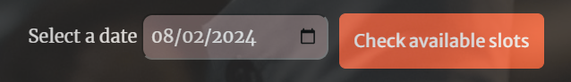

* 1. The “update car details” and “book appointment” buttons should be both centred.

1. In Examination page
   1. We should use a different background image, so the text can be easier to read.

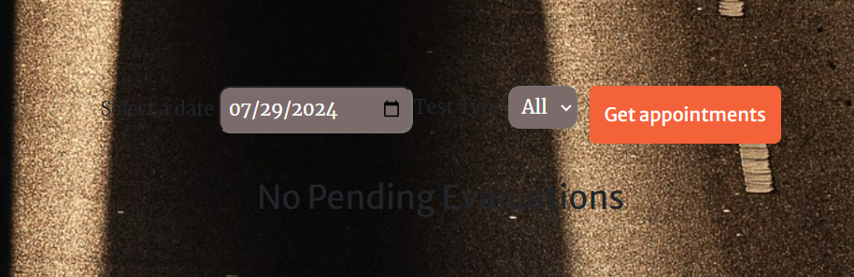

1. In Appointment page
   1. We should use a different background image, so the text can be easier to read.
   2. When I tried to select another **date**, I got this error:

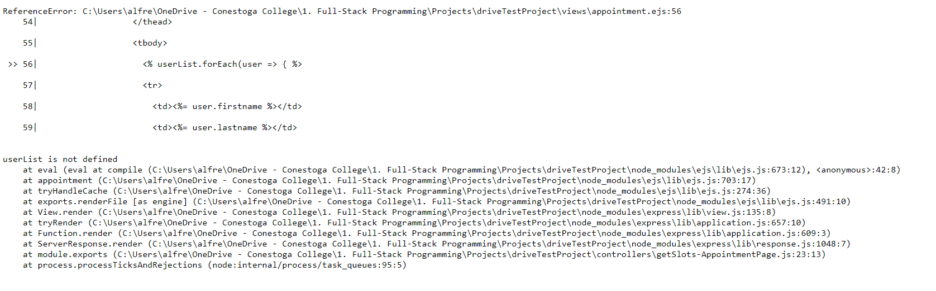

* 1. “No Pending Evaluations” message is shown even if there is a booked appointment.

