INTELLIGENT ACCOMMODATION REVIEW SYSTEM (IARS)
A MERN-Stack Accommodation Booking Platform with Sentiment-Aware Reviews
and a Hybrid Recommendation Engine

Final Year Project Dissertation
submitted in partial fulfilment of the requirements for the
degree of Bachelor of Science in Computer Science

Submitted by:
[Student Name] — [Registration / Roll No.]
Supervised by:
[Supervisor Name]
Department of Computer Science
[University Name]
[Month, Year]

FINAL APPROVAL
This project report titled "Intelligent Accommodation Review System (IARS)", submitted by the student named on the title page, has been evaluated and is hereby approved for submission in partial fulfilment of the requirements for the degree of Bachelor of Science in Computer Science.

_______________________________ Internal Examiner
_______________________________ External Examiner
_______________________________ Supervisor

CERTIFICATE
This is to certify that the project work titled "Intelligent Accommodation Review System (IARS)" has been carried out and completed under my supervision. To the best of my knowledge, the work presented in this report is an accurate description of the system implemented by the student and is approved for submission for evaluation.

_______________________________
Supervisor's Signature and Date

ACKNOWLEDGEMENT
I would like to express my sincere gratitude to my project supervisor for the guidance, feedback, and encouragement provided throughout the development of this project. I am also thankful to the faculty of the Department of Computer Science for the knowledge and skills imparted during the course of my studies, which formed the foundation for this work. Finally, I am grateful to my family and friends for their continuous support and patience throughout this project.

DECLARATION
I hereby declare that this project report, titled "Intelligent Accommodation Review System (IARS)," and the work presented in it are my own. I confirm that the system described has been designed and implemented by me, that any material drawn from external sources has been properly referenced, and that this work has not been submitted, in whole or in part, for any other degree or qualification at this or any other institution.

_______________________________
Student's Signature and Date

ABSTRACT
The Intelligent Accommodation Review System (IARS) is a web-based accommodation booking platform that combines a conventional search-and-book workflow with sentiment-aware review analysis, heuristic image verification, and a hybrid property-recommendation engine. Built on the MERN stack — MongoDB, Express.js, React.js, and Node.js — and supported by a dedicated Python FastAPI microservice for sentiment classification, IARS allows guests to search approved property listings, book online through Stripe's test-mode checkout or submit a form-based offline request, and leave reviews that are automatically classified by sentiment and broken down by aspect (cleanliness, staff, location, and others). Property owners can create and edit listings and upload up to five images per property, each of which is checked for duplication and given a heuristic quality score before being queued for administrator review; a listing cannot be approved until at least one of its images has been marked verified. A recommendation engine combines Bayesian-smoothed quality scoring, content-based similarity, and collaborative filtering derived from a guest's booking, viewing, and search history to personalise the properties shown to returning guests, while new or anonymous visitors receive a quality-ranked cold-start selection. The interface supports English, Urdu, and Arabic, with automatic right-to-left layout adaptation for the latter two languages. This report documents the system's requirements, architecture, database schema, API design, implementation, and testing, and evaluates the sentiment, recommendation, and image-verification subsystems against the objectives defined at the outset of the project.

PROJECT IN BRIEF
Item | Details
Project Title | Intelligent Accommodation Review System (IARS)
Team | [Student Name] — [Registration / Roll No.]
Supervisor | [Supervisor Name]
Start Date | [Start Date]
Completion Date | [Completion Date]
Frontend | React 18, Vite, Tailwind CSS, shadcn/ui, react-router-dom, i18next
Backend | Node.js, Express.js, Mongoose
Database | MongoDB
AI / ML Component | Python, FastAPI, scikit-learn (TF-IDF + Logistic Regression)
Payment Integration | Stripe API (test mode)
Languages Supported | English (default, LTR), Urdu (RTL), Arabic (RTL)
Tools | Git, VS Code, Postman, MongoDB Compass

TABLE OF CONTENTS
(Update this field in Word: select all, then press F9)

LIST OF FIGURES
(Update this field in Word: select all, then press F9)

LIST OF TABLES
(Update this field in Word: select all, then press F9)

CHAPTER 1
INTRODUCTION

1.1 Purpose
This report documents the analysis, design, implementation, and testing of the Intelligent Accommodation Review System (IARS), a web-based accommodation booking platform developed as a final-year project using the MERN stack (MongoDB, Express.js, React.js, Node.js) together with a dedicated Python sentiment-analysis microservice. The purpose of this document is to provide a complete and verifiable account of the system as it has actually been implemented, so that the reader can trace every described capability back to a concrete controller, route, model, or interface component in the source code. The report follows the sequence in which the system was conceived, analysed, designed, built, and evaluated, and it is intended to serve both as an academic submission and as a technical reference for anyone extending the platform in the future.

1.2 Background and Motivation
Online accommodation booking has become one of the most visible applications of web technology, with global platforms such as Airbnb [1] and Booking.com [2], and regional travel-search aggregators such as Wego [3], demonstrating how search, booking, and guest feedback can be combined into a single digital experience. Smaller markets and student-built systems, however, rarely have access to the scale of data or infrastructure that such platforms rely on, and they must instead demonstrate the same core ideas — property discovery, secure booking, and trustworthy guest feedback — using lighter-weight, self-contained components. IARS was motivated by this gap: the aim was to build a single, coherent booking platform in which every stage of the guest journey, from searching for a property to leaving a review, is backed by a working, inspectable implementation rather than a simulated or partially mocked feature.
A second motivation was the observation that guest reviews on many booking platforms are presented as raw text and a star rating, leaving prospective guests to read through long lists of comments to judge whether a property is actually a good fit. IARS addresses this by pairing every review with an automated sentiment classification and an aspect-level breakdown (cleanliness, staff, location, and so on), so that the emotional tone and specific strengths or concerns raised by past guests are surfaced directly on the property page rather than left implicit in unstructured text.
A third motivation concerns trust in listing images. Property photographs are one of the main drivers of a guest's decision to book, yet they are also easy to reuse or misrepresent. IARS therefore incorporates an image-verification step in the property-listing workflow, combining automatic duplicate detection with a heuristic quality score and a mandatory administrator audit before a listing can be approved for public display.

1.3 Problem Statement
Guests searching for short-term accommodation must currently rely on unstructured, unverified information: property photographs are not checked for duplication or quality before being published, and written reviews are not summarised in a way that lets a guest quickly judge the overall sentiment of past stays without reading every comment individually. At the same time, property owners lack a lightweight, non-technical channel to receive booking interest from guests who are unable or unwilling to complete an online payment, and administrators lack a single workspace in which to moderate incoming listings against a consistent, evidence-based standard. IARS was defined to address these three linked problems within a single platform: verified image submission, sentiment-aware review presentation, and an administrator-mediated approval workflow, wrapped around a conventional search-and-book user journey.

1.4 Proposed Solution (IARS Overview)
IARS is implemented as three cooperating services. A React single-page application (built with Vite, styled with Tailwind CSS and shadcn/ui component primitives) provides the guest-, owner-, and administrator-facing interfaces and supports English, Urdu, and Arabic through i18next with automatic right-to-left layout switching for the latter two. A Node.js/Express REST API, backed by MongoDB through Mongoose, implements authentication, property and booking management, the recommendation engine, and the administrative moderation workflows. A separate Python FastAPI microservice hosts a trained TF‑IDF and Logistic Regression sentiment-classification pipeline, which the Express API calls whenever a guest submits a review.
Guests can register, search and filter approved properties, view a property's sentiment-annotated review history, make an online booking secured through Stripe's test-mode checkout, or submit a form-based "offline request" when they prefer not to complete an online payment immediately. Property owners can create and edit listings, upload up to five images per property (each of which is hashed and heuristically scored before being queued for administrator review), and respond to offline requests from prospective guests. Administrators review pending listings, audit uploaded images, and manage user accounts, with listing approval explicitly gated on at least one image having been marked "verified". Beyond the core booking loop, a hybrid recommendation engine — combining Bayesian-smoothed quality scoring, content-based similarity, and collaborative filtering signals derived from a guest's own booking, viewing, and search history — personalises the properties shown to returning guests, while new or anonymous visitors are shown a quality-ranked cold-start selection.

1.5 Objectives of the System
The system was designed to meet the following objectives, each of which corresponds to a module that has been implemented and is discussed in the chapters that follow:
- To provide role-based registration and authentication for guests, property owners, and administrators using JSON Web Tokens and bcrypt-hashed passwords. - To allow property owners to create, edit, and illustrate listings with images that are automatically checked for duplication and heuristically scored before administrator approval. - To enforce a listing-approval workflow in which administrators cannot approve a property until at least one of its images has been marked verified. - To allow guests to search and filter approved properties by city, price range, and availability, and to book a property online with a date-overlap and availability check enforced on the server. - To integrate Stripe's test-mode Checkout API as the platform's online payment path, while retaining a form-based "offline request" as a non-payment alternative for guests who are unable to complete checkout immediately. - To classify every submitted review through a trained sentiment-analysis microservice and to present the resulting sentiment, confidence, and aspect-level insights alongside the review itself, aggregated into a per-property sentiment snapshot. - To generate personalised property recommendations for returning guests and quality-ranked cold-start recommendations for new or anonymous visitors, using a combination of Bayesian ranking, content similarity, and collaborative filtering. - To support English, Urdu, and Arabic throughout the interface, including automatic right-to-left layout adaptation, without translating user-generated content such as property titles, descriptions, or reviews. - To give administrators a dedicated workspace for listing moderation, image auditing, and user account management.

1.6 Scope of the Project
The scope of IARS, as implemented, is limited to the booking, review, and moderation workflow described above. The system does not implement live chat, a wishlist feature, coupon or discount codes, a production payment gateway, email or SMS notification delivery, PDF receipt generation, a public blog, advanced analytics dashboards, or subscription-based access tiers; these were intentionally excluded so that the project could focus on delivering a complete and well-tested implementation of its core scope rather than a partially implemented broader one. Where the original project proposal referred to capabilities such as SMS-based offline booking or a conversational chat interface, the implemented system instead provides an equivalent form-based offline-request workflow, which is discussed alongside the reasoning for this substitution in Chapter 3. Similarly, payment is implemented against Stripe's test-mode API rather than a live production gateway, consistent with the project's status as an academic prototype rather than a commercially deployed service.

1.7 Research Contribution
While IARS is primarily an engineering project, it brings together three techniques — sentiment-aware review aggregation, hybrid (content-based, collaborative, and Bayesian) property recommendation, and heuristic image-verification gating — inside a single, cohesive booking workflow rather than treating them as independent demonstrations. The specific contribution of this project lies in the integration design: the sentiment snapshot computed for each property is not only displayed to the guest but is also consumed as a scoring signal inside the recommendation engine's Bayesian quality calculation, and the image-verification outcome is not merely advisory but is enforced as a hard precondition for listing approval. This tight coupling between the AI-assisted subsystems and the core transactional workflow — rather than the novelty of any single algorithm — is what the project set out to demonstrate and what is evaluated in Chapter 4.

1.8 Organization of the Report
The remainder of this report is organised as follows. Chapter 2 presents the system analysis, including the development methodology, functional and non-functional requirements, use-case descriptions, and the activity and sequence diagrams that describe how each actor interacts with the system. Chapter 3 covers system design and implementation together, presenting the architecture, entity-relationship and class diagrams, API design, and the recommendation and sentiment pipelines, followed by a detailed account of how each module was implemented in code. Chapter 4 describes the testing strategy applied to the system, the individual test cases exercised against each module, and a qualitative evaluation of the recommendation, sentiment, and image-verification subsystems. Chapter 5 concludes the report with a summary of the work completed, its limitations, and directions for future enhancement. Chapter 6 documents the user interface screen by screen for each of the three user roles. Chapter 7 lists the references consulted during the project, and the appendices that follow provide supporting technical material, including the environment setup instructions, the full API reference, the complete database schema listing, and sentiment-model training details.

CHAPTER 2
SYSTEM ANALYSIS

2.1 Development Methodology
The Intelligent Accommodation Review System (IARS) was developed by a single student developer under FYP supervision, and the process actually followed over the course of the project is best characterised as phase-based iterative and incremental development rather than a strict Waterfall or a large-team Agile framework such as Scrum. A rigid sequential model was unsuitable given that the project combines three technically distinct layers — a React/Vite client, a Node.js/Express/MongoDB server, and a separate Python FastAPI sentiment microservice — whose interfaces could only be finalised once early integration attempts revealed the practical constraints of each layer. Equally, a full ceremony-driven Agile process (sprint planning, daily stand-ups, retrospectives) was not appropriate for a one-person team, so the project instead adopted the underlying principle of Agile/iterative development — building working increments, testing them, and refining requirements based on what was learned — without the organisational overhead meant for multi-person teams.
The starting point for requirements was the original project proposal, which envisaged a broader feature set including SMS-based booking notifications, a chatbot, and a relational database. As implementation progressed, several of these proposed capabilities were deliberately re-scoped: SMS notification was replaced by a form-based Offline Request workflow that does not depend on any telecom gateway, MySQL/PostgreSQL was replaced by MongoDB and Mongoose to better fit the variable, nested structure of property and sentiment data (embedded image-verification metadata, aspect-level sentiment breakdowns, availability ranges), and the payment gateway was narrowed to Stripe's test mode supplemented by an internal demo-payment code path retained for offline testing. This re-scoping was not a departure from requirement engineering but a direct output of it: requirements were revisited at the start of each development phase in light of what the previous phase had proven feasible, which is the defining characteristic of the iterative model.
Development proceeded module by module, with each module treated as its own short iteration consisting of requirement refinement, schema design, backend route/controller implementation, frontend page/component implementation, and manual verification before the next module began. The first iterations delivered the authentication subsystem (authController.js, authMiddleware.js, the User model) and the property catalogue (Property model, owner property routes), since every subsequent module — booking, review, recommendation — depends on a registered user and an approved property existing. Later iterations added the image-verification pipeline, the booking-and-payment module (including the Stripe Checkout integration), the review-and-sentiment integration with the external FastAPI service, the offline-request module, the recommendation engine, and finally the administrative moderation tools. Each iteration produced a runnable increment of the system rather than a design document alone, allowing the developer to test end-to-end flows (for example, creating a booking and immediately attempting to pay for it) as soon as a module was functionally complete rather than deferring integration to a single late "system testing" phase.
Testing was carried out continuously alongside implementation rather than as an isolated downstream activity. Each new route was exercised manually through the running client and, where convenient, directly against the Express API, and defects such as incorrect booking-overlap detection or a missing verified-image gate on listing approval were fixed within the same iteration in which they were discovered. This continuous-testing discipline is reflected later in Chapter 4, which documents the black-box and white-box test cases derived from the same set of modules described here. Because the sentiment-analysis model already existed as a trained artifact prior to this integration project, the sentiment microservice itself was treated as a fixed external dependency during MERN-side iterations — the FastAPI /predict contract was integrated against and tested, but the underlying TF-IDF and Logistic Regression pipeline was not retrained, consistent with the project's stated scope of integrating, not rebuilding, the existing sentiment model.

2.2 Stakeholders and System Actors
Three human roles interact directly with IARS, distinguished at the data level by the role field on the User model (guest, owner, admin) and enforced at the route level by the authorize(...roles) middleware layered on top of the JWT-based protect middleware. Each role has a distinct goal set and a distinct set of touchpoints across the platform, and two non-human subsystems additionally act on the system's behalf without a user interface of their own.
The Guest is the platform's consumer-facing actor: an individual seeking accommodation who registers or logs in, searches and filters approved properties, inspects a property's gallery, sentiment snapshot and reviews, and either books online through the Stripe-backed checkout flow or falls back to the form-based Offline Request when an online booking is not appropriate for their circumstance. After a stay is confirmed, the guest's remaining touchpoint is the review workflow, through which a single review per booking (enforced by the unique booking reference on the Review model) is submitted and automatically scored for sentiment. Guests also passively generate signal data — property views recorded through POST /api/properties/:id/view and search queries persisted to SearchHistory — that is never surfaced to them directly but feeds the recommendation engine on their next visit.
The Property Owner is the supply-side actor whose goal is to list accommodation, keep listings compliant with the platform's image-verification requirement, and manage the resulting bookings and guest interactions. An owner authenticates with the same JWT mechanism as a guest but is authorised for a distinct set of routes: creating and editing properties with multipart image uploads, viewing only their own properties (GET /api/properties/owner/my-properties) and bookings (GET /api/bookings/owner-bookings), and responding to offline requests addressed to their properties. Because a listing cannot be approved by the admin workflow without at least one image reaching verificationStatus: "verified", the owner's upload behaviour is directly coupled to whether their property ever becomes visible to guests at all.
The Admin is the platform's governance actor, responsible for two forms of quality control that gate what guests are allowed to see: listing moderation (via the stricter admin/listings pending/approve/reject path, which enforces the verified-image rule) and image auditing (via admin/image-audit, where each individual image's verificationStatus and aiScore are reviewed and adjusted). The admin additionally manages the user base — listing users by role and toggling isVerified — which the frontend currently exposes only for verification status, even though the underlying route also supports role changes.
Beyond these three human actors, two backend subsystems function as system-level actors that participate in workflows without any direct user interface. The sentiment microservice is a separate Python FastAPI process, invoked internally by sentimentService.js whenever a review is submitted; it receives the raw review text, returns a structured sentiment result, and is entirely opaque to the guest who only ever sees the resulting label and aspect breakdown. The recommendation engine, implemented across buildUserProfile.js, bayesianRanking.js, propertySimilarity.js, and collaborativeFiltering.js, similarly acts autonomously each time GET /api/recommendations is called, synthesising a guest's implicit behavioural signals into ranked property sections without any explicit guest input beyond ordinary browsing.

2.3 Functional Requirements
The functional requirements of IARS were derived directly from the module boundaries established during iterative development and correspond one-to-one with the routes, controllers, and models described in the preceding sections. They span nine functional areas: account management, property listing management, image verification, search and discovery, booking, payment, review and sentiment analysis, offline requests, and administrative moderation. Authentication requirements establish the identity layer on which every other module depends — a user cannot create a property, make a booking, or submit a review without first holding a valid JWT issued at login and validated by authMiddleware.js on each subsequent request. Property-management requirements govern how an owner introduces a listing into the system and how that listing progresses from pending to approved, while the image-verification requirements describe the hashing, duplicate-detection and heuristic scoring behaviour that must occur before any admin decision on a listing can be made.
Booking and payment requirements reflect the two-stage nature of a confirmed stay in IARS: a Booking document is first created in a pending state once availability and overlap checks pass, and is only transitioned to confirmed once a payment — through Stripe test-mode checkout or, where triggered directly against the backend, the demo-payment endpoint — has been verified. Review and sentiment requirements capture the constraint that a review can only be attached to a completed, confirmed booking that has not already been reviewed, and that every accepted review is automatically forwarded to the external sentiment model before being persisted. The offline-request requirements describe the form-based contact-and-booking-negotiation path that exists as an alternative to the fully online booking flow, and the recommendation requirements describe the two ranking modes — cold-start and personalised — that the system falls back between depending on the guest's authentication state and history. Administrative requirements, finally, describe the two levels of control the admin exercises over supply-side quality: listing approval and image auditing, together with basic user-account governance.
Table 2.1: Functional Requirements by Module
ID | Requirement | Module
FR-01 | The system shall allow a new user to register with name, email, phone, password and role (guest or owner), storing the password only as a bcrypt hash. | Authentication
FR-02 | The system shall allow a registered user to log in with email and password and receive a signed JWT for subsequent authenticated requests. | Authentication
FR-03 | The system shall expose the authenticated user's own profile via GET /api/auth/me, protected by the protect middleware. | Authentication
FR-04 | The system shall restrict role-specific routes using the authorize(...roles) middleware so that only owners can manage properties and only admins can moderate listings, audit images, or manage users. | Authentication
FR-05 | The system shall allow an owner to create a property listing with title, description, location (address, city, country), price, and up to five images uploaded as multipart form data. | Property Management
FR-06 | The system shall allow an owner to edit an existing property they own, including its details and availability calendar, via PUT /api/properties/:id. | Property Management
FR-07 | The system shall allow an owner to view only the properties they own via GET /api/properties/owner/my-properties. | Property Management
FR-08 | The system shall expose only properties with status: "approved" to public/guest browsing via GET /api/properties. | Property Management
FR-09 | The system shall compute a SHA-256 hash for each uploaded image and discard exact duplicates found within the same upload batch. | Image Verification
FR-10 | The system shall mark an uploaded image as verificationStatus: "suspicious" with aiScore: 0.45 when its hash matches an image already stored elsewhere in the database. | Image Verification
FR-11 | The system shall compute a heuristic aiScore between 0 and 1 for each newly uploaded, non-duplicate image using imageAiScore.js, based on dimensions, resolution, compression ratio, and aspect ratio. | Image Verification
FR-12 | The system shall allow an admin to review all property images across the platform via GET /api/admin/image-audit and set each image's verificationStatus via PUT /api/admin/image-audit/:propertyId/:imageId. | Image Verification
FR-13 | The system shall prevent guests from viewing any property image whose verificationStatus is not "verified" on an approved listing. | Image Verification
FR-14 | The system shall allow a guest (authenticated or anonymous) to search approved properties by city, title, price range, and availability date via GET /api/search, persisting the query to SearchHistory when the requester is authenticated. | Search & Discovery
FR-15 | The system shall record a PropertyView document each time a guest opens a property detail page, via POST /api/properties/:id/view. | Search & Discovery
FR-16 | The system shall allow a guest to view full property details, including the gallery of verified images and the denormalised sentimentSnapshot, via GET /api/properties/:id. | Search & Discovery
FR-17 | The system shall create a Booking in pending status only after validating that the property is approved, that any non-empty availabilityCalendar contains a range covering the requested dates, and that no overlapping pending or confirmed booking already exists for the same property. | Booking
FR-18 | The system shall compute totalAmount on a booking as price multiplied by the number of nights between startDate and endDate. | Booking
FR-19 | The system shall reject a booking attempt with a distinct error code (BOOKING_ALREADY_EXISTS or DATES_UNAVAILABLE) depending on whether the conflict is with an existing booking or with the property's declared availability. | Booking
FR-20 | The system shall allow a guest to cancel their own booking via PUT /api/bookings/:id/cancel, after which the booking cannot be paid or reconfirmed. | Booking
FR-21 | The system shall allow a guest to initiate a Stripe test-mode checkout session for a pending booking via POST /api/payments/stripe/create-checkout-session, converting the PKR total to USD cents at a fixed demo rate of 280 PKR/USD. | Payment
FR-22 | The system shall verify a completed Stripe session via GET /api/payments/stripe/verify-session and transition the booking to status: "confirmed", paymentStatus: "confirmed", paymentMethod: "stripe_test" only when Stripe reports payment_status === "paid". | Payment
FR-23 | The system shall expose a signature-verified Stripe webhook endpoint (POST /api/payments/stripe/webhook) that accepts the raw request body for event verification. | Payment
FR-24 | The system shall provide a PUT /api/bookings/:id/confirm-demo-payment endpoint allowing a booking to be confirmed through an internal demo-payment path, independent of Stripe. | Payment
FR-25 | The system shall allow a guest to submit a review (rating 1-5, text up to 1000 characters) only for a booking they own that is confirmed and does not already have an associated review. | Review & Sentiment
FR-26 | The system shall forward every accepted review's text to the external sentiment microservice's /predict endpoint and persist the returned sentiment, sentimentScore, aspects, aspectInsights, and summary fields on the Review document. | Review & Sentiment
FR-27 | The system shall recompute and store the property's denormalised sentimentSnapshot (totals, per-category counts, percentages, aspect breakdown) after every new review, via syncPropertySentiment(). | Review & Sentiment
FR-28 | The system shall list a guest's bookings eligible for review (confirmed, unreviewed) via GET /api/reviews/eligible/:propertyId. | Review & Sentiment
FR-29 | The system shall allow any visitor, authenticated or anonymous, to submit an Offline Request with guest name, phone, location, stay dates, and room type via POST /api/offline-requests. | Offline Requests
FR-30 | The system shall automatically link previously anonymous Offline Requests to a guest's account when the phone number on the request matches the phone number on their profile at next login. | Offline Requests
FR-31 | The system shall allow an owner to view all pending Offline Requests addressed to their properties via GET /api/offline-requests/owner and respond with a responseMessage, setting status to responded or closed. | Offline Requests
FR-32 | The system shall build a guest's behavioural profile (preferred city, latest budget, preferred property types and amenities) from their last five SearchHistory entries, bookings, high-rated reviews, and property views. | Recommendations
FR-33 | The system shall serve cold-start recommendations, ranked by Bayesian-smoothed quality across Top Rated, Best Reviewed, and Trending sections, to anonymous or history-less guests. | Recommendations
FR-34 | The system shall serve personalised recommendations combining content similarity and collaborative filtering, organised into up to six sections, to authenticated guests with sufficient behavioural history. | Recommendations
FR-35 | The system shall allow an admin to list properties pending approval (GET /api/admin/listings/pending) and approve a listing only if it has at least one image with verificationStatus: "verified". | Admin
FR-36 | The system shall allow an admin to reject a pending listing via PUT /api/admin/listings/:id/reject. | Admin
FR-37 | The system shall allow an admin to list all users, optionally filtered by role, and toggle a user's isVerified flag via PUT /api/admin/users/:id/verify. | Admin

2.4 Non-Functional Requirements
Non-functional requirements for IARS were shaped by the fact that the system is a demonstrable academic prototype rather than a production platform, but several of its architectural choices were made specifically because they would hold up under realistic load and multilingual usage. Statelessness of authentication (JWT rather than server-side session storage) was chosen so that the Express API can, in principle, be horizontally scaled without a shared session store, and password security relies entirely on bcrypt hashing rather than reversible encryption. The requirement to support English, Urdu, and Arabic — with the latter two rendered right-to-left — was treated as a first-class design constraint rather than a cosmetic add-on, driving the use of i18next/react-i18next and direction-safe Tailwind utility classes (text-start, text-end, ms-*, me-*) throughout the client rather than hardcoded left/right positioning.
Table 2.2: Non-Functional Requirements
Category | Requirement Description
Performance | Search and recommendation queries shall rely on indexed MongoDB fields (SearchHistory.user, PropertyView.user/property) to keep behavioural-profile lookups efficient as the number of guest interactions grows.
Performance | The denormalised Property.sentimentSnapshot shall be maintained incrementally by syncPropertySentiment() rather than recomputed from all reviews on every property-detail or search request.
Performance | Image AI-scoring shall use a lightweight deterministic heuristic (imageAiScore.js) rather than a heavyweight machine-learning inference call, keeping property-creation requests responsive.
Usability | Booking, listing, and offline-request forms shall provide clear validation feedback (for example, distinct BOOKING_ALREADY_EXISTS and DATES_UNAVAILABLE error codes) so guests and owners understand why an action failed.
Usability | The interface shall present loading and empty states for asynchronous data (search results, recommendation sections, admin queues) rather than blank screens.
Usability | Property detail pages shall surface the sentiment snapshot (positive/negative/neutral/mixed counts, average rating, praised and concern aspects) alongside raw reviews to help guests make faster decisions.
Security | User passwords shall never be stored or transmitted in plaintext; all password fields are hashed with bcrypt before persistence.
Security | Every protected route shall validate a JWT via protect middleware, and role-restricted routes shall additionally validate the caller's role via authorize(...roles) before executing controller logic.
Security | The Stripe webhook endpoint shall verify the request signature against the raw request body before trusting any payment event, preventing forged payment confirmations.
Security | A property image shall never be exposed to guests unless its verificationStatus is "verified", preventing unaudited or suspicious images from reaching the public catalogue.
Localization | The default application language shall be English, with Urdu and Arabic available as additional locales through i18next/react-i18next.
Localization | All static UI text shall be sourced from translation keys rather than hardcoded strings, while user-generated content (property titles/descriptions, reviews, names, contact details, image URLs) shall never be machine-translated.
Localization | Layout components (navbar, footer, forms, cards, tables, dashboards) shall use direction-safe classes (text-start, text-end, logical start/end spacing, flex-wrap, responsive grids) so that the interface renders correctly in both LTR and RTL locales without structural breakage.
Availability & Reliability | Booking creation shall perform availability and overlap validation synchronously before persisting a booking, preventing the creation of conflicting reservations even under near-simultaneous requests.
Availability & Reliability | Payment status shall only be escalated to confirmed after explicit verification against Stripe's reported payment_status, preventing a booking from being marked paid on the basis of an unverified client-side redirect alone.
Maintainability | Backend responsibilities shall be separated into distinct route/controller modules per domain (auth, properties, bookings, payments, reviews, sentiment, offline requests, admin, search/recommendations), keeping each module independently testable and extensible.
Maintainability | The recommendation engine's scoring logic shall remain isolated in dedicated utility modules (buildUserProfile.js, bayesianRanking.js, propertySimilarity.js, collaborativeFiltering.js) so that individual signals can be tuned without touching route-handling code.
Maintainability | The sentiment-analysis capability shall remain an independently deployable FastAPI microservice accessed only through the SENTIMENT_API_URL configuration, so the trained model can be updated or redeployed without changes to the MERN codebase.

2.5 Use Case Diagram
The use case diagram for IARS identifies three human actors — Guest, Property Owner, and Admin — situated outside a single system boundary labelled "IARS," inside which the platform's use cases are grouped by functional area: account access, property discovery, booking and payment, review and sentiment, offline requests, recommendations, and administration. The Guest actor connects to the largest number of use cases, reflecting the platform's guest-facing focus, while the Property Owner and Admin actors connect to a smaller, more specialised set centred on listing management and platform governance respectively. Two use cases — Track Property View and View Personalized/Cold-Start Recommendations — are triggered by guest browsing behaviour but are fulfilled by system-level logic (the recommendation engine) rather than by an explicit guest action, and are shown as guest-initiated use cases that internally depend on the automated subsystem described in Section 2.2. Shared use cases such as Cancel Booking and Write Review are restricted to the Guest actor because only the guest who created a booking may act on it, whereas Respond to Offline Request and Approve/Reject Listing are restricted to Owner and Admin respectively, reflecting the role-based authorization enforced by roleMiddleware.js.
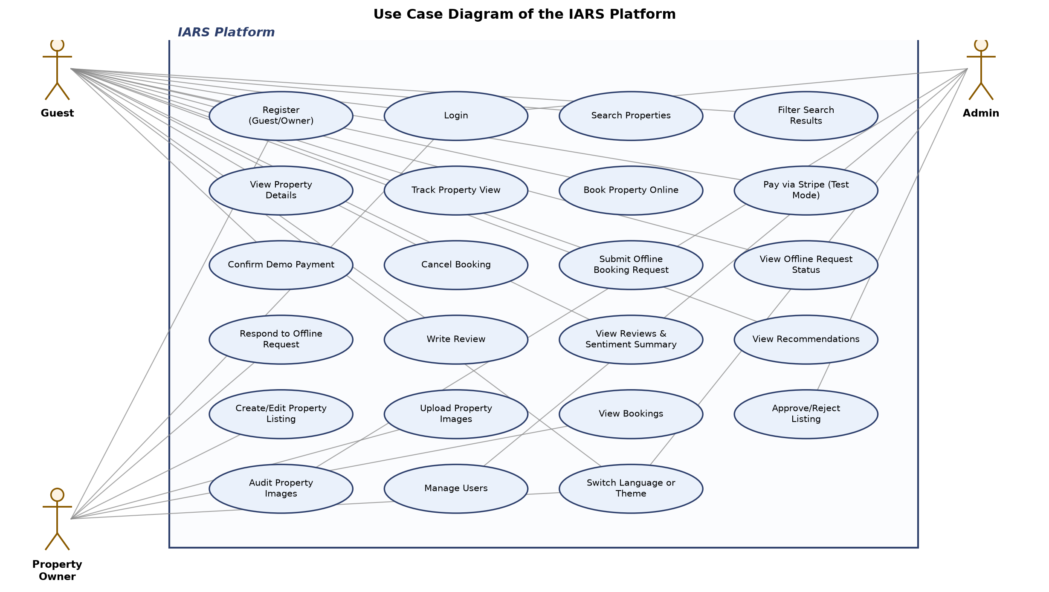
Figure 2.1: Use Case Diagram of the IARS Platform

2.6 Use Case Descriptions in Detail
The following subsections describe each of the twenty-three use cases identified for IARS in structured form, covering the primary actor, goal, pre- and post-conditions, and both the success and alternate execution paths as implemented in the codebase.

2.6.1 Register (Guest/Owner) — UC-01
A new visitor creates an account by choosing either the guest or owner role, after which the credentials are validated and the password is hashed before storage.
Table 2.3: Use Case for Register (Guest/Owner)
Field | Description
Use Case No. | UC-01
Scope | Authentication
Name | Register (Guest/Owner)
Primary Actor(s) | Guest, Property Owner
Goal | Create a new account with a chosen role so that role-appropriate features become accessible.
Pre-Conditions | The visitor does not already hold an account with the supplied email.
Post-Conditions | A User document is created with a bcrypt-hashed password and the chosen role; the user may now log in.
Success Scenario | Visitor submits name, email, phone, password and role via the registration form -> server validates uniqueness of email -> password is hashed with bcrypt -> User document is saved -> success response returned.
Alternate Scenario | If the email is already registered, POST /api/auth/register returns a validation error and no document is created; the visitor is prompted to log in instead.

2.6.2 Login — UC-02
Any registered actor authenticates with email and password to obtain a JWT that authorizes subsequent requests according to their role.
Table 2.4: Use Case for Login
Field | Description
Use Case No. | UC-02
Scope | Authentication
Name | Login
Primary Actor(s) | Guest, Property Owner, Admin
Goal | Obtain a signed JWT to access role-appropriate protected routes.
Pre-Conditions | The actor already holds a registered account.
Post-Conditions | A JWT is issued and stored client-side; the actor is treated as authenticated on subsequent requests carrying the token.
Success Scenario | Actor submits email and password to POST /api/auth/login -> server locates the matching User, compares the bcrypt hash -> on match, a JWT encoding the user id and role is signed and returned -> client stores the token and redirects to the role-appropriate dashboard.
Alternate Scenario | If the email is not found or the password hash does not match, the server returns an authentication error and no token is issued; if a previously anonymous Offline Request's phone number matches this user's phone, it is auto-linked to their account at this point.

2.6.3 Search Properties — UC-03
A guest, whether logged in or anonymous, queries the catalogue of approved properties by city, title, price, or availability date.
Table 2.5: Use Case for Search Properties
Field | Description
Use Case No. | UC-03
Scope | Search & Discovery
Name | Search Properties
Primary Actor(s) | Guest
Goal | Retrieve a list of approved properties matching search criteria.
Pre-Conditions | None; the guest may or may not be authenticated (optionalProtect).
Post-Conditions | A ranked list of matching approved properties is returned; if the guest is authenticated, a SearchHistory document recording the query is saved.
Success Scenario | Guest enters a city, title keyword, price range, or availability date -> GET /api/search filters approved properties by the supplied parameters -> if authenticated, the query is persisted to SearchHistory -> matching properties are returned to the client.
Alternate Scenario | If no criteria are supplied, the endpoint returns the general approved-property catalogue; if no properties match, an empty result set is returned and the client displays an empty state.

2.6.4 Filter Search Results — UC-04
A guest narrows an existing search result set further by combining multiple criteria such as city, price band, and availability simultaneously.
Table 2.6: Use Case for Filter Search Results
Field | Description
Use Case No. | UC-04
Scope | Search & Discovery
Name | Filter Search Results
Primary Actor(s) | Guest
Goal | Combine multiple search parameters to reach a more precise subset of approved properties.
Pre-Conditions | The guest has an active search context on the properties page.
Post-Conditions | The result list reflects all currently selected filter values simultaneously.
Success Scenario | Guest adjusts one or more filter controls (city, minPrice, maxPrice, availabilityDate, title) -> client re-issues GET /api/search with the combined parameters -> server applies all supplied filters in the same query -> the filtered list is returned and rendered.
Alternate Scenario | If the combined filters yield no matching approved property, the client renders an empty-state message rather than an error, since an empty result is a valid outcome of GET /api/search.

2.6.5 View Property Details — UC-05
A guest opens a specific property to inspect its gallery, description, location, pricing, sentiment snapshot, and reviews before deciding whether to book.
Table 2.7: Use Case for View Property Details
Field | Description
Use Case No. | UC-05
Scope | Search & Discovery
Name | View Property Details
Primary Actor(s) | Guest
Goal | Review complete information about a property to support a booking decision.
Pre-Conditions | The property exists; if it is not approved, only the owner or an admin may view it.
Post-Conditions | Property detail data, including the verified-image gallery and sentimentSnapshot, is displayed; a PropertyView record may be created as a side effect (see UC-06).
Success Scenario | Guest selects a property from search results or recommendations -> client requests GET /api/properties/:id with optionalProtect -> server returns title, description, location, price, verified images only, availability, and the denormalised sentiment snapshot -> client renders the PropertyDetailPage, including reviews and the booking call-to-action.
Alternate Scenario | If the requesting user is neither the owner nor an admin and the property is not approved, the server withholds the property, and the client displays a not-found state.

2.6.6 Track Property View — UC-06
Each time a guest opens a property detail page, the system silently records the interaction to feed the recommendation engine's behavioural profile, without any visible action from the guest.
Table 2.8: Use Case for Track Property View
Field | Description
Use Case No. | UC-06
Scope | Recommendations (system-level)
Name | Track Property View
Primary Actor(s) | Guest (indirectly); Recommendation Engine (system actor)
Goal | Persist an implicit interest signal so that future recommendations can reflect the guest's browsing behaviour.
Pre-Conditions | The guest has opened a property detail page.
Post-Conditions | A PropertyView document referencing the user and property, timestamped by viewedAt, is created.
Success Scenario | Guest opens a property detail page -> client calls POST /api/properties/:id/view -> server creates a PropertyView record -> the recommendation engine later reads this record as part of buildUserProfile.js when computing viewed-similar recommendations.
Alternate Scenario | If the guest is anonymous, no PropertyView is recorded since the route requires an identified guest, and the view contributes only to that session's browsing, not to any stored profile.

2.6.7 Book Property Online — UC-07
An authenticated guest selects a property, chosen dates, and a guest count to initiate a reservation, which the server validates before creating a pending booking.
Table 2.9: Use Case for Book Property Online
Field | Description
Use Case No. | UC-07
Scope | Booking
Name | Book Property Online
Primary Actor(s) | Guest
Goal | Reserve a property for a chosen date range pending payment confirmation.
Pre-Conditions | The guest is authenticated; the target property is approved.
Post-Conditions | A Booking document is created with status: "pending", paymentStatus: "pending", and totalAmount computed as price x nights.
Success Scenario | Guest selects property, start/end dates, and guest count on BookingNewPage -> client submits POST /api/bookings -> server confirms the property is approved, checks the requested dates fall within the property's availabilityCalendar (if non-empty), and checks for an overlapping pending/confirmed booking -> server creates the pending booking -> guest is routed to BookingPaymentPage.
Alternate Scenario | If an overlapping booking already exists, the server returns BOOKING_ALREADY_EXISTS; if the dates fall outside the declared availability, it returns DATES_UNAVAILABLE; in either case no booking is created and the client surfaces the specific error to the guest.

2.6.8 Pay via Stripe (Test Mode) — UC-08
The guest completes payment for a pending booking through Stripe's hosted test-mode checkout, after which the server verifies the session before confirming the booking.
Table 2.10: Use Case for Pay via Stripe (Test Mode)
Field | Description
Use Case No. | UC-08
Scope | Payment
Name | Pay via Stripe (Test Mode)
Primary Actor(s) | Guest
Goal | Confirm and pay for a pending booking through Stripe's test-mode checkout.
Pre-Conditions | A pending, unpaid booking exists and belongs to the guest.
Post-Conditions | On success, the booking transitions to status: "confirmed", paymentStatus: "confirmed", paymentMethod: "stripe_test", with stripeSessionId, stripePaymentIntentId, and paymentConfirmedAt populated.
Success Scenario | Guest proceeds from BookingPaymentPage -> client calls POST /api/payments/stripe/create-checkout-session, which converts the PKR total to USD cents at the fixed 280 PKR/USD demo rate -> guest completes payment on Stripe's hosted checkout -> Stripe redirects to BookingPaymentSuccessPage -> client calls GET /api/payments/stripe/verify-session -> server confirms payment_status === "paid" and updates the booking accordingly.
Alternate Scenario | If the guest abandons checkout or the verified session does not report paid, the booking remains pending/unpaid and no status change occurs; the Stripe webhook (POST /api/payments/stripe/webhook) independently verifies event signatures as a secondary confirmation path.

2.6.9 Confirm Demo Payment — UC-09
A backend capability exists to mark a booking as paid through an internal demo path rather than Stripe, intended for testing; it currently has no corresponding button in the frontend.
Table 2.11: Use Case for Confirm Demo Payment
Field | Description
Use Case No. | UC-09
Scope | Payment
Name | Confirm Demo Payment
Primary Actor(s) | Guest
Goal | Confirm payment for a pending booking without routing through Stripe, for testing purposes.
Pre-Conditions | A pending, unpaid booking exists and belongs to the guest; the endpoint is invoked directly, since no UI control currently triggers it.
Post-Conditions | The booking transitions to status: "confirmed", paymentStatus: "confirmed", paymentMethod: "demo".
Success Scenario | A request is made to PUT /api/bookings/:id/confirm-demo-payment for the guest's own pending booking -> server validates ownership and pending status -> booking is marked confirmed with paymentMethod: "demo".
Alternate Scenario | If the booking has already been cancelled or confirmed, the endpoint rejects the transition; because no frontend button currently exposes this action, it is presently only reachable through direct API invocation rather than through normal guest interaction with the client.

2.6.10 Cancel Booking — UC-10
A guest withdraws from a booking they created, whether it is still pending or already confirmed, closing off any further payment or reconfirmation on it.
Table 2.12: Use Case for Cancel Booking
Field | Description
Use Case No. | UC-10
Scope | Booking
Name | Cancel Booking
Primary Actor(s) | Guest
Goal | Withdraw from a booking the guest no longer wishes to keep.
Pre-Conditions | The booking belongs to the requesting guest and is not already cancelled.
Post-Conditions | The booking's status is set to "cancelled"; it can no longer be paid or reconfirmed.
Success Scenario | Guest selects a booking from GuestBookingsPage and requests cancellation -> client calls PUT /api/bookings/:id/cancel -> server verifies ownership -> booking status is updated to "cancelled".
Alternate Scenario | If the booking does not belong to the requesting guest or does not exist, the server rejects the request; if the booking was already cancelled, the cancellation is idempotent and no further state change occurs.

2.6.11 Submit Offline Booking Request — UC-11
A visitor, logged in or anonymous, uses a form to request accommodation without going through the online booking-and-payment flow, for cases where an online reservation is not suitable.
Table 2.13: Use Case for Submit Offline Booking Request
Field | Description
Use Case No. | UC-11
Scope | Offline Requests
Name | Submit Offline Booking Request
Primary Actor(s) | Guest (authenticated or anonymous)
Goal | Request accommodation through a form-based alternative to the online booking flow.
Pre-Conditions | None; the route uses optionalProtect and allows anonymous submission.
Post-Conditions | An OfflineRequest document is created with status: "pending", linked to the guest's account if authenticated.
Success Scenario | Visitor completes the OfflineBookingPage form with guest name, phone, location, start/end dates, and room type, optionally referencing a specific property -> client calls POST /api/offline-requests -> server creates the request, linking it to the guest's account if logged in.
Alternate Scenario | If submitted anonymously, the request has no guest reference at creation time; it is automatically linked to a guest account later if that account's phone number matches on a subsequent login (UC-02).

2.6.12 View Offline Request Status — UC-12
An authenticated guest checks the status of the offline requests associated with their account, including any that were originally submitted anonymously and later linked.
Table 2.14: Use Case for View Offline Request Status
Field | Description
Use Case No. | UC-12
Scope | Offline Requests
Name | View Offline Request Status
Primary Actor(s) | Guest
Goal | Track whether a submitted offline request has received an owner response.
Pre-Conditions | The guest is authenticated and has at least one associated OfflineRequest.
Post-Conditions | The guest sees the current status (pending, responded, or closed) and any responseMessage for each of their requests.
Success Scenario | Guest opens GuestOfflineRequestsPage -> client calls GET /api/offline-requests/guest -> server returns all OfflineRequest documents linked to the guest's account, including auto-linked ones -> client renders status and response text.
Alternate Scenario | If the guest has no offline requests, the page renders an empty state; if a request is still pending, no responseMessage is shown yet.

2.6.13 Respond to Offline Request — UC-13
A property owner reviews pending offline requests addressed to their listings and replies with a message, marking the request as responded or closed.
Table 2.15: Use Case for Respond to Offline Request
Field | Description
Use Case No. | UC-13
Scope | Offline Requests
Name | Respond to Offline Request
Primary Actor(s) | Property Owner
Goal | Reply to a guest's offline request and move it toward resolution.
Pre-Conditions | The offline request references one of the owner's properties (or is otherwise addressed to them) and is not already closed.
Post-Conditions | The request's responseMessage is set and its status becomes "responded" or "closed".
Success Scenario | Owner opens OwnerOfflineRequestsPage -> client calls GET /api/offline-requests/owner to list pending requests -> owner composes a reply -> client calls PUT /api/offline-requests/:id/respond with the message and desired status -> request is updated; the guest may subsequently proceed to a normal online booking for that property (UC-07).
Alternate Scenario | If the owner attempts to respond to a request already closed, the update is rejected or has no further effect, since the request has already reached its terminal state.

2.6.14 Write Review — UC-14
A guest with a confirmed, unreviewed booking submits a rating and text review, which the system automatically scores for sentiment before storing.
Table 2.16: Use Case for Write Review
Field | Description
Use Case No. | UC-14
Scope | Review & Sentiment
Name | Write Review
Primary Actor(s) | Guest
Goal | Record a rating and written opinion about a completed stay.
Pre-Conditions | The guest holds a confirmed booking for the property with no existing Review referencing it (enforced by the unique booking field).
Post-Conditions | A Review document is created with rating, text, and sentiment fields populated by the sentiment microservice; the property's sentimentSnapshot is refreshed.
Success Scenario | Guest opens ReviewForm from an eligible booking (GET /api/reviews/eligible/:propertyId) -> submits rating and text (<=1000 characters) via POST /api/reviews -> server verifies the booking is confirmed and unreviewed -> server calls sentimentService.js, which posts the review text to the FastAPI /predict endpoint -> returned sentiment fields are stored on the review -> syncPropertySentiment() updates the property's sentimentSnapshot.
Alternate Scenario | If the booking is not confirmed, does not belong to the guest, or already has a review, POST /api/reviews rejects the submission; if the sentiment microservice is unreachable, the review submission is expected to surface an error rather than silently store an unscored review.

2.6.15 View Reviews and Sentiment Summary — UC-15
Any visitor viewing a property can read the individual guest reviews alongside an aggregated sentiment summary computed from all reviews for that property.
Table 2.17: Use Case for View Reviews and Sentiment Summary
Field | Description
Use Case No. | UC-15
Scope | Review & Sentiment
Name | View Reviews and Sentiment Summary
Primary Actor(s) | Guest
Goal | Understand overall guest sentiment about a property before booking.
Pre-Conditions | The property has at least one review to display a non-empty summary (an empty summary is otherwise shown).
Post-Conditions | The reviews list and sentiment summary are rendered on the property detail page.
Success Scenario | Guest opens a property detail page -> client calls GET /api/reviews/property/:propertyId for individual reviews and/or GET /api/sentiment/property/:propertyId for the aggregated snapshot -> ReviewsList and SentimentSummary components render ratings, sentiment labels, praised/concern aspects, and the average rating.
Alternate Scenario | If no reviews exist yet for the property, the sentiment summary displays a neutral/empty state rather than fabricated statistics.

2.6.16 View Personalized/Cold-Start Recommendations — UC-16
The system presents a set of recommended properties to the guest, choosing between a behaviour-driven personalised mode and a general-quality cold-start mode depending on how much history the guest has.
Table 2.18: Use Case for View Personalized/Cold-Start Recommendations
Field | Description
Use Case No. | UC-16
Scope | Recommendations
Name | View Personalized/Cold-Start Recommendations
Primary Actor(s) | Guest; Recommendation Engine (system actor)
Goal | Discover properties relevant to the guest's demonstrated or inferred preferences.
Pre-Conditions | None; both authenticated and anonymous guests may request recommendations.
Post-Conditions | A set of ranked property sections is returned and rendered by the RecommendedProperties component.
Success Scenario (personalized) | Authenticated guest with prior views, bookings, reviews, or searches requests recommendations -> GET /api/recommendations calls buildUserProfile.js to derive preferred city, budget, property types and amenities -> buildRecommendationMode() selects hybrid-personalized-sectioned -> propertySimilarity.js and collaborativeFiltering.js compute content and co-occurrence signals -> up to six sections (recent_searches, previous_bookings, preferred_budget, viewed_similar, popular_in_city, recommended_for_you) are built, deduplicated, capped at four items each, and annotated with match reasons.
Alternate Scenario | If the guest is anonymous or has no recorded views, bookings, reviews, or searches, buildRecommendationMode() selects bayesian-sentiment-cold-start, and bayesianRanking.js ranks properties into Top Rated, Best Reviewed, and Trending sections using the Bayesian-smoothed quality score (prior mean 3.5, weight 4) instead of behavioural signals.

2.6.17 Create or Edit Property Listing — UC-17
An owner introduces a new listing or modifies an existing one, supplying descriptive details, pricing, and availability that will later be reviewed for admin approval.
Table 2.19: Use Case for Create or Edit Property Listing
Field | Description
Use Case No. | UC-17
Scope | Property Management
Name | Create or Edit Property Listing
Primary Actor(s) | Property Owner
Goal | Introduce or update a property so it can eventually be approved and discovered by guests.
Pre-Conditions | The owner is authenticated; for edits, the property belongs to the owner.
Post-Conditions | A new Property document exists with status: "pending", or an existing one is updated, in either case reflecting the submitted title, description, location, price, and availability.
Success Scenario | Owner completes PropertyForm on OwnerPropertyNewPage (or OwnerPropertyEditPage) with title, description, location, price, and availability ranges -> client submits POST /api/properties (or PUT /api/properties/:id) -> server persists the listing, defaulting new listings to status: "pending".
Alternate Scenario | If required fields are missing or invalid, the server rejects the submission and the form surfaces validation errors; editing a listing does not reset an already-approved status unless the change specifically warrants re-review.

2.6.18 Upload Property Images — UC-18
While creating or editing a listing, the owner uploads up to five images, each of which is hashed for duplicate detection and heuristically scored before an admin ever inspects it.
Table 2.20: Use Case for Upload Property Images
Field | Description
Use Case No. | UC-18
Scope | Image Verification
Name | Upload Property Images
Primary Actor(s) | Property Owner
Goal | Attach visual evidence of the property to the listing so it can pass admin image verification.
Pre-Conditions | The owner is submitting or editing a property; each file is jpg, png, or webp and at most 5MB.
Post-Conditions | Each accepted image is stored with a url, SHA-256 hash, verificationStatus, and heuristic aiScore; exact duplicates within the same batch are discarded.
Success Scenario | Owner selects up to five image files in PropertyForm -> files are uploaded as multipart form data with the property submission -> server computes a SHA-256 hash per file, discards in-batch duplicates, and for each remaining file either marks it "suspicious" (aiScore 0.45) if the hash matches an existing database image or "pending" with a computed heuristic aiScore (from imageAiScore.js) otherwise.
Alternate Scenario | If a file exceeds 5MB or is not one of the accepted formats, it is rejected before hashing; if all uploaded images are duplicates or rejected, the property is saved without any usable image, which will later block admin approval (UC-20).

2.6.19 View Bookings — UC-19
An owner reviews the bookings made against their properties to track occupancy and guest activity.
Table 2.21: Use Case for View Bookings
Field | Description
Use Case No. | UC-19
Scope | Booking
Name | View Bookings
Primary Actor(s) | Property Owner
Goal | Monitor reservations made against the owner's properties.
Pre-Conditions | The owner is authenticated and owns at least one property to have any bookings against.
Post-Conditions | The owner sees a list of bookings for their properties, including guest, dates, and status.
Success Scenario | Owner opens their bookings dashboard -> client calls GET /api/bookings/owner-bookings -> server returns bookings scoped to properties owned by the requesting owner, including status and paymentStatus for each.
Alternate Scenario | If the owner has no properties or no bookings yet, the dashboard renders an empty state rather than an error.

2.6.20 Approve or Reject Listing — UC-20
An admin reviews properties awaiting approval and either approves them, subject to the verified-image requirement, or rejects them.
Table 2.22: Use Case for Approve or Reject Listing
Field | Description
Use Case No. | UC-20
Scope | Admin
Name | Approve or Reject Listing
Primary Actor(s) | Admin
Goal | Control which listings become visible to guests, ensuring at least minimal image-verification quality.
Pre-Conditions | The property has status: "pending" and appears in the admin's pending-listings queue.
Post-Conditions | The property's status becomes "approved" (making it visible to guest search) or "rejected".
Success Scenario | Admin opens AdminListingsPage -> client calls GET /api/admin/listings/pending -> admin selects a listing with at least one verificationStatus: "verified" image and approves it -> client calls PUT /api/admin/listings/:id/approve -> server confirms the hasVerifiedImage check passes and sets status: "approved".
Alternate Scenario | If the listing has no verified image, the approve action is rejected by the server regardless of the admin's intent, forcing an image audit (UC-21) first; the admin may instead call PUT /api/admin/listings/:id/reject at any point, which has no verified-image precondition. A simpler, less strict PUT /api/properties/:id/moderate path also exists in the codebase without the verified-image check, but the frontend's AdminListingsPage exclusively uses the stricter admin/listings path.

2.6.21 Audit Property Images — UC-21
An admin inspects every uploaded image across the platform's properties and manually confirms, flags, or rejects each one, directly gating whether the owning listing can later be approved.
Table 2.23: Use Case for Audit Property Images
Field | Description
Use Case No. | UC-21
Scope | Image Verification
Name | Audit Property Images
Primary Actor(s) | Admin
Goal | Manually confirm the authenticity and quality of uploaded property images.
Pre-Conditions | At least one image exists across the platform's properties with a verificationStatus other than the admin's intended final decision.
Post-Conditions | The targeted image's verificationStatus (and, where applicable, aiScore) is updated to verified, suspicious, or rejected.
Success Scenario | Admin opens AdminImageAuditPage -> client calls GET /api/admin/image-audit to list all images with their current verificationStatus and heuristic aiScore -> admin reviews an image and sets its status -> client calls PUT /api/admin/image-audit/:propertyId/:imageId -> the image's status is updated, potentially unlocking listing approval (UC-20) if it becomes the property's first verified image.
Alternate Scenario | If an image is marked rejected, it remains hidden from guests and does not count toward the verified-image requirement even if other images on the same property are later approved.

2.6.22 Manage Users — UC-22
An admin reviews the platform's user base and toggles account verification, with role management technically available on the backend though not currently wired into the admin interface.
Table 2.24: Use Case for Manage Users
Field | Description
Use Case No. | UC-22
Scope | Admin
Name | Manage Users
Primary Actor(s) | Admin
Goal | Oversee the platform's registered accounts and their verification status.
Pre-Conditions | The admin is authenticated; at least one user other than themself exists to manage.
Post-Conditions | A user's isVerified flag (and, via the backend route, potentially their role) is updated.
Success Scenario | Admin opens AdminUsersPage -> client calls GET /api/admin/users, optionally filtered by role -> admin selects a user and toggles verification -> client calls PUT /api/admin/users/:id/verify -> the user's isVerified flag is updated.
Alternate Scenario | The backend also exposes PUT /api/admin/users/:id/role for changing a user's role, but the current AdminUsersPage frontend does not present a control for it, so role changes are presently only reachable through direct API calls rather than the admin interface.

2.6.23 Switch Language or Theme — UC-23
Any user, authenticated or not, changes the active display language among English, Urdu, and Arabic, causing the interface to re-render with the appropriate direction and translated static text.
Table 2.25: Use Case for Switch Language or Theme
Field | Description
Use Case No. | UC-23
Scope | Localization
Name | Switch Language or Theme
Primary Actor(s) | Guest, Property Owner, Admin (any authenticated or anonymous user)
Goal | View the interface in a preferred language with correct text direction.
Pre-Conditions | None; available from any page via the language switcher.
Post-Conditions | The active i18next locale changes to English, Urdu, or Arabic; layout direction switches to RTL for Urdu and Arabic and LTR for English; static UI text re-renders from translation keys while user-generated content remains untranslated.
Success Scenario | User selects a language from the switcher -> i18next loads the corresponding translation resources -> the document direction attribute updates to rtl for Urdu/Arabic or ltr for English -> direction-safe layout classes (text-start, text-end, logical spacing) re-flow forms, cards, tables, navbar, and footer correctly without breaking.
Alternate Scenario | If the user's browser or account carries a stored languagePref, that preference is applied automatically on load rather than defaulting to English, though English always remains the fallback if no preference is recorded.

2.7 Activity Diagrams
The following activity diagrams describe, in swimlane form, the end-to-end behaviour of each primary human actor across a representative session on the platform, tracing the same routes and status transitions documented in the use cases above rather than an idealised or generic workflow.
The Guest Activity Diagram traces a guest from arrival through to leaving feedback. The guest's lane begins with either registering or logging in, then moves into searching and filtering the approved-property catalogue and opening a property of interest, which simultaneously triggers the system's property-view tracking in a parallel system lane. From the property detail view, the flow branches: the guest either proceeds into the online booking path — creating a pending booking, completing Stripe test-mode checkout, and having the booking confirmed once the session is verified — or, where an online reservation is not appropriate, submits an offline request instead and waits for an owner response before optionally converting to an online booking afterward. After a stay is confirmed, the guest's lane rejoins at the review step, where a rating and text are submitted and handed off to the sentiment-microservice lane before the flow terminates.
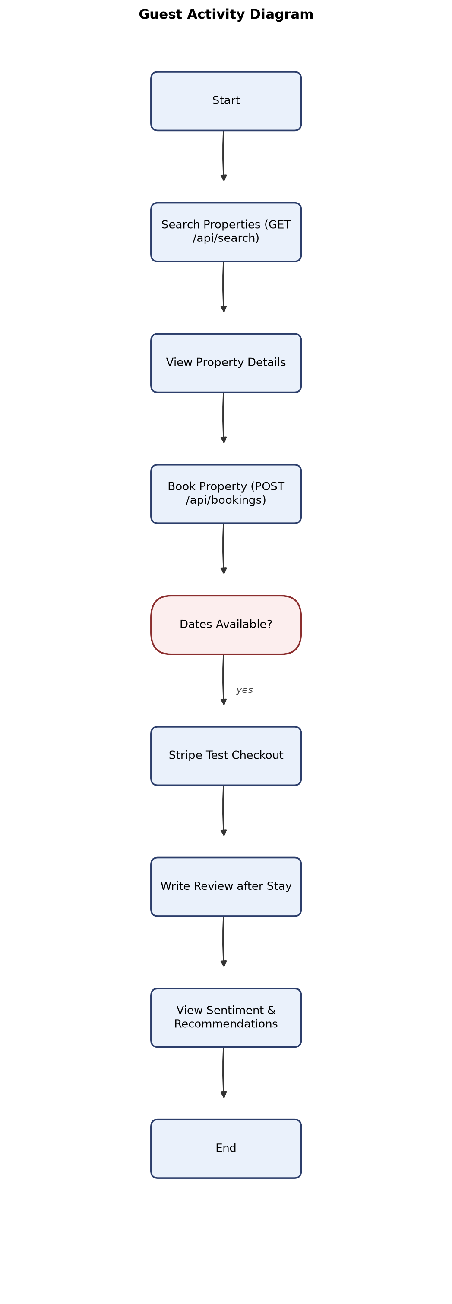
Figure 2.2: Guest Activity Diagram
The Property Owner Activity Diagram begins after login with the owner deciding whether to create a new listing or edit an existing one; both paths converge on the image-upload step, where each submitted file is hashed and, in the owner's lane, appears with a provisional pending or suspicious status pending admin review. The diagram then forks into two recurring loops that run independently of listing status: one lane in which the owner periodically checks incoming bookings for their properties, and another in which the owner checks for pending offline requests and responds to each with a message that moves it to responded or closed. The listing itself does not advance past the owner's lane; its approval decision belongs to the admin lane depicted separately, and the diagram shows this handoff as an asynchronous boundary rather than a step the owner controls directly.
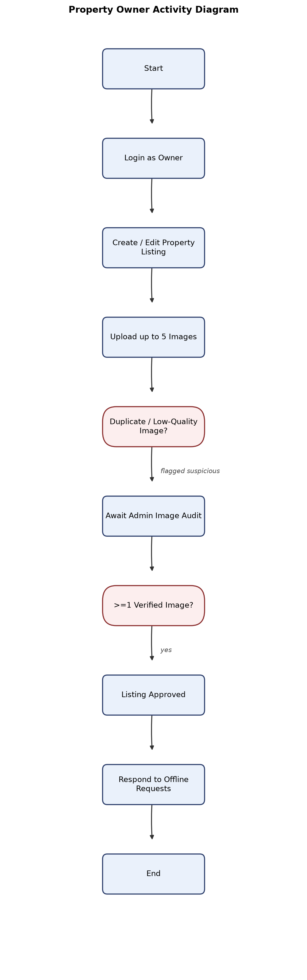
Figure 2.3: Property Owner Activity Diagram
The Admin Activity Diagram centres on the two moderation responsibilities described in Section 2.2. One lane shows the admin opening the image-audit queue, inspecting each pending image's heuristic aiScore, and setting its verificationStatus to verified, suspicious, or rejected. A second, dependent lane shows the admin opening the pending-listings queue; for each listing, a decision node checks whether at least one image has reached verified status — if not, control returns to the image-audit lane before an approval can proceed, and if so, the admin may approve or reject the listing directly. A third, independent lane shows the admin periodically reviewing the user list and toggling verification status as needed, a step that does not depend on the outcome of the other two lanes.
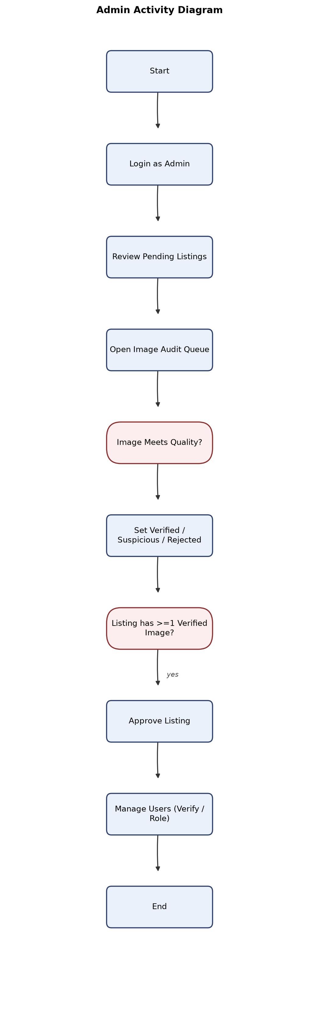
Figure 2.4: Admin Activity Diagram

2.8 System Sequence Diagrams
The system sequence diagrams that follow decompose the fourteen most significant end-to-end workflows in IARS into their constituent actor-client-server-(and, where relevant, external service) interactions, grounded in the exact routes, controllers, and status fields already described in this chapter. Each diagram involves at minimum the initiating actor, the React client, and the Express API, with the sentiment microservice and Stripe appearing as additional external participants in the workflows that depend on them.

2.8.1 Register User
The registration sequence begins when a visitor submits the registration form on the client, which issues a POST /api/auth/register request carrying name, email, phone, password, and the chosen role. The Express route hands off to authController.js, which checks for an existing user with the same email, hashes the submitted password with bcrypt, and persists a new User document with isVerified left at its default value. Control returns to the client with a success acknowledgement, after which the visitor is redirected to the login page rather than being auto-authenticated, since registration and login are handled as two distinct sequences in this implementation. No JWT is issued at this stage; that is deferred to the login sequence described next.
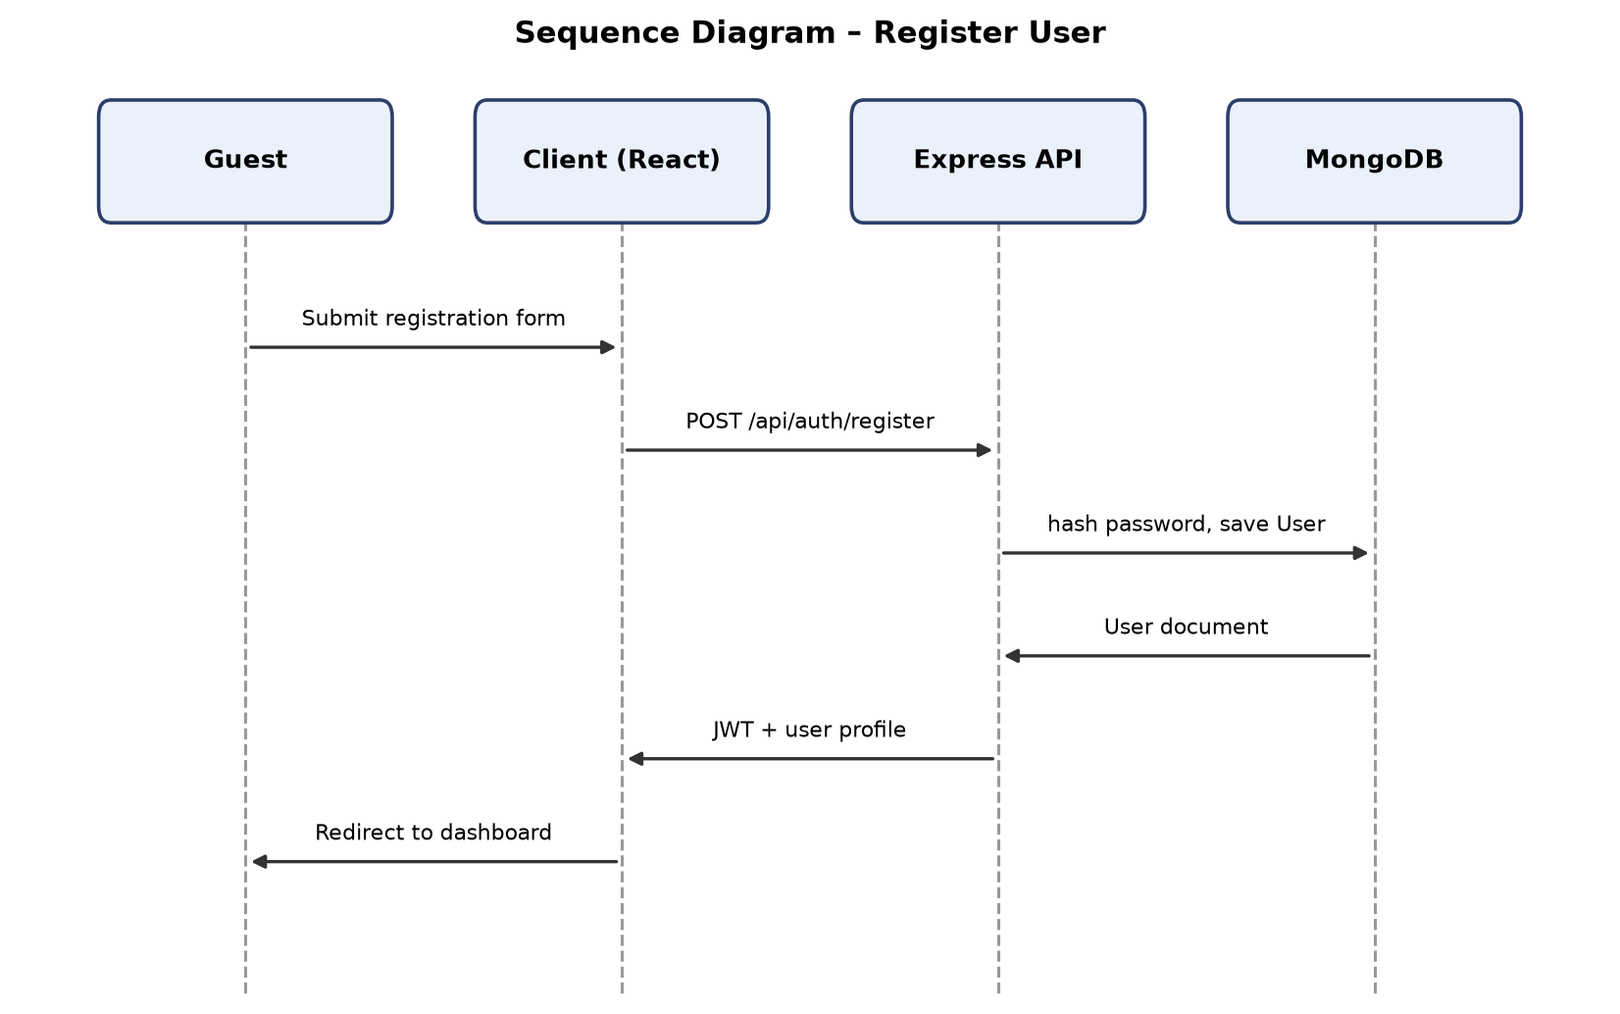
Figure 2.5: Sequence Diagram – Register User

2.8.2 Login
The login sequence starts with the actor submitting email and password from the client, which sends POST /api/auth/login to the server. authController.js retrieves the matching User document, compares the submitted password against the stored bcrypt hash, and, on success, signs a JWT embedding the user's id and role before returning it to the client. The client stores the token and immediately issues GET /api/auth/me (through protect middleware) to hydrate the authenticated session state, after which it routes the actor to the dashboard appropriate to their role. As a side effect specific to this sequence, if the authenticating user's phone number matches an anonymous OfflineRequest, that request is linked to the account at this point.
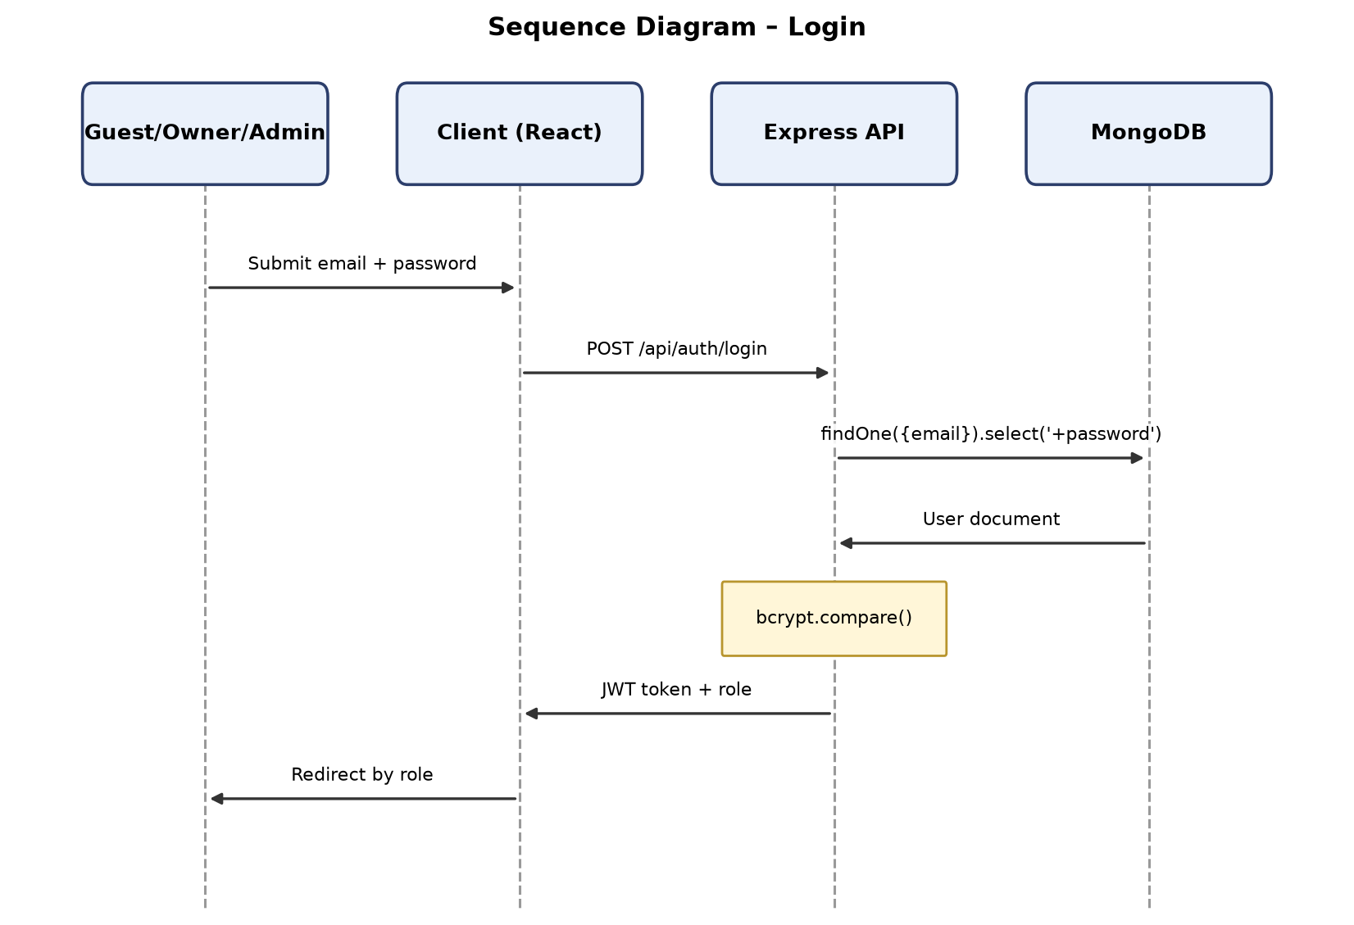
Figure 2.6: Sequence Diagram – Login

2.8.3 Search and Filter Properties
This sequence begins with the guest entering search parameters — city, title keyword, price range, and/or availability date — on the client, which issues GET /api/search carrying those parameters as query strings under optionalProtect. The server-side search handler builds a MongoDB query restricted to status: "approved" properties matching the supplied filters and, if the request carries a valid JWT, concurrently writes a SearchHistory document capturing the same parameters against the user's id. The matching properties are returned to the client, which renders the result grid; subsequent filter adjustments by the guest repeat this same request-response cycle with updated parameters rather than filtering client-side, since filtering is authoritative on the server.
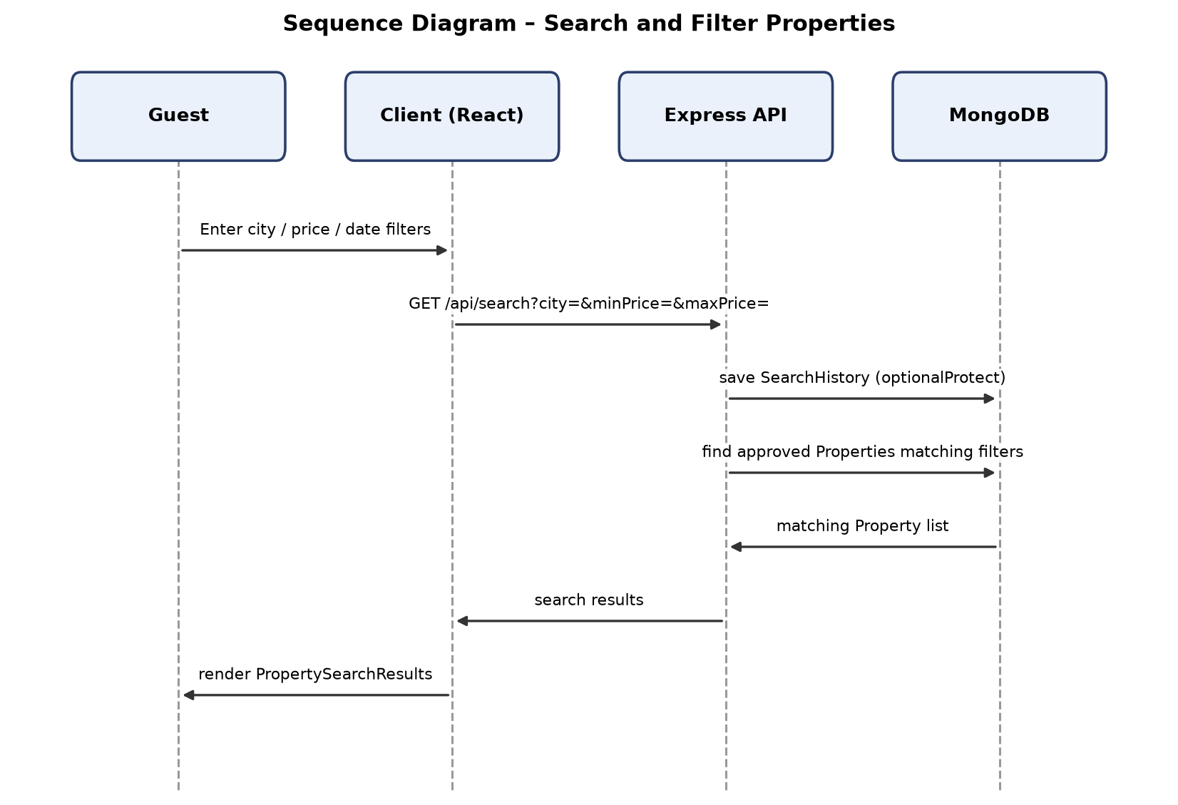
Figure 2.7: Sequence Diagram – Search and Filter Properties

2.8.4 View Property Details
When the guest selects a property, the client issues GET /api/properties/:id under optionalProtect and, in parallel, POST /api/properties/:id/view to record the interaction. The properties controller loads the Property document, filters its images array so that only entries with verificationStatus: "verified" are returned to a guest caller (owners and admins receive the fuller, non-rejected set), and includes the denormalised sentimentSnapshot. The client then issues two further reads — GET /api/reviews/property/:propertyId and GET /api/sentiment/property/:propertyId — to populate the reviews list and sentiment summary components on the PropertyDetailPage. The POST /api/properties/:id/view call, handled independently by the properties route, creates a PropertyView document that plays no role in this page's own rendering but is consumed later by the recommendation sequence (Section 2.8.11).
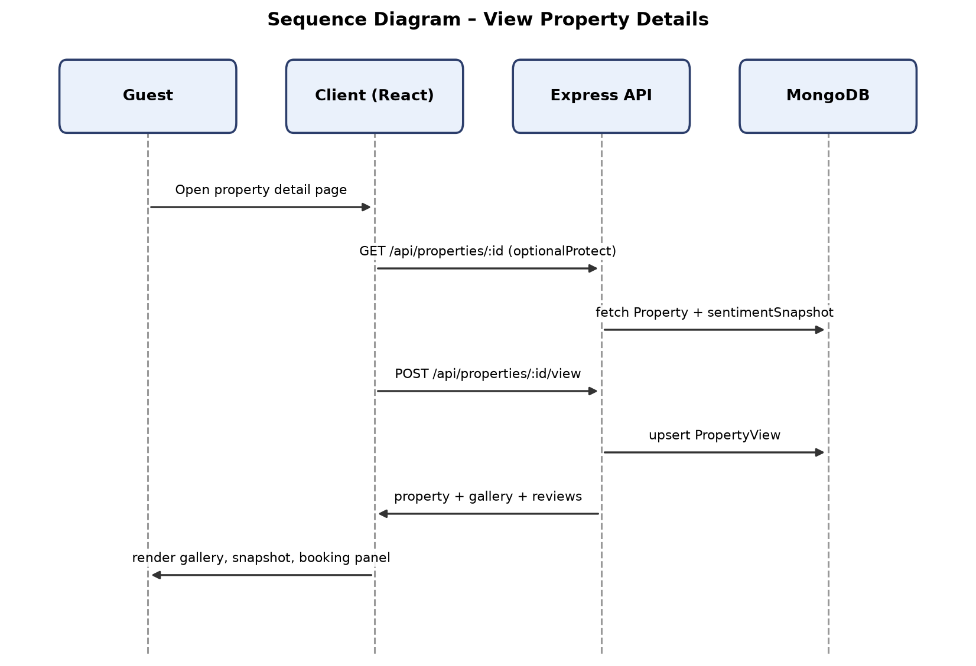
Figure 2.8: Sequence Diagram – View Property Details

2.8.5 Book Property and Create Booking
The booking sequence begins on BookingNewPage, where the guest specifies dates and guest count and the client issues POST /api/bookings. The bookings controller first confirms the target property's status is "approved", then checks the requested date range against the property's availabilityCalendar (only if it is non-empty) and against any existing pending or confirmed booking for overlapping dates. If both checks pass, the server computes totalAmount as price multiplied by the number of nights and persists a new Booking with status: "pending" and paymentStatus: "pending". The created booking's id is returned to the client, which navigates the guest directly into BookingPaymentPage to begin the payment sequence described next; if either validation check fails, the server instead returns BOOKING_ALREADY_EXISTS or DATES_UNAVAILABLE and no document is persisted.
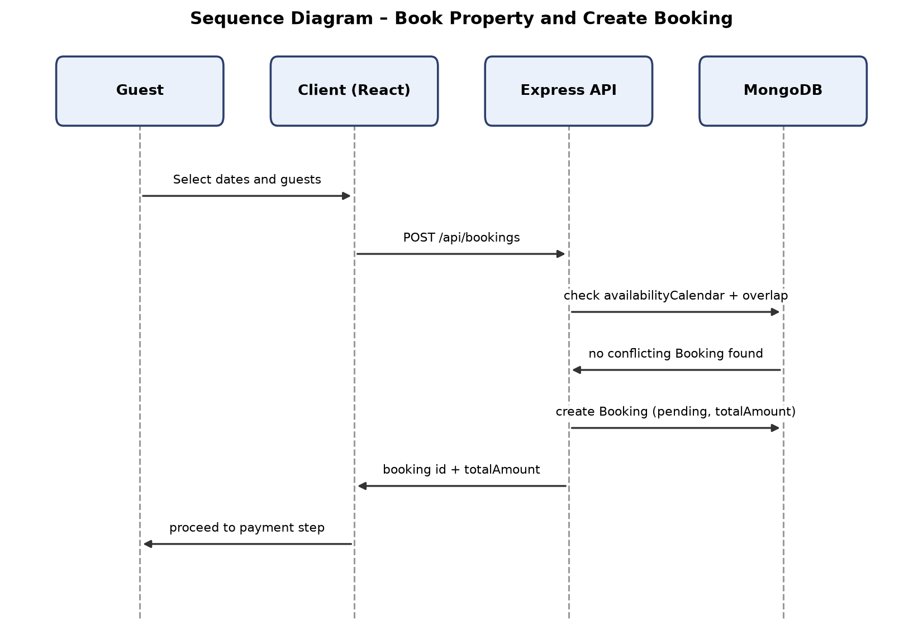
Figure 2.9: Sequence Diagram – Book Property and Create Booking

2.8.6 Stripe Checkout Payment
From BookingPaymentPage, the client issues POST /api/payments/stripe/create-checkout-session for the pending booking's id. The payments controller converts the booking's PKR totalAmount to USD cents using the fixed 280 PKR/USD demo rate and calls the Stripe API to create a hosted Checkout Session, returning its URL to the client, which redirects the guest's browser to Stripe. After the guest completes (or cancels) payment on Stripe's hosted page, Stripe redirects back to BookingPaymentSuccessPage with a session identifier, and the client calls GET /api/payments/stripe/verify-session. The server retrieves the session from Stripe, and only if payment_status === "paid" does it update the Booking document's status to "confirmed", paymentStatus to "confirmed", paymentMethod to "stripe_test", and populate stripeSessionId, stripePaymentIntentId, and paymentConfirmedAt. Independently of this synchronous verification, Stripe may also deliver an asynchronous event to POST /api/payments/stripe/webhook, which the server verifies against the raw request body's signature before trusting it.
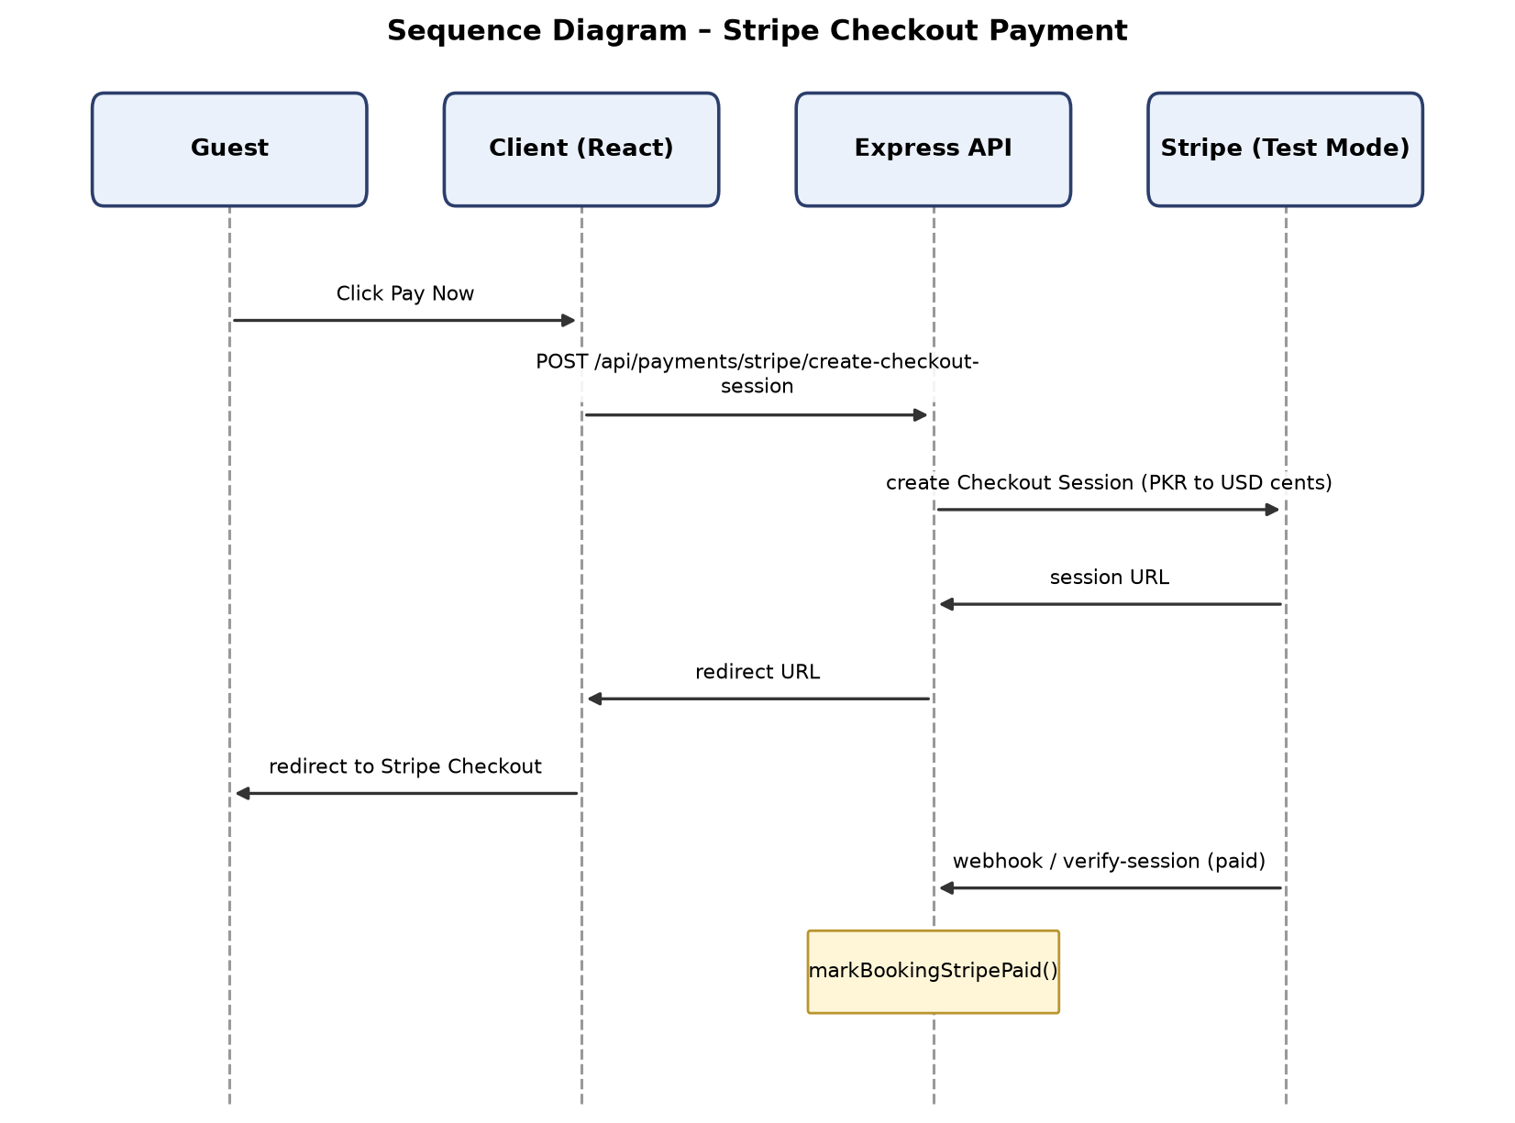
Figure 2.10: Sequence Diagram – Stripe Checkout Payment

2.8.7 Cancel Booking
The guest initiates this sequence from GuestBookingsPage by selecting a booking and requesting cancellation, which the client sends as PUT /api/bookings/:id/cancel. The bookings controller verifies that the requesting guest owns the booking referenced by the id, then sets its status to "cancelled" regardless of whether it was previously pending or confirmed. The updated booking is returned to the client, which reflects the cancelled state in the guest's booking list; any later attempt to invoke the payment sequence (Section 2.8.6) or the demo-payment endpoint against this booking is expected to be rejected by the server, since a cancelled booking is treated as terminal.
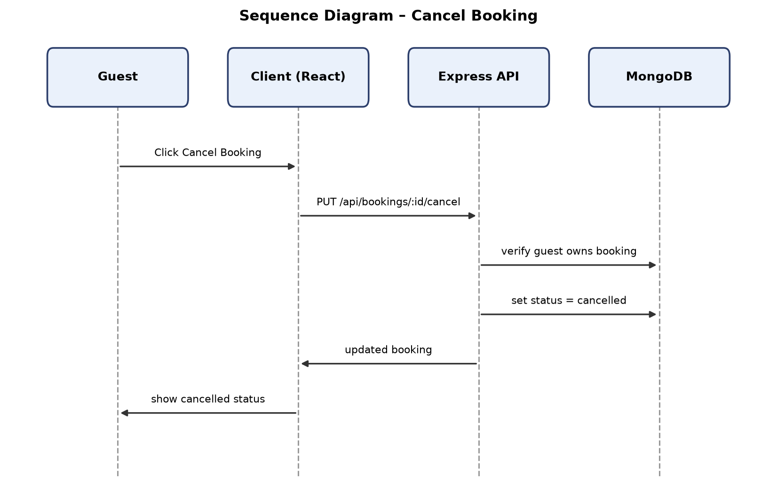
Figure 2.11: Sequence Diagram – Cancel Booking

2.8.8 Submit Offline Booking Request
A visitor, who may or may not be authenticated, completes the OfflineBookingPage form with guest name, phone, location, stay dates, and room type, optionally selecting a specific property. The client issues POST /api/offline-requests under optionalProtect; the offline-requests controller creates a new OfflineRequest document with status: "pending", attaching the authenticated user's id as the guest reference when a valid JWT is present, and leaving it null for anonymous submissions. The created request's confirmation is returned to the client. No further server-side action occurs at submission time; the request remains pending until an owner responds in the sequence described in Section 2.8.9, or until the phone-matching auto-link described in Section 2.8.2 associates it with a guest account at a later login.
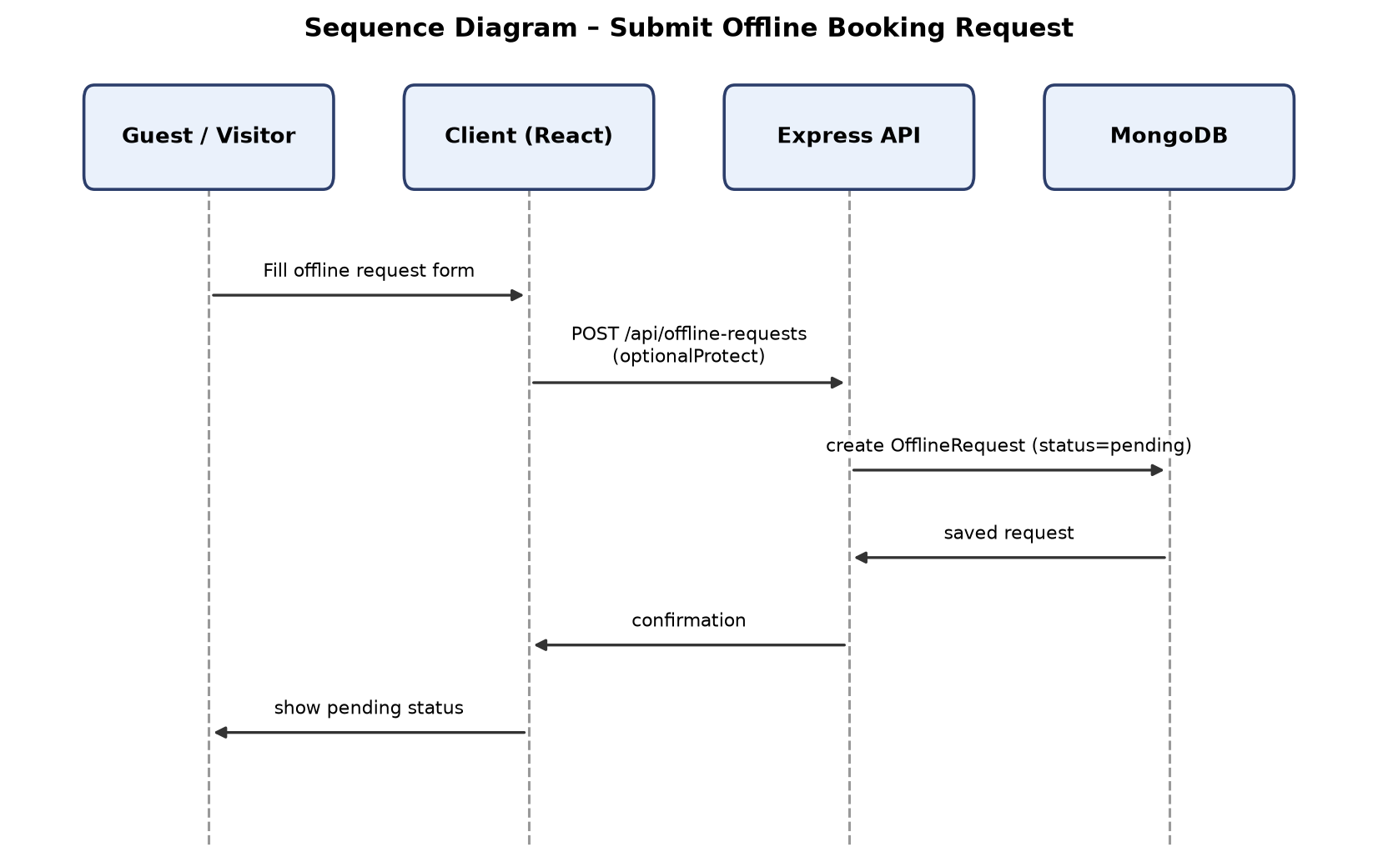
Figure 2.12: Sequence Diagram – Submit Offline Booking Request

2.8.9 Owner Responds to Offline Request
The owner opens OwnerOfflineRequestsPage, and the client issues GET /api/offline-requests/owner, which the offline-requests controller resolves by matching requests against properties owned by the requesting owner. After selecting a request and composing a reply, the client issues PUT /api/offline-requests/:id/respond carrying the responseMessage text and the intended terminal status (responded or closed). The server updates the corresponding OfflineRequest document with both fields and returns the updated document to the client. The guest later observes this update through the parallel GET /api/offline-requests/guest sequence (an instance of UC-12) and may, from that point, choose to proceed into the online booking sequence (Section 2.8.5) for the referenced property.
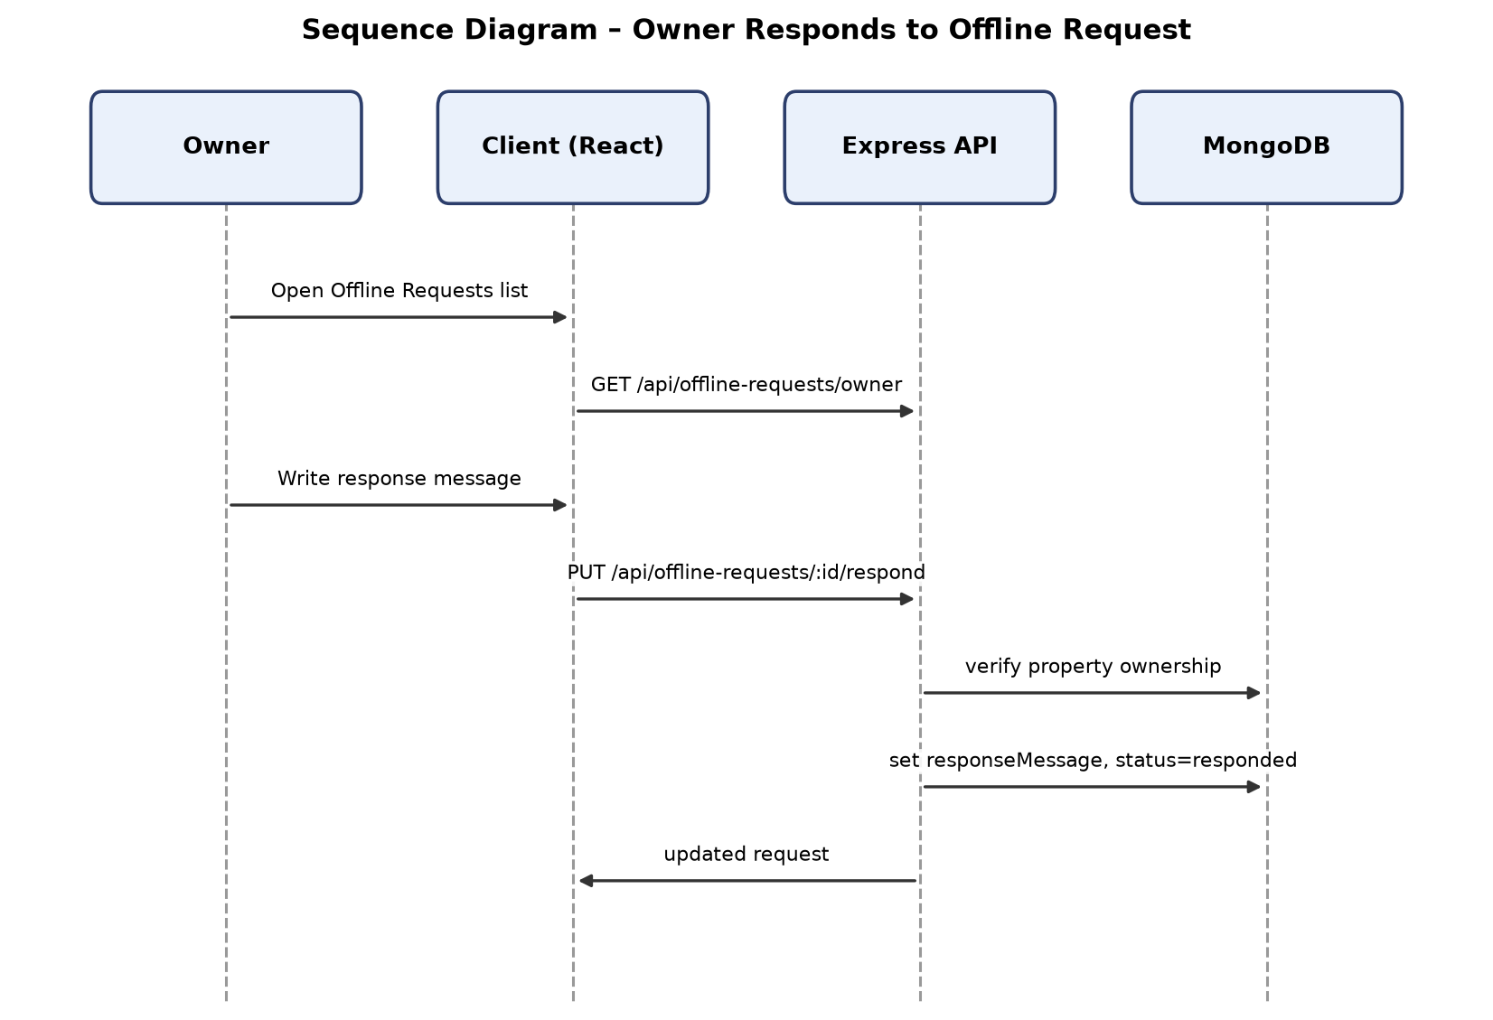
Figure 2.13: Sequence Diagram – Owner Responds to Offline Request

2.8.10 Write Review and Sentiment Analysis
Before rendering ReviewForm, the client calls GET /api/reviews/eligible/:propertyId to list the guest's confirmed, unreviewed bookings for that property. Upon submission of a rating and text, the client issues POST /api/reviews; the reviews controller re-verifies eligibility (confirmed booking, no existing review for that booking reference) and then calls sentimentService.js, which makes an outbound HTTP request to the FastAPI microservice's /predict endpoint at SENTIMENT_API_URL, passing { review: text }. The Python service splits the text into clauses, classifies each with its TF-IDF plus Logistic Regression pipeline, applies its negation-override rule, aggregates an overall sentiment (including "mixed" where applicable), detects aspects across its nine keyword categories, and returns { sentiment, confidence, aspects, aspectInsights, summary }. The Express server persists these fields onto the new Review document alongside the rating and text, then invokes syncPropertySentiment() to recompute the owning property's sentimentSnapshot before returning the saved review to the client.
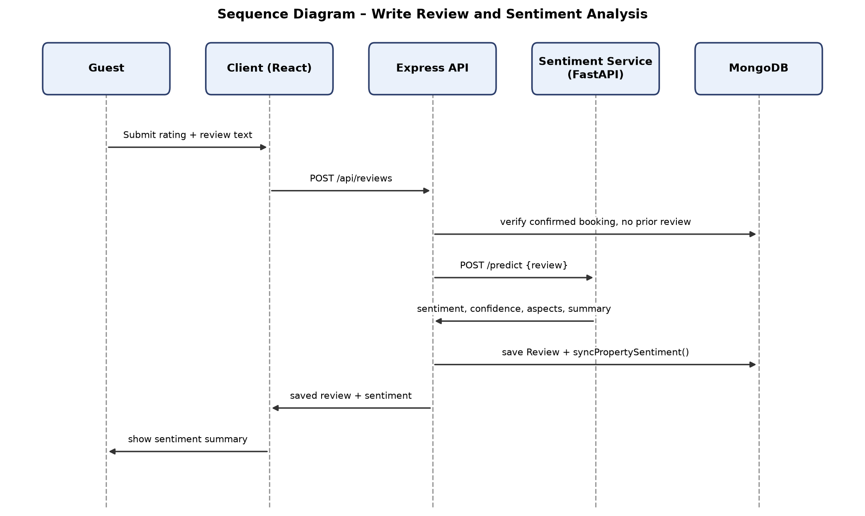
Figure 2.14: Sequence Diagram – Write Review and Sentiment Analysis

2.8.11 View Personalized Recommendations
The client issues GET /api/recommendations under optionalProtect. The server first calls buildUserProfile.js, which reads the guest's last five SearchHistory entries, their bookings, reviews rated four or above, and PropertyView records to derive preferred city, latest budget, preferred property types, and preferred amenities. buildRecommendationMode() then inspects whether the guest is authenticated and has at least one non-empty signal among views, bookings, reviews, or searches; if so, it selects the hybrid-personalized-sectioned path, which additionally invokes propertySimilarity.js (weighting city match, price similarity, amenity overlap, and sentiment similarity) and collaborativeFiltering.js (drawing on a co-occurrence matrix built from booking and view pairs across guests) to compute a combined score gated by the MIN_QUALITY_SCORE trust floor. The server assembles up to six capped, deduplicated sections annotated with match reasons and returns them to the client's RecommendedProperties component; if the guest fails the personalization precondition, the sequence instead proceeds identically to the cold-start path described in Section 2.6.16, using bayesianRanking.js alone.
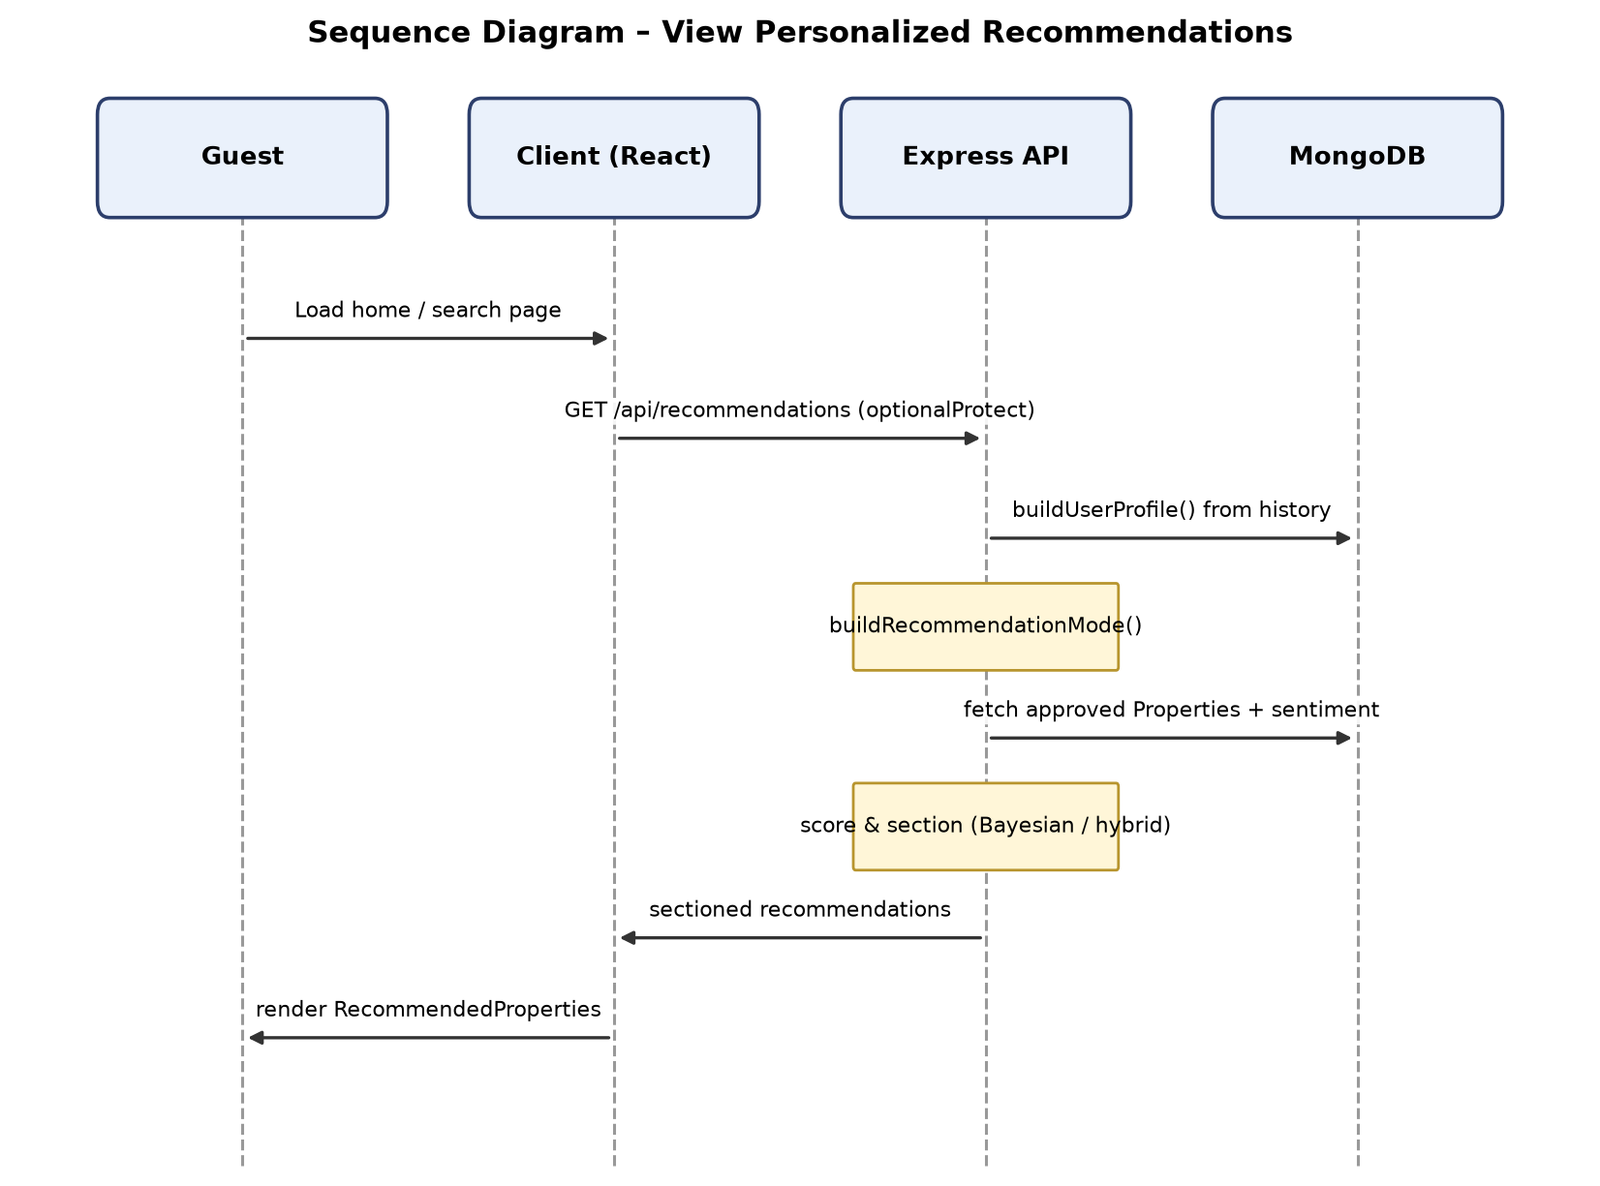
Figure 2.15: Sequence Diagram – View Personalized Recommendations

2.8.12 Create or Edit Listing with Image Upload
The owner completes PropertyForm on OwnerPropertyNewPage or OwnerPropertyEditPage, attaching up to five image files alongside the property's textual and pricing fields, and the client submits this as a multipart request to POST /api/properties or PUT /api/properties/:id. The properties controller persists the non-image fields first, then processes each uploaded file: it computes a SHA-256 hash, discards any file whose hash duplicates another file in the same batch, marks a file "suspicious" with aiScore: 0.45 if its hash matches an image already stored on any property in the database, and otherwise computes a heuristic aiScore via imageAiScore.js from the image's dimensions, resolution, compression ratio, and aspect ratio and stores it with verificationStatus: "pending". The resulting images array, along with the rest of the saved Property document, is returned to the client, which reflects each image's provisional status back to the owner; no image reaches "verified" at this stage, since that decision belongs exclusively to the admin image-audit sequence.
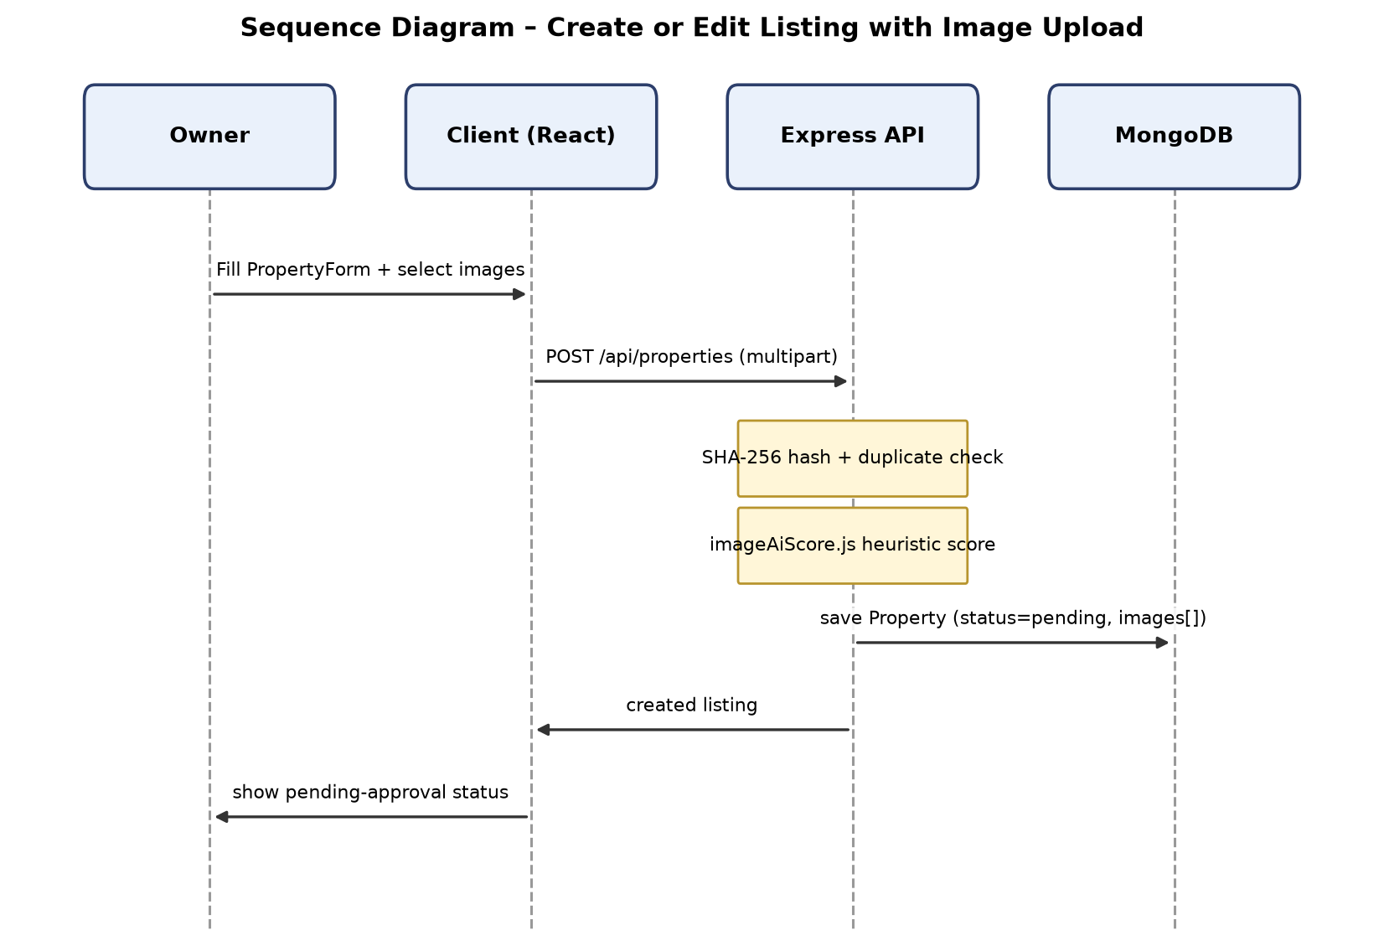
Figure 2.16: Sequence Diagram – Create or Edit Listing with Image Upload

2.8.13 Admin Approve or Reject Listing
The admin opens AdminListingsPage, and the client issues GET /api/admin/listings/pending to retrieve properties with status: "pending". When the admin chooses to approve a listing, the client issues PUT /api/admin/listings/:id/approve; the admin controller performs a hasVerifiedImage check against the property's images array before allowing the transition, and only sets status: "approved" if at least one image has verificationStatus: "verified" — otherwise the request is rejected regardless of the admin's intent, requiring an image-audit pass first (Section 2.8.14). Rejection, by contrast, is issued via PUT /api/admin/listings/:id/reject with no such precondition and sets status: "rejected" unconditionally. The updated property is returned to the client and removed from the pending queue in either case.
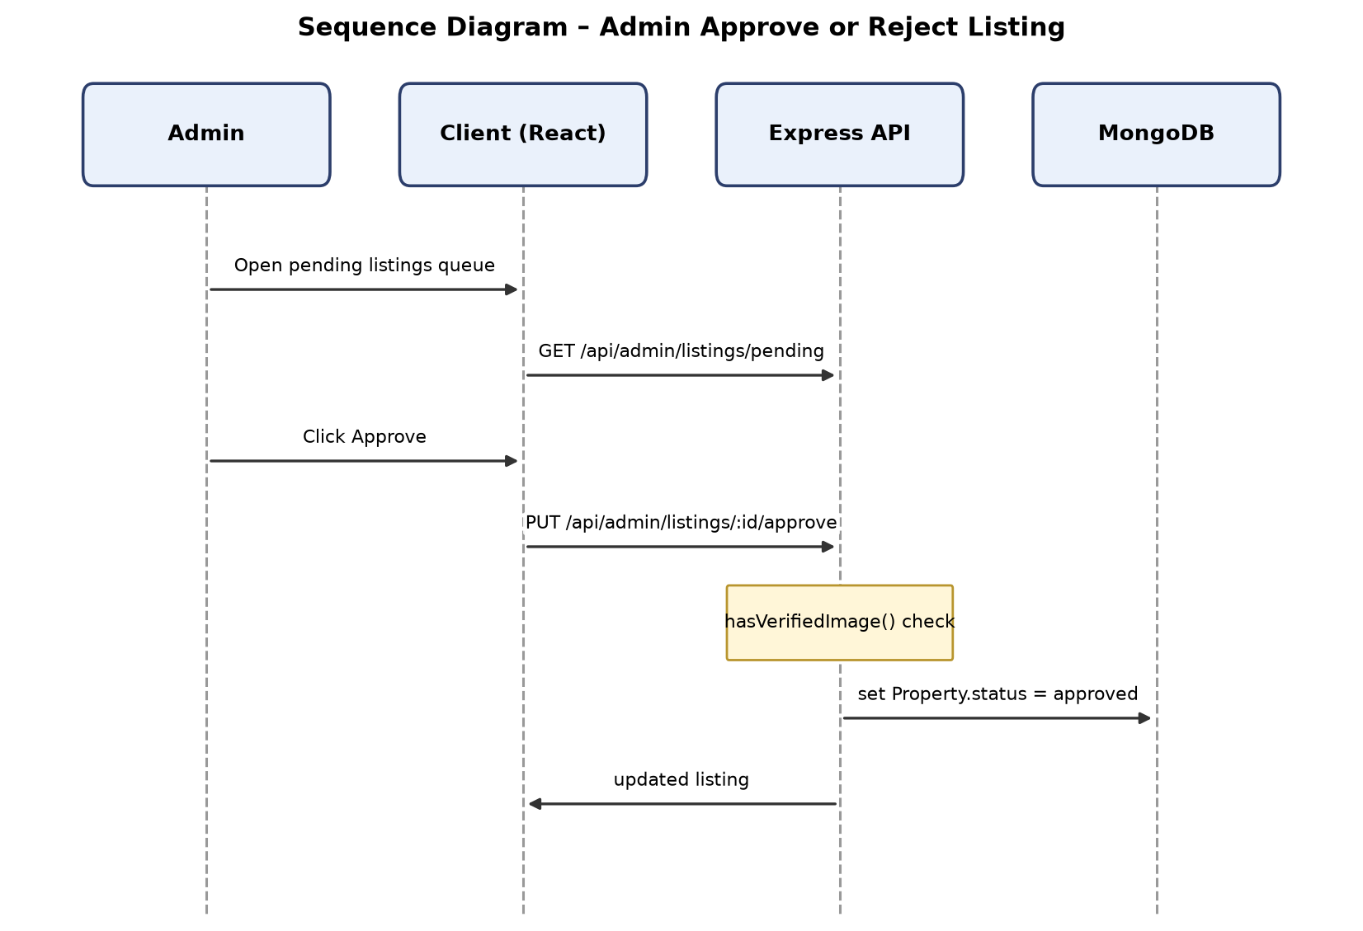
Figure 2.17: Sequence Diagram – Admin Approve or Reject Listing

2.8.14 Admin Image Audit and User Management
For image auditing, the admin opens AdminImageAuditPage, and the client issues GET /api/admin/image-audit, which the admin controller resolves by scanning across all properties' images arrays and returning them alongside their current verificationStatus and heuristic aiScore. Selecting an individual image and setting its decision triggers PUT /api/admin/image-audit/:propertyId/:imageId, updating that single embedded image's verificationStatus (to verified, suspicious, or rejected) within the parent Property document. Independently, for user management, the admin opens AdminUsersPage, and the client issues GET /api/admin/users, optionally filtered by role; toggling a user's verification status issues PUT /api/admin/users/:id/verify, which flips the isVerified field on that User document. These two administrative flows share no direct sequencing dependency on one another, though an image-audit approval performed in the first flow may subsequently unblock a listing-approval sequence (Section 2.8.13) that was previously rejected for lacking a verified image.
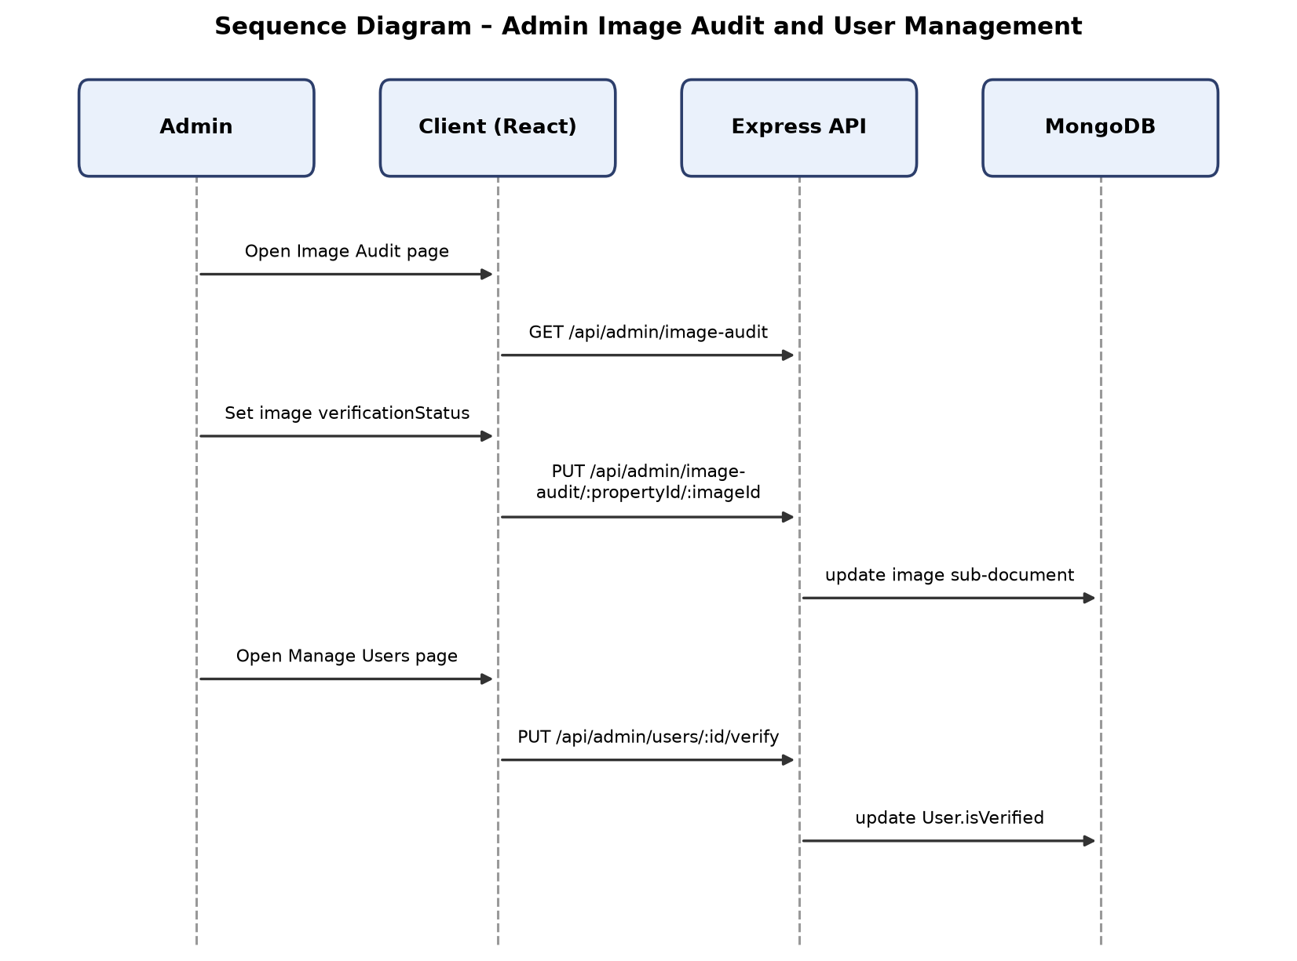
Figure 2.18: Sequence Diagram – Admin Image Audit and User Management

CHAPTER 3
SYSTEM DESIGN AND IMPLEMENTATION

3.1 System Architecture Overview
IARS is realised as three independently deployable services rather than a single monolithic application, a decision that keeps the machine-learning concerns of sentiment inference isolated from the transactional concerns of booking, user management, and property moderation. The presentation tier, client/, is a React 18 [16] single-page application built with Vite and written entirely in JSX, deliberately avoiding TypeScript so that the codebase remains approachable for the project's contributors while still benefiting from component-based structuring. Styling is handled through Tailwind CSS utility classes composed with shadcn/ui primitives, giving the interface a consistent design language without a bespoke component library having to be built from scratch. Client-side routing is handled by react-router-dom v6, and all outbound communication with the backend is centralised through an axios instance configured with the base URL http://localhost:5000/api; every authenticated request attaches a JWT [20] bearer token that axios reads from localStorage. Because IARS is required to support English, Urdu, and Arabic with English as the default and Urdu/Arabic rendered right-to-left, the client also integrates i18next and react-i18next [17], applying right-to-left structural markup consistent with W3C guidance on bidirectional text [18], with all static interface strings routed through translation keys rather than hardcoded literals, while user-generated content (property titles, descriptions, reviews, names, contact details) is deliberately left untranslated. The client is served in development on port 5173.
The application tier, server/, is a Node.js and Express [15] application written using ES module syntax and backed by MongoDB [13] through Mongoose [14]. The entry point, server/server.js, follows a deliberate bootstrap order: environment variables are loaded via dotenv, the MongoDB connection is established through connectDB() in config/db.js, and Cross-Origin Resource Sharing is configured with credentials: true scoped to the CLIENT_URL so that the SPA and API can exchange authenticated requests across their respective ports. A structurally significant detail of this bootstrap sequence is that the Stripe webhook route is registered before the global express.json() body-parser middleware. Stripe's webhook signature verification requires access to the raw, unparsed request body; registering the webhook handler ahead of the JSON parser, and mounting it with express.raw(), preserves that raw byte stream specifically for the one route that needs it, while every other route in the application continues to receive a parsed JSON body as normal. Once this ordering-sensitive route is in place, the remaining domain routers are mounted, and the request pipeline is closed off with a notFound handler for unmatched paths followed by a centralised errorHandler middleware that normalises error responses across the API. The Express server listens on port 5000 and is the sole gateway to the system's data: no other component reads from or writes to MongoDB directly.
The third tier, sentiment-service/, is a Python FastAPI [19] microservice dedicated exclusively to natural-language inference over guest review text. At process startup it loads a previously trained scikit-learn [4] pipeline from a joblib-serialised artefact — a TF-IDF vectoriser configured for unigrams through trigrams feeding a Logistic Regression classifier trained with class_weight="balanced" to counteract the class imbalance typical of review sentiment corpora, consistent with established bag-of-n-grams baselines for sentiment classification [5]. The service exposes only two endpoints: GET /health, used for liveness checks, and POST /predict, which accepts review text and returns a sentiment classification. This service listens on port 8000 and has no knowledge of MongoDB, bookings, users, or any other domain concept in IARS; it is a stateless text-classification endpoint.
Crucially, the client never communicates with the sentiment microservice directly. All sentiment inference is brokered by the Express server through server/services/sentimentService.js, which posts a JSON payload of the form { review: text } to ${SENTIMENT_API_URL}/predict with a fifteen-second request timeout. This mediation serves two purposes: it keeps the sentiment microservice's network surface closed to the public internet, and it allows the server to apply a safe fallback — { sentiment: "neutral", confidence: 0, ... } — whenever the Python service is slow, unreachable, or returns a malformed response, so that a review submission is never blocked or lost purely because the ML component is temporarily unavailable. Payment processing follows an analogous mediation pattern but with a different downstream party: the Express server, through server/config/stripe.js, calls the Stripe test-mode Checkout API [12] directly using a key that is validated at startup to begin with the sk_test_ prefix, ensuring that no live payment credential can accidentally be loaded into the system. The client therefore has exactly one upstream dependency (the Express API), and the Express API has exactly two downstream dependencies (MongoDB and, conditionally, the sentiment microservice and the Stripe API), which keeps the overall call graph shallow and each service's responsibilities clearly bounded.
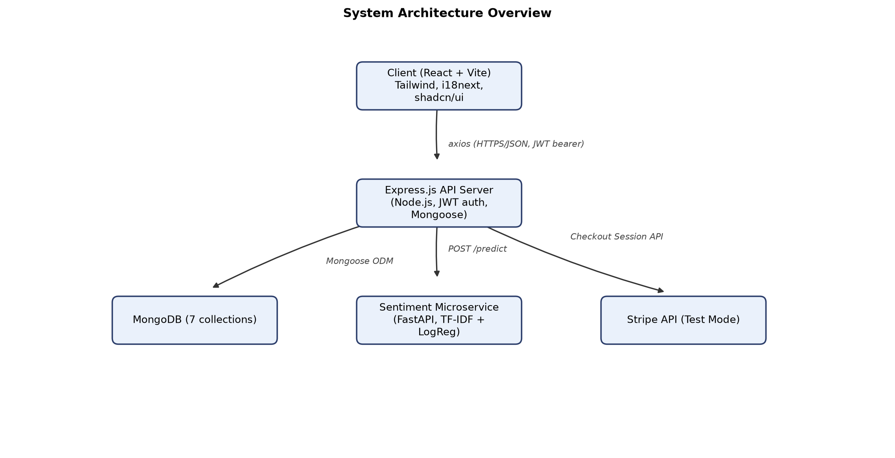
Figure 3.1: System Architecture Overview

3.2 Entity Relationship Diagram
The IARS data model is expressed as seven MongoDB collections managed through Mongoose schemas, and the relationships between them are logical associations expressed via ObjectId references rather than enforced foreign-key constraints, since MongoDB is a document store with no native referential-integrity mechanism. The User collection sits at the centre of the graph: a single user with role: "owner" may own many documents in the Property collection (a one-to-many relationship carried by the owner field on Property), a single user with role: "guest" may accumulate many Booking documents (one-to-many, via the guest field on Booking), many Review documents (one-to-many, via the guest field on Review), many OfflineRequest submissions (one-to-many, and optionally nullable since anonymous submissions are permitted), many PropertyView records (one-to-many, capped at fifty per user by application logic), and many SearchHistory entries (one-to-many, capped at twenty per user).
Property is the second major hub of the schema. Each property belongs to exactly one owning User and may be the subject of many Booking documents over time, many Review documents, many OfflineRequest submissions that name it, and many PropertyView records logging who has looked at it. Property images are not modelled as a separate collection; instead, each Property document embeds an array of imageMetaSchema subdocuments directly under images, so that a property's photographs, their verification status, their AI heuristic score, and their content hash travel with the property document itself rather than requiring a join. This is a deliberate document-modelling choice appropriate to MongoDB: because images are always read and written in the context of their owning property (during listing creation, image-audit review, and property-detail display), embedding avoids the read amplification that a normalised, separately-collectioned Image entity would introduce.
The relationship between Booking and Review is the one place in the schema where a strict one-to-one cardinality is enforced at the database level rather than merely assumed at the application level: the Review schema declares a unique index on its booking field, which means MongoDB itself will reject any attempt to insert a second review referencing the same booking. This directly encodes the business rule that a guest may leave exactly one review per completed stay. Both Booking and Review in turn reference Property and User (as guest), forming a triangle of associations: a booking connects a guest to a property for a date range, and a review — which can only be created once that booking exists — connects the same guest to the same property with an evaluative rating, free-text comment, and derived sentiment. There is no separate "Image" collection and no dedicated "Complaint" entity in the schema; the OfflineRequest collection, while primarily a form-based alternative for guests without straightforward access to the online booking flow, is the closest analogue to a complaint/contact workflow, since it is the only collection carrying an owner-authored responseMessage field addressed back to a named submitter.
Because none of these associations are enforced by the database engine itself (with the singular exception of the Review.booking uniqueness constraint), referential integrity across the remaining relationships — for instance, ensuring a Booking.property value actually points at an existing Property document — is the responsibility of the Mongoose-layer controllers rather than the storage engine, a distinction that is characteristic of NoSQL data modelling and is called out explicitly here so that the diagram is not misread as a relational schema with foreign-key enforcement.
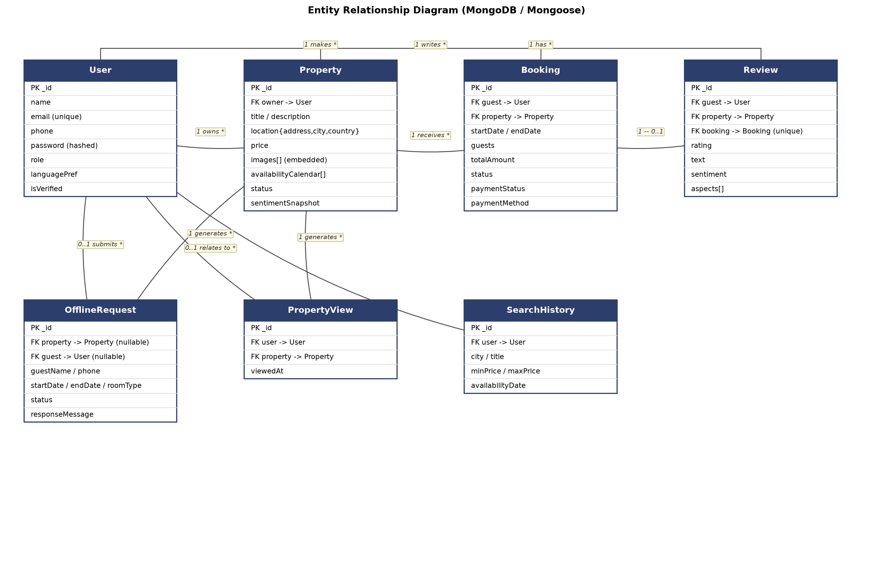
Figure 3.2: Entity Relationship Diagram

3.3 Database Schema and Data Dictionary
The following subsections document each of the seven Mongoose collections that constitute the IARS persistence layer, all of which live under server/models/. Each subsection lists the collection's fields, their types, and the constraints or notes that govern their use, including default values, enumerations, indexes, and any denormalisation applied for read performance.

3.3.1 User Collection
The User collection stores the single account record shared by all three roles — guest, owner, and admin — distinguished by a role enumeration rather than by separate collections, which keeps authentication and authorisation logic uniform across the system. Passwords are never stored in plaintext: a Mongoose pre('save') hook hashes the password field with bcrypt using ten salt rounds whenever it is created or modified, and the field is marked select: false so that it is excluded from query results unless explicitly requested. Password verification during login is performed by the schema's matchPassword() instance method, which wraps bcrypt.compare().
Table 3.1: User Collection Schema
Field | Type | Constraints/Notes
name | String | Required
email | String | Required, unique, stored lowercase
phone | String | Optional
password | String | Required, minimum length 6, select: false, bcrypt-hashed (10 salt rounds) via pre('save') hook
role | String (enum) | guest \ | owner \ | admin; default guest
languagePref | String | Default "en"; persists the user's last-selected interface language
isVerified | Boolean | Default false; toggled by admin via PUT /api/admin/users/:id/verify
createdAt / updatedAt | Date | Automatic Mongoose timestamps

3.3.2 Property Collection
The Property collection is the largest and most composite of the seven schemas, combining core listing attributes, an embedded array of image metadata, a loosely structured availability calendar, a moderation status, and a materialised sentimentSnapshot object. The sentimentSnapshot is a cache that is recomputed and overwritten every time a new review is submitted for the property, rather than a value derived on demand; this means that the property-detail page and the recommendation engine can read pre-aggregated sentiment figures — total review count, per-class counts, positive percentage, average rating, aspect-level breakdowns, and a short insight classification — without re-scanning and re-aggregating the full Review collection on every read.
Table 3.2: Property Collection Schema
Field | Type | Constraints/Notes
title | String | Required
description | String | Required
location.address | String | Required (embedded sub-schema)
location.city | String | Required
location.country | String | Required
price | Number | Minimum 0
owner | ObjectId (ref User) | Required
images | Array of imageMetaSchema | Embedded subdocuments; see fields below
images[].url | String | Path to the stored upload
images[].verificationStatus | String (enum) | pending \ | verified \ | suspicious \ | rejected; default pending
images[].aiScore | Number | Range 0-1; default 0; heuristic authenticity score
images[].hash | String | SHA-256 hash of the image file, used for duplicate detection
images[].uploadedAt | Date | Timestamp of upload
availabilityCalendar | Array (Mixed) | List of { startDate, endDate } string pairs
status | String (enum) | pending \ | approved \ | rejected; default pending
sentimentSnapshot.totalReviews | Number | Denormalised count, refreshed on each new review
sentimentSnapshot.positiveCount / negativeCount / neutralCount / mixedCount | Number | Per-class review counts
sentimentSnapshot.positivePercent | Number | Positive review share, used by the recommendation engine
sentimentSnapshot.averageRating | Number | Mean of Review.rating for the property
sentimentSnapshot.aspectBreakdown | Array | Per-aspect sentiment tallies
sentimentSnapshot.praisedAspects / concernAspects | Array of String | Aspects most frequently praised/criticised
sentimentSnapshot.insightType | String | Short classification label summarising overall guest sentiment
sentimentSnapshot.topPraisedAspect | String | Single most-praised aspect
sentimentSnapshot.updatedAt | Date | Last time the snapshot was recomputed
createdAt / updatedAt | Date | Automatic Mongoose timestamps

3.3.3 Booking Collection
The Booking collection records a guest's reservation of a property for a given date range and tracks both the reservation's lifecycle status and its independent payment status, since a booking can exist in a confirmed reservation state while its payment is still pending reconciliation (as happens between Stripe checkout-session creation and webhook confirmation). Two Stripe-specific identifiers are retained purely for online payments and are left unset for demo-payment bookings.
Table 3.3: Booking Collection Schema
Field | Type | Constraints/Notes
guest | ObjectId (ref User) | Required
property | ObjectId (ref Property) | Required
startDate | String | ISO date, format YYYY-MM-DD
endDate | String | ISO date, format YYYY-MM-DD
guests | Number | Minimum 1
totalAmount | Number | Minimum 0
status | String (enum) | pending \ | confirmed \ | cancelled
paymentStatus | String (enum) | pending \ | confirmed \ | failed
paymentMethod | String (enum) | demo \ | stripe_test
stripeSessionId | String | Set only for stripe_test bookings
stripePaymentIntentId | String | Set only for stripe_test bookings once payment intent is created
paymentConfirmedAt | Date | Set when payment status transitions to confirmed
createdAt / updatedAt | Date | Automatic Mongoose timestamps

3.3.4 Review Collection
The Review collection captures a guest's post-stay evaluation of a property and the results of the sentiment pipeline applied to its free-text content. A unique index on booking enforces the one-review-per-booking rule directly at the database layer, and a compound index on { property: 1, createdAt: -1 } supports the common access pattern of listing a property's most recent reviews.
Table 3.4: Review Collection Schema
Field | Type | Constraints/Notes
guest | ObjectId (ref User) | Required
property | ObjectId (ref Property) | Required
booking | ObjectId (ref Booking) | Required; unique index — enforces one review per booking
rating | Number | Range 1-5
text | String | Maximum length 1000 characters
sentiment | String (enum) | positive \ | negative \ | neutral \ | mixed; default neutral
sentimentScore | Number | Stores the ML classifier's confidence value
aspects | Array of String | Aspect categories detected in the review text
aspectInsights | Array of Object | { aspect, sentiment, confidence, mentions } per detected aspect
summary | String | Human-readable summary generated by the sentiment pipeline
createdAt / updatedAt | Date | Automatic Mongoose timestamps; compound index { property: 1, createdAt: -1 }

3.3.5 OfflineRequest Collection
The OfflineRequest collection supports a form-based alternative booking channel for guests who are not proceeding through the standard online booking-and-payment flow. Submissions may be linked to a registered guest and/or a specific property, but both associations are nullable so that anonymous, unauthenticated submissions and general (non-property-specific) enquiries are both representable.
Table 3.5: OfflineRequest Collection Schema
Field | Type | Constraints/Notes
guestName | String | Required
phone | String | Required
location | String | Required
startDate | String | Required
endDate | String | Required
roomType | String | Required
property | ObjectId (ref Property) | Nullable
guest | ObjectId (ref User) | Nullable — null indicates an anonymous submission
responseMessage | String | Default ""; populated by the owner on response
status | String (enum) | pending \ | responded \ | closed
createdAt / updatedAt | Date | Automatic Mongoose timestamps

3.3.6 PropertyView Collection
The PropertyView collection tracks which properties a given user has viewed and when, forming one of the interaction signals consumed by the recommendation engine's user-profile builder. A unique compound index on { user: 1, property: 1 } means a repeat view of the same property by the same user updates the existing record's viewedAt timestamp rather than inserting a duplicate row, and a secondary index on { user: 1, viewedAt: -1 } supports efficient retrieval of a user's most recent views. The collection is additionally capped in application logic at fifty rows per user, with the oldest view deleted whenever an insertion would exceed that cap.
Table 3.6: PropertyView Collection Schema
Field | Type | Constraints/Notes
user | ObjectId (ref User) | Indexed
property | ObjectId (ref Property) | Indexed
viewedAt | Date | Updated on re-view
(index) |  | Unique compound index { user: 1, property: 1 }
(index) |  | Secondary index { user: 1, viewedAt: -1 } for recency queries
(cap) |  | Capped at 50 entries per user (application-level; oldest purged on insert past cap)

3.3.7 SearchHistory Collection
The SearchHistory collection persists the parameters of a signed-in user's past property searches, which feed both the "recent searches" recommendation section and the guest profile builder. Like PropertyView, it is bounded in application code rather than by a database-level constraint.
Table 3.7: SearchHistory Collection Schema
Field | Type | Constraints/Notes
user | ObjectId (ref User) | Indexed
city | String | Optional search filter value
title | String | Optional search filter value (keyword/title match)
minPrice | Number | Optional search filter value
maxPrice | Number | Optional search filter value
availabilityDate | String | Optional search filter value
createdAt / updatedAt | Date | Automatic Mongoose timestamps; capped at 20 entries per user, pruned in searchController.saveSearchHistory

3.4 Class Diagram
While IARS is implemented in JavaScript's function-and-module style rather than a strictly class-based object model, its logical structure still separates cleanly into persistent-entity classes and service-layer classes, and it is this logical structure — rather than the literal file layout — that the class diagram in Figure 3.3 represents. The seven Mongoose models described in Section 3.3 form the entity layer: User, Property, Booking, Review, OfflineRequest, PropertyView, and SearchHistory. Each is modelled as a class carrying its schema fields as attributes and, where applicable, its schema-level behaviour as methods — most notably User.matchPassword(), which encapsulates the bcrypt comparison used during authentication, and the pre-save hashing hook that intercepts password mutations before persistence. The associations among these entity classes mirror the relationships established in Section 3.2: User is associated with Property through ownership, with Booking and Review through guest authorship, and with OfflineRequest, PropertyView, and SearchHistory through the various interaction trails a guest leaves behind; Property embeds its imageMetaSchema array as a composition relationship rather than an association, since image metadata has no independent lifecycle outside its parent property document.
Layered above the entity classes are five logical service classes that group the request-handling and business-rule logic that Express implements as controller and utility modules. AuthService corresponds to the responsibilities of authController.js and authMiddleware.js: issuing and verifying JWTs, enforcing role-based route access through the protect and authorize() middleware functions, and delegating credential checks to User.matchPassword(). PropertyService corresponds to propertyController.js together with the image-handling utilities in server/utils/: it is responsible for listing creation and update, multipart image ingestion via multer, SHA-256 hashing and heuristic AI-score computation for uploaded images, and moderation-status transitions. BookingService corresponds to bookingController.js: it validates date-range and guest-count constraints, computes totalAmount, and manages the coupled status/paymentStatus transitions described in Section 3.9, coordinating with the Stripe integration in server/config/stripe.js for online payments and with a simpler direct-confirmation path for demo payments. RecommendationEngine corresponds to the module cluster in server/utils/ — buildUserProfile.js, personalizedRecommendationEngine.js, bayesianRanking.js, propertySimilarity.js, and collaborativeFiltering.js — and is detailed at length in Section 3.6. SentimentClient corresponds to server/services/sentimentService.js and encapsulates the single external responsibility of posting review text to the FastAPI /predict endpoint, applying the fifteen-second timeout, and substituting the neutral-fallback response object on failure so that no other part of the system needs to handle the sentiment microservice's availability directly.
The dependency direction among these service classes flows consistently downward from controller-adjacent services toward the entity classes: BookingService depends on Booking and Property; RecommendationEngine depends on Property, Booking, Review, PropertyView, and SearchHistory as its data sources but does not mutate any of them, since it is a read-only aggregation and ranking layer; and SentimentClient is depended upon by the review-submission flow (which persists its output onto Review.sentiment, Review.sentimentScore, and Review.aspectInsights, and triggers a Property.sentimentSnapshot resync) without itself depending on any entity class. AuthService sits orthogonally to the others as a cross-cutting concern invoked by nearly every protected route rather than being invoked by the other services directly.
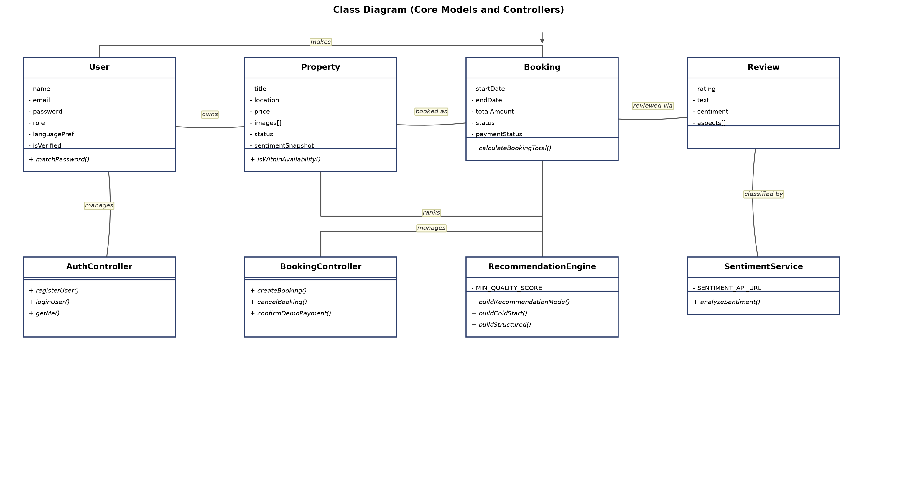
Figure 3.3: Class Diagram

3.5 API Design
The IARS API surface is organised into nine Express router modules under server/routes/, each scoped to a distinct area of functionality and each composed with the appropriate combination of authentication middleware (protect), role authorisation middleware (authorize("owner"), authorize("admin"), etc.), an optional-authentication variant (optionalProtect) for endpoints that behave differently for signed-in versus anonymous callers, and, where file uploads are involved, multer middleware for multipart parsing. The subsections below document each router in the order it is mounted conceptually within the domain: authentication, property management, administration, search and recommendation, reviews, sentiment, booking, payment, and offline requests.

3.5.1 Authentication API (`authRoutes.js`)
The authentication router exposes registration, login, and current-session retrieval. Registration and login are unauthenticated by necessity, while the profile-retrieval endpoint requires a valid JWT.
Table 3.8: Authentication API Endpoints
Method | Endpoint | Access | Description
POST | /api/auth/register | Public | Create a new guest or owner account
POST | /api/auth/login | Public | Authenticate credentials and issue a JWT
GET | /api/auth/me | Protected (protect) | Retrieve the authenticated user's profile

3.5.2 Property API (`propertyRoutes.js`)
The property router serves both the public-facing browsing experience and the owner-facing listing-management workflow. Public listing retrieval is restricted to approved properties only, while creation and update are scoped to the owning user and gated behind multer for image handling.
Table 3.9: Property API Endpoints
Method | Endpoint | Access | Description
GET | /api/properties | Public | List approved properties
GET | /api/properties/owner/my-properties | Protected, authorize("owner") | List the authenticated owner's properties
POST | /api/properties | Protected, authorize("owner"), multer multipart | Create a new listing with uploaded images
PUT | /api/properties/:id/moderate | Protected, authorize("admin") | Update a property's moderation status
POST | /api/properties/:id/view | Protected, authorize("guest") | Record a property view for the recommendation engine
GET | /api/properties/:id | optionalProtect | Retrieve property detail (behaviour varies for signed-in guests)
PUT | /api/properties/:id | Protected, authorize("owner") | Update an owned listing

3.5.3 Admin API (`adminRoutes.js`)
Every route on the admin router is protected and additionally restricted to the admin role via authorize("admin"), since this router concentrates the platform's moderation and account-governance capabilities: user verification and role management, the image-audit queue, and listing approval/rejection.
Table 3.10: Admin API Endpoints
Method | Endpoint | Access | Description
GET | /api/admin/users | Protected, authorize("admin") | List all registered users
PUT | /api/admin/users/:id/verify | Protected, authorize("admin") | Toggle a user's isVerified flag
PUT | /api/admin/users/:id/role | Protected, authorize("admin") | Change a user's role
GET | /api/admin/image-audit | Protected, authorize("admin") | Retrieve the queue of property images pending audit
PUT | /api/admin/image-audit/:propertyId/:imageId | Protected, authorize("admin") | Set the final verification status of a specific image
GET | /api/admin/listings/pending | Protected, authorize("admin") | List properties awaiting approval
PUT | /api/admin/listings/:id/approve | Protected, authorize("admin") | Approve a pending listing
PUT | /api/admin/listings/:id/reject | Protected, authorize("admin") | Reject a pending listing

3.5.4 Search and Recommendation API (`searchRoutes.js`)
This router exposes filtered property search and the personalised/cold-start recommendation feed described in Section 3.6. Both endpoints use optionalProtect because search and recommendation behaviour is meaningful for both anonymous visitors and signed-in guests, differing only in whether interaction-history signals are available.
Table 3.11: Search and Recommendation API Endpoints
Method | Endpoint | Access | Description
GET | /api/search | optionalProtect | Search approved properties by city, title, price range, and availability date
GET | /api/recommendations | optionalProtect | Retrieve personalised or cold-start recommendation sections

3.5.5 Review API (`reviewRoutes.js`)
The review router allows a guest to submit a review tied to a completed booking, allows anyone to read a property's published reviews, and allows a guest to check which of their bookings remain eligible for review (i.e., have no review yet, satisfying the unique booking index on Review).
Table 3.12: Review API Endpoints
Method | Endpoint | Access | Description
POST | /api/reviews | Protected, authorize("guest") | Submit a review for a completed booking
GET | /api/reviews/property/:propertyId | Public | Retrieve all reviews for a property
GET | /api/reviews/eligible/:propertyId | Protected, authorize("guest") | Retrieve the guest's bookings for the property eligible for review

3.5.6 Sentiment API (`sentimentRoutes.js`)
The sentiment router exposes the aggregated sentiment view for a property rather than direct access to the classifier itself; the underlying inference call to the Python microservice happens internally within the review-submission flow, not through this router.
Table 3.13: Sentiment API Endpoints
Method | Endpoint | Access | Description
GET | /api/sentiment/property/:propertyId | Public | Retrieve the property's aggregated sentimentSnapshot

3.5.7 Booking API (`bookingRoutes.js`)
Every endpoint on the booking router requires authentication, since bookings are always tied to an identified guest or the properties an identified owner manages. The router covers booking creation, retrieval from both the guest and owner perspectives, demo-payment confirmation, and cancellation.
Table 3.14: Booking API Endpoints
Method | Endpoint | Access | Description
POST | /api/bookings | Protected, authorize("guest") | Create a new booking request
GET | /api/bookings/my-bookings | Protected, authorize("guest") | List the authenticated guest's bookings
GET | /api/bookings/owner-bookings | Protected, authorize("owner") | List bookings across the authenticated owner's properties
PUT | /api/bookings/:id/confirm-demo-payment | Protected, authorize("guest") | Confirm payment for a booking via the demo payment path
PUT | /api/bookings/:id/cancel | Protected, authorize("guest") | Cancel an existing booking
GET | /api/bookings/:id | Protected | Retrieve a single booking's detail

3.5.8 Stripe Payment API (`stripePaymentRoutes.js`)
The Stripe payment router covers the two guest-facing steps of an online checkout: creating a Stripe Checkout session and verifying its outcome. The Stripe webhook endpoint that ultimately confirms payment server-side is deliberately not part of this router; it is mounted directly in server/server.js ahead of the JSON body-parser, using express.raw(), so that Stripe's signature verification against the untouched request body succeeds.
Table 3.15: Stripe Payment API Endpoints
Method | Endpoint | Access | Description
POST | /api/payments/stripe/create-checkout-session | Protected, authorize("guest") | Create a Stripe test-mode Checkout session for a booking
GET | /api/payments/stripe/verify-session | Protected, authorize("guest") | Verify the outcome of a completed Checkout session
POST | /api/payments/stripe/webhook | Public (Stripe-signed), mounted in server.js with express.raw() | Receive and verify Stripe webhook events, confirming payment server-side

3.5.9 Offline Request API (`offlineRequestRoutes.js`)
The offline request router supports the form-based alternative booking channel described in Section 3.3.5. Submission uses optionalProtect so that both anonymous visitors and signed-in guests can submit a request, while retrieval and response are scoped to the guest who submitted a request and the owner who must act on it, respectively.
Table 3.16: Offline Request API Endpoints
Method | Endpoint | Access | Description
POST | /api/offline-requests | optionalProtect | Submit an offline booking request (guest or anonymous)
GET | /api/offline-requests/guest | Protected, authorize("guest") | List the authenticated guest's submitted requests
GET | /api/offline-requests/owner | Protected, authorize("owner") | List offline requests directed at the owner's properties
PUT | /api/offline-requests/:id/respond | Protected, authorize("owner") | Owner responds to a request, updating its status

3.6 Recommendation Engine Design
Following established practice in the recommender-systems literature, where hybrid combinations of content-based, collaborative, and quality-ranking signals are widely reported to outperform any single technique in isolation [9] [10], the recommendation engine is implemented as a modular pipeline within server/utils/, composed of five cooperating scripts — buildUserProfile.js, personalizedRecommendationEngine.js, bayesianRanking.js, propertySimilarity.js, and collaborativeFiltering.js — that together transform raw interaction history and property data into a set of ranked, sectioned recommendation lists served through GET /api/recommendations. The pipeline is best understood as six sequential stages: profile building, candidate retrieval, signal attachment, mode decision, scoring, and sectioning, culminating in the response returned to the client.
The pipeline begins with profile building, performed by buildUserProfile.js, which constructs a lightweight behavioural profile for the requesting guest by reading, for that user, the most recent five entries from four sources: SearchHistory (recent city/price/date filters), Booking (properties actually reserved), Review where rating >= 4 (properties the guest rated highly, taken as an explicit positive-preference signal), and PropertyView (properties browsed, whether or not they were booked). Because each of these four signal sources is independently bounded to the five most recent entries, the resulting profile stays current with the guest's latest behaviour rather than being dominated by old activity, while remaining cheap to construct on every request.
The second stage, candidate retrieval, restricts the universe of properties under consideration to those with status: "approved", so that pending or rejected listings — which have not cleared the admin moderation and image-verification gate described in Section 3.8 — can never surface in a recommendation feed regardless of how well they might otherwise score.
The third stage, signal attachment, enriches each candidate property with the review statistics and sentiment figures it needs for scoring, drawing on the same sentimentSnapshot cache described in Section 3.3.2 rather than recomputing aggregates from the Review collection on every recommendation request.
The fourth stage, mode decision, is handled by buildRecommendationMode() inside personalizedRecommendationEngine.js. A personalised recommendation mode is only selected when two conditions both hold: the requesting user is authenticated, and their profile (from stage one) contains at least one interaction signal — a past search, booking, qualifying review, or view. If either condition fails — the caller is anonymous, or is a brand-new authenticated user with no recorded activity yet — the engine falls back to a cold-start mode, ensuring that every caller, regardless of history, receives a populated recommendation feed rather than an empty one.
In cold-start mode, buildColdStartRecommendations() produces exactly three sections that require no personal history at all: top_bayesian (properties ranked purely by the Bayesian-smoothed quality score described below), best_reviewed (properties ranked by sentiment-positive share and review volume), and trending (properties with recent view/booking momentum). In personalised mode, buildStructuredRecommendations() produces up to six sections, each populated only when the underlying signal is available and each capped at four items so that no single section dominates the page: recent_searches (properties matching the guest's last search filters), previous_bookings (properties similar to ones the guest has already stayed at), preferred_budget (properties within the guest's typical price range), viewed_similar (properties similar to ones the guest has viewed but not booked), popular_in_city (well-regarded properties in cities the guest has shown interest in), and recommended_for_you (a general blended-score section combining all available signals).
The scoring stage draws on two further modules depending on which section is being computed. bayesianRanking.js computes a Bayesian-smoothed rating for every candidate property by blending its raw average rating toward a prior mean of 3.5 with an effective prior weight of 4 — the standard formulation, following the Bayesian aggregate-feedback ranking approach described by Chakrabarti et al. [8], for shrinking small-sample averages toward a global expectation so that a property with only one five-star review is not ranked above a property with fifty consistently four-star reviews. This smoothed rating is then further blended with the property's sentiment-positive percentage (from sentimentSnapshot.positivePercent), a review-count credibility term, an availability signal derived from availabilityCalendar, and an amenity-keyword score computed from the property description. Any property whose combined quality score falls below the constant MIN_QUALITY_SCORE = 0.28 is excluded from ranked output entirely, acting as a trust floor that prevents very poorly reviewed or under-evidenced properties from ever being recommended, regardless of how well they might otherwise match a guest's stated preferences. propertySimilarity.js computes a separate content-based similarity score used by the previous_bookings and viewed_similar sections, combining four weighted components: city match (32%), price similarity (28%), amenity Jaccard similarity (22%), and sentiment similarity (18%) — that is, how closely two properties' sentiment profiles resemble one another, on top of the more conventional location, price, and amenity comparisons. collaborativeFiltering.js supplies a third, independent scoring signal, in the tradition of item-based collaborative filtering techniques [11], by building a co-occurrence matrix across guest pairs: two properties are considered collaboratively related when the same guests have interacted with both, with booking pairs weighted at 1.0 and view pairs weighted at 0.35, reflecting the stronger preference signal carried by an actual reservation compared with a browsing view.
The final stage, sectioning, assembles whichever scored candidates survive the trust floor into the section structure determined during the mode-decision stage, and this sectioned structure — rather than a single flat ranked list — is what is returned as the JSON response from GET /api/recommendations.
Table 3.17: Recommendation Scoring Signals and Weights
Signal | Source Module | Weight/Parameter | Description
Bayesian-smoothed rating | bayesianRanking.js | Prior mean 3.5, prior weight 4 | Shrinks small-sample average ratings toward a global prior to avoid overweighting properties with few reviews
Sentiment positive percentage | bayesianRanking.js (reads Property.sentimentSnapshot.positivePercent) | Blended component | Incorporates review-sentiment polarity into the overall quality score
Review-count credibility | bayesianRanking.js | Blended component | Rewards properties with a larger, more corroborated body of reviews
Availability score | bayesianRanking.js | Blended component | Derived from availabilityCalendar; penalises properties with no near-term open dates
Amenity-keyword score | bayesianRanking.js | Blended component | Rewards descriptions mentioning recognised amenity keywords
Minimum quality trust floor | bayesianRanking.js | MIN_QUALITY_SCORE = 0.28 | Properties scoring below this threshold are excluded from ranked sections entirely
City match | propertySimilarity.js | 32% | Content-similarity component comparing property location city
Price similarity | propertySimilarity.js | 28% | Content-similarity component comparing listed price
Amenity Jaccard similarity | propertySimilarity.js | 22% | Content-similarity component comparing amenity-keyword sets
Sentiment similarity | propertySimilarity.js | 18% | Content-similarity component comparing sentiment profiles
Booking co-occurrence | collaborativeFiltering.js | Weight 1.0 | Co-occurrence contribution from guest pairs who both booked the same properties
View co-occurrence | collaborativeFiltering.js | Weight 0.35 | Co-occurrence contribution from guest pairs who both viewed the same properties

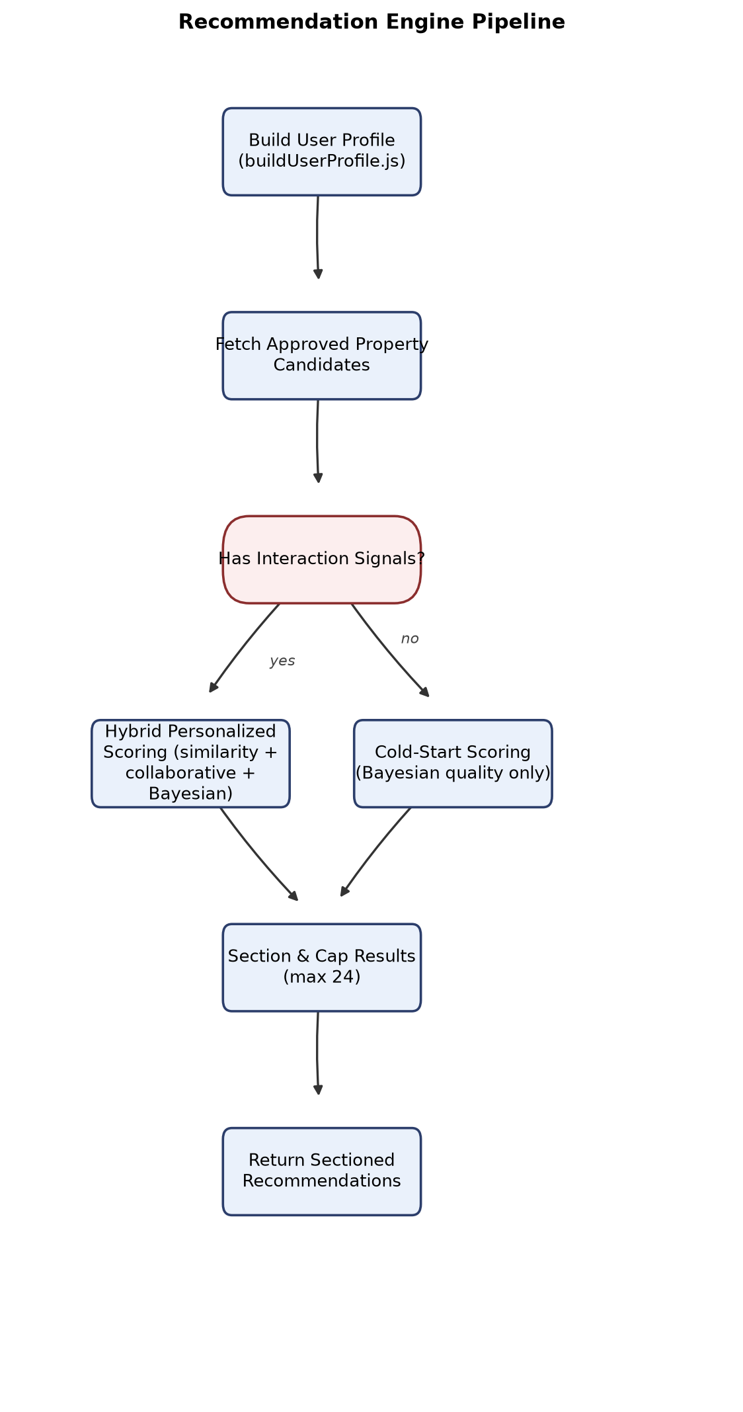
Figure 3.4: Recommendation Engine Pipeline

3.7 Sentiment Analysis Pipeline Design
Sentiment analysis in IARS follows the general opinion-mining formulation of classifying text into polarity classes and associated target aspects [6] [7], and is triggered whenever a guest submits a review through POST /api/reviews, with the pipeline that processes the review text distributed across both the sentiment microservice and the Express server that calls it. The first stage, clause splitting, occurs before any machine-learning inference takes place: the raw review text is decomposed into sentences and, within those sentences, further split at contrast conjunctions — "but", "however", "although" — so that a single review such as "The room was clean but the staff were rude" is analysed as two semantically distinct clauses rather than as one undifferentiated block of text. This decomposition is what allows the pipeline to later recognise and represent mixed sentiment within a single review, rather than forcing every review into a single overall polarity.
Each resulting clause is then passed independently through the trained classifier: the TF-IDF vectoriser (configured for one-, two-, and three-gram features) transforms the clause into a sparse numeric representation, which the Logistic Regression model — trained with class_weight="balanced" to compensate for skewed class frequencies in the training data — classifies with an associated confidence score. This per-clause classification is followed by a rule-based negation override: certain lexical negation patterns that a purely statistical bag-of-n-grams model can misjudge (for instance, negated positive adjectives) are checked explicitly and, where a negation pattern is detected around a polarity-bearing term, the clause's classifier output is overridden to better reflect the negated meaning rather than the surface-level n-gram statistics alone.
Once every clause has been classified, the pipeline performs aspect keyword matching against nine predefined aspect categories (such as cleanliness, staff, location, value, and comparable service-quality dimensions relevant to accommodation reviews), associating each clause with whichever aspect category its vocabulary matches, if any. This produces the aspectInsights structure ultimately persisted on the Review document — an array of { aspect, sentiment, confidence, mentions } entries, one per aspect category the review actually touches on.
The per-clause and per-aspect results are then aggregated into a single overall sentiment label for the review as a whole. If clauses of only one polarity are present, that polarity becomes the overall sentiment value; if both positive and negative clauses are present within the same review — as in the "clean room, rude staff" example — the overall sentiment is classified as mixed rather than averaged away into a false neutral. Alongside the aggregated label, the pipeline generates a concise human-readable summary string characterising the review's sentiment and dominant aspects in plain language, suitable for display without requiring a reader to inspect the raw aspect breakdown.
This aggregated result — sentiment label, confidence score, aspect list, aspect insights, and summary — is returned across the network boundary from the FastAPI /predict endpoint to the Express server's sentimentService.js, which is the only component that ever calls the sentiment microservice directly. The reviewController persists these fields onto the newly created Review document (sentiment, sentimentScore, aspects, aspectInsights, summary) and, immediately afterward, triggers a resync of the owning property's sentimentSnapshot, recomputing the denormalised totals, percentages, and aspect breakdown described in Section 3.3.2 so that every other part of the system — the property-detail page, the sentiment API, and the recommendation engine's quality scoring — reads an up-to-date cached view rather than a stale one. Should the call to the sentiment microservice itself fail or time out (per the fifteen-second timeout configured in sentimentService.js), the safe fallback of { sentiment: "neutral", confidence: 0 } is persisted instead, so that a temporary outage of the Python service degrades the richness of the stored sentiment data without ever blocking the review submission itself.
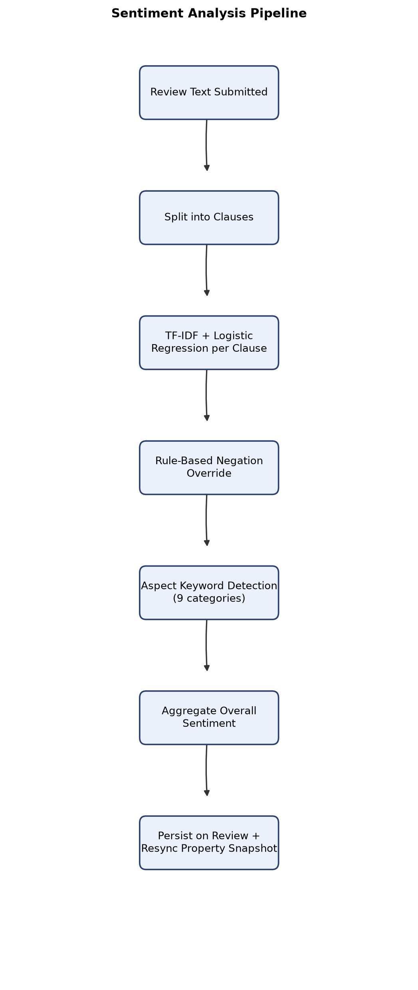
Figure 3.5: Sentiment Analysis Pipeline

3.8 Image Verification Workflow Design
The image verification workflow governs every photograph an owner attaches to a property listing and is designed to catch duplicate or low-quality uploads before a listing ever reaches the admin approval stage, without relying on a trained computer-vision model. When an owner submits property images through the multipart POST /api/properties endpoint, each uploaded file is first hashed with SHA-256, producing a content fingerprint that is stable across re-uploads of the identical file.
This hash is checked against two scopes in sequence. First, it is checked within the current upload batch itself: if two files in the same submission hash identically, the duplicate is silently discarded rather than being stored twice under the same listing. Second, the hash is checked against the hashes already recorded across the existing Property.images data in the database; if a match is found there, the newly uploaded image is not discarded but is instead accepted and flagged immediately as verificationStatus: "suspicious" with a fixed aiScore of 0.45, since an image identical to one already present elsewhere in the system is a meaningful signal of image reuse or misrepresentation that the admin reviewer should specifically be alerted to, even though it may occasionally have an innocent explanation.
If an uploaded image's hash matches neither of the above, it is treated as genuinely new content and is instead scored by a heuristic function in server/utils/imageAiScore.js. It is important to be precise about what this function is: it is not a trained machine-learning model, but a deterministic heuristic that derives an aiScore between 0 and 1 from measurable properties of the image file itself — its pixel dimensions, effective resolution, degree of compression, and aspect ratio — on the reasoning that authentic, well-captured property photographs tend to fall within predictable ranges on these dimensions, while very low-resolution, heavily compressed, or unusually proportioned images are more likely to be placeholder content, screenshots, or otherwise unsuitable for a listing. Every image that clears both hash checks and receives a heuristic score is stored with verificationStatus: "pending", deferring the final judgement to a human reviewer rather than allowing the heuristic alone to admit or reject content automatically.
The pending queue produced by this stage is surfaced to administrators through GET /api/admin/image-audit, and an admin's decision on each individual image is recorded through PUT /api/admin/image-audit/:propertyId/:imageId, which sets the image's final verificationStatus to verified, suspicious (if the admin independently reaches that judgement rather than the hash check having already flagged it), or rejected. A rejection additionally forces the image's aiScore to 0, so that a rejected image can never be mistaken, by any downstream code inspecting aiScore alone, for a legitimately high-scoring photograph. The workflow's final gate is enforced at the listing-approval stage rather than at upload time: a property cannot be approved by an administrator through PUT /api/admin/listings/:id/approve unless it has at least one image with verificationStatus: "verified", which means a listing with only pending, suspicious, or rejected images is structurally prevented from reaching the publicly browsable, approved-properties pool described in Section 3.6's candidate-retrieval stage, regardless of how complete the rest of its listing content might be.
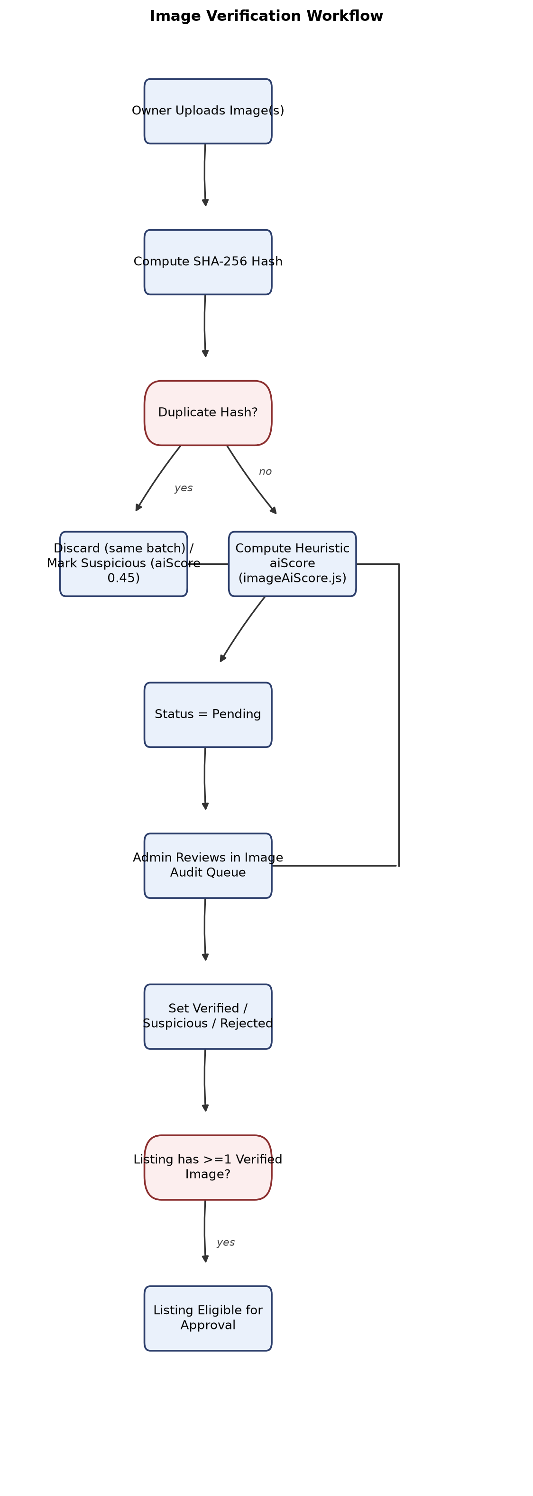
Figure 3.6: Image Verification Workflow

3.9 State Lifecycle Diagrams and Deployment Architecture
Three entities in IARS carry an explicit status field whose permitted transitions are constrained enough to warrant representation as a formal state machine rather than an unconstrained enumeration: Booking, OfflineRequest, and the embedded property image metadata.
The booking lifecycle involves two related but independently tracked state variables: status and paymentStatus. A booking is created in status: "pending". It advances to status: "confirmed" through either of two payment paths — a guest-initiated demo-payment confirmation via PUT /api/bookings/:id/confirm-demo-payment, or a successful Stripe test-mode payment verified through the webhook-driven flow described in Section 3.5.8 — both of which also drive paymentStatus from pending to confirmed. From either the pending or confirmed state, a guest may cancel the booking through PUT /api/bookings/:id/cancel, moving status to cancelled; this cancelled state is terminal, meaning a cancelled booking can never be paid for or reconfirmed once it has reached that state. Independently of the status transitions, paymentStatus has one additional transition not mirrored on status: it can move from pending directly to failed if a Stripe payment verification attempt does not succeed, without necessarily forcing the booking's overall status out of pending, since a failed payment attempt does not by itself cancel the reservation — the guest retains the option to retry payment or cancel explicitly.
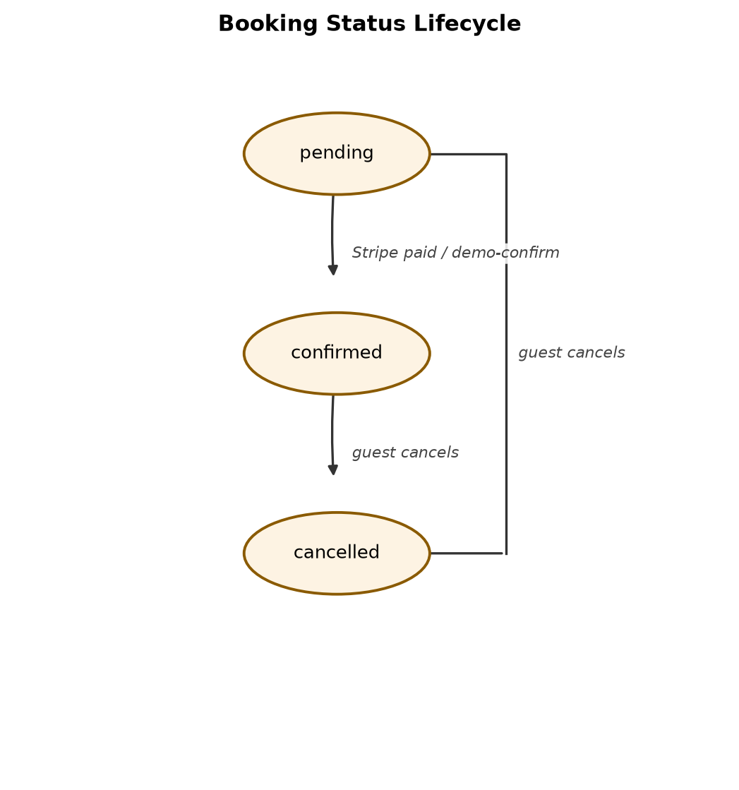
Figure 3.7: Booking Status Lifecycle
The offline request lifecycle is simpler and entirely owner-controlled from the point of submission onward. A request begins in status: "pending" when a guest or anonymous visitor submits it through POST /api/offline-requests. An owner, acting through PUT /api/offline-requests/:id/respond, may then transition the request to status: "responded", recording a responseMessage addressed to the submitter, or may transition it to status: "closed" if the request requires no further action. Both responded and closed are reachable directly from pending, and neither transition is available to the guest side of the workflow — the guest can only submit and subsequently view the status of their own request, never alter it.
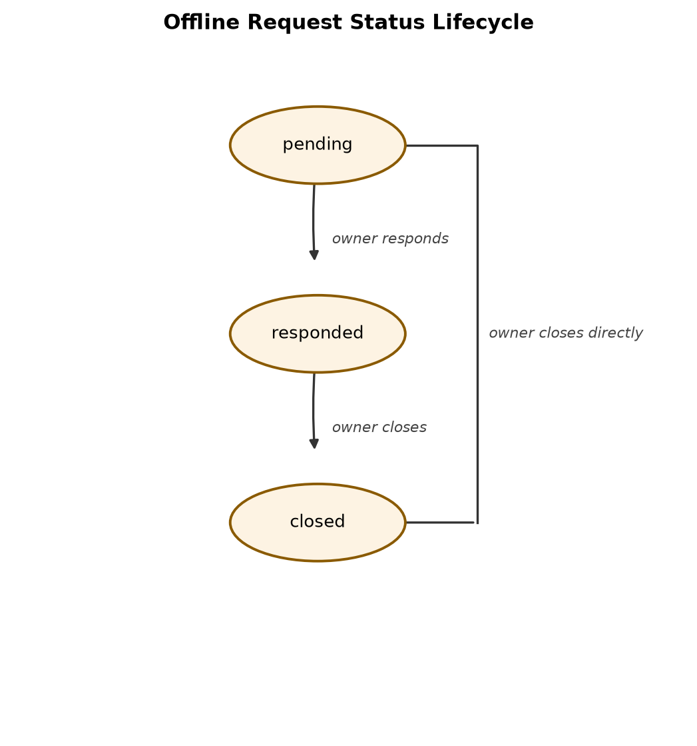
Figure 3.8: Offline Request Status Lifecycle
The image verification lifecycle begins the moment an image clears the duplicate-hash checks described in Section 3.8 and is assigned verificationStatus: "pending" (or, in the case of a cross-listing duplicate hash match, is assigned "suspicious" immediately rather than passing through "pending" at all). From pending, the lifecycle is entirely admin-controlled: an administrator's decision through PUT /api/admin/image-audit/:propertyId/:imageId moves the image to exactly one of three terminal-for-this-image states — verified, suspicious, or rejected — with a rejected outcome additionally forcing the image's aiScore field to 0 as noted previously. Unlike the booking lifecycle, no further application-level transition out of these three end states is exposed through the current API; correcting an admin decision would require the image to be re-audited through the same endpoint rather than through any guest- or owner-initiated action.
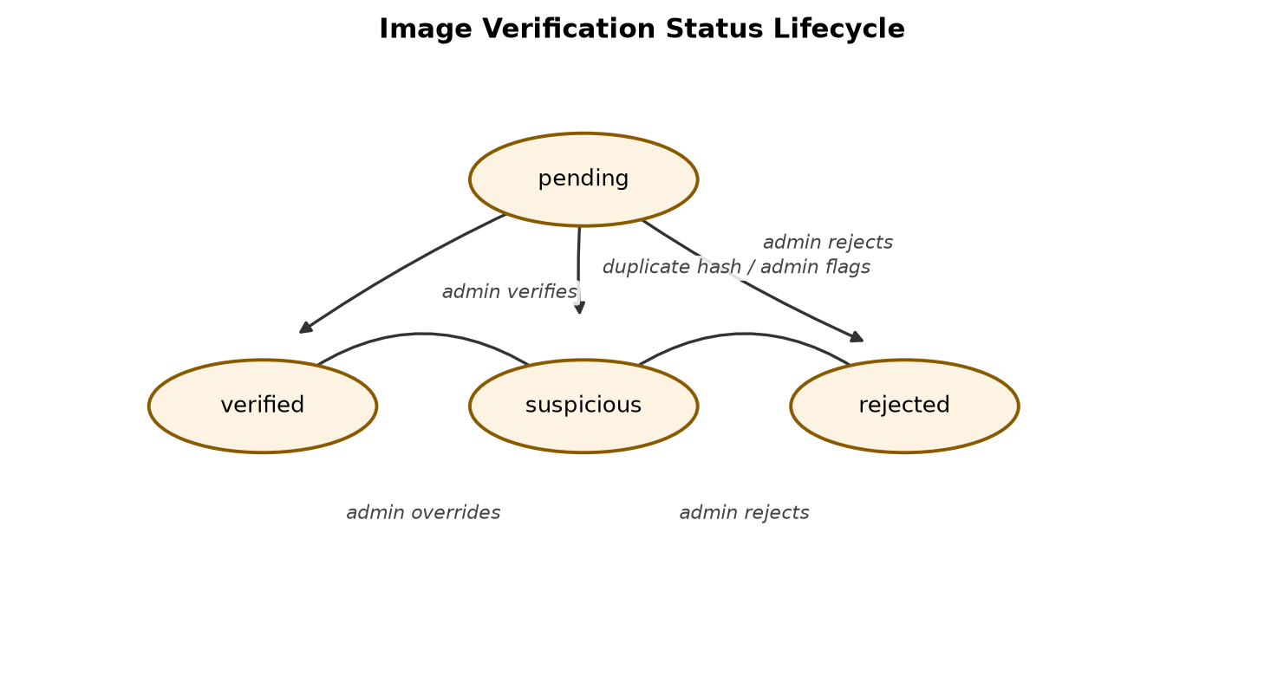
Figure 3.9: Image Verification Status Lifecycle
Turning from behaviour to deployment, IARS is designed to run as three independently startable processes during development, orchestrated through concurrently-style npm scripts rather than a single combined runtime. The client is served by the Vite development server on port 5173, compiling and hot-reloading the React SPA. The Express server runs as a standalone Node.js process on port 5000, establishing its own MongoDB connection at startup via the MONGO_URI environment variable and serving statically uploaded property images directly from the server/uploads directory through Express's static-file middleware, so that image URLs stored in Property.images[].url resolve directly against the running Express instance without a separate file-serving component. The sentiment microservice runs as a separate Uvicorn-hosted FastAPI process on port 8000, loading its joblib-serialised classifier pipeline into memory once at startup and serving inference requests from that in-memory model thereafter. All three services are configured exclusively through environment variables rather than hardcoded values — PORT, MONGO_URI, and CLIENT_URL for the Express server's networking and CORS behaviour; SENTIMENT_API_URL for locating the Python service; JWT_SECRET and JWT_EXPIRES_IN for authentication token signing; STRIPE_SECRET_KEY and STRIPE_WEBHOOK_SECRET for the payment integration; and a set of seed credentials used to bootstrap initial accounts — which allows the same codebase to be pointed at different database instances, client origins, or payment/webhook secrets across development and any future deployment target without code changes. Because the three services communicate exclusively over HTTP (the client to the Express API, the Express API to the sentiment microservice and to Stripe), each can, in principle, be relocated to a separate host or container without any change to the others beyond updating the relevant environment variable, even though the current development setup runs all three on a single machine under distinct ports.
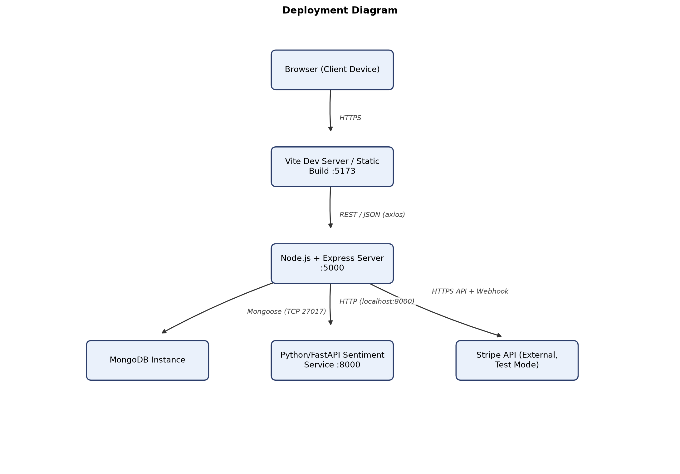
Figure 3.10: Deployment Diagram

3.10 Development Environment and Tools
The implementation of IARS was carried out using a JavaScript-first toolchain on the client and server tiers, complemented by a Python-based scientific computing stack for the sentiment microservice. This separation of environments was a deliberate architectural choice: the MERN application handles all transactional, relational-style logic (users, listings, bookings, offline requests) through Node.js and MongoDB, while the sentiment microservice is isolated as an independently runnable FastAPI application so that its scikit-learn dependencies, model artifacts, and Python runtime do not entangle the Node.js dependency tree. Both halves of the system communicate over a plain HTTP contract, which kept the two codebases loosely coupled throughout development and allowed each to be started, tested, and restarted independently during local development.
On the frontend, the project was scaffolded with Vite rather than Create React App, chosen for its fast cold-start and hot-module-replacement characteristics during iterative UI development. React 18 was used with plain JSX rather than TypeScript, in keeping with the technology constraints set for the project, and Tailwind CSS supplied the utility-first styling layer on top of which shadcn/ui component primitives (housed under client/src/components/ui/) were composed into buttons, cards, dialogs, tables, and form controls. Client-side routing was implemented with react-router-dom v6, HTTP communication with axios, iconography with lucide-react, and internationalisation with i18next and react-i18next.
On the backend, Node.js and Express were used with native ES module syntax ("type": "module" in package.json), which required consistent use of import/export syntax throughout the controllers, routes, and utility modules rather than CommonJS require. Mongoose was used as the object-document mapper over MongoDB, bcryptjs for password hashing, jsonwebtoken for stateless authentication tokens, multer for handling multipart image uploads, and the Stripe Node SDK (configured in test mode) for payment processing. The sentiment microservice was built with FastAPI served by uvicorn, with scikit-learn providing the TF-IDF vectoriser and logistic regression classifier, joblib for model persistence, and pandas for dataset handling during training.
Version control was managed with Git, and the three runtimes (client, server, sentiment service) were run concurrently during development using separate terminal processes, with environment-specific configuration isolated into .env files per service so that secrets such as the JWT signing key, MongoDB connection string, and Stripe API keys were never hard-coded into source files. The combination of tools listed in Table 3.18 reflects a stack that is conventional for a MERN-based final year project while still accommodating the specialised requirements of a machine-learning-backed sentiment pipeline and a multilingual, RTL-aware user interface.
Table 3.18: Development Tools and Technologies
Layer | Tool / Technology | Purpose
Frontend | React 18 (JSX) | Component-based UI library
Frontend | Vite | Development server and build tool
Frontend | Tailwind CSS | Utility-first styling
Frontend | shadcn/ui | Accessible UI component primitives
Frontend | react-router-dom v6 | Client-side routing and route guarding
Frontend | axios | HTTP client with request/response interceptors
Frontend | i18next / react-i18next | Multilingual translation and RTL/LTR handling
Frontend | lucide-react | Icon library
Backend | Node.js | JavaScript runtime
Backend | Express (ES modules) | HTTP server and routing framework
Backend | MongoDB / Mongoose | Document database and schema modelling
Backend | bcryptjs | Password hashing
Backend | jsonwebtoken | Stateless JWT authentication
Backend | multer | Multipart form-data and image upload handling
Backend | Stripe SDK (test mode) | Card payment processing
Sentiment microservice | Python | Runtime for the sentiment service
Sentiment microservice | FastAPI / uvicorn | Asynchronous API framework and ASGI server
Sentiment microservice | scikit-learn | TF-IDF vectorisation and logistic regression classifier
Sentiment microservice | joblib | Model and vectoriser serialisation
Sentiment microservice | pandas | Dataset loading and preprocessing for training
Tooling | Git | Version control

3.11 Backend Implementation

3.11.1 Project Structure and Module Organization
The Express application under server/ follows a conventional layered organisation that separates configuration, request handling, data modelling, cross-cutting concerns, and reusable computation into distinct directories. Two configuration modules live under config/: db.js, which establishes the Mongoose connection to MongoDB, and stripe.js, which instantiates the Stripe client after validating that the configured secret key is in test mode. Request handling logic is concentrated into eleven controller files under controllers/ — authController, propertyController, bookingController, reviewController, searchController, sentimentController, stripePaymentController, offlineRequestController, listingModerationController, imageAuditController, and userManagementController — each of which owns the business logic for one functional area rather than mixing concerns across a single monolithic file. Four middleware modules under middleware/ supply authentication (authMiddleware.js, exporting protect and optionalProtect), authorisation (roleMiddleware.js, exporting authorize(...roles)), centralised error handling (errorMiddleware.js, exporting notFound and errorHandler), and file-upload validation (uploadMiddleware.js, the multer configuration for property images). Seven Mongoose schemas live under models/, and nine route files under routes/ bind URL paths to controller functions with the appropriate middleware chain applied per endpoint.
A services/ directory holds sentimentService.js, the single point of contact between the Express server and the Python sentiment microservice; it wraps an axios POST request to the /predict endpoint with a fifteen-second timeout and a graceful fallback path so that a temporarily unavailable sentiment service does not prevent a review from being saved. The heaviest concentration of domain logic sits in utils/, a fourteen-file directory that includes bayesianRanking.js, bookingAmount.js, bookingReviewStatus.js, buildUserProfile.js, collaborativeFiltering.js, generateToken.js, imageAiScore.js, imageVerification.js, personalizedRecommendationEngine.js, propertySentimentStore.js, propertySignals.js, propertySimilarity.js, recommendationEnrichment.js, and sentimentAggregation.js. Keeping these as independently testable pure-function modules, rather than inlining their logic into controllers, was a conscious structural decision that made the recommendation and sentiment-aggregation pipelines easier to reason about as they grew in complexity. Finally, a scripts/ directory holds one-off maintenance and data-seeding utilities — seed.js (which creates the admin account from ADMIN_* environment variables), seedProperties.js, seedDemoReviews.js, syncPropertySentiment.js, reanalyzeReviews.js, and clearListings.js — which are run directly with Node rather than exposed through the API, since they are development and data-maintenance tools rather than user-facing functionality.
server/
├── config/ (db.js, stripe.js)
├── controllers/ (11 controller files)
├── middleware/ (auth, role, error, upload)
├── models/ (7 Mongoose schemas)
├── routes/ (9 route files)
├── services/ (sentimentService.js)
├── utils/ (14 utility modules)
└── scripts/ (seed and maintenance scripts)
This structure keeps each functional module — authentication, property/image handling, booking/payment, review/sentiment, offline requests, recommendations, and administration — reachable through a small, predictable set of files, which in turn made it straightforward to trace a request from its route definition, through its middleware chain, into its controller, and finally into the utility functions and Mongoose models it depends on.

3.11.2 Authentication and Authorization Implementation
User authentication in IARS is implemented as a stateless, JWT-based scheme layered on top of a User Mongoose model with a select: false password field. When a new guest or owner registers, authController.registerUser deliberately restricts the accepted role value to guest or owner; there is no code path through which a self-registering user can obtain the admin role, since administrator accounts are only ever created out-of-band by running scripts/seed.js, which reads ADMIN_* environment variables and inserts the account directly into the database. This design decision reflects the principle that privileged accounts should never be reachable through a public-facing endpoint. On successful registration, the controller issues a JSON Web Token, following the RFC 7519 specification [20], by calling generateToken(user._id), a small utility that wraps jwt.sign({ id }, JWT_SECRET, { expiresIn: JWT_EXPIRES_IN || "7d" }), giving every issued token both a cryptographic signature and a bounded lifetime that defaults to seven days if no explicit expiry is configured.
Login is handled by loginUser, which re-fetches the target user document with .select("+password") — necessary because the schema excludes the password field from ordinary queries by default — and then delegates the credential comparison to the matchPassword instance method defined on the User model, which internally calls bcrypt.compare against the stored hash. Password hashing itself happens transparently through a Mongoose pre("save") hook on the User schema: whenever a document is saved and its password field has been modified, the hook salts and hashes the plaintext with bcrypt [21] using ten salt rounds before persistence, and leaves the field untouched on saves that do not touch the password (for example, a profile update). This guarantees that plaintext passwords are never written to the database and that re-saving a user for an unrelated reason cannot accidentally re-hash an already-hashed value.
Authorisation on protected routes is enforced through two complementary middleware functions. protect, defined in authMiddleware.js, extracts the bearer token from the Authorization header, verifies its signature and expiry against JWT_SECRET, loads the corresponding user (excluding the password field) into req.user, and responds with a 401 status on any failure — a missing header, an invalid signature, an expired token, or a user that no longer exists. optionalProtect performs the identical lookup but, critically, does not reject the request when no token is present or the token is invalid; it simply leaves req.user undefined and allows the request to continue. This distinction is what allows endpoints such as /api/search, /api/recommendations, and the property detail endpoint (GET /api/properties/:id) to serve both anonymous visitors and authenticated users from the same route, differentiating their response only when an authenticated identity is actually present — for instance, personalising recommendation results for a logged-in guest while still returning a sensible cold-start result set for an anonymous one. Role-based access control is then layered on top of protect through authorize(...roles), a higher-order middleware in roleMiddleware.js that inspects req.user.role (already populated by protect) against an allow-list of roles supplied per route and returns a 403 if the authenticated user's role is not among them; because it runs strictly after protect, it can assume req.user is already a valid, loaded document.
On the client, this scheme is mirrored by client/src/services/api.js, which reads the JWT and user object out of localStorage and attaches an Authorization: Bearer <token> header to every outgoing axios request. A response interceptor watches for any 401 response — excluding the login and register calls themselves, since those legitimately return non-2xx statuses for invalid credentials rather than an expired session — and, upon seeing one, clears the stored session and redirects the browser to /login?session=expired, so that a token which has expired or been revoked server-side does not leave the user stranded on a broken authenticated view.

3.11.3 Property Management and Image Verification Implementation
Property creation is an owner-only workflow that begins on the client as a multipart form submission containing the listing's title, description, address fields (address, city, country), price, an availabilityCalendar serialised as a JSON string, and up to five image files. This payload passes through the uploadMiddleware.js multer configuration before it reaches propertyController.createProperty, and that configuration enforces both a maximum file count of five and a maximum size of five megabytes per file, restricted to the jpg, png, and webp MIME types — a request that violates either constraint is rejected before any controller logic executes. Inside createProperty, each accepted file is passed through buildVerifiedImagesFromFiles(), a routine that computes a SHA-256 hash of the file contents to detect duplicate uploads (whether duplicated within the same submission or against images already stored for other properties), and separately computes a heuristic quality score using server/utils/imageAiScore.js. That module inspects the raw PNG, JPEG, or WEBP file headers to recover pixel dimensions and estimates a score from resolution, apparent compression artefacts, and aspect ratio; it is explicitly a deterministic heuristic scoring function rather than a trained image-classification model, and this distinction is preserved throughout the codebase and the admin-facing tooling that consumes its output. The resulting image metadata — hash, dimensions, heuristic score, and an initial verificationStatus — is attached to the new Property document, which is itself created with status: "pending", meaning it is invisible to guest-facing search and browse endpoints until an administrator reviews it.
Editing an existing listing is handled by updateProperty, which supports a mixed image update: the client sends a retainedImageIds array identifying which of the property's existing images should be kept, alongside any newly uploaded files, which are processed through the same buildVerifiedImagesFromFiles() path as on creation. Images that are neither retained nor newly uploaded are dropped from the property's image list, which allows an owner to prune a listing's gallery without needing to re-upload every image on every edit.
The verification status attached to each image — verified, pending, suspicious, or rejected — governs what guests are permitted to see. Guest-facing read paths apply filterGuestImages, which strips any image that is not verified from the response, so a guest browsing an approved listing only ever sees images that have cleared moderation, even if that listing also carries images still pending review or flagged as suspicious from a more recent edit. Owner and administrator views, by contrast, are shown every image except those explicitly rejected, since owners need visibility into the state of their own submissions and administrators need the full picture in order to adjudicate it. This split between what an owner submits, what an administrator reviews, and what a guest is ultimately shown forms the backbone of the image-verification workflow that later feeds into the listing-approval gate described in section 3.11.8.

3.11.4 Booking and Payment Implementation
The booking workflow is coordinated by bookingController.createBooking, which performs a sequence of server-side validations before a Booking document is ever written, deliberately duplicating checks that the frontend also performs, on the principle that client-side validation can be bypassed and must never be the only line of defence. The controller first confirms that the target property's status is approved — a guest cannot book a listing that has not cleared admin moderation — and then calls isWithinAvailability() to verify that the requested date range falls inside the property's availabilityCalendar. It subsequently checks for date overlap against the property's existing bookings that are in a pending or confirmed state, returning a distinct BOOKING_ALREADY_EXISTS error code when the same guest already holds an active booking for that property and dates, and a DATES_UNAVAILABLE code when the conflict is with a different guest's booking, which allows the frontend to present a more specific and useful error message in each case rather than a single generic failure. Once these checks pass, the total price is computed by calculateBookingTotal, which multiplies the property's nightly price by the number of nights returned by countBookingNights over the requested check-in and check-out dates.
Payment is handled through Stripe in test mode via stripePaymentController.createCheckoutSession, which constructs a Stripe Checkout Session configured for card-only, one-time "payment" mode. Because Stripe Checkout for this integration operates in US dollars while the platform's listing prices and totals are denominated in PKR, the controller converts the booking's totalAmount to USD cents using toStripeUsdCents, which applies a fixed demonstration exchange rate of 280 PKR per USD and enforces a fifty-cent minimum charge to satisfy Stripe's own minimum-amount constraint. The resulting session is created with metadata containing the bookingId, guestId, and propertyId, and the generated sessionId is persisted back onto the Booking document so that it can later be reconciled against Stripe's own record of the payment. Confirmation of a successful payment can arrive through either of two paths that both converge on the same helper, markBookingStripePaid(): verifyCheckoutSession, which the frontend calls after the guest is redirected back from Stripe's hosted checkout page, and the /webhook handler, which Stripe calls asynchronously and independently of the browser redirect. Both paths check that Stripe reports the session's payment_status as "paid" before calling markBookingStripePaid(), which sets the booking's status and paymentStatus fields to confirmed and its paymentMethod to "stripe_test". A second endpoint, confirmDemoPayment, exists on the backend as a development and testing convenience that bypasses Stripe entirely, but it is not wired to any button or action in the deployed frontend; the Stripe test checkout flow is therefore the only payment path a real user of the application can currently trigger. Cancellation, handled by cancelBooking, simply sets the booking's status to cancelled without altering paymentStatus, which preserves an accurate historical record of whether a since-cancelled booking had actually been paid for.

3.11.5 Review and Sentiment Integration Implementation
Reviews are the mechanism through which IARS's sentiment analysis becomes visible to guests and owners, and reviewController.createReview is written to guarantee that a review can only be created under conditions that make it trustworthy. Before anything else, the controller confirms that the submitting guest holds a confirmed booking for the property in question, and that no review already exists for that same booking; this is enforced twice — once as an explicit application-level check inside the controller, and again as a unique index on the Review model's booking field, which acts as a database-level guarantee against a race condition producing duplicate reviews for the same booking. Only after both checks pass does the controller call analyzeSentiment(text), the function exported from services/sentimentService.js, which sends the review's free-text content to the Python microservice's /predict endpoint and receives back a structured response containing a sentiment label, a confidence score, a list of aspects, per-aspect aspectInsights, and a short summary. These fields are mapped directly onto the corresponding fields of the new Review document, so the sentiment result is stored permanently alongside the review text rather than being recomputed on every subsequent read.
Immediately after the review is saved, the controller calls propertySentimentStore.syncPropertySentiment(property), which re-aggregates every review associated with that property and writes the result into the property's own sentimentSnapshot field. This denormalisation is a deliberate performance decision: the property detail page, the search results list, and the candidate-scoring stage of the recommendation engine all need a property's aggregate sentiment picture frequently and cheaply, and recomputing it from the full Review collection on every one of those reads would be wasteful once a property accumulates a meaningful review history. By instead maintaining sentimentSnapshot as a materialised, eagerly updated summary that is only recalculated at the moment a new review is written, every other part of the system that needs a property's sentiment standing can read it directly off the Property document without touching the Review collection at all. The same syncPropertySentiment logic is reused by the scripts/syncPropertySentiment.js and scripts/reanalyzeReviews.js maintenance scripts, which allows the aggregate to be rebuilt in bulk if the underlying sentiment model or aggregation logic is ever revised, without requiring every review to be individually re-submitted through the API.

3.11.6 Offline Request Implementation
Not every prospective guest is comfortable completing an online card payment, and the offline request module exists to give such guests a form-based alternative route to inquire about a property. offlineRequestController.createOfflineRequest is deliberately placed behind optionalProtect rather than protect, which means both an authenticated guest and a completely anonymous visitor can submit a request; in the anonymous case, the resulting OfflineRequest document is stored with a guest field of null and relies instead on the phone number the visitor entered in the form. This design accommodates a realistic scenario in a property-booking context: a visitor may want to inquire about a listing before deciding whether the effort of registering an account is worthwhile.
The retrieval side of this workflow, getGuestOfflineRequests, has to reconcile that same scenario once the visitor eventually does create an account. It matches requests where the guest field equals the currently authenticated user's id, or, separately, where guest is null and the request's stored phone number matches the phone number on the authenticated user's profile. The first time a guest with a matching phone number logs in and views their offline requests, the controller performs an updateMany call that retroactively attaches their user id to any previously anonymous requests that match by phone, so that from that point forward those historical requests appear as a normal part of that guest's account rather than remaining orphaned anonymous records. On the owner side, respondToOfflineRequest allows an owner to set a status and responseMessage on a request directed at one of their properties, but only after verifying that the property referenced by the request actually belongs to the owner making the call — a check that prevents one owner from responding to, or even inferring the existence of, an offline request submitted against another owner's listing.

3.11.7 Recommendation Engine Implementation
The recommendation pipeline is orchestrated end-to-end by searchController.getRecommendations, which begins by running four largely independent data-gathering operations concurrently: buildUserRecommendationProfile (constructing a behavioural profile of the requesting guest, when one is authenticated), getGlobalBookingCounts (aggregate booking popularity across the platform), buildCoOccurrenceMatrix (the collaborative-filtering structure described in section 3.14.3), and a Property.find({ status: "approved" }) query that gathers the full candidate pool of listings eligible for recommendation. Running these as parallel operations rather than sequentially was a deliberate performance choice, since none of them depends on the others' output and the naive sequential approach would otherwise add unnecessary latency to every recommendation request.
Once the candidate properties are retrieved, each one is enriched with its review statistics and sentiment summary before scoring begins, ensuring that every downstream scoring function — the Bayesian ranking described in section 3.14.1, the content-based similarity comparisons of 3.14.2, and the collaborative co-occurrence scoring of 3.14.3 — operates on a consistent, fully-populated candidate object rather than needing to fetch additional data mid-computation. The controller then calls buildRecommendationMode, a decision function that inspects the strength and quantity of signal available for the requesting guest — essentially, whether the guest has enough booking and viewing history to support a meaningful personalised profile — and chooses between two downstream builders accordingly: buildStructuredRecommendations for guests with sufficient interaction history, producing a personalised set of sections, or buildColdStartRecommendations for anonymous visitors or guests with too little history, which instead leans on popularity, Bayesian quality, and diversity heuristics to produce a still-useful result set without requiring any prior personal signal. In both cases, the final step is a call to finalizePersonalizedRecommendations, which enriches each recommended property's matchReasons — human-readable explanations of why a given property was surfaced, drawing on recommendationEnrichment.js — before the controller assembles the final response. That response is shaped as a set of named sections (each mapped in the frontend to a translated heading) plus a single flattened data array capped at twenty-four items via the RECOMMENDATION_TOTAL constant, giving the client a bounded, predictable payload size regardless of how many approved properties currently exist in the system.

3.11.8 Admin Module Implementation
Administrative oversight in IARS is split across three controllers, each responsible for one axis of platform governance. listingModerationController handles the approval workflow for newly submitted properties: getPendingListings returns every property still awaiting a decision, and for each one attaches an imageSummary that tallies how many of its images currently sit in the verified, pending, suspicious, and rejected states, giving the reviewing administrator an at-a-glance sense of how trustworthy a listing's photo evidence is before opening it in detail. approveListing enforces a hard gate on that trustworthiness: it calls hasVerifiedImage(property.images) and returns a 400 error if the listing does not have at least one image that has actually been verified, which prevents a property from going live with no verified visual evidence at all, regardless of how complete its textual description might be. rejectListing provides the corresponding negative outcome, moving the property out of the pending queue without ever exposing it to guests.
Image-level moderation is handled separately by imageAuditController, since a listing can be approved overall while individual images within it still need individual attention (for instance, an owner adding a new photo to an already-approved listing after the fact). getImageAuditList flattens every property's images into a single administrator-facing list spanning the whole platform, and, as part of building that list, refreshes the heuristic AI score for any image whose score is still in a pending state, ensuring the audit view reflects the current heuristic output rather than a stale value. updateImageAudit lets an administrator set an image's verificationStatus directly and, if desired, manually override its aiScore — human judgement is permitted to take precedence over the heuristic score in either direction — with one safeguard: setting the status to rejected always forces the stored aiScore to zero, so a rejected image can never be left carrying a score that would misleadingly suggest it had passed quality assessment.
The third axis, user governance, is handled by userManagementController. getAllUsers gives administrators visibility into the full user base, updateUserVerification lets an administrator mark a user's account as verified, and updateUserRole allows role changes between the platform's roles — but with two defensive checks built directly into the controller logic: an administrator is blocked from demoting their own account, and the system is blocked from demoting the last remaining administrator account on the platform. Both checks exist to prevent an administrative action from ever accidentally leaving the platform with zero administrator accounts able to manage it.

3.12 Sentiment Microservice Implementation
The sentiment microservice is implemented as a standalone FastAPI application, run under uvicorn, that is intentionally kept independent of the Node.js/Express server both as a process and as a codebase. At startup, the service loads a previously trained scikit-learn pipeline — a TF-IDF vectoriser paired with a logistic regression classifier — from disk using joblib, so that the comparatively expensive step of fitting the vectoriser's vocabulary and the classifier's weights happens once, offline, during a separate training run rather than on every request or every service restart. The model artifacts are trained on a labelled hotel-review dataset processed with pandas, where each review's raw text is transformed into a TF-IDF feature vector before being fit against the corresponding positive/negative/neutral sentiment labels; a dedicated training script performs this fitting step and persists the resulting vectoriser and classifier objects with joblib so that the FastAPI application can load them directly rather than repeating the training process at request time.
The service's single functional endpoint, /predict, accepts a piece of review text and returns a structured JSON payload containing a sentiment label, a confidence score, a set of detected aspects (aspect-level themes present in the review, such as cleanliness or location), aspectInsights describing the sentiment associated with each detected aspect, and a short human-readable summary. Internally, the prediction pipeline first passes the incoming text through the same TF-IDF vectoriser used during training and obtains the trained logistic regression classifier's predicted label and probability. That base classification is then checked against a rule-based negation-override layer, described in detail in section 3.14.4, which exists specifically to correct a known weakness of a bag-of-words-style TF-IDF representation: phrases such as "not clean" or "not good" can be scored as superficially positive by a classifier that has learned strong positive associations for words like "clean" or "good" without adequately weighting the preceding negation, and the rule-based layer intercepts these known negated-positive patterns and forces a negative classification with a high confidence value whenever they are detected, overriding the base classifier's output in that specific case. The final combined result — whichever of the base classifier's or the rule-based override's output prevails — is what is returned to the calling Express server through sentimentService.js, which the review controller then persists onto the corresponding Review document as described in section 3.11.5. Because the sentiment service is called synchronously from the Node.js backend but guarded by a timeout and a fallback path on the calling side, the microservice's availability is decoupled from the correctness of the rest of the review-creation workflow: a review can still be saved even if the sentiment service is briefly unreachable, with its sentiment fields simply left unpopulated until a later re-analysis pass (via scripts/reanalyzeReviews.js) can fill them in.

3.13 Frontend Implementation

3.13.1 Application Structure and Routing
The React client is bootstrapped in main.jsx, where a deliberate provider nesting order establishes the application's cross-cutting context before any route is rendered: ThemeProvider wraps BrowserRouter, which wraps AuthProvider, which wraps a Toaster (for transient notification messages) and finally the application's Routes. This ordering matters because both theme and authentication state need to be available to every routed page, and placing BrowserRouter between the two providers ensures that navigation triggered by either theme or authentication changes (for example, a redirect on logout) has access to the router. AuthContext.jsx is the central piece of client-side session state: it persists the JWT and the authenticated user object in localStorage, attempts to restore an existing session on mount by calling GET /auth/me, and exposes login, register, logout, and a getDashboardPath helper that maps a user's role to the correct landing route — /guest/dashboard for guests, /owner/dashboard for owners, and /admin/dashboard for administrators — which is used consistently across the login flow and any role-aware redirect logic rather than being recomputed ad hoc in individual components.
Route protection is layered through two composable components: ProtectedRoute, which acts purely as an authentication gate and redirects an unauthenticated visitor to the login page, and RoleBasedRoute, which wraps ProtectedRoute and additionally checks the authenticated user's role against a list of roles permitted for that route, redirecting to an appropriate fallback if the role does not match. Every guest, owner, and admin page in the application is reached through one of these guards, so a logged-in guest, for instance, cannot navigate directly to an admin route by manipulating the URL. Three distinct layout shells govern the visual chrome around routed pages: PublicLayout, which wraps a Navbar and Footer around unauthenticated, publicly browsable pages such as search and property details; AuthShellLayout, a minimal-header shell used specifically for the login and registration pages, where a full navigation bar would be redundant; and DashboardLayout, used by every guest, owner, and admin page, which renders a fixed sidebar whose navigation items are driven by a role-specific configuration object — Dashboard, My Bookings, and Offline Requests for guests; Dashboard, Properties, and Offline Requests for owners; and Dashboard, Moderate Listings, Manage Users, and Image Audit for administrators. Across the public, authentication, guest, owner, and admin route groups, the application comprises twenty-two page components in total, each mapped to one of these three layout shells according to its audience and authentication requirements.

3.13.2 Role-Based Dashboards
Because IARS serves three structurally different audiences through the same codebase, the dashboard experience for each role is composed from the same DashboardLayout shell but populated with entirely different content and navigation. The guest dashboard surfaces the guest's own bookings and offers quick access to their offline requests, giving a returning guest a single place to check the status of an in-progress booking or a pending offline inquiry without needing to search the platform again. The owner dashboard instead orients around the owner's property portfolio and the bookings made against it, with a dedicated Properties section for creating and editing listings via PropertyForm.jsx and a view of the offline requests submitted specifically against the owner's own properties. The admin dashboard is the most operationally dense of the three, giving direct navigation into the moderation queue (Moderate Listings), the platform-wide image audit list, and user management, reflecting the fact that an administrator's day-to-day interaction with the platform is almost entirely about governance rather than browsing or transacting.
This role-specific navigation configuration is what DashboardLayout's sidebar reads from, rather than the sidebar itself containing any role-conditional branching logic; each role's page set and ordering is defined once, in one place, and the layout component simply renders whichever configuration corresponds to the currently authenticated user's role. Because RoleBasedRoute guards every route inside each of these dashboards, a guest who somehow navigates to an owner-only URL is redirected away rather than shown a broken or empty owner page, which keeps the three dashboard experiences cleanly separated even though they share the same underlying layout component and the same authentication context.

3.13.3 Booking and Review Flow Interfaces
The path from discovering a property to leaving a review after staying there spans several distinct page components, each corresponding to a specific stage of the workflow implemented on the backend. A guest first encounters RecommendedProperties.jsx or the search results view, both of which surface approved listings; RecommendedProperties.jsx in particular is written to handle two different response shapes coming back from the recommendation API, rendering a sectioned layout (mapping each section's titleKey through i18next to produce a translated heading) when the backend returns personalised or cold-start sections, and falling back to a flat grid when it does not, while also adjusting the hint text shown above the results depending on whether the visitor is anonymous, receiving a personalised result set, or receiving a cold-start result set. From a property's detail page, a guest proceeds into the booking flow, which surfaces the server-side availability and overlap validation described in section 3.11.4 as user-facing error messaging — a guest attempting to book already-booked dates is shown a message distinguishing whether they already hold a conflicting booking themselves or whether the conflict belongs to someone else, mirroring the BOOKING_ALREADY_EXISTS and DATES_UNAVAILABLE error codes returned by the API. Payment is completed through the Stripe test checkout redirect, after which the guest is returned to a confirmation view that reflects the booking's updated confirmed status once verifyCheckoutSession has run.
Once a booking reaches a confirmed state and its stay period has passed, the guest becomes eligible to leave a review, and the review submission form is gated by the same booking-ownership and no-existing-review rules enforced server-side, so the interface only offers the review action where it is actually valid to use it rather than surfacing a form that the backend would reject. On property detail pages, submitted reviews are displayed alongside their sentiment result and, in aggregate, the property's sentimentSnapshot, giving prospective guests a quick sense of how existing guests' feedback has trended before they commit to booking. On the owner side, PropertyForm.jsx — shared between the create-listing and edit-listing flows — submits its data as FormData rather than JSON, since it needs to carry both structured fields and binary image files in a single request; it serialises availabilityCalendar as a JSON string field within that form data, and, specifically when editing an existing listing, additionally includes a retainedImageIds field as a JSON-encoded array so the server can determine which existing images to keep alongside whatever new files are attached, exactly mirroring the updateProperty logic described in section 3.11.3.

3.13.4 Multilingual (i18n) and Right-to-Left Implementation
IARS is required to present its interface in English, Urdu, and Arabic, with English as the default language and Urdu and Arabic both rendered right-to-left, and this requirement is implemented through i18next and react-i18next backed by three separate JSON dictionary files, one per language, organised under nested domain-specific keys rather than as a single flat list of strings. Every piece of static interface text — button labels, navigation items, form labels, validation messages, section headings — is referenced in components through a translation key rather than being hard-coded, which is what makes it possible to add or adjust a language's wording without touching component code. A deliberate and important exception is carved out for user-generated content: property titles and descriptions, guest reviews, and personal fields such as names, emails, and phone numbers are never passed through the translation layer, since translating content that a real user actually typed would misrepresent what they wrote; these fields are rendered verbatim regardless of the interface's currently selected language.
The currently selected language is persisted in localStorage so that a returning visitor sees the interface in the language they last chose, and a languageUtils helper is responsible for applying the correct reading direction and language attribute to the document — setting dir to rtl for Urdu and Arabic and ltr for English, and setting lang accordingly on the root <html> element, which is what allows browser-level and assistive-technology behaviours (as well as CSS logical properties) to respond correctly to the active language. Because a right-to-left layout inverts the visual meaning of "left" and "right", components throughout the application avoid hard-coded directional classes in favour of direction-safe alternatives such as text-start/text-end and logical start/end spacing utilities rather than text-left/text-right or ml-/mr- utilities, alongside liberal use of flex-wrap, w-full, and responsive grid classes. This discipline is what keeps forms, property cards, tables, dashboard sidebars, the navigation bar, and the footer visually coherent regardless of which of the three supported languages and reading directions is active, rather than requiring a separate mirrored layout to be maintained for right-to-left languages.

3.13.5 Theming (Dark and Light Mode)
Alongside language, IARS supports a light and dark visual theme, implemented through ThemeContext.jsx and toggled from the interface via a dedicated ThemeToggle component. The context tracks the currently active theme, persists the user's choice in localStorage so it survives a page reload or a new session, and applies the corresponding theme class to the root <html> element, which allows Tailwind's dark-mode variant utilities used throughout the shadcn/ui-based component set to respond automatically without individual components needing their own theme-detection logic. Because the theme, language, and authentication contexts are all established at the top of the component tree in main.jsx, a change to any one of them — switching from light to dark mode, switching from English to Urdu, or logging in and out — takes effect consistently across every currently rendered page rather than requiring a full reload or per-page reinitialisation. This kept the theming implementation deliberately simple and scoped to exactly the two states the project requires, rather than expanding into a broader design-token system that would have gone beyond what the platform's UI actually needed.

3.14 Key Algorithms
Several parts of IARS depend on computation that goes beyond straightforward CRUD logic: ranking listings by trustworthy quality rather than raw average rating, judging how similar two properties are to one another, inferring a guest's preferences from their past behaviour without an explicit ratings matrix, and correcting for a specific, predictable failure mode of a bag-of-words sentiment classifier. The four subsections below present the core logic behind each of these, expressed as representative pseudocode of the reasoning implemented in the corresponding utility files rather than as literal file excerpts.

3.14.1 Bayesian Quality Ranking
Ranking properties purely by their raw average star rating rewards listings with very few reviews unfairly — a single five-star review produces a higher average than a listing with fifty reviews averaging 4.6 — so bayesianRanking.js instead computes a Bayesian-smoothed score that blends each property's own review history with a platform-wide prior. The prior assumes a baseline mean rating of 3.5 and is given a smoothing weight equivalent to four "phantom" reviews, meaning a property with very few real reviews has its score pulled substantially toward that neutral prior, while a property with a long, robust review history has its score dominated almost entirely by its actual reviews. On top of that Bayesian-smoothed base, the score is further penalised for low review credibility (very small review counts, which are inherently less trustworthy signals even after smoothing) and for a high proportion of negative sentiment among the property's reviews, so that a listing whose sentiment analysis skews negative does not rank as highly as its raw star average alone might suggest. Finally, a trust floor is applied through a MIN_QUALITY_SCORE constant of 0.28, ensuring that even a poorly-performing or extremely new listing retains some minimal baseline visibility rather than being scored at or near zero and effectively disappearing from ranked results.
function bayesianQualityScore(property):
PRIOR_MEAN = 3.5
PRIOR_WEIGHT = 4
MIN_QUALITY_SCORE = 0.28
reviewCount = property.reviewStats.count
averageRating = property.reviewStats.averageRating
negativeShare = property.sentimentSnapshot.negativeRatio
smoothedRating = (
(PRIOR_WEIGHT * PRIOR_MEAN) + (reviewCount * averageRating)
) / (PRIOR_WEIGHT + reviewCount)
credibilityPenalty = penaltyForLowReviewCount(reviewCount)
sentimentPenalty = negativeShare * NEGATIVE_SENTIMENT_WEIGHT
rawScore = normalize(smoothedRating) - credibilityPenalty - sentimentPenalty
return max(rawScore, MIN_QUALITY_SCORE)

3.14.2 Content-Based Similarity Scoring
To recommend properties that resemble ones a guest has already shown interest in, propertySimilarity.js computes a weighted composite similarity score between a candidate property and a reference property (or a guest's aggregated preference profile) across four independent dimensions, each contributing a fixed share of the final score: whether the two properties are in the same city, contributing a weight of 0.32; how close their nightly prices are to one another, contributing 0.28; how much overlap exists between their amenity sets, measured as a Jaccard similarity and contributing 0.22; and how similar their aggregate guest sentiment profiles are, contributing the remaining 0.18. Weighting city match and price proximity most heavily reflects the practical reality that a guest browsing accommodation is usually anchored to a specific destination and budget range first, with amenity overlap and sentiment alignment acting as secondary refinements once those two harder constraints are already satisfied. Because each dimension's contribution is capped by its own weight, the four weights sum to exactly 1.0, keeping the final composite score on a consistent, easily-interpreted normalised scale regardless of how many of the four dimensions align strongly.
function contentSimilarity(candidate, reference):
citySim = candidate.city === reference.city ? 1 : 0
priceSim = 1 - normalizedAbsoluteDifference(candidate.price, reference.price)
amenitySim = jaccardSimilarity(candidate.amenities, reference.amenities)
sentimentSim = 1 - normalizedAbsoluteDifference(
candidate.sentimentSnapshot.positiveRatio,
reference.sentimentSnapshot.positiveRatio
)
return (0.32 * citySim)
+ (0.28 * priceSim)
+ (0.22 * amenitySim)
+ (0.18 * sentimentSim)

3.14.3 Collaborative Filtering Co-Occurrence Scoring
Where content-based similarity reasons about the attributes of properties themselves, collaborativeFiltering.js reasons instead about patterns of behaviour across guests, without needing an explicit ratings matrix. It builds a co-occurrence matrix by scanning historical bookings and property views: every pair of properties that the same guest has booked contributes a full weight of 1 to that pair's entry in the matrix, while every pair of properties the same guest has merely viewed (without necessarily booking) contributes a smaller weight of 0.35, reflecting the intuition that a completed booking is a much stronger signal of genuine interest and satisfaction than a passing view. Once this matrix is built across all guests, scoring a specific candidate property for a specific guest is a matter of looking up every property already in that guest's own interaction set (their past bookings and views), summing the co-occurrence weight between the candidate and each of those known properties, and using that sum as the candidate's collaborative score — properties that have frequently co-occurred, across the platform's collective history, with properties this particular guest already engaged with end up scored more highly than properties with no such co-occurrence relationship at all.
function buildCoOccurrenceMatrix(allBookings, allViews):
matrix = {}
for guestBookings in groupByGuest(allBookings):
for (propertyA, propertyB) in allPairs(guestBookings):
matrix[propertyA][propertyB] += 1
matrix[propertyB][propertyA] += 1
for guestViews in groupByGuest(allViews):
for (propertyA, propertyB) in allPairs(guestViews):
matrix[propertyA][propertyB] += 0.35
matrix[propertyB][propertyA] += 0.35
return matrix
function collaborativeScore(candidateProperty, guestInteractionSet, matrix):
score = 0
for knownProperty in guestInteractionSet:
score += matrix[candidateProperty][knownProperty] || 0
return score

3.14.4 Sentiment Rule-Based Negation Override
The sentiment microservice's primary classifier is a TF-IDF and logistic regression pipeline, which represents review text as a bag of weighted terms and is consequently prone to a well-known failure mode: a phrase like "not clean" or "not good" contains a strongly positive-associated word ("clean", "good") immediately preceded by a negation the vectoriser does not explicitly model as flipping that word's contribution. Left uncorrected, this can cause a review that is actually complaining about a property to be scored as positive simply because it contains vocabulary the classifier has learned to associate with positive reviews. To correct for this specific, predictable pattern, a rule-based override layer runs alongside the trained classifier: it pattern-matches the review text against a set of known negated-positive phrase patterns, and whenever one of those patterns is detected, it forces the final classification to negative with a confidence value of at least 0.88, regardless of what the base classifier's own probability output was. This override is intentionally narrow in scope — it targets a specific, well-understood blind spot of the bag-of-words model rather than attempting to re-implement general-purpose negation handling — and it is applied after the base classifier runs, so it acts strictly as a correcting layer on top of the trained model rather than as a replacement for it.
NEGATED_POSITIVE_PATTERNS = [
"not good", "not clean", "not friendly", "not comfortable",
"not worth", "not great", "not nice"
]
function classifySentiment(reviewText, trainedModel):
baseResult = trainedModel.predict(reviewText)
for pattern in NEGATED_POSITIVE_PATTERNS:
if reviewText.toLowerCase().includes(pattern):
return {
sentiment: "negative",
confidence: max(0.88, baseResult.confidence)
}
return baseResult

3.15 Security Measures Implemented
Security in IARS was implemented as a series of targeted measures, each addressing a specific, identifiable risk rather than as a generic checklist applied uniformly without regard to what the platform actually needed to protect. Authentication risk is addressed first: sessions are stateless JSON Web Tokens signed with a configurable secret and a configurable expiry, which avoids the need for server-side session storage while still bounding how long a stolen or leaked token remains usable. Underneath that, credentials themselves are never stored in a recoverable form — passwords are hashed with bcrypt at ten salt rounds before being persisted, and the User schema additionally marks the password field as excluded from ordinary queries (select: false) and therefore from any JSON response the API returns, so that even a bug elsewhere in the codebase that accidentally serialises a full user document cannot leak a password hash to a client.
Authorisation is enforced structurally rather than left to individual controllers to remember: role-based middleware sits in front of every sensitive route, so that a request reaching a controller has already been confirmed to belong to an authenticated user of an appropriate role before any business logic executes, which removes an entire class of "forgot to check the role" bugs by making the check a routing-level concern instead of a per-controller one. Because client-side checks can always be bypassed by a sufficiently motivated or malicious client, the booking workflow deliberately re-validates ownership, property approval status, availability, and date-overlap conditions on the server even though the same checks already inform what the frontend displays and disables — the frontend's validation exists purely for user experience, while the server's validation is what actually protects data integrity.
Payment-specific risk is addressed at the configuration layer: the Stripe integration validates at startup that the configured secret key begins with the sk_test_ prefix, which is a direct, low-effort safeguard against a misconfigured environment accidentally processing real charges against a live Stripe account during development or testing. Complementing that, incoming Stripe webhook events are verified against a signature computed with STRIPE_WEBHOOK_SECRET, so that the booking-confirmation logic triggered by a webhook call cannot be spoofed by an attacker simply posting a fabricated payload to the webhook URL. File-upload risk is constrained by the multer configuration underlying property image uploads, which limits both the number of files (a maximum of five) and the size of each file (five megabytes) and restricts accepted types to jpg, png, and webp, preventing arbitrarily large or arbitrarily typed files from being accepted through that endpoint. Separately, SHA-256 hashing of each uploaded image allows the system to detect duplicate uploads, which supports the integrity of the image-verification workflow by making it harder for a single image to be reused across multiple listings without that reuse being noticed. Finally, cross-origin access to the API is restricted to the configured CLIENT_URL with credentials enabled, rather than left open to any origin, which ensures that only the platform's own deployed frontend — not an arbitrary third-party site — can make authenticated, cookie- or credential-bearing requests against the API.

3.16 Chapter Summary
This chapter has traced the implementation of IARS from its foundational design decisions through to the concrete code structures that realise them, covering the development toolchain, the eight functional pillars of the backend, the standalone sentiment microservice, the role-aware and multilingual frontend, the four algorithms that give the platform's ranking and sentiment features their analytical substance, and the security measures woven through every layer of the stack. Taken together with the design artefacts presented earlier in this chapter, the implementation demonstrates a system in which the authentication scheme, the property and image verification pipeline, the booking and payment workflow, the review and sentiment integration, the offline request mechanism, the recommendation engine, and the administrative governance tools are not independent features bolted together, but a set of modules that consistently rely on one another's guarantees — approved-status checks gating bookings, verified-image checks gating listing approval, sentiment snapshots feeding recommendation scoring, and role middleware gating every administrative action.
Having established what was built and how, the natural next question is whether it actually works as intended under realistic conditions, and to what degree it can be trusted to behave correctly when guests, owners, and administrators use it as designed — and, just as importantly, when they do not. The following chapter, System Testing, takes up that question directly, applying black-box and white-box testing strategies to the modules described here and documenting the specific test cases, execution results, and defects uncovered and resolved during that process.

CHAPTER 4
SYSTEM TESTING

4.1 Testing Objectives and Strategy
The objective of the testing phase for the Intelligent Accommodation Review System (IARS) was to verify that the implemented functionality across the three constituent services — the React client, the Node.js/Express/MongoDB server, and the Python sentiment microservice — behaved correctly against the requirements established during system analysis, and that the three services interoperated correctly as a whole. Because IARS integrates several distinct concerns (authentication, listing management with image verification, booking and payment, review submission with automated sentiment scoring, offline request handling, a recommendation engine, and administrative moderation), the testing strategy was designed to exercise each module both in isolation and as part of the end-to-end guest, owner, and admin workflows described in Chapter 3.
Testing combined black box and white box approaches. Black box testing was used to validate externally observable behaviour — form submissions, HTTP responses, and role-based access restrictions — without reference to how a given controller or component achieved that behaviour internally. White box testing was reserved for logic that carries meaningful branching and is not adequately exercised by input/output checks alone, such as the booking overlap-detection logic, the sentiment service's rule-based negation override, the recommendation engine's section-selection logic, and the image duplicate-hash comparison performed during property image upload.
Testing was organised along two complementary axes. The first axis was by user role: guest-facing flows (registration, search, booking, review, offline requests, recommendations), owner-facing flows (listing creation, image upload, offline request responses), and admin-facing flows (listing approval, image audit, user management) were each tested against the permissions and UI states appropriate to that role. The second axis was by functional module, following the structure already established in the requirements and design chapters, so that every module identified in the use case catalogue had at least one corresponding test case.
All manual test execution was performed against a locally seeded MongoDB instance populated using the seeding scripts under server/scripts (seed.js, seedAdmin.js, seedProperties.js, and seedDemoReviews.js), which provided a repeatable baseline of users, properties, and reviews for each test run. The Python sentiment microservice was run concurrently so that review submissions during testing exercised the real /predict classification pipeline rather than a stub. Stripe payments were tested exclusively in Stripe's test mode using publishable/secret test keys, and no production payment credentials were used at any point during testing.

4.2 Black Box Testing
Black box testing treated each module of IARS as a set of inputs and expected observable outputs, without reference to the underlying implementation. For the authentication module, this meant submitting registration and login forms with valid, invalid, and boundary-case data (duplicate emails, incorrect passwords, missing fields) and confirming that the correct HTTP status codes, error messages, and JWT tokens were returned, and that role-based UI elements and route access matched the guest, owner, or admin role encoded in the token.
For the property and search modules, black box testing focused on the relationship between input filters submitted to GET /api/search (city, title, price range, and availability date) and the set of properties returned, with particular attention to the rule that only properties with verificationStatus/listing status of approved are ever surfaced to guests, regardless of the filters applied. Listing creation and image upload were tested by submitting valid and invalid image files (correct and incorrect formats, oversized files, and repeated uploads of an identical file) and observing the resulting verificationStatus and error responses, without inspecting how the server computed those outcomes internally.
Booking, payment, cancellation, review, and offline-request flows were similarly tested from the perspective of a user interacting with forms and buttons: submitting a booking for available or already-booked dates, completing a Stripe test-mode checkout, cancelling a confirmed booking, submitting a review against a completed booking, and submitting an offline request with or without an authenticated account. In each case, the test verified that the response returned to the client (success payload, error code, or status change visible on screen) matched what the requirement specified, and that role restrictions were enforced — for example, that only the guest who made a booking can cancel it, and that an admin-only endpoint rejects requests from a guest or owner token. Admin screens (user list, image audit, listing approval) were tested by confirming that the actions available in the UI produced the expected state changes and were unavailable to non-admin sessions.

4.3 White Box Testing
White box testing was applied to logic paths where correctness depends on internal branching that black box input/output testing alone cannot adequately probe. The most significant target of white box testing was the booking availability and overlap-checking logic in the booking controller. This logic first checks whether the requesting guest already holds a booking for the same property covering the requested dates, in which case it raises an error tagged BOOKING_ALREADY_EXISTS; if not, it separately checks whether the requested date range overlaps any other guest's existing confirmed booking for that property, raising DATES_UNAVAILABLE in that case. Because these are two distinct code paths with two distinct error codes reached under different combinations of existing bookings, test cases were designed to walk through each branch individually — an overlap against the tester's own prior booking, an overlap against a different guest's booking, and a genuinely free date range — to confirm each branch was reachable and returned the correct code and totalAmount calculation (price × nights).
The sentiment microservice's rule-based negation override was tested with reference to its internal logic path rather than only its final label. The TF-IDF plus Logistic Regression classifier can mis-score short reviews containing a negated positive adjective (for example, "not clean") as positive purely from the presence of the adjective "clean"; the override logic detects negation cue words adjacent to sentiment-bearing terms and flips or dampens the classifier's raw output before the final label and aspect list are returned. Testing here specifically targeted inputs constructed to trigger this override path, rather than only random review text, so that the branch could be confirmed as functioning rather than merely coincidentally correct.
The image duplicate-detection logic was examined at the level of its SHA-256 hashing and comparison path: whether a newly uploaded image's hash matched any hash already stored against the same property or against other properties, and how that comparison interacted with the heuristic aiScore computation and the verificationStatus transition. Finally, the recommendation engine's section-selection branching — the condition that determines whether a request is served the cold-start set (top_bayesian, best_reviewed, trending) or the personalized set derived from booking, view, and search history — was traced directly against the code path that inspects whether the requesting user has an authenticated session with recorded history, to confirm the boundary between the two modes behaved as designed rather than only observing the rendered output.

4.4 Test Case Design
The following subsections document the twenty test cases executed against IARS, covering the core guest, owner, and admin workflows identified in Chapter 3. Each test case specifies the feature under test, its purpose, any precondition that had to hold before execution, the steps carried out against the seeded environment, and the result expected based on the system's specified behaviour; actual execution outcomes are consolidated in Section 4.5.

4.4.1 TC-01 User Registration (Guest)
This test case verifies that a new guest account can be created through the registration form and that the account is issued a valid JWT with the guest role.
Table 4.1: Test Case TC-01 User Registration
Test Case ID | Feature | Purpose | Precondition | Test Steps | Expected Result
TC-01 | User Registration (Guest) | Verify a new guest account is created with correctly hashed credentials and a valid session token | No existing account is registered with the test email address | 1. Navigate to the registration page. 2. Enter name "Ayesha Khan", email "ayesha.khan@example.com", password "Passw0rd!23", and select role "Guest". 3. Submit the form via POST /api/auth/register. | Account is created with the password stored as a bcrypt hash (never in plain text); server responds with HTTP 201, a signed JWT, and role "guest"; client redirects to the guest dashboard.

4.4.2 TC-02 User Registration (Owner)
This test case verifies that a new property owner account can be registered with the owner role and is subsequently permitted to access owner-only listing screens.
Table 4.2: Test Case TC-02 User Registration
Test Case ID | Feature | Purpose | Precondition | Test Steps | Expected Result
TC-02 | User Registration (Owner) | Verify a new owner account is created and granted access to owner-only functionality | No existing account is registered with the test email address | 1. Navigate to the registration page. 2. Enter name "Bilal Ahmed", email "bilal.ahmed@example.com", password "OwnerPass1!", and select role "Owner". 3. Submit the form via POST /api/auth/register. | Account is created with role "owner"; server responds with HTTP 201 and a JWT encoding role "owner"; the owner dashboard and "Create Listing" option become accessible on the client.

4.4.3 TC-03 Valid Login
This test case verifies that an existing, correctly credentialed user can log in and receive a valid session token.
Table 4.3: Test Case TC-03 Valid Login
Test Case ID | Feature | Purpose | Precondition | Test Steps | Expected Result
TC-03 | Valid Login | Verify correct credentials result in successful authentication | The account "ayesha.khan@example.com" / "Passw0rd!23" already exists (from TC-01) | 1. Navigate to the login page. 2. Enter email "ayesha.khan@example.com" and password "Passw0rd!23". 3. Submit the form via POST /api/auth/login. | Server responds with HTTP 200, a valid JWT, and the user's profile (name, email, role); client stores the token and redirects to the guest dashboard; GET /api/auth/me subsequently returns the authenticated profile.

4.4.4 TC-04 Invalid Login Attempt
This test case verifies that login is correctly rejected when the wrong password is supplied, and that no session token is issued.
Table 4.4: Test Case TC-04 Invalid Login Attempt
Test Case ID | Feature | Purpose | Precondition | Test Steps | Expected Result
TC-04 | Invalid Login Attempt | Verify incorrect credentials are rejected without leaking whether the email exists | The account "ayesha.khan@example.com" already exists with password "Passw0rd!23" | 1. Navigate to the login page. 2. Enter email "ayesha.khan@example.com" and password "WrongPass99". 3. Submit the form via POST /api/auth/login. | Server responds with HTTP 401 and a generic "invalid credentials" message; no JWT is issued; client remains on the login page and displays the error without revealing whether the email was recognised.

4.4.5 TC-05 Property Search by City
This test case verifies that searching by city returns only approved properties matching the requested city.
Table 4.5: Test Case TC-05 Property Search by City
Test Case ID | Feature | Purpose | Precondition | Test Steps | Expected Result
TC-05 | Property Search by City | Verify city-based search returns only approved listings located in the requested city | Seeded database contains approved properties in "Lahore" and "Karachi", plus at least one pending property in "Lahore" | 1. Open the search page as an anonymous guest. 2. Enter city "Lahore" in the search field. 3. Submit the search, triggering GET /api/search?city=Lahore. | Response contains only properties with status=approved located in Lahore; the pending Lahore property is excluded; properties from Karachi are excluded.

4.4.6 TC-06 Property Search with Price Filter
This test case verifies that the minimum and maximum price filters correctly narrow the search results to properties within the specified nightly price range.
Table 4.6: Test Case TC-06 Property Search with Price Filter
Test Case ID | Feature | Purpose | Precondition | Test Steps | Expected Result
TC-06 | Property Search with Price Filter | Verify minPrice/maxPrice filters exclude properties outside the requested range | Seeded database contains approved properties priced at PKR 4,500, PKR 8,000, and PKR 15,000 per night | 1. Open the search page. 2. Set minimum price to PKR 5,000 and maximum price to PKR 10,000. 3. Submit the search, triggering GET /api/search?minPrice=5000&maxPrice=10000. | Only the PKR 8,000 property is returned; the PKR 4,500 property (below range) and PKR 15,000 property (above range) are excluded from the result set.

4.4.7 TC-07 Property Listing Creation with Images
This test case verifies that an owner can create a new listing with up to five valid images and that each image is assigned an initial pending verification status and a heuristic aiScore.
Table 4.7: Test Case TC-07 Property Listing Creation with Images
Test Case ID | Feature | Purpose | Precondition | Test Steps | Expected Result
TC-07 | Property Listing Creation with Images | Verify listing creation accepts valid images and initializes image verification metadata | Test account "bilal.ahmed@example.com" is logged in with role "owner" | 1. Navigate to "Create Listing". 2. Enter title "Sunset Guest House", city "Islamabad", price PKR 6,500/night, and description. 3. Upload four images (two .jpg, one .png, one .webp, each under 5MB). 4. Submit via POST /api/properties. | Listing is created with status=pending; all four images are stored with verificationStatus=pending and a computed aiScore; owner dashboard shows the new listing awaiting admin approval.

4.4.8 TC-08 Duplicate Image Detection
This test case verifies that uploading an image whose content is identical to an image already stored against a property is flagged via SHA-256 hash comparison.
Table 4.8: Test Case TC-08 Duplicate Image Detection
Test Case ID | Feature | Purpose | Precondition | Test Steps | Expected Result
TC-08 | Duplicate Image Detection | Verify byte-identical duplicate images are detected via hash comparison rather than filename | Listing "Sunset Guest House" already has an image "facade.jpg" uploaded (from TC-07) | 1. Rename the file "facade.jpg" to "front-view.jpg" (same binary content, different filename). 2. Upload "front-view.jpg" to the same listing via POST /api/properties/:id. 3. Observe the resulting image metadata. | The SHA-256 hash of "front-view.jpg" matches the stored hash of "facade.jpg"; the new image is flagged as a duplicate and its verificationStatus is set to suspicious rather than pending, despite the differing filename.

4.4.9 TC-09 Booking Creation — Available Dates
This test case verifies that a guest can successfully create a booking for a date range with no conflicting reservation, and that the total amount is calculated correctly.
Table 4.9: Test Case TC-09 Booking Creation — Available Dates
Test Case ID | Feature | Purpose | Precondition | Test Steps | Expected Result
TC-09 | Booking Creation — Available Dates | Verify a booking is created for unbooked dates with the correct total amount | Property "Sunset Guest House" (PKR 6,500/night) is approved and has no existing bookings for the target dates | 1. Log in as "ayesha.khan@example.com". 2. Open the property detail page for "Sunset Guest House". 3. Select check-in 2026-08-10 and check-out 2026-08-13 (3 nights). 4. Submit via POST /api/bookings. | Booking is created with status=pending/awaiting payment and totalAmount = PKR 19,500 (6,500 × 3 nights); no BOOKING_ALREADY_EXISTS or DATES_UNAVAILABLE error is raised.

4.4.10 TC-10 Booking Creation — Overlapping Dates Rejected
This test case verifies that attempting to book a property for dates that overlap another guest's existing booking is rejected with the DATES_UNAVAILABLE error code.
Table 4.10: Test Case TC-10 Booking Creation — Overlapping Dates Rejected
Test Case ID | Feature | Purpose | Precondition | Test Steps | Expected Result
TC-10 | Booking Creation — Overlapping Dates Rejected | Verify overlap-detection logic rejects a booking that conflicts with another guest's reservation | Guest "ayesha.khan@example.com" holds a confirmed booking on "Sunset Guest House" for 2026-08-10 to 2026-08-13 (from TC-09) | 1. Log in as a second guest account, "hina.malik@example.com". 2. Open the property detail page for "Sunset Guest House". 3. Select check-in 2026-08-12 and check-out 2026-08-15 (overlapping the existing booking by two nights). 4. Submit via POST /api/bookings. | Server rejects the request with error code DATES_UNAVAILABLE; no new booking document is created; the calendar view continues to show 2026-08-10–2026-08-13 as unavailable.

4.4.11 TC-11 Stripe Test Payment Success
This test case verifies that a booking can be paid for through the Stripe test-mode checkout flow and that the booking status updates correctly once the session is verified.
Table 4.11: Test Case TC-11 Stripe Test Payment Success
Test Case ID | Feature | Purpose | Precondition | Test Steps | Expected Result
TC-11 | Stripe Test Payment Success | Verify Stripe test-mode checkout completes and the booking is marked as paid/confirmed | Booking from TC-09 exists with status=pending; server is configured with an sk_test_ Stripe secret key | 1. From the booking confirmation screen, select "Pay Now". 2. Complete the Stripe-hosted test checkout using card number 4242 4242 4242 4242, any future expiry, and any CVC. 3. On redirect, allow the client to call GET /api/payments/stripe/verify-session. | Stripe confirms the test payment; verify-session updates the booking's payment/status field to reflect a completed payment; the guest's "My Bookings" page shows the booking as confirmed/paid.

4.4.12 TC-12 Booking Cancellation
This test case verifies that a guest can cancel their own confirmed booking and that the booking status is updated to cancelled.
Table 4.12: Test Case TC-12 Booking Cancellation
Test Case ID | Feature | Purpose | Precondition | Test Steps | Expected Result
TC-12 | Booking Cancellation | Verify the booking owner (guest) can cancel a confirmed booking | Guest "ayesha.khan@example.com" holds a confirmed booking on "Sunset Guest House" for 2026-08-10 to 2026-08-13 | 1. Log in as "ayesha.khan@example.com". 2. Navigate to "My Bookings". 3. Select the booking and choose "Cancel Booking". 4. Confirm via PUT /api/bookings/:id/cancel. | Booking's status field is updated to cancelled; the dates 2026-08-10 to 2026-08-13 become available again for other guests; the owner's booking list reflects the cancellation.

4.4.13 TC-13 Review Submission and Sentiment Classification
This test case verifies that a guest with a confirmed booking can submit a review, and that the sentiment microservice correctly classifies the review text and returns aspect-level tags.
Table 4.13: Test Case TC-13 Review Submission and Sentiment Classification
Test Case ID | Feature | Purpose | Precondition | Test Steps | Expected Result
TC-13 | Review Submission and Sentiment Classification | Verify a review linked to a confirmed booking is scored by the sentiment service and stored with sentiment metadata | Guest "hina.malik@example.com" holds a confirmed, unreviewed booking on a property; sentiment microservice is running | 1. Log in as "hina.malik@example.com". 2. Navigate to the completed booking and open "Write a Review". 3. Enter rating 5 and text "The room was spotless, the staff were extremely helpful, and the location was very convenient." 4. Submit via POST /api/reviews. | Server forwards the text to the sentiment service's /predict endpoint; review is stored with sentiment=positive, a confidence score, and aspects including "cleanliness", "staff", and "location"; Property.sentimentSnapshot for the reviewed property is resynced to include the new review.

4.4.14 TC-14 Duplicate Review Prevention
This test case verifies that a guest cannot submit a second review for a booking they have already reviewed.
Table 4.14: Test Case TC-14 Duplicate Review Prevention
Test Case ID | Feature | Purpose | Precondition | Test Steps | Expected Result
TC-14 | Duplicate Review Prevention | Verify the unique booking–review constraint blocks a second review on the same booking | Guest "hina.malik@example.com" has already submitted a review for the booking used in TC-13 | 1. Log in as "hina.malik@example.com". 2. Navigate to the same completed booking. 3. Attempt to submit a second review via POST /api/reviews with different text. | Request is rejected due to the unique index on booking/review association; server responds with an error indicating a review already exists for this booking; no second review document is created.

4.4.15 TC-15 Offline Booking Request Submission
This test case verifies that an offline booking request can be submitted, including as an anonymous (unauthenticated) visitor.
Table 4.15: Test Case TC-15 Offline Booking Request Submission
Test Case ID | Feature | Purpose | Precondition | Test Steps | Expected Result
TC-15 | Offline Booking Request Submission | Verify an anonymous visitor can submit an offline booking request without an account | None (visitor is not logged in) | 1. Navigate to the "Request Offline Booking" form without logging in. 2. Enter guest name "Usman Tariq", phone "+92-300-1234567", location "Murree", desired dates 2026-09-01 to 2026-09-03, and room type "Double". 3. Submit via POST /api/offline-requests without linking a property or guest account. | Offline request is created with guestName, phone, location, dates, and roomType populated, and no linked guest/property reference; request status defaults to pending; confirmation message is shown to the visitor.

4.4.16 TC-16 Owner Response to Offline Request
This test case verifies that an owner can respond to a submitted offline request and that the request's status transitions accordingly.
Table 4.16: Test Case TC-16 Owner Response to Offline Request
Test Case ID | Feature | Purpose | Precondition | Test Steps | Expected Result
TC-16 | Owner Response to Offline Request | Verify the owner can attach a response message and close an offline request | The offline request from TC-15 exists and is linked to the owner's property "Sunset Guest House" | 1. Log in as "bilal.ahmed@example.com". 2. Open the "Offline Requests" section of the owner dashboard. 3. Select Usman Tariq's request and enter response message "Room available; please arrive after 2 PM on 1 September." 4. Submit via PUT /api/offline-requests/:id/respond with status "responded". | Offline request is updated with responseMessage set to the entered text and status=responded; the request is subsequently listed as answered on the owner dashboard.

4.4.17 TC-17 Cold-Start Recommendation Display (Anonymous Guest)
This test case verifies that a visitor with no browsing or booking history is served the cold-start recommendation sections.
Table 4.17: Test Case TC-17 Cold-Start Recommendation Display (Anonymous Guest)
Test Case ID | Feature | Purpose | Precondition | Test Steps | Expected Result
TC-17 | Cold-Start Recommendation Display (Anonymous Guest) | Verify a user with no history receives the cold-start recommendation sections | Browser session has no authentication token and no prior search/view history | 1. Open the IARS homepage in a fresh, unauthenticated browser session. 2. Allow the client to call GET /api/recommendations. 3. Observe the sections rendered on the homepage. | Response contains exactly the cold-start sections top_bayesian, best_reviewed, and trending; no personalized sections (e.g. previous_bookings) are present, since no booking/view/search history exists for the session.

4.4.18 TC-18 Personalized Recommendation Display (Returning Guest)
This test case verifies that an authenticated guest with recorded booking, view, and search history is served personalized recommendation sections with correctly matched properties.
Table 4.18: Test Case TC-18 Personalized Recommendation Display (Returning Guest)
Test Case ID | Feature | Purpose | Precondition | Test Steps | Expected Result
TC-18 | Personalized Recommendation Display (Returning Guest) | Verify a returning guest with history receives personalized recommendation sections | Guest "ayesha.khan@example.com" has one confirmed booking (Sunset Guest House), has viewed two properties in Lahore, and has searched for "Lahore" twice | 1. Log in as "ayesha.khan@example.com". 2. Open the homepage. 3. Allow the client to call GET /api/recommendations. | Response includes up to six personalized sections; previous_bookings lists "Sunset Guest House"; popular_in_city lists Lahore properties with a matchReason referencing the guest's search/view activity in Lahore; cold-start-only sections are not shown in place of the personalized ones.

4.4.19 TC-19 Admin Listing Approval Blocked Without Verified Image
This test case verifies that the admin listing-approval endpoint enforces the requirement of at least one verified image before a listing can be approved.
Table 4.19: Test Case TC-19 Admin Listing Approval Blocked Without Verified Image
Test Case ID | Feature | Purpose | Precondition | Test Steps | Expected Result
TC-19 | Admin Listing Approval Blocked Without Verified Image | Verify a listing cannot be approved through the gated endpoint while all its images remain unverified | Listing "Sunset Guest House" is pending and all uploaded images have verificationStatus=pending (none verified) | 1. Log in as an admin account. 2. Open the pending listings queue. 3. Attempt to approve "Sunset Guest House" via PUT /api/admin/listings/:id/approve without first verifying any image. | Request is rejected because no image on the listing has verificationStatus=verified; listing status remains pending; the admin UI displays an error indicating that at least one verified image is required before approval.

4.4.20 TC-20 Language Switch to Urdu (RTL Layout)
This test case verifies that switching the interface language to Urdu applies a right-to-left layout while leaving user-generated content untranslated, and that the preference persists across sessions.
Table 4.20: Test Case TC-20 Language Switch to Urdu (RTL Layout)
Test Case ID | Feature | Purpose | Precondition | Test Steps | Expected Result
TC-20 | Language Switch to Urdu (RTL Layout) | Verify the language switcher applies Urdu translations, flips layout direction to RTL, and persists the choice | User is on any page with the language switcher visible; at least one property with an English title/description is loaded on screen | 1. Open the language switcher in the navigation bar. 2. Select "Urdu (اردو)". 3. Reload the browser and revisit the page. | Static UI labels (navigation, buttons, form labels) render in Urdu translation strings; the document direction attribute switches to rtl and layouts using text-start/text-end/flex-wrap reflow correctly without breaking; the property title/description remain in their original, untranslated English text; after reload, the language preference is read back from localStorage and Urdu remains selected.

4.5 Test Results Summary
Table 4.21: Summary of Test Case Execution Results
Test Case ID | Feature | Result (Pass/Fail) | Remarks
TC-01 | User Registration (Guest) | Pass | Registered successfully, password hashed with bcrypt, JWT issued with role "guest"
TC-02 | User Registration (Owner) | Pass | Owner account created, owner dashboard and listing tools became accessible
TC-03 | Valid Login | Pass | Correct credentials authenticated, valid JWT and profile returned
TC-04 | Invalid Login Attempt | Pass | Wrong password correctly rejected with HTTP 401, no token issued
TC-05 | Property Search by City | Pass | Only approved Lahore listings returned, pending Lahore listing correctly excluded
TC-06 | Property Search with Price Filter | Pass | Only the PKR 8,000 property returned within the PKR 5,000–10,000 range
TC-07 | Property Listing Creation with Images | Pass | Listing created as pending; all four images stored with pending status and an aiScore
TC-08 | Duplicate Image Detection | Pass | Renamed duplicate correctly caught by SHA-256 hash match and flagged suspicious
TC-09 | Booking Creation — Available Dates | Pass | Booking created with correct totalAmount (PKR 19,500 for 3 nights)
TC-10 | Booking Creation — Overlapping Dates Rejected | Pass | Overlap correctly rejected with DATES_UNAVAILABLE, no booking created
TC-11 | Stripe Test Payment Success | Pass | Test-mode checkout completed with test card, booking marked as paid
TC-12 | Booking Cancellation | Pass | Booking status updated to cancelled, dates released back to availability
TC-13 | Review Submission and Sentiment Classification | Pass | Review classified as positive with cleanliness/staff/location aspects, snapshot resynced
TC-14 | Duplicate Review Prevention | Pass | Second review attempt rejected by unique booking–review constraint
TC-15 | Offline Booking Request Submission | Pass | Anonymous request submitted successfully with no guest/property link
TC-16 | Owner Response to Offline Request | Pass | Response message saved and status updated to responded
TC-17 | Cold-Start Recommendation Display (Anonymous Guest) | Pass | Only top_bayesian, best_reviewed, and trending sections shown to anonymous session
TC-18 | Personalized Recommendation Display (Returning Guest) | Pass | previous_bookings and popular_in_city sections shown with matching matchReasons
TC-19 | Admin Listing Approval Blocked Without Verified Image | Pass | Approval correctly blocked; listing remained pending until an image was verified
TC-20 | Language Switch to Urdu (RTL Layout) | Pass | Urdu labels applied, layout flipped to RTL, property title stayed untranslated, choice persisted

All twenty test cases produced a Pass outcome on the execution run documented here, indicating that the core guest, owner, and admin workflows behaved in accordance with the requirements defined in Chapter 3 at the point of testing. It is worth noting that several of these test cases — particularly TC-08, TC-10, TC-14, and TC-19 — exercise deliberately constrained or negative scenarios (duplicate images, overlapping bookings, duplicate reviews, and an ungated approval attempt) rather than only the "happy path," and a Pass result on these rows specifically confirms that the corresponding guard logic rejected the invalid action rather than merely that the valid action succeeded. Because a Pass result on a negative test case reflects correct rejection rather than correct completion, these rows carry particular weight in demonstrating that the safeguards described in the system design were not only present in the code but observably effective at run time. The fact that no failures were recorded across authentication, search, listing, booking, payment, review, offline request, recommendation, and admin functionality suggests that the implementation was reasonably stable by the point testing was carried out, though this reflects a single manual execution pass on a seeded dataset rather than an exhaustive or automated regression suite, a limitation returned to in the Conclusion chapter.

4.6 Evaluation of AI Components

4.6.1 Sentiment Model Evaluation
Evaluating the sentiment microservice's classification quality was treated as an ongoing methodological activity carried out during development rather than a single, isolated benchmarking exercise producing a fixed set of headline figures. Because the underlying classifier is a TF-IDF (1–3 gram) feature representation feeding a Logistic Regression model, its accuracy, precision, and recall on any given evaluation set can in principle be computed against a held-out labelled sample of reviews using standard classification-report tooling; the more informative activity for the purposes of this dissertation, however, was to verify that the pipeline behaved sensibly on inputs representative of what real guests would write, and that the rule-based negation override correctly corrected a known category of classifier error rather than merely existing as unused code.
Testing proceeded by constructing a set of sample reviews spanning clearly positive statements ("The room was spotless and the staff were incredibly helpful"), clearly negative statements ("The room was dirty and the wifi never worked"), and deliberately mixed statements combining a positive element with a negative one ("Great location, but the room was noisy at night"), and confirming that each was returned with the expected positive, negative, or mixed label along with a plausible confidence score and a non-empty aspect list drawn from the nine defined categories (cleanliness, staff, location, room, wifi, value, facilities, food, noise). Particular attention was paid to short reviews built around a negated adjective, such as "The room was not clean" or "Staff were not helpful at all," which a purely lexical bag-of-n-grams model is prone to mis-classify as positive because the sentiment-bearing adjective itself ("clean," "helpful") is positive in isolation. These inputs were used specifically to exercise the rule-based negation override, and it was confirmed that the override correctly recognised the negation cue adjacent to the sentiment term and adjusted the final label to negative rather than allowing the raw classifier output to stand uncorrected.
This qualitative, scenario-driven testing approach does not substitute for a formal accuracy/precision/recall evaluation against a large held-out labelled corpus, and no such large-scale numeric evaluation is claimed here. What it does establish is that the pipeline's two layers — the statistical classifier and the deterministic override — were each exercised against inputs designed to probe their respective responsibilities, and that the override's stated purpose of correcting known negation failure cases was verified to hold on representative examples rather than assumed from its presence in the code.

4.6.2 Recommendation Engine Evaluation
The recommendation engine was evaluated by manually constructing a guest account, deliberately generating a history of interactions for that account, and then confirming that the sections and per-property matchReason fields returned by GET /api/recommendations reflected that history correctly, rather than by comparing against a fixed ground-truth ranking (which does not exist for a personalization feature of this kind). A fresh guest account was created and, in a fresh browser session with no prior activity, was confirmed to receive only the three cold-start sections (top_bayesian, best_reviewed, trending), establishing the baseline anonymous/no-history behaviour described in Chapter 3.
The same account was then used to generate a realistic activity trail: the guest searched for properties in a specific city, viewed several individual property pages within that city, and completed a booking on one of them. After this history had accumulated, the recommendation request was repeated, and it was confirmed that the response transitioned from the cold-start set to the personalized set of up to six sections. Specifically, the previous_bookings section was checked to contain the property the guest had actually booked, the recent_searches section was checked against the city term the guest had searched, viewed_similar was checked to surface properties sharing attributes with the ones the guest had viewed, and popular_in_city was checked to surface other well-reviewed properties in the same city the guest had shown interest in. Each returned property's matchReason field was inspected to confirm it referenced a signal that was actually present in the guest's recorded history (for instance, referencing the searched city or the booked property) rather than an arbitrary or generic justification.
This manual validation approach confirms that the boundary condition between cold-start and personalized modes is correctly triggered by the presence of history, and that the content of each personalized section is traceable to a real, verifiable signal in that guest's own activity, which was the primary property the recommendation engine needed to demonstrate. It does not constitute a large-scale offline evaluation against held-out interaction logs, which was outside the scope of manual testing performed here.

4.6.3 Image Verification Heuristic Evaluation
The image verification module's heuristic aiScore, which is derived from image dimension and compression characteristics rather than from a trained fraud-detection or authenticity-classification model, was evaluated by manually assembling a small set of test images spanning genuinely distinct quality tiers: high-resolution, unedited photographs taken directly from a camera or modern smartphone; deliberately downscaled or heavily compressed low-resolution images; and byte-identical duplicates of images already uploaded to a listing (as also exercised in TC-08). Each image was uploaded through the normal listing-creation flow, and the resulting aiScore and verificationStatus were recorded and compared against the intuitive quality tier the image belonged to.
The high-resolution genuine photographs were consistently assigned higher heuristic scores and reached pending (awaiting admin review) rather than being automatically flagged, while the low-resolution and heavily compressed images tended to receive lower scores, consistent with the heuristic's basis in dimension and compression characteristics rather than genuine content analysis. Duplicate images were correctly separated out through the SHA-256 hash comparison path rather than through the aiScore itself, since the score alone cannot distinguish a duplicate from a low-quality original.
It is important to state plainly, and consistently with how the feature is described in the system design, that this heuristic is not a trained machine-learning fraud-detection model and was never claimed to be one; it is a deterministic scoring function intended to surface likely candidates for closer inspection, not to make an autonomous accept/reject decision. Consequently, the evaluation performed here was limited to confirming that the score behaved plausibly across a small, hand-selected set of test images rather than measuring detection accuracy against a large adversarial dataset. The image audit screen and the listing-approval gate that requires at least one verified image (Section 4.4.19) exist precisely so that an administrator, rather than the heuristic alone, makes the final verification decision, and this human-in-the-loop safeguard was treated as the primary mitigation for the heuristic's inherent limitations throughout testing.

4.7 Defects Identified and Resolved During Testing
Several defects were identified during the course of development and testing and were resolved before the workflows described above were considered stable. During early testing of the booking module, it was found that a booking could be created for dates that overlapped an existing confirmed booking on the same property, because the initial implementation of the booking creation logic checked only whether the requesting guest already held a booking on those dates and did not separately check for conflicts against other guests' bookings. This was resolved by introducing the second, distinct overlap-detection branch — now surfaced as the DATES_UNAVAILABLE error code alongside the guest-specific BOOKING_ALREADY_EXISTS code — so that any overlapping reservation on the property, regardless of which guest holds it, is rejected at creation time.
During testing of the image upload flow, it was found that uploading several images to the same listing in quick succession could, under certain timing conditions, allow two images with identical content to both pass through as pending rather than one being flagged as a duplicate, because the duplicate-hash comparison was initially performed only against images already persisted at the start of the request rather than against the full batch being uploaded together. This was resolved by extending the duplicate check to compare hashes within the same upload batch as well as against previously stored images, closing the gap that had allowed within-batch duplicates to slip through undetected, as later confirmed by TC-08.
During testing of the review and sentiment integration, it was found that after a new review was submitted and classified, the property's sentimentSnapshot — the aggregated summary shown on the property detail page — did not immediately reflect the new review's sentiment and aspect data, because the snapshot-resync step had not yet been wired into the review-creation controller and instead relied on a separate script being run manually. This was resolved by invoking the resync logic directly at the end of the review-creation flow, so that the snapshot is recalculated synchronously whenever a review is saved, which was subsequently confirmed by TC-13. Finally, it was found during early testing of the admin listing-approval endpoint that a listing could be approved even when none of its images had been marked verified, since the image-verification gate had not yet been added to that endpoint; this was resolved by introducing the explicit check for at least one verified image before allowing PUT /api/admin/listings/:id/approve to proceed, which TC-19 was later designed specifically to confirm.

4.8 Chapter Summary
This chapter has presented the testing strategy applied to IARS, combining black box and white box techniques across the client, server, and sentiment microservice, organised by user role and by functional module, and executed manually against a locally seeded MongoDB instance and a live sentiment service. Twenty representative test cases were designed and executed covering authentication, search, listing and image verification, booking and payment, cancellation, review and sentiment classification, offline requests, recommendations, admin approval, and multilingual layout, all of which produced Pass outcomes on the execution run documented here. The evaluation of the system's AI-adjacent components — the sentiment classifier, the recommendation engine, and the image verification heuristic — was conducted through targeted, scenario-based manual validation rather than large-scale statistical benchmarking, and was reported honestly on that basis. Several genuine defects uncovered during development, spanning booking overlap detection, batch-level image deduplication, sentiment snapshot synchronisation, and the listing-approval verification gate, were documented alongside the fixes applied to resolve them. Having established that the implemented system behaves correctly against its stated requirements and that its more experimental components were evaluated appropriately for their nature, the following chapter reflects on the project as a whole, considering what these testing results imply about the system's readiness, the limitations of the evaluation performed, and directions for future work.

CHAPTER 5
CONCLUSION AND FUTURE WORK

5.1 Summary of Work
This report has presented the analysis, design, implementation, and testing of IARS, a MERN-stack accommodation booking platform integrated with a Python sentiment-analysis microservice. Chapter 2 established the system's functional and non-functional requirements and traced twenty-three use cases across the guest, property-owner, and administrator roles, supported by a use-case diagram, three activity diagrams, and fourteen sequence diagrams describing the platform's core workflows. Chapter 3 translated those requirements into a concrete three-tier architecture, a seven-collection MongoDB schema, a class diagram of the core models and controllers, and a documented API surface of thirty-odd endpoints, before describing how each module — authentication, property and image management, booking and payment, review and sentiment integration, offline requests, recommendations, and administration — was implemented in the Node.js/Express backend, the Python/FastAPI sentiment service, and the React frontend. Chapter 4 exercised the resulting system against twenty representative test cases spanning every module, summarised the outcomes, and discussed how the sentiment classifier, recommendation engine, and image-verification heuristic were validated qualitatively during development. Chapter 6, which follows this conclusion, documents the interface presented to each of the three user roles, and the appendices provide supporting technical reference material.
Across these chapters, the recurring theme has been the tight coupling between the platform's transactional core (registration, listing, booking, and payment) and its two AI-assisted subsystems: sentiment analysis, whose output is persisted on every review and aggregated into a property-level sentiment snapshot that is itself consumed by the recommendation engine's quality scoring; and image verification, whose outcome is enforced as a hard precondition on listing approval rather than treated as an advisory flag. The completed system demonstrates that these subsystems can be integrated into a single, internally consistent booking workflow rather than bolted on as separate demonstrations.

5.2 Limitations
Several limitations of the current implementation should be acknowledged. The image-verification "AI score" is a deterministic heuristic derived from image dimensions, compression ratio, and aspect ratio rather than a trained fraud- or quality-detection model, and it is explicitly treated as a first-pass filter that an administrator must still confirm or override. The sentiment-classification pipeline is a TF-IDF and Logistic Regression model trained on a general hotel-review dataset; it performs a rule-based negation override to correct a known class of failures (for example, phrases such as "not clean" being otherwise misclassified as positive), but it has not been evaluated against a held-out, IARS-specific labelled test set, and its aspect detection relies on keyword matching rather than a learned aspect-extraction model. The payment flow is implemented against Stripe's test-mode API together with an internal demo-confirmation endpoint that has no corresponding frontend control; no production payment gateway has been integrated. The offline-request workflow is a form-based substitute for the SMS-based process outlined in the original project proposal, reflecting a deliberate scope decision rather than an unimplemented feature. Finally, the recommendation engine's collaborative-filtering signal depends on having enough guests with overlapping booking or viewing history to produce a meaningful co-occurrence matrix, and its behaviour on a very small or newly seeded dataset is necessarily closer to the cold-start path than the fully personalised one.

5.3 Future Enhancements
Building on the current implementation, several extensions would be natural next steps. The heuristic image-verification score could be replaced with a trained image-classification model once a sufficiently large, labelled set of genuine and problematic property photographs is available. The sentiment classifier could be retrained and evaluated against reviews collected directly from IARS usage rather than a general-purpose dataset, and its aspect detection could be upgraded from keyword matching to a learned aspect-based sentiment model. The recommendation engine's collaborative-filtering component would benefit from a larger volume of real guest interaction data, which would allow its co-occurrence signal to contribute more strongly relative to the Bayesian and content-similarity components. Beyond the modules evaluated in this report, a production payment integration, richer owner-side analytics, and an expanded administrator audit trail are all reasonable directions for a subsequent iteration, though each would need to be scoped and specified separately in line with the project's original boundaries.

5.4 Conclusion
IARS was set out to demonstrate that a student-built booking platform could integrate verified image submission, sentiment-aware review presentation, and personalised recommendation into a single, working system rather than presenting these as isolated features. The implementation described in this report — spanning a React frontend, an Express/MongoDB backend, and a dedicated FastAPI sentiment service — fulfils the objectives set out in Chapter 1: role-based authentication, a gated listing-approval workflow, an availability-checked booking and test-mode payment path, a sentiment-classified review system feeding a property-level sentiment snapshot, and a hybrid recommendation engine that adapts between cold-start and personalised modes depending on the available guest history. The testing performed in Chapter 4 confirms that these modules function correctly against their defined test cases, and the limitations acknowledged above delineate honestly where the current heuristics and models would benefit from further refinement rather than overstating their maturity. On this basis, the project is considered to have met its stated objectives within its declared scope.

CHAPTER 6
USER INTERFACE

6.1 Introduction to the User Interface
The preceding chapters described how the Intelligent Accommodation Review System (IARS) is designed and built across its client, server, and sentiment-analysis layers. This chapter turns from implementation to experience, presenting a systematic walkthrough of every screen that a user of the deployed application actually encounters. Because IARS distinguishes between three categories of user — the guest who searches for and books accommodation, the property owner who lists and manages properties, and the administrator who moderates the platform — the chapter is organized around these three roles, with one section devoted to each. A fourth section addresses interface elements that are shared across all roles, namely language switching and light/dark theming, and the chapter closes with a brief summary.
Every screen described below is drawn directly from the pages and components implemented in the client/src source tree; no page, form field, or control is introduced that does not exist in the codebase. Because no live-running capture of the deployed instance is available at the time of writing, each screen is represented by a labelled figure placeholder rather than an actual screenshot, accompanied by a prose description of the screen's structure, content, and behaviour.
A distinguishing characteristic of the IARS interface, applicable to every screen discussed in this chapter, is that it is fully localized. The application supports English, Urdu, and Arabic, with English as the default language, and it switches automatically between left-to-right and right-to-left layout depending on the language selected. In addition, every screen supports a light and a dark visual theme, selectable independently of the language.

6.2 Guest Interface
The guest is the primary consumer-facing actor in IARS: an unauthenticated visitor or registered account holder who searches for properties, reviews their details, books a stay, pays for it, and subsequently leaves a review. This section walks through the nine guest-facing screens in the order a guest would typically encounter them, from initial registration through to booking confirmation and follow-up actions.

6.2.1 Guest Registration
New users create an account through the registration page, implemented in RegisterPage.jsx. The form collects the fields required to establish an account and to personalise the experience from the outset: full name, email address, phone number, password, an account role selector distinguishing between "guest" and "owner", and a language preference field. Capturing the role at registration time allows the system to route the new account into the correct dashboard and permission set immediately after sign-up, while the language preference field allows a user's chosen interface language to be recorded as part of their profile rather than re-selected on every visit. As with all authentication-related forms in the system, the registration page is rendered in the interface language currently active in the browser, and its layout mirrors correctly when that language is Urdu or Arabic.

Figure 6.1: Guest Registration Page (RegisterPage.jsx)

6.2.2 Guest Login
Returning users authenticate through the login page, implemented in LoginPage.jsx, which presents a straightforward email and password form. A notable behaviour of this screen is its handling of session expiry: if a user is redirected to the login page because a previous request was rejected with an unauthorized (401) response — for example, after a JSON Web Token has expired during an active session — the page displays a session-expired alert banner above the form, informing the user that they must sign in again to continue. This distinguishes a routine login visit from an involuntary one caused by session timeout, giving the user context for why they have landed back on this screen. Once credentials are submitted successfully, the user is routed to the dashboard appropriate to their role.
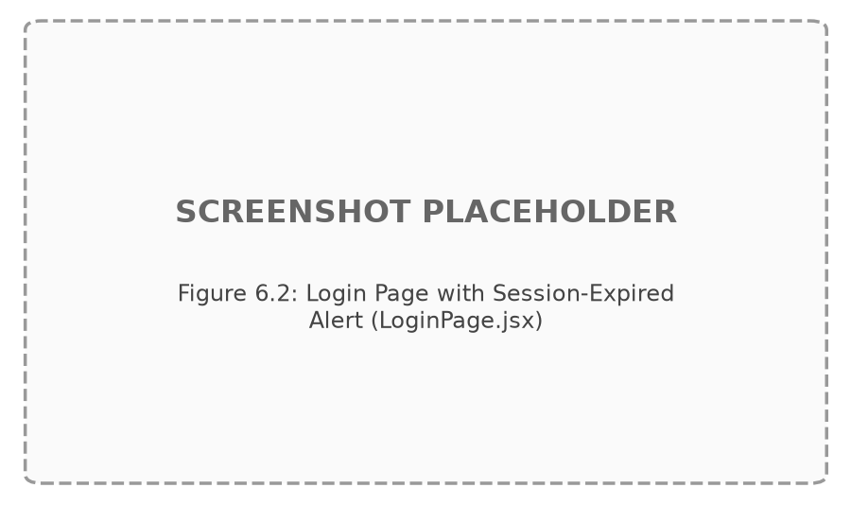
Figure 6.2: Login Page with Session-Expired Alert (LoginPage.jsx)

6.2.3 Home Page and Search Page
Property discovery begins at the home page, HomePage.jsx, whose hero section presents a search form to any visitor, authenticated or not. As soon as search criteria are entered, the page displays a live preview of matching results directly beneath the hero, capped at eight properties, with a "view all" link that carries the visitor through to the dedicated search page for the complete result set. Below the results preview, the home page also surfaces a recommendations section, presenting properties suggested to the current visitor independently of the search they have just performed.
The dedicated search page, SearchPage.jsx, expands on this with the full PropertySearchForm, exposing the complete set of search and filter controls, followed by the PropertySearchResults component rendered as a grid of property cards, and, beneath the results, a RecommendedProperties section mirroring the recommendation logic used on the home page. Together, the two pages give guests both a fast, minimal entry point for a quick search and a fuller page for browsing and refining results at length.
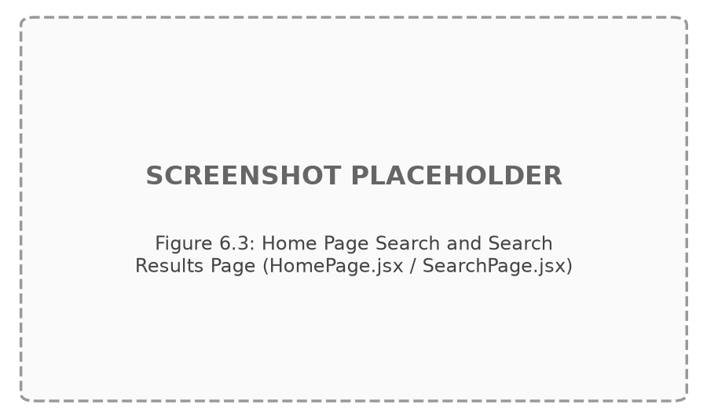
Figure 6.3: Home Page Search and Search Results Page (HomePage.jsx / SearchPage.jsx)

6.2.4 Property Detail Page
PropertyDetailPage.jsx is the most content-dense guest-facing screen in the system. At the top of the page sits an image gallery for the property, with each image showing its verification badge so that guests can see, at a glance, which photographs have passed image verification. On smaller screens, a mobile sentiment snapshot is shown near the top of the page, giving a condensed view of review sentiment before the guest scrolls further. Navigation through the page's content is assisted by a sticky section-navigation bar containing pills for "About", "Location", "Availability", and "Reviews", allowing the guest to jump directly to a section of interest.
The page body itself presents the property description, its address, and its availability date ranges, followed by the SentimentSummary component, a ReviewForm (visible only to authenticated guests), and the ReviewsList showing existing reviews. On desktop, a sticky PropertyBookingPanel remains visible alongside the content, showing the price, aggregate rating, an insight strip, and buttons to begin an online booking or submit an offline booking request; on mobile, this is replaced by a fixed bottom call-to-action bar offering the same two actions.

Figure 6.4: Property Detail Page (PropertyDetailPage.jsx)

6.2.5 Booking Creation Page
Once a guest chooses to book online from the property detail page, they arrive at BookingNewPage.jsx, the first step of the online booking flow. A BookingStepIndicator at the top of the page marks this as step one of the process, orienting the guest within the overall booking sequence. The form itself collects the intended start date, end date, and number of guests for the stay. As dates are entered, the page performs overlap validation against the property's existing bookings and availability windows, preventing the guest from proceeding with a date range that conflicts with an already-booked or unavailable period. Only once a valid, non-overlapping date range and guest count have been supplied can the guest proceed to the payment step.

Figure 6.5: Booking Creation Page (BookingNewPage.jsx)

6.2.6 Booking Payment Page
The second step of the booking flow is handled by BookingPaymentPage.jsx, again marked by the BookingStepIndicator, this time showing step two. The page presents a summary of the booking just created — the property, the selected dates, and the resulting total — so the guest can confirm the details before paying. Payment itself is initiated through a Stripe checkout button, which hands the guest off to Stripe's hosted checkout flow to complete payment for the booking. Successful completion of this step updates the underlying booking's payment status and carries the guest forward to the confirmation page.
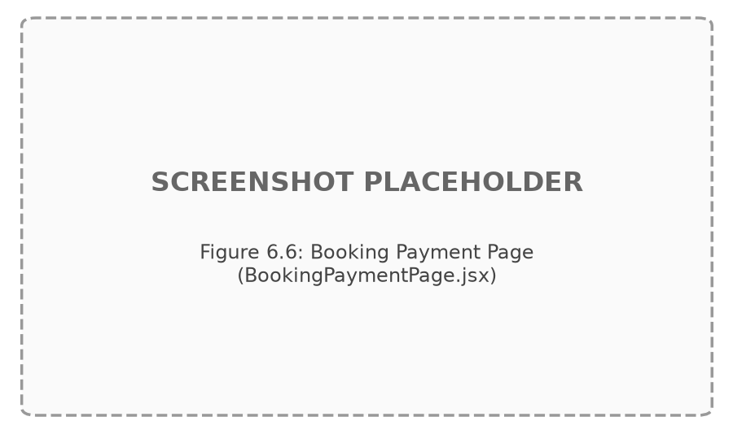
Figure 6.6: Booking Payment Page (BookingPaymentPage.jsx)

6.2.7 Booking Payment Success Page
After payment completes, the guest is directed to BookingPaymentSuccessPage.jsx, which displays a confirmation card acknowledging that the booking and payment have been completed successfully. From this page, the guest is offered links onward to their bookings list and to the review-writing flow for the property just booked, closing the loop between payment and the eventual review stage of the guest journey. This page is intentionally simple, giving the guest a clear, unambiguous endpoint to the booking transaction rather than continuing to present booking-flow controls.
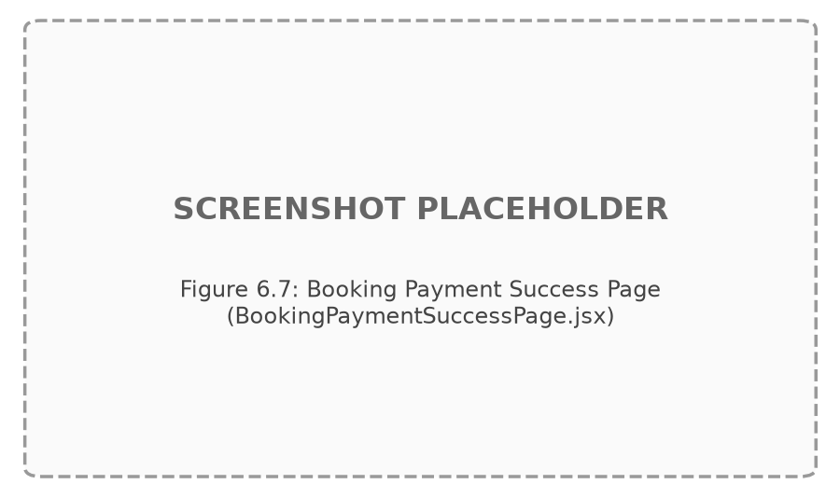
Figure 6.7: Booking Payment Success Page (BookingPaymentSuccessPage.jsx)

6.2.8 My Bookings Page
GuestBookingsPage.jsx gives a guest an overview of all of their bookings. At the top of the page, a row of stat chips summarises the guest's booking activity across four counts: total bookings, bookings pending payment, bookings that need a review, and bookings already reviewed. Below the stat chips, a set of filter chips lets the guest narrow the list down to a particular subset matching one of those categories. The bookings themselves are presented as a grid of GuestBookingCard components, each showing the property's cover image, a badge indicating the timing of the stay, the total amount paid, and contextual action buttons that let the guest complete payment or write a review directly from the card, depending on the booking's current status. This page therefore functions as the guest's central hub for tracking every stage of their bookings after they have been created.

Figure 6.8: My Bookings Page (GuestBookingsPage.jsx)

6.2.9 Offline Booking Request Page
For guests who prefer, or need, to arrange a stay without completing the online payment flow, OfflineBookingPage.jsx provides a form-based alternative. The page opens with a three-step explanation of how the offline process works, setting expectations before the guest reaches the form itself. The form collects the guest's name, phone number, location, intended start and end dates, room type, and a property selector. When the guest arrives at this page from a specific property's detail page, the property field is pre-filled automatically via a propertyId query parameter, sparing the guest from having to search for the property a second time. Once submitted, the request is queued for the property owner to review and respond to; guests can subsequently track the status of their submitted offline requests from their guest dashboard.

Figure 6.9: Offline Booking Request Page (OfflineBookingPage.jsx)

6.3 Property Owner Interface
Property owners are the second principal actor in IARS. Once registered with the "owner" role, an owner's account gives access to a distinct set of dashboard screens for creating and maintaining property listings, uploading and tracking image verification, and responding to offline booking requests submitted by guests. This section documents the four screens that make up the owner's working area.

6.3.1 Owner Dashboard
OwnerDashboard.jsx is the landing screen for an owner after login, built on the shared DashboardShell layout used across role-specific dashboards. It presents quick-link cards for the owner's three primary tasks: viewing their properties, creating a new property, and managing offline requests. Beneath these quick links, the dashboard includes a preview card of the owner's most recent offline requests, giving a snapshot of pending guest enquiries without requiring a navigation to the dedicated offline requests page. This design allows an owner to orient themselves quickly on login and to move directly to whichever task needs attention.
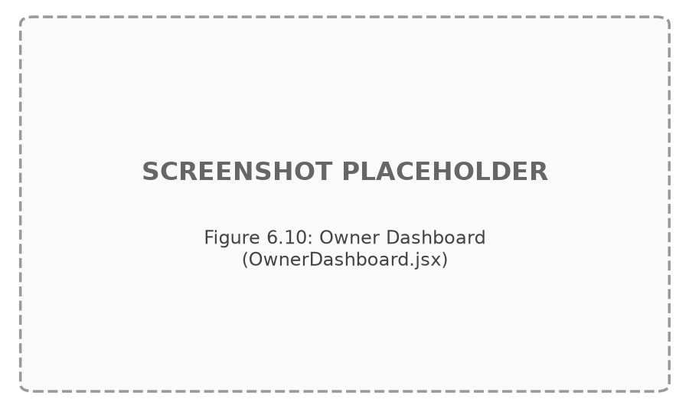
Figure 6.10: Owner Dashboard (OwnerDashboard.jsx)

6.3.2 Property Listing Management Page
OwnerPropertiesPage.jsx lists every property belonging to the signed-in owner as a set of property cards. Each card shows the property's cover image alongside two status indicators: a PropertyStatusBadge, reflecting whether the listing is pending, approved, or rejected by an administrator, and an ImageVerificationBadge, reflecting the aggregate verification state of the property's uploaded images. Where relevant, individual cards also surface contextual flags such as "waiting for approval" or "images under review", making it clear to the owner why a particular listing has not yet gone live and what, if anything, still needs to happen before it can be shown to guests. From this page, the owner can navigate onward to create a new listing or edit an existing one.

Figure 6.11: Property Listing Management Page (OwnerPropertiesPage.jsx)

6.3.3 Create and Edit Property Form
Creating a new listing (OwnerPropertyNewPage.jsx) and editing an existing one (OwnerPropertyEditPage.jsx) both rely on the same shared PropertyForm component, ensuring a consistent editing experience regardless of whether the owner is starting from scratch or revising a live listing. The form is organised into a basic information section, a location section, a dynamic set of availability-calendar rows that the owner can add to or remove as needed to describe when the property is bookable, and an image-upload section supporting up to five images per property. When editing an existing property, each uploaded image additionally displays its current per-image verification status, letting the owner see exactly which photographs have been verified, are still pending review, or have been flagged, without having to visit a separate screen.
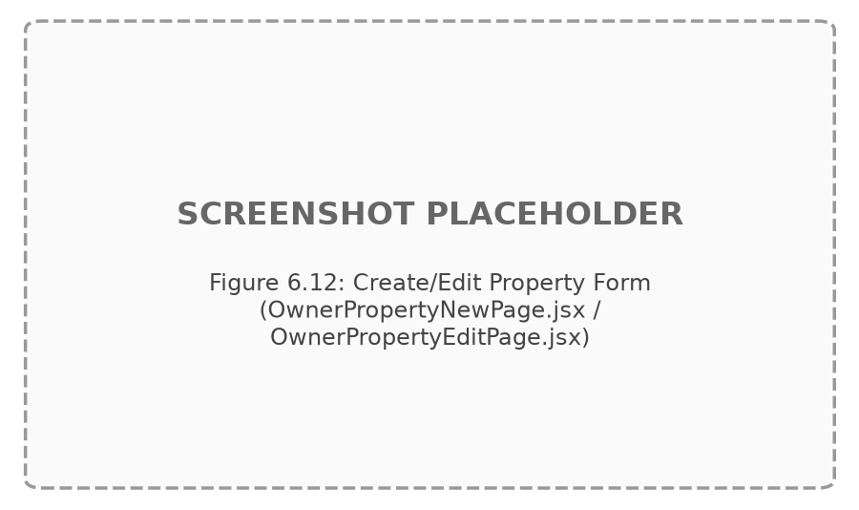
Figure 6.12: Create/Edit Property Form (OwnerPropertyNewPage.jsx / OwnerPropertyEditPage.jsx)

6.3.4 Offline Request Management Page
OwnerOfflineRequestsPage.jsx presents the owner with the list of offline booking requests submitted by guests against their properties. Each pending request in the list is paired with a response textarea, allowing the owner to type a reply directly against that request, along with respond and close actions to submit that reply or mark the request as resolved. This page gives the owner a single place to work through incoming offline enquiries sequentially, without needing to correspond with guests through any channel outside the platform.
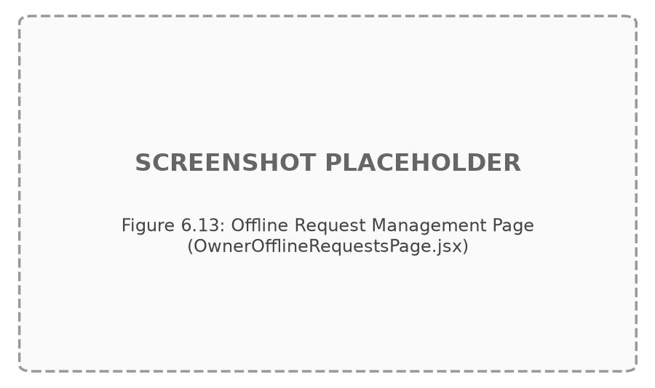
Figure 6.13: Offline Request Management Page (OwnerOfflineRequestsPage.jsx)

6.4 Administrator Interface
The administrator role oversees the integrity of the platform as a whole: approving or rejecting submitted property listings, auditing uploaded images for authenticity, and managing user accounts. The four administrator screens described in this section are reached from the admin dashboard and share the same DashboardLayout sidebar navigation used by the other authenticated roles.

6.4.1 Admin Dashboard
AdminDashboard.jsx presents the administrator with three static task cards on login: Moderate Listings, Manage Users, and Image Audit. Rather than surfacing dynamic counts or previews, this dashboard acts as a simple, direct entry point into each of the administrator's three areas of responsibility, keeping the landing screen uncluttered and directing the administrator's attention to the specific workflow they intend to carry out next.
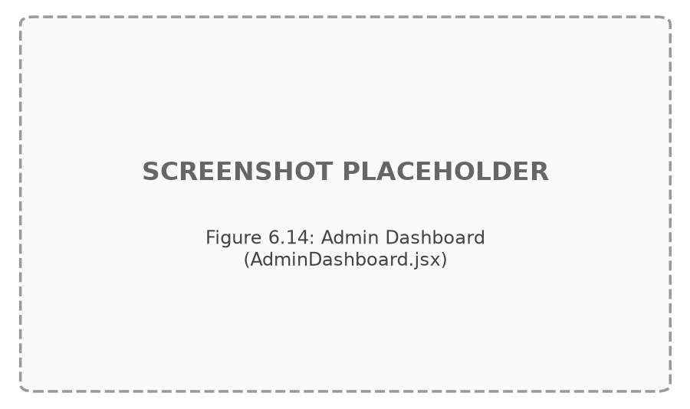
Figure 6.14: Admin Dashboard (AdminDashboard.jsx)

6.4.2 Listing Moderation Page
AdminListingsPage.jsx presents the properties awaiting moderation in a pending-listings table or card list. Selecting a listing opens a detail panel showing its images together with their AI-generated verification scores, giving the administrator the evidence needed to make an approval decision. An Approve action is available from this panel, but it is deliberately blocked if the property has no verified image at all, and it triggers a confirmation dialog if any of the property's images remain unverified, ensuring that an administrator cannot approve a listing without at least being warned about, or prevented from proceeding past, unresolved image-verification concerns. A Reject action is also available for listings the administrator decides not to approve. This gate ties the listing-approval workflow directly to the outcome of image verification rather than treating the two as independent processes.

Figure 6.15: Listing Moderation Page (AdminListingsPage.jsx)

6.4.3 Image Audit Page
AdminImageAuditPage.jsx, together with its ImageAuditPropertyGroup component, organises every uploaded property image into groups by property, so the administrator reviews photographs in the context of the listing they belong to rather than as an undifferentiated stream. An ImageAuditStatsBar sits above the grouped grid, offering filters for all, pending, verified, suspicious, and rejected images, so the administrator can focus on a particular subset of the image pool at a time. Each image in the grid is shown with an AiScoreMeter reflecting its automated verification score, alongside quick-action buttons allowing the administrator to mark the image as Verify, Suspicious, or Reject directly from the grid, without opening a separate detail view for each photograph.

Figure 6.16: Image Audit Page (AdminImageAuditPage.jsx)

6.4.4 User Management Page
AdminUsersPage.jsx lists the platform's registered users, with role filter chips at the top of the page allowing the administrator to narrow the list to guests, owners, or administrators. Against each user, a verify or unverify toggle lets the administrator change that user's verification state directly from the list, without a separate edit screen. This page gives the administrator a compact but complete view of the user base and the single action — verification status — that they are responsible for managing over it.

Figure 6.17: User Management Page (AdminUsersPage.jsx)

6.5 Multilingual and Theming Interface Elements
Two controls recur identically across every authenticated and public screen in IARS: the language switcher and the theme toggle. For unauthenticated and public pages, both controls are located in the Navbar, alongside the application logo, the Home and Search navigation links, and — depending on whether the visitor is signed in — either Dashboard, Login, and Register links, or a user menu with a logout option. For authenticated, role-specific screens, the same two controls reappear inside the DashboardLayout sidebar, positioned alongside a card showing the signed-in user's information and the sidebar's own logout action. Placing the language switcher and theme toggle in both navigation contexts ensures that a user is never more than one click away from changing either setting, regardless of which part of the application they are currently using.
The language switcher allows selection between English, Urdu, and Arabic. English is the default language for the interface, and its layout reads left to right. Selecting Urdu or Arabic switches the entire page to a right-to-left reading direction: navigation links, sidebar items, form labels and their associated inputs, and card content all mirror their horizontal ordering so that the natural reading flow of the selected language is preserved. Rather than relying on layout classes that hardcode a left or right position, the interface's components are built using direction-aware alignment such as start- and end-based positioning, which is what allows this mirroring to happen consistently across forms, tables, dashboards, the navbar, and the footer without any single component needing special-case logic for a particular language.
The theme toggle switches the interface between a light and a dark visual theme. This setting is independent of the language selection, so any of the three supported languages can be viewed in either theme. Because both controls are implemented once, in the shared navbar and sidebar components, their behaviour is uniform everywhere in the application — a change made on one screen persists as the user navigates to the next.
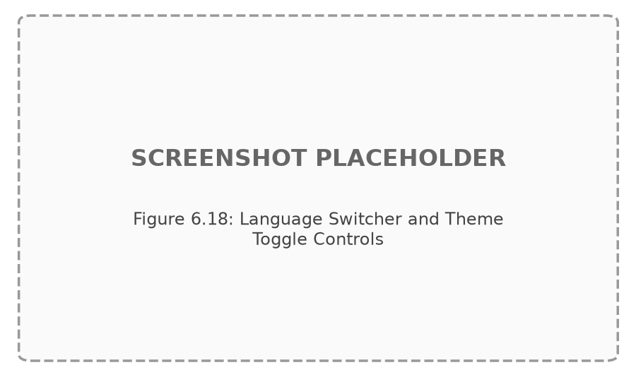
Figure 6.18: Language Switcher and Theme Toggle Controls

6.6 Chapter Summary
This chapter has walked through every screen implemented in the IARS client application, organised by the three user roles the system serves. The guest interface takes a visitor from registration through search, property inspection, booking, payment, and post-stay review, with an offline form-based alternative available at every point where online payment is not the preferred path. The owner interface gives property owners a focused set of screens for managing listings, image uploads, and offline enquiries, while the administrator interface concentrates on listing moderation, image auditing, and user management. Running beneath all of these role-specific screens are the shared language and theming controls, which extend consistent multilingual, right-to-left-aware, and light/dark presentation to the entire application. Having now completed the functional description of the system from the perspective of each user role, alongside the requirements, design, implementation, and testing evidence presented in the preceding chapters, the dissertation turns to its closing reference material: Chapter 7 lists the sources consulted during the project, and the appendices that follow provide supporting technical detail, including environment setup instructions, the full API and database reference, sentiment-model configuration, additional screenshots, and the complete test execution log.

CHAPTER 7
REFERENCES
[1] Airbnb, Inc., "Airbnb — Vacation Rentals, Cabins, Beach Houses & More," Online: https://www.airbnb.com.
[2] Booking Holdings Inc., "Booking.com — Hotels, Homes & Much More," Online: https://www.booking.com.
[3] Wego Pte. Ltd., "Wego — Compare Flights and Hotels," Online: https://www.wego.com.
[4] F. Pedregosa et al., "Scikit-learn: Machine Learning in Python," Journal of Machine Learning Research, vol. 12, pp. 2825-2830, 2011.
[5] S. Wang and C. D. Manning, "Baselines and Bigrams: Simple, Good Sentiment and Topic Classification," in Proc. 50th Annual Meeting of the Association for Computational Linguistics, 2012.
[6] B. Pang and L. Lee, "Opinion Mining and Sentiment Analysis," Foundations and Trends in Information Retrieval, vol. 2, no. 1-2, pp. 1-135, 2008.
[7] B. Liu, "Sentiment Analysis and Opinion Mining," Synthesis Lectures on Human Language Technologies, Morgan & Claypool Publishers, 2012.
[8] D. Chakrabarti, R. Kumar, and K. Punera, "A Bayesian Approach to Ranking with Aggregate Feedback," Yahoo! Research Technical Report, 2008 (basis for Bayesian-average quality smoothing).
[9] G. Adomavicius and A. Tuzhilin, "Toward the Next Generation of Recommender Systems: A Survey of the State-of-the-Art and Possible Extensions," IEEE Transactions on Knowledge and Data Engineering, vol. 17, no. 6, pp. 734-749, 2005.
[10] F. Ricci, L. Rokach, and B. Shapira, "Recommender Systems Handbook," 2nd ed., Springer, 2015.
[11] X. Su and T. M. Khoshgoftaar, "A Survey of Collaborative Filtering Techniques," Advances in Artificial Intelligence, vol. 2009, Article ID 421425, 2009.
[12] Stripe, Inc., "Stripe API Reference — Checkout Sessions," Online: https://stripe.com/docs/api/checkout/sessions.
[13] MongoDB, Inc., "MongoDB Manual," Online: https://www.mongodb.com/docs/manual/.
[14] Mongoose OS Contributors, "Mongoose — Elegant MongoDB Object Modeling for Node.js," Online: https://mongoosejs.com/docs/.
[15] OpenJS Foundation, "Express.js — Fast, Unopinionated, Minimalist Web Framework for Node.js," Online: https://expressjs.com/.
[16] Meta Platforms, Inc., "React — The Library for Web and Native User Interfaces," Online: https://react.dev/.
[17] i18next Contributors, "i18next — Internationalization Framework for JavaScript," Online: https://www.i18next.com/.
[18] W3C, "Structural Markup and Right-to-Left Text in HTML," Online: https://www.w3.org/International/questions/qa-html-dir.
[19] Tiangolo (S. Ramirez), "FastAPI — Modern, Fast (High-Performance) Web Framework for Building APIs with Python," Online: https://fastapi.tiangolo.com/.
[20] JSON Web Token Working Group, "RFC 7519 — JSON Web Token (JWT)," IETF, 2015. Online: https://www.rfc-editor.org/rfc/rfc7519.
[21] N. Provos and D. Mazieres, "bcrypt: A Future-Adaptable Password Scheme," in Proc. USENIX Annual Technical Conference, 1999.

APPENDICES

Appendix A: Environment Setup and Installation Guide
Appendix A describes how to configure and run the three IARS services locally: the React client, the Express/MongoDB API server, and the Python sentiment microservice.

A.1 Prerequisites
Node.js (v18 or later), npm, Python 3.10 or later, and a running MongoDB instance (local or a connection string to a hosted instance) are required. A Stripe test-mode account (publishable and secret keys beginning with pk_test_/sk_test_) is required for the payment flow.

A.2 Environment Variables (server/.env)
Table A.1: Server Environment Variables
Variable | Purpose
PORT | Port on which the Express API listens (default 5000)
MONGO_URI | MongoDB connection string
CLIENT_URL | Origin allowed by the CORS configuration
SENTIMENT_API_URL | Base URL of the Python sentiment microservice (default http://localhost:8000)
JWT_SECRET | Secret key used to sign JSON Web Tokens
JWT_EXPIRES_IN | Token expiry duration (e.g. 7d)
STRIPE_SECRET_KEY | Stripe secret key (must begin with sk_test_)
STRIPE_WEBHOOK_SECRET | Secret used to verify incoming Stripe webhook signatures
ADMIN_EMAIL / ADMIN_PASSWORD | Seed credentials consumed by server/scripts/seed.js to create the initial administrator account

A.3 Running the Services
Each service is started independently during development: npm install && npm run dev inside server/ starts the Express API; npm install && npm run dev inside client/ starts the Vite development server; and pip install -r requirements.txt followed by uvicorn app.main:app --reload --port 8000 (or the project's equivalent entry point) inside sentiment-service/ starts the FastAPI microservice. The database can be populated with sample data using the scripts in server/scripts/ (seed.js for the administrator account, seedProperties.js for sample listings, and seedDemoReviews.js for sample reviews).

Appendix B: Full API Endpoint Reference
Appendix B consolidates every REST endpoint exposed by the Express API server, grouped by route file, exactly as documented in Chapter 3.
Table B.1: Authentication Endpoints (/api/auth)
Method | Endpoint | Access | Description
POST | /api/auth/register | Public | Register a new guest or owner account
POST | /api/auth/login | Public | Authenticate and receive a JWT
GET | /api/auth/me | Protected | Retrieve the authenticated user's profile

Table B.2: Property Endpoints (/api/properties)
Method | Endpoint | Access | Description
GET | /api/properties | Public | List approved properties
GET | /api/properties/owner/my-properties | Owner | List the authenticated owner's properties
POST | /api/properties | Owner | Create a property listing with images
PUT | /api/properties/:id | Owner | Edit an existing property listing
PUT | /api/properties/:id/moderate | Admin | Simple approve/reject without the verified-image gate
POST | /api/properties/:id/view | Guest | Record a property view for recommendations
GET | /api/properties/:id | Optional auth | Retrieve full property detail

Table B.3: Admin Endpoints (/api/admin)
Method | Endpoint | Access | Description
GET | /api/admin/users | Admin | List users, optionally filtered by role
PUT | /api/admin/users/:id/verify | Admin | Toggle a user's verification flag
PUT | /api/admin/users/:id/role | Admin | Change a user's role
GET | /api/admin/image-audit | Admin | List all property images for audit
PUT | /api/admin/image-audit/:propertyId/:imageId | Admin | Update an image's verification status/score
GET | /api/admin/listings/pending | Admin | List listings awaiting approval
PUT | /api/admin/listings/:id/approve | Admin | Approve a listing (requires >=1 verified image)
PUT | /api/admin/listings/:id/reject | Admin | Reject a listing

Table B.4: Search and Recommendation Endpoints
Method | Endpoint | Access | Description
GET | /api/search | Optional auth | Search/filter approved properties, records SearchHistory
GET | /api/recommendations | Optional auth | Retrieve cold-start or personalized recommendations

Table B.5: Review and Sentiment Endpoints
Method | Endpoint | Access | Description
POST | /api/reviews | Guest | Submit a review, triggers sentiment classification
GET | /api/reviews/property/:propertyId | Public | List reviews for a property
GET | /api/reviews/eligible/:propertyId | Guest | List bookings eligible for a review
GET | /api/sentiment/property/:propertyId | Public | Retrieve the property's aggregated sentiment snapshot

Table B.6: Booking Endpoints (/api/bookings)
Method | Endpoint | Access | Description
POST | /api/bookings | Guest | Create a booking (availability/overlap checked)
GET | /api/bookings/my-bookings | Guest | List the guest's own bookings
GET | /api/bookings/owner-bookings | Owner | List bookings on the owner's properties
PUT | /api/bookings/:id/confirm-demo-payment | Guest | Backend demo-payment confirmation (no frontend control)
PUT | /api/bookings/:id/cancel | Guest | Cancel a booking
GET | /api/bookings/:id | Guest/Owner | Retrieve a single booking

Table B.7: Payment Endpoints (/api/payments/stripe)
Method | Endpoint | Access | Description
POST | /api/payments/stripe/create-checkout-session | Guest | Create a Stripe test-mode Checkout Session
GET | /api/payments/stripe/verify-session | Guest | Verify a completed Checkout Session
POST | /api/payments/stripe/webhook | Stripe (signed) | Handle asynchronous payment-confirmation events

Table B.8: Offline Request Endpoints (/api/offline-requests)
Method | Endpoint | Access | Description
POST | /api/offline-requests | Optional auth | Submit an offline booking request (anonymous allowed)
GET | /api/offline-requests/guest | Guest | List the guest's own offline requests
GET | /api/offline-requests/owner | Owner | List offline requests on the owner's properties
PUT | /api/offline-requests/:id/respond | Owner | Respond to and close/keep open an offline request

Appendix C: Complete Database Schema Listing
Appendix C lists the complete field set of each of the seven Mongoose schemas that make up the IARS database, supplementing the data dictionary presented in Chapter 3.
Table C.1: User Schema — Complete Field Listing
Field | Type | Notes
name | String | Required
email | String | Required, unique, lowercase
phone | String | Optional
password | String | Required, min length 6, select:false, bcrypt-hashed
role | String (enum) | guest \ | owner \ | admin, default guest
languagePref | String | Default "en"
isVerified | Boolean | Default false
createdAt / updatedAt | Date | Mongoose timestamps

Table C.2: Property Schema — Complete Field Listing
Field | Type | Notes
title | String | Required
description | String | Required
location.address / city / country | String | Required sub-schema
price | Number | Minimum 0
owner | ObjectId (ref User) | Required
images[].url / verificationStatus / aiScore / hash / uploadedAt | Embedded array | verificationStatus enum pending\ | verified\ | suspicious\ | rejected
availabilityCalendar[] | Mixed array | {startDate, endDate} pairs
status | String (enum) | pending \ | approved \ | rejected
sentimentSnapshot | Embedded object | totalReviews, positiveCount, negativeCount, neutralCount, mixedCount, positivePercent, averageRating, aspectBreakdown[], praisedAspects[], concernAspects[], insightType, topPraisedAspect, updatedAt

Table C.3: Booking Schema — Complete Field Listing
Field | Type | Notes
guest | ObjectId (ref User) | Required
property | ObjectId (ref Property) | Required
startDate / endDate | String (ISO date) | Required
guests | Number | Minimum 1
totalAmount | Number | Minimum 0
status | String (enum) | pending \ | confirmed \ | cancelled
paymentStatus | String (enum) | pending \ | confirmed \ | failed
paymentMethod | String (enum) | demo \ | stripe_test
stripeSessionId / stripePaymentIntentId | String | Populated during Stripe checkout
paymentConfirmedAt | Date | Set when payment is confirmed

Table C.4: Review Schema — Complete Field Listing
Field | Type | Notes
guest | ObjectId (ref User) | Required
property | ObjectId (ref Property) | Required
booking | ObjectId (ref Booking) | Required, unique index (one review per booking)
rating | Number | 1 to 5
text | String | Maximum 1000 characters
sentiment | String (enum) | positive \ | negative \ | neutral \ | mixed
sentimentScore | Number | Classifier confidence
aspects[] | String array | Detected aspect categories
aspectInsights[] | Embedded array | {aspect, sentiment, confidence, mentions}
summary | String | Human-readable sentiment summary

Table C.5: OfflineRequest Schema — Complete Field Listing
Field | Type | Notes
guestName / phone / location / roomType | String | Required
startDate / endDate | String | Required
property | ObjectId (ref Property) | Nullable
guest | ObjectId (ref User) | Nullable (anonymous submissions)
responseMessage | String | Default empty string
status | String (enum) | pending \ | responded \ | closed

Table C.6: PropertyView Schema — Complete Field Listing
Field | Type | Notes
user | ObjectId (ref User) | Indexed
property | ObjectId (ref Property) | Indexed
viewedAt | Date | Unique compound index with user; capped at 50 per user

Table C.7: SearchHistory Schema — Complete Field Listing
Field | Type | Notes
user | ObjectId (ref User) | Indexed
city / title | String | Optional filters
minPrice / maxPrice | Number | Optional filters
availabilityDate | String | Optional filter, capped at 20 entries per user

Appendix D: Sentiment Model and Training Data Details
Appendix D summarises the configuration of the sentiment-classification pipeline hosted by the Python microservice.

D.1 Pipeline Configuration
Table D.1: Sentiment Pipeline Configuration
Parameter | Value
Vectorizer | TF-IDF, n-gram range (1,3)
Classifier | Logistic Regression, class_weight="balanced"
Serialization | joblib
Serving framework | FastAPI (Uvicorn)
Endpoint | POST /predict
Clause splitting | Sentence and contrast-conjunction ("but", "however", "although") based
Negation override | Rule-based pattern match forcing negative classification on negated positive phrases

D.2 Aspect Categories
Table D.2: Aspect Detection Categories
Aspect | Example Keywords
Cleanliness | clean, dirty, spotless, hygiene, dusty
Staff | staff, service, receptionist, helpful, rude
Location | location, nearby, central, access, distance
Room | room, bed, spacious, comfortable, small
Wifi | wifi, internet, connection, network
Value | price, value, worth, expensive, cheap
Facilities | facilities, pool, gym, parking, amenities
Food | food, breakfast, restaurant, meal, taste
Noise | noise, quiet, loud, traffic, peaceful

Appendix E: Additional UI Screenshots
Appendix E reserves space for additional interface screenshots beyond those included in Chapter 6, to be attached once the application is captured running against a live, seeded MongoDB instance and a running sentiment microservice. Recommended additional captures include the mobile-responsive layouts of the property detail page, the Urdu and Arabic right-to-left renderings of the guest dashboard, and the admin image-audit grid with a mixed set of verified, suspicious, and rejected images.

Appendix F: Full Test Case Execution Log
Appendix F expands Table 4.21 (Summary of Test Case Execution Results) with space for the date of execution and tester notes, for use during a live demonstration or formal test sign-off.
Table F.1: Full Test Case Execution Log Template
Test Case ID | Feature | Date Executed | Executed By | Result | Notes
TC-01 | User Registration (Guest)
TC-02 | User Registration (Owner)
TC-03 | Valid Login
TC-04 | Invalid Login Attempt
TC-05 | Property Search by City
TC-06 | Property Search with Price Filter
TC-07 | Property Listing Creation with Images
TC-08 | Duplicate Image Detection
TC-09 | Booking Creation — Available Dates
TC-10 | Booking Creation — Overlapping Dates Rejected
TC-11 | Stripe Test Payment Success
TC-12 | Booking Cancellation
TC-13 | Review Submission and Sentiment Classification
TC-14 | Duplicate Review Prevention
TC-15 | Offline Booking Request Submission
TC-16 | Owner Response to Offline Request
TC-17 | Cold-Start Recommendation Display
TC-18 | Personalized Recommendation Display
TC-19 | Admin Listing Approval Blocked Without Verified Image
TC-20 | Language Switch to Urdu (RTL Layout)

