

College of Engineering

CMP 433: Artificial Intelligence

Project 2

Angie Guirguis 69678

Abdullah Siddiqui 75201

Asif Rasheed 73877

Date of Submission: 20/04/2020

Prof. Michel Pasquier

Sculptures Puzzle:

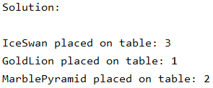

Map Colouring:

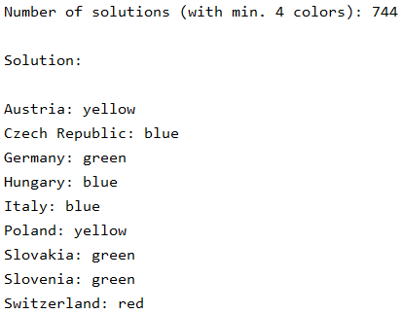

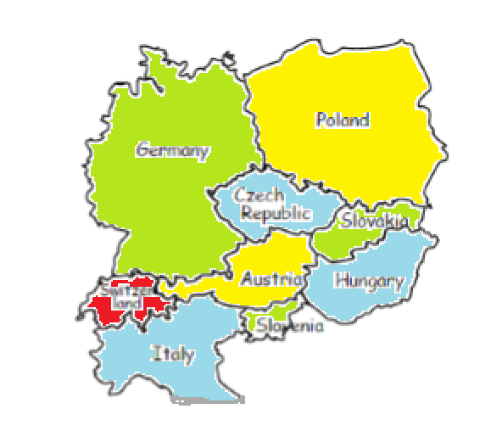

Magic Triangle:

==========MAGIC TRIANGLE WITH 6 CIRCLES==========

Total Number of Possible Solutions for Sum 9 : 6

1

6 5

2 4 3

Total Number of Possible Solutions for Sum 10 : 6

1

6 4

3 2 5

Total Number of Possible Solutions for Sum 11 : 6

2

5 3

4 1 6

Total Number of Possible Solutions for Sum 12 : 6

4

3 2

5 1 6

==========MAGIC TRIANGLE WITH 9 CIRCLES==========

Total Number of Possible Solutions for Sum 17 : 96

1

7 9

6 5

3 4 8 2

Total Number of Possible Solutions for Sum 18 : 0

Total Number of Possible Solutions for Sum 19 : 192

1

9 8

2 6

7 3 5 4

Total Number of Possible Solutions for Sum 20 : 288

1

3 8

7 6

9 2 4 5

Total Number of Possible Solutions for Sum 21 : 192

3

8 7

1 5

9 4 2 6

Total Number of Possible Solutions for Sum 22 : 0

Total Number of Possible Solutions for Sum 23 : 96

7

1 5

6 3

9 4 2 8

Interview Scheduling:

Possible Schedules (without considering preferences):

Ali: 3pm, Dan: 4pm, Bob: 2pm, Cyl: 1pm

Ali: 3pm, Dan: 4pm, Bob: 1pm, Cyl: 2pm

Ali: 1pm, Dan: 4pm, Bob: 3pm, Cyl: 2pm

Ali: 1pm, Dan: 4pm, Bob: 2pm, Cyl: 3pm

Ali: 4pm, Dan: 1pm, Bob: 3pm, Cyl: 2pm

Ali: 4pm, Dan: 1pm, Bob: 2pm, Cyl: 3pm

Possible Schedules (considering preferences):

Ali: 3pm, Dan: 4pm, Bob: 2pm, Cyl: 1pm

N-queens Problem:

Total Time Taken to Solve The Puzzle using Incremental Approach:

N Time

1 2.3371000000008135e-05 seconds

2 4.913100000000781e-05 seconds

3 0.0008592300000000025 seconds

4 0.00031269700000000067 seconds

5 0.0011110440000000055 seconds

6 0.003081575000000003 seconds

7 0.009248712000000006 seconds

8 0.03263041499999998 seconds

9 0.13365099900000002 seconds

10 0.54464855 seconds

11 2.487988716 seconds

Total Time Taken to Solve The Puzzles using Iterative Approach:

N Time

1 2.103500000005809e-05 seconds

2 0.0094221219999997 seconds

3 0.020712400999999936 seconds

4 8.399099999989446e-05 seconds

5 0.0003974289999999492 seconds

6 0.015104349000000017 seconds

7 0.0010629039999998646 seconds

8 0.0019268430000001224 seconds

9 0.002019263999999854 seconds

10 0.028752294999999872 seconds

11 0.04186327700000003 seconds

12 0.01698382899999995 seconds

13 0.0169329760000001 seconds

14 0.004180776000000108 seconds

15 0.02259080899999999 seconds

16 0.005204202999999907 seconds

17 0.03632674700000038 seconds

18 0.007194372999999921 seconds

19 0.022679201000000315 seconds

20 0.025797241999999887 seconds

21 0.02699811200000024 seconds

22 0.020451883000000226 seconds

23 0.02705965400000032 seconds

24 0.02574565799999995 seconds

25 0.02794587400000026 seconds

26 0.08964904199999957 seconds

27 0.058223217000000105 seconds

28 0.04280762699999974 seconds

29 0.1322688379999999 seconds

30 0.03705479100000009 seconds

31 0.03482538400000035 seconds

32 0.12138586100000026 seconds

33 0.12815878000000058 seconds

34 0.11746173099999968 seconds

35 0.0600514040000002 seconds

36 0.18561328899999996 seconds

37 0.07623179099999966 seconds

38 0.08188486500000014 seconds

39 0.09490433900000017 seconds

40 0.06717827800000009 seconds

41 0.06495234199999977 seconds

42 0.06124093500000072 seconds

43 0.1468476609999998 seconds

44 0.13175180899999983 seconds

45 0.13727772500000057 seconds

46 0.15064574800000052 seconds

47 0.12431692999999999 seconds

48 0.14767663399999975 seconds

49 0.16486102999999996 seconds

50 0.27043706799999967 seconds

51 0.18592784500000015 seconds

52 0.22679932999999952 seconds

53 0.2212521540000001 seconds

54 0.1927557870000003 seconds

55 0.2750190529999994 seconds

56 0.22266184000000067 seconds

57 0.29603683599999986 seconds

58 0.31005612900000123 seconds

59 0.3230539220000015 seconds

60 0.25084463600000007 seconds

61 0.3392691439999993 seconds

62 0.33604657499999924 seconds

63 0.7532186789999997 seconds

64 0.44643853300000025 seconds

65 0.35356152900000026 seconds

66 0.6162353090000003 seconds

67 0.6032740749999999 seconds

68 0.34435570700000007 seconds

69 0.4170964640000001 seconds

70 0.38254283099999853 seconds

71 0.423679967 seconds

72 0.6966675879999986 seconds

73 0.7194132060000005 seconds

74 0.45887513999999996 seconds

75 0.4907934360000006 seconds

76 0.8054736720000015 seconds

77 0.5115290469999998 seconds

78 0.6963483440000005 seconds

79 0.8460636500000014 seconds

80 0.5496500330000025 seconds

81 0.9400963000000004 seconds

82 0.8933374769999993 seconds

83 0.8480566849999995 seconds

84 0.8514531729999995 seconds

85 0.5556702589999993 seconds

86 1.0352704740000007 seconds

Cross Number Grid Generator:

Number 1(Down): 78643

Number 2(Down): 7387

Number 3(Across): 83445

Number 4(Down): 88012

Number 5(Across): 873

Number 5(Down): 891825

Number 6(Down): 43

Number 7(Down): 8806

Number 8(Across): 919

Number 9(Across): 4658879

Number 10(Down): 55