5.)

**SGD:**

**a. Coefficient obtained for SGD:** 1.44892797

**b. Intercept obtained for SGD:** 68.92448172

**c. RMSE, RSE and R2 score for SGD:**

**Root Mean squared error (RMSE) is:** 2.447989270662575

**RSE - Residual Squared Error is:** 2.4502632974145717

**R2 score is:** 0.2436950747544867

**Mini batch gradient descent:**

**d. Coefficient obtained for mini batch:** 1.63541422

**e. Intercept obtained for mini batch:** 68.72704713

**f. RMSE, RSE and R2 score for mini batch:**

**Root Mean squared error (RMSE) is:** 2.44658799716723

**RSE - Residual Squared Error is:** 2.448860722225037

**R2 score is:** 0.377793399967883

**Gradient descent:**

**g. Coefficient obtained for gradient descent:** 1.29564938

**h. Intercept obtained for gradient descent:** 68.72168382

**i. RMSE, RSE and R2 score for gradient descent:**

**Root Mean squared error (RMSE) is:** 2.4388755072114656

**RSE - Residual Squared Error is:** 2.4411410678553183

**R2 score is:** 0.26633213741382733

Please find the snapshots for the same :

SGD:

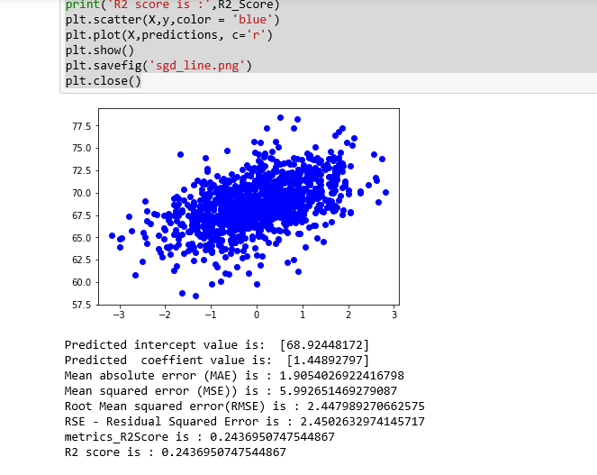

Mini – batch Gradient descent:

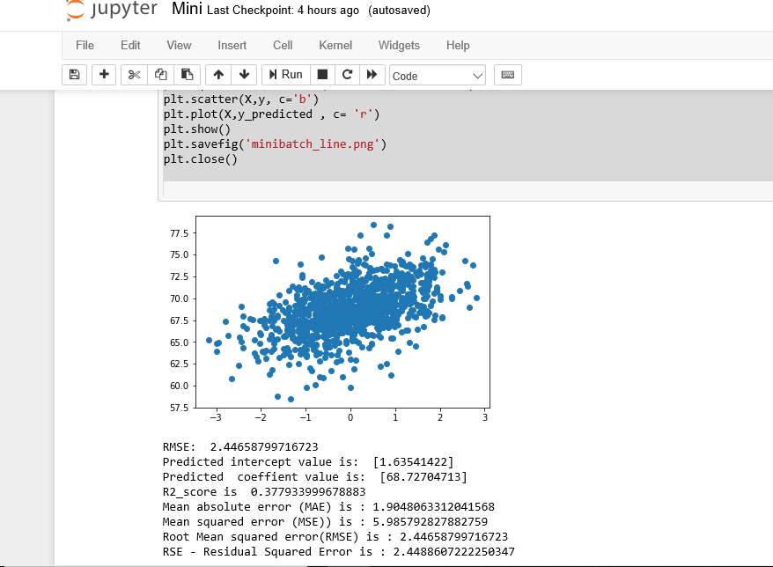

For Gradient descent :

