Stage 1 – Beginner (DOM Basics + Styling)
Goal → Get comfortable with HTML structure, CSS styling, and basic JS events.
Focus → Buttons, forms, text updates, and styling changes.
- Digital Clock
  - Show current time, update every second.
  - Learn setInterval() + DOM text updates.
- Color Theme Changer
  - Button changes background color randomly.
  - Practice Math.random() and CSS changes via JS.
- Basic Calculator
  - +, −, ×, ÷ with buttons.
  - Learn event listeners & basic math logic.

Stage 2 – Beginner-Intermediate (DOM Manipulation + localStorage)
Goal → Create dynamic elements and store data locally.
Focus → Adding/removing DOM elements, saving data.
- To-Do List
  - Add/remove tasks.
  - Save tasks in localStorage.
- Quiz App
  - Multiple-choice questions.
  - Score at the end.
- Image Slider
  - Buttons to move left/right between images.
  - Practice changing src dynamically.

Stage 3 – Intermediate (Fetch API + Async/Await)
Goal → Work with real-world data from APIs.
Focus → fetch(), JSON parsing, async/await.
- Weather App
  - Search city → get weather from API.
  - Show temp, conditions, icon.
- Movie Search App
  - Search movies from OMDb API.
  - Show poster, rating, release date.
- Recipe Finder
  - Search food → get recipes from API.
  - Show image + ingredients.

Stage 4 – Advanced (Complex UI + State Management)
Goal → Build multi-feature apps.
Focus → Multiple pages, drag-and-drop, data storage.
- Expense Tracker
  - Add incomes/expenses, calculate balance.
  - Store in localStorage.
- Kanban Board
  - Drag & drop tasks between columns.
  - Save layout in localStorage.
- E-Commerce Product Page
  - Show products from API.
  - Add to cart, calculate total, store in localStorage.

Stage 5 – Portfolio Level (Real-World Simulation)
Goal → Combine everything (HTML, CSS, JS, APIs, storage, responsive design).
Focus → Smooth animations, error handling, real use-case.
- Portfolio Website
  - Your bio, projects, and contact form.
- Chat App (Local)
  - Messages appear instantly between two mock users.
- Travel Planner
  - Choose locations, fetch info from API, store trips.

💡 Learning Path Rule:
- Each project must add one new skill on top of what you already know.
- Don’t jump to APIs before mastering DOM events.
- Keep improving one project instead of making many unfinished ones.

If you want, I can make you a 90-day HTML, CSS, JS learning plan where you build these projects in a specific order with deadlines and practice goals. That way, you’ll go from basic to advanced smoothly.


🔄 What is Event Bubbling in JavaScript?
Event bubbling is how events move from the innermost element up to the outermost (parent → grandparent → ...).

🧠 Simple Definition:
When you click on an element, the event first runs on the clicked element, then "bubbles up" to its parents (and their parents...).

🔍 Visual Example (HTML):
<div id="outer">
<div id="inner">
<button id="btn">Click Me</button>
</div>
</div>

💻 JavaScript:
document.getElementById("btn").addEventListener("click", () => {
console.log("Button clicked");
});

document.getElementById("inner").addEventListener("click", () => {
console.log("Inner DIV clicked");
});

document.getElementById("outer").addEventListener("click", () => {
console.log("Outer DIV clicked");
});

🧾 Output (if you click the button):
Button clicked
Inner DIV clicked
Outer DIV clicked
This is bubbling: The event goes upward, from child to parent.

🔁 Summary Table:
Feature | Description
Starts from | Target element (e.g., button)
Moves to | Parent → Grandparent → Document (upward)
Default behavior | Yes, unless you stop it manually
Stop it with | event.stopPropagation()

⛔ Stop Event Bubbling:
button.addEventListener("click", function(event) {
event.stopPropagation(); // stops bubbling here
console.log("Button only");
});

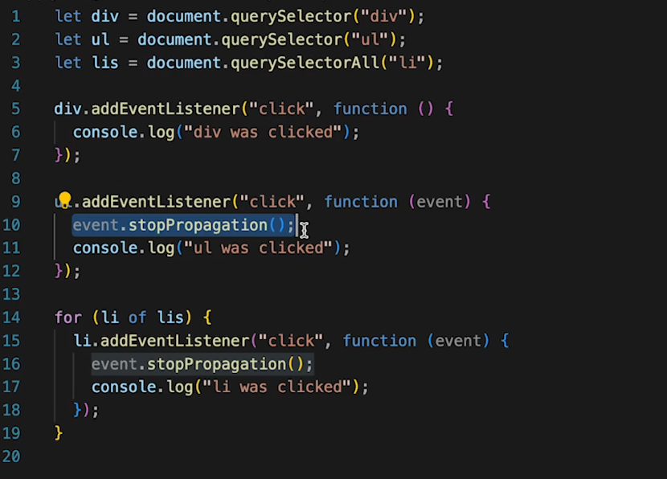
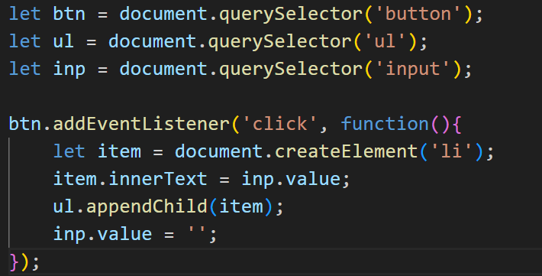
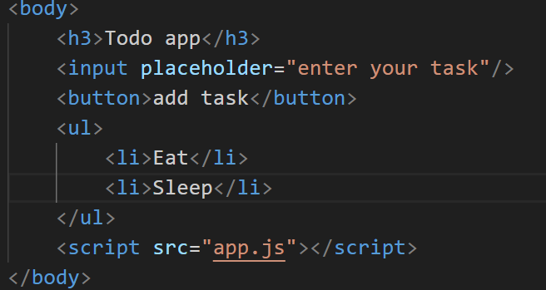
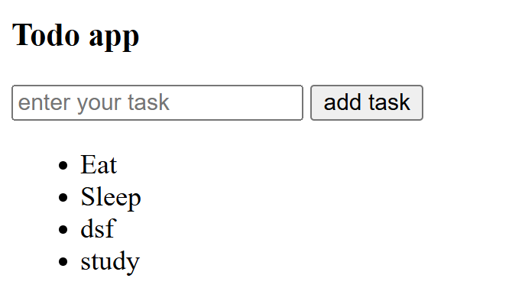
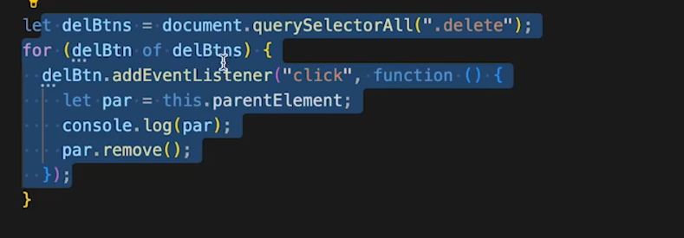
This is for delete item but not apply for new element so therefore we use Event Delegation

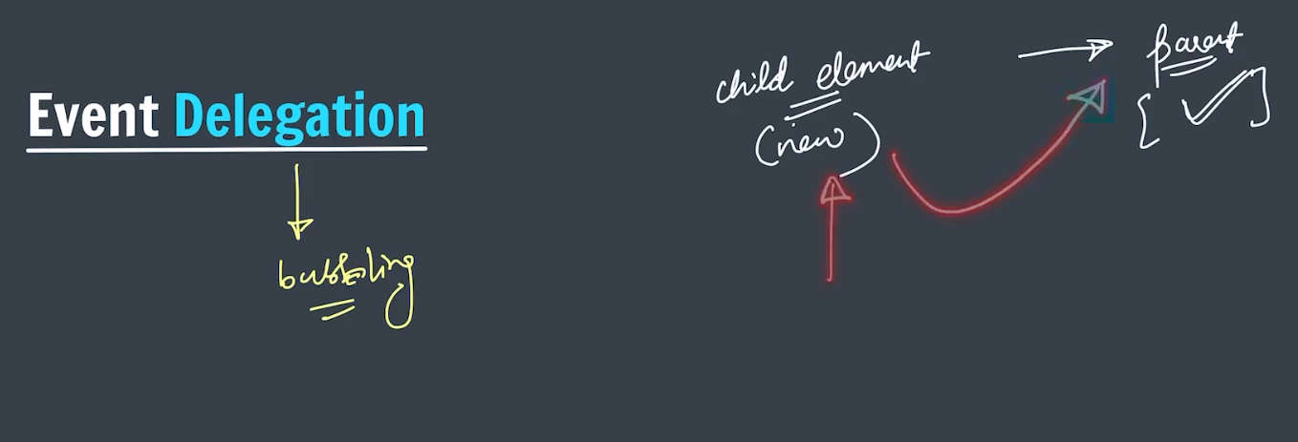
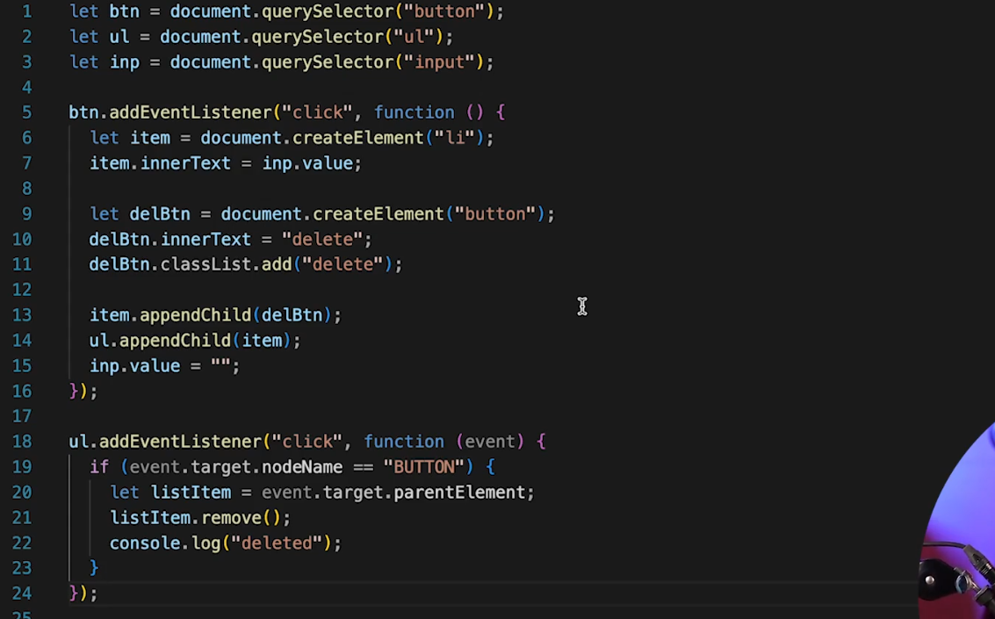

Simon Play Game

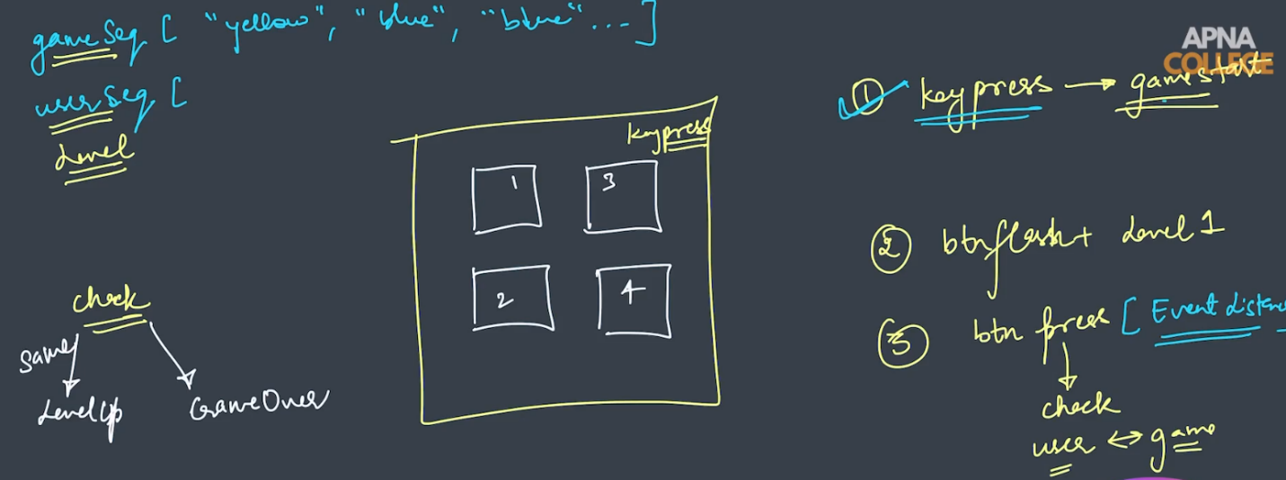
random
Track

