Database Layout

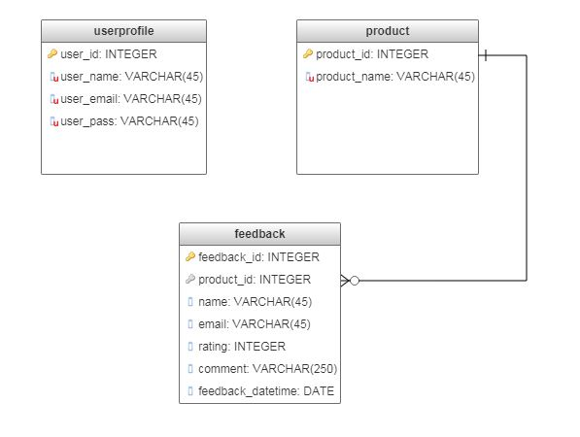

Here, I have designed the database layout using three table.

1. **userprofile**

This table will be used to store the admin information of NeoTech like user name, user email and user password. Where all columns are unique and not null and primary key is user_id.

"user_id" serial NOT NULL UNIQUE,

"user_name" varchar(45) NOT NULL UNIQUE,

"user_email" varchar(45) NOT NULL UNIQUE,

"user_pass" varchar(45) NOT NULL UNIQUE,

CONSTRAINT userprofile_pk PRIMARY KEY ("user_id")

1. **product**

This table will be used to store product information. Both product id and name will be unique and not null. Product id will be primary key but not auto increased.

"product_id" int NOT NULL UNIQUE,

"product_name" varchar(45) NOT NULL UNIQUE,

CONSTRAINT product_pk PRIMARY KEY ("product_id")

1. **feedback**

This table will be used to store users feedback data. Here feedback id, product id, and rating will be not null and product id is used as a foreign key from product table. Name, email and comment will accept null value and feedback time will be filled by the system using current datetime.

"feedback_id" serial NOT NULL UNIQUE,

"name" varchar(45),

"email" varchar(45),

"product_id" int NOT NULL,

"rating" int NOT NULL,

"comment" varchar(250),

"feedback_time" DATE NOT NULL,

CONSTRAINT feedback_pk PRIMARY KEY ("feedback_id")

ALTER TABLE "feedback" ADD CONSTRAINT "feedback_fk0" FOREIGN KEY ("product_id") REFERENCES "product"("product_id");