Log Monitoring with NGINX, Promtail & Loki - Report

Log Monitoring and Visualization Setup

Prepared by: Asifahmed Hussain Shaikh
Date: April 08, 2025

Workflow Diagram

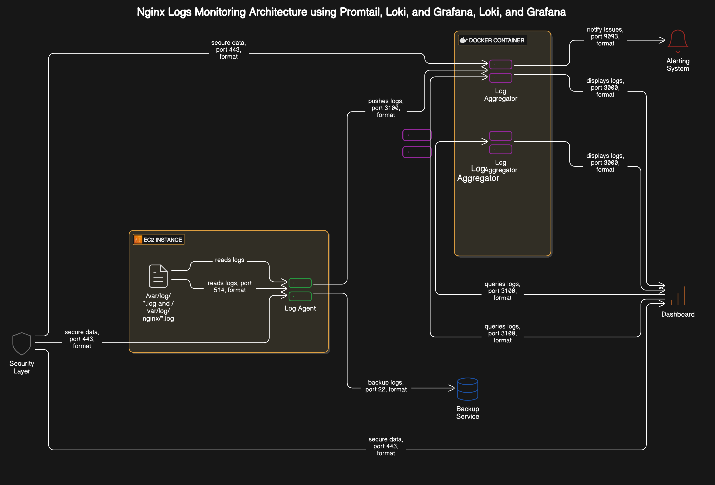

Step 1:Launching EC2 Instance on AWS

To run our monitoring stack, we need a virtual machine. AWS EC2 provides a reliable and scalable environment, so we launched an EC2 instance to act as our server for installing and testing NGINX, Promtail, Loki, and Grafana.
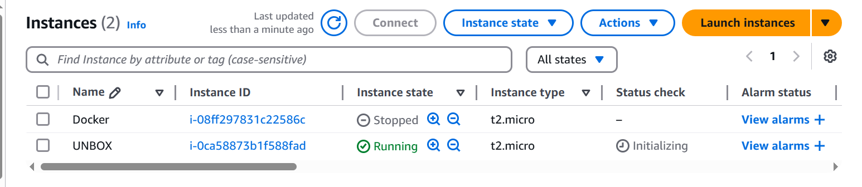

Step 2: Connecting to EC2 Instance Using SSH

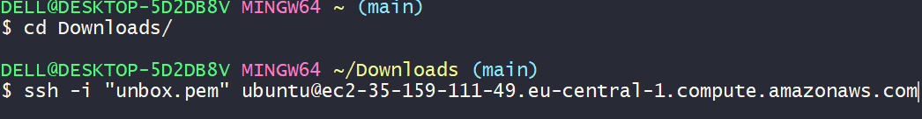

Installing and Starting NGINX Web Server
NGINX is a lightweight and high-performance web server used for serving websites and handling requests. In our setup, we use NGINX to generate access and error logs, which are later monitored using Promtail and visualized through Grafana.
We installed NGINX on our EC2 instance using APT package manager, started the service, and enabled it to run on system boot. This ensures that NGINX is up and running to generate real-time log

Allowing NGINX Port in AWS Security Group
By default, AWS blocks all incoming traffic to EC2 instances for security. Since NGINX runs on port 80 (HTTP), we need to allow this port in the EC2 instance’s security group. This step ensures that our web server can be accessed publicly through a browser using the server's public IP

Accessing NGINX in Browser via Public IP
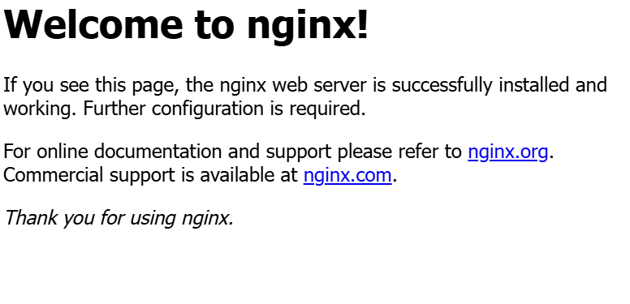

Installing Grafana
Grafana is an open-source tool used to visualize logs and metrics in real time. We installed Grafana on our EC2 instance to build interactive dashboards and monitor logs collected from NGINX. Grafana connects to Loki as a data source, allowing us to query and analyze logs efficiently
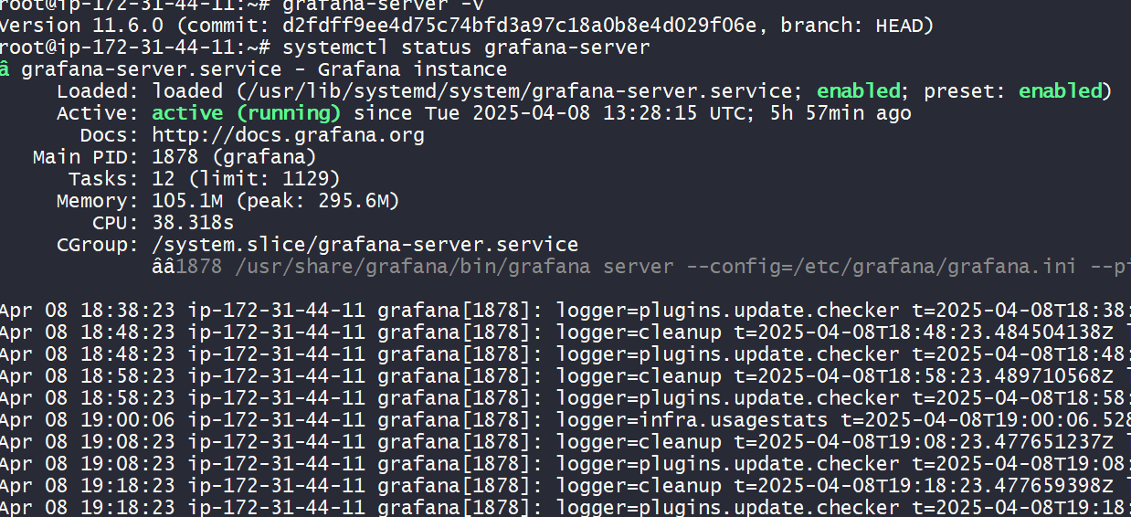

Accessing Grafana
After installing Grafana, we started the service and accessed the web interface using the EC2 instance's public IP on port 3000. The default login credentials (admin / admin) were used to log in for the first time
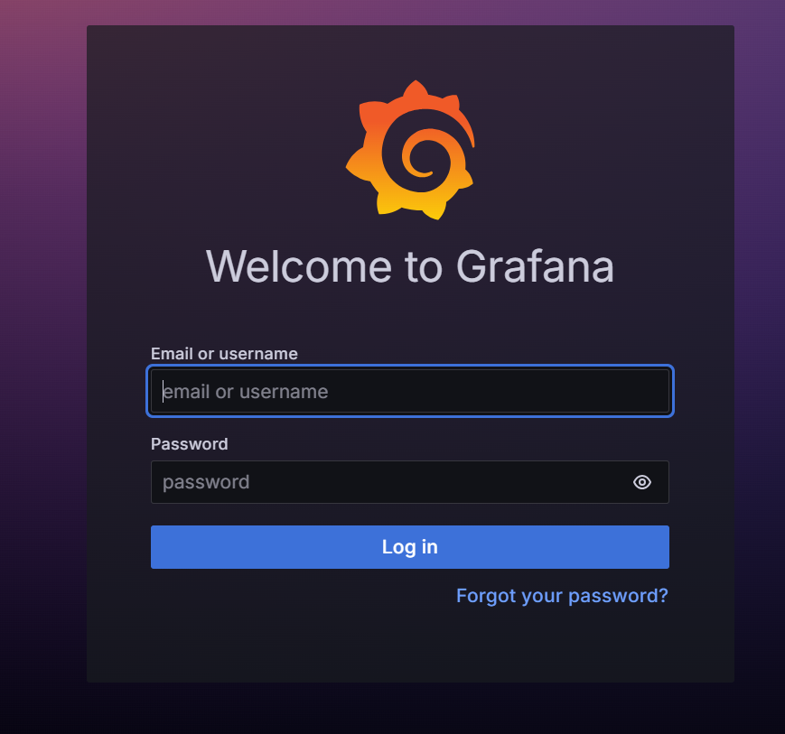

Installing Docker
To run Loki and Promtail in isolated environments, we used Docker. It simplifies deployment and ensures consistency across different systems. Docker allows us to manage services as containers, making setup faster and more efficient for development and testing purposes
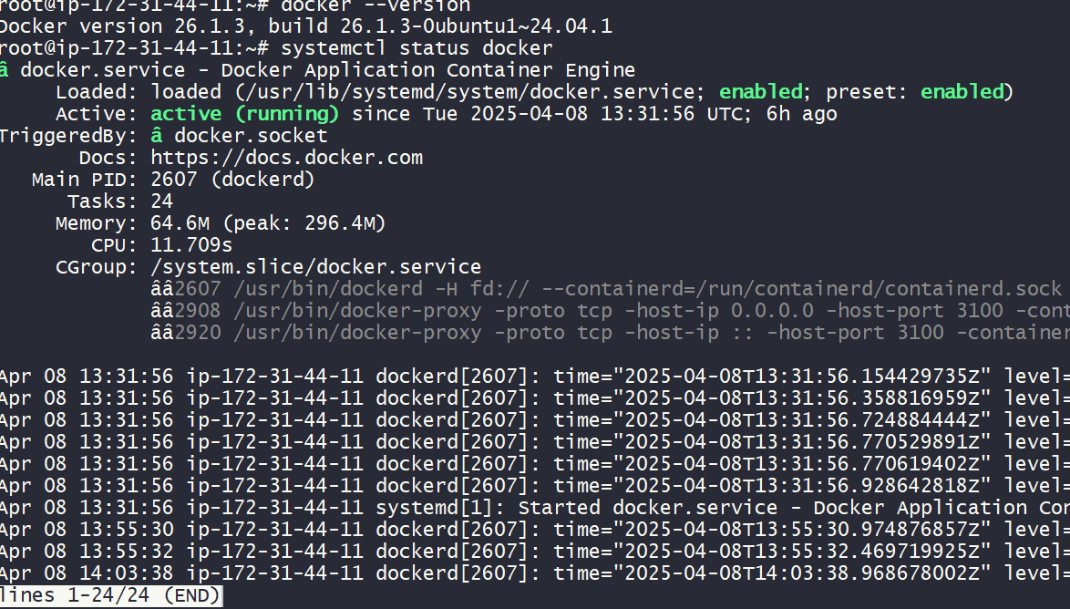

Installing Loki with the Help of Docker Container
Before installing Loki, we downloaded its default configuration file (loki-local-config.yaml) from the official GitHub page. This file is needed to define how Loki will work.
After that, we used Docker to run the Loki container. Using Docker made the setup easy and fast. It also helped to run Loki without installing everything manually.
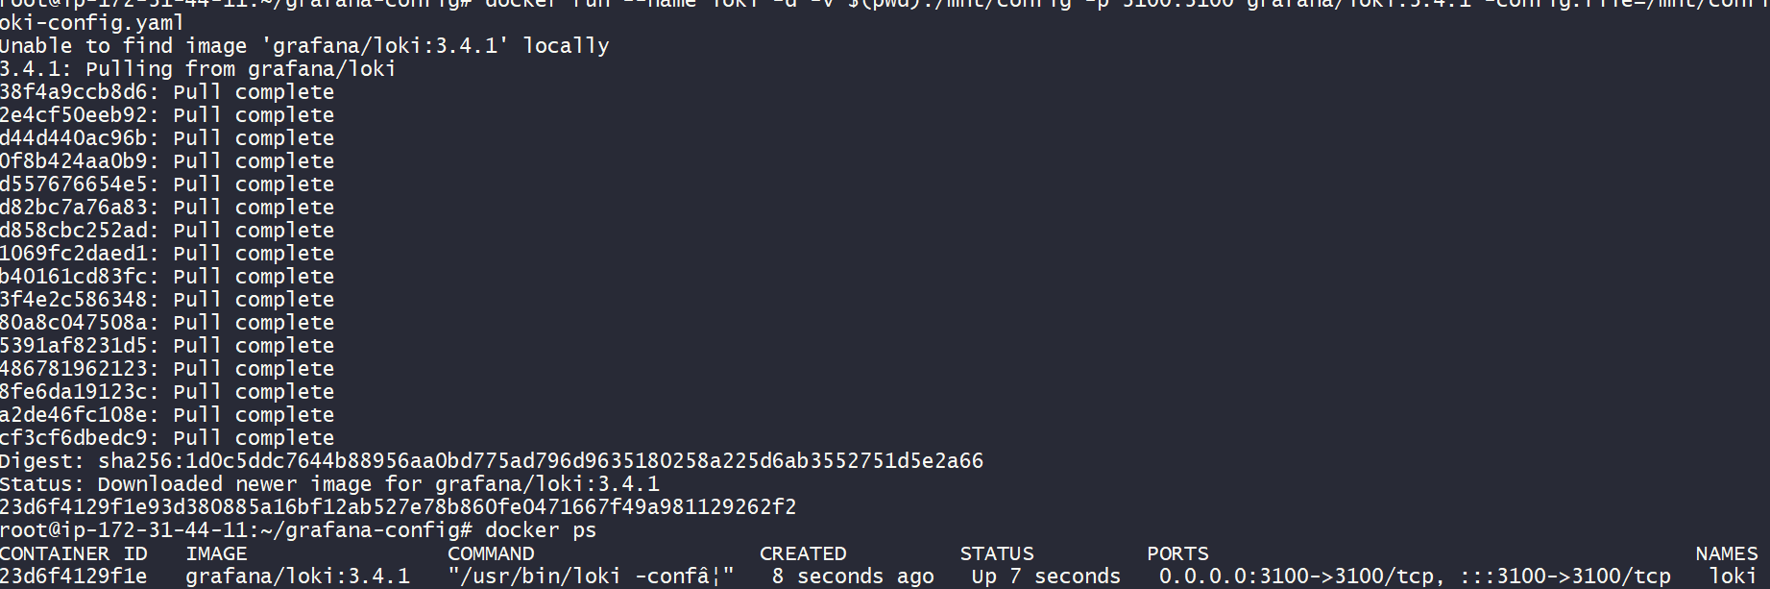

Installing Promtail
Just like Loki, we also downloaded Promtail’s default configuration file (promtail-docker-config.yaml) from its GitHub page. This config file tells Promtail which log files to read and where to send them.
We then used Docker to run Promtail. It reads the log files from /var/log/ and sends them to Loki. Running Promtail with Docker saved time and made the process easy.

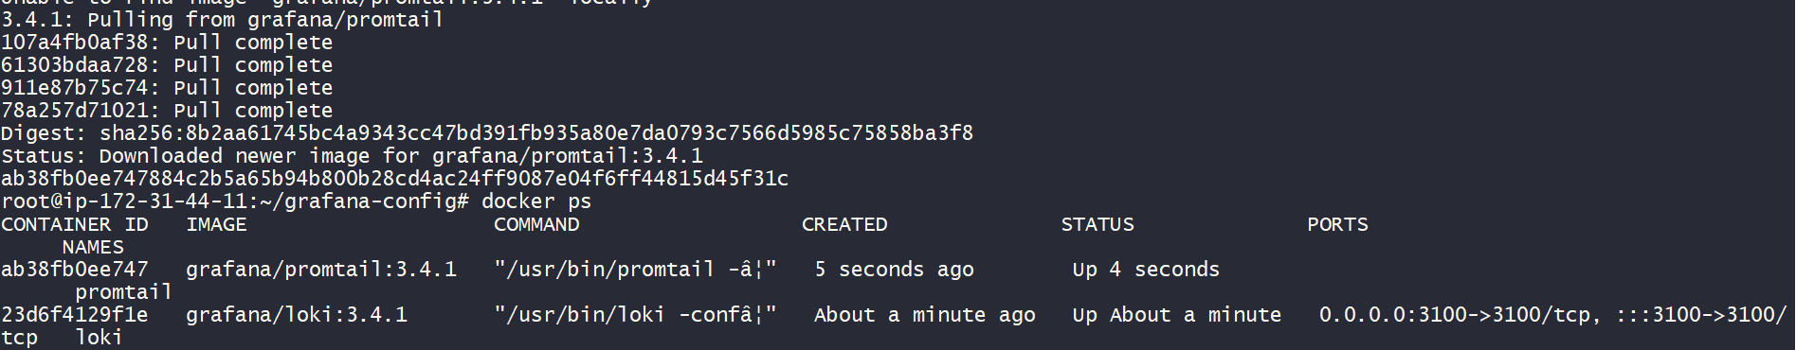

Creating Dashboard in Grafana
To make log monitoring easier, we created a dashboard in Grafana. We added a new panel and used a query like {job="nginx"} to show live logs from NGINX.
This dashboard helps to view logs in a visual way. We can also apply filters, set time ranges, and customize the panel to track specific log patterns.

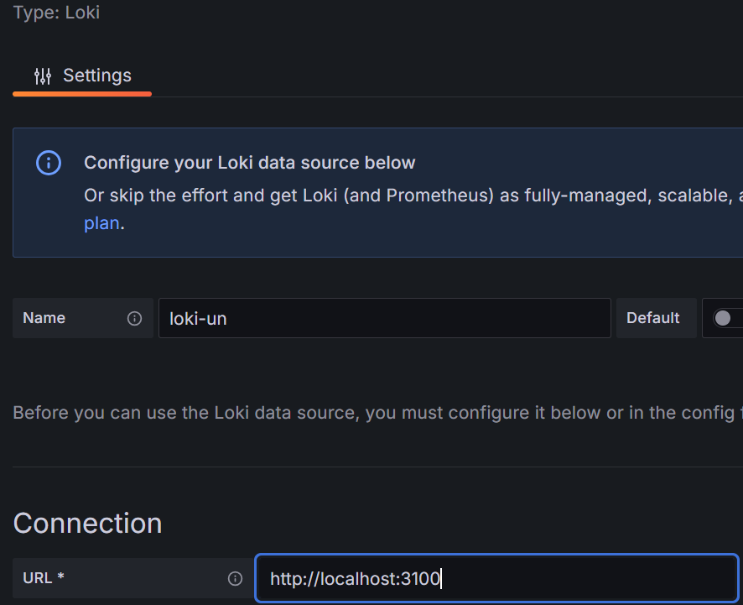

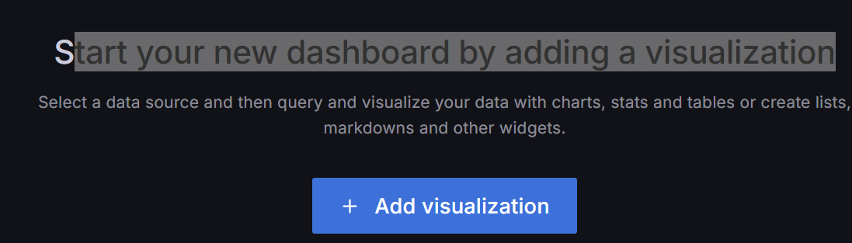
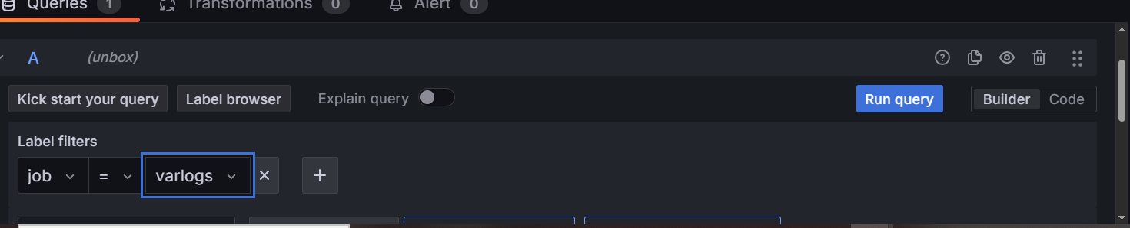

Accessing Logs in Grafana
After setting up Loki and Promtail, we opened Grafana in the browser using port 3000. Then we added Loki as a data source in Grafana.
Once connected, we went to the "Explore" section and selected the Loki data source. There, we used simple queries like {job="nginx"} to see the logs coming from NGINX in real time.
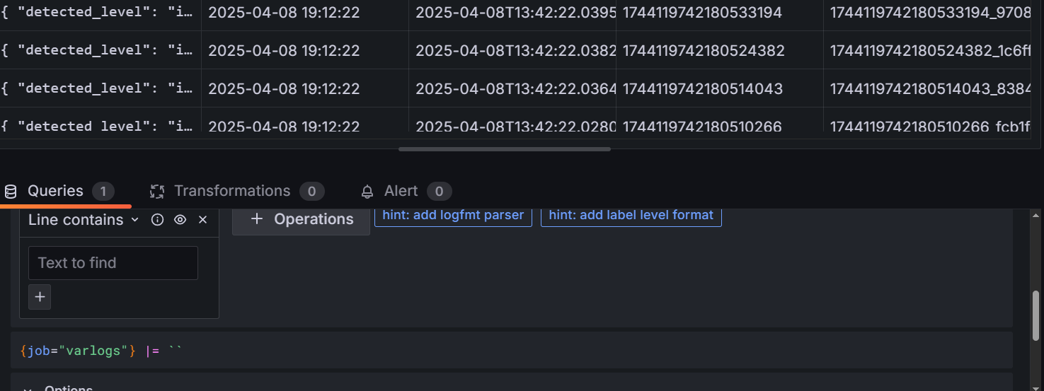
If an Error Occurs – What We See in the Browser
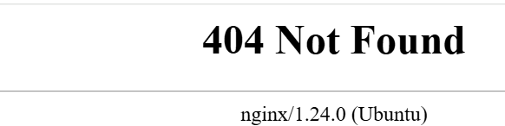

How Logs Appear in Grafana Explore Section
{ "detected_level": "unknown", "filename": "/var/log/nginx/access.log", "job": "nginx", "service_name": "nginx" }
2025-04-08 19:51:15103.195.83.125 - - [08/Apr/2025:14:21:15 +0000] "GET /apps HTTP/1.1" 404 196 "-" "Mozilla/5.0 (Windows NT 10.0; Win64; x64) AppleWebKit/537.36 (KHTML, like Gecko) Chrome/134.0.0.0 Safari/537.36"17441220753982899661744122075398289966_6bd32742
{ "detected_level": "unknown", "filename": "/var/log/nginx/access.log", "job": "nginx", "service_name": "nginx" }
2025-04-08 19:51:09103.195.83.125 - - [08/Apr/2025:14:21:09 +0000] "GET /apps HTTP/1.1" 404 196 "-" "Mozilla/5.0 (Windows NT 10.0; Win64; x64) AppleWebKit/537.36 (KHTML, like Gecko) Chrome/134.0.0.0 Safari/537.36"17441220696331966141744122069633196614_8dc00e17
{ "detected_level": "unknown", "filename": "/var/log/nginx/access.log", "job": "nginx", "service_name": "nginx" }
2025-04-08 19:50:26103.195.83.125 - - [08/Apr/2025:14:20:26 +0000] "GET /app HTTP/1.1" 404 196 "-" "Mozilla/5.0 (Windows NT 10.0; Win64; x64) AppleWebKit/537.36 (KHTML, like Gecko) Chrome/134.0.0.0 Safari/537.36"17441220265325163181744122026532516318_dfdd67ce
{ "detected_level": "unknown", "filename": "/var/log/nginx/access.log", "job": "nginx", "service_name": "nginx" }
2025-04-08 19:50:11103.195.83.125 - - [08/Apr/2025:14:20:11 +0000] "GET /app HTTP/1.1" 404 196 "-" "Mozilla/5.0 (Windows NT 10.0; Win64; x64) AppleWebKit/537.36 (KHTML, like Gecko) Chrome/134.0.0.0 Safari/537.36"17441220114950931611744122011495093161_b43daaec
{ "detected_level": "unknown", "filename": "/var/log/nginx/access.log", "job": "nginx", "service_name": "nginx" }
2025-04-08 19:46:18103.195.83.125 - - [08/Apr/2025:14:16:18 +0000] "GET /AAP HTTP/1.1" 404 196 "-" "Mozilla/5.0 (Windows NT 10.0; Win64; x64) AppleWebKit/537.36 (KHTML, like Gecko) Chrome/134.0.0.0 Safari/537.36"17441217789205128641744121778920512864_e044028d
{ "detected_level": "unknown", "filename": "/var/log/nginx/access.log", "job": "nginx", "service_name": "nginx" }
2025-04-08 19:46:17103.195.83.125 - - [08/Apr/2025:14:16:17 +0000] "GET /AAP HTTP/1.1" 404 196 "-" "Mozilla/5.0 (Windows NT 10.0; Win64; x64) AppleWebKit/537.36 (KHTML, like Gecko) Chrome/134.0.0.0 Safari/537.36"17441217779179947841744121777917994784_4cdd3f8e

Conclusion
In this project, we successfully set up a centralized log monitoring system using NGINX, Promtail, Loki, and Grafana on an EC2 instance. The logs generated by NGINX were collected using Promtail, stored in Loki, and visualized in real-time through Grafana dashboards. This setup helps in monitoring server activity efficiently and lays the foundation for scalable observability in any production environment.

