Linear Regression Algorithm and Decision Tree Algorithm implementation on a data set to assess Mean Squared Error and Accuracy Score Respectively.

**Result:**

1.As, Linear Regression Algorithm is a Regression Algorithm. So Mean Squared Error was calculated. The Answer is given below:

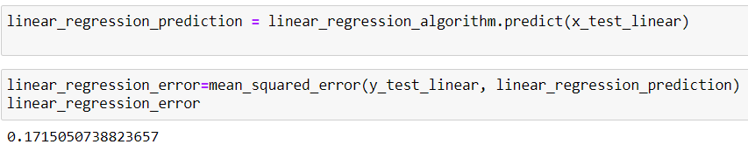By applying Linear Regression Algorithm, Mean Squared Error was resulted as 0.172.

2. As, Decision Tree Algorithm is a Classification Algorithm. So Accuracy Score was calculated. The Answer is given below:

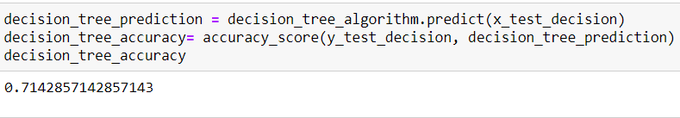

By applying Decision Tree Algorithm, Accuracy Score was resulted as 0.714.