

***The University of Azad Jammu and Kashmir Muzaffarabad***

|  |  |
| --- | --- |
| ***Name:*** | ***Asifullah*** |
| ***Roll No:*** | ***2023-SE-38*** |
| ***Course:*** | ***Operating System*** |
| ***Submitted To:*** | ***Mam Sidra*** |
| ***Lab Task no:*** | ***4*** |

**Q1: What is a Virtual Machine?**

A virtual machine (VM) is a software-based simulation of a physical computer. It allows multiple operating systems to operate on the same hardware while being independent of one another.

Each virtual machine is isolated from others, ensuring system stability and security.

Different operating systems, such as Windows, Linux, or macOS, can run on a single machine simultaneously.

Resources like CPU, memory, and storage are allocated as needed without affecting the host system.

VMs are widely used for testing applications, software development, and deployment.

**Common Uses:**

Developers use VMs to test software in different environments without requiring separate physical devices.

Businesses deploy multiple server applications on a single physical server, reducing costs.

Security professionals use VMs to run isolated environments for testing malware and security breaches.

**Popular VM Software:**

**VirtualBox:** A free, open-source virtualization tool.

**VMware Workstation:** A powerful, widely used virtualization platform.

**Microsoft Hyper-V:** A built-in VM tool available in Windows.

**Q2: Linux-Based Operating System**

A Linux-based operating system is built around the Linux kernel and serves as an open-source, customizable, and secure platform for a wide range of applications.

The source code of Linux is freely available, allowing users to modify it according to their needs.

It offers strong security, making it resistant to most malware and cyber threats.

Linux is known for its stability and efficiency, making it ideal for enterprise servers and cloud computing.

Users can personalize their experience by choosing from various desktop environments and software packages.

Linux distributions manage software installation and updates using package managers for seamless maintenance.

**Popular Linux Distributions:**

**Ubuntu:** A beginner-friendly, widely used OS.

**Fedora:** Offers the latest software innovations.

**Debian:** Known for its stability and long-term support.

**CentOS:** A reliable choice for enterprise applications.

**Arch Linux:** Designed for experienced users who prefer complete system control.

**Common Uses:**

Linux powers web servers, cloud infrastructure, and embedded systems such as smart devices and appliances.

Developers prefer Linux for its flexibility and strong command-line tools.

It is widely used for security applications and penetration testing.

**Q3: Architecture of UNIX-Based OS**

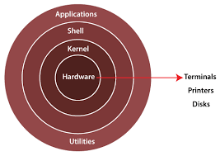

UNIX operating systems are structured into multiple layers, which interact between the user and the hardware. The main components are:

**Hardware Layer:** This includes physical components such as the CPU, memory, and storage.

**Kernel:** The core part of the OS that manages system resources, including process scheduling, memory handling, and device communication.

**Shell:** A command-line interface that interprets user commands and passes them to the kernel.

**Application Programs:** User-installed software that performs specific tasks such as document creation, file management, and system monitoring.

**Q4: Difference Between Ubuntu and Linux**

**Linux** refers to the kernel, which is the core component of the operating system. It handles hardware communication and resource management.

**Ubuntu** is a Linux distribution based on Debian, designed for ease of use with a graphical user interface and pre-installed software.

While Linux serves as the foundation, Ubuntu provides a complete and ready-to-use operating system.

Ubuntu is preferred for general users, whereas Linux allows customization for specific needs.

**Q5: Difference Between Linux and Kali Linux**

**Linux** is a kernel that serves as the base for many operating systems, catering to a wide range of applications from general computing to enterprise environments.

**Kali Linux** is a specialized Linux distribution built for cybersecurity, penetration testing, and digital forensics.

Kali Linux comes pre-installed with advanced security tools for ethical hacking and vulnerability assessment, whereas general Linux distributions focus on a broader range of computing tasks.

**Q6: Difference Between Ubuntu and Kali Linux**

**Ubuntu** is a general-purpose operating system designed for ease of use, featuring a polished graphical interface and user-friendly applications.

**Kali Linux** is specifically developed for cybersecurity experts, containing a vast set of security tools.

While Ubuntu is ideal for desktops and servers, Kali Linux is tailored for security assessments and network analysis.

**Q7: Best OS for Deployment (Linux, Kali Linux, Ubuntu)**

**Ubuntu** is the most suitable choice for general deployment, offering stability, long-term support, and an extensive software repository.

**Linux (General)** allows users to select a distribution that meets their specific requirements, making it ideal for servers and embedded systems.

**Kali Linux** is best suited for security-focused environments and penetration testing but is not recommended for general deployment.

**Q8: VMware Installation Process**

**Step-by-Step Guide:**

1. **Download VMware Workstation** from the official VMware website.
2. **Run the Installer** from the downloads folder.

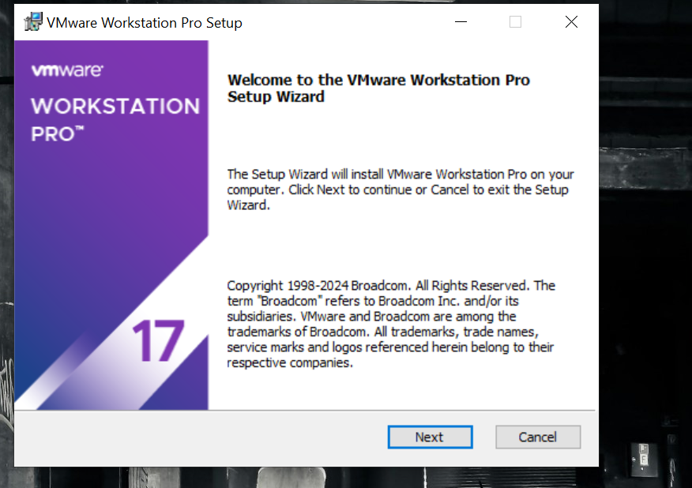

1. **Accept the License Agreement** to proceed.

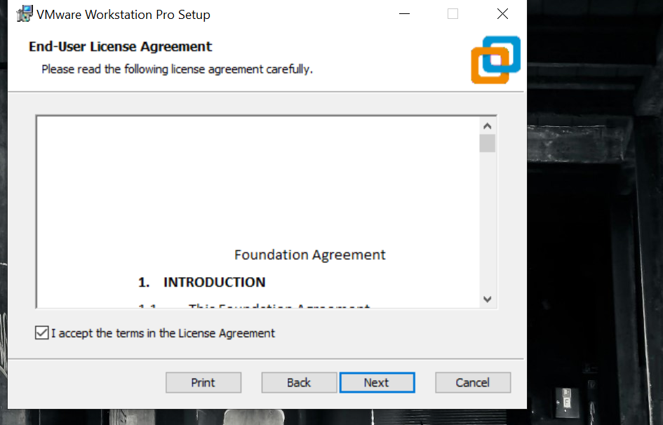

1. **Select Installation Directory** (default or custom path).

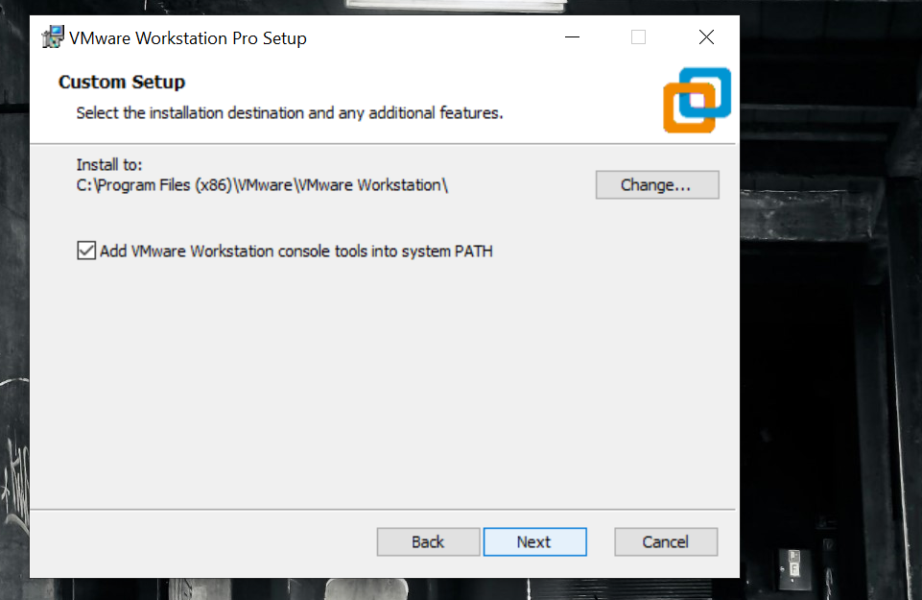

1. **Customize Shortcuts** (optional for desktop/start menu).

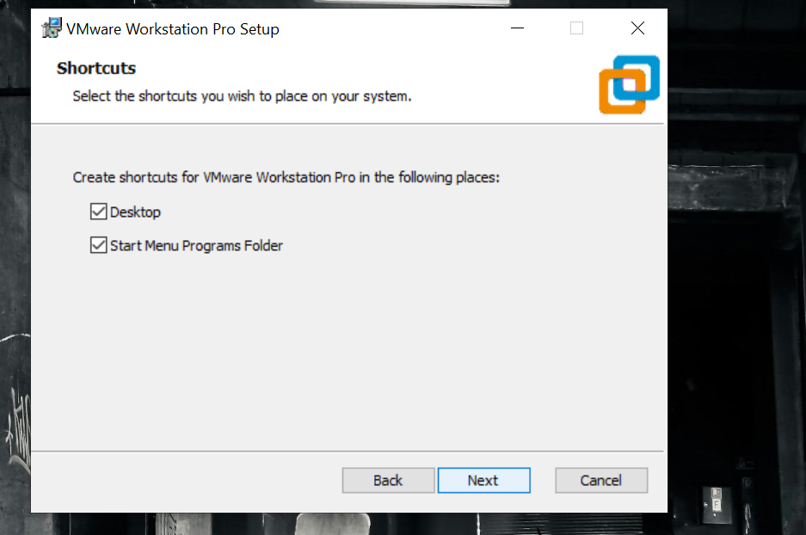

1. **Begin Installation** and wait for completion.

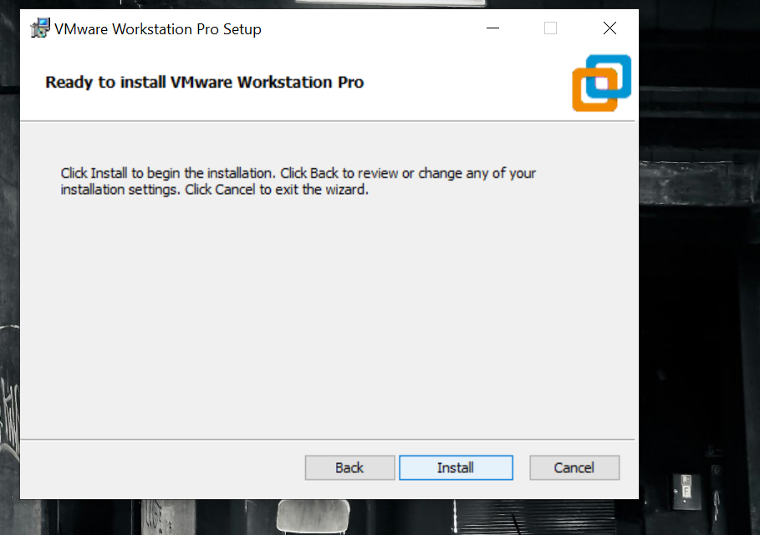

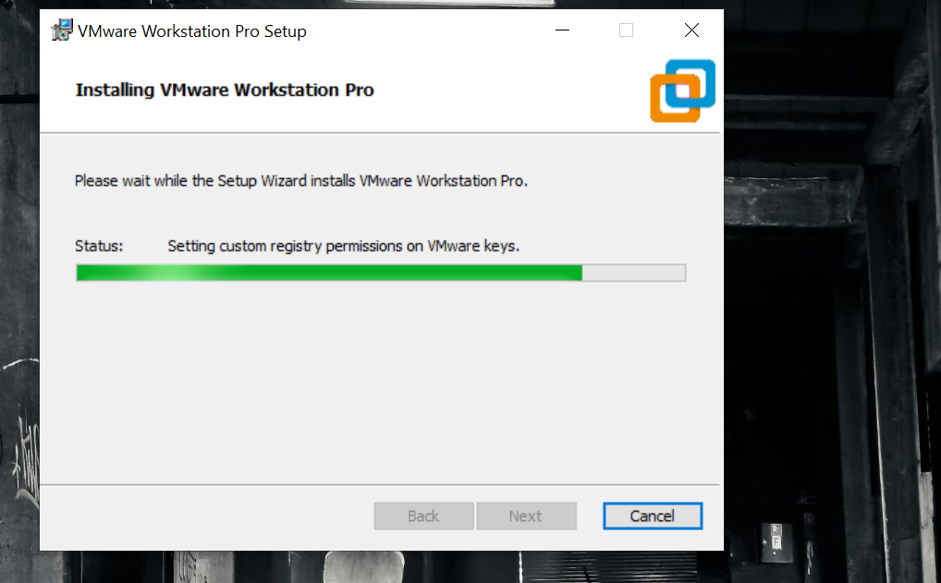

1. **Restart the System** after installation.

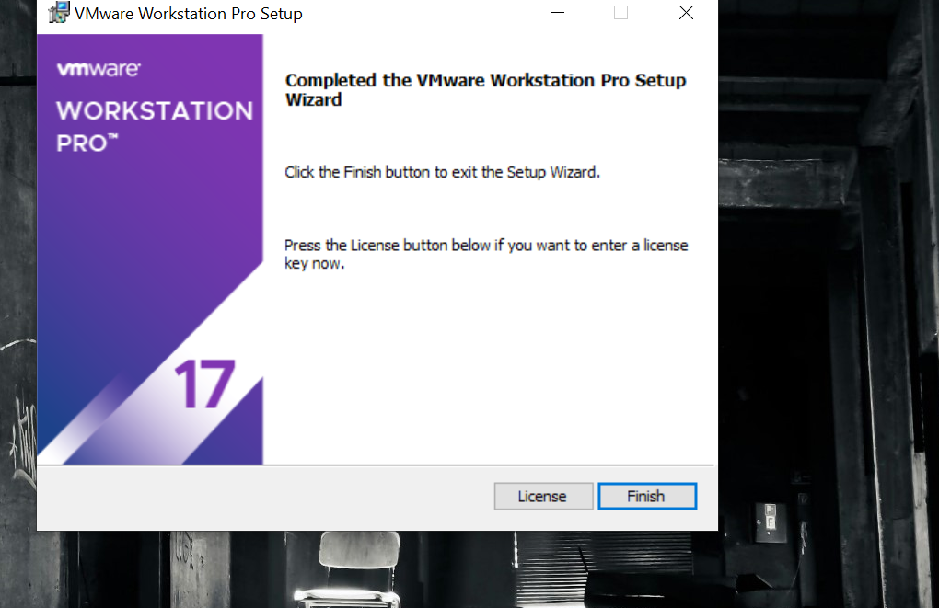

1. **Launch VMware Workstation** from the Start Menu.

**System Requirements:**

* Windows 10 or 11 operating system.
* A 64-bit processor with multiple cores.
* At least 16 GB of RAM (32 GB recommended).
* Minimum 4 GB disk space, with SSD preferred for better performance.
* A valid VMware license if using the Pro version.