ASIF ULLL HAQUE  Digital Marketer | SEO Expert | Social Media Manager | Canva Designer | Experienced Digital Marketer, SEO Expert, Social Media Manager, and Canva Designer. I am skilled in improving SEO rankings, creating engaging content, and managing social media campaigns. Focused on driving brand growth and delivering measurable results through creative, data-driven marketing strategies.

 | 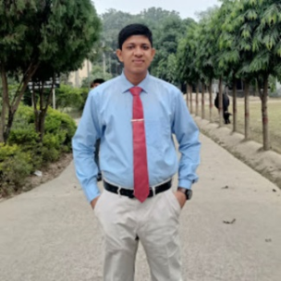  Contact  Address  Naogaon, 6500 Rajshahi  Phone  +8801768264069  E-mail  asifullhaque2001@gmail.com  Websites, Portfolios, Profiles  - https://bd.linkedin.com/in/asif-ull-haque  - www.facebook.com/graphene2001  Core Skills  Languages |  |   Work Experience  Education  Blog  asifullhaque.blogspot.com
  - MS Word
  - MS Excel
  - MS Powerpoint
  - Digital Marketing
  - Lead Generation
  - Email Marketing
  - Social Media Marketing
  - Bulk Email
  - Email Verification
  - Email Campaigns
  - Youtube SEO
  - Web Scraping
  - Search Engine Optimization (SEO)
  - Keyword Research
  - SEO Audits
  - On-Page SEO
  - Off-Page SEO
  - Technical SEO
  - Backlinks
  - Canva
  - Card Design
  - Banner Design
  - Motion Graphics
  - Infographics
  Bengali
  English
   | 2024-03 - 2024-04 |  | Sales Executive  Natai Clothing Brand, Naogaon  - Promoted and sold clothing products, built strong customer relationships, and exceeded sales targets  - Focused on delivering personalized shopping experiences, driving brand awareness, and increasing revenue through strategic product recommendations and exceptional service
   | 2022-07 - Current |  | BSc(Honours): Mathematics  National University Of Bangladesh
   | 2019-07 - 2021-12 |  | HSC: Science  Naogaon Govt. College - Naogaon  GPA: 5.00
   | 2017-01 - 2019-02 |  | SSC: Science  Naogaon KD Govt. High School - Naogaon  GPA: 5.00

