Password Manager Project Report

## Course Name:

CSE 215 Programming Language II Lab

## Section:

Section 9

## Instructor's Name:

## [Saifur Rahman Durjoy](https://northsouth.instructure.com/courses/45215/users/9874)

## Group Members:

Member 1 – Asifur Rahman Apon (2512131642)

Member 2 – Tondra Pal Joya (2511713042)

Member 3 – Ifte Khairul Islam Ariyan (2423347642)

## Submission Date:

17 August 2025

# Abstract

This project is a Password Manager application developed using Java. It allows users to securely store, manage, and retrieve their credentials with robust encryption and authentication mechanisms. The system provides a secure storage vault, password generation utilities, and user-friendly interfaces for effective credential management.

# Introduction

## Objective of the Project:

The main objective of this project is to design and implement a secure Password Manager application using Object-Oriented Programming concepts. The system ensures confidentiality, integrity, and usability.

## Background and Significance:

As online services grow, managing multiple strong passwords becomes challenging. This project addresses this problem by providing a secure password vault, reducing password reuse, and improving overall security.

# Features and Implementation

The Password Manager consists of the following key features:  
1. User Registration & Login (Member 3)  
2. Encryption & Key Management (Member 3)  
3. Storage Layer for Users & Vaults (Member 3)  
4. Session Timeout / Auto-Lock (Member 3)  
5. Credential CRUD Operations (Member 2)  
6. Clipboard Operations (Member 2)  
7. Search & Filtering (Member 2)  
8. Password Generator & Strength Checker (Member 2)  
9. Main Application UI (Member 1)  
10. Settings Page (Member 1)  
11. Import/Export Vault (Member 1)  
12. Error Handling & Validation (Member 1)

# Implementation of OOP Concepts

The project extensively uses Object-Oriented Programming concepts:  
- Encapsulation: User data and credentials are securely managed in classes with controlled access.  
- Inheritance: Common utility functions and exceptions extend base classes.  
- Polymorphism: Dialogs and UI panels override methods for rendering.  
- Abstraction: Interfaces and abstract methods hide complex implementations.

# Member Contribution

|  |  |  |
| --- | --- | --- |
| Feature/Task | Implemented By (Name & ID) | Description |
| User & Security Systems | Ifte Khairul Islam Ariyan (2423347642) | Login, registration, encryption, and session handling |
| Credential Management & Utilities | Tondra Pal Joya (2511713042) | CRUD for credentials, password tools, clipboard, search |
| User Interface & Extra Features | Asifur Rahman Apon (2512131642) | UI implementation, settings, import/export, validation |

# Testing and Results

Test cases included login validation, encryption/decryption verification, vault CRUD operations, and password generator outputs. Each function was tested with valid and invalid inputs. Screenshots of UI operations and expected outputs confirm correctness.

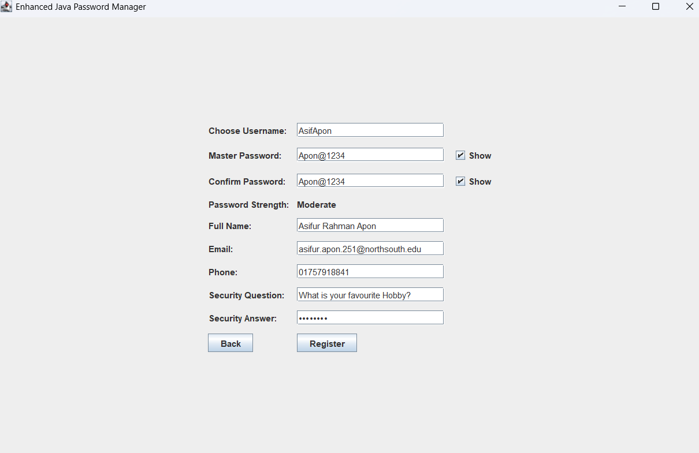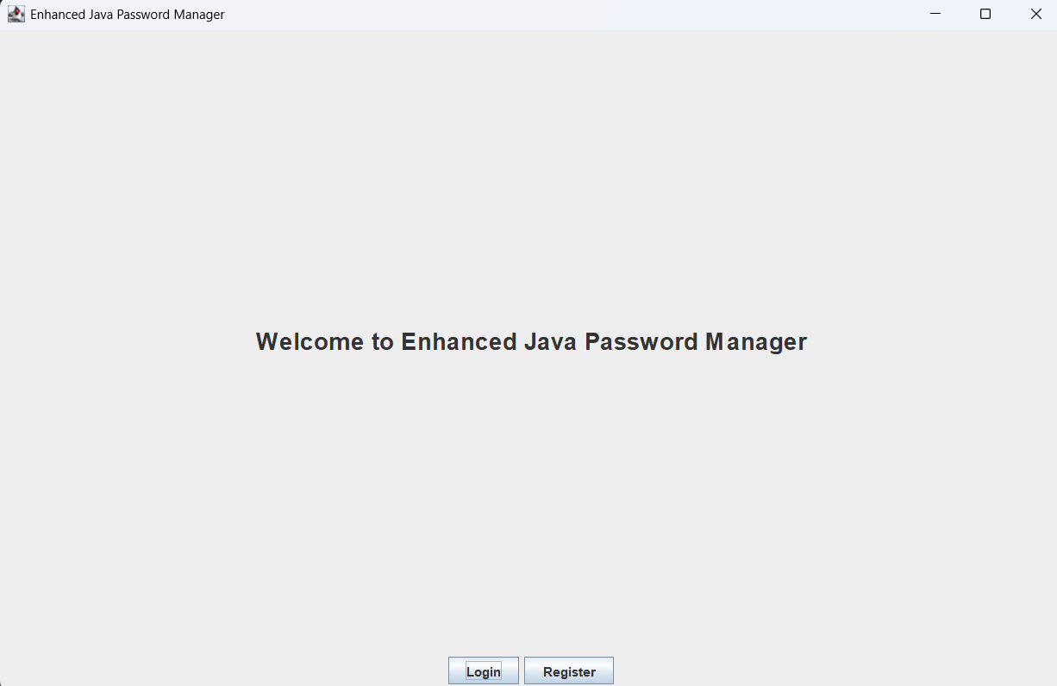

# 

# Challenges and Solutions

Challenges faced during development included ensuring secure encryption, managing session auto-lock, and synchronizing UI with data persistence. These were resolved through rigorous debugging, modular design, and the use of Java libraries such as the Java Cryptography API.

# Conclusion

The Password Manager project successfully demonstrates secure credential storage and management using OOP principles. It reinforced concepts such as encapsulation, abstraction, inheritance, and polymorphism. Future improvements may include cloud sync, biometric authentication, and cross-platform support.