**Full Wave-Operating Principle**: Full-wave rectification with a bridge rectifier enhances DC level by 100%, ensuring continuous current flow, improving efficiency over half-wave rectification.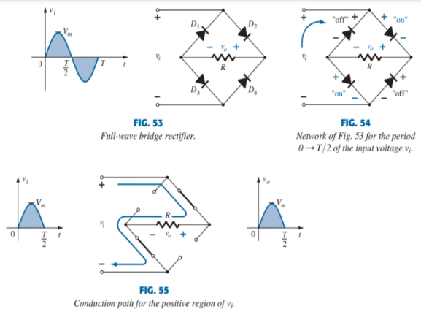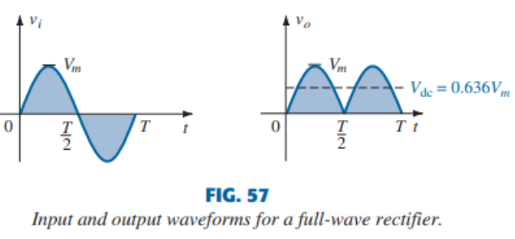

**Parallel Positive clipper**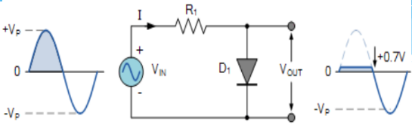   
In this diode clipping circuit, the diode is forward-biased during the positive half cycle of the sinusoidal input when the anode is more positive than the cathode. For forward bias, the input voltage magnitude must exceed +0.7 volts (0.3 volts for a germanium diode).

**Clipping of Both Half Cycles**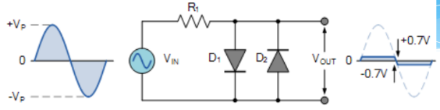

If we connected two diodes in inverse parallel as shown, then both the positive and negative half cycles would be clipped as diode D1 clips the positive half cycle of the sinusoidal input waveform while diode D2 clips the negative half cycle. Then diode clipping circuits can be used to clip the positive half cycle, the negative half cycle or both.

**Positive Bias Diode Clipping**

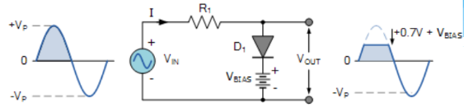

Likewise, by reversing the diode and the battery bias voltage, when a diode conducts the negative half cycle of the output waveform is held to a level -VBIAS - 0.7V as shown.

**Negative Bias Diode Clipping**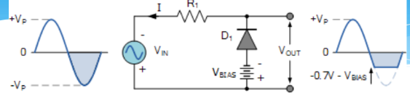

Variable diode clipping is achieved by adjusting bias voltage. To clip both half-cycles, two diodes with different positive and negative bias voltages, like 4V and 6V, are used.

Ex-17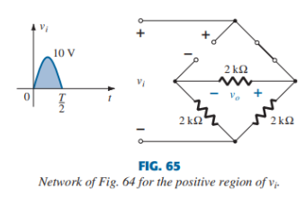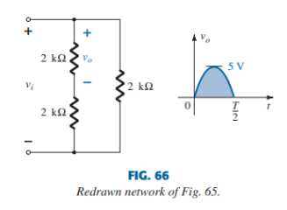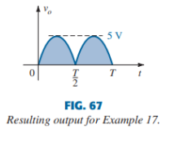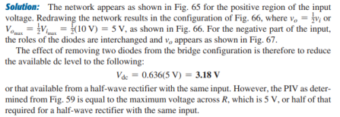

**Determine VL,Vr,Iz**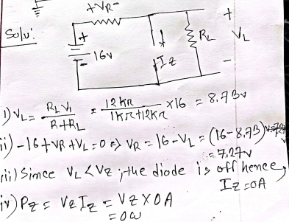

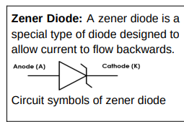

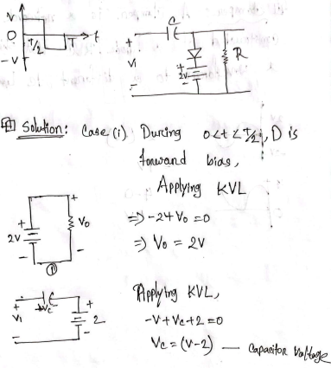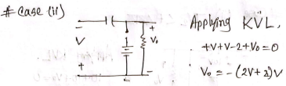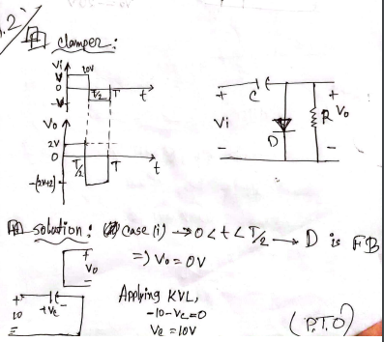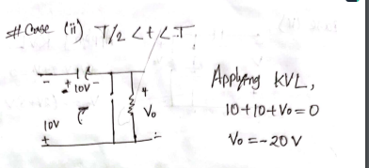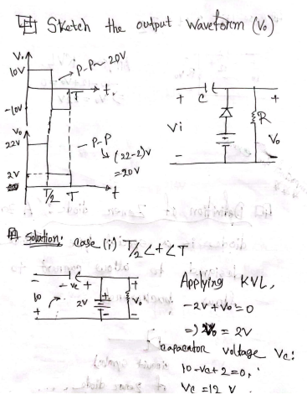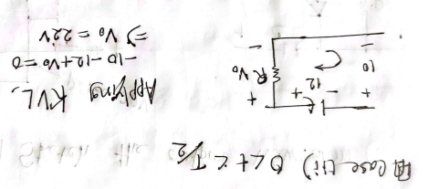

**1.**Semiconductors that are pure and impurities-free are known as **intrinsic semiconductors.**

**2.** The semiconductors that has been subjected to doping is called **extrinsic semiconductor**.

**3.N-type Semiconductor:** In an n-type material the electron is called the majority carrier and the hole the minority carrier. **Example: As, P, Sb**

**4.P-type Semiconductor:** In a p-type material the hole is the majority carrier and the electron is the minority carrier. **Example: B, Ga, In**

**5.Diode Circuit Symbol**

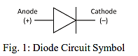

**6.** a) Conduction and (b) nonconduction states of the ideal diode as determined by the applied bias

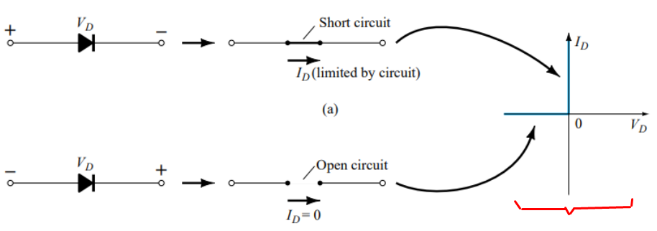

**7. I-V Characteristics of Ideal Diode:**The ideal diode model is a simple switch. In forward bias, it behaves like a closed switch, and in reverse bias, it acts like an open switch (Figure a and b). The ideal V-I characteristic curve (Figure c) illustrates this ideal diode operation.

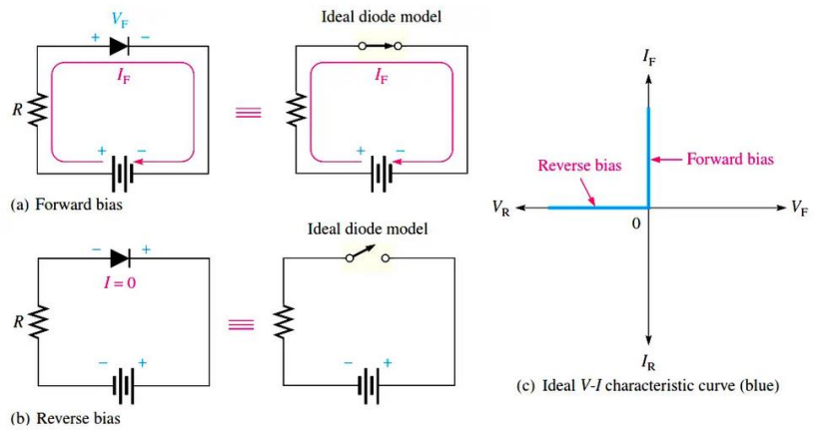

**8.** **V-I Characteristics of P-N Junction Diode:**

V-I characteristics of a PN junction diode, shown in Fig 1, illustrate the voltage-current curve for zero bias, forward bias, and reverse bias.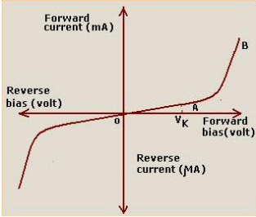

Fig 2: A p–n junction with no external bias: an internal distribution of charge.

**Zero Bias:** In zero bias, the open circuit maintains a potential barrier, preventing current flow and forming the depletion region with uncovered ions.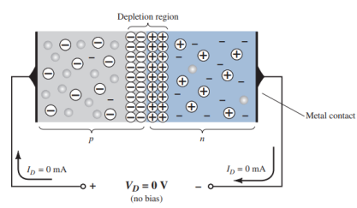

**Forward Bias:** Forward bias connects, initiates current at 0.7 V (Si) or 0.3 V (Ge), gradually increases, sharply rises, resembling a conductor.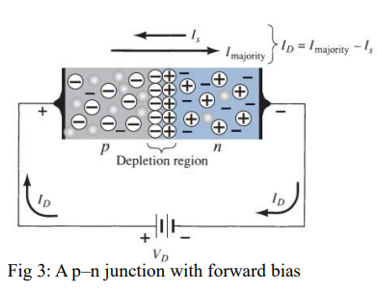

**Reverse Bias:** Reverse bias increases barrier, yielding high resistance, minimal current. Breakdown risks damage..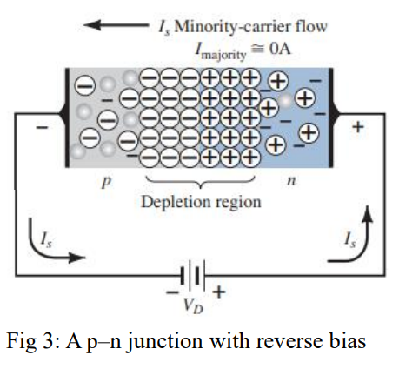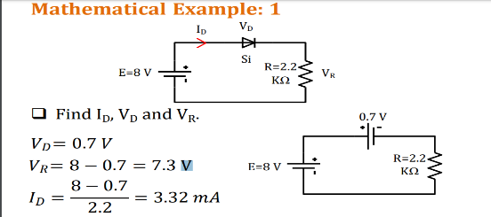

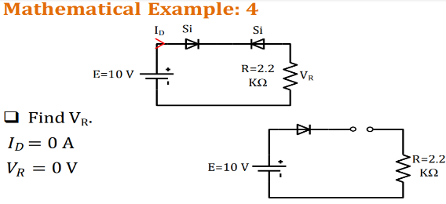

**Clamper**: A clamper is a network constructed of a diode, a resistor and a capacitor that shifts a waveform to a different dc level. **Clippers** are networks that empty diodes to clip away a portion of an input signal

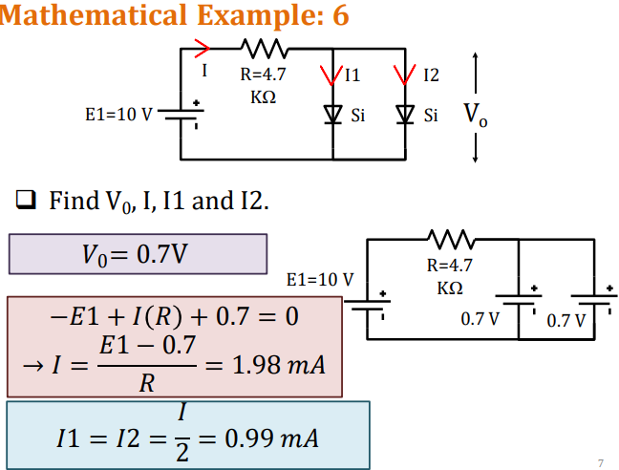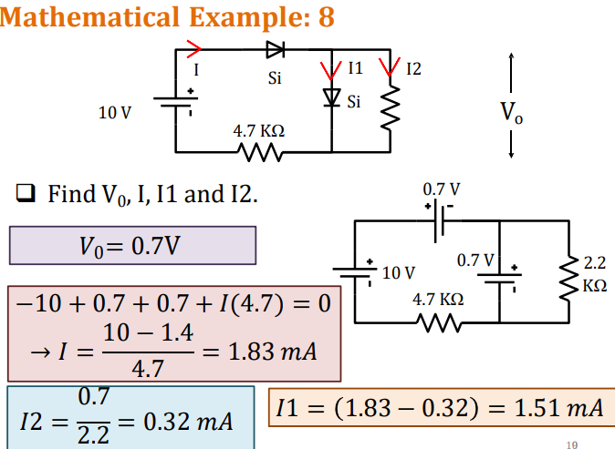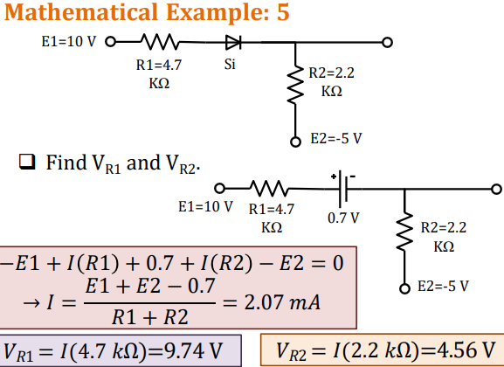 **Half-Wave Rectifier Output:**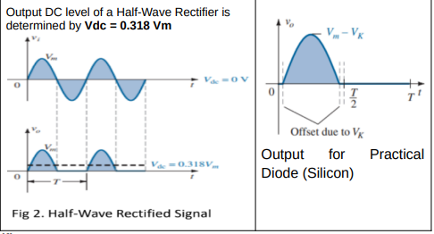

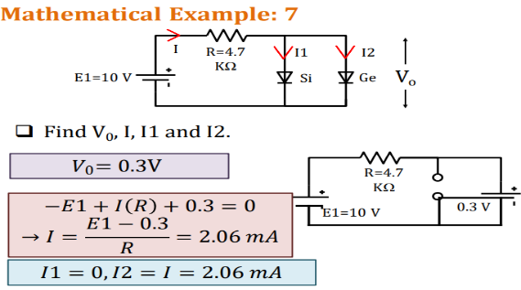

**Series Clipper:**