

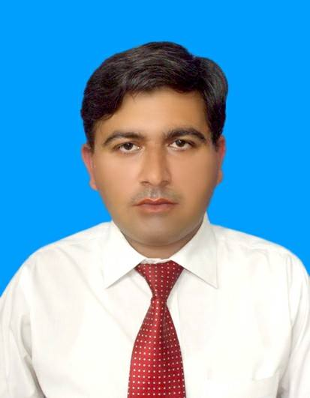

Student Picture

**ADMISSION FORM**

|  |  |  |  |  |  |  |  |  |  |  |  |  |  |  |  |  |  |  |  |  |  |
| --- | --- | --- | --- | --- | --- | --- | --- | --- | --- | --- | --- | --- | --- | --- | --- | --- | --- | --- | --- | --- | --- |
| Course Enrolled: | | | |  | | | | | | | | | | Timings: | | |  | | | | |
|  | | | | | | | | | | | | | | | | | | | | | |
| Student Name: | | | | **Asif Usman Khattak** | | | | | | | | | | | | | | | | | |
|  | | | | | | | | | | | | | | | | | | | | | |
| Postal Address: | | | | **Village Nar Jasmal P/o Sarai Naurang District Lakki Marwat KP** | | | | | | | | | | | | | | | | | |
|  | | | | | | | | | | | | | | | | | | | | | |
| |  |  |  |  |  |  |  |  |  |  |  |  |  |  |  |  | | --- | --- | --- | --- | --- | --- | --- | --- | --- | --- | --- | --- | --- | --- | --- | --- | | CNIC NO. | 1 | 1 | **2** | **0** | **1** | **----** | **5** | **7** | **3** | **8** | **1** | **2** | **1** | **----** | **5** | | | | | | | | | | | | | | | | | | | | | | |
| Email ID: | | | | **Asifusmankhattak@gmail.com** | | | | | | | | | | | | | | | | | |
|  | | | | | | | | | | | | | | | | | | | | | |
| Cell No: | | | **03479389419** | | | | | | | | | | | | | | | | | | |
|  | | | | | | | | | | | | | | | | | | | | | |
| Occupation: | | | | **Student** | | | | | Age: | | | 36 | | Date of Birth: | | | | | **18-03-1984** | | |
|  | | | | | | | | | | | | | | | | | | | | | |
| How did you hear about Oranet Training & Solutions? | | | | | | | | | | | | | | | | | | | | | |
|  | | | | | | | | | | | | | | | | | | | | | |
|  | Face book | | |  | SMS |  | | Instagram | | |  | LinkedIn | | |  | Friends | | |  | | Relatives |
|  | Website | | | Others (Please Specify): | | | | | | |  | | | | | | | | | | |
|  | | | | | | | | | | | | | | | | | | | | | |
|  | | | | | | | | | | | | | | | | | | | | | |
| Date: | | **9-05-2020** | | | | | | | Place: | Lakki marwat | | | | Signature: | | | |  | | | |
| **-----------------------------------------For Office Use Only-----------------------------------------** | | | | | | | | | | | | | | | | | | | | | |
| Accepted by: | | | |  | | | | | | | | | | | | | | | | | |
| Counselor: | | | |  | | | | | | | | | | | | | | | | | |
| Centre: | | | |  | | | | | | | | | City: |  | | | | | | | |
| Receipt No: | | | |  | | | Date: | | |  | | | | Batch Allocated: | | | | | |  | |
| Roll No: | |  | | | | | | | | Remarks: | | | |  | | | | | | | |
|  | | | | | | | | | | | | | | | | | | | | | |