

|  |  |
| --- | --- |
| Group number: 7 | Mohammad Wasefi  Student Number: s0156154  Mohammad.wasefi@student.uantwerpen.be |

|  |
| --- |
| **6 – Distributed Systems**  **Practicum Report – Sessions 2 and 3** |

Contents

Session 2: REST 3

Server 3

Deposit 3

Withdraw 3

Get Balance 4

GetEntry 4

Spring Boot 4

Client 5

Deposit 5

Withdraw 5

Get balance. 5

Session 3: Naming Server 7

Hash function 7

Add node. 8

Add node with existing node name. 9

Send a filename and the IP address. 9

Send a filename with a hash smaller than the smallest hash of the nodes. 9

Send a filename with filename and at the same time remove the node. 9

Ask from two PCs for an IP address of a filename. 9

Questions 9

GitHub Repo 11

REST 11

Naming server 11

Bibliography 12

# Session 2: REST

In this project we explore REST which uses HTTP protocol. On the server side I use [Spring Boot](https://spring.io/projects/spring-boot) framework in Java which listens for port 80. On client side I use [Postman](https://www.postman.com/).

## Server

The server runs a simple bank application where one can deposit, withdraw, and get balance from the account.

### Deposit

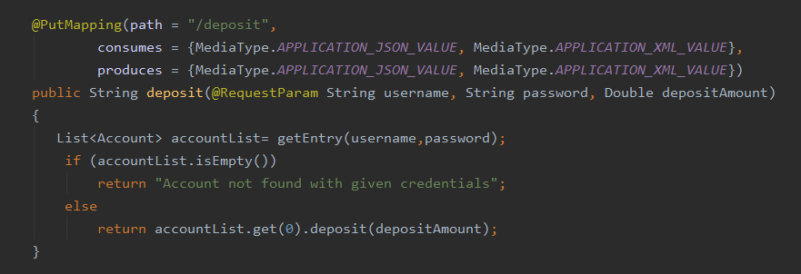

Figure 1: I use a single database which holds Hashmap of String (key) and Accounts (value). Key is the unique username of the account. The account is retrieved by getEntry(username, password) method.

### Withdraw

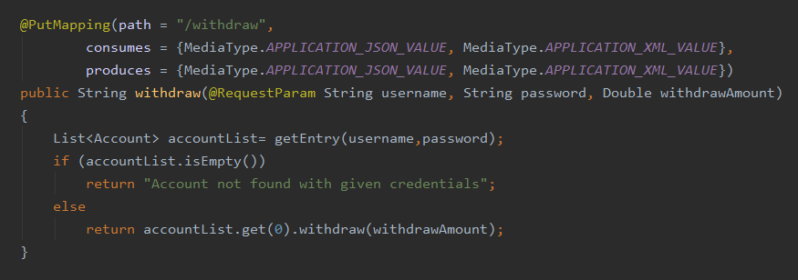

Figure 2: withdraw also uses getEntry(username, password) to retrieve the account from the database. It is then used to withdraw money from.

### Get Balance

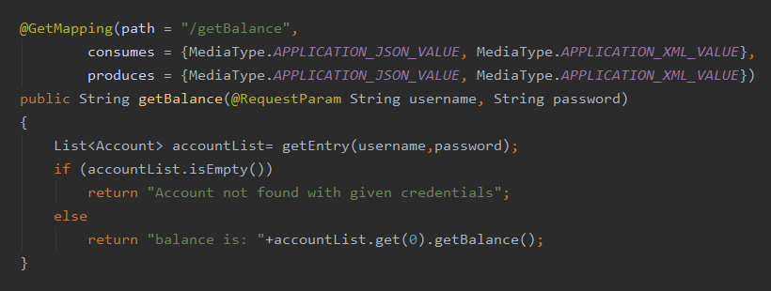

Figure 3: this method is like deposit/withdraw. It uses getEntry(username, password)

### GetEntry

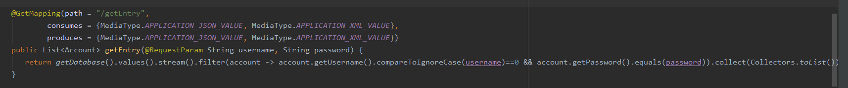

Figure 4: this method returns a list of all accounts which match with the given username and password. Of course, this would return a single account if any

### Spring Boot

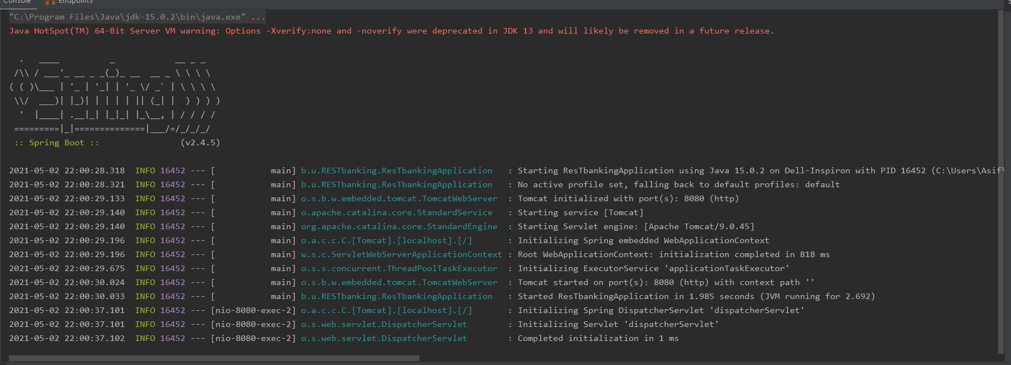

Figure 5: Spring boot server running on Java in IntelliJ IDE. The server listens to REST requests on HTTP port.

## Client

### Deposit

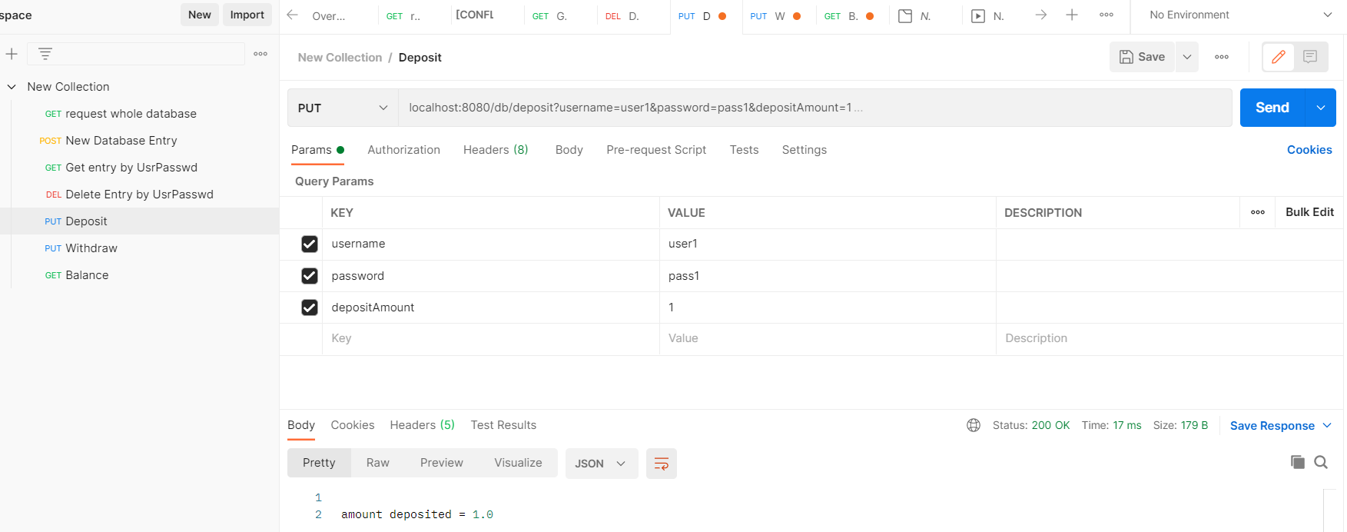

Figure 6: on client side (=Postman) one can deposit some amount on a bank account using PUT request. The deposit only succeeds if the username and password match.

### Withdraw

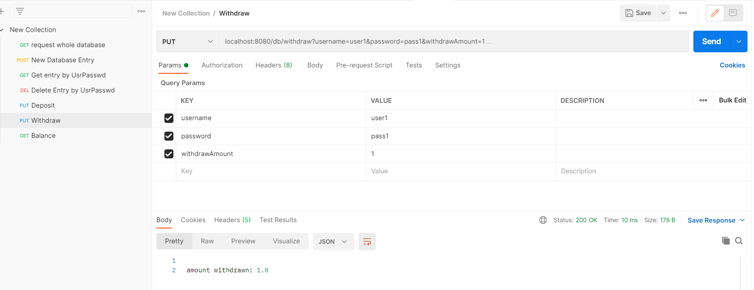

Figure 7: withdraw option uses PUT request. The authentication happens via username and password combination. Any amount higher than the balance cannot be withdrawn.

### Get balance.

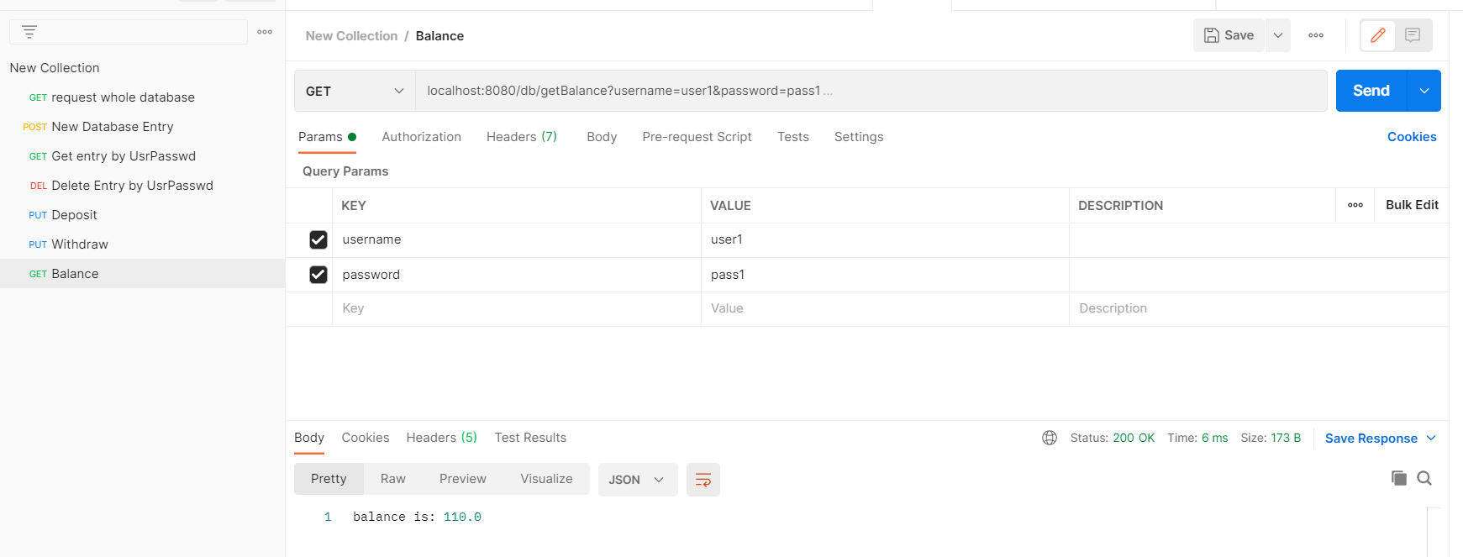

Figure 8: this GET request returns the balance of a bank account. Username and password are needed for login.

Multi-threading

|  |  |
| --- | --- |
| Figure 9: Here I use 10 deposit and 10 withdraw threads. These threads access the same account. The access to critical sections (withdraw and deposit methods) is protected by semaphores. |  |

# Session 3: Naming Server

## Hash function

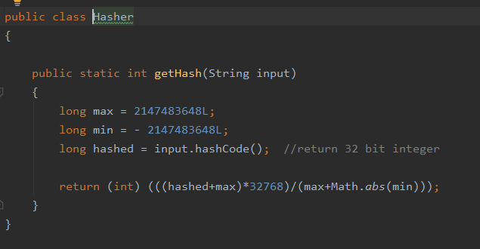

Figure 10: the hashing function maps values from min to max to range (0 to 32768)

## Add node.

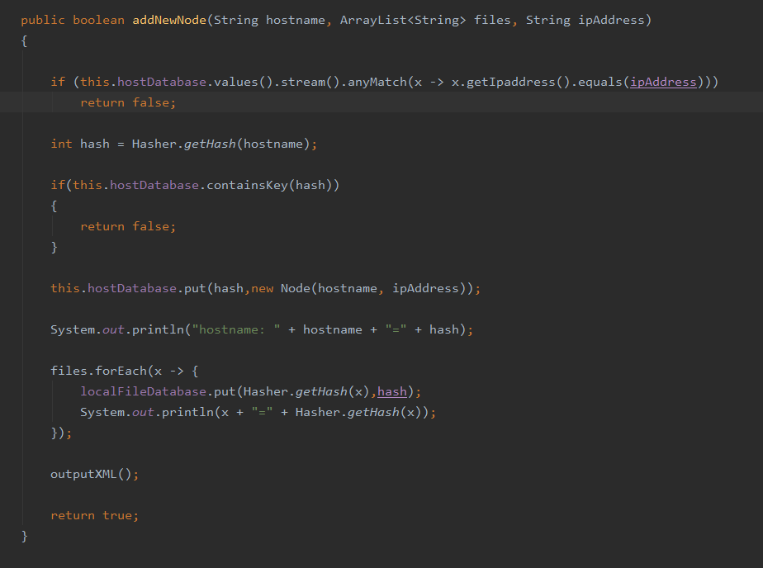

Figure 11: adding a new node needs node name, a list of files(s) it hosts, and IP address of the node. The name of node will be hashed and saved as a key in the hostDatabase HashMap (value= node itself). The localFileDatabase is used for files where the key= hash of filename and value is hash of hosting node name.

## Add node with existing node name.



Figure 12: if the node already exists (=the node name hash already exists) the method will return false and add this node to the database (=overwriting the existing one).

## Send a filename and the IP address.

## Send a filename with a hash smaller than the smallest hash of the nodes.

## Send a filename with filename and at the same time remove the node.

## Ask from two PCs for an IP address of a filename.

# Questions

1. Explain the steps on how you managed to push your code to remote repository on GitHub.

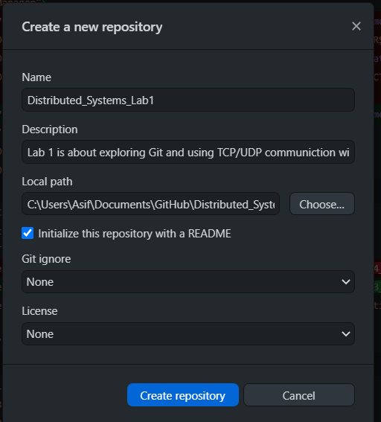

Figure 13: create a local repository on GitHub GUI. 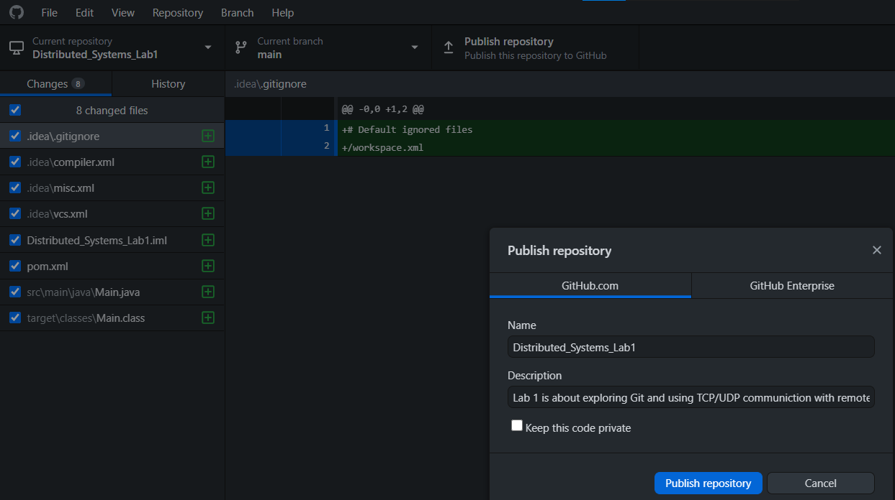

Figure 14: after creating the repository this can be made public by publishing it to remote repository.

1. What framework did you used to develop client-server application that communicates via TCP?

I used [Spring Boots](https://spring.io/projects/spring-boot) framework on server side which functions as a server. On client side I use [Postman](https://www.postman.com/).

1. Explain how you enabled multithreading.

I made a class ClientThread which implement extends Thread superclass. In the overridden “run” method of the classes I withdraw/deposit to an account whose username and password are passed as parameters. The deposit/withdraw amount is also given as parameter. The threads are created in Main class and run by Thread.start() method.

# GitHub Repo

## REST

<https://github.com/asifwasefi/Distributed_Systems_Lab2v2>

## Naming server

<https://github.com/TissieVA/Distributed-Systems>

# Bibliography

<https://spring.io/projects/spring-boot>

<https://www.postman.com/>

<https://docs.oracle.com/javase/7/docs/api/java/util/concurrent/Semaphore.html>

<https://www.geeksforgeeks.org/multithreading-in-java/>

<https://maven.apache.org/guides/getting-started/index.html#What_is_Maven>

<https://www.geeksforgeeks.org/multithreading-in-java/>