ARM
Command Line
Workbook

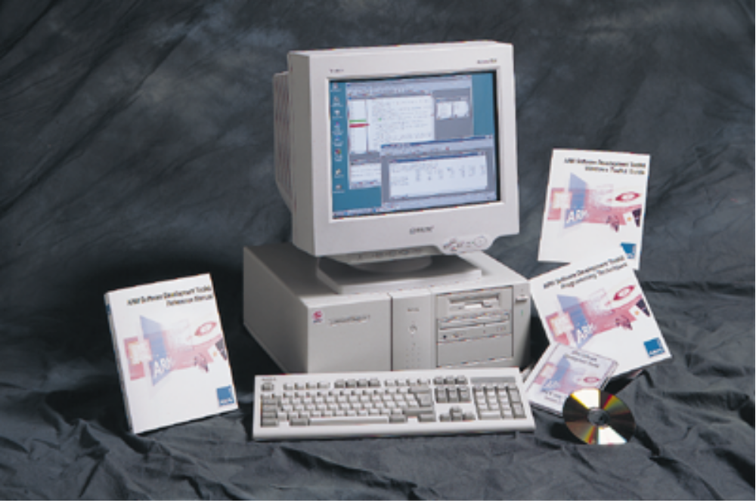

ARM University Program
Version 1.0
January 14, 1997

Introduction

Aim

This workbook provides the student with a basic understanding of the facilities provided by the ARM Toolkit for command line users.

Note : For all of the command line tools provided with the toolkit it is possible to get on-line help on the command line parameters by specifying the toolname followed by -help.

Compiler

The ‘Hello World’ example program is a simple C program which calls a subroutine. This program file can be found as
c:\work\cmd\hello.c

#include <stdio.h>

/* Declare subroutine before used by main */
void subroutine (void);

int main() {
printf("Hello World from main\n");
subroutine();
printf("And Goodbye from main\n");
return 0;
}

/* Define subroutine */
void subroutine() {
printf("Hello from subroutine\n");
}

Exercise 1.1

Compile this program with the ARM C compiler type
armcc -g hello.c

The C compiler automatically invokes the linker to produce an executable with the same name as the C module but with no file extension.

Thus this command will compile the C code, link with the default C library and produce an ARM Image Format (AIF) executable called hello.

Exercise 1.2

To specify a differently named executable then use the -o compiler option
armcc -g hello.c -o tester

Note : The -g option adds high level debugging information to the final object. If -g is not specified then the program will still produce the same results when executed but it will not be possible to see the source code in the debugger. This is discussed in more detail later.

To execute this program type
armsd hello
go
armsd responds with
Hello World from main
Hello from subroutine
And Goodbye from main
Program terminated normally at PC = 0x00008da8 (__rt_exit + 0x24)
+0024 0x00008da8: 0xef000011 .... : swi 0x11

Exercise 1.3

It is possible to produce an assembly language listing generated by the C compiler using the -S option. (Note : The -S is an upper case character.)
armcc -S hello.c

This command will produce an output file called hello.s which can be viewed using any text editor.

Multiple C Files

If multiple C files are used in an application then it is necessary to force the C compiler to simply produce a .o file (and not invoke the linker).

Exercise 1.6

Produce an object file only using the C compiler by typing
armcc -g -c hello.c

Look at the directory listing and check that a file named hello.o has recently been written.

Exercise 1.7

Create two new modules from the original hello.c program. The first module should contain all the original code but not the subroutine procedure. (Hint : You will need to declare the subroutine as an external procedure in the first module.) The second module should only contain the subroutine procedure.

(Hint : Two example modules called hello1.c and hello2.c are provided with the workbook with the required modifications already done.)

Now compile these two new modules using the ARM compiler.
armcc -g -c hello1.c hello2.c

Exercise 1.8

It is now necessary to link your two code modules with the appropriate C library. The C libraries can be found in the lib subdirectory of the toolkit installation. Thus if the toolkit is installed in c:\arm200, you would link with the appropriate library as follows: (Note that the ‘l’ signifies little-endian not the number one.)
armlink hello1.o hello2.o c:\arm200\lib\armlib.32l -o demo

The example links two source files with the 32-bit version of the C library and produces an executable output file called demo.

Exercise 1.9

Now load and run the demo program and see that the output is the same as that shown in exercise 1.2.

Assembler

Practical experience of ARM assembler command line usage is detailed in the ARM Assembler Workbook.

The ARM assembler is called
armasm

Debugger

The ARM symbolic debugger can be invoked from the command line by simply typing armsd. The user will then be greeted by the specifics of their version of the debugger followed by the armsd prompt.

It is possible to get on-line help from the debugger by issuing the help command. Further detail is available by specifying help followed by the particular help subject, for example, help break would provide a detailed description of the syntax and usage of the break command.

Hint : It is possible to shorten most of the commands used in the debugger. Issuing the help command displays the full list of available commands, with the minimum number of characters required for the command displayed in upper case.

Loading an executable into the debugger.

It is possible to specify the name of the executable being debugged upon invocation of the debugger.
armsd hello

Alternatively the executable can be loaded after the debugger had been started by using the load command.
armsd
load hello

To quit from the debugger issue the quit command:
quit

Viewing Source Code

In order to view source code it is necessary to have compiled or assembled the source code with the -g option.
armcc -g hello.c -o hello
armsd hello

Set a breakpoint on the first statement in function main and execute the program up to that point
break main ; go

Now view the C source
type

It is possible to list the C source from a particular line number
type 1

With the type command an error is reported if program execution is not currently within a source code module.
(The reload command will reload the object file specified on the armsd command line, or the last load command. Breakpoints (but not watchpoints) remain set after a reload command.)
reload
type
armsd responds with
** Error: No file

It is possible to look at the source code separately from within execution context by specifying the module filename and a start and end line.
type 1,10,hello.c

It is not necessary to specify the start and end lines to display.
type ,,hello.c
type 1,,hello.c

If the source code is in another directory then it is necessary to include either the full pathname or the relative pathname from the current directory
type 1,30,c:\work\cmd\hello.c
type 1,25,cmd\hello.c

Viewing assembler source code uses the same debugger command syntax.

Breakpoints

To view the current set of breakpoints the break command is issued without any parameters.
break
armsd responds with
#1 hw break main:7

To set a breakpoint on a procedure then the procedure name is required
break main

It is also possible to set a breakpoint on a procedure exit
break main:$exit

To set a breakpoint on a particular line within a source file it is possible to either specify the procedure name or the module name (preceded by a #) followed by the module line number.
(The following two commands will set a breakpoint on the same statement.)
break main:7
break #hello:7

If no compiled code exists for the source line then the debugger flags up the error
** Error: No code compiled for source line

Further Debugger Facilities

The following sections of this workbook also make use of another example program called trial.c. The program serves no real function, but simply acts as an example which can be used to set watchpoints and breakpoints on.

The initmem function is used to clear a block of memory.
The quickfunc function is a very simple function.
The results function is a demonstration of semi-hosting.

This file can be found at
c:\work\cmd\trial.c

#include <stdio.h>

#define BLOCKSTART (int *) 0x4000
#define BLOCKEND (int *) 0x4100
#define TESTADDR (int *) 0x4200

/* Memory Initialisation to Zero */

static void initmem()
{
int *i;
int a;

a = 0;
i=BLOCKSTART;

do {
*i++ = 0;
a++;
} while (i<BLOCKEND);

}

static void results()
{
printf("The memory area has now been cleared.\n");
}

static void quickfunc(int a, int b, int c)
{
int x,y,z;
x = 3;
y = 4;
z = x * y;
x = (z << 8) + y;
}

int main()
{
int *datablock;
int a,b,c;

datablock = BLOCKSTART;
a = 10;
b = 20;
c = 30;

initmem();
quickfunc(a,b,c);
quickfunc(b,c,a);
quickfunc(c,a,b);
results();
}

Complex breakpoints.

It is possible to specify the number of times a statement is to be executed before the application is suspended, the default of which is one.
armsd trial
break initmem:28 10
go
armsd responds with
Breakpoint #1 at #trial:initmem, line 28 of trial.c
28 *I++ = 0;

At this point the code statement displayed after the breakpoint has not been executed and will be the next statement to be executed.

To execute a debugger command (or commands) after a breakpoint has been reached then the commands must be enclosed in braces and follow the breakpoint definition.
(The where command displays the program position when the breakpoint is executed.)
break initmem:28 10 do {where; print a}
go

The breakpoint can also be conditionally defined by using the if clause.
(The following will stop program execution at line 28 of the module containing the initmem procedure, display the current program location and value of a, only if local variable a is greater than ten.)
break initmem:28 10 do {where; print a} if a > 10
go

To remove a breakpoint the number of the breakpoint must be specified preceded by a #
unbreak #1

Note : Breakpoints are not renumbered following deletion of other breakpoints. Once a breakpoint has been assigned a number it keeps it.

Viewing Memory Contents

The list command displays memory locations in instruction, hex and character format. It is possible to specify the size of the instruction followed by a start location and byte count. If the size is not defined then the debugger will attempt to guess the instruction size from the debugging information.
armsd hello
list 0x0
list @main,20
list 0x8000

Note : Low level symbols are differentiated from high-level ones by preceding them by an “@”. A low level symbol for a procedure refers to its call address, which is often the fist instruction of the stack frame initialisation. This differs from a high level symbol for a procedure which refers to the address of the code generated by the first statement in the procedure.

If source level debugging is enabled (by using the -g option) then it is not necessary to use the @ symbol
list subroutine,100

Examining Memory Locations

To view the contents of memory the examine command displays both hexadecimal and ASCII formats between a pair of addresses.
(The following will, by default, display128 bytes of memory.)
armsd trial
examine 0x4000

To view a larger section of memory then either it is possible to specify a number of bytes to be displayed, or an end address.
examine 0x4000,+300
examine 0x4000,+0x300
examine 0x4000,0x4500

Watchpoints

To set watchpoints on memory locations and variables use the watch command.
(The following sets two watchpoints; the first on the local variable a in the initmem procedure, and the second on the memory location 0x4000.)
armsd trial
break initmem
go
watch 0x4000
watch a
go
armsd responds with
Watchpoint #2 at a changed at #trial:initmem, line 24 of trial.c
24 a = 0;

Unlike breakpoints, the statement displayed when a watchpoint is taken has been executed, and was the statement that caused the change to the variable or memory location.

To view the watchpoints which have been set simply type watch with no parameters
watch
armsd responds with
#1 sw at 0x4000
#2 sw at a

Using these watchpoint numbers it is possible to delete the watchpoint
unwatch #2

Complex Watchpoints

Watchpoints can be conditionally executed and perform debugger commands in the same way as breakpoints.
(The following will stop program execution when the value in local variable a has changed twenty times, only if the value in a is less than 100.)
watch a 20 do {print a} if a < 100

Accessing variables, registers and arguments

The print command examines the contents of the applications variables, or displays the result of arbitrary calculations involving variables and constants. It is possible to change the default display format by specifying a display format immediately after the print command.
print a
print/%x a
print BLOCKEND
print/%d BLOCKEND
print/%x a * BLOCKEND
print I

To view a list of local variables (symbols) from within a procedure, type
symbols

To view a list of the global variables then the module name must be specified
symbols trial

To view a list of procedure parameters from outside the execution context then the procedure name must be specified.
symbols quickfunc

It is possible to view all of the registers:
reg

This will display the register R0 to R15 and the CPSR. The CPSR shows the current status flags, and the interrupt disable flags plus a textual description of the current mode. The flag characters in lower-case signify that the flag bit is unset, with an upper-case character signifying that the bit is set.

To view the banked registers for a different mode then the mode must be specified:
reg IRQ32

Typical mode definitions are USER32, SVC32, IRQ32, FIQ32, ABORT32, SYSTEM32 and UNDEF32. The textual description for the mode can be in upper or lower case.

During debugging it is often necessary to change the value contained in a variable or register. This is possible using the let command (although it is not necessary to actually specify let.)
reload ; go
let r0 = 10
reg
let a = 20
print a
a = 25
print a

Similarly, it is possible to change to value of the CPSR.
(The following will set the Negative and Zero conditional flags in the CPSR and set the mode to FIQ mode.)
cpsr = %NZ_fiq32

Similarly it is possible to modify the value of the SPSR when it a privileged mode.
spsr = %IF_IRQ32

To view the values of any arguments passed into a procedure from anywhere within the execution context of the procedure use the arguments command
quit
armsd trial
break quickfunc
go
arguments

Stepping through applications

The step command steps through one of more application statements. To actually step into a procedure from the calling line step in must be specified.
(The following instruction sequence steps through the local variable initialisations then steps into the initmem procedure.)
quit
armsd trial
break main
go
step 5
step in

To step back out of a procedure (to the line of code which follows the originating procedure call) type
step out

To step through instructions as opposed to statements then set the language to none or use the istep command
reload ; go
language none
step

When using the istep command the debugger will still only display the source code and will display the same source line if several instructions are associated with it. To view each step then the list command must be issued. It is still necessary to use istep in to follow a branch with link instruction.
(Note that after a reload the language setting is reset.)
reload; go
istep 4
istep in
istep
list
istep ; list

To see what the language setting is type
language

To actually display source code statements interleaved with ARM assembler instructions, type
istep in; list ^pc,+4

This is quite a verbose command to have to type in so it is best to use the alias command and assign the full command to, for example, an unused character
alias f "istep in; list ^pc,+4"

From then on simply typing f will perform the desired command.

To list the aliases that have been set up just type alias with no parameters.
alias

DECAOF - Decode AOF

When a ARM Object Format object has been produced by the compiler or assembler it is possible to decode this and examine the output.
(The following will produce decoded output, showing disassembled code areas, from the file hello.o)
decaof -c hello.o

To redirect the output to another file type which can be viewed by any text editor
decaof -c hello.o > hello.decaof

