ARM
Windows Toolkit
Workbook

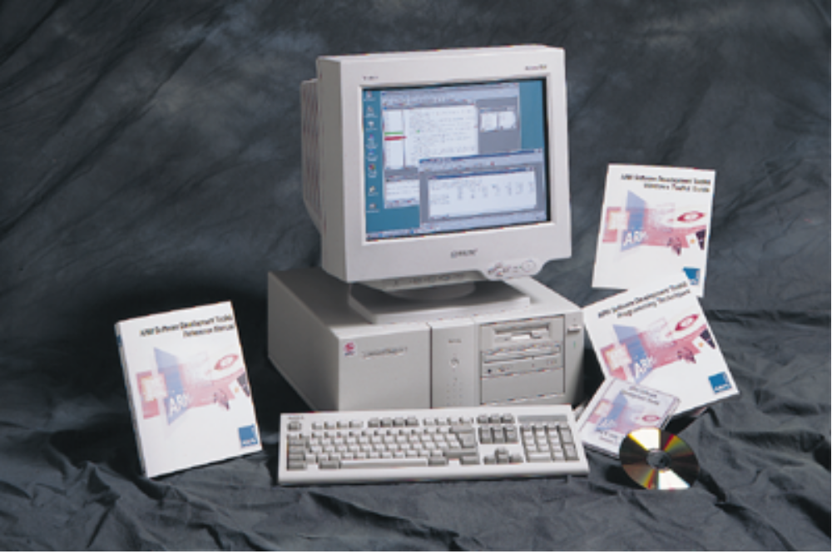

ARM University Program
Version 1.0
January 14th, 1997

Introduction
This workbook introduces the ARM Windows Toolkit which has been added to the ARM Software Development Toolkit, as from v2.00.

The ARM Project Manager
The ARM Project Manager (APM) takes over the operations of armmake and provides transparent use of armcc, armasm, armlib and armlink. Instead of makefiles, the APM has the concept of projects, where a project contains a list of the source files that make up your program, and all of the options that are required to create an image or library.

The ARM Debugger for Windows
The ARM Debugger for Windows (ADW) provides a simple point-and-click interface onto the ARM Debugger ToolBox (also used by armsd). It provides a visual representation of the program being debugged, and allows a user to start working on the debugging task immediately without the need to learn many complex commands.

The Example
This introductory example first makes use of the APM to build an image from some source files. Any compilation errors reported will then be removed using the built-in editor. Finally ADW will be used to remove any logic errors that may have crept into the program. Thus while the example is very simple it highlights some important aspects of the ARM Windows Toolkit and software development in general.

The example requires two components to be built: A library (LIB.APJ) and the final image (EXAMPLE1.APJ) which will make use of the library.

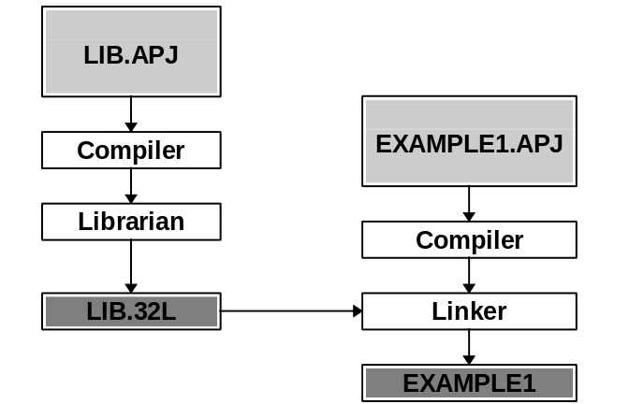

Creating LIB.APJ
1. Start the ARM Project Manager by double-clicking on the ARM Project Manager icon in the Program Manager or single-click from the Start menu on Windows 95.
2. Choose File->New from the menu. Enter the following ‘C’ function:

/* lib.c */

#include <stdio.h>
#include "lib.h"

void print(char* szText)
{
printf("Print Lib: %s\n", szText);
}

3. Choose File->Save as from the menu.
Move through the directory structure to: C:\WORK\WWB\
and enter the filename: LIB.C
Choose ‘OK’ to overwrite (if necessary).

4. Choose Project->New from the menu.
Enter the name: C:\WORK\WWB\LIB.APJ
Choose ‘OK’ to overwrite (if necessary).

5. Press the ‘Add...’ button in the Edit Project Dialog that should now be displayed.
Double-click on ‘LIB.C’
Choose ‘OK’ in the Edit Project Dialog.

6. Select ‘Yes’ to re-display the project summary

7. Select Options->Project from the menu.

8. Use the drop-down list next to ‘Project Type:’ to select ARM Object Library Format.

9. Choose OK.

10. Press the Rebuild-All button on the Toolbar (use the ToolTips to find it!).
The project should build with the following messages:

Building...
ARMCC C:\WORK\WWB\LIB.C
Creating Library (C:\WORK\WWB\LIB.32L) ...
Build Complete.

Creating EXAMPLE1.APJ
1. Choose Project->New from the menu.
Enter the name: C:\WORK\WWB\EXAMPLE1.APJ
Choose ‘OK’ to overwrite (if necessary).

2. Press the ‘Add...’ button in the Edit Project Dialog that should now be displayed.
Double-click on ‘EXAMPLE1.C’
Click ‘Add...’ again.
Now, using the Drop-down list, select ‘List Files of Type: Libraries’
Double-click on ‘LIB.32L’
Choose ‘OK’ in the Edit Project Dialog.

3. Select ‘Yes’ to re-display the project summary

4. Choose OK.

5. Try selecting Project->Show Dependencies from the menu.

6. Press the Rebuild-All button on the Toolbar (use the ToolTips to find it!).
The project should build with the following messages:

Building...
ARMCC C:\WORK\WWB\EXAMPLE1.C
"C:\WORK\WWB\EXAMPLE1.C", line 13: Error: undeclared name, inventing 'extern int HASH_DEFINED'
"C:\WORK\WWB\EXAMPLE1.C", line 13: Error: <function argument>: implicit cast of non-0 int to pointer
"C:\WORK\WWB\EXAMPLE1.C", line 17: Error: expected ')' or ',' - inserted ')' before ';'
C:\WORK\WWB\EXAMPLE1.C: 0 warnings, 3 errors, 0 serious errors
Build Unsuccessful

7. Press F4 to move to the first error in the list. The ARM Project Manager will load the correct source file, and select the line that caused the error.
You will find that there is nothing wrong with the code!

The source contains a reference to the macro ‘HASH_DEFINED’ which has not been defined within any of the source files. Normally a command-line parameter would have to be added to ARMCC to specify:
-DHASH_DEFINED=“Defined\n”

Within the ARM Project Manager, simply select Project->Edit.
Select example1.c and click ‘Edit Params...’
Type in the following:
-DHASH_DEFINED=“Defined\n”
and press RETURN.
Click on ‘OK’ in the Edit Project Dialog, then rebuild the project using Rebuild-All.

The project should build with the following messages:
Building...
ARMCC C:\WORK\WWB\EXAMPLE1.C
"C:\WORK\WWB\EXAMPLE1.C", line 17: Error: expected ')' or ',' - inserted ')' before ';'
C:\WORK\WWB\EXAMPLE1.C: 0 warnings, 1 error, 0 serious errors
Build Unsuccessful

8. Press F4 to move to the first error in the list. Again, the ARM Project Manager will load the correct source file, and select the line that caused the error. This time, there is something wrong with the code! There is a close bracket missing. the line should read:

print(“Hello, World - From the Library!”);

Correct the error, by adding the missing bracket, and then press Rebuild All again.
Click on ‘Yes’ to instruct the ARM Project Manager to save the changed source.

The project should build with the following messages:

Building...
ARMCC C:\WORK\WWB\EXAMPLE1.C
Linking (C:\WORK\WWB\EXAMPLE1) ...
code inline inline 'const' RW 0-Init debug
size data strings data data data data
Object totals 256 0 144 0 0 0 2156
Library totals 12884 188 684 128 512 1104 2012
Grand totals 13140 188 828 128 512 1104 4168
Build Complete.

Executing Example1
1. Click on the ‘Execute’ toolbar icon. This will load the ARM Debugger for Windows, and run the image that the ARM Project Manager has just built.

You will notice that StringFunction() has returned the same value twice. This is not the required behaviour.

2. Quit the ARM Debugger for Windows by selecting File->Exit.

Debugging Example1
1. Press the ‘Debug’ icon on the Toolbar of the ARM Project Manager. This time the ARM Debugger for Windows is invoked, and the image loaded ready for debugging.

The ARM Debugger for Windows will have set a breakpoint on ‘main’ so that if you select ‘Go’ from the toolbar execution will halt on the entry to the main function in EXAMPLE1.C.

Do this now.

2. Find the function called ‘StringFunction()’ either by Selecting View->Function Names, and double-clicking the ‘StringFunction’ entry. Or by scrolling the Execution Window manually.

3. Set a breakpoint on the ‘switch’ statement by positioning the cursor on the line and clicking on the ‘Toggle breakpoint’ icon on the toolbar (use those ToolTips!).

4. Select Execute->Go from the menu, or click the ‘Go’ toolbar icon.

The ARM Windows Debugger will stop on the switch statement, and report to you that it has stopped on a breakpoint by displaying a message in the Status Bar.

5. Display the local variables by selecting View->Variables->Local. A new window will open showing the two local variables: nNum and szString.

StringFunction() handles two cases, and since we wish to see both, the program must first follow the first case, and then the second. As you can see the number nNum is initially 1, so this execution should take the first path.
6. Select ‘Go’ again and look at the Console Window.

The ARM Debugger for Windows will have stopped a second time on the same breakpoint as before. Look at the local variables; again nNum is 1 but we want it to be 2.

To change the contents of a local variable, simply double-click on the VALUE you wish to change, and enter the new value into the dialog that is displayed.

Once you have changed nNum to 2, press ‘Go’ again. Again, look at the Console Window to view the program output. This time, correctly, StringFunction() has returned two different values.

7. You can quit the ARM Debugger for Windows, by selecting File->Exit, and go back to the ARM Project Manager. In the ARM Project Manager, click on the EXAMPLE1.APJ Window. Click on the ‘Show Project’ toolbar button.

The ARM Project Manager will now ask if it is OK to clear the project output window. Answer ‘YES’ to the question.

8. You now need to correct line 28 of EXAMPLE1.C to contain a 2 instead of a 1. Double-click on the line that contains: EXAMPLE1.C , this will open the source file ‘EXAMPLE1.C’.

Now we need to find line 28 in the source file. Select Edit->Go To...
Type in ‘28’ and click on ‘OK’

The editor cursor will now be positioned at the following line of code:
StringFunction(1, szText);

Using the editor, change the line to read:
StringFunction(2, szText);

9. Once you have done this, click on the ‘Rebuild All’ toolbar button.
(Answer ‘YES’ to save the modified file)

10. After the project has built successfully, click the ‘Execute’ toolbar button.

Once the ARM Debugger for Windows has loaded and run the EXAMPLE1
image, review the Console Window. It should contain something like the
following:

Defined
Print Lib: Hello, World - From the Library!
Another Line.
StringFunction() returned: 'ARM Project Manager'
StringFunction() returned: 'ARM Software Development Toolkit v2.00'
Quit the ARM Debugger for Windows by selecting File->Exit.

