ROBIL INTEGRATION TEST PLAN

Table of Contents
1 Milestone stage 1 - basic skills 3
1.1 Test Name : Skil1 3
1.2 Test Name : Skil2 8
1.3 Test Name : Skill2B 11

Milestone stage 1 - basic skills
Test List :

Test Name : Skil1
Test ID :2
Subject : Milestone stage 1 - basic skills
Status : Design
Designer : istern
Creation Date : 27/12/2012
Type : MANUAL
Description : Skill 1: Stand stable, turn in place, receive ground and obstacle map and plan path to target

Execution Status : No Run
Entry Criteria : 1. Tasks:
1 LocalizationTrack - C25 tracks robot position in 3D environment, fails when it's no longer possible to do so (not when localization is bad)
2 ObstacleDetection - C24 detects obstacles in 3D, fails when it's no longer possible to detect objects
3 PathPlanning - C31 calculates paths on occupancy grids, fails when it's no longer possible to do so
4 PathPlanningFocus(??) - C31 Path planner should set the planning for ??
5 C45_PostureControl(direction=1) - C45 turns torso 60 degrees left
7 C45_PostureControl(direction=0) - C45 turns torso back to center
8 C45_PostureControl(direction=-1) - C45 turns torso 60 degrees right
See attached file skil1 Tree

World : skill1.world

Attachments :
Reference Name: TEST_2_qc_snapshot_1.jpg
Reference Description: Stand stable, turn in place, receive ground and obstacle map and plan path to target - skil1 Tree

File:
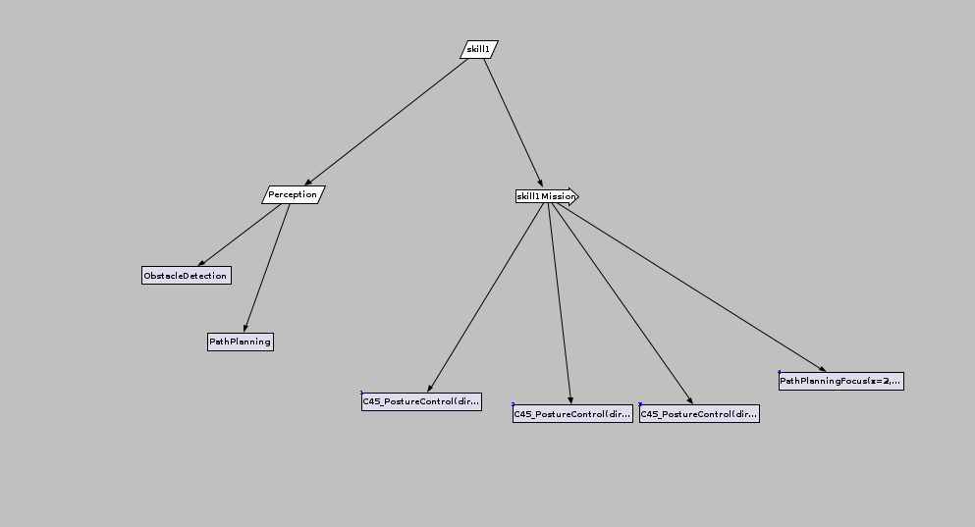

Steps :
Step Name | Description | Expected Result
Step 1- Create –skill1 treeCreate – skill1 Tree  Upload the designer:  roslaunch C34_Designer start.launch  Open an xml tree-file.  Enter a sequencers and tasks(steps) in order to build a tree (as in the Entry Criteria and the attached file)  Compile and Run the tree | Created skill1.xml file
Step 3 - Run Simulator | Upload the simulator with the appropriate world  roslaunch atlas_utils atlas.launch gzworld:=skill1.world | The Robot Stand stable in skill1.world
Step 4 - Stand stable | Verify Stabilize robot for 10 minutes (without moving) | Stabilize robot for 10 minutes (without moving)
Step 5 | Stop the tree | The robot stay stable
Step 6 | Verify the receiving pic at Rviz are the expected world | the receiving pic at Rviz are the expected world
Step 7 - Stand stable - while moving torso and Turn torso from side to side | Run the skil1 tree until the C45_PostureControl <direction=1> has been executed | The robot turn left, stay stable and the receiving pic at Rviz are the expected world
Step 8 | Run the skill tree again until the C45_PostureControl < direction=0> has been executed | The robot return to Center, stay stable and the receiving pic at Rviz are the expected world
Step 9 | Run the skill tree until the C45_PostureControl < direction=-1> has been executed | The robot return to right, stay stable and the receiving pic at Rviz are the expected world
Step 11 - Receive ground and obstacle map and Plan path to target | Run the skill tree to end
Step 12 | Verify that the PathPlannig Focus receive the expected obstacle map | that the PathPlannig Focus has received the expected obstacle map

Test Name : Skil2
Test ID :3
Subject : Milestone stage 1 - basic skills
Status : Design
Designer : istern
Creation Date : 27/12/2012
Type : MANUAL
Description : Skill 2: Sit inside vehicle, receive ground and obstacle map, and plan path to target

Execution Status : No Run
Entry Criteria : Tasks:
1 LocalizationTrack - C25 tracks robot position in 3D environment, fails when it's no longer possible to do so (not when localization is bad)
2 ObstacleDetection - C24 detects obstacles in 3D, fails when it's no longer possible to detect objects
3 PathPlanning - C31 calculates paths on occupancy grids, fails when it's no longer possible to do so
4 PathPlanningFocus(??) - C31 Path planner should set the planning for ??
See attached file skil2 Tree

World : atlas_golf_cart_fire_hose.world

Attachments :
Reference Name: TEST_3_qc_snapshot_1.jpg
Reference Description: Sit inside vehicle,receive ground and obstacle map, and plan path to target - skil2 Tree

File:
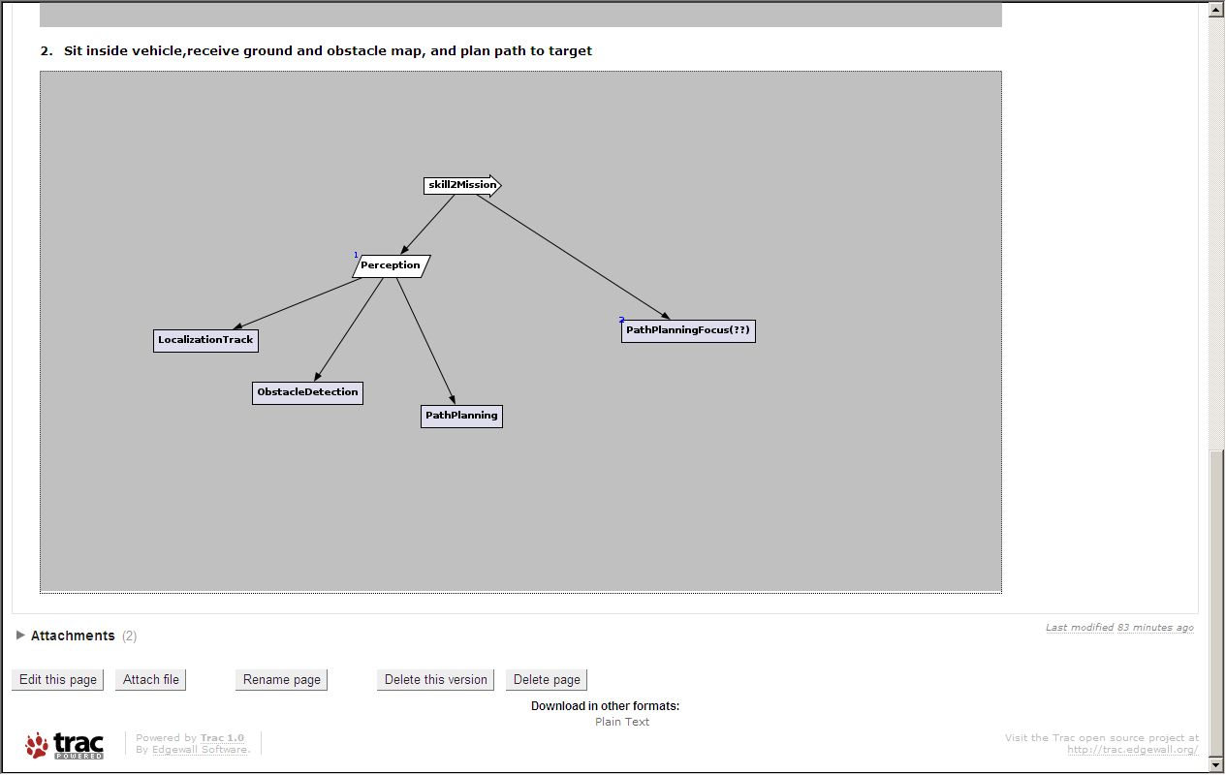

Steps :
Step Name | Description | Expected Result
Step 1- Create skill2.xml file | Create -skill2 treeCreate – skill2 Tree  Upload the designer:  roslaunch C34_Designer start.launch  Open an xml tree-file.  Enter a sequencers and tasks(steps) in order to build a tree (as in the Entry Criteria and the attached file)  Compile and Run the tree | Skill2.xml file created.
Step 3 - Run Simulator | Upload the simulator with the appropriate world  roslaunch atlas_utils atlas_golf_cart_fire_hose.launch | The Robot Stand stable in world  atlas_golf_cart_fire_hose.world
Step 4 - place robot inside vehicle (pinned) | Activate the relevant topic (according the Tutorial):  rostopic pub --once /drc_world/robot_enter_car geometry_msgs/Pose '{position: {x: 0, y: 0, z: 0}, orientation: {w: 1, x: 0, y: 0, z: 0}}' | The robot sit in the vehicle at the driver seat
Step 5 - Receive ground and obstacle map and Plan path to target | Run the skil2 tree to end | The robot sit in the vehicle, stay stable and the receiving pic at Rviz are the expected world
Step 6 | Verify that the PathPlannig Focus receive the expected obstacle map | that the PathPlannig Focus has received the expected obstacle map

Test Name : Skill2B
Test ID :4
Subject : Milestone stage 1 - basic skills PLUS
Status : Design
Designer : istern
Creation Date : 15/01/13
Type : MANUAL
Description : Skill 2B: Sit inside vehicle activating module C46, receive ground and obstacle map, and plan path to target

Execution Status : No Run
Entry Criteria : Tasks:
1 LocalizationTrack - C25 tracks robot position in 3D environment, fails when it's no longer possible to do so (not when localization is bad)
2 ObstacleDetection - C24 detects obstacles in 3D, fails when it's no longer possible to detect objects
3 PathPlanning - C31 calculates paths on occupancy grids, fails when it's no longer possible to do so
4 PathPlanningFocus(??) - C31 Path planner should set the planning for ??
5.MountVehicle(param=Mount) – C46 Mount Vehicle
See attached file skill2B Tree

World : atlas_golf_cart_fire_hose.world

Attachments :
Reference Name: TEST_3_qc_snapshot_1.jpg
Reference Description: Sit inside vehicle using C46 module, receive ground and obstacle map, and plan path to target - skill2B Tree

File:
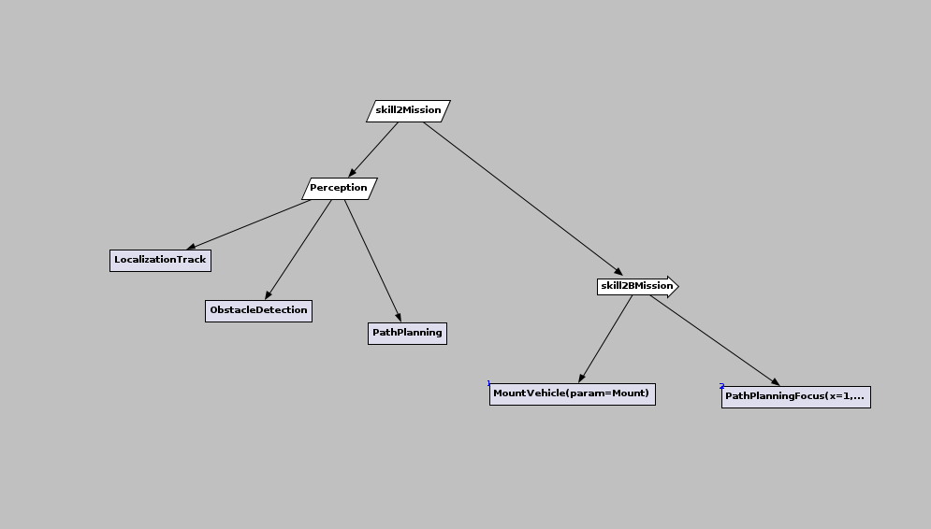

Steps :
Step Name | Description | Expected Result
Step 1- Create -skill2B treeCreate – skill2B Tree  Upload the designer:  roslaunch C34_Designer start.launch  Open an xml tree-file.  Enter a sequencers and tasks(steps) in order to build a tree (as in the Entry Criteria and the attached file)  Compile and Run the tree | Step 1- Create -skill2B treeCreate – skill2B Tree  Upload the designer:  roslaunch C34_Designer start.launch  Open an xml tree-file.  Enter a sequencers and tasks(steps) in order to build a tree (as in the Entry Criteria and the attached file)  Compile and Run the tree | Skill2B created
Step 3 - Run Simulator | Upload the simulator with the appropriate world  roslaunch atlas_utils atlas_golf_cart_fire_hose.launch  Run all the relevant modules: C21, C22, C24, C25, C31, C34, C46 | The Robot Stand stable in world atlas_golf_cart_fire_hose.world
Step 4 - place robot near the door of the vehicle (pinned) | Activate the relevant topic (according the Tutorial):  rostopic pub --once /drc_world/robot_exit_car geometry_msgs/Pose '{position: {x: 0, y: 0, z: 0}, orientation: {w: 1, x: 0, y: 0, z: 0}}' | The robot stands outside the vehicle near the driver door
Step 5 - Receive ground and obstacle map and Plan path to target | Run the skill2B tree to end | The robot sit in the vehicle, stay stable and the receiving pic at Rviz are the expected world
Step 6 | Verify that the PathPlannig Focus receive the expected obstacle map | that the PathPlannig Focus has received the expected obstacle map

