ROBIL INTEGRATION TEST PLAN

Table of Contents
1 Milestone stage 1 - basic skills 3
1.1 Test Name : Skil1 3
1.2 Test Name : Skil2 8
1.3 Test Name : Skill2B 11

Milestone stage 1 - basic skills
Test List :

Test Name : Skil1
Test ID :2
Subject : Milestone stage 1 - basic skills
Status : Design
Designer : istern
Creation Date : 27/12/2012
Type : MANUAL
Description : Skill 1: Stand stable, turn in place, receive ground and obstacle map and plan path to target

Execution Status : No Run
Entry Criteria : 1. Tasks:
1 LocalizationTrack - C25 tracks robot position in 3D environment, fails when it's no longer possible to do so (not when localization is bad)
2 ObstacleDetection - C24 detects obstacles in 3D, fails when it's no longer possible to detect objects
3 PathPlanning - C31 calculates paths on occupancy grids, fails when it's no longer possible to do so
4 PathPlanningFocus(??) - C31 Path planner should set the planning for ??
5 C45_PostureControl(direction=1) - C45 turns torso 60 degrees left
7 C45_PostureControl(direction=0) - C45 turns torso back to center
8 C45_PostureControl(direction=-1) - C45 turns torso 60 degrees right
See attached file skil1 Tree

World : skill1.world

Attachments :
Reference Name: TEST_2_qc_snapshot_1.jpg
Reference Description: Stand stable, turn in place, receive ground and obstacle map and plan path to target - skil1 Tree

File:
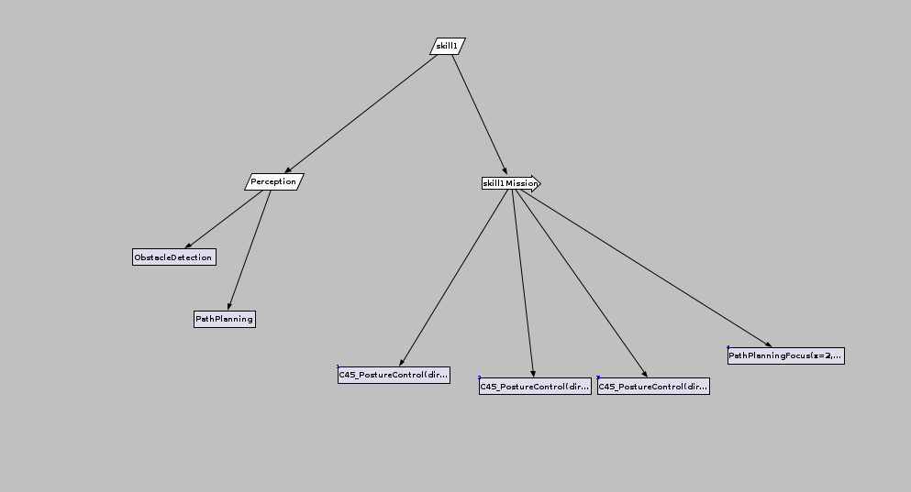

Steps :
Step Name | Description | Expected Result
Step 1- Create –skill1 treeCreate – skill1 Tree  Upload the designer:  roslaunch C34_Designer start.launch  Open an xml tree-file.  Enter a sequencers and tasks(steps) in order to build a tree (as in the Entry Criteria and the attached file)  Compile and Run the tree | Created skill1.xml file
Step 3 - Run Simulator | Upload the simulator with the appropriate world  roslaunch atlas_utils atlas.launch gzworld:=skill1.world | The Robot Stand stable in skill1.world
Step 4 - Stand stable | Verify Stabilize robot for 10 minutes (without moving) | Stabilize robot for 10 minutes (without moving)
Step 5 | Stop the tree | The robot stay stable
Step 6 | Verify the receiving pic at Rviz are the expected world | the receiving pic at Rviz are the expected world
Step 7 - Stand stable - while moving torso and Turn torso from side to side | Run the skil1 tree until the C45_PostureControl <direction=1> has been executed | The robot turn left, stay stable and the receiving pic at Rviz are the expected world
Step 8 | Run the skill tree again until the C45_PostureControl < direction=0> has been executed | The robot return to Center, stay stable and the receiving pic at Rviz are the expected world
Step 9 | Run the skill tree until the C45_PostureControl < direction=-1> has been executed | The robot return to right, stay stable and the receiving pic at Rviz are the expected world
Step 11 - Receive ground and obstacle map and Plan path to target | Run the skill tree to end
Step 12 | Verify that the PathPlannig Focus receive the expected obstacle map | that the PathPlannig Focus has received the expected obstacle map

Test Name : Skil2
Test ID :3
Subject : Milestone stage 1 - basic skills
Status : Design
Designer : istern
Creation Date : 18/02/2013
Type : MANUAL
Description : Skill 4: Sit inside vehicle, receive ground and obstacle map, and plan path to target

Execution Status : No Run
Entry Criteria : Tasks:
1 LocalizationTrack - C25 tracks robot position in 3D environment, fails when it's no longer possible to do so (not when localization is bad)
2 ObstacleDetection - C24 detects obstacles in 3D, fails when it's no longer possible to detect objects
3 PathPlanning - C31 calculates paths on occupancy grids, fails when it's no longer possible to do so
4 PathPlanningFocus(??) - C31 Path planner should set the planning for ??
See attached file skil2 Tree

World : atlas_golf_cart_fire_hose.world

Attachments :
Reference Name: TEST_3_qc_snapshot_1.jpg
Reference Description: Sit inside vehicle,receive ground and obstacle map, and plan path to target - skil2 Tree

File:
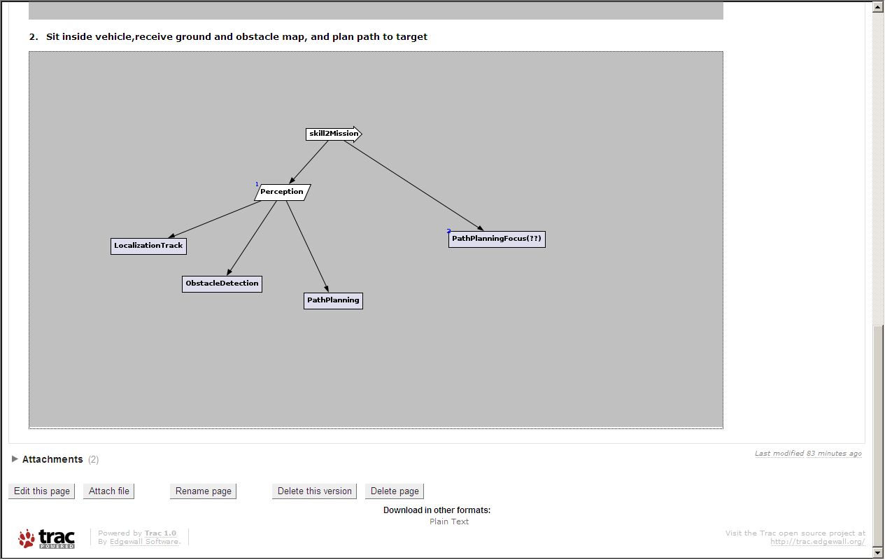

Steps :
Step Name | Description | Expected Result
Step 1- Create skill2.xml file | Create -skill2 treeCreate – skill2 Tree  Upload the designer:  roslaunch C34_Designer start.launch  Open an xml tree-file.  Enter a sequencers and tasks(steps) in order to build a tree (as in the Entry Criteria and the attached file)  Compile and Run the tree | Skill2.xml file created.
Step 3 - Run Simulator | Upload the simulator with the appropriate world  roslaunch atlas_utils atlas_golf_cart_fire_hose.launch | The Robot Stand stable in world  atlas_golf_cart_fire_hose.world
Step 4 - place robot inside vehicle (pinned) | Activate the relevant topic (according the Tutorial):  rostopic pub --once /drc_world/robot_enter_car geometry_msgs/Pose '{position: {x: 0, y: 0, z: 0}, orientation: {w: 1, x: 0, y: 0, z: 0}}' | The robot sit in the vehicle at the driver seat
Step 5 - Receive ground and obstacle map and Plan path to target | Run the skil2 tree to end | The robot sit in the vehicle, stay stable and the receiving pic at Rviz are the expected world
Step 6 | Verify that the PathPlannig Focus receive the expected obstacle map | that the PathPlannig Focus has received the expected obstacle map

Test Name : Skill2B
Test ID :4
Subject : Milestone stage 1 - basic skills PLUS
Status : Design
Designer : istern
Creation Date : 15/01/13
Type : MANUAL
Description : Skill 2B: Sit inside vehicle activating module C46, receive ground and obstacle map, and plan path to target

Execution Status : No Run
Entry Criteria : Tasks:
1 LocalizationTrack - C25 tracks robot position in 3D environment, fails when it's no longer possible to do so (not when localization is bad)
2 ObstacleDetection - C24 detects obstacles in 3D, fails when it's no longer possible to detect objects
3 PathPlanning - C31 calculates paths on occupancy grids, fails when it's no longer possible to do so
4 PathPlanningFocus(??) - C31 Path planner should set the planning for ??
5.MountVehicle(param=Mount) – C46 Mount Vehicle
See attached file skill2B Tree

World : atlas_golf_cart_fire_hose.world

Attachments :
Reference Name: TEST_3_qc_snapshot_1.jpg
Reference Description: Sit inside vehicle using C46 module, receive ground and obstacle map, and plan path to target - skill2B Tree

File:
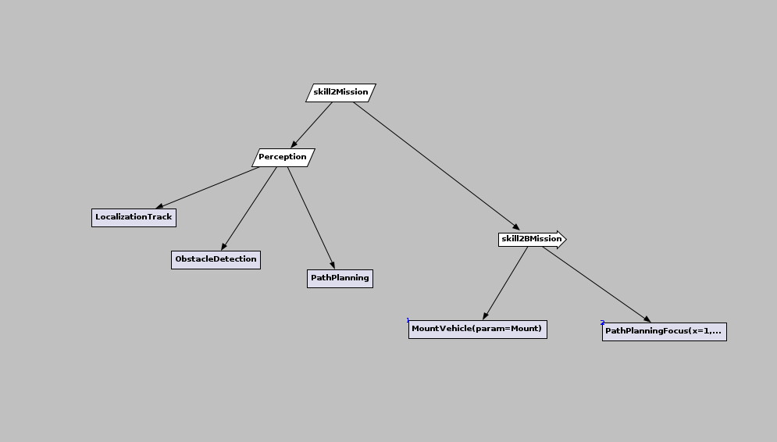

Steps :
Step Name | Description | Expected Result
Step 1- Create -skill2B treeCreate – skill2B Tree  Upload the designer:  roslaunch C34_Designer start.launch  Open an xml tree-file.  Enter a sequencers and tasks(steps) in order to build a tree (as in the Entry Criteria and the attached file)  Compile and Run the tree | Step 1- Create -skill2B treeCreate – skill2B Tree  Upload the designer:  roslaunch C34_Designer start.launch  Open an xml tree-file.  Enter a sequencers and tasks(steps) in order to build a tree (as in the Entry Criteria and the attached file)  Compile and Run the tree | Skill2B created
Step 3 - Run Simulator | Upload the simulator with the appropriate world  roslaunch atlas_utils atlas_golf_cart_fire_hose.launch  Run all the relevant modules: C21, C22, C24, C25, C31, C34, C46 | The Robot Stand stable in world atlas_golf_cart_fire_hose.world
Step 4 - place robot near the door of the vehicle (pinned) | Activate the relevant topic (according the Tutorial):  rostopic pub --once /drc_world/robot_exit_car geometry_msgs/Pose '{position: {x: 0, y: 0, z: 0}, orientation: {w: 1, x: 0, y: 0, z: 0}}' | The robot stands outside the vehicle near the driver door
Step 5 - Receive ground and obstacle map and Plan path to target | Run the skill2B tree to end | The robot sit in the vehicle, stay stable and the receiving pic at Rviz are the expected world
Step 6 | Verify that the PathPlannig Focus receive the expected obstacle map | that the PathPlannig Focus has received the expected obstacle map

Test Name : Skill4
Test ID :5
Subject : Milestone stage 1 - basic skills PLUS
Status : Design
Designer : istern
Creation Date : 15/01/13
Type : MANUAL
Description : Skill 4: Sit inside vehicle activating module C46, receive ground and obstacle map, and plan path to target, detect Wheel, Operate golf Cart (direct) from WP

Execution Status : Run
Entry Criteria : Tasks:
1 LocalizationTrack - C25 tracks robot position in 3D environment, fails when it's no longer possible to do so (not when localization is bad)
2 ObstacleDetection - C24 detects obstacles in 3D, fails when it's no longer possible to detect objects
3 PathPlanning - C31 calculates paths on occupancy grids, fails when it's no longer possible to do so
4 PathPlanningFocus(C31) - C31 Path planner should set the planning in the map
5.MountVehicle (C46)(param=Mount) – C46 Get the robot from standing outside the vehicle to a safe sitting position inside it.
6. GroundRecognition (C22) – C22 Ground recognition and mapping get ground position and surface shape
7. SearchObject (C23) – C23 Object Recognition - receives an object and tries to find it in the current image. Process image and provide detection of object and return localization data.
8. WayPointDriving (C51) – C51 Drive the car according way point, received from PathPlanning
9. InitDrive (C52) – C52 Check, that a gear is in the neutral/forward state and a car is ready to driving,
10. FinishDrive (C52) – C52 check that driving was finished
11. MonitorTime (C35) – C35 mission monitoring (decision making)

See attached file skill4 tree

World : atlas_golf_cart_fire_hose.world

Attachments :
Reference Name: TEST_4_qc_snapshot_1.jpg
Reference Description: Move the robot to vehicle direction, get it outside the vehicle, sit inside vehicle. Receive ground and obstacle map, and the drive plan. Drive path to target – skill4 Tree

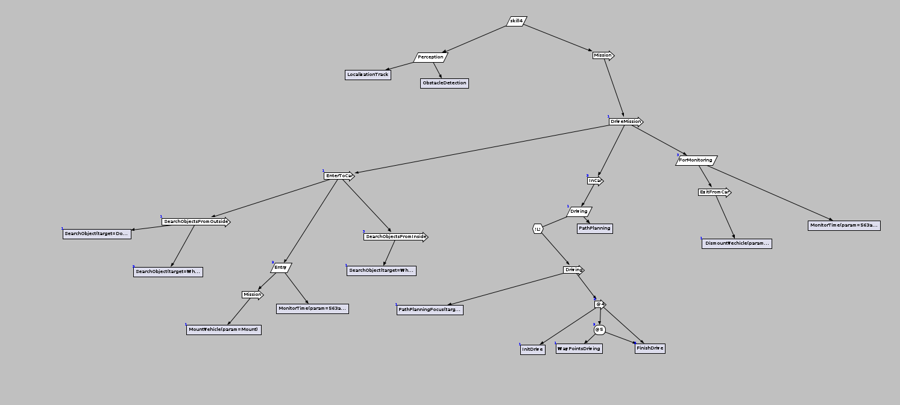
picture 4

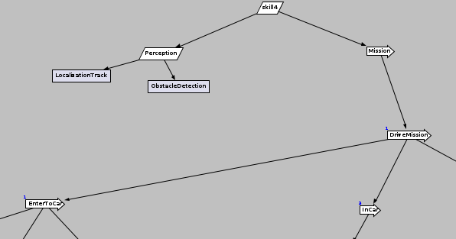
picture 4a (top skill)
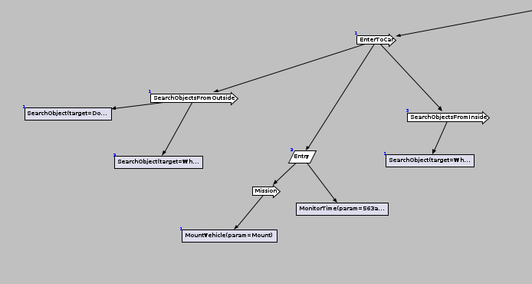
Picture 4b

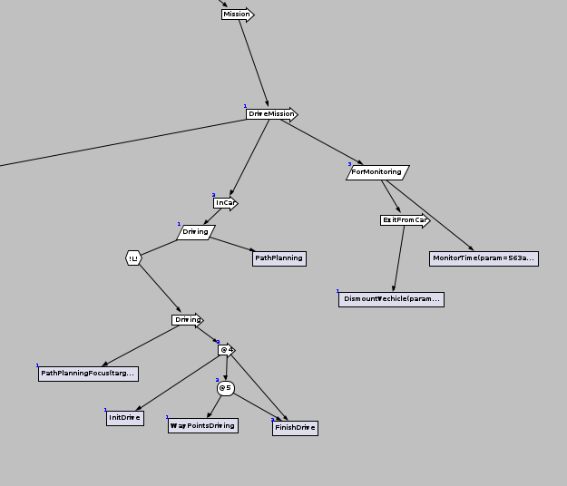
Picture 4c

Step Name | Description | Expected Result
Step 1-  The test preparation: create the tree, launch the designer, compile and run the tree. | Step 1- Create -skill4 treeCreate – skill4 Tree  Upload the designer:  roslaunch C34_Designer start.launch  Open an xml tree-file.  Enter a sequencers and tasks(steps) in order to build a tree (as in the Entry Criteria and the attached file)  Compile and Run the tree | - Skill4 created
Step 3 - Run Simulator | Upload the simulator with the appropriate world  roslaunch atlas_utils atlas_drc_vehicle_fire_hose.launch  Run all the relevant modules: C22, C23, C24, C25, C31, C34, C35, C46,C51, C52 | The Robot Stand stable in world atlas_golf_cart_fire_hose.world
Step 4 - place the robot 4 meters from the vehicle | Activate the relevant topic (according the Tutorial):  rostopic pub --once /drc_world/robot_exit_car geometry_msgs/Pose '{position: {x: 2, y: 2, z: 0}, orientation: {w: 1, x: 0, y: 0, z: 0}}' | The robot stands outside the vehicle by 4 meters offset (x=2, y=2)
Step 5 - Receive ground and obstacle map and Plan path to vehicle | Run the skill4 tree: perception and mission branches simultaneously. Check from what distance robot recognize objects #1 and #4 (car driver side and wheel). (C23) | The robot is outside the vehicle, receives ground and obstacle map, detected relative coordinates of the vehicle, calculate the direction of movement and move the robot toward the vehicle.
Step 6 – Put the robot onto the vehicle | Run the “EnterToCar” branch. Move the robot into the car(C24, C25)  rostopic pub --once /drc_world/robot_enter_car geometry_msgs/Pose '{}'  Verify that the PathPlannig Focus (C31) receive the expected obstacle map (C21) and the PathPlanning data. | Check that the PathPlannig Focus has received the expected obstacle map. Goal: the robot sit in the vehicle and ready to drive.
Step 7 – Check that the vehicle is ready to driving and start it. | Check, that objects #4, #5 and #6 (wheel, pedals and arm-brake) were recognized). Check receiving the path planning data (C31). | Finish if the robot recognised the wheel
Step 8 – Init Drive | Perform car ignition, check the steering wheel, pedals and gear validity. (C51, initDrive component) | Finish if the robot will ready to drive
Step 9 –  Drive, according to way points | Begin to drive (C51). Check the updating of ground and obstacle maps (C21, C25), verify the path planning data access (C31) by the PathPlanningFocus behavior. | Ends when the vehicle come to the last point. (C51, C31)
Step 10 – Unmount the robot out of the vehicle | Check, that the vehicle was stopped(C51). Make the robot to leave the car (C47)

