Department or Program Name
[System/Application Name]

Technical Design Specification

Technical Design Specification
Template Guideline

To aid in the completion of a Functional System Design please adhere to the following guidelines. For specific information regarding project deliverables, please refer to the University Services Program Management Office. Remove these guidelines from the completed document.

Definition | A Technical Design Specification defines the program modifications needed to satisfy the requested business requirements and what functionality is being changed or required per system application. Although it is NOT an architectural logical design document, it may be reviewed during an architecture design reviews.
Purpose | The Technical Design Specification forms the basis for technical design, technical development, workflows, and procedures for using the system/product/ service and all testing plans. They describe how the business requirements will be translated into the system and application components. Its goal is to help ensure a clear understanding of what the developers are supposed to build in satisfying overall business requirements, and to ensure internal standards and best practices are met.
Ownership | The project development team is responsible for preparing Technical Design Specification documents. Prior to proceeding, the Technical Design Specification documents must include approvals from the key Stakeholders.
When | Technical Design Specification documents are completed during the Design phase of the Solution Delivery Life Cycle. It is started once the Business Requirements Definition document is more finalized, since business requirements supply core information needed to begin a Technical Design Specification, and in conjunction with any system architecture and data specifications to ensure alignment between the documents. It is important to note that the Technical Design Specification serves a different purpose than the architectural design.  A Technical Design Specification is a required deliverable on all system development projects.
Template Flexibility | This Technical Design Specification template includes data input fields that support internal controls and processes, policies and risk mitigation principles, governance drivers, and/or project management control standards and proven best practices. It provides the minimum basic fields required to successfully complete a technical design document deliverable in meeting PMO requirements for all system development projects. The amount of detail included in the template will depend on the size, complexity and type of project, as well as the kinds of systems involved.  The project development leads/teams are empowered to utilize this template as necessary to best serve the needs of the project and business owner. Each data input field provided in this template should be considered for applicability and relevance to the project at hand. Multiple Technical Design Specification documents may need to be created for larger projects.
Template Completion | - This Template Guidelines section is for reference purposes only. It should be printed and deleted prior to completing the final document.  - To input text within a text field ( ), place the cursor inside the field and just start typing.  - Enter the required information on the Title Page and add additional fields as needed.  - Complete the document utilizing suggested text where applicable and entering text/fields where shown within <blue text> brackets. Note that the blue text is NOT to be included in your final document. Its purpose is to either provide guidance for completing requested information, or to show where text is to be input.
Template Completion | - As changes are made to the document, ensure that the Document Contributors, Document Revision History and Table of Contents (TOC) sections are updated accordingly.  - The development team needs to ensure that the Technical Design Specification documents (and all design solutions) traces back to and addresses the requirements as defined in the Business Requirements Document and traces forward to the Test Plans and Test Cases.  - Prior to finalizing the Technical Design Specification documents, the Project Manager should schedule and facilitate a design walk-thru meeting with all appropriate parties. The developers should use their specific knowledge and judgment to make the final determination as to who should be reviewers and/or approvers of this design document.  - Complete the attached Design Review & Approval attachment per the provided instructions, listing all necessary final reviewers, approvers and others who only require acknowledgement. Route accordingly.  - Upon receipt of the Review & Approval attachments, notify the reviewers and approvers of any critical design recommendations that will NOT be incorporated and the rationale.  - Once the Technical Design Specification is completed and after the project has been closed, this document is to be retained with other project documentation in accordance with the records management policy and the business line’s records schedule, storage and destruction requirements.
Important Notice | As this template may change, it is highly recommended that you access a blank template from the Program Management Office website (http://www.uservices.umn.edu/pmo/) each time you need one for a new project and not merely use one from a previous project by changing the old text.

Document Information and Approvals

Version History
Version # | Date |  | Revised By | Reason for change
1.0 | 9/17/09 |  | Aaron Demenge | PMO Review

Document Approvals
Approver Name | Project Role |  | Signature/Electronic Approval | Date

Table of Contents
1.0 Overview 1
2.0 Architecture 1
2.1 System Architecture 1
2.2 Application Architecture 1
2.3 Hardware Requirements 1
2.4 Software Requirements 1
2.4.1 Servers 1
2.4.2 Client 1
3.0 Installation Instructions 1
3.1 System Configuration 1
3.2 System Parameters 1
4.0 Detailed Design 1
4.1 User Interface 1
4.1.1 Screens 1
4.1.2 Reports 1
4.2 Business Services 2
4.2.1 Diagram 2
4.2.2 Batch Processing 2
4.2.3 Scripts 2
4.2.5 Business Processes 2
4.3 Data 2
4.3.1 File Structure 2
4.3.2 Extract Functionality 2
4.3.3 Export Functionality 2
4.3.4 Schema Objects 2
4.3.5 Table Descriptions 2
4.3.6 Data Mapping 2
4.3.7 Security 2
5.0 Backup and Recovery 3
6.0 Appendix 3

1.0 Overview

Provide an overview of the Unifier interface to PDI. Include diagrams if appropriate.

2.0 Architecture

2.1 System Architecture
Enter information…

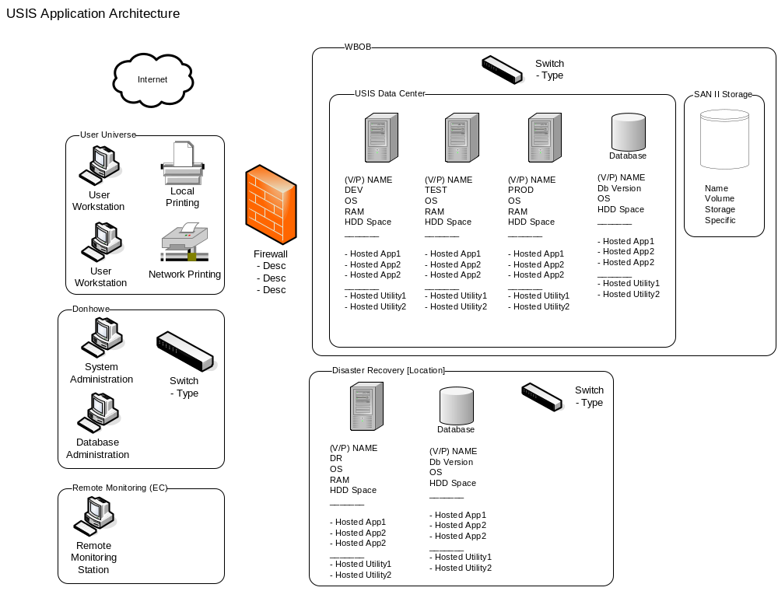

2.2 Application Architecture
Enter information…

2.3 Hardware Requirements
Enter information…

2.4 Software Requirements

2.4.1 Servers

2.4.2 Client
3.0 Installation Instructions

3.1 System Configuration
Enter information…

3.2 System Parameters
Enter information…

4.0 Detailed Design

4.1 User Interface

4.1.1 Screens

4.1.2 Reports

4.2 Business Services

4.2.1 Diagram
Include a diagram of the application or system. Click on the sample diagram to open Visio and make any changes.

Sample diagram:
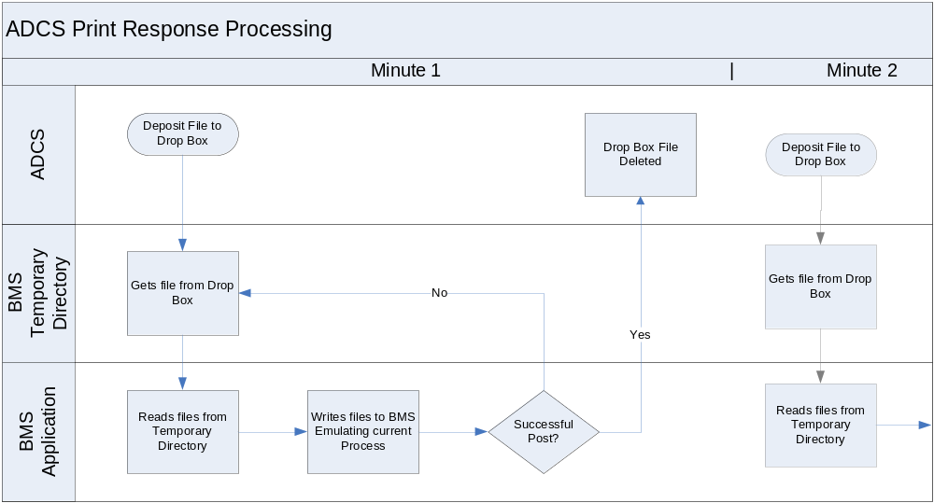

4.2.2 Batch Processing

4.2.3 Scripts

4.2.5 Business Processes

4.3 Data

4.3.1 File Structure

4.3.2 Extract Functionality

4.3.3 Export Functionality

4.3.4 Schema Objects

4.3.5 Table Descriptions

4.3.6 Data Mapping

4.3.7 Security

5.0 Backup and Recovery

6.0 Appendix

