**Experiment No:05**

**Experiment name :** Connecting to Database in Linux .

**Aim and objectives :**

To know how to install database in Linux and perform various operation via connecting to it .

**Commands :**

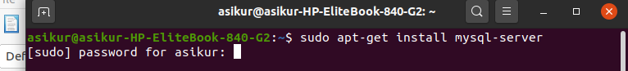

To word with database we first need to install the database in our system using the command below we can install mysql-server

sudo apt-get update sudo apt-get install mysql-server

after installation we need to set it up , to do so we can type the command /usr/bin/mysql\_secure\_installation

The secure installer goes through the process of setting up MySQL including creating a root user password. It will prompt us for some security options, including removing remote access to the root user and setting the root password.

Now that we are done with setups we can start out experimenting with database system by logging in

To get the list of data Databases type show Databases

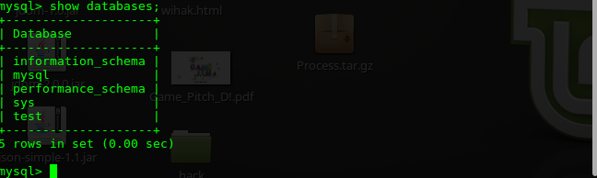

We need to select a database first to do so we use the keyword select ‘DatabaseName’

C:\Users\AR Istaik\Desktop\os lb 3\OS_LAB_DB_PIC\use_test.png

Now to create a table we use the syntax create table ‘TableName’ Values(val1\_name <data\_type> , val2\_name <data\_type>…….);

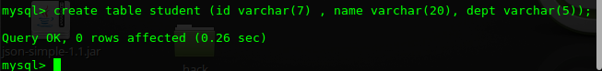

Now to insert values to the table we use the keyword

Insert into ‘TableName’ Values( val1 , val2…);

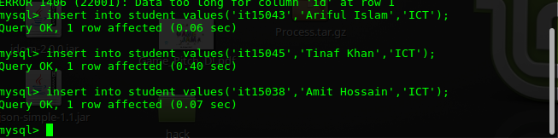

Now to see whats in the table we use select \* from ‘TableName’

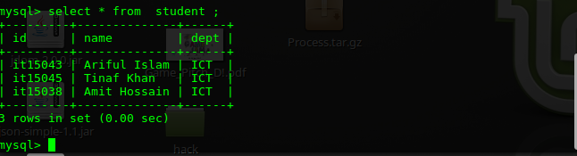

Now if we want to exit the database then we just have to type “exit “



**Conclusion :**

In this lab we learnt how to install database in Linux bases operating systems . Using database is a convenient way of saving data in both research and technical fields , so it will be of great help in near future .