horizontal line

**Elizabeth Endri, Aseel Fawalha, Waiyat Hamdani**

Dr. Hao Wu

CSC 265 Networking and Security

May 7, 2019

**Pathfïnder**

**Change the way you chat.**

# 

# 

# 

# 

# 

# 

# 

# 

# Overview

In this assignment, we were asked to create an instant messaging (IM)/online chat software. Our chat is secure because uses the closed server methodology. This means that outsiders can not access without the application.

# Motivation

All of us grew up using various instant messaging systems in our teen years so this project allowed us to create our own version of the applications we used to use all the time. We chose this name for our app because we are connecting people with each other.

# Functionalities

In this project we were able to connect and chat with two to five people at a time. The messages are encrypted the Vigenere Cipher. Our software has a nice light blue easy to use Graphical User Interface.

# Complications

First, we started with dictionary listing every single character which in total is 87 characters but then we switched to implementing ord(). The ord() method returns an integer representing Unicode code point for the given Unicode character. We ended up using the regular dictionary though.

Another issue that arose was that when we tried to send files through through our app, it would sometimes create random characters in the sent message.

We thought we would be able to implement the block function. But we found out that once implemented, the IP Address has to be blocked, this would lead to the entire program crashing. Due to time, we could not resolve these issues.

## 

## How to Use Our App

**Here is a step by step instruction guide on how to use our app.**

1. First open the server .py file.
2. Then wait until the server is listening. You should get a message that says “Socket Listening.”
3. Then in parallel run, the client1 .py file.
4. Repeat step 3 for as many users you have.
5. When you click the **File** tab in the left hand corner and then **Open File** you will get a list of options.
   1. It will open the file and you can select which file you wish to send.
   2. The about us tab introduces all the creators of the app.
   3. The third option is a how to use weChat in order to use. We need to turn the server on. After the socket is created then we can activate multiple chats.
   4. The last option gives you the option to exit the chat.

Below is a screenshot of a chat interaction between 2 people.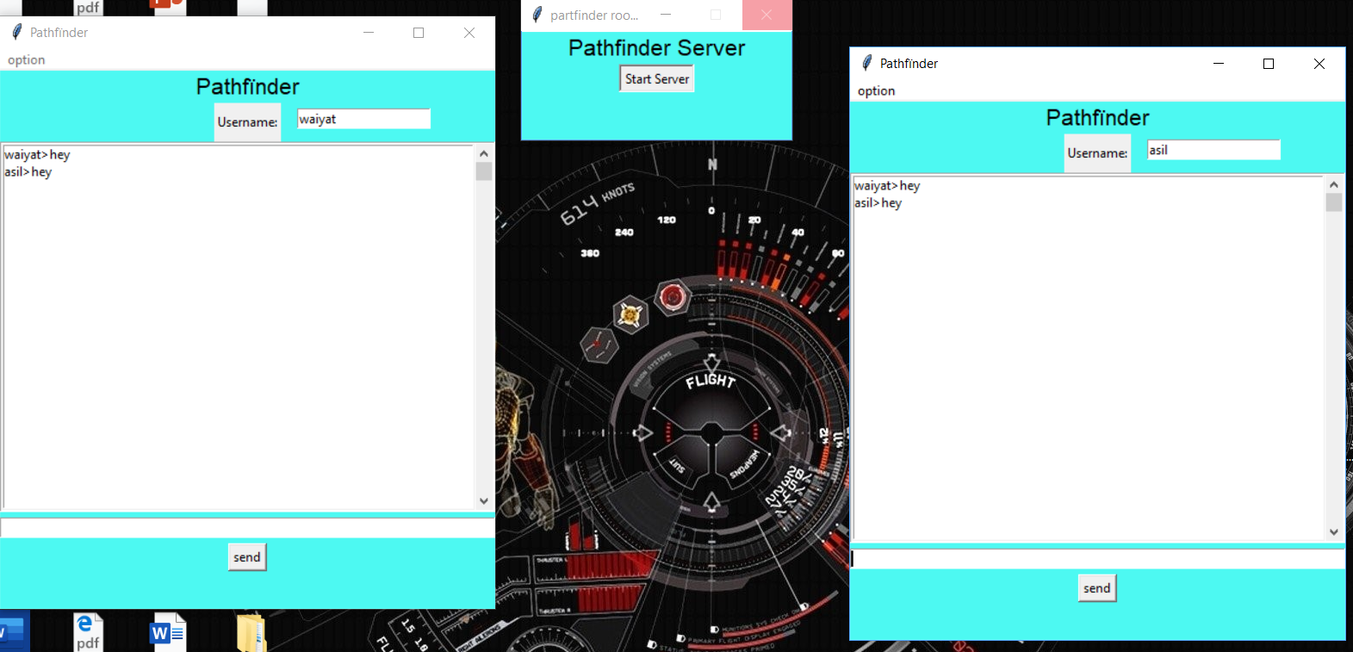

## 

## 

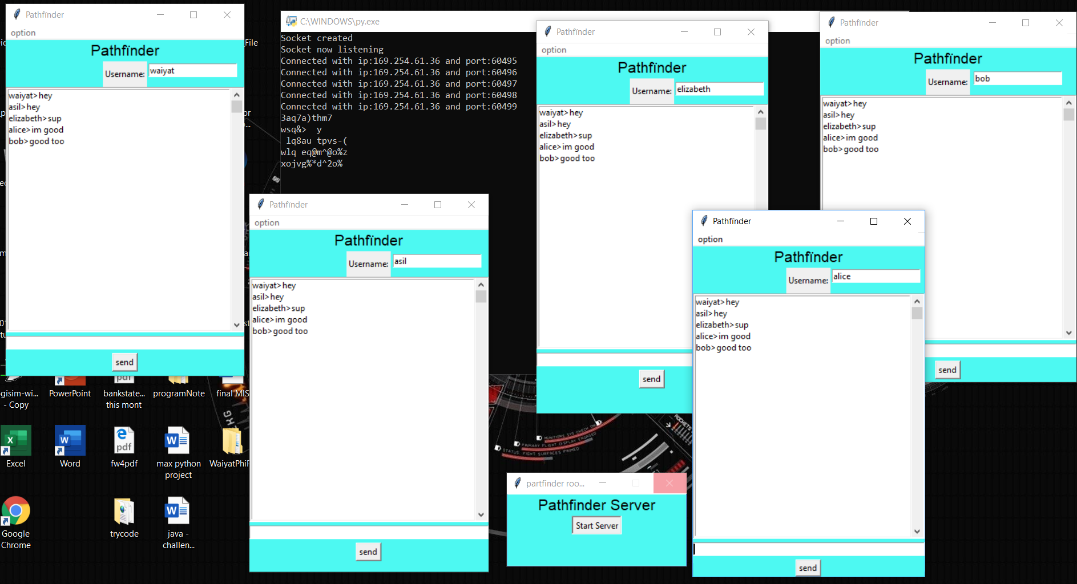

## 

## 

## Conclusion

In sum, we were asked to create an instant messaging (IM) /online chat software. We able to successfully implement certain functions like text encryption and multiple users.