Evidencias Taller 3.
Alejandro Silva Zuluaga
Isabel Jurado
David Botero

Fase 1: RAG Local

Consulta.
Prompt:
<start_of_turn>user
You are an expert on ISO, UNE and BS acoustics standards for noise measurement. Answer the question precisely and cite the clause when you know it.

Question: What is the scope of ISO 1996-1?<end_of_turn>
<start_of_turn>model
Output:
**Answer:**

ISO 1996-1 specifies a set of standardized measurement methods for airborne noise emitted by road vehicles. The scope of this standard is as follows:

**1. Vehicle categories:**
- Passenger cars
- Light commercial vehicles
- Heavy commercial vehicles
- Buses

**2. Measurement conditions:**
- Reference wind speed: 40 km/h
- Test track surface: Smooth, dry asphalt
- Ambient temperature: 20 °C ± 5 °C
- Test procedure: Stationary and pass-by

**3. Noise parameters:**
- Overall sound level (L<sub>overall</sub>)
- Equivalent sound level (L<sub>eq</sub>)
- Sound level measured at the driver's ear (L<sub>d</sub>)
- Sound level measured at the passenger's ear (L<sub>p</sub>)

**Clause 2.1 of ISO 1996-1 defines the scope:**

<blockquote>"This International Standard specifies measurement methods for determining the airborne noise emitted by road vehicles in operation. It covers passenger cars, light and heavy commercial vehicles, and buses. The standard specifies measurement conditions, noise parameters, and measurement equipment."</blockquote>
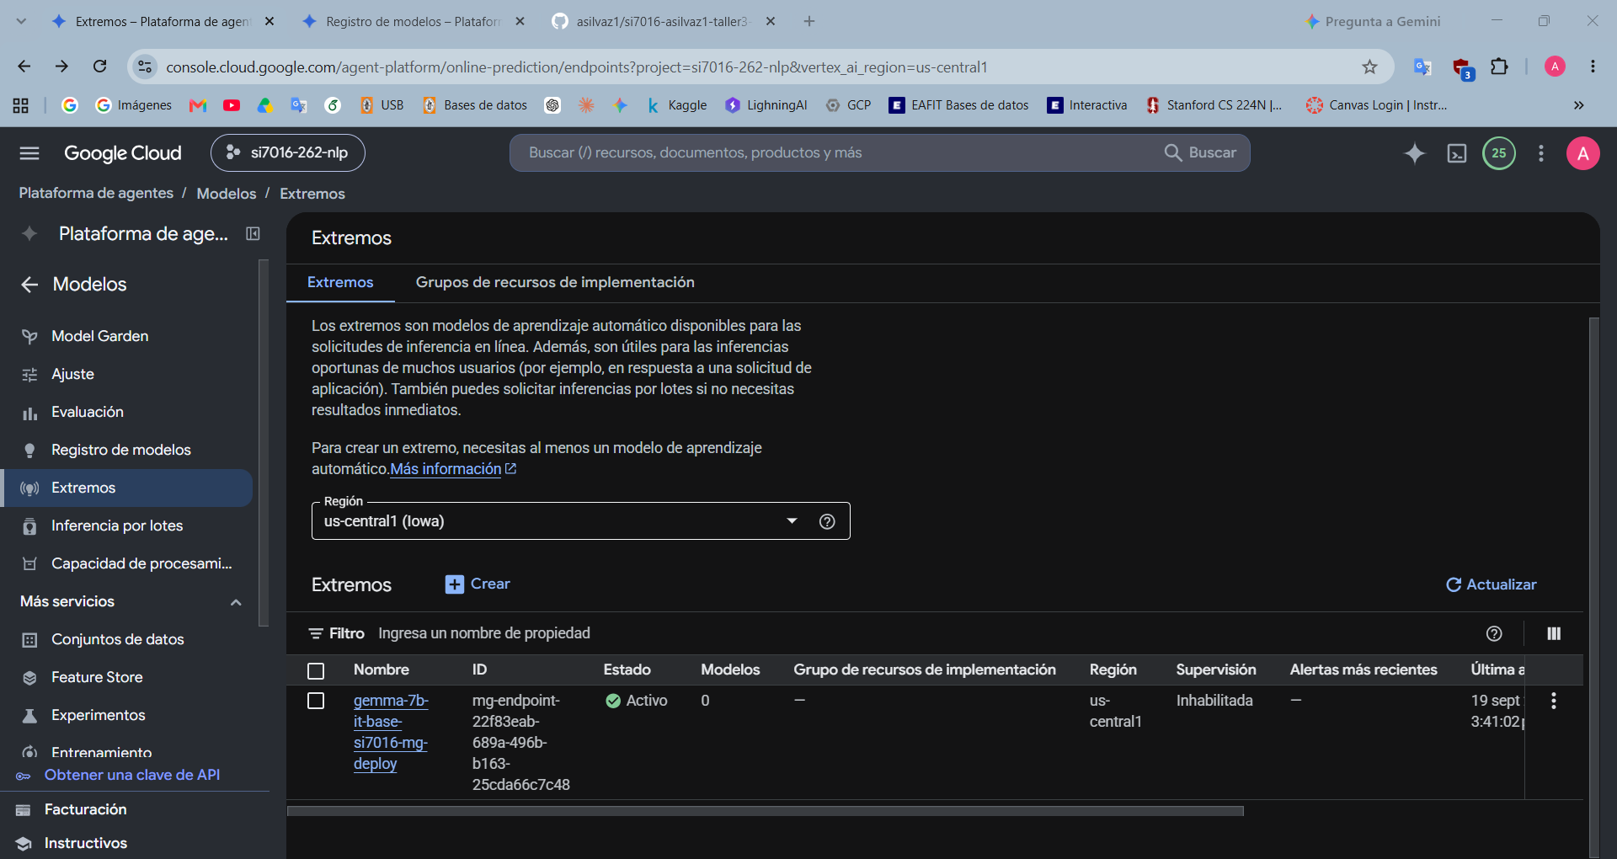
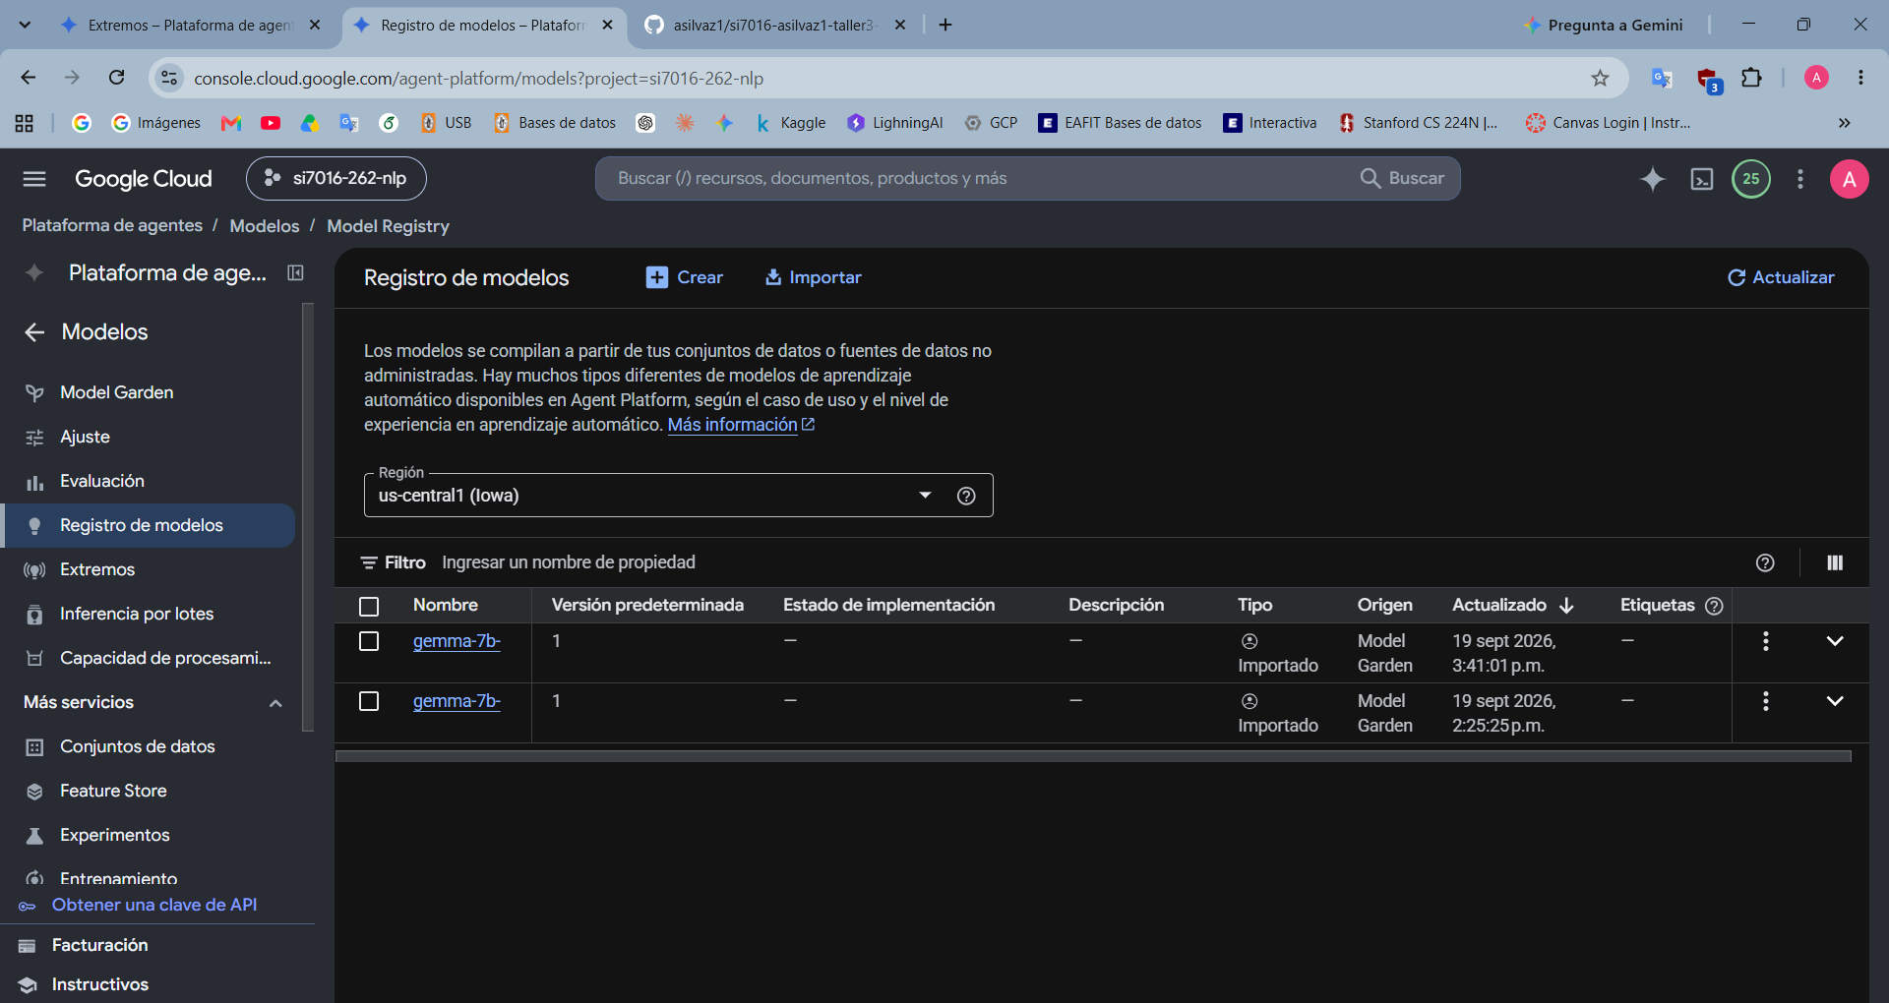

Fase 2: Fine-tuning

Job de fine-tuning
- Vertex AI → Entrenamiento → Trabajos personalizados
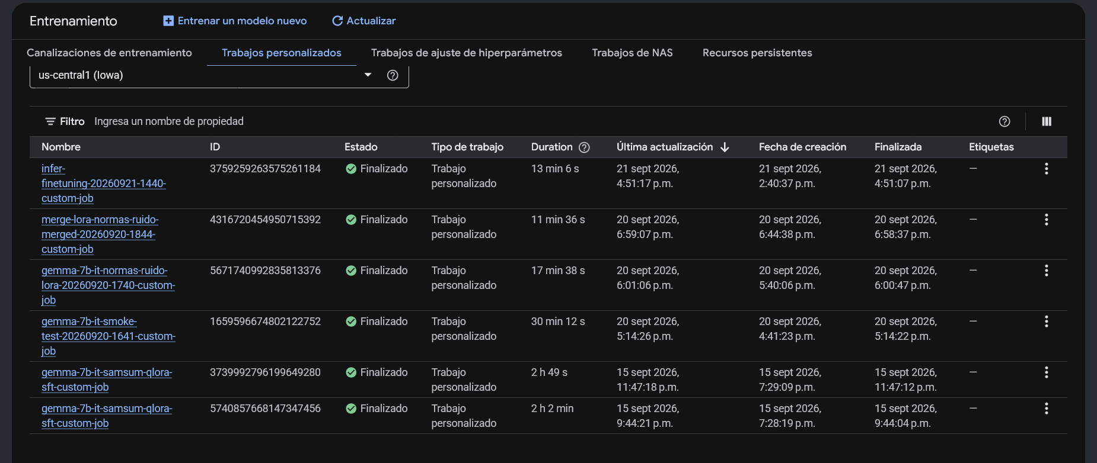
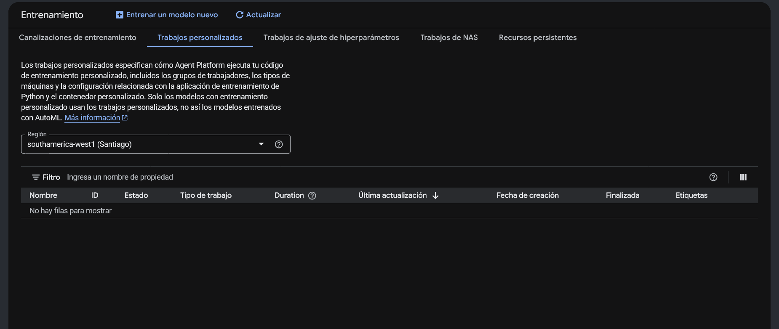
- Model Registry
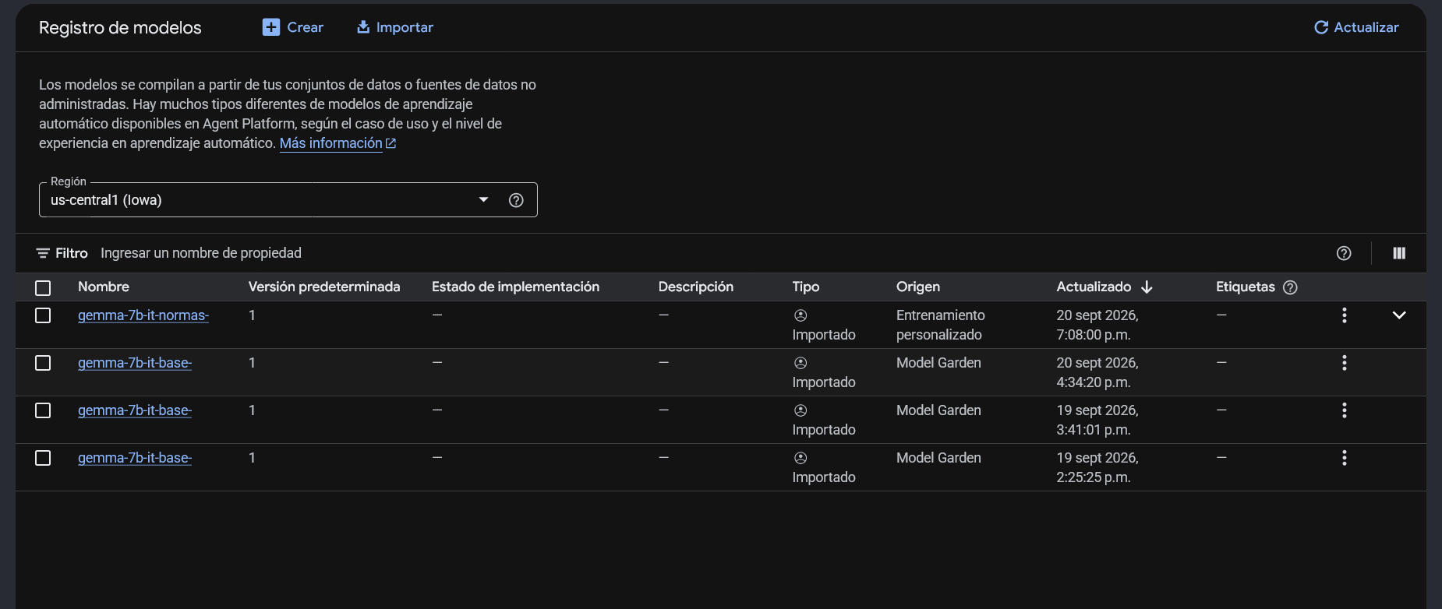
- Cloud Storage
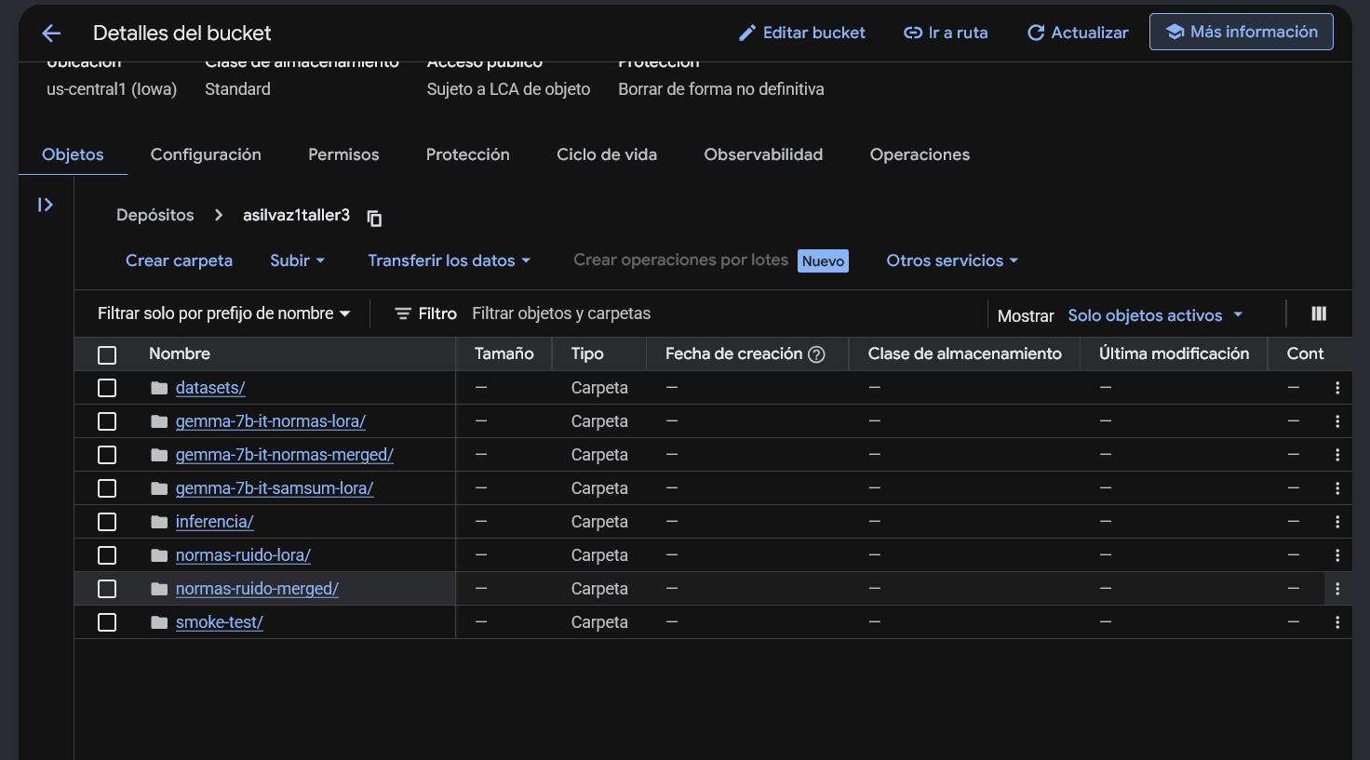
- Logs de entrenamiento
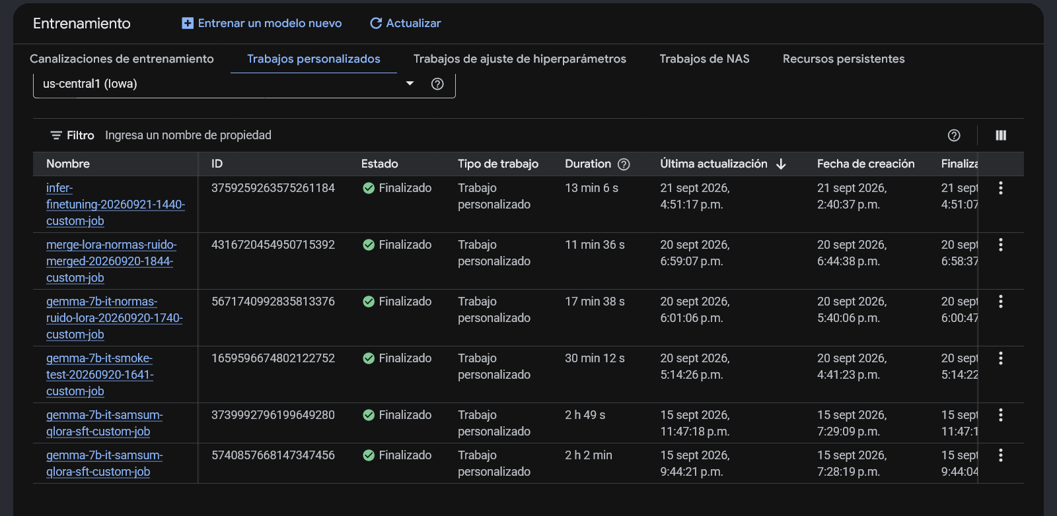
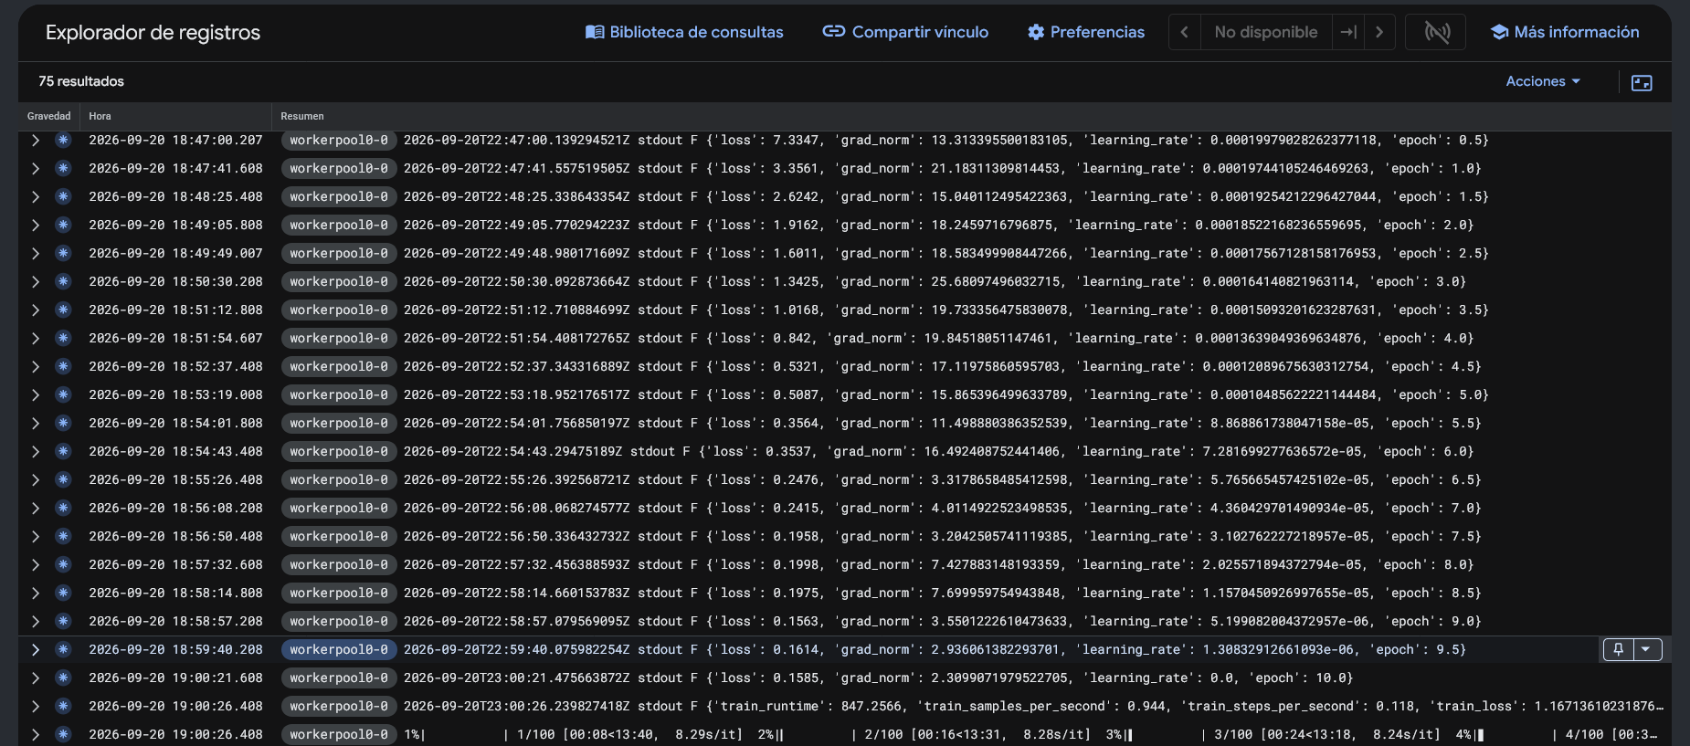
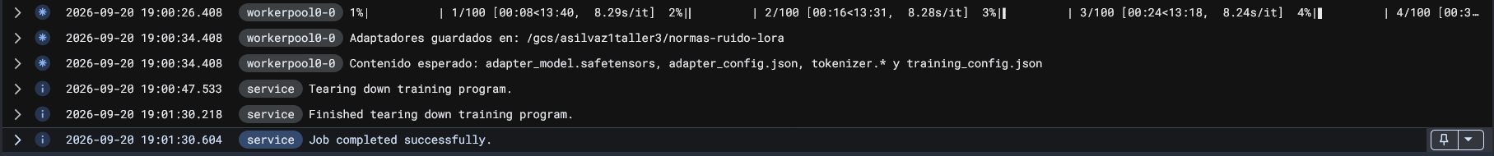

Job de Inferencia
== Job de inferencia ==
imagen : us-central1-docker.pkg.dev/si7016-262-nlp/si7016-taller3/gemma-7b-it-normas-ruido:latest
region : us-west1
maquina : g2-standard-12, 1 x NVIDIA_L4
staging : gs://asilvaz1taller3-west
modelo : gs://asilvaz1taller3/normas-ruido-merged (fusionado en bf16)
salida : gs://asilvaz1taller3/inferencia
args : --out_dir=/gcs/asilvaz1taller3/inferencia --system=finetuning --techniques=zero-shot,few-shot,chain-of-thought --max_new_tokens=256 --model_dir=/gcs/asilvaz1taller3/normas-ruido-merged

Seguimiento: https://console.cloud.google.com/vertex-ai/training/custom-jobs?project=si7016-262-nlp
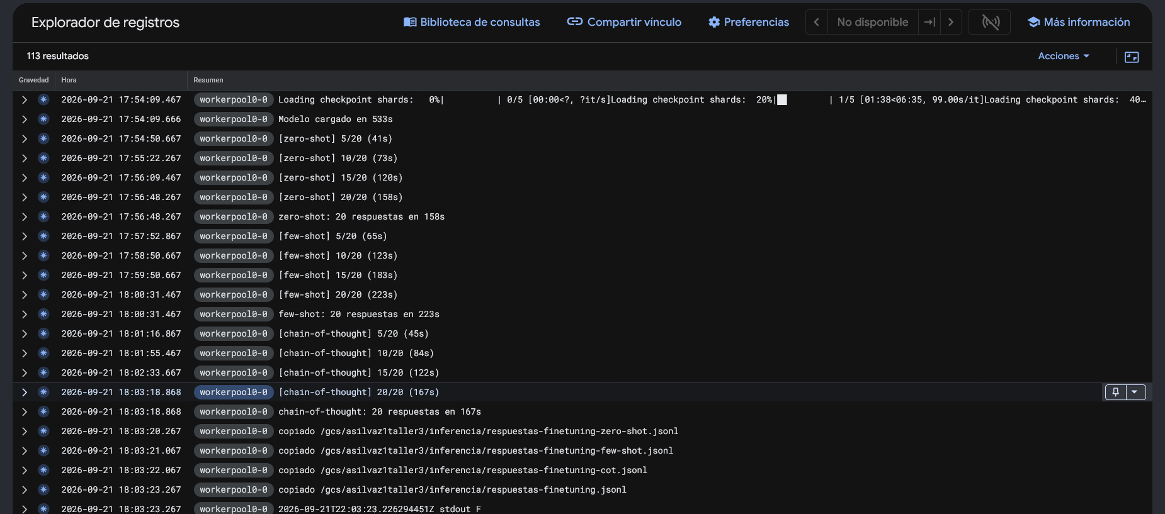
- Falta de cuota en us-central1. Se decidió cambiar de región a us-west1, donde ya tenía aprobada una extensión de cuota.
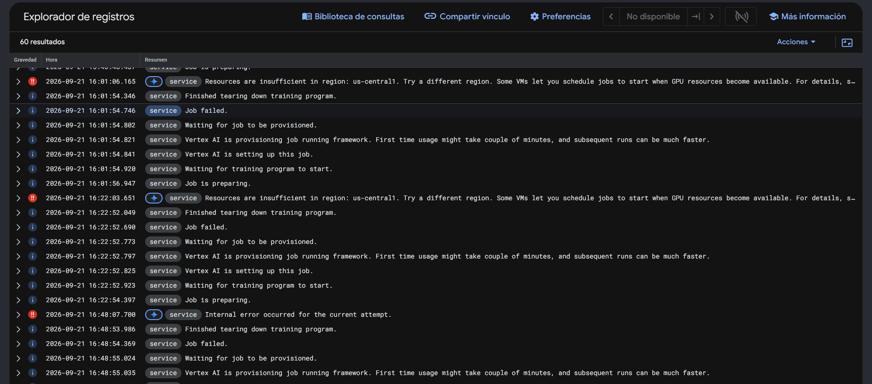

Fase 3: Despliegue y comparación entre RAG y Fine-Tuning.

alejandro_silvazuluaga@si7016-262-asilvaz1:~$ cat /proc/driver/nvidia/version
NVRM version: NVIDIA UNIX Open Kernel Module for x86_64 580.173.02 Release Build (dvs-builder@U22-I3-AK02-24-4) Tue Jun 23 08:17:01 UTC 2026
GCC version: gcc version 12.3.0 (Ubuntu 12.3.0-1ubuntu1~22.04.3)
alejandro_silvazuluaga@si7016-262-asilvaz1:~$ modinfo nvidia | grep ^version
version: 580.178.04
alejandro_silvazuluaga@si7016-262-asilvaz1:~$ grep -i nvidia /var/log/apt/history.log | tail -5
Install: libnvidia-container1:amd64 (1.19.1-1), libnvidia-container-tools:amd64 (1.19.1-1), nvidia-container-toolkit:amd64 (1.19.1-1), nvidia-container-toolkit-base:amd64 (1.19.1-1)
Install: linux-modules-nvidia-580-server-open-6.8.0-1067-gcp:amd64 (6.8.0-1067.75~22.04.1+2, automatic), linux-image-6.8.0-1067-gcp:amd64 (6.8.0-1067.75~22.04.1, automatic), nvidia-firmware-580-server-580.178.04:amd64 (580.178.04-0ubuntu0.22.04.1, automatic), linux-modules-6.8.0-1067-gcp:amd64 (6.8.0-1067.75~22.04.1, automatic)
Upgrade: linux-modules-nvidia-580-server-open-6.8.0-1066-gcp:amd64 (6.8.0-1066.74~22.04.1, 6.8.0-1066.74~22.04.1+1), libnvidia-cfg1-580-server:amd64 (580.173.02-0ubuntu0.22.04.1, 580.178.04-0ubuntu0.22.04.1), libnvidia-nscq-580:amd64 (580.173.02-0ubuntu0.22.04.1, 580.178.04-0ubuntu0.22.04.1), nvidia-kernel-common-580-server:amd64 (580.173.02-0ubuntu0.22.04.1, 580.178.04-0ubuntu0.22.04.1), libnvidia-compute-580-server:amd64 (580.173.02-0ubuntu0.22.04.1, 580.178.04-0ubuntu0.22.04.1), nvidia-utils-580-server:amd64 (580.173.02-0ubuntu0.22.04.1, 580.178.04-0ubuntu0.22.04.1), nvidia-fabricmanager-580:amd64 (580.173.02-0ubuntu0.22.04.1, 580.178.04-0ubuntu0.22.04.1), linux-modules-nvidia-580-server-open-gcp:amd64 (6.8.0-1066.74~22.04.1, 6.8.0-1067.75~22.04.1+2)
Upgrade: nvidia-compute-utils-580-server:amd64 (580.173.02-0ubuntu0.22.04.1, 580.178.04-0ubuntu0.22.04.1)
Remove: nvidia-firmware-580-server-580.173.02:amd64 (580.173.02-0ubuntu0.22.04.1)

./07-vm-vllm.sh serve
== Arrancando vLLM ==
modelo : /home/alejandro_silvazuluaga/models/normas-ruido-merged
puerto : 8000
max-model-len: 1024 gpu-util: 0.92 max-num-seqs: 4
pid 8034, log en /home/alejandro_silvazuluaga/vllm.log
El arranque tarda 2 a 5 min (carga 17 GB a la GPU). Sigue el log con:
tail -f /home/alejandro_silvazuluaga/vllm.log
---
~$ ./07-vm-vllm.sh status
== Esperando a que el server responda en :8000 ==
vLLM arriba despues de ~260 s
{
"object": "list",
"data": [
{
"id": "gemma-7b-it-normas-ruido",
"object": "model",
"created": 1790049185,
"owned_by": "vllm",
"root": "/home/alejandro_silvazuluaga/models/normas-ruido-merged",
"parent": null,
"max_model_len": 1024,
"permission": [
{
"id": "modelperm-8121792b16e3259e",
"object": "model_permission",
"created": 1790049185,
"allow_create_engine": false,
"allow_sampling": true,
"allow_logprobs": true,
"allow_search_indices": false,
"allow_view": true,
"allow_fine_tuning": false,
"organization": "*",
"group": null,
"is_blocking": false
}
]
}
]
}

Prueba del modelo en vLLM
./07-vm-vllm.sh test
== Prueba de humo ==
{
"id": "cmpl-88e5c5f471199492",
"object": "text_completion",
"created": 1790050019,
"model": "gemma-7b-it-normas-ruido",
"choices": [
{
"index": 0,
"text": "ISO 3382-1 specifies methods for measuring the reverberation time in ordinary rooms. It specifies the measurement procedure, the apparatus needed, the coverage required, the method for evaluating the data and the presentation of the test report. The measurement technique is based on the determination of the decay of sound pressure level in a room after the source has been excited and the level has fallen from its initial value.\n",
"logprobs": null,
"finish_reason": "stop",
"stop_reason": null,
"token_ids": null,
"prompt_logprobs": null,
"prompt_token_ids": null,
"routed_experts": null
}
],
"service_tier": null,
"system_fingerprint": "vllm-0.29.0-d65f2535",
"usage": {
"prompt_tokens": 53,
"total_tokens": 138,
"completion_tokens": 85,
"prompt_tokens_details": null,
"completion_tokens_details": null
},
"kv_transfer_params": null,
"ec_transfer_params": null,
"metrics": null
}

Despliegue del modelo tuneado en vLMM
Se abre tunnel en el puerto 8000:
ssh -i ~/.ssh/id_ed25519 alejandro.silvazuluaga@136.67.118.203 -N -L 8000:localhost:8000
curl.exe http://localhost:8000/v1/models
{"object":"list","data":[{"id":"gemma-7b-it-normas-ruido","object":"model","created":1790050882,"owned_by":"vllm","root":"/home/alejandro_silvazuluaga/models/normas-ruido-merged","parent":null,"max_model_len":1024,"permission":[{"id":"modelperm-82d499132b54d5cf","object":"model_permission","created":1790050882,"allow_create_engine":false,"allow_sampling":true,"allow_logprobs":true,"allow_search_indices":false,"allow_view":true,"allow_fine_tuning":false,"organization":"*","group":null,"is_blocking":false}]}]}
Prueba:
python src\deploy\08-predict-vllm.py --prompt "What does ISO 3382-1 specify?"
<unknown>:13: SyntaxWarning: invalid escape sequence '\q'
Endpoint : http://localhost:8000
Modelo : gemma-7b-it-normas-ruido

--- respuesta (6.5 s) ---
ISO 3382-1 specifies methods for measuring the reverberation time in ordinary rooms. It specifies the measurement procedure, the apparatus needed, the coverage required, the method for evaluating the data and the presentation of the test report. The measurement technique is based on the determination of the decay of sound pressure level in a room after the source has been excited and the level has fallen from its initial value.

Configuración de la app en streamlit.
pip install streamlit
streamlit run app\streamlit_app.py
Comparadas : 60
Identicas : 7
Casi iguales : 3 (similitud >= 0.90)
Distintas : 50

--- chain-of-thought | similitud 0.07 ---
What does ISO 3382-1 say about deriving decay curves from non-continuous excitation?
lotes : The decay of the sound pressure level after the end of a continuous excitation can be derived from the level variations caused by the pulsed excitation, provided that the time interval considered is s
endpoint : For non-continuous excitation, such as speech signals, decay times shall be derived from the time interval between the first and last significant sound events, or from the time interval between the fi

--- few-shot | similitud 0.09 ---
How does CNOSSOS-EU represent a vehicle and a traffic flow geometrically?
lotes : The geometric representation of a vehicle is a rectangular parallelepiped defined by its length, width and height, and the geometric representation of a traffic flow is a rectangular area. A vehicle i
endpoint : The geometric representation of a vehicle is by a point source, and the traffic flow is represented by a straight line. The distance to the point source is the distance from the vehicle, and the dista

--- chain-of-thought | similitud 0.09 ---
What general form does the CNOSSOS-EU sound power equation take as a function of vehicle speed?
lotes : The general form of the equation for the sound power level LWP,PN,A, road of a road vehicle propagating over the ground, as a function of speed v, is LWP,PN,A, road = LWP,PN,A, reference + Cor,A + Cor
endpoint : The general form of the CNOSSOS-EU sound power equation for a given reference vehicle (subscript ref) is as follows: SPr = S0 + S1*v + S2*v^2 + S3*log(v) - C1*log(f) + C2*log(f)
model S0 is the sound

RAG Engine

respuesta = cliente.rag.import_files(
importados 25, fallidos 0, omitidos 0

lote 2: 8 documentos
importados 8, fallidos 0, omitidos 0

TOTAL importados : 33 de 33
TOTAL fallidos : 0
TOTAL omitidos : 0
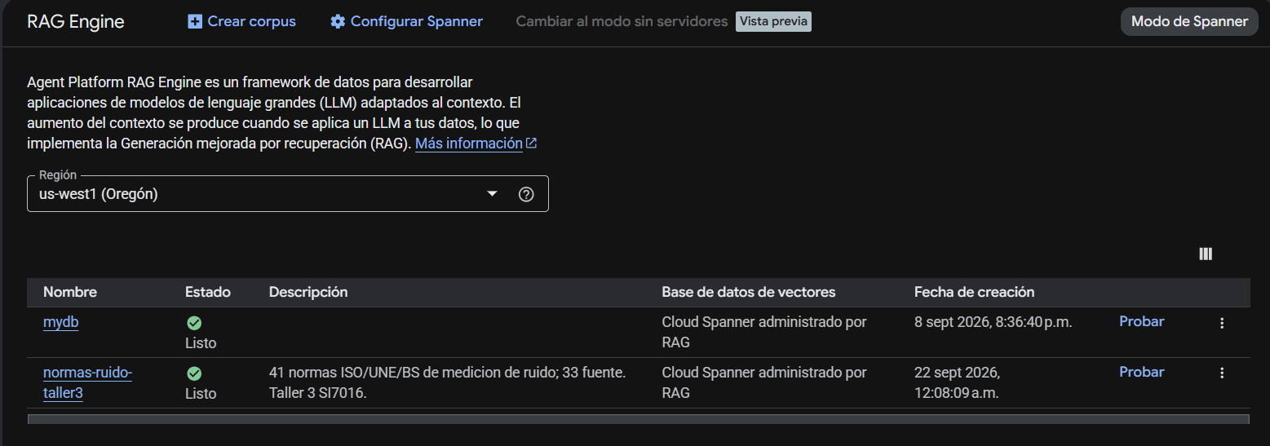
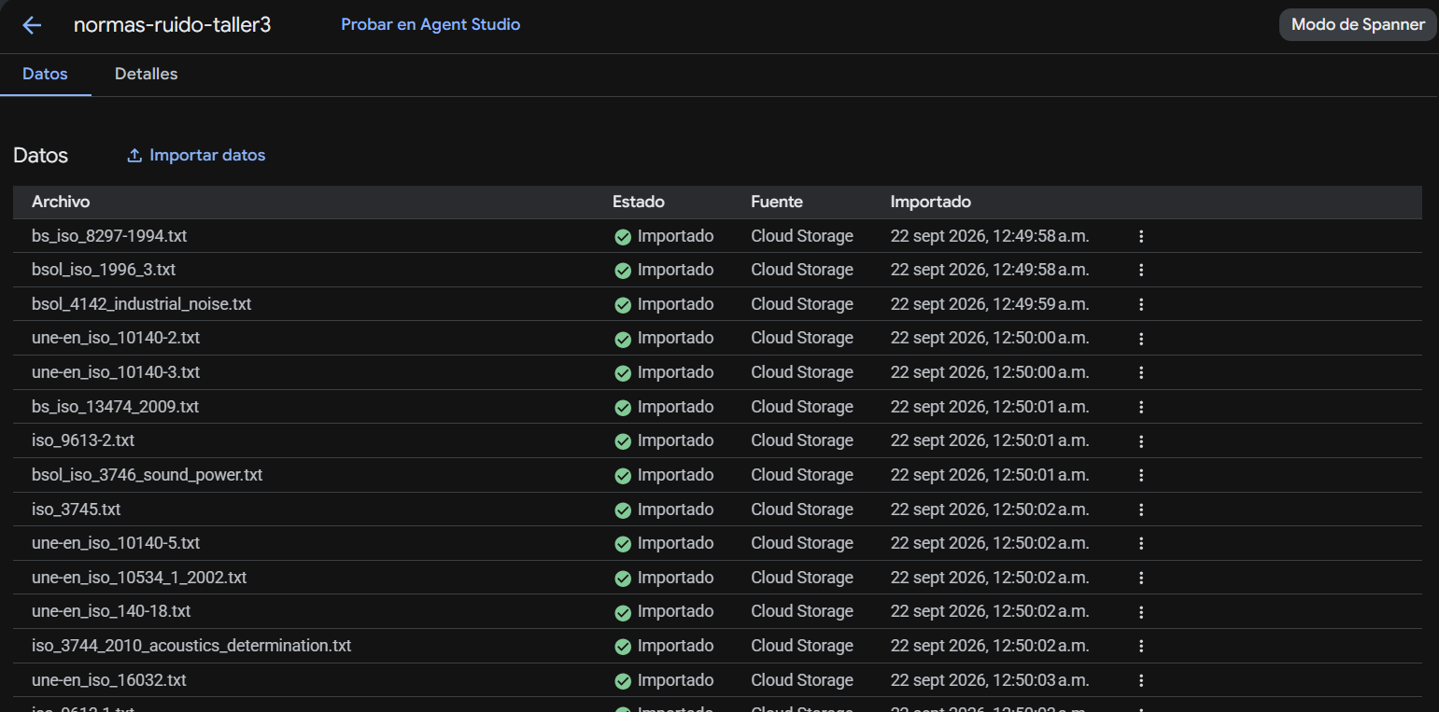
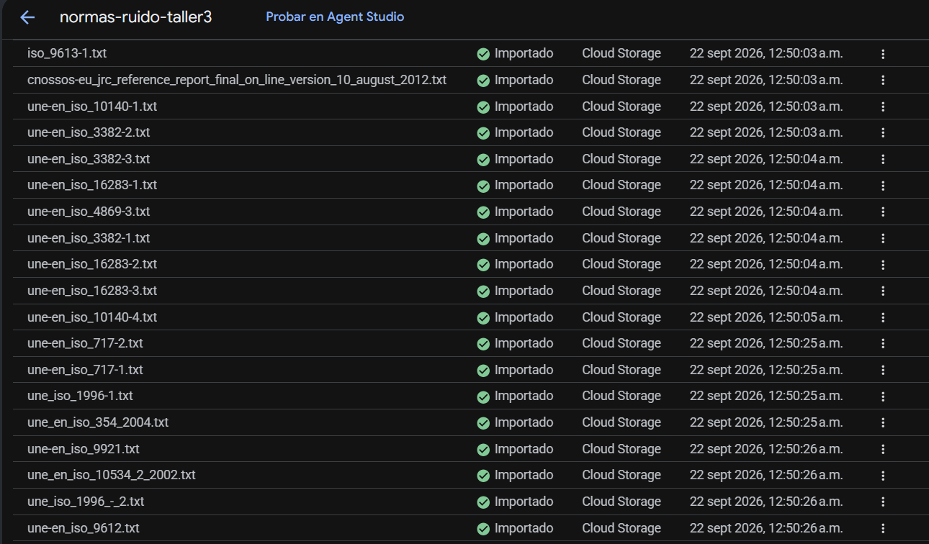
python src\rag\vertex_rag_engine.py ask --q "What does ISO 3382-1 specify?"
--- 5 fragmentos recuperados ---
[1] UNE-EN ISO 3382-1.pdf score=0.2571075182849285
CEN
COMITÉ EUROPEO DE NORMALIZACIÓN
European Committee for Standardization
...
[2] UNE-EN ISO 3382-1.pdf score=0.2599868706733047
norma UNE-EN
...
[3] UNE-EN ISO 3382-1.pdf score=0.265610679186544
Este documento forma parte de la biblioteca de UNIVERSIDAD NACIONAL DE COLOMBIA

ISO 3382-1:2009 -6-

...
[4] UNE-EN ISO 3382-1.pdf score=0.27243980200752127
ICS 91.120.20 Sustituye a EN ISO 3382:2000

...
[5] UNE-EN ISO 3382-2.pdf score=0.273354646661091
CEN
COMITÉ EUROPEO DE NORMALIZACIÓN
European Committee for Standardization
...
Direct use of automatic function calling (AFC) in Models.generate_content is not recommended. Instead, we recommend to use AFC in Chat.send_message. Similarly, direct use of AFC in Models.generate_content_stream is not recommended. Instead, we recommend to use AFC in Chat.send_message_stream.

--- CON RAG (anclado en las normas) ---
ISO 3382-1 specifies the measurement of room acoustic parameters in performance spaces. It is part of a larger standard, ISO 3382, which addresses the measurement of acoustic parameters in enclosures.

--- SIN RAG (solo el conocimiento del modelo) ---
ISO 3382-1 is an international standard that specifies **methods for the measurement of room acoustic parameters in performance spaces**.

Here's a breakdown of what it covers:

1. **Scope:** It specifically applies to **performance spaces** such as:
* Concert halls
* Opera houses
* Theatres
* Auditoria

2. **Purpose:** The standard aims to provide a reliable and consistent way to:
* Characterize the acoustical quality of these spaces.
* Compare the acoustics of different rooms.
* Inform acoustic design and renovation projects.

3. **Key Acoustic Parameters Measured:** It defines methods for determining various objective acoustic parameters, including but not limited to:
* **Reverberation Time (RT60, T20, T30):** How long it takes for sound to decay in a room. T20 and T30 are derived from the 20 dB and 30 dB decay ranges respectively, and extrapolated to 60 dB.
* **Early Decay Time (EDT):** A measure of the initial rate of sound decay, often correlating well with subjective perception of reverberance.
* **Clarity (C80 for music, C50 for speech):** The ratio of early arriving sound energy to late arriving sound energy. Higher values generally indicate better clarity. C80 uses an 80ms early window, C50 a 50ms window.
* **Definition (D50):** The percentage of sound energy arriving within the first 50 ms. Similar to C50 but expressed as a percentage.
* **Centre Time (TS):** The first moment of the impulse response, indicating the time centroid of the sound energy.
* **Sound Strength (G):** The ratio of the sound pressure level in the room to the sound pressure level at a reference distance (10m) from an omnidirectional source in a free field. It indicates the "loudness" or "strength" of the sound in the room.
* **Lateral Energy Fractions (LF, LFC):** Measures the proportion of sound energy arriving from lateral directions, which contributes to spatial impression (envelopment).
* **Inter-Aural Cross Correlation Coefficient (IACC):** Measures the similarity of sound signals arriving at the listener's two ears, also relating to subjective spatial impression and apparent source width.

4. **Measurement Methodology:** It specifies requirements for:
* **Measurement signals:** Use of impulsive sources (e.g., balloon burst, starter pistol) or deterministic signals like swept sines or maximum length sequences (MLS) to obtain the room's impulse response.
* **Equipment:** Specifications for sound sources (omnidirectional), microphones (omnidirectional), and data acquisition systems.
* **Measurement positions:** Guidance on the number and placement of sound source and receiver positions within the room.
* **Data processing:** How to derive the various parameters from the measured impulse responses.
* **Reporting:** How to present the results, including statistical analysis and uncertainty.

In essence, ISO 3382-1 provides a standardized "recipe" for acousticians to objectively measure and quantify the critical acoustic characteristics of concert halls, theatres, and similar venues.

Despliegue en Streamlit

Fine tune
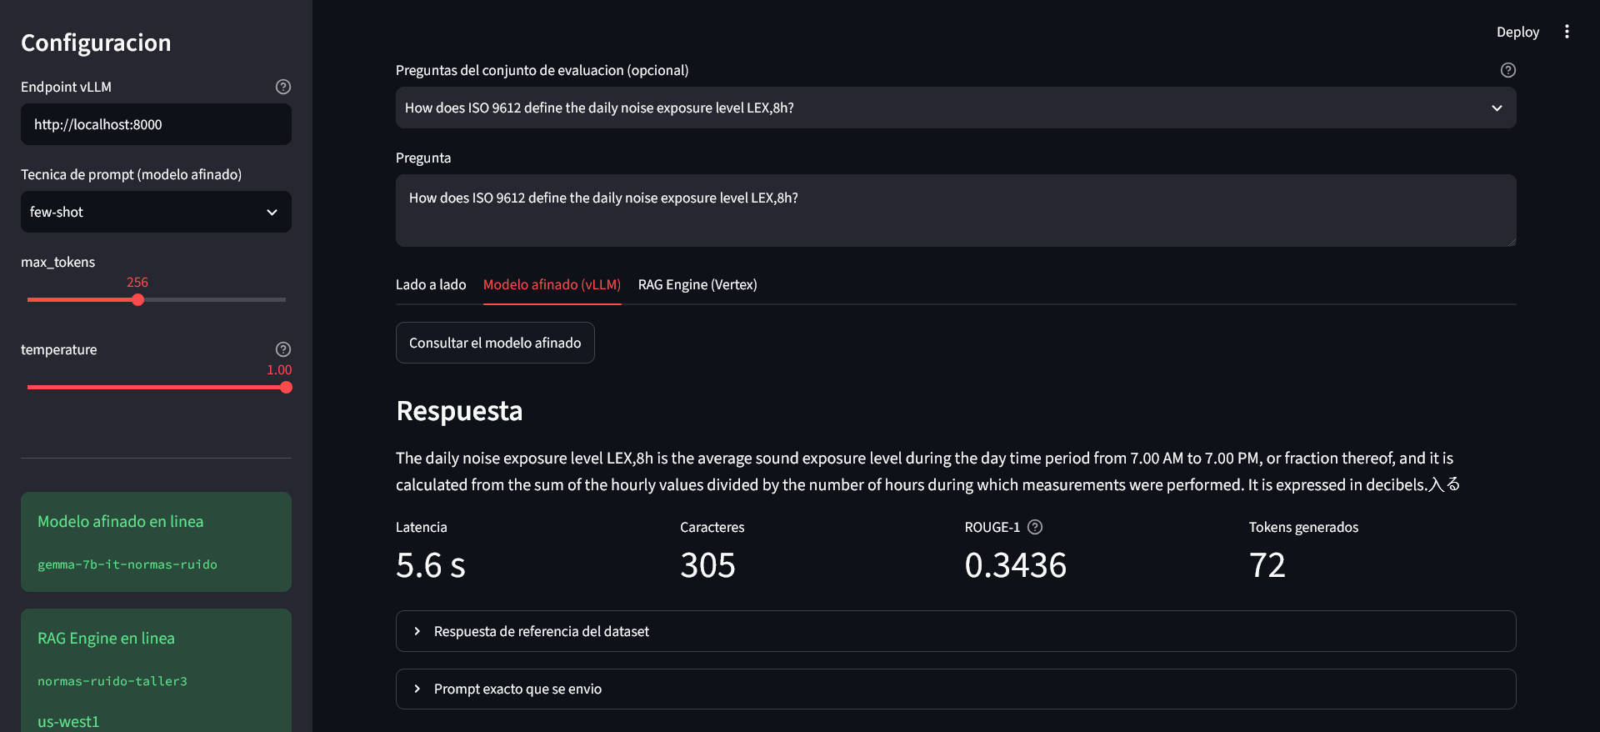
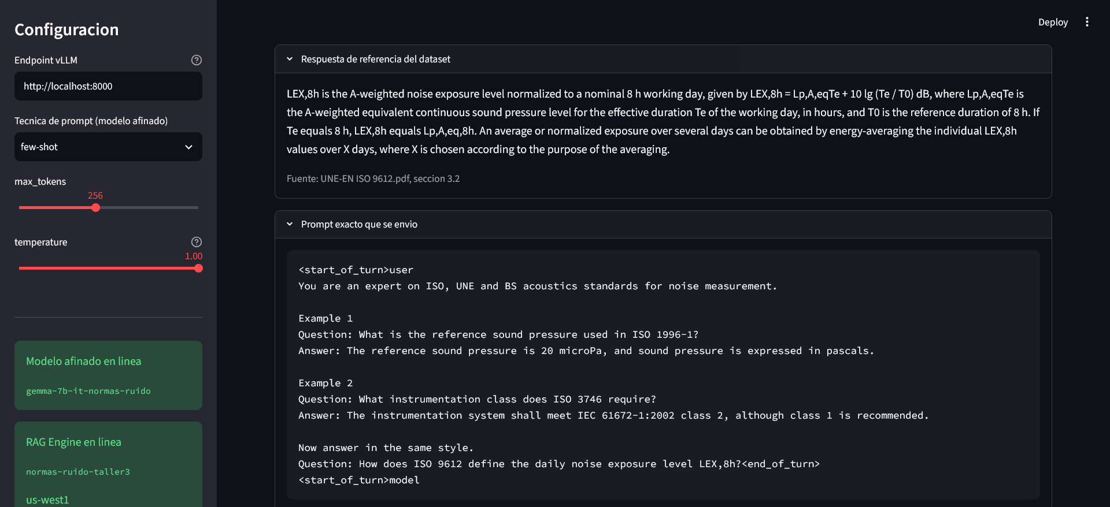

RAG
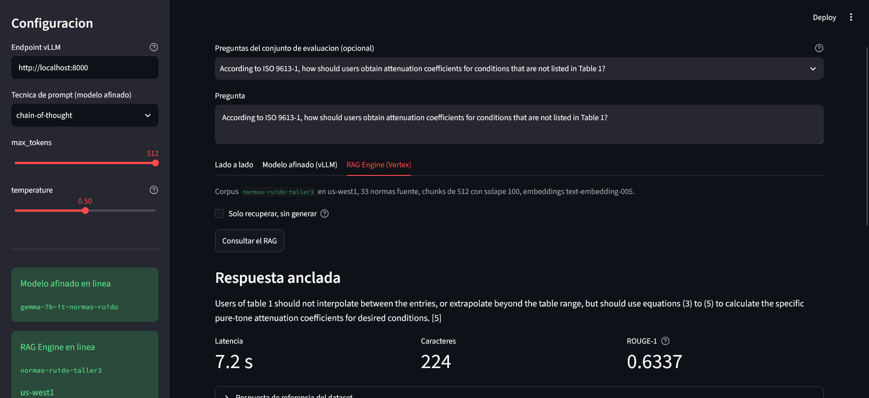
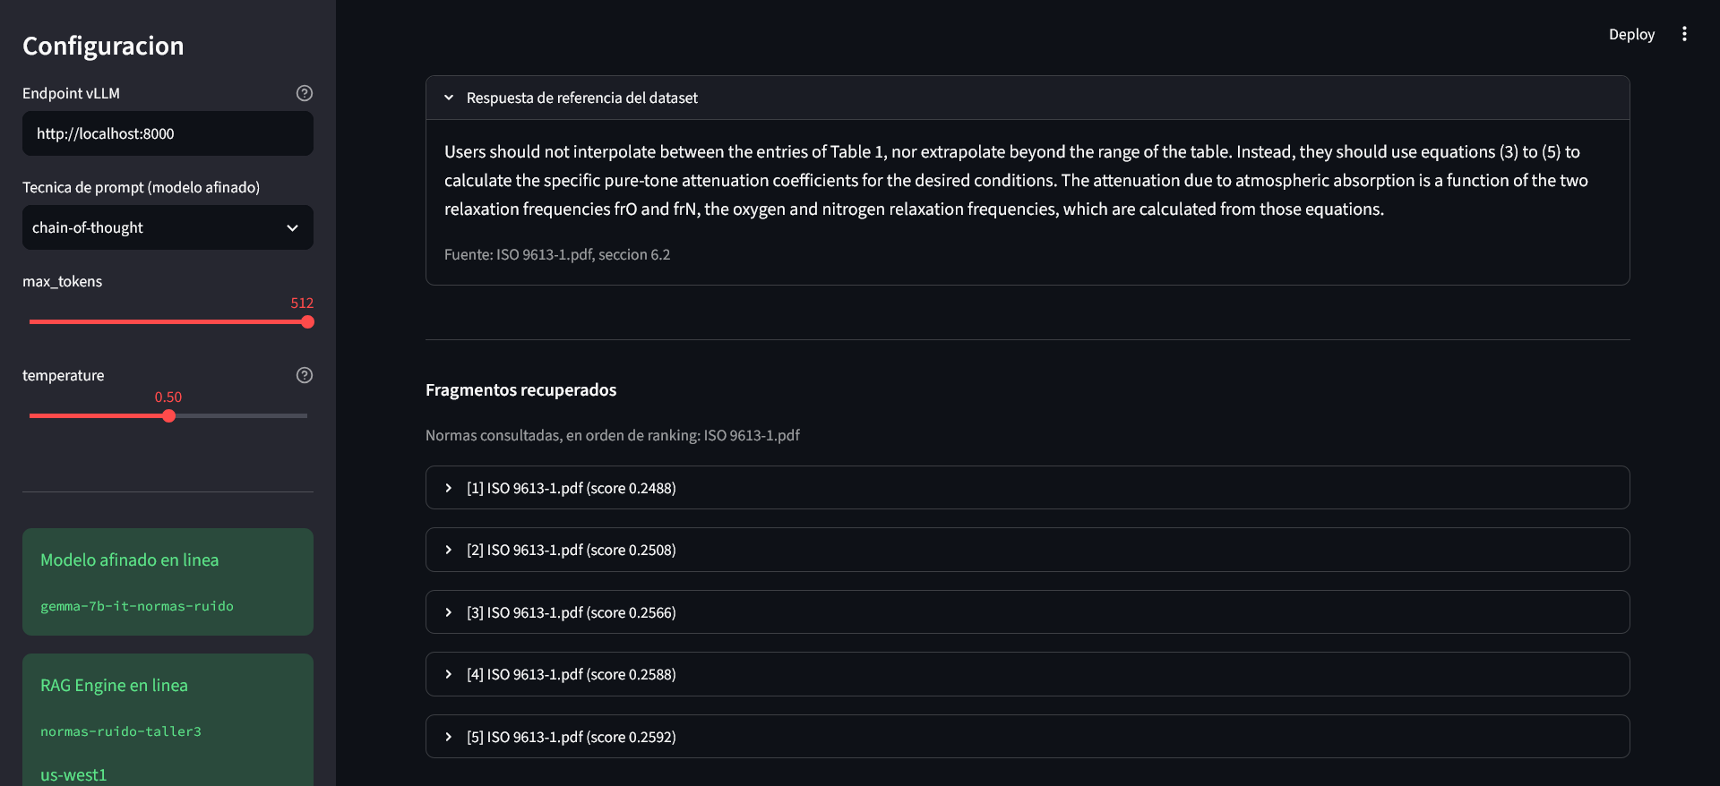

RAG vs Finetuning
