Database Design Document
for
VaagBanda
Smart Mobile Expense-Splitting Application

Version 1.0
Prepared by CyberSquadNp
Dongshin University
Glocal Autonomous Major College
May 2026
Design Phase – Database Design Document

Database Design

Dual Database Architecture
AuthDB + SharedExpenseDB
working in concert
User Management
Identity, authentication, and
secure access control
Expense Tracking
Store expenses, splits, balances,
and settlements

An expense-splitting system backed by a clean, structured relational data model

AUTHENTICATION LAYER

AuthDB — Authentication Database
AuthDB is dedicated solely to user identity and secure access. It handles login flows, session persistence, biometric preferences, and password recovery — completely isolated from business logic.
🔐 Login & Security
Validates credentials and guards access

Separation of auth from app data is a core security best practice, limiting blast radius in case of a breach.
🪪 Identity Management
Owns the authoritative user record
📋 Tables
Users · Sessions · BiometricAuth · PasswordReset

AUTHDB SCHEMA

AuthDB — Table Breakdown

Table Purpose Key Fields

Users Stores user info and hashed credentials user_id, email, password_hash, created_at Sessions Manages login tokens to keep users signed in session_id, user_id, token, expires_at

BiometricAuth Tracks whether biometric login is enabled per
device
user_id, device_id, enabled, updated_at

PasswordReset Handles secure password recovery token flow reset_id, user_id, token, used, expires_at

Privacy note: No raw biometric data is stored — only a flag indicating whether the feature is enabled on a given device.

CORE APPLICATION DATA

SharedExpenseDB — Overview
The primary application database. Every user-facing feature — creating groups, logging expenses, splitting bills, recording payments — is backed by this database.



Groups & Members
Groups, GroupMembers

Expenses & Splits
Expenses, Splits



Settlements
Settlements

Notifications & Categories
Notifications, Categories

SHAREDEXPENSEDB

Core Tables — Groups & Expenses

Key Design Decisions
Groups
Stores group name, description, and creator. The root entity for all shared expenses.
GroupMembers
Junction table linking users to groups.
Supports many-to- many membership with roles.

- Every expense belongs to exactly one group
- The paid_by field references a user in GroupMembers
- GroupMembers acts as a bridge — a user can belong to many groups simultaneously
- Categories are a separate lookup table for
consistency
Expenses
Records who paid, the total amount, category, and timestamp for each expense event.

Splits & Settlements

Splits = Debt Recorded
Defines each member's share of an expense.
Created when an expense is logged. Fields: split_id, expense_id, user_id, amount_owed

Settlements = Payment Made
Records an actual payment between two users. Created when someone settles up.
Fields: settlement_id, payer_id, payee_id, amount, settled_at

Why Two Tables?
Splitting the obligation from the payment gives the system a full audit trail. You can always see:
- What was owed and when the expense was created
- What was actually paid and when
- The outstanding balance at any point in time

This separation is what makes real-time balance
calculation possible.

SCHEMA RELATIONSHIPS
Entity Relationships

Users ↔ Groups
Many-to-many via GroupMembers linking users to groups.
Groups →
Expenses
Each group can have multiple expense records.
Expenses →
Splits
Each expense breaks down into per-user splits.
Users →
Settlements
Users record one- to-many payment settlements.

  - Users ↔ Groups — many-to-many via GroupMembers
  - Groups → Expenses — one group has many expenses
  - Expenses → Splits — each expense fans out into per-user splits
  - Users → Settlements — payment tracking between any two users

BALANCE ENGINE

Balance Calculation Logic

How It Works
Design Advantages
•
•
•
•
No stale cached balances
Full history preserved in source tables Recalculate anytime from raw data
Supports partial payments naturally

The system derives each user's real-time balance by aggregating two tables — Splits and Settlements — without storing a running total. This keeps the data consistent and auditable.

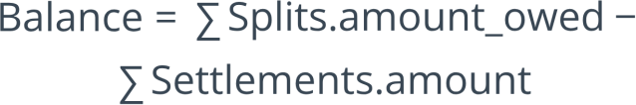

Example: User owes $100 across multiple splits. They've settled $40. Outstanding balance = $60.

DATA MODEL

ER Diagram — Entity Overview

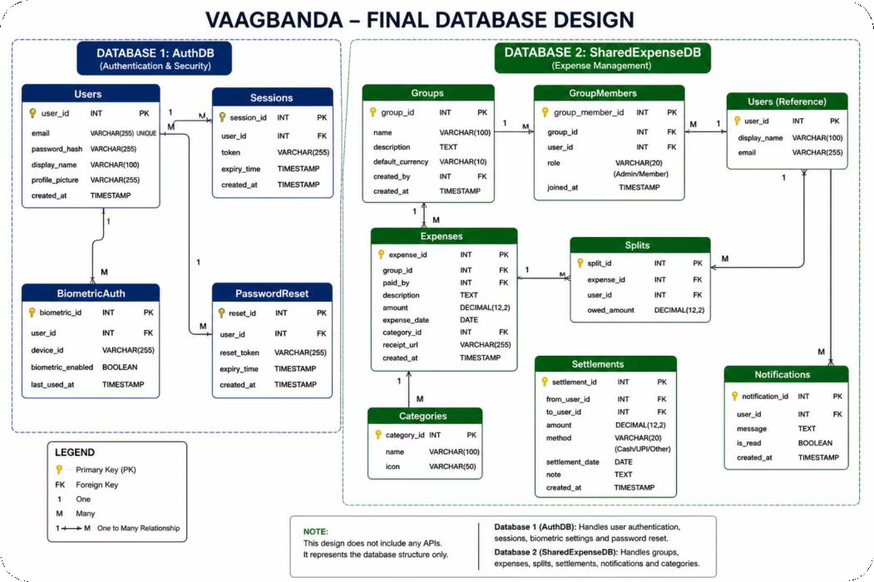
Relationship Summary
- Users ↔ Groups via GroupMembers
- Groups → Expenses (1:N)
- Expenses → Splits (1:N)
- Users → Settlements (payer & payee)
- Expenses → Categories (lookup)

All foreign keys enforce referential integrity at the database level.

Conclusion
The VaagBanda database design is clean, purposeful, and built to grow.

1

Structured & Separation of Concerns
AuthDB and SharedExpenseDB each own their domain with no overlap
2

Feature Complete
Every app feature — groups, expenses, splits, settlements, notifications — has dedicated backing tables

3

Maintainable
Normalized schema with clear relationships reduces redundancy and simplifies updates
4

Scalable
Stateless balance calculations and indexed foreign keys keep queries performant as data grows

