Software Requirements Specification
for
VaagBanda
Smart Mobile Expense-Splitting Application

Version 1.0
Prepared by CyberSquadNp
Dongshin University
Glocal Autonomous Major College
April 2026
Analysis Phase – Requirements Document
Incremental Model | Agile Method | Hybrid Pipe-and-Filter + Client-Server Architecture

Table of Contents
Table of Contents 2
1. Introduction 5
1.1 Purpose 5
1.2 Document Conventions 5
1.3 Intended Audience and Reading Suggestions 5
1.4 Product Scope 6
1.5 References 6
2. Overall Description 7
2.1 Product Perspective 7
2.1.1 Context Diagram…………………………………………………………………………… 7
2.2 Product Functions 7
2.3 User Classes and Characteristics 7
2.4 Operating Environment 8
2.5 Design and Implementation Constraints 8
2.6 User Documentation 9
2.7 System Architecture……………………………………………………………………………….9
2.7.1 Client- Server Architecture…………………………………………………………………9
2.7.2 Pipe- filter Architecture…………………………………………………………………….10
2.8 Assumptions and Dependencies………………………………………………………………..10
3. External Interface Requirements 10
3.1 User Interfaces 10
3.2 Hardware Interfaces 10
3.3 Software Interfaces 10
3.4 Communications Interfaces 11
4. System Features 12
4.1 User Registration and Authentication 12
4.1.1 Description and Priority 12
4.1.2 Stimulus/Response Sequences 12
4.1.3 Functional Requirements 12
4.2 Group Management 14
4.2.1 Description and Priority 14
4.2.2 Stimulus/Response Sequences 14
4.2.3 Functional Requirements 14
4.3 Expense Entry and Splitting 15
4.3.1 Description and Priority 15
4.3.2 Stimulus/Response Sequences 15
4.3.3 Functional Requirements 15
4.4 Balance Display and Debt Simplification 17
4.4.1 Description and Priority 17
4.4.2 Stimulus/Response Sequences 17
4.4.3 Functional Requirements 17
4.5 Settlement Recording 17
4.5.1 Description and Priority 17
4.5.2 Stimulus/Response Sequences 18
4.5.3 Functional Requirements 18
4.6 Notifications and Reminders 19
4.6.1 Description and Priority 19
4.6.2 Stimulus/Response Sequences 19
4.6.3 Functional Requirements 19
4.7 Multi-Currency Support 19
4.7.1 Description and Priority 19
4.7.2 Stimulus/Response Sequences 19
4.7.3 Functional Requirements 20
4.8 Analytics Dashboard and Report Export 21
4.8.1 Description and Priority 21
4.8.2 Stimulus/Response Sequences 21
4.8.3 Functional Requirements 21
5. Other Nonfunctional Requirements 22
5.1 Performance Requirements 22
5.2 Safety Requirements 22
5.3 Security Requirements 22
5.4 Software Quality Attributes 22
5.5 Business Rules 23
6. Other Requirements 24
6.1 Development Methodology 24
6.2 Database Requirements 24
6.3 Internationalization 24
6.4 Project Constraints 24
6.5 Risk Analysis 24
Appendix A: Glossary 26
Appendix B: Analysis Models 27
B.1 Use Case Diagram 27
B.2 Sequence Diagram: Add Expense 28
B.3 Sequence Diagram: User Registration 29
B.4 Sequence Diagram: Record Settlement 29
B.5 Activity Diagram: Add Expense Flow 31
B.6 Class Diagram: Core Domain Model 32
B.7 Data Dictionary 33
B.8 Entity-Relationship Summary 35
Appendix C: To Be Determined List 36

1. Introduction

1.1 Purpose
This Software Requirements Specification (SRS) provides a complete description of the requirements for VaagBanda version 1.0, a smart mobile expense-splitting application. This document covers the full scope of the VaagBanda system, which is planned to be developed across three increments. This SRS is being produced during the Analysis phase of the project and describes what the system should do, not how it should be built. Design and implementation decisions will be addressed in subsequent phases.
The purpose of this document is to serve as the definitive agreement between the development team and stakeholders regarding the functional and non-functional requirements that VaagBanda must satisfy.

1.2 Document Conventions
This document follows the IEEE 830-1998 standard for Software Requirements Specifications. The following conventions apply:
- Requirements are organized by system feature, following the IEEE recommended structure.
- Priority levels use the MoSCoW method: Must Have, Should Have, Could Have, and Won’t Have (this release).
- Higher-level requirement priorities are inherited by their child requirements unless explicitly stated otherwise.
- Bold text indicates key terms defined in Appendix A (Glossary).
- UML diagrams follow standard notation as described in the referenced textbooks.
- This document focuses on requirements only. All design decisions, technology selections, and implementation details are deferred to the Design phase.

1.3 Intended Audience and Reading Suggestions
This document is intended for the following audiences:
- Course Instructor and Teaching Assistants – for evaluating the completeness of the analysis phase deliverable. Read the full document sequentially.
- Project Manager – for tracking scope, constraints, and risks. Sections 1, 2, and 6 are most relevant.
- Systems Analyst – for validating requirements completeness and use case coverage. Sections 3, 4, and Appendix B are most relevant.
- UI/UX Designer – for understanding user classes and interface requirements. Sections 2.3, 3.1, and 4 are most relevant.
- Developer – for understanding what the system must do before beginning design. Sections 2, 3, 4, and 5 are most relevant.
All readers should begin with Sections 1 and 2 for an overview, then proceed to sections most pertinent to their role.

1.4 Product Scope
VaagBanda is a cross-platform mobile application designed to solve the common problem of splitting shared expenses among groups of people. Whether traveling with friends, sharing household costs, or managing team event budgets, users currently rely on manual calculations, spreadsheets, or fragmented messaging — all of which are error-prone and time-consuming.
VaagBanda provides a centralized solution for recording, tracking, and managing shared expenses. Users can create groups, add expenses, split costs using multiple methods, record that external settlements have occurred, receive notifications, handle multiple currencies, scan receipts, and view spending analytics. The system records and manages expense data only; it does not process actual financial transactions. Users settle debts externally and record the settlement in the app.
The system is planned for incremental delivery: core expense tracking first, followed by enhanced splitting and notifications, and finally advanced features like receipt scanning and analytics. The application is being developed as part of a Systems Analysis & Design course project.

1.5 References
- Dennis, A., Wixom, B. H., & Roth, R. M. – Systems Analysis and Design, 8th Edition, John Wiley & Sons.
- Sommerville, I. – Software Engineering, 10th Edition, Pearson Education, 2016.
- IEEE 830-1998 – IEEE Recommended Practice for Software Requirements Specifications.
- Splitwise – https://www.splitwise.com (competitive reference and domain inspiration).
- React Native Documentation – https://reactnative.dev

2. Overall Description

2.1 Product Perspective
VaagBanda is a new, self-contained product. It is inspired by commercial expense-splitting applications such as Splitwise, but is being designed and built independently as an academic project to demonstrate the application of systems analysis and design principles.
The system will use a hybrid architecture combining Client-Server and Pipe-and-Filter patterns. The Client-Server pattern separates the mobile application (presentation), the server (application logic), and the database (data storage) into distinct tiers. The Pipe-and-Filter pattern structures the server’s request processing as a pipeline where each incoming request flows through a sequence of processing steps (validation, authentication, business logic, data access, response formatting). These architectural patterns are described in Dennis, Wixom & Roth (Chapter 10) and Sommerville (Chapter 6).
The mobile application will act as a Rich Client, meaning it handles significant processing locally, such as user interface rendering, input validation, local data caching, and offline support, rather than sending everything to the server. This approach reduces network dependency and improves responsiveness.
The system will interface with two external services: a currency exchange rate service for real-time currency conversion, and a push notification service for delivering alerts to users. The system will NOT interface with any payment processing or financial transaction service.
2.1.1 Context Diagram

VaagBanda is the main expense-splitting system that connects with external services.

It uses authentication for login, notifications for alerts, currency exchange for conversions, receipt scanning for expense input, settlement recording for payments, and analytics for reports.

The diagram shows only system boundaries and interactions, not internal details.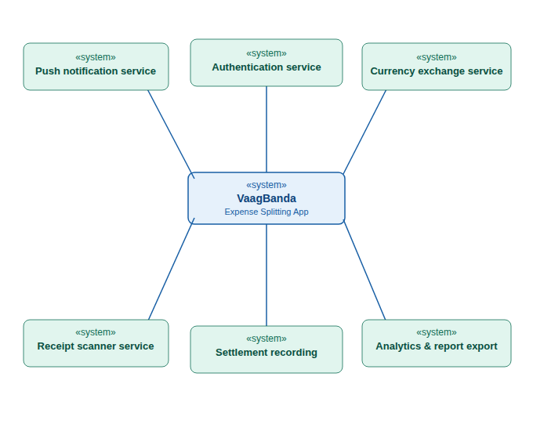
Name | Context Diagram
Description | A high-level diagram that shows a system and its interaction with external systems or services.
Example | VaagBanda app connected to authentication, notification, currency, and analytics services.
When used | Used in early design to understand system boundaries and external interactions.
Advantages | Simple and easy to understand
 | Shows overall system view
 | Helps identify external dependencies
Disadvantages | Does not show internal details
 | Limited technical depth
 | Not suitable for detailed design

2.2 Product Functions
The major functions of VaagBanda are summarized below. Detailed requirements for each function are provided in Section 4 (System Features).
The core functions include user registration and login (with support for social login and biometric access), creating and managing expense groups, adding expenses with various splitting methods (equal division, percentage-based, exact amounts, and shares), viewing balances and expense history, and recording that settlements have been made externally.
Enhanced functions include push notifications for group activity and payment reminders, support for multiple currencies with automatic conversion, and the ability to enter expenses while offline with automatic synchronization when connectivity returns.
Advanced functions include scanning receipts to automatically extract expense information, a visual analytics dashboard showing spending patterns and trends, custom expense categories and tags, and the ability to export expense reports.

2.3 User Classes and Characteristics
VaagBanda identifies three user classes:
Regular User (Primary): The most common user class. Regular users can register, join groups, add expenses, view balances, record settlements, and access analytics. They are expected to be young adults with moderate smartphone proficiency. This is the most important user class and all features are designed with their needs as the top priority.
Group Administrator: A regular user who created a group and has additional privileges: managing group members (add/remove), editing group settings (name, currency, category), and deleting the group. A single user can be an admin of multiple groups and a regular member of others.
New/Occasional User: Users who are invited to a group but may use the app infrequently. The interface must be intuitive enough for first-time users to add an expense or view their balance without a learning curve. Onboarding guidance and contextual help address this class.

2.4 Operating Environment
The VaagBanda mobile application shall operate on modern smartphones running current and recent versions of iOS and Android operating systems. The application must support a range of screen sizes commonly found in modern smartphones, in both portrait and landscape orientations.
The application requires internet connectivity for initial setup, synchronization, and real-time features, but should also support a limited offline mode allowing users to enter expenses locally and sync them when connectivity returns.
The backend server and database will be hosted on a cloud platform. The specific hosting provider and configuration will be determined during the Design phase.

2.5 Design and Implementation Constraints
- This is an academic project with a fixed timeline and limited team size of four members with assigned roles (Project Manager, Systems Analyst, UI/UX Designer, Developer).
- The project has zero budget; all tools, hosting, and external services must be free or open-source.
- The mobile application will be built using React Native to ensure cross-platform compatibility (iOS and Android from a single codebase), as required by the project scope.
- The development methodology is the Incremental Model with Agile practices, as prescribed by the course and described in Dennis, Wixom & Roth and Sommerville.
- The system must NOT process actual financial transactions. It only records and manages expense and settlement data.
- All calculations involving money must use precise decimal arithmetic to avoid rounding errors.

2.6 User Documentation
The following documentation will be delivered alongside the software:
- An in-app onboarding guide for first-time users.
- Contextual help on key screens to assist users with core tasks.
- Project repository documentation covering setup and usage instructions.
- A brief user guide explaining core workflows: creating groups, adding expenses, recording settlements, and viewing analytics.
2.7 System Architecture:
System architecture is the high-level structure of a system that defines its main components, how they are organized, and how they interact with each other. It provides a blueprint for designing and developing the system, ensuring that all parts work together efficiently. It also helps in managing complexity, improving scalability, and maintaining the system over time.

2.7.1 Client–Server Architecture:
Client–Server Architecture is a system design where clients (such as mobile apps) send requests to a central server, and the server processes those requests and returns responses. Communication between client and server happens over the Internet using protocols like HTTPS. The application server handles the main logic such as user login, expense management, and group operations, while the database server stores data like users and expenses. External services are integrated to provide additional features such as notifications and authentication (e.g., Face ID).

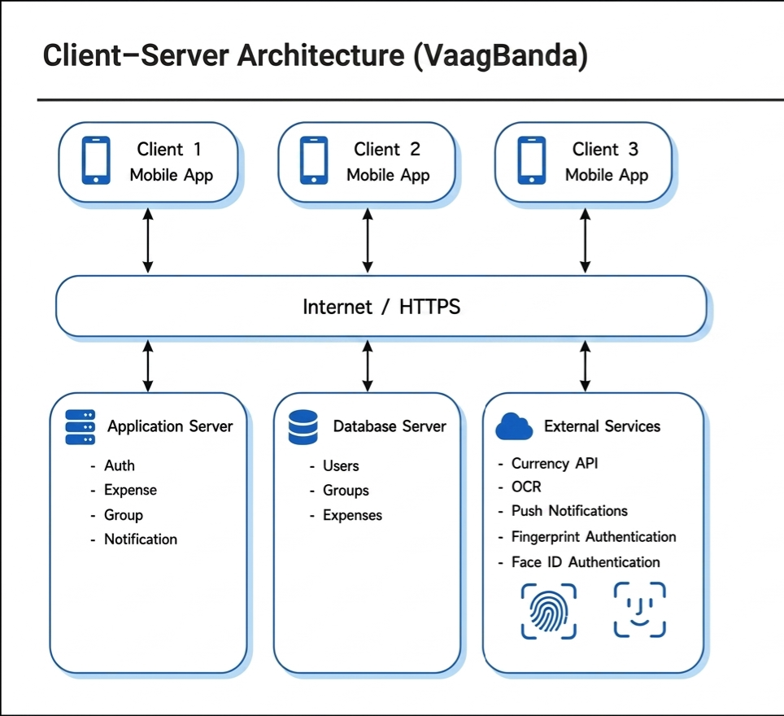

Name | Client–Server
Description | Clients send requests to the server, and the server processes and returns results.
Example | Mobile app where users add and share expenses.
When used | Used in web and mobile apps with many users.
Advantages | Easy to manage Supports many users Scalable
Disadvantages | Needs internet Server failure affects all Can be slow under heavy load

2.7.2 Pipe-and-Filter Architecture
Pipe-and-Filter Architecture is a design where data flows through a sequence of processing steps called filters. Each filter performs a specific task and passes its output to the next stage. In the server, the process starts with a client request and ends with a response sent back to the client. The request handler acts as the entry point, followed by validation to check input data, authentication to verify the user, and authorization to check permissions. Then, business logic processes the core operations, data access interacts with the database, and finally, the response formatter prepares the output (usually in JSON format).
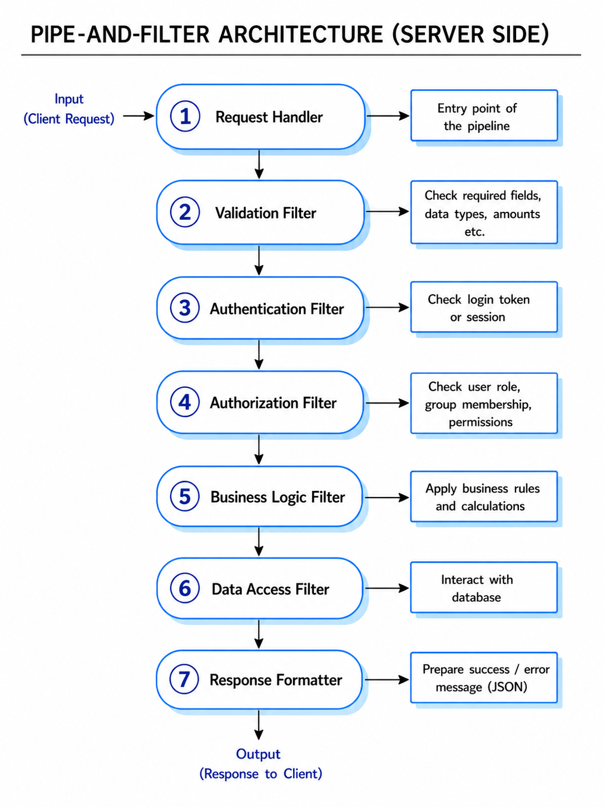
Name | Pipe-and-Filter
Description | Data is processed in a sequence of steps (filters), where each filter transforms input and passes it to the next through pipes.
Example | Server request processing: validation → authentication → authorization → business logic → database → response.
When used | Used in data processing systems and backend request pipelines.
Advantages | Simple and modular design
 | Easy to test and maintain
 | Reusable components
Disadvantages | Not suitable for interactive systems
 | Data format must be consistent
 | Can add processing overhead

2.8 Assumptions and Dependencies
- Users have smartphones running current versions of iOS or Android with access to the internet for initial setup and periodic syncing.
- Free-tier cloud hosting services provide sufficient resources for the scale of this academic project.
- A free currency exchange rate service is available with sufficient request limits for development and testing.
- A free push notification service is available for delivering alerts to mobile devices.
- All team members contribute consistently throughout the project duration.
- Users settle debts through external means (cash, bank transfer, etc.) and use VaagBanda only to record that the settlement has occurred.
- The university provides necessary development tools, version control hosting, and testing resources.

3. External Interface Requirements

3.1 User Interfaces
The mobile application shall present a tab-based navigation interface with primary sections for Home (group list and overall balance), Groups (detailed group view with expenses), Activity (recent transactions and notifications), and Profile (user settings and preferences). The interface should follow the native design conventions of each platform so that the app looks and feels natural to both iOS and Android users.
Key screens include: a login and registration screen with options for social login; a group creation flow allowing users to set a name, category, currency, and invite members; an expense entry form with fields for amount, description, date, category, payer selection, split method, and an option to attach a receipt photo; a balance summary showing how much each member owes or is owed; and an analytics dashboard with visual charts showing spending patterns.
The interface should be designed so that core tasks like adding an expense or viewing a balance can be completed quickly with minimal navigation. Error messages should appear clearly next to the relevant input fields. The app should be usable with one hand on typical smartphone screen sizes.

3.2 Hardware Interfaces
The application will interact with the following hardware capabilities of the user’s mobile device:
- Camera: Used for capturing photos of receipts that can be processed to extract expense information.
- Biometric sensors: Fingerprint reader or facial recognition hardware used for quick and secure login.
- Network interface: Wi-Fi and cellular data connections for communicating with the server. The app should detect when connectivity is unavailable and switch to offline mode.
- Local storage: The device’s storage for caching data locally and storing expenses entered while offline.

3.3 Software Interfaces
VaagBanda will interface with the following external software services:
Currency Exchange Rate Service: The server will retrieve current exchange rates from an external currency service to support multi-currency groups. The system should cache rates to reduce the number of external requests and should handle service unavailability gracefully by using the most recently cached rates.
Push Notification Service: The server will send push notifications through an external notification service to alert users about new expenses, settlement recordings, group invitations, and payment reminders.
OCR (Optical Character Recognition) Service: Receipt images will be processed using an OCR capability (either on-device or server-side, to be determined during Design) to extract text such as the total amount, date, and vendor name. The extracted data will pre-fill the expense form for user confirmation.
Database System: The server will connect to a relational database for persistent storage of all user, group, expense, split, and settlement data. The specific database system will be selected during the Design phase.

3.4 Communications Interfaces
All communication between the mobile application and the server shall be encrypted to protect user data in transit. The server will expose a RESTful API that the mobile app consumes, using standard web protocols and a structured data format for requests and responses.
For features that benefit from real-time updates (such as live balance changes when another group member adds an expense), the system should support a real-time communication channel in addition to the standard request-response API.
User authentication shall be handled through secure tokens that are transmitted with each request. The token mechanism should support automatic renewal so that users are not frequently asked to log in again.

4. System Features
This section describes the system’s functional requirements organized by feature. Each feature includes a description and priority, the stimulus/response sequences (user actions and system reactions), and the specific requirements that the feature must satisfy. These requirements describe what the system must do; design and implementation decisions for how these requirements will be met are deferred to the Design phase.

4.1 User Registration and Authentication

4.1.1 Description and Priority
This feature allows new users to create accounts and existing users to securely access the system. It forms the foundation of user identity management and is required before any other feature can be used. The system should support traditional email and password registration as well as social login options to reduce friction. Biometric login should be available for returning users on devices that support it.
Priority: Must Have

4.1.2 Stimulus/Response Sequences
- User opens the app for the first time → System displays a welcome screen with options to sign up or log in.
- User chooses to sign up and provides their email, a password, and a display name → System checks that the email is not already registered, creates the account, logs the user in, and navigates to the home screen.
- User chooses to log in with existing credentials → System verifies the credentials and navigates to the home screen.
- User taps a social login option (such as Google or Apple) → System handles the social login flow, creates or links the account, and navigates to the home screen.
- Returning user opens the app → System offers biometric login if previously enabled by the user.
- User enters incorrect credentials multiple times → System temporarily locks the account to prevent unauthorized access.

4.1.3 Functional Requirements
- The system shall allow users to register with a valid email address and a password that meets reasonable complexity requirements (such as minimum length and character variety).
- The system shall support social login through at least one major provider (such as Google or Apple) #will be incremented in next version.
- The system shall verify that each email address is unique during registration and inform the user if the email is already taken.
- The system shall store passwords securely using a strong hashing algorithm; plaintext passwords must never be stored or logged.
- The system shall keep users logged in across sessions and support automatic session renewal so users do not need to log in frequently.
- The system shall support biometric login (fingerprint or face recognition) on devices that have the necessary hardware.
- The system shall temporarily lock accounts after a configurable number of consecutive failed login attempts to prevent brute-force attacks.

4.2 Group Management

4.2.1 Description and Priority
This feature allows users to create expense groups, invite members, manage group settings, and delete groups. Groups are the organizational unit around which all expense tracking is structured. Each group has a name, an optional description, a category (such as trip, household, event, or couple), and a default currency. The user who creates a group is automatically its administrator.
Priority: Must Have

4.2.2 Stimulus/Response Sequences
- User taps "Create Group" → System presents a form for group name, description, category, and default currency. User adds members by searching by email, phone, or username. System creates the group and notifies invited members.
- An invited user receives a notification → User accepts or declines. If the invitee is not already registered, they receive an invitation to join VaagBanda first.
- Group admin opens group settings → System displays options to edit the group name, currency, and member list. Admin can remove members or delete the group.

4.2.3 Functional Requirements
- The system shall allow authenticated users to create groups with a name, optional description, category, and default currency.
- The system shall allow group creators to invite members by email, phone number, or in-app search.
- The system shall send notifications to invited users and send join invitations to people who are not yet registered.
- The system shall assign an administrator role to the group creator and a member role to all other participants.
- Group administrators shall be able to edit group settings, remove members, and delete the group.
- The system shall warn administrators before deleting a group that has unsettled balances and require confirmation.

4.3 Expense Entry and Splitting

4.3.1 Description and Priority
This is the central feature of VaagBanda. Users can add shared expenses to a group, optionally attach a receipt image, and choose how to split the cost among group members. The system calculates each person’s share and updates the group’s balances. Multiple splitting methods should be supported: equal division (where everyone pays the same), and later unequal methods including exact amounts, percentages, and shares. Receipt scanning with automatic data extraction is planned for a later increment.
Priority: Must Have (equal splitting first; unequal and OCR in later increments)

4.3.2 Stimulus/Response Sequences
- User navigates to a group and taps "Add Expense" → System shows a form with fields for amount, description, date, category, who paid, and how to split.
- User fills in the details, selects participants, chooses a split method, and saves → System validates the input, calculates each person’s share, saves the expense, updates balances, and notifies all participants.
- User optionally attaches a receipt photo → In a later increment, the system will use OCR to extract amount, date, and vendor and pre-fill the form for the user to confirm.
- A required field is missing or the amount is invalid → System highlights the problem and asks the user to correct it.
- User is offline → System saves the expense locally and syncs it automatically when connectivity returns.

4.3.3 Functional Requirements
- The system shall allow users to add an expense with the following information: amount (required, must be positive), description (required), date (required, defaulting to today), category (optional), who paid (required, defaulting to the current user), and a receipt image (optional).
- The system shall support equal splitting where the total is divided evenly among selected participants. Any rounding remainder should be handled consistently (for example, assigned to the payer).
- The system shall support unequal splitting by exact amounts, percentages, and shares, and shall ensure that the individual portions add up to the total expense amount.
- The system shall support receipt scanning that extracts key information (amount, date, vendor) and pre-fills the expense form, allowing the user to review and confirm before saving.
- The system shall support offline expense entry, storing the expense locally and syncing it automatically when the device regains connectivity.
- The system shall update group balances immediately when a new expense is saved.
- The system shall notify all participants in the expense when it is created.

4.4 Balance Display and Debt Simplification

4.4.1 Description and Priority
This feature calculates and displays how much each person owes or is owed within a group, and across all groups. In a later increment, the system should implement a debt simplification algorithm that minimizes the number of individual settlements needed to clear all debts. For example, if person A owes person B some amount, and B owes person C the same amount, the system would suggest that A pay C directly, eliminating one unnecessary transfer.
Priority: Must Have (basic balances first; simplification in a later increment)

4.4.2 Stimulus/Response Sequences
- User opens a group → System displays a balance summary showing each member’s net position (how much they owe or are owed).
- User navigates to the home screen → System shows an overall balance summary across all groups.
- User requests simplified debts → System calculates the minimum number of settlements needed and displays the suggestions.
- User taps on a specific member’s balance → System shows the detailed history of expenses and settlements between the current user and that member.

4.4.3 Functional Requirements
- The system shall calculate and display net balances per member within each group, updated whenever expenses or settlements change.
- The system shall display an overall balance summary across all of a user’s groups on the home screen.
- The system shall implement a debt simplification algorithm that minimizes the total number of settlements needed to resolve all debts in a group.
- The system shall allow users to view a detailed transaction history between themselves and any other group member.

4.5 Settlement Recording

4.5.1 Description and Priority
This feature allows users to record that a settlement has been made outside the app. VaagBanda does not process any actual money transfer; it simply logs that a payment was made externally (for example, via cash, bank transfer, or other method) so that the group’s balances can be updated. Users can record full or partial settlements and add optional notes describing the payment.
Priority: Must Have

4.5.2 Stimulus/Response Sequences
- User taps "Settle Up" on the balance screen → System displays a list of outstanding balances with each member.
- User selects a creditor to settle with → System shows the total amount owed and suggests a full settlement.
- User confirms the amount (full or partial), indicates how they paid externally, and optionally adds a note → System records the settlement, updates balance for both parties, and notifies the creditor.

4.5.3 Functional Requirements
- The system shall allow users to record that a settlement has occurred, specifying: the amount (required, must be positive, and cannot exceed what is owed), the external payment method used (such as cash, bank transfer, or other), and an optional note.
- The system shall support partial settlements, where only a portion of the owed amount is recorded. The remaining balance shall persist.
- The system shall update balances for both the debtor and creditor immediately upon recording a settlement.
- The system shall notify the creditor when a settlement is recorded against them.
- The system shall handle the situation where two people try to record settlements at the same time gracefully, without producing incorrect balances.

4.6 Notifications and Reminders

4.6.1 Description and Priority
This feature keeps users informed about group activity and outstanding balances through push notifications and configurable reminders. Notifications are triggered by events such as new expenses being added, settlements being recorded, or group invitations being sent. The system should also send periodic reminders for unpaid debts.
Priority: Should Have

4.6.2 Stimulus/Response Sequences
- An expense is added to a group → System sends a notification to all participants with the expense details.
- A settlement is recorded → System notifies the creditor.
- A user is invited to a group → System sends an invitation notification.
- A user has an outstanding balance that has been unpaid for a while → System sends a payment reminder.

4.6.3 Functional Requirements
- The system shall send push notifications for key events: new expenses, settlement recordings, group invitations, and member changes.
- The system shall send automated payment reminders for outstanding balances that have remained unpaid beyond a configurable period.
- Users shall be able to configure their notification preferences, choosing which types of notifications they want to receive.
- The system shall maintain a notification history that users can access from within the app, with the ability to see which notifications have been read.

4.7 Multi-Currency Support

4.7.1 Description and Priority
This feature allows groups to operate in different currencies and automatically converts expense amounts for balance calculations. Each group has a default currency, and individual expenses can be entered in any supported currency. The system retrieves exchange rates from an external service and converts amounts as needed.
Priority: Should Have

4.7.2 Stimulus/Response Sequences
- User creates a group and selects a default currency → System stores this setting.
- User adds an expense in a different currency than the group’s default → System retrieves the current exchange rate and converts the amount for balance calculations, while preserving the original currency and amount.

4.7.3 Functional Requirements
- The system shall support multiple currencies with conversion using rates from an external exchange rate service.
- Each group shall have a configurable default currency used for balance calculations.
- The system shall cache exchange rates to reduce external requests and shall fall back to cached rates when the service is unavailable.
- The system shall preserve the original currency and amount for each expense alongside the converted amount.

4.8 Analytics Dashboard and Report Export

4.8.1 Description and Priority
This feature provides spending insights through visual charts and allows users to export expense reports. The dashboard should include a category breakdown (such as a pie chart), spending trends over time (such as a line chart), identification of top spending groups, and summaries of how much each member has contributed. Users should be able to export their data for external use.
Priority: Could Have

4.8.2 Stimulus/Response Sequences
- User navigates to the Analytics section → System displays visual charts summarizing the user’s spending patterns.
- User taps "Export" and selects a format and date range → System generates and provides the report for download.

4.8.3 Functional Requirements
- The system shall display a spending analytics dashboard with: a category breakdown chart, a spending trend chart over time, top spending groups, and per-member contribution summaries.
- The system shall allow users to filter analytics by date range and by group.
- The system shall support exporting group expense reports in at least two formats (such as PDF and CSV), with options to filter by date range, group, and member.
- The system shall provide predefined expense categories (such as food, transport, accommodation, entertainment, and utilities) and allow users to create custom categories and tags.

5. Other Nonfunctional Requirements

5.1 Performance Requirements
The system should respond to user actions quickly enough that the application feels responsive and fluid. Loading lists of expenses and calculating balances should not introduce noticeable delays on typical modern smartphones. When the number of expenses in a group grows large, the system should use pagination or similar techniques to maintain performance.
The server should be able to handle the expected number of concurrent users for an academic-scale deployment without significant slowdowns. Specific performance targets and benchmarks will be defined during the Design phase based on the selected technology stack and hosting environment.

5.2 Safety Requirements
The system shall validate all user input on both the client and server sides to prevent corrupted or malicious data from entering the system. This protects against common attacks such as injection and cross-site scripting that could compromise expense data or expose user information.
When network errors occur, the system should handle them gracefully and avoid data loss. Expenses entered during network failures should be preserved locally and synchronized when connectivity is restored. The system should prevent situations where simultaneous updates could result in incorrect balance calculations.

5.3 Security Requirements
All communication between the mobile application and the server shall be encrypted to protect data in transit. User passwords shall be stored using a strong, industry-standard hashing algorithm; plaintext passwords must never be stored or logged anywhere in the system.
Sensitive personal information stored in the database should be protected with appropriate encryption. The system shall enforce access control so that users can only access data belonging to groups they are members of. Administrative operations within a group (such as removing members) shall be restricted to users with the administrator role.
Authentication tokens should be stored securely on the user’s device using the platform’s secure storage mechanism, and should not be stored in plaintext.

5.4 Software Quality Attributes
Usability: The application should be intuitive enough that new users can perform core tasks (adding an expense, viewing a balance) without needing external help or training. The interface should be tested with real users to validate its usability, and the target should be a high usability score on a standard usability assessment. Core tasks should require minimal navigation steps from the home screen.
Reliability: The system should be stable and available whenever users need it. Planned downtime for maintenance should be minimal and scheduled during low-usage periods. The system should recover gracefully from errors and provide meaningful feedback to users when problems occur.
Maintainability: The codebase should follow consistent coding standards and be well-documented. Automated tests should cover the core business logic to catch regressions early. The API should be documented using a standard specification format to make it easy for future developers to understand and extend. These practices align with Sommerville’s discussion of software quality management.
Portability: The mobile application should run on both iOS and Android without requiring separate platform-specific codebases, thanks to the cross-platform framework. The backend should be deployable on any standard cloud hosting environment.
Compatibility: The application should render correctly on the range of screen sizes commonly found in modern smartphones and should work in both portrait and landscape orientations. The app should coexist with other applications on the device without conflicts.

5.5 Business Rules
All expense splits must add up exactly to the total expense amount. When splitting equally produces amounts that cannot divide evenly, the rounding remainder should be handled consistently.
Settlement amounts must be greater than zero and cannot exceed the total amount currently owed by the debtor to the creditor.
Only group administrators can remove members or modify group settings.
Groups with unsettled balances cannot be deleted without first settling or recording settlements for all outstanding amounts.
Users may belong to any number of groups simultaneously, and there is no restriction on the number of expenses within a group.
The system records settlement events only; it does not verify or process actual external payments. Trust between group members is assumed.

6. Other Requirements

6.1 Development Methodology
The project follows the Incremental Model as its primary development strategy, as described in Dennis, Wixom & Roth (Chapter 1) and Sommerville (Chapter 2). The system will be delivered in three increments, each producing a working, testable build. Each increment extends the previous one’s functionality while maintaining backward compatibility. Within each increment, the team will practice Agile methods with short iterative cycles, regular planning sessions, and retrospectives for continuous improvement.

6.2 Database Requirements
The system shall use a relational database to store all persistent data. All monetary amounts shall be stored using a precise decimal data type to avoid rounding errors from floating-point arithmetic. The database design shall enforce data integrity through proper constraints and relationships. The specific database system and schema will be designed during the Design phase.

6.3 Internationalization
The user interface shall initially support English. The application’s architecture should use a localization framework so that additional languages can be added in the future without requiring code changes. Currency and number formatting should respect locale conventions.

6.4 Project Constraints
Constraint | Description
Timeline | Academic semester with a midterm checkpoint; all deliverables must be completed within the course schedule
Budget | Zero budget; must use free-tier services and open-source tools exclusively
Team Size | Four members with flexible roles; with Professor Ibrahim Musa as supervisors
Technology | React Native for the mobile client (cross-platform requirement)
Scope Limitation | No actual financial transactions; the system only records and manages expense and settlement data

6.5 Risk Analysis
Risk | Likelihood | Impact | Mitigation
Scope creep from adding unplanned features | High | High | Follow the increment plan strictly; new ideas go to the backlog for future consideration
Team member unavailability or workload imbalance | Medium | High | Cross-training so each member understands other roles; maintain shared documentation
External service unavailability or rate limits | Medium | Medium | Cache external data locally; design the system to degrade gracefully when services are unavailable
Performance issues on lower-end devices | Medium | Medium | Test on a range of devices early and often; optimize heavy screens during development
Data security vulnerability | Low | Critical | Follow security best practices; encrypt sensitive data; review dependencies for known vulnerabilities

Appendix A: Glossary
Term | Definition
SDLC | Systems Development Life Cycle – the structured process for planning, creating, testing, and deploying an information system (Dennis, Wixom & Roth Ch. 1; Sommerville Ch. 2)
Incremental Model | A development approach where the system is built and delivered in successive increments, each adding new functionality to the previous version (Sommerville Ch. 2)
Agile | A family of development methodologies emphasizing iterative delivery, collaboration, and responsiveness to change (Sommerville Ch. 3)
Pipe-and-Filter | An architectural pattern where data flows through a sequence of processing steps (filters), each performing a specific transformation (Sommerville Ch. 6)
Client-Server | An architectural pattern where client applications request services from centralized server components (Sommerville Ch. 6)
Rich Client | A client application that performs significant processing locally on the user’s device, rather than sending all work to the server
OCR | Optical Character Recognition – technology that reads and extracts text from images or scanned documents
REST API | Representational State Transfer – a style for designing networked applications using standard web protocols and operations
Debt Simplification | An algorithm that reduces the number of individual payments needed to settle all debts within a group by finding the most efficient payment paths
Settlement Recording | The act of logging in the app that a payment was made externally (cash, bank transfer, etc.) – the system does not process any actual financial transaction
SRS | Software Requirements Specification – a document that fully describes what a software system should do, following the IEEE 830 standard
MoSCoW | A prioritization method that categorizes requirements as Must Have, Should Have, Could Have, or Won’t Have
Use Case | A description of how a user (actor) interacts with the system to achieve a specific goal, including the normal flow and alternative scenarios (Dennis, Wixom & Roth Ch. 4)
Stakeholder | Group members(developers/testers), user, professor Musa(client), customer service, marketing..

Appendix B: Analysis Models
This appendix contains UML analysis models for VaagBanda, following standard notation as described in Dennis, Wixom & Roth (Chapters 4–6) and Sommerville (Chapter 5). These models were developed during the Analysis phase to capture and communicate the system’s structure and behavior. Six diagrams are provided: a use case diagram, three sequence diagrams, an activity diagram, and a class diagram.

B.1 Use Case Diagram
The use case diagram identifies all actors who interact with the system and the use cases (goals) they can perform. The primary actors are the User and the Group Admin (who has additional privileges). External system actors include the Currency Exchange Service and the Push Notification Service. There is no payment processing actor because the system does not handle financial transactions.
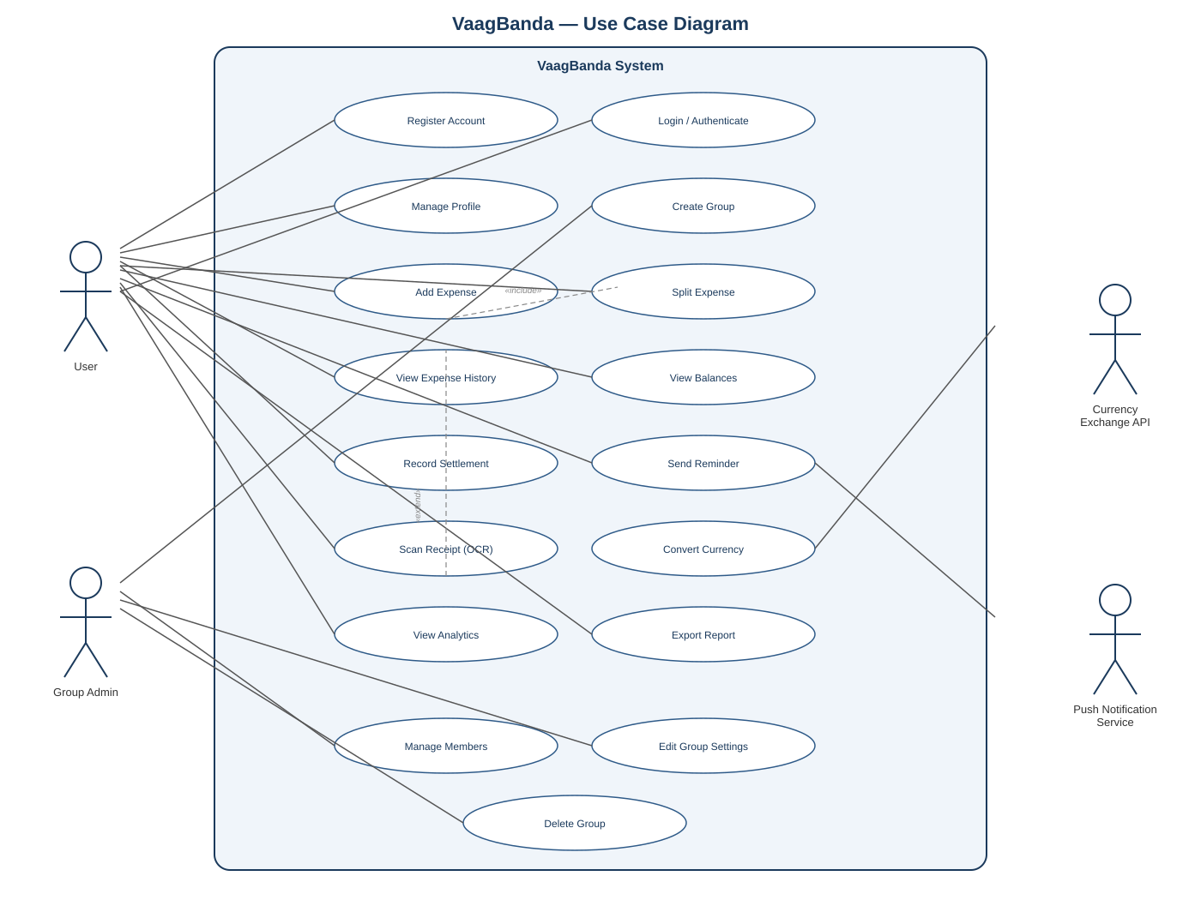
Figure B.1 – VaagBanda Use Case Diagram

B.2 Sequence Diagram: Add Expense
This sequence diagram shows the step-by-step interactions that occur when a user adds a new expense to a group. It illustrates how the request flows from the user through the mobile app to the server and database, including input validation (with an alternative path for invalid data), split calculation, data storage, balance updates, and notification dispatch.
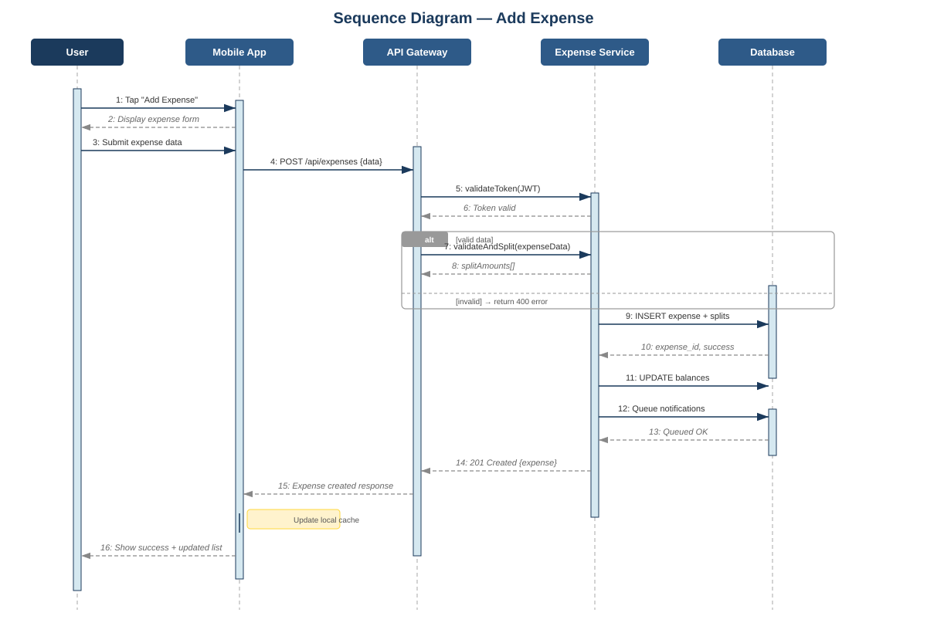
Figure B.2 – Sequence Diagram: Add Expense

B.3 Sequence Diagram: User Registration
This sequence diagram shows the interactions during user registration, including client-side validation, server-side checks for duplicate emails (with an alternative path if the email is already taken), secure password storage, session creation, and the sending of a welcome email.
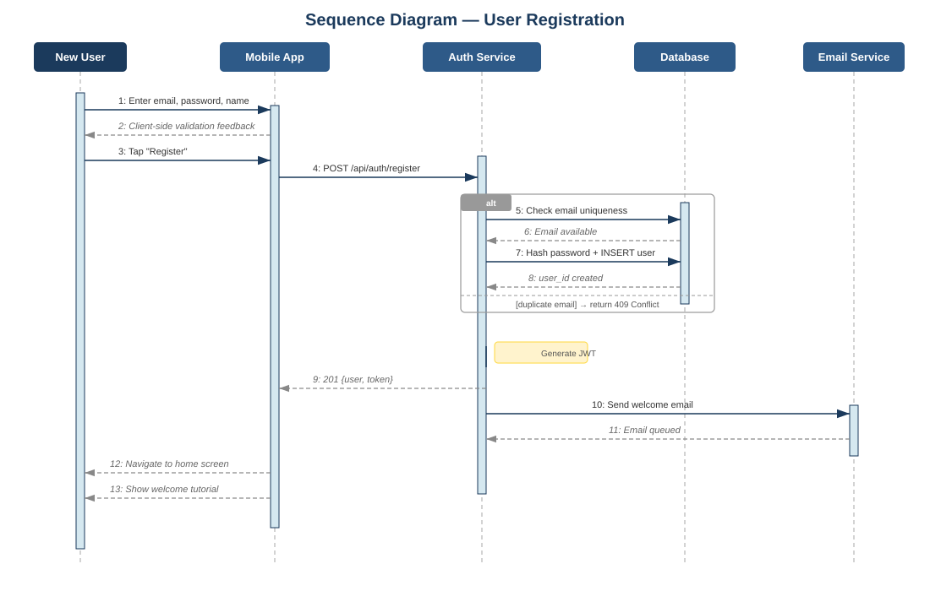
Figure B.3 – Sequence Diagram: User Registration

B.4 Sequence Diagram: Record Settlement
This sequence diagram shows what happens when a user records that they have settled a debt with another group member externally. The system verifies the outstanding balance, records the settlement within a database transaction to ensure data consistency, updates both users’ balances, and notifies the creditor. No actual money transfer is processed by the system.
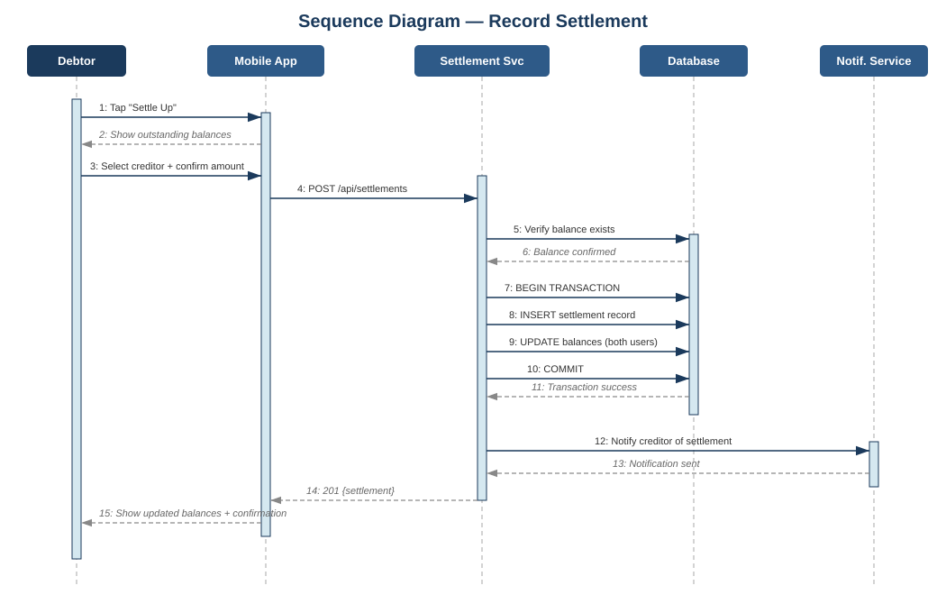
Figure B.4 – Sequence Diagram: Record Settlement

B.5 Activity Diagram: Add Expense Flow
This activity diagram models the workflow of adding an expense, using swimlanes to show which part of the system is responsible for each step. The three swimlanes represent the User/Mobile App, the Application Server, and the Database. The diagram includes decision points for whether the user attaches a receipt (leading to an optional scanning step) and whether the input data is valid (leading to either successful processing or an error path back to the user).
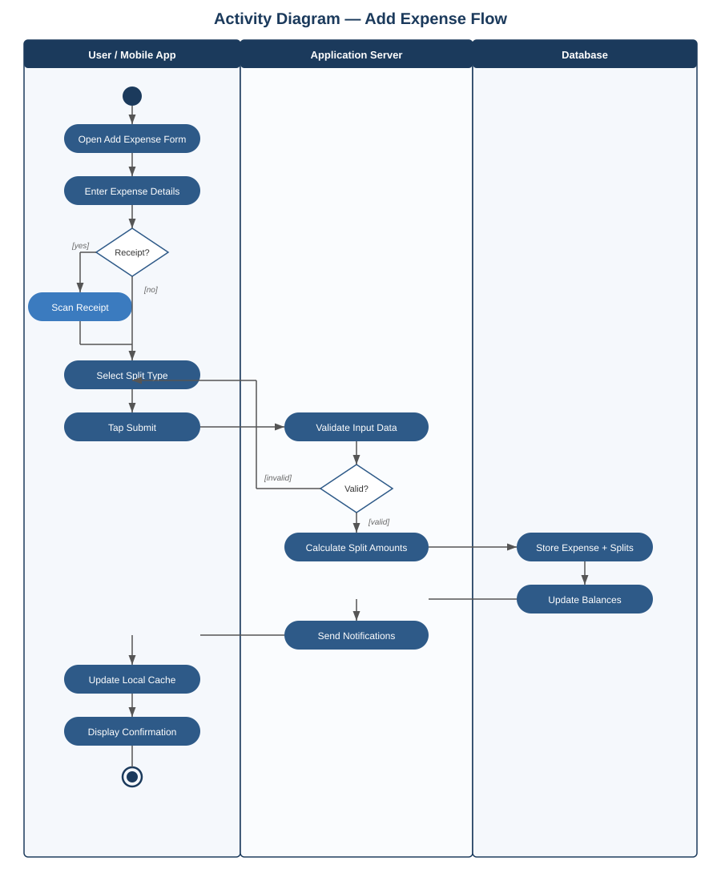
Figure B.5 – Activity Diagram: Add Expense with Swimlanes

B.6 Class Diagram: Core Domain Model
This class diagram shows the core entities in the VaagBanda system, their attributes, their methods, and how they relate to each other. The seven classes are User, Group, Expense, Split, Settlement, Notification, and GroupMember (which resolves the many-to-many relationship between User and Group). Each relationship shows its multiplicity. Note that the Settlement class records an external event and does not represent a financial transaction handled by the system.
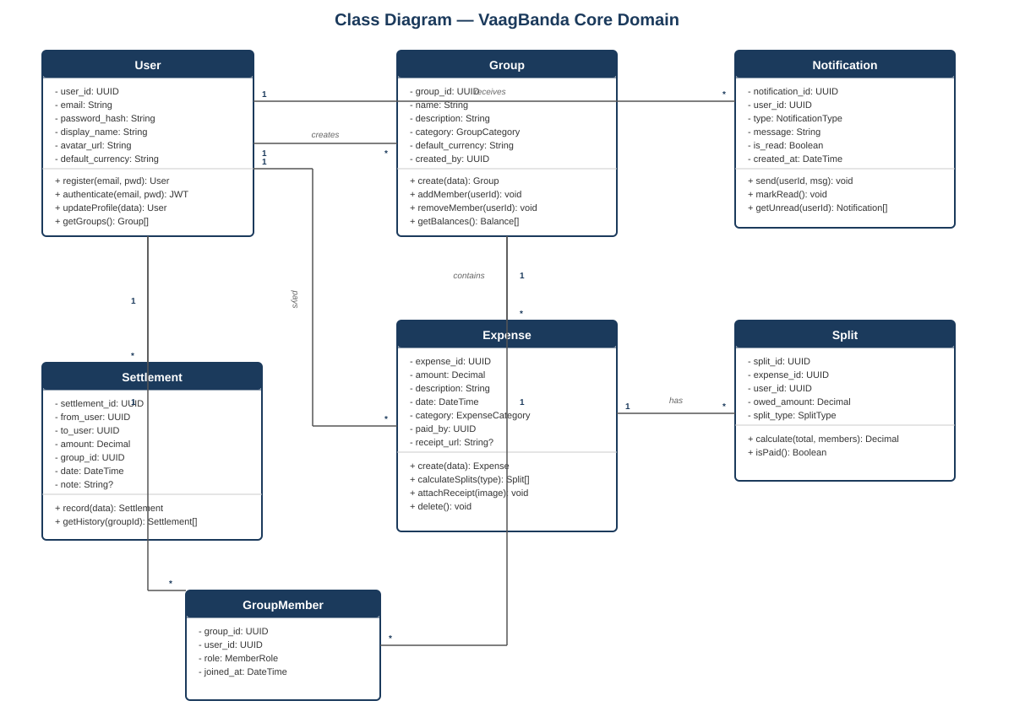
Figure B.6 – Class Diagram: Core Domain Model

B.7 Data Dictionary
The following data dictionary describes the key attributes of each core entity. Data types and specific constraints shown here represent the logical data model; physical implementation details will be finalized during the Design phase.
Entity | Attribute | Data Type | Constraint | Description
User | user_id | Unique ID | Primary Key | Unique identifier for each registered user
User | email | Text | Unique, Required | User’s email address used for login
User | password_hash | Text | Required | Securely hashed password
User | display_name | Text | Required | Name shown to other users
Group | group_id | Unique ID | Primary Key | Unique identifier for expense group
Group | name | Text | Required | Display name of the group
Group | default_currency | Text (3 chars) | Required | Currency code (e.g., USD, EUR)
Group | created_by | Unique ID | References User | User who created the group
Expense | expense_id | Unique ID | Primary Key | Unique identifier for each expense
Expense | amount | Decimal | Required, > 0 | Total expense amount
Expense | description | Text | Required | Brief description of the expense
Expense | paid_by | Unique ID | References User | User who paid
Expense | group_id | Unique ID | References Group | Group this expense belongs to
Split | split_id | Unique ID | Primary Key | Unique identifier for each split
Split | owed_amount | Decimal | Required, ≥ 0 | Amount this user owes for the expense
Split | expense_id | Unique ID | References Expense | Parent expense
Split | user_id | Unique ID | References User | User who owes this portion
Settlement | settlement_id | Unique ID | Primary Key | Unique identifier for settlement record
Settlement | from_user | Unique ID | References User | User who made the external payment
Settlement | to_user | Unique ID | References User | User who received the payment
Settlement | amount | Decimal | Required, > 0 | Amount recorded as settled
Settlement | method | Text | Required | How payment was made externally (cash, bank, etc.)

B.8 Entity-Relationship Summary
The following relationships exist between the core entities:
- User (1) creates (many) Group: A user can create multiple groups. Each group has exactly one creator.
- User (many) belongs to (many) Group: Resolved through the GroupMember association, which tracks each user’s role (Admin or Member) and when they joined.
- User (1) pays for (many) Expense: A user can be the payer for multiple expenses. Each expense has exactly one payer.
- Group (1) contains (many) Expense: A group holds multiple expenses. Each expense belongs to exactly one group.
- Expense (1) is divided into (many) Split: Each expense produces one split record per participating member.
- User (1) records (many) Settlement: A user can record multiple settlements as either the person who paid (from_user) or the person who received (to_user).
- User (1) receives (many) Notification: Each notification targets one specific user.

Appendix C: To Be Determined List
The following items remain to be determined and will be resolved during the Design phase of the project:
# | Item | Description
1 | Backend technology stack | Selection of the specific server framework, database system, and ORM to be used
2 | OCR approach | Whether receipt text extraction should happen on the device or on the server, and which library or service to use
3 | Currency exchange rate provider | Which specific API to use for exchange rates, based on free-tier limits and reliability #in vr2.
4 | Offline conflict resolution strategy | How the system should handle conflicts when multiple users edit the same data while offline
5 | Hosting provider | Which cloud platform to use for deploying the server and database, based on free-tier offerings
6 | Detailed UI wireframes and prototype | High-fidelity screen designs and an interactive prototype for usability testing
7 | Detailed data flow diagrams | Level 2 DFDs decomposing each major process into sub-processes
8 | Performance benchmarks | Specific measurable targets for response times, load capacity, and resource usage
9 | Testing strategy | Detailed test plan covering unit, integration, system, and user acceptance testing

— Version_1 completed —

