Full Pacman Game with Levels



Session 2025 - 2029

Submitted by:
Muhammad Asim Iqbal 2025(S)-CS-57

Supervised by:
Sir Laeeq Khan Niazi

Course:
CSC-102 Programming Fundamentals

Department of Computer Science
University of Engineering and Technology
Lahore Pakistan
- Short Description and Story Writing of Game
Pacman: Multi-Level Maze Game is a classic 2D maze arcade-style game developed in C++ using console graphics. The player controls Pacman, navigating through a maze, collecting points, and avoiding ghosts. The game consists of two levels, each with increasing difficulty and new maze layouts. The story revolves around Pacman trying to survive in haunted mazes while collecting food and bonuses to win.
- Game Characters Description
Character | Symbol | Description
Pacman | P | Main player controlled by the user. Moves around the maze to collect points and avoid ghosts.
Ghosts | G | Enemies that move in set patterns. If they collide with Pacman, a life is lost.
Food | F | Collectible item giving bonus points (+30).
Bonus | B | Rare collectible giving high score (+50).
Health | H | Health Character Gives the Player one Extra Life

- Game Objects Description
Object | Symbol | Purpose
Wall | # or % | To Stop Player Going out of the Maze
Dot / Points | ‘.’ | Gives +10 points when eaten.
Blank Space |  | Empty path where Pacman and ghosts can move.

- Rules & Interactions
1. Pacman can move using arrow keys (← ↑ ↓ →).
2. Game starts from Level 1 and shifts to Level 2 after scoring 1000 points.
3. Level 2 is completed after reaching 3000 points, and the player wins.
4. Touching a ghost (G) or harmful one life.
5. The game starts with 3 lives.
6. If all lives are lost, the game ends with a "Game Over" message.
7. Pressing ESC key exits the game at any point.
8. Winner's name is stored in a file winners.txt if game is completed.
9. There are Power ups in Game which are Health (H), Bonus(B) and Food(F)

- Goal of the Game
• Collect points by eating dots (.), food (F), and bonus items (B).
•Avoid ghosts (G)
•Eat Health Power Ups For Extra Life
•Reach 1000 points to unlock Level 2.
•Reach 3000 points to win the game and get your name recorded in the winners list.

- Wireframes of the Game
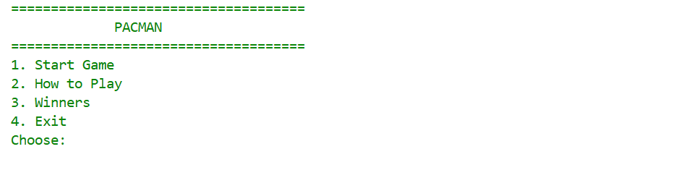
Fig1: Main Menu
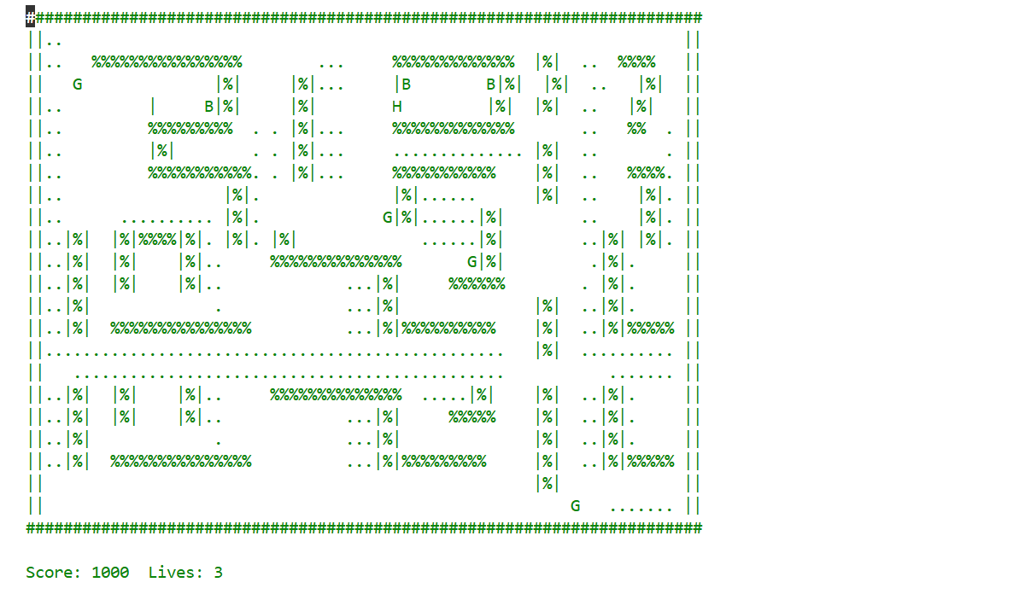Fig2:Maze1
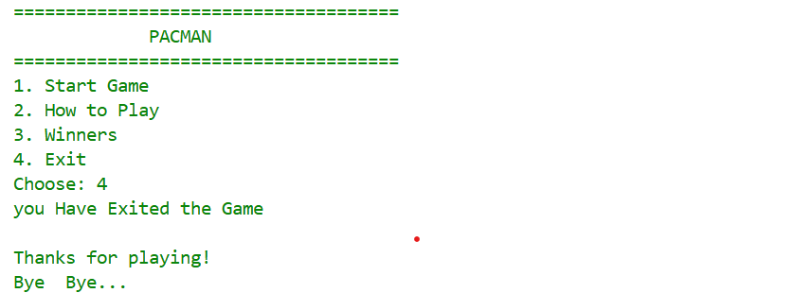
Fig3: Exit Game

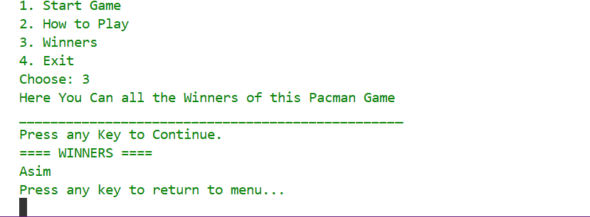
Fig4: Show Winners

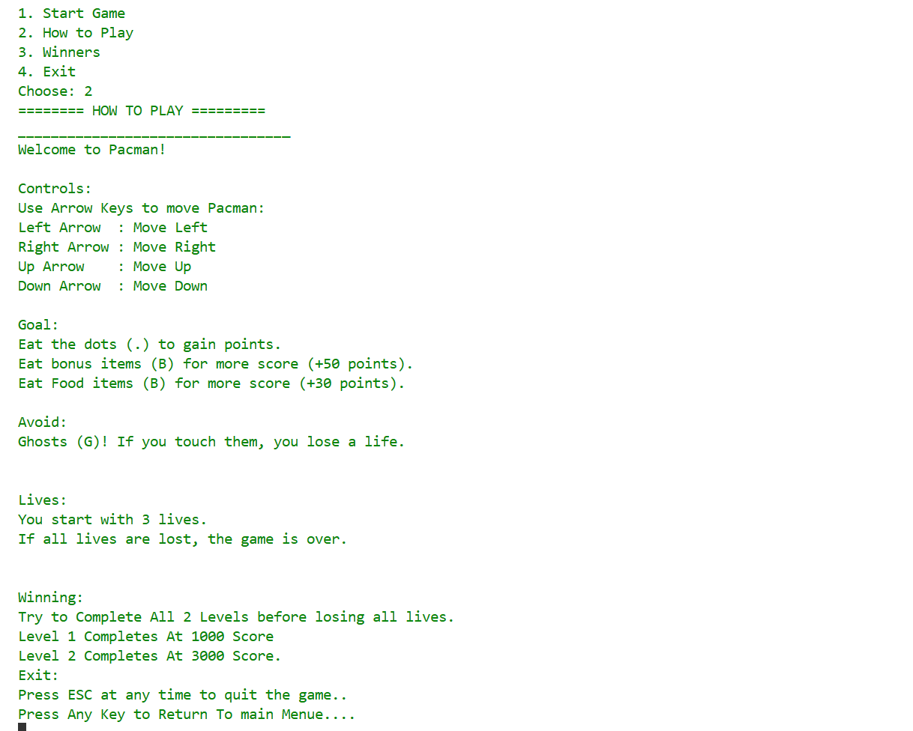

Fig5: How to Play
- Data Structures
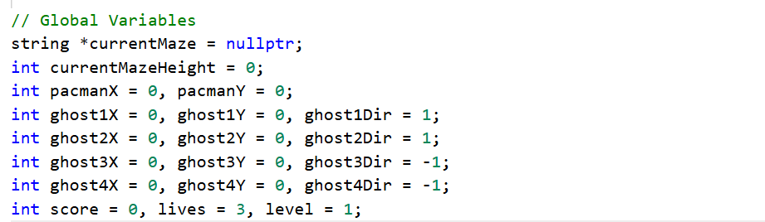
Fig1: Global Variables
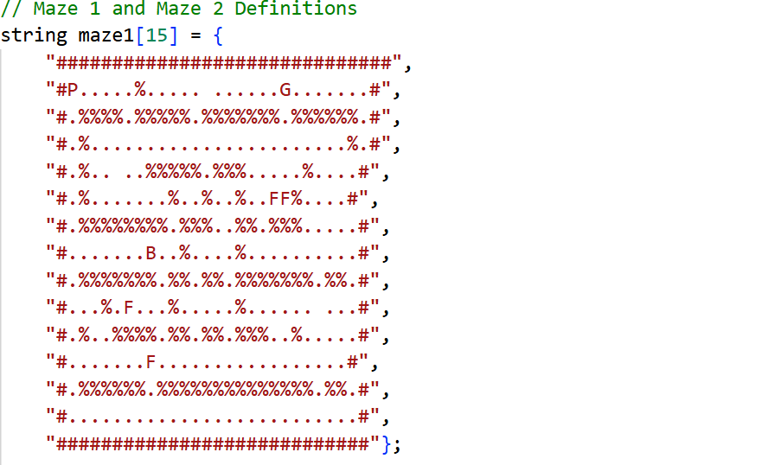
Fig2:Maze1

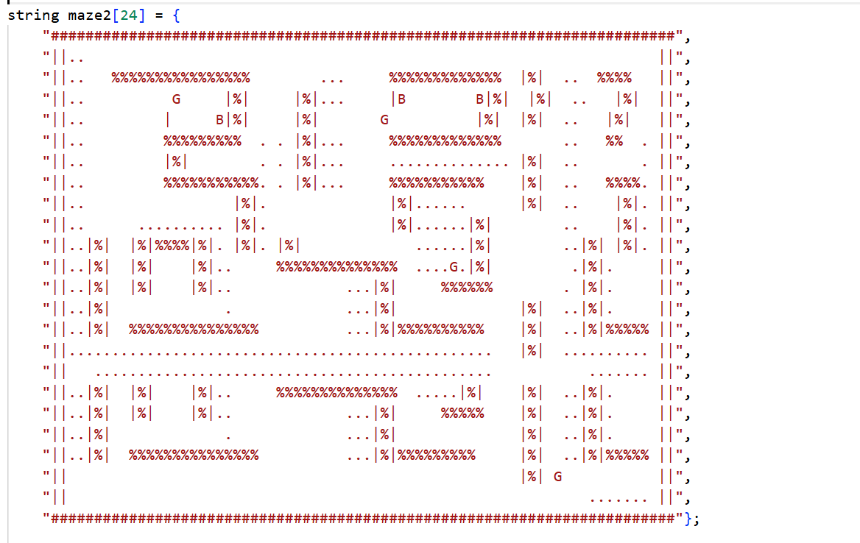
Fig3:Maze2

8. Function Prototypes

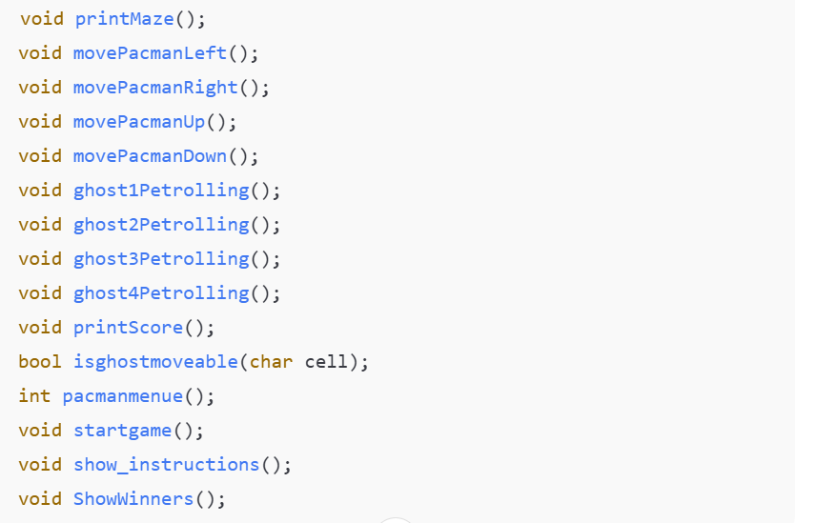

9. Complete Code
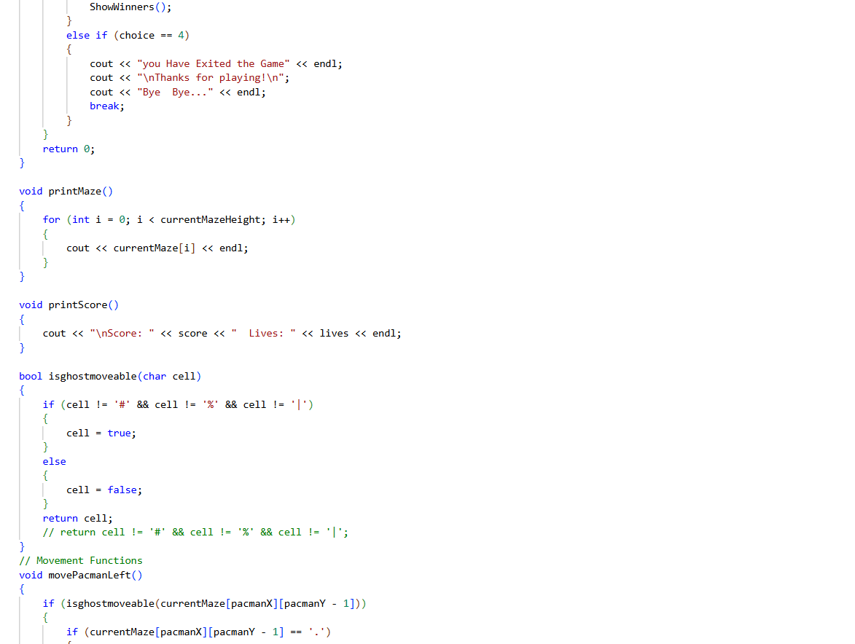
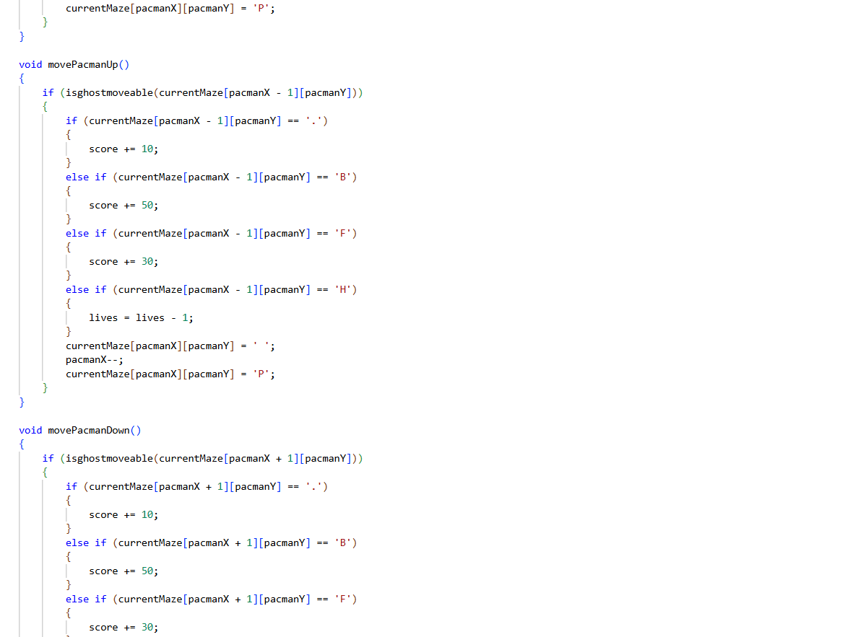
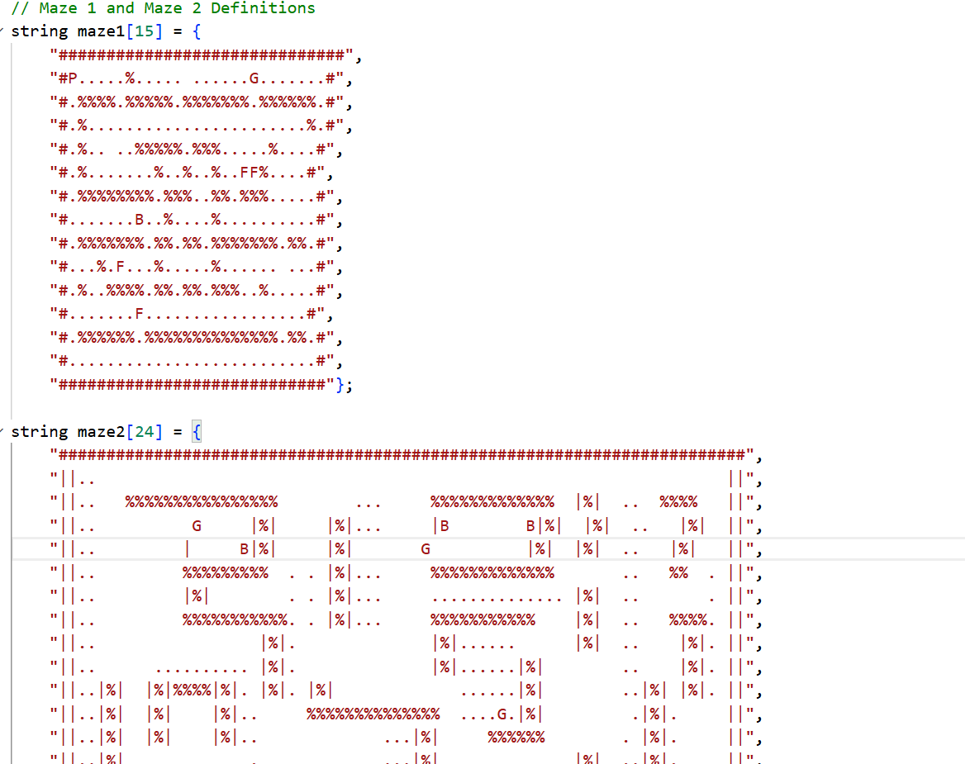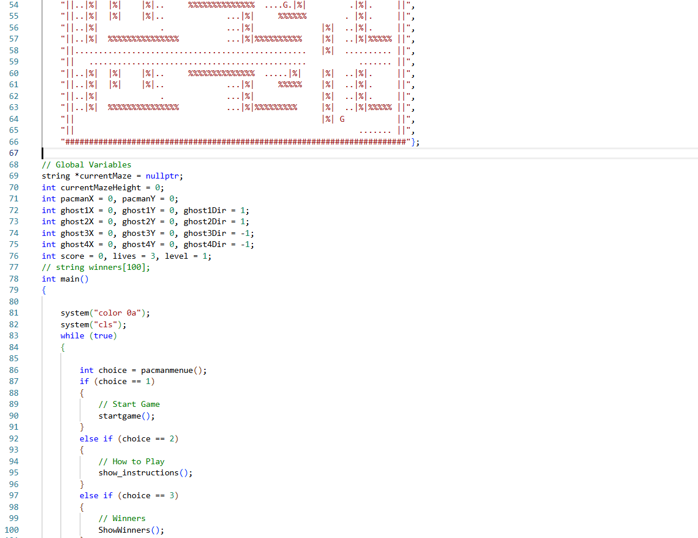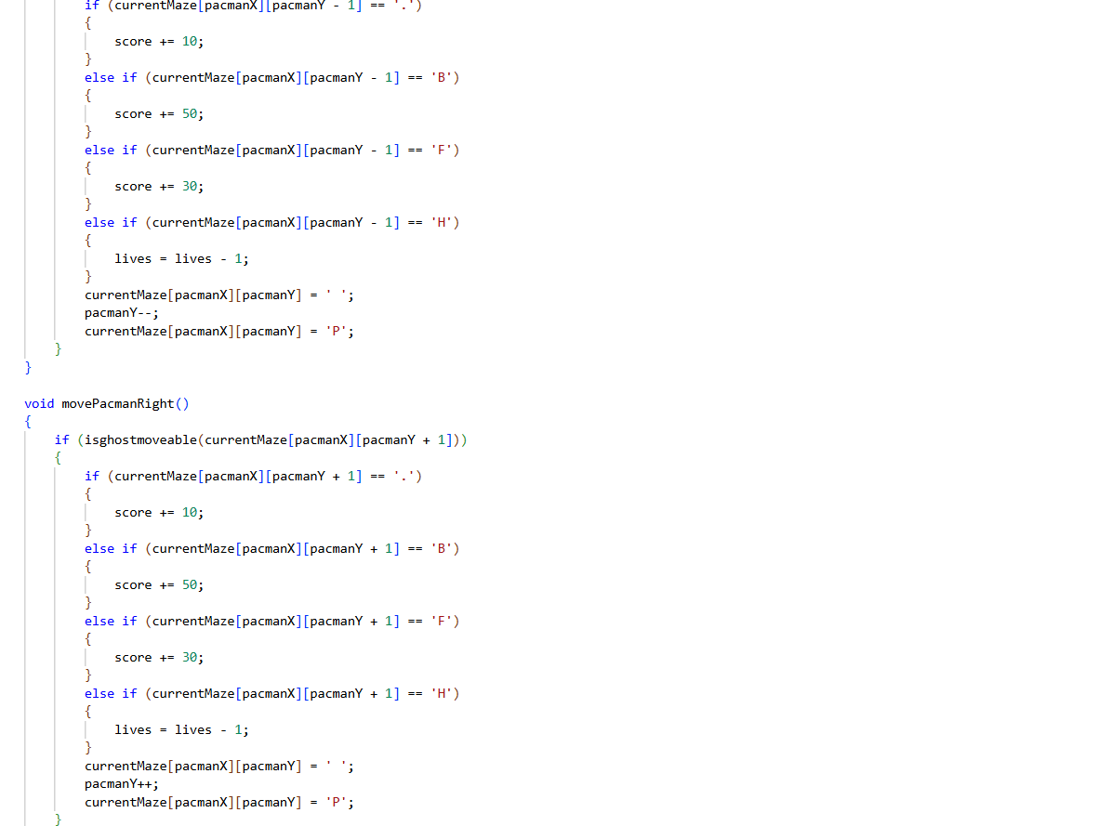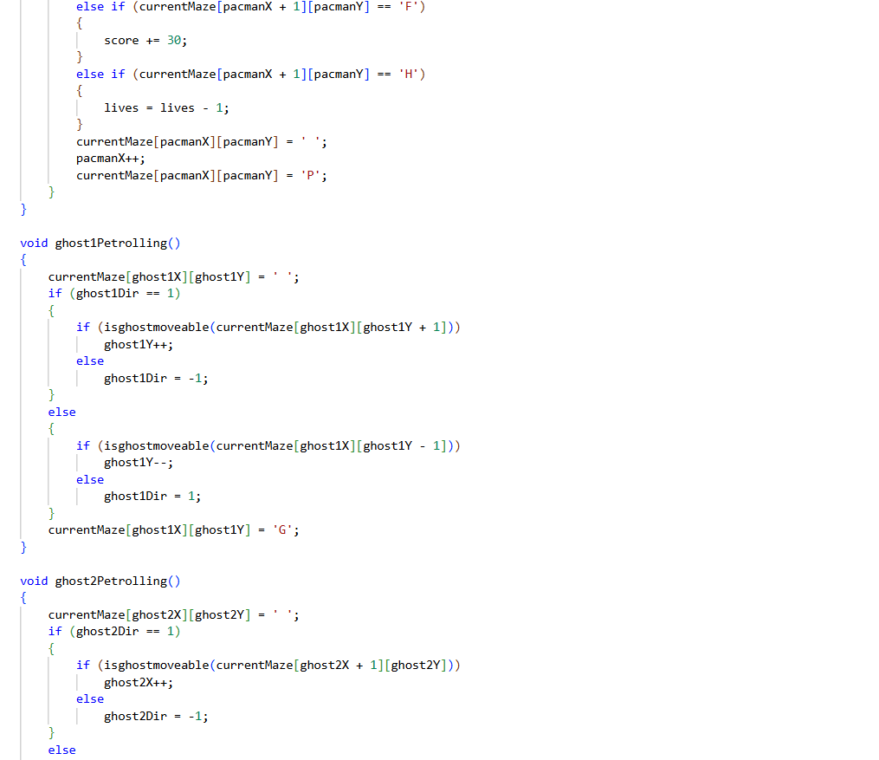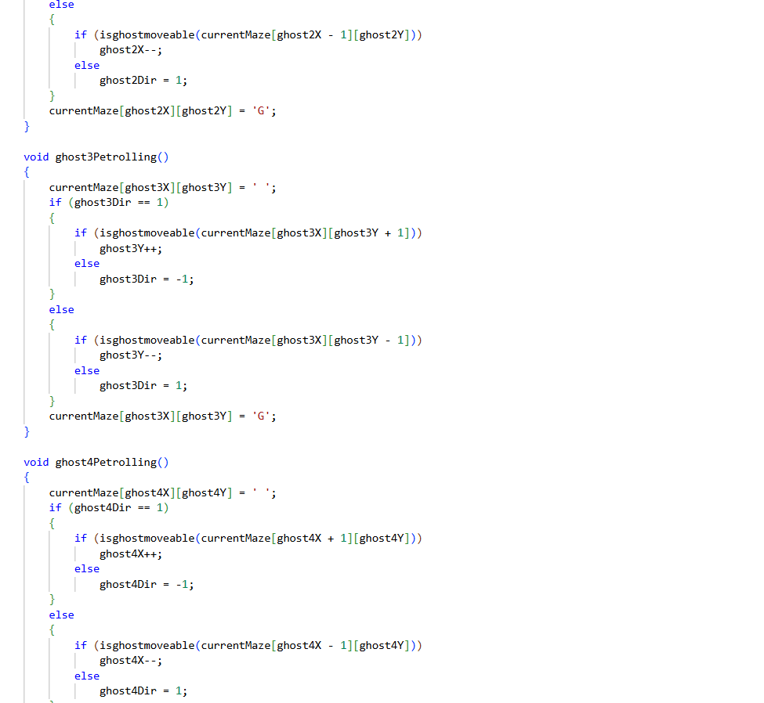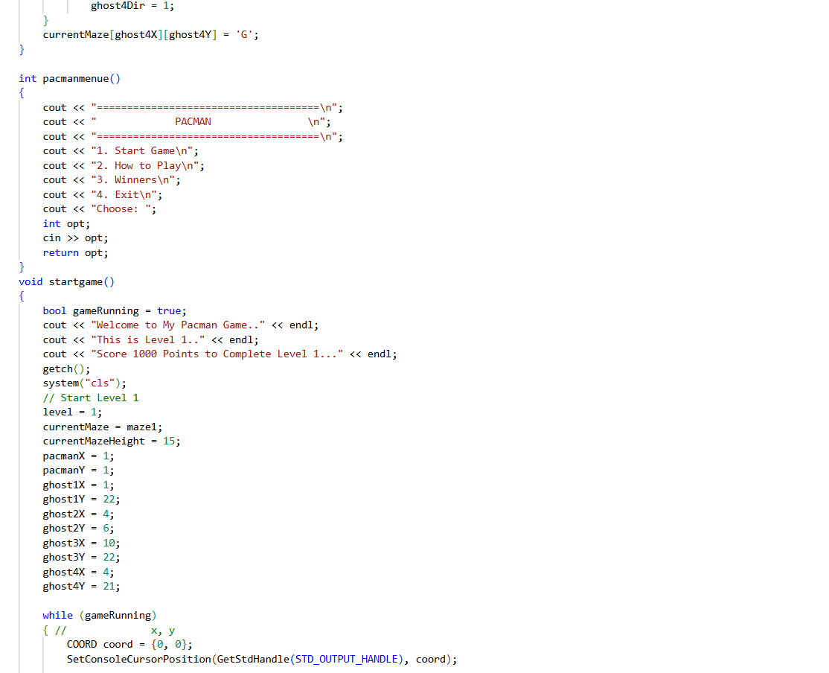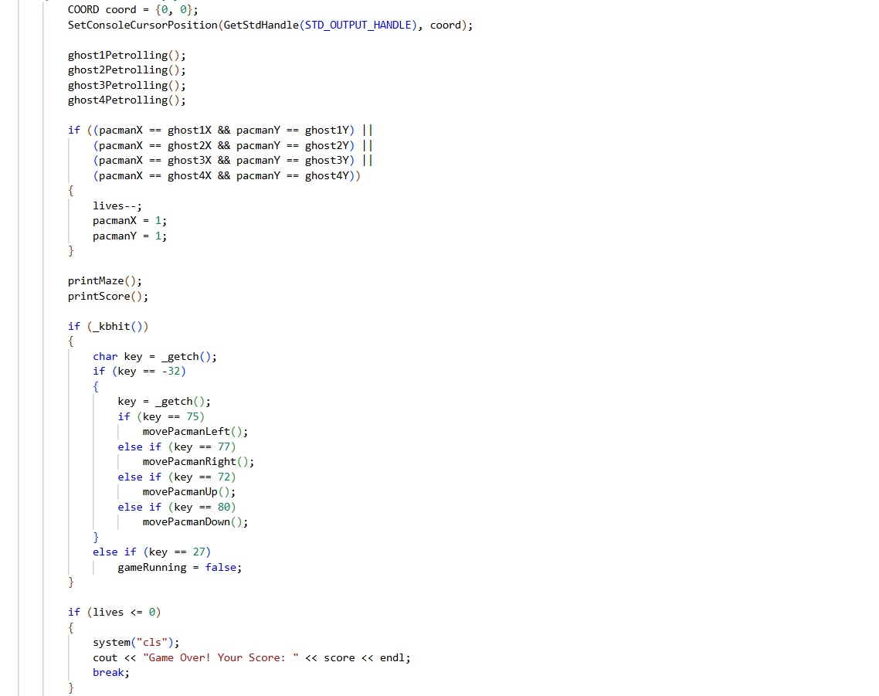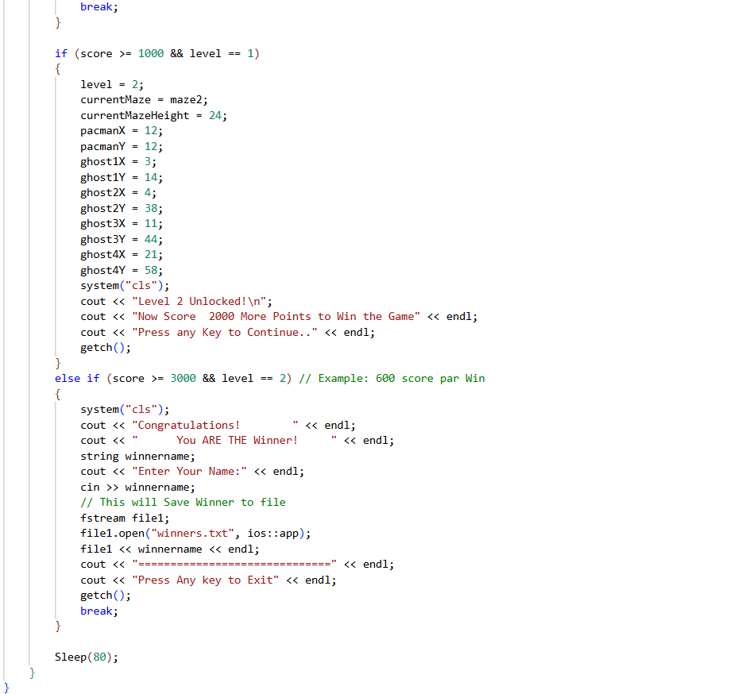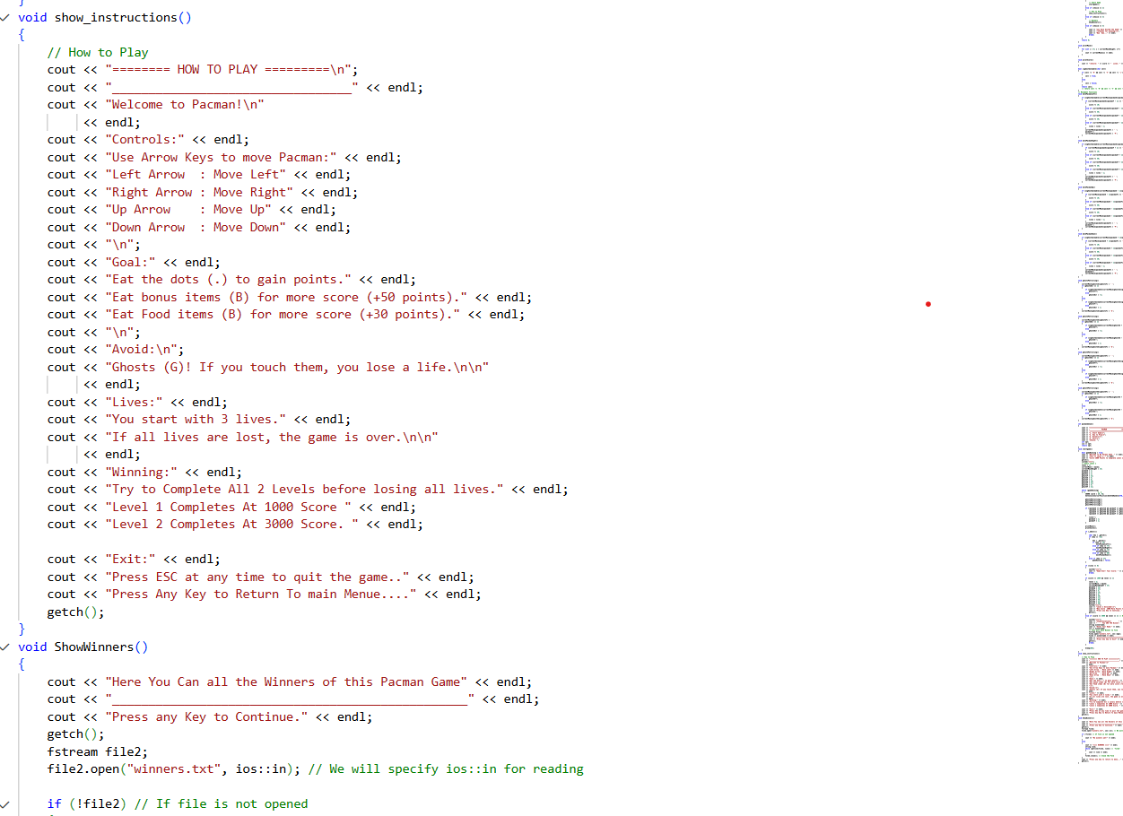

Student Reg. No: 20225(S)-CS-57 Student Name: Muhammad Asim Iqbal
 | A-Extensive Evidence | B-Convincing Evidence | C-Limited Evidence | D-No Evidence
Documentation Formatting Grade: | All the documentation meets all the criteria. | Documentation is well formatted but some of the criteria is not fulfilled. | Documentation is required a lot of improvement. | Documentation is not Available
Documentation Formatting Criteria: In Binder, Title Page, Header-Footers, Font Style, Font Size all are all consistence and according to given guidelines.
Project Poster is professionally design and well presented
Documentation Contents Grade: | Documentation includes all of the criteria. | Documentation meet more than 80% of the criteria given. | Documentation meet more than 50% of the criteria. | When the documentation meet less than 50% of the criteria.
Documentation Contents Criteria: Title Page - Table of Contents - Project Short Description and Story Writing of Game - Game Characters Description - Rules & Interactions - Goal of the Game - Screenshot of the Game - Data Structures Used in the Game - Functions Prototype - Full Code
Project  Complexity  Grade: | Project has at least 1 Player and 3 enemies. Proper use of gotoxy() function. Health system, Firing System and lives decreasing system. | Project complexity meet 80% criteria given in extensive evidence | Project complexity meet 50% criteria given in extensive evidence | Project complexity meet less than 50% criteria given in extensive evidence
Randomness Grade: | Objects are produced randomly in the game. | meet more than 80% of the criteria given. | meet more than 50% of the criteria given. | Objects are appearing in the same pattern
Code Style  Grade: | All Code style criteria is followed | All code style criteria followed but some improvements  required | lot of improvements required in coding style. | Did not follow code style,
Code Style Criteria: Consistent code style. Code is well indented. Variable and Function names are well defined. White Spaces are well used. Comments are added.
Code  Documentation Mapping Grade: | Code and documentation is synchronized. | Code and documentation does not synchronized at some places | Code and documentation does not synchronized at many places | Code and documentation does not synchronized.
Idea Novelty and  Creativity Grade: | Idea is unique of the game | Idea is merged by combining other different games | Same idea as a previous game | Could not implement the existing game idea.
Data Structure  (2D Arrays)  Optional | Data structure is sufficient for the project requirements | Data Structure is sufficient but require improvement to meet project requirements. | Data structure is not sufficient and need a lot of improvement | Data Structure is not properly identified and declared.
File Handling Optional | Game maze is loaded and  the updated maze is stored in the file | Game maze is loaded and partial data is stored in the file. | Game maze is just loaded but the updated game configuration is not stored in the maze. | Project do not contain file handling
Modularity Grade: | Meet all Modularity criteria | Meet all Modularity criteria but at some places it is missing | Do not sufficiently meet the modularity criteria. | No modularity or very minimum modularity.
Modularity criteria: Functions are defined for each major feature. Functions are independent (identify from parameter list and return types)- There is no global variable defined. Arrays and variables are passed as parameters to the functions. Functions exhibit single responsibility principle.
Screen flickering Grade: | There is no Screen flickering. | Maze is not flickering but the characters are flickering at great speed | Flickering is done at lot of places | Screen is flickering at all places
Presentation and  Demo  Grade: | Presentation and Demo was 100% working | Presentation and Demo require some improvements | Presentation and Demo require a lot of improvements | Presentation was not ok and Demo was not working
Student Understanding with the Code.  Grade: | Student has complete understanding how the code is working and knows the concept. | Student has good understand but some place he does not know the concepts | Student has a very little understand and lack the major concepts. | Student does not have any level of understanding of the code.
Checked by: | Click or tap here to enter text.

