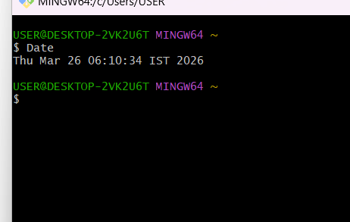

Date - It is used to see date
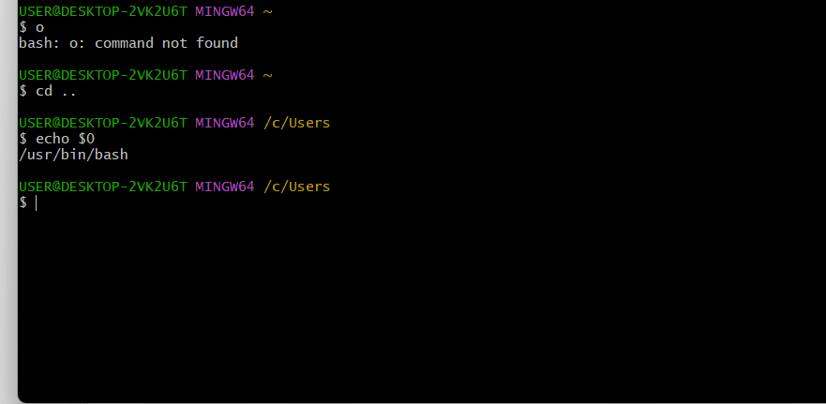

Echo $0: this command displays the shell
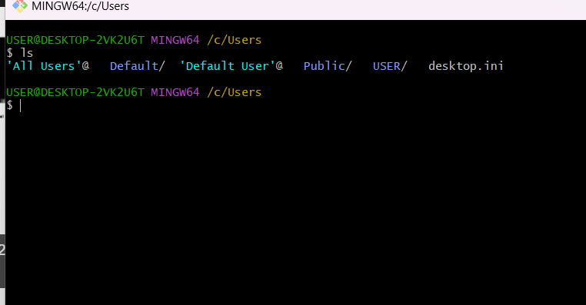

Ls : this command used to list the file
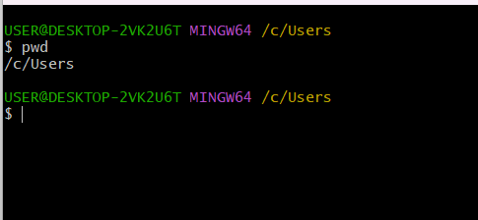
Pwd : present working directory this command used to check where present you are
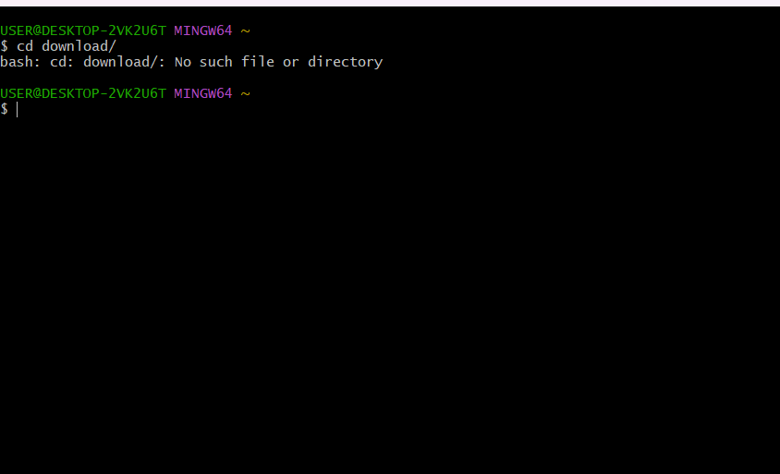
Cd : change directory cmd used to enter inside the directory

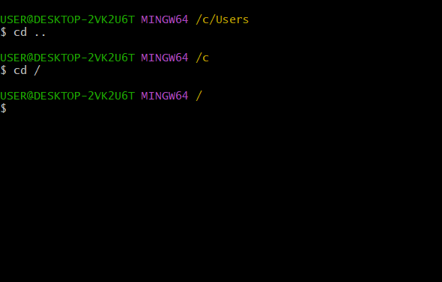
cd.. : this is used exit from the directory
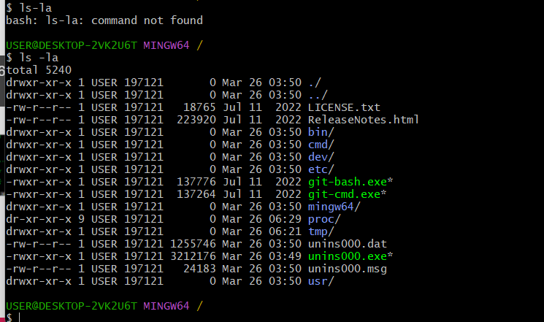

Ls –la: used to display all hidden file

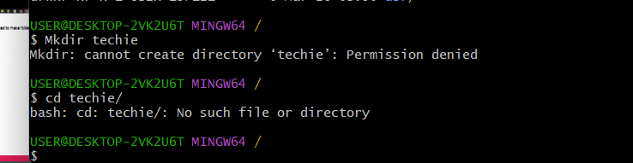

Mkdir: make directory used to make folder or directory

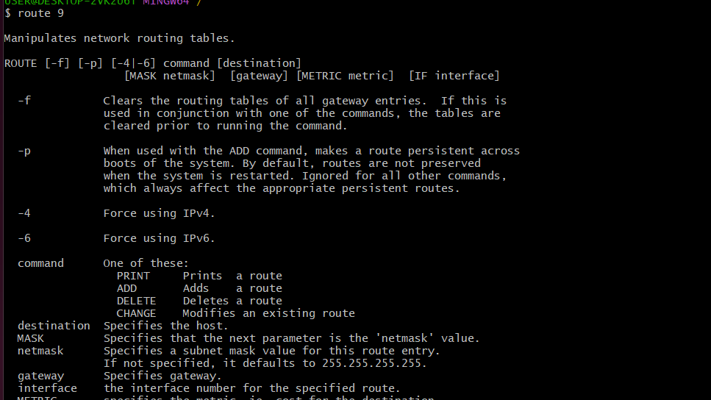
This is useful for cases where you want to pass transitory configuration options to git
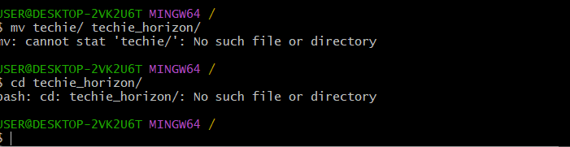

Mv: this command used to mv file from one location to another
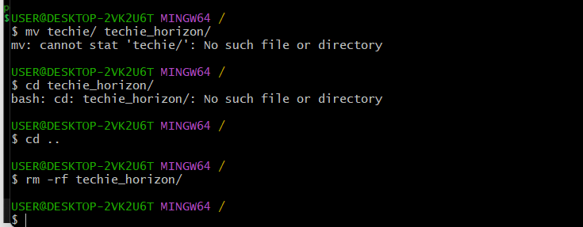

Rm –rf : remove recursively used to dlt file permenantly

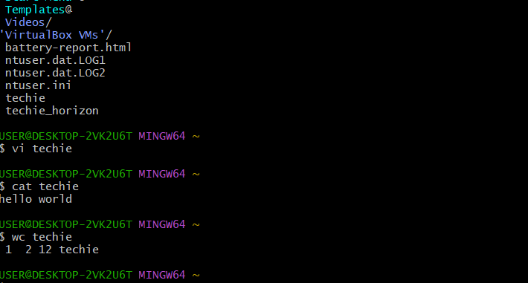
At : to read the file content from outside without entering into it

