Muhammad Asim Abrar

F2020266185

Advance Web Development V1

**Mini-Project-1 (Expense Tracker App)**

**ScreenShot of Visual Studio code Snippets:-**

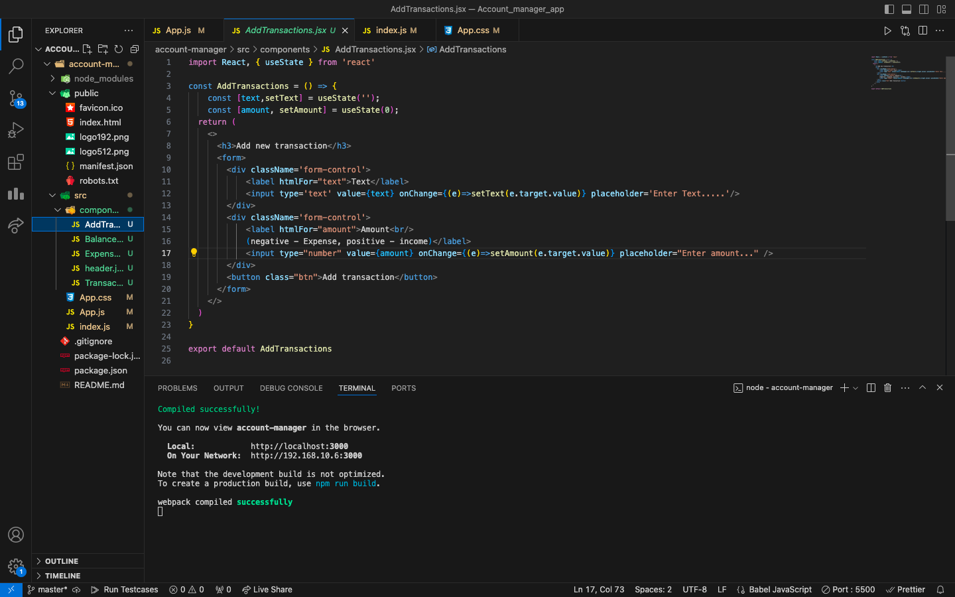

**ScreenShot of Local Host:300 of a Running Application:-**

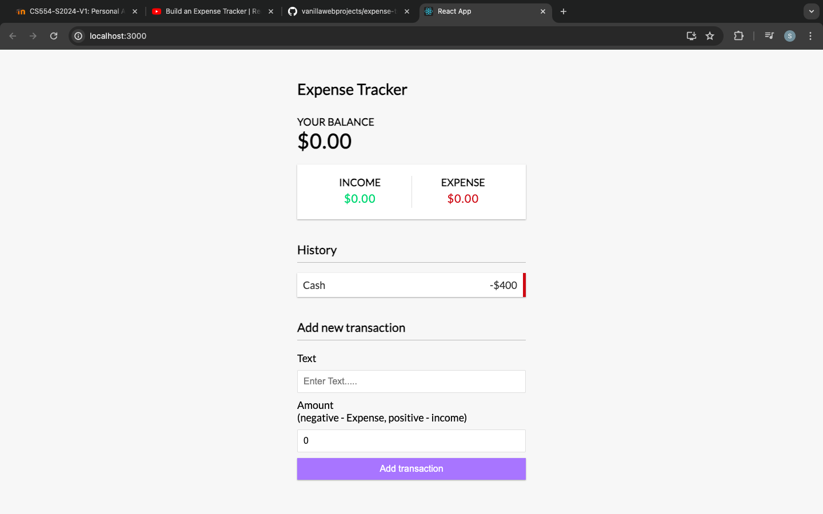

**Here I attached the Github Repository Link for the source code of this Project:-**

https://github.com/imszain5/account-manager.git