library(readxl)

veri1 <- read_excel("C:/veri1.xls") View(veri1)

library(dplyr)library(ggplot2) library(corrplot)

Warning: package 'corrplot' was built under R version 4.3.3

corrplot 0.92 loaded

# Install the reshape2 package if it is not already installed if (!requireNamespace("reshape2", quietly = TRUE)) {

install.packages("reshape2")

}

library(reshape2)

head(veri1)

# A tibble: 6 × 9

index name date_of_birth height weight spike block position_number

<dbl> <chr> <dttm> <dbl> <dbl> <dbl> <dbl>

<dbl>

1 0 Angelina … 1998-04-13 00:00:00 193 80 320 305

3

2 1 Svetlana … 1996-05-15 00:00:00 182 71 295 284

1

3 2 Ekaterina… 1996-06-17 00:00:00 190 72 306 296

2

4 3 Kristina … 1997-06-17 00:00:00 176 62 288 278

6

|  |  |  |  |  |  |  |  |  |
| --- | --- | --- | --- | --- | --- | --- | --- | --- |
| 5 | 4 | Ekaterina… | 1996-12-07 | 00:00:00 | 181 | 70 | 290 | 275 |
| 1 |  |  |  |  |  |  |  |  |
| 6 | 5 | Victoria … | 1996-03-17 | 00:00:00 | 186 | 67 | 306 | 297 |
| 3 |  |  |  |  |  |  |  |  |
| # ℹ 1 more variable: country <dbl>  data <- na.omit(veri1) | | | | | | | | |

|  |  |  |  |  |  |  |  |  |  |
| --- | --- | --- | --- | --- | --- | --- | --- | --- | --- |
| summary(veri1)  index | | name | | date_of_birth | | | | | |
| Min. : 0.0 | | Length:432 | | Min. :1996-01-03 00:00:00 | | | | | |
| 1st Qu.:107.8 | | Class :character | | 1st Qu.:1996-05-26 18:00:00 | | | | | |
| Median :215.5  Mean :215.5 3rd Qu.:323.2 Max. :431.0  height | | Mode :character  weight | | Median :1997-01-11 12:00:00  Mean :1997-03-27 10:20:00  3rd Qu.:1997-07-30 00:00:00  Max. :2000-11-25 00:00:00  spike block | | | | | |
| Min. | :153.0 | Min. | :52.00 | Min. | : | 0.0 | Min. | : | 0.0 |
| 1st Qu.:175.8 | | 1st Qu.:63.75 | | 1st Qu.:285.0 | | | 1st Qu.:273.5 | | |
| Median :182.0 | | Median :69.50 | | Median :293.5 | | | Median :283.0 | | |
| Mean | :181.0 | Mean | :68.74 | Mean | :286.8 | | Mean | :275.5 | |
| 3rd Qu.:187.0 | | 3rd Qu.:73.00 | | 3rd Qu.:304.0 | | | 3rd Qu.:292.0 | | |

Max. :199.0 Max. :87.00 Max. :336.0 Max. :310.0

position_number country Min. :1.000 Min. : 5.00 1st Qu.:2.000 1st Qu.:10.00

Median :2.000 Median :21.00

Mean :2.757 Mean :19.70 3rd Qu.:3.000 3rd Qu.:26.75 Max. :6.000 Max. :31.00

# Simple Linear Regression Model: spike ~ height + weight

model <- lm(spike ~ height + weight, data = veri1)

summary(model)

Call:

lm(formula = spike ~ height + weight, data = veri1)

Residuals:

Min 1Q Median 3Q Max

-276.511 -5.214 4.271 14.652 42.743

Coefficients:

Estimate Std. Error t value Pr(>|t|)

|  |  |  |  |  |  |
| --- | --- | --- | --- | --- | --- |
| (Intercept) | -122.2271 | 33.2514 | -3.676 | 0.000267 | *** |
| height | 2.6569 | 0.2299 | 11.555 | < 2e-16 | *** |
| weight | -1.0449 | 0.2572 | -4.063 | 5.76e-05 | *** |
| --- |  |  |  |  |  |

Signif. codes: 0 '***' 0.001 '**' 0.01 '*' 0.05 '.' 0.1 ' ' 1

Residual standard error: 30.15 on 429 degrees of freedom Multiple R-squared: 0.2619, Adjusted R-squared: 0.2584 F-statistic: 76.1 on 2 and 429 DF, p-value: < 2.2e-16

# Graphical representation of the model (for height) ggplot(data, aes(x = height, y = spike)) +

geom_point() +

geom_smooth(method = "lm", col = "red")

`geom_smooth()` using formula = 'y ~ x'

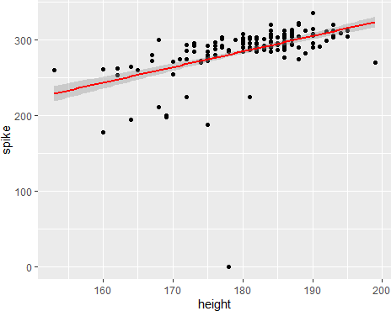

# Graphical representation of the model (for weight)

ggplot(data, aes(x = weight, y = spike)) + geom_point() +

geom_smooth(method = "lm", col = "blue")

`geom_smooth()` using formula = 'y ~ x'

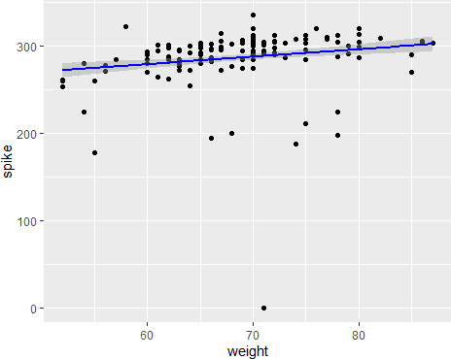

# Model summary

model_summary <- summary(model)

# Obtaining standard errors of coefficients

standard_errors <- model_summary$coefficients[, "Std. Error"] # Print standard errors

print(standard_errors)

(Intercept) height weight 33.2514339 0.2299314 0.2571781

# Obtaining R^2 value

r_squared <- model_summary$r.squared print(r_squared)

[1] 0.2618823

# Calculate the correlation matrix

correlation_matrix <- cor(veri1[, c("height", "weight", "spike")]) # Seçili sütunlar için

print(correlation_matrix)

= "circle")

|  |  |  |  |
| --- | --- | --- | --- |
|  | height | weight | spike |
| height | 1.0000000 | 0.6392886 | 0.4831985 |
| weight | 0.6392886 | 1.0000000 | 0.1793112 |
| spike | 0.4831985 | 0.1793112 | 1.0000000 |
| corrplot(correlation_matrix, method | | | |

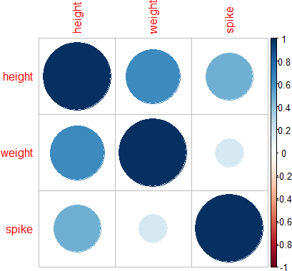

# Checking whether the regression residuals have a normal distribution

# Q-Q chart qqnorm(model$residuals)

qqline(model$residuals, col = "red")

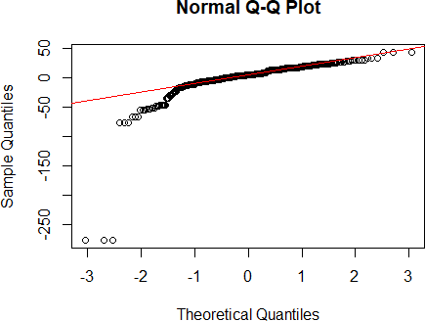

# Corrected section for detection of outliers for(column in colnames(veri1)) {

if(is.numeric(veri1[[column]])) {

Q1 <- quantile(veri1[[column]], 0.25, na.rm = TRUE) Q3 <- quantile(veri1[[column]], 0.75, na.rm = TRUE)

IQR <- Q3 - Q1

lower_bound <- Q1 - 1.5 * IQR upper_bound <- Q3 + 1.5 * IQR

outliers <- sum(veri1[[column]] < lower_bound | veri1[[column]] > upper_bound, na.rm = TRUE)

cat(column, "için aykırı değer sayısı:", outliers, "\n")

}

}

index için aykırı değer sayısı: 0 height için aykırı değer sayısı: 3 weight için aykırı değer sayısı: 3 spike için aykırı değer sayısı: 36 block için aykırı değer sayısı: 39

position_number için aykırı değer sayısı: 42 country için aykırı değer sayısı: 0 long_veri1 <- melt(veri1, id.vars = NULL)

Warning: attributes are not identical across measure variables; they will be dropped

numerics <- veri1 %>% select_if(is.numeric) long_numerics <- melt(numerics, id.vars = NULL)

ggplot(long_numerics, aes(x = variable, y = value)) + geom_boxplot() +

theme_minimal() +

labs(title = "Boxplot of Numerical Variables", x = "Variables", y = "Values")

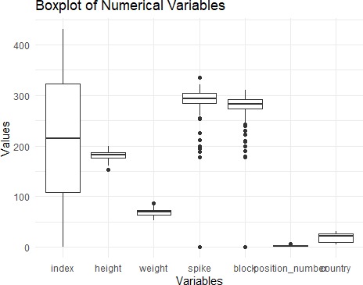

# Loading and Checking Data:

* + We used a tool called **readxl** to get data from an Excel file. After loading, we looked at the data quickly using something called **View**.

# Preparing the Data:

* + We removed any missing information with a step called **na.omit**. This makes sure our analysis is accurate.

# Making the Regression Model:

* + We used a function called **lm** to see how two things we measured (**height** and **weight**) can predict another thing (**spike**). After making the model, we checked a summary to understand how well it works.

# Evaluating the Model:

* + We looked at some numbers from the model's summary (like standard errors of coefficients and 𝑅 2 value) and a correlation matrix to understand the relationship between the things we measured.

# Checking for Outliers:

* + We used a method called IQR to find any unusual values in each thing we measured. This helps us identify any data that looks strange.

# Checking if Residuals are Normally Distributed:

* + We checked if the leftovers (residuals) from our model fit a normal distribution by drawing a type of graph called Q-Q plot and by looking at outliers. This checks if our model's predictions are reliable.

This process goes through basic steps to make and check a regression model with data ready for analysis. Each step is important for making sure the analysis is done right.