Auratrimto – Generative Vision Engineer Intern Assignment

Name: Mohammad Asim Alam

Role Applied: Generative Vision Engineer Intern

Date: 28/12/2025

Task 1: Conceptual Understanding

When you use the hairstyle try-on system it starts with a picture of yourself that you provide. This picture needs to be taken from the front. It has to be bright and clear. You should not wear a hat. Use too many filters, on the virtual hairstyle try-on system. The hairstyle try-on system needs a good picture of your face to work properly and find the features of your face. The hairstyle try-on system has to be able to see your face clearly to give you good results.

The first part of the pipeline is about finding faces. This is where the system looks at a picture and finds the face in it. It then figures out where important parts of the face are, like the eyes, nose, mouth, jawline and where the hair starts. The face detection part of the pipeline finds these important parts of the face which helps us understand how the face is turned how big it is and how it is posed. This information helps us put hairstyles on the users head in a way that looks really good and is exactly right, for the face. The face detection is a part of making sure the hairstyles look great on the users head.

After we find the face we separate the hair and face. We look at each part of the picture and say what it is. Hair, skin or background. This gives us a map that just shows the hair. The hair map makes sure that when we change the hairstyle it only changes the hair, not the face or the things, around it. The face and background stay the same.

The system uses the landmarks and hair mask it found to give the user a hairstyle. It can do this in two ways.

* It can use something that already exists, like a 2D or 3D picture of a hairstyle. Adjust the size and direction of this hairstyle picture to fit the users head.

The system. Rotates and aligns the hairstyle picture to match the users head shape.

*. The system can create a new hairstyle just for the user.

The system uses models that can make new pictures from old ones or that can make new pictures by adding a little bit of something at a time.

These models create hairstyles right on the users head and they fit the head shape and the way the user is sitting or standing really well.

The hairstyles made by the system using these models look like they were always meant to be, on the users head.

To get results we use image blending and post-processing techniques. This includes making sure the colors of the image and the hairstyle match and that the edges of the hair are smooth and not sharp. We also adjust the lighting so that everything looks consistent. This helps prevent the image from having edges or colors that do not look right.

Ultimately, the system produces a preview image displaying the user with the chosen hairstyle. This preview enables users to envision the result prior to scheduling a grooming or salon appointment, thereby enhancing confidence and aiding in decision-making.

Face Detection:

Face detection models like RetinaFace or YOLOv5-Face are really good for when you need to do things on a server. This is because they are very good at finding faces even when people are looking at the camera from angles or when the light is not very good. If you need something that works fast and does not use a lot of power you can use MediaPipe Face Detection or BlazeFace. These face detection models are great for when you need to do things and you are using a mobile phone. Face detection models like MediaPipe Face Detection and BlazeFace are good, for phones because they are made to work fast and use less power.

Hair Segmentation:
MediaPipe Hair Segmenter is a tool for getting hair masks quickly and it works really well for live demonstrations. If you want control over the results you can use other models like U-Net or DeepLab. These models can be trained on hair datasets like Figaro-1k to get the results you need. MediaPipe Hair Segmenter is very useful for people who want to get started away but models like U-Net or DeepLab are better for people who want to customize everything. MediaPipe Hair Segmenter and these other models are all options, for extracting hair masks.

Hairstyle Overlay and Blending:
You can make a hairstyle look nice on a picture by using alpha blending with edges. This makes the hairstyle go on top of the picture fast.. If you want the edges of the hairstyle to look really good with the rest of the picture you can use something called Poisson image blending. The Poisson image blending helps make sure the colors of the hairstyle and the original picture look good together. Some systems are really advanced. They use something called diffusion-based inpainting models to make the hairstyle look super realistic, on the picture.

Improving Realism:
Realism can be further enhanced through color transfer techniques, tone mapping, and diffusion models fine-tuned on hairstyle datasets to better match lighting, shadows, and hair texture

Task 2: Practical Thinking
You can make a hairstyle try-on system that does not cost anything. This system can be made using technologies that're free to use. The main language used for this is Python. Python is a choice because it has a lot of tools, for computer vision and machine learning.

The system uses OpenCV to load and prepare images. OpenCV is also used to separate and mix the images. This makes it easy to try out things without having to pay for licenses. The virtual hairstyle try-on. Opencv work well together to make this possible.

You can do some cool things with advanced extensions. For example you can use deep learning frameworks like PyTorch to detect faces or segment hair. PyTorch can also be used to create hairstyles.

The system is pretty easy to work with because you can use a backend framework, like FastAPI or Flask. This means you can easily connect the system to a web or mobile application and it will just work with the PyTorch face detection or the PyTorch hair segmentation or the PyTorch generative hairstyle synthesis.

The system can work on a computer with a standard processor when it is first being developed and tested.

For things that need a lot of power like making images with diffusion the system can be moved to a service that has a good graphics card and does not cost too much.

The system is open to everyone. Does not use paid services so it can grow from a small test version to a full version that is ready, for real use.

We made a hairstyle try-on system that actually works. This system takes a picture of you like a selfie. Then it uses computer vision to change your hairstyle in the picture. The hairstyle try-on system generates different hairstyles for you to try on. The system is pretty cool because it uses a series of steps to make these hairstyle variations. The hairstyle try-on system is a fun way to see how you would look with different hairstyles.

In the demo OpenCV GrabCut is used to separate the foreground from the background. This is a way to find the hair in a picture. The top part of the head is looked at. Then the color and brightness of the pixels are used to find the hair. This way the system works well on a computer and it is easy to see how the whole process works with OpenCV GrabCut for hair segmentation.

When we find the part of the picture with hair we add a color on top of it. This is done to see what the hair would look like in styles. We can try different hair colors, like brown, black, red and even green. We do this by changing the color that we add on top of the hair. This shows that we can use the basic steps to try different hairstyles without having to change everything.

While this implementation does not produce pixel-perfect hair boundaries, it effectively demonstrates the complete virtual hairstyle try-on workflow. In a production system, this heuristic-based segmentation module can be replaced with deep learning-based hair segmentation models and generative diffusion models to achieve higher realism and accuracy.

Demo Output:
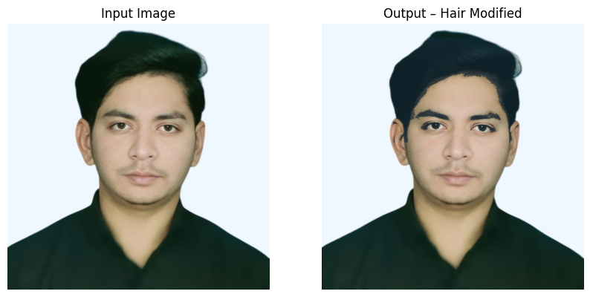

Figure: Sample input image and corresponding output after hairstyle color modification using the prototype system

