***Extinction Calendar***  
By Asimanshu Samal and Ayaan Rastogi, Class 12A, DPS Electronic City

**Introduction**  
The Extinction Calendar is a project using Data Science as the key domain. It predicts potential extinction dates of endangered and critically endangered animals based on their population data of previous years obtained from government websites. This date is not an inevitability, it is a deadline to show a possible outcome if no conservation steps are taken. The goal is to raise awareness about species decline and emphasize the urgency of action.

The SDGs we are focusing on are SDG 13: Climate Action, SDG 14: Life Below Water and SDG 15: Life on Land

**Inspiration**  
This idea has originated from us noticing that most sites primarily focus on the prediction of human events and harmful effects of climate change, but very few forecast extinction timelines for specific animals. While projects like the Climate Clock, IPCC reports, or Google Earth Engine provide valuable information, they don't give species-specific extinction warnings based on population data.

The calendar gives in depth analysis based on our extensive .CSV dataspread obtained from reliable sources.

**Prerequisites**   
To run this project, you need a basic Python environment with a few essential libraries installed. Here are the details:

Required Libraries:

* Pandas: used in a dataframe made from the comprehensive csv
* numpy: used to make arrays for the independent and dependent variables
* matplotlib: used to create graphs that show population trends
* Scikit-learn: to show the trends and possible extinction dates

Python Version:

* Python 3.8 or higher is recommended

File Format:

Hardware Requirements:

* Minimum 4 GB RAM (8 GB recommended for large datasets)
* Any modern CPU (Intel i3, Ryzen 3 or better)
* No dedicated GPU required
* Less than 100 MB storage space needed

Development Tools:

* Jupyter Notebook, VS Code, or PyCharm can be used to run the project
* Command line interface for installing libraries and running scripts

**Project Workflow**

The project follows this sequence:

Step 1: Read CSV Data  
 Load species population data from a structured file.

Step 2: Preprocess Data  
 Convert year columns to numeric format and separate them from population values.

Step 3: Train Model  
 Use regression models to fit the data and find trends.

Step 4: Predict Future Populations  
 Use the trained model to estimate population values in upcoming decades.

Step 5: Visualize Results

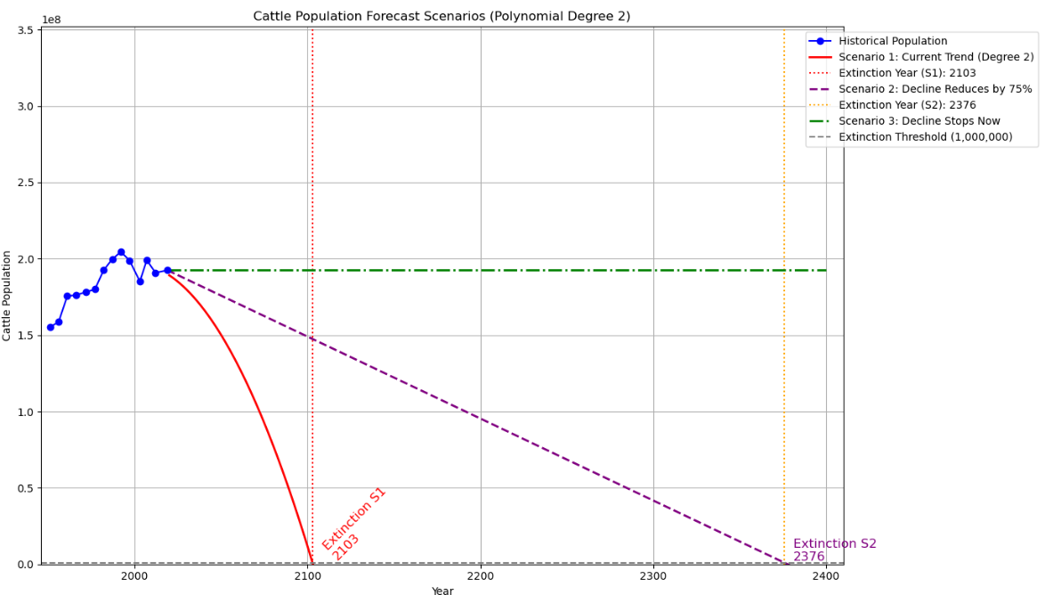  
 Create graphs to compare past and projected population levels.

Step 6: Estimate Extinction Risk  
 Highlight years where populations approach zero, suggesting a potential extinction date.

Step 7: Encourage Conservation  
 Use the projections to raise awareness and promote action.

**Future Enhancements**

* Turning the project into an interactive web app
* Put informative conservation advice taken from the UN database
* Adding recommendations for reversing population declines
* Letting users choose different species and compare their risks

Asimanshu Samal  
 Ayaan Rastogi  
 Class 12A, Delhi Public School, Electronic City