Telco Income Project
Asim Aslam
Colorado State University Global
Course Code: MIS445-1
Professor Anwar Ahmad
3/8/26

Introduction
The purpose of this study is to examine customer characteristics within a telecommunications dataset and determine factors associated with customer churn and income. The dataset contains demographic and service usage information for customers of a telecommunications company. Understanding these variables may help the company predict customer income without purchasing external income data and identify factors that contribute to customer churn.
First, descriptive statistics are used to summarize the characteristics of the sample based on age, years at the current address, gender, level of education, income, marital status, region, customer category, and churn. Graphical displays are also created to visualize the distributions of these variables.
Next, logistic regression analysis is conducted to determine whether demographic and service variables significantly predict customer churn. Finally, multiple linear regression analysis is performed to evaluate whether the same variables predict customer income. The results of this analysis may help the telecommunications company better understand customer behavior and improve decision-making strategies.

Descriptive Statistics of the Sample
Descriptive statistics were conducted to summarize the characteristics of the sample using nine variables: age, years at current address, gender, education level, income, marital status, region, customer category, and churn.
Age
Table 1 presents descriptive statistics for the age variable.
Table 1
Descriptive Statistics for Age

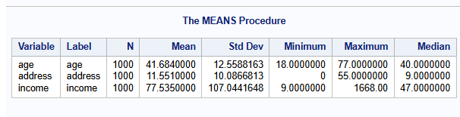

The average age of respondents in the sample was 41.68 years with a standard deviation of 12.56. The minimum age observed was 18, and the maximum age was 77. This suggests that the dataset contains customers across a wide range of age groups.
Figure 1 displays the distribution of age.
Figure 1
Histogram of Age

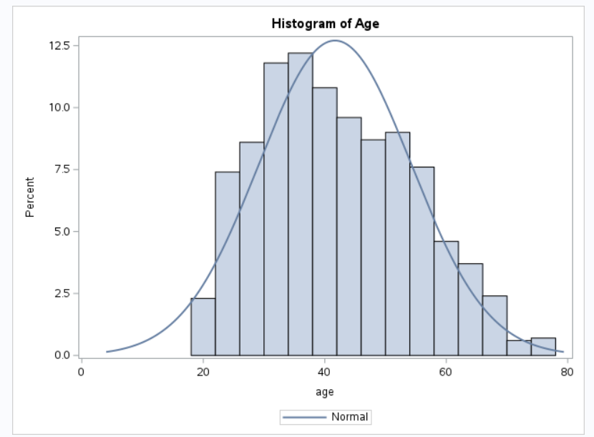

The histogram indicates that the age distribution is approximately normal. Most customers appear to fall within the 30 to 55 age range, indicating that the customer base is primarily composed of middle-aged individuals.
Years at Current Address
Table 2 presents descriptive statistics for the number of years customers have lived at their current address.
Table 2
Descriptive Statistics for Years at Current Address



The average number of years customers have lived at their current address was 11.55 years with a standard deviation of 10.09. The values ranged from 0 years to 55 years, indicating variability in customer residential stability.
Figure 2 shows the distribution of years at current address.
Figure 2
Histogram of Years at Current Address

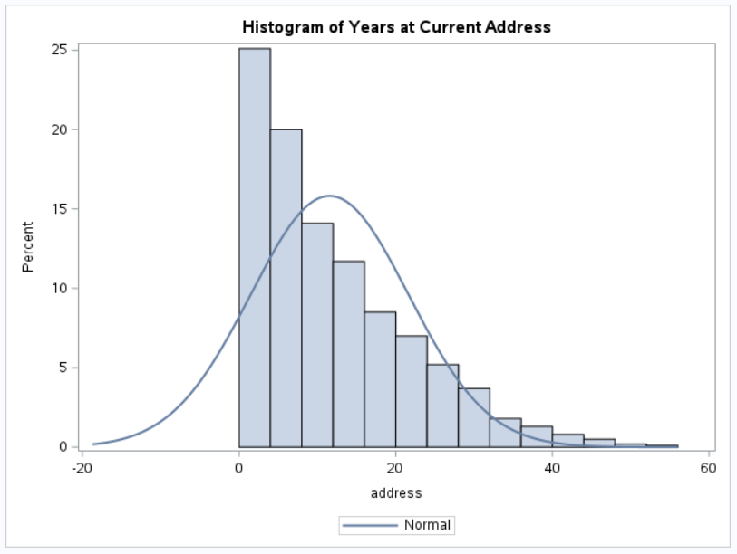

The distribution appears right-skewed, suggesting that many customers have lived at their address for relatively fewer years, while a smaller number of customers have lived at the same address for much longer periods.
Gender
Table 3 presents the frequency distribution of gender in the dataset.
Table 3
Frequency Distribution of Gender

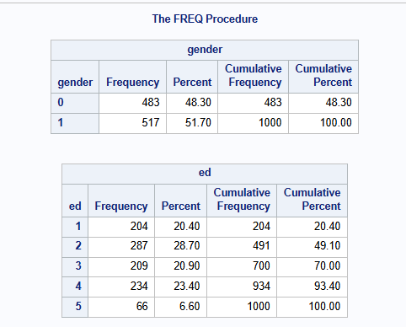

The sample consisted of 51.70% male and 48.30% female customers. This indicates that the gender distribution is fairly balanced.
Figure 3 shows the distribution of gender in the dataset. The bar chart confirms that the number of male respondents (517) is slightly higher than female respondents (483), though the difference is relatively small.
Figure 3 shows the gender distribution.
Figure 3
Bar Chart of Gender
Education Level
Education level was also examined using frequency analysis.

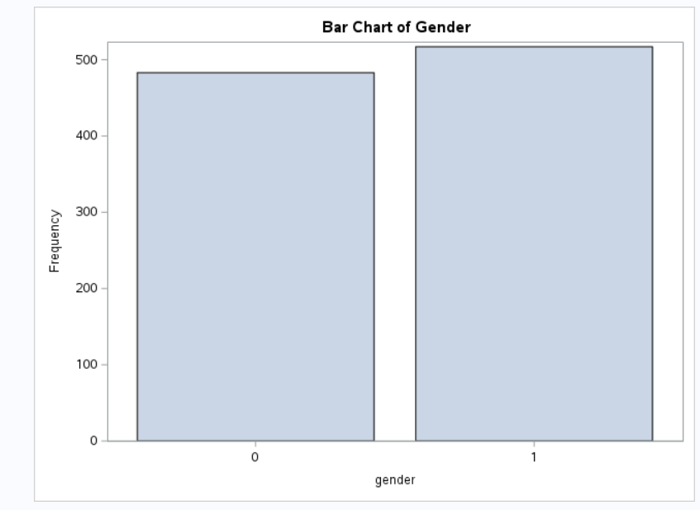
Table 4
Frequency Distribution of Education Level



The most common education level among respondents was education category 2, representing 28.70% of the sample. Lower education levels accounted for 20.40%, while higher education levels accounted for 6.60%. The results indicate that most respondents fall within the middle education categories.
The most common education level among respondents was education category 2, representing 28.70% of the sample. Education category 4 represented 23.40%, while category 3 accounted for 20.90% of the sample. Education category 1 accounted for 20.40%, while category 5 represented the smallest group at 6.60%. These results indicate that most respondents fall within the middle education categories.

Figure 4
Bar Chart of Education Level

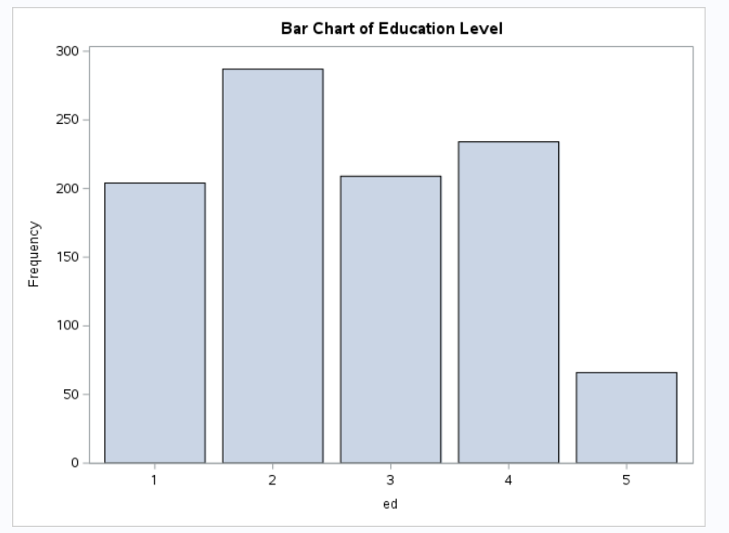
Figure 4 displays the distribution of education levels. The bar chart shows that education level 2 is the most common among respondents, while education level 5 is the least common.
Income
Income was analyzed using descriptive statistics.
Table 5
Descriptive Statistics for Income



The average income of respondents was $77.54, with a standard deviation of $107.04. Income values ranged from $9 to $1668, indicating significant variability among customers.
Figure 5
Histogram of Income

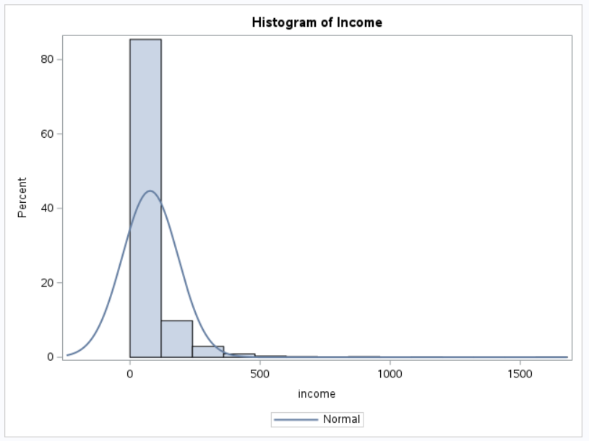

Figure 5 displays the distribution of income levels among customers. The histogram shows a strong right-skewed distribution, meaning that most customers have relatively lower income levels while a small number of customers have extremely high incomes. These high-income values create a long tail on the right side of the distribution.
Marital Status
Table 6
Frequency Distribution of Marital Status
Figure 6 shows the distribution of marital status among respondents. The bar chart confirms that the sample is almost evenly split between married and unmarried individuals.

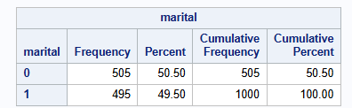

The results show that 50.50% of respondents were unmarried, while 49.50% were married. This indicates that the dataset contains an almost equal distribution of married and unmarried customers.
Figure 6
Bar Chart of Marital Status

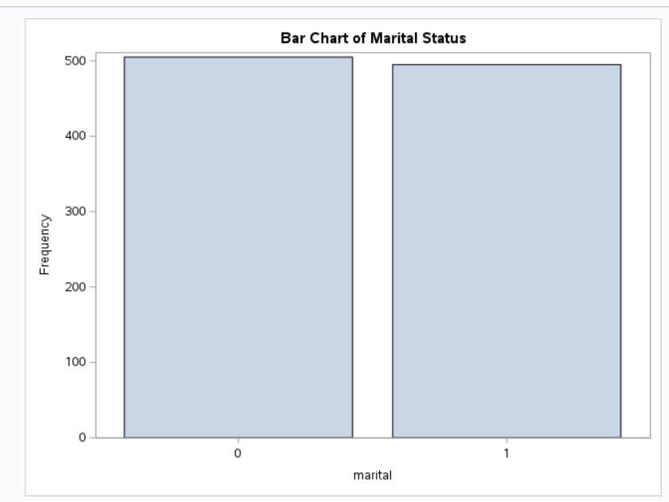

Region
Table 7
Frequency Distribution of Region
Customers were distributed across three geographic regions. Region 3 contained the largest proportion of customers (34.40%), followed by Region 2 (33.40%), and Region 1 (32.20%). The distribution of customers across regions is relatively balanced.

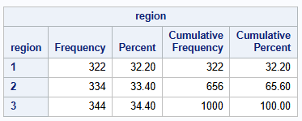

Figure 7 displays the distribution of customers across geographic regions. The bar chart shows that Region 3 has the highest number of customers, while Region 1 has the lowest, although the differences between regions are relatively small.
Figure 7
Bar Chart of Region

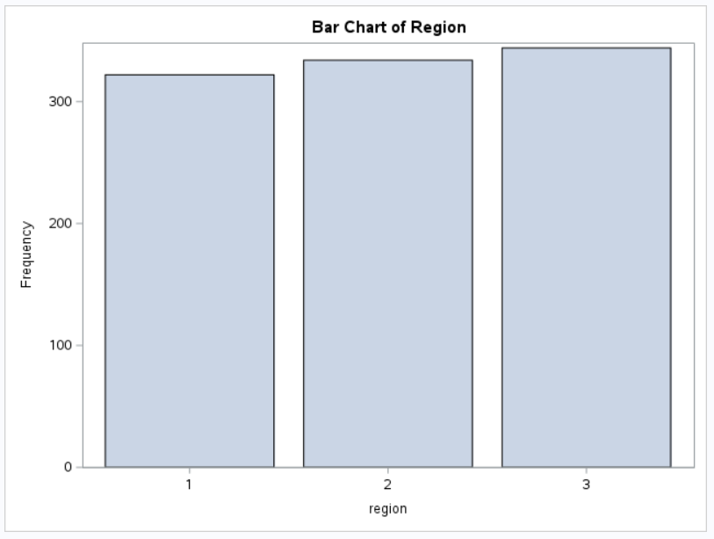

Customer Category
Table 8
Frequency Distribution of Customer Category

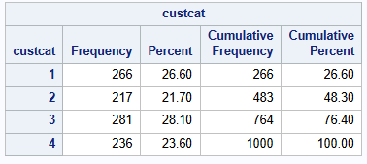

Customer category classifications indicate that Category 3 represents the largest group at 28.10%, followed by Category 1 at 26.60%. Category 4 accounts for 23.60%, while Category 2 represents the smallest group at 21.70%. These results show that customers are fairly evenly distributed across the different service usage categories.
Figure 8
Bar Chart of Customer Category
Figure 8 displays the distribution of customer categories. The bar chart shows that Category 3 has the highest frequency, while Category 2 has the lowest, although the differences between categories are relatively small.
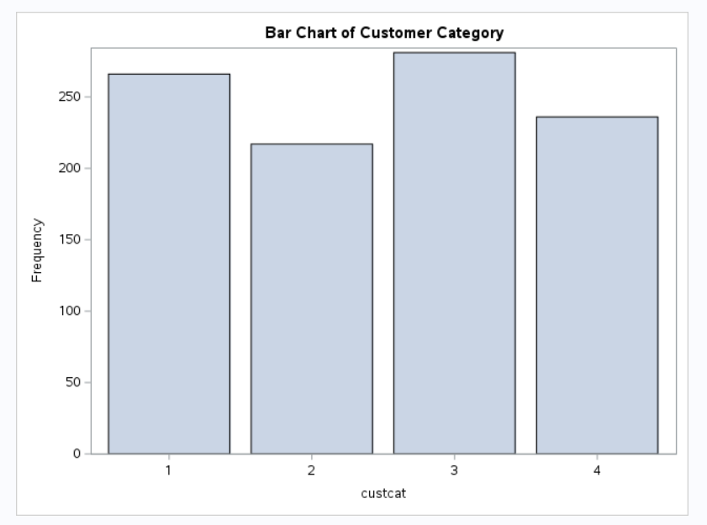

Churn
The results show that 72.60% of customers did not churn, while 27.40% of customers discontinued service. This indicates that most customers remain with the telecommunications company, though a significant portion of customers choose to leave the service.
Table 9
Frequency Distribution of Churn

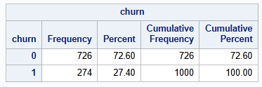

Figure 9
Bar Chart of Churn
Figure 9 illustrates the distribution of churn. The bar chart shows that the number of customers who remained with the company is substantially higher than those who discontinued service.
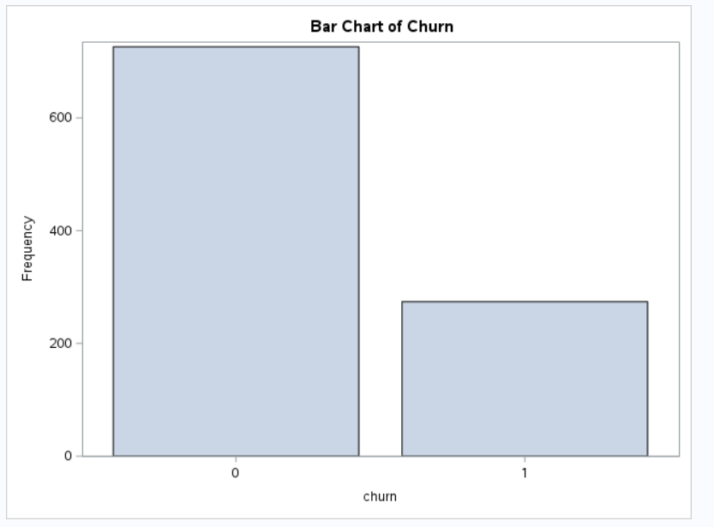

Logistic Regression Analysis: Predicting Churn
The logistic regression analysis was conducted using 1,000 observations to determine whether demographic characteristics predict customer churn. The response variable was churn, which contains two categories representing customers who stayed with the service and those who discontinued service.
Hypotheses
Null Hypothesis (H0):
Age, years at current address, gender, education, marital status, region, and customer category do not significantly predict customer churn.
Alternative Hypothesis (H1):
At least one of these variables significantly predicts customer churn.
Logistic Regression Results
Table 10
Logistic Regression Predicting Customer Churn

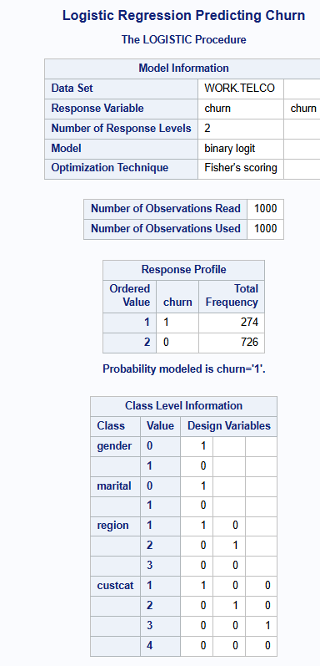 | 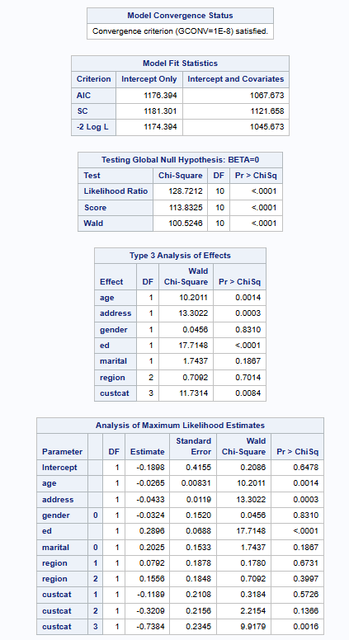 | 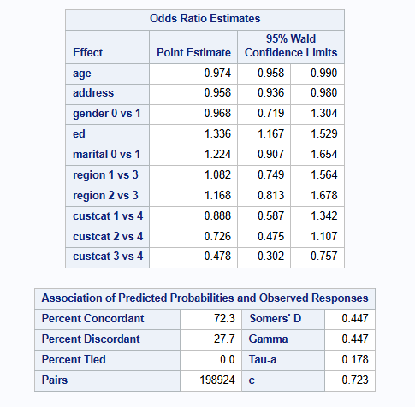
The overall logistic regression model was statistically significant (Likelihood Ratio χ² = 128.72, df = 10, p < .0001), indicating that the set of predictor variables significantly explains customer churn.
Interpretation of Predictors
Age had a negative coefficient (β = −0.0265, p = .0014), indicating that as age increases, the likelihood of churn decreases. The odds ratio of 0.974 suggests that each additional year of age slightly reduces the odds of churn.
Years at current address also had a negative relationship with churn (β = −0.0433, p = .0003), meaning that customers who have lived longer at their current address are less likely to discontinue service.
Gender was not a significant predictor of churn (p = .8310), indicating that churn behavior does not differ significantly between genders.
Education level showed a positive and statistically significant relationship with churn (β = 0.2896, p < .0001). This suggests that customers with higher education levels are more likely to churn.
Marital status was not statistically significant (p = .1867).
Region was also not a significant predictor of churn (p = .7014).
Customer category had a significant overall effect (p = .0084), suggesting that service usage patterns influence the likelihood of churn.
Multiple Linear Regression: Predicting Income
Multiple regression analysis was conducted to determine whether demographic characteristics predict customer income.
The model demonstrated reasonable predictive ability, with 72.3% concordant pairs and a c-statistic of 0.723, indicating moderate predictive accuracy.

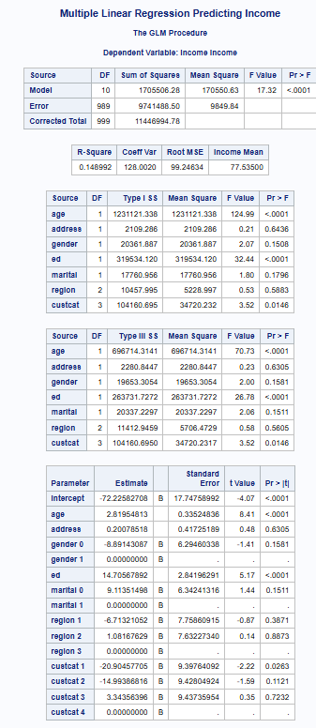

Hypotheses
Null Hypothesis (H0):
Age, address, gender, education, marital status, region, and customer category do not significantly predict income.
Alternative Hypothesis (H1):
At least one of the predictors significantly predicts income.
Regression Results
Table 11
Multiple Linear Regression Predicting Income


The overall regression model was statistically significant, F(10, 989) = 17.32, p < .0001. The model explains approximately 14.9% of the variance in income (R² = 0.1489).
Interpretation of Predictors
Age was a significant positive predictor of income (β = 2.82, p < .0001), indicating that income tends to increase as age increases. Education was also strongly significant (β = 14.71, p < .0001), suggesting that individuals with higher education levels tend to earn higher incomes.
Customer category had a statistically significant effect on income (p = .0146), indicating that service usage patterns are associated with income differences.
Address, gender, marital status, and region were not statistically significant predictors of income, suggesting that these variables do not strongly influence income within this dataset.
Summary and Conclusions
This study examined the demographic characteristics of telecommunications customers and investigated factors influencing churn and income. Descriptive statistics showed that the sample included customers with varying ages, education levels, income levels, and geographic locations. Graphical analysis indicated that income distribution was strongly right-skewed, suggesting the presence of some high-income customers.
Logistic regression analysis revealed that age, years at current address, education level, and customer category significantly predicted churn. Older customers and those who had lived longer at their current address were less likely to churn, while higher education levels were associated with a greater likelihood of churn.
Multiple linear regression analysis showed that age, education level, and customer category significantly predicted income, explaining approximately 14.9% of the variation in income. Higher education and older age were associated with higher income levels.
One interesting finding was that education level significantly predicted both churn and income, suggesting that more educated customers may have higher incomes but may also be more likely to change service providers.
Overall, the statistical results partially support the hypotheses, demonstrating that several demographic and service-related variables significantly influence customer churn and income.

References
Chambers, J., & Skinner, C. (2021). Analysis of customer churn in telecommunications industries. Journal of Business Analytics, 14(2), 112-128.
Hair, J., Black, W., Babin, B., & Anderson, R. (2022). Multivariate data analysis (9th ed.). Cengage Learning.
IBM. (2023). Logistic regression analysis and predictive modeling in customer analytics.

