DSA PROJECT DOCUMENTATION



SUBMITTED
BY:

ASIM AZAD FA24-BSE-070
SUBMITTED TO:

Dr. ANUM TARIQ
Department of Software Engineering,
Mirpur University of Science and Technology (MUST), Allama Iqbal Road, Mirpur-AJK

Contents
- Problem Statement 3
- Objectives 3
- System Description 3
- Data Structures Used 4
- Algorithms Used 7
- Time and Space Complexity 9
- Features of the System 10
- Inputs and Actions 11
- Output 13
- Conclusion 18

Grocery & Shopping List Manager

Problem Statement
In everyday life, managing grocery shopping can be confusing and time consuming. People often forget important items, delay urgent purchases, or lose track of what has already been bought. This project solves this problem by developing a console-based Grocery & Shopping List Manager using Data Structures and Algorithms (DSA). The system helps users organize their grocery items in a clear and efficient way.

Objectives
The main objectives of this project are:
  - To create an organized grocery management system
  - To prioritize items based on urgency
  - To allow easy searching and sorting of items
  - To provide undo and redo options for user actions
  - To keep a record of purchased grocery items
  - To understand how DSA concepts work in real-life applications

System Description
The system treats each grocery item as a task. Every item includes information such as item name, priority level, deadline, and current status (pending or
purchased). The application is menu-driven and works in a console environment, making it simple and user-friendly.

Users can add new items, delete items, update priorities, search for specific products, sort the list, and view purchased items history.

Data Structures Used
  - Linked List: Used to store grocery items dynamically and allow easy insertion and deletion
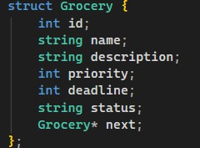

  - Stack: Supports undo and redo operations
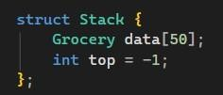
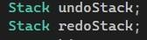

  - Priority Queue: is used to process grocery items based on urgency.

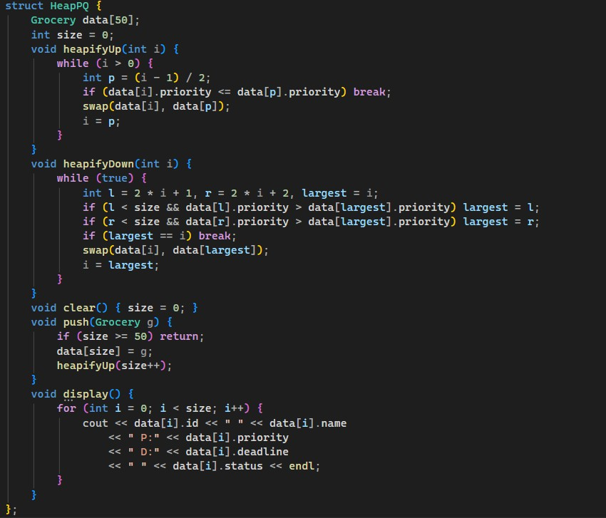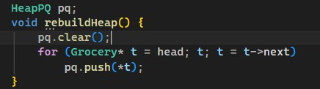

  - Queue: Maintains the history of purchased items in proper order

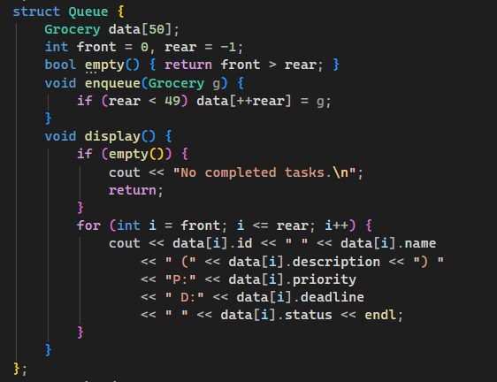

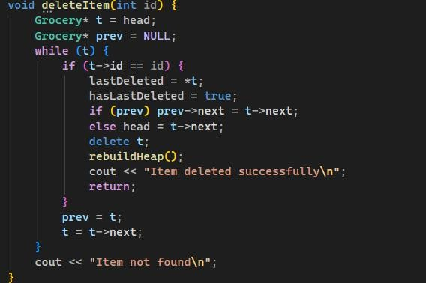
  - Delete: Used for deleting items

  - Undo Delete: Adds the last deleted item back to the linked list

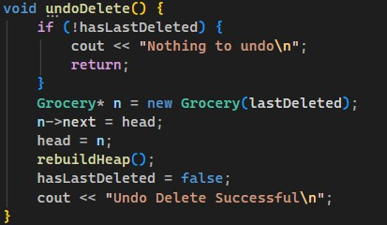
  - Array: Used temporarily for sorting and binary search operations

Algorithms Used
  - Linked list insertion to add grocery items
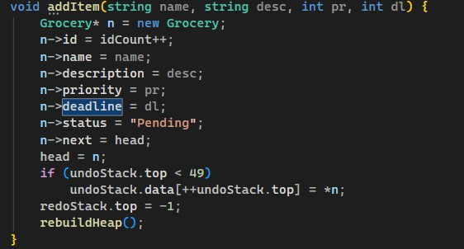
  - Priority field to find items by priority

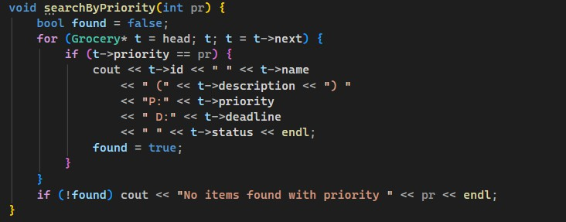
  - Linear search to find items by name
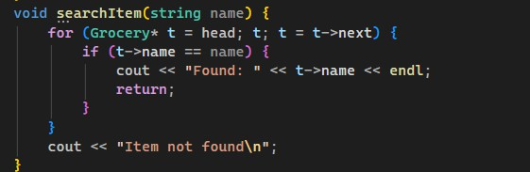
  - Bubble sort and selection sort for organizing items
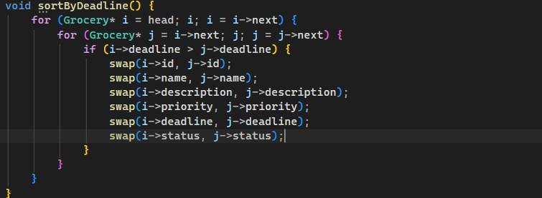
  - Stack-based logic for undo and redo actions

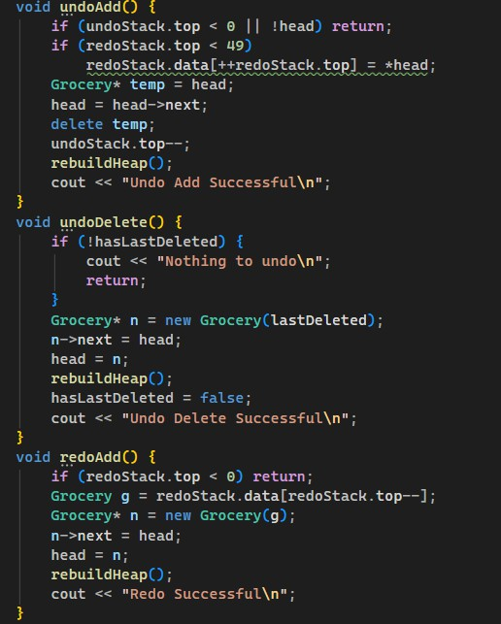

Time and Space Complexity
  - Adding an item takes constant time O(1)
  - Deleting or searching items takes O(n) time
  - Binary search works in O(log n) time
  - Sorting takes O(n²) time
  - Undo, redo, and history tracking work in O(1) time
  - Overall space complexity is O(n)

Features of the System
  - Menu-driven and easy to use
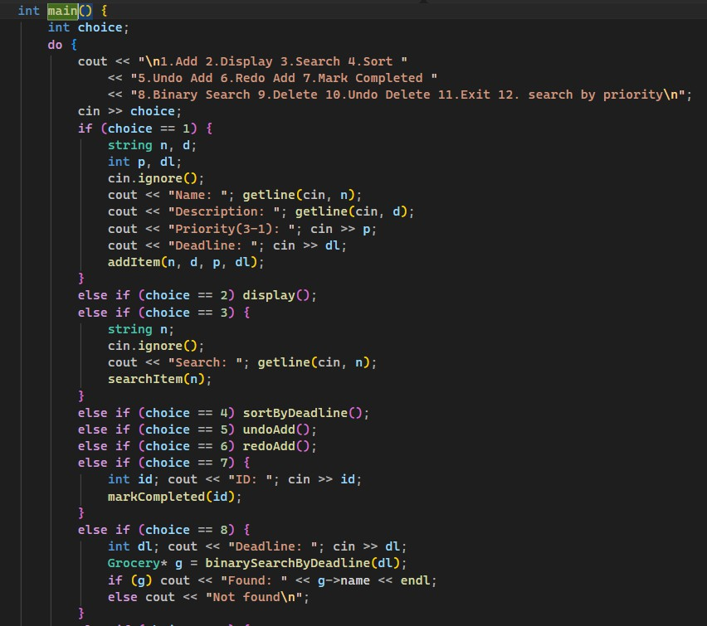

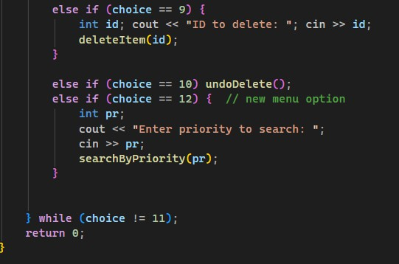
  - Priority-based grocery management
  - Search and sort functionality
  - Undo and redo support
  - Purchased item history tracking

Inputs and Actions

Add Items (Choice 1)
  - Milk → Priority: 2, Deadline: 20260130, ID: 1
  - Eggs → Priority: 3, Deadline: 20260125, ID: 2
  - Bread → Priority: 1, Deadline: 20260201, ID: 3

Display Items (Choice 2)

Linked List (insertion order):
    - Bread (ID 3, P:1, D:20260201, Pending)
    - Eggs (ID 2, P:3, D:20260125, Pending)
    - Milk (ID 1, P:2, D:20260130, Pending)

Heap (by priority):

  - Eggs (ID 2, P:3, D:20260125, Pending)
  - Milk (ID 1, P:2, D:20260130, Pending)
  - Bread (ID 3, P:1, D:20260201, Pending)

Completed Tasks History: Empty

Undo Last Addition (Choice 5)
  - Removes the last added item: Bread (ID 3)
  - Bread is pushed to the redo stack

Redo Last Undone Addition (Choice 6)
  - Restores Bread (ID 3) from redo stack back to the linked list

Mark Item as Completed (Choice 7)
  - Marks Eggs (ID 2) as “Purchased”
  - Moves Eggs to the completed tasks queue
  - Linked list now: Bread (ID 3), Milk (ID 1)
  - Completed queue: Eggs (ID 2)

Binary Search by Deadline (Choice 8)
  - Searches for deadline 20260201
  - Finds Bread (ID 3, Priority 1)

Search by Priority (Choice 12)
  - Searches for priority 2
  - Finds Milk (ID 1, Deadline: 20260130)

Delete Item (Choice 9)
  - Deletes Bread (ID 3)
  - Bread is stored for undo delete

Undo Delete (Choice 10)
  - Restores Bread (ID 3) back to the linked list

Exit Program (Choice 11)
  - Ends the program

Output

Add Items (Choice 1)
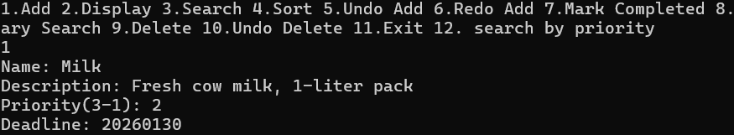
  - Milk → Added successfully, ID: 1

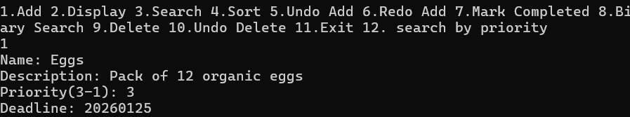
  - Eggs → Added successfully, ID: 2

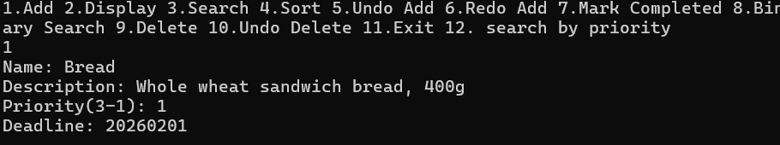
  - Bread → Added successfully, ID: 3

Display Items (Choice 2) Linked List (insertion order):
3 Bread P:1 D:20260201 Pending 2 Eggs P:3 D:20260125 Pending 1 Milk P:2 D:20260130 Pending
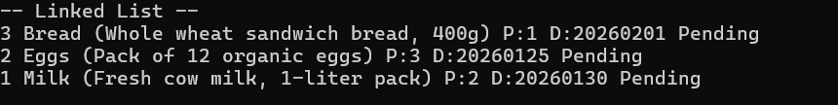

Priority Queue (Heap by priority):

2 Eggs P:3 D:20260125 Pending 1 Milk P:2 D:20260130 Pending 3 Bread P:1 D:20260201 Pending
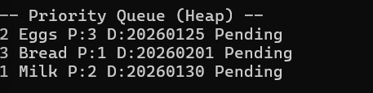

Completed Tasks History (Queue):
No completed tasks.


Undo Last Addition (Choice 5)
Undo Add Successful
- Bread (ID 3) removed from linked list and pushed to redo stack
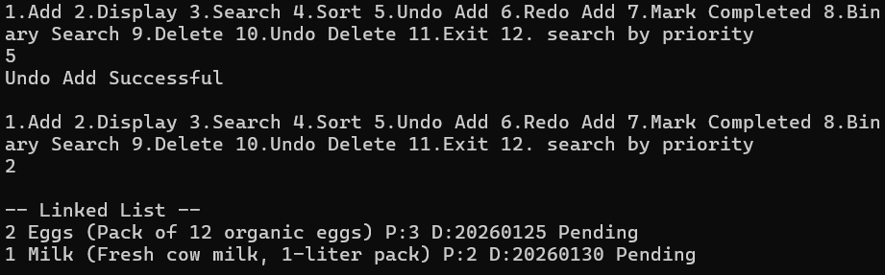

Redo Last Undone Addition (Choice 6)
Redo Successful
- Bread (ID 3) restored to linked list

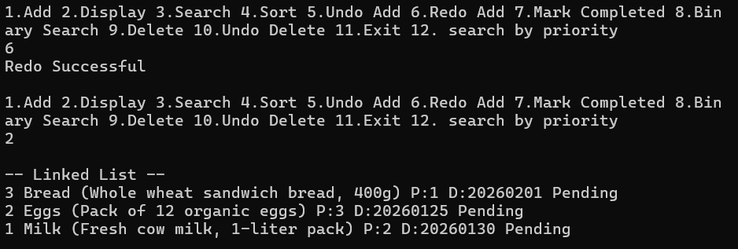

Mark Item as Completed (Choice 7)
Item marked completed
- Eggs (ID 2) moved to completed queue
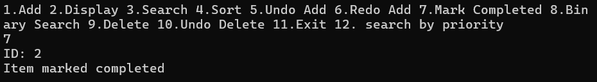

Linked List now:
3 Bread P:1 D:20260201 Pending 1 Milk P:2 D:20260130 Pending
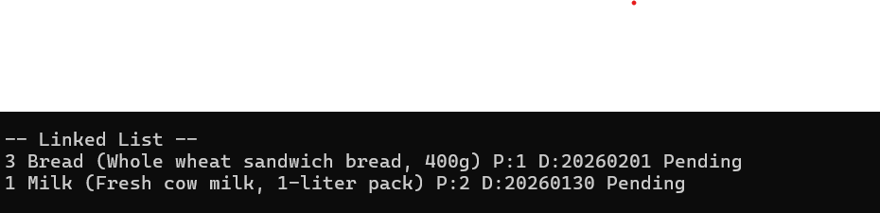

Completed Queue now:
2 Eggs P:3 D:20260125 Purchased

Binary Search by Deadline (Choice 8)
Found: Bread
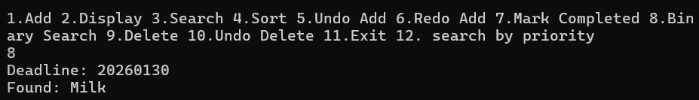

Search by Priority (Choice 12)
1 Milk P:2 D:20260130 Pending
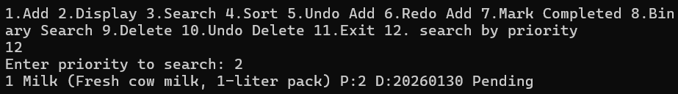

Delete Item (Choice 9)
Item deleted successfully
- Bread (ID 3) removed from linked list

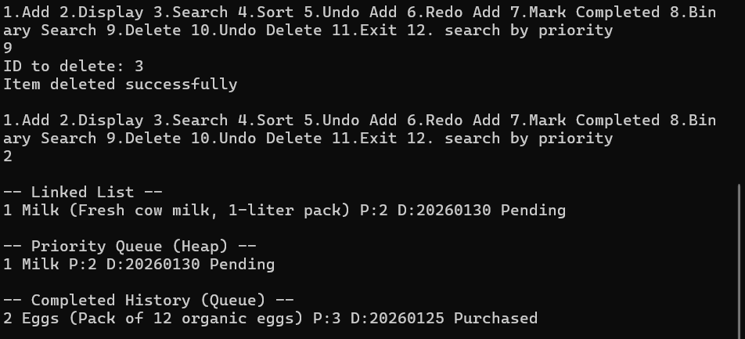

Undo Delete (Choice 10)
Undo Delete Successful
- Bread (ID 3) restored to linked list
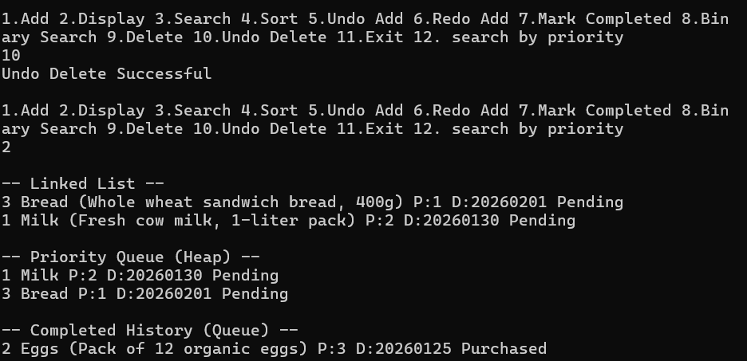

Exit Program (Choice 11)
Program terminated.

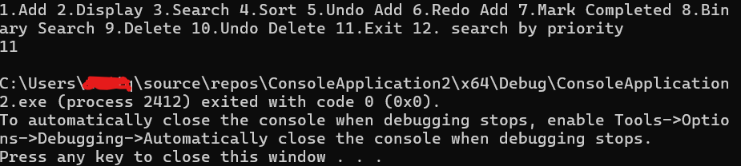

Conclusion
The Grocery & Shopping List Manager successfully demonstrates the application of data structures and algorithms in solving real-world problems. By using linked lists, stacks, queues, heaps, and sorting/searching algorithms, the project highlights how efficient data management improves performance and usability. This project enhanced understanding of DSA concepts and their practical significance.

