# **AZƏRBAYCAN RESPUBLİKASI TƏHSİL NAZİRLİYİ**

# **BAKI MÜHƏNDİSLİK UNİVERSİTETİ**

*“Kompüter və İnformasiya Texnologiyaları”kafedrası*

*“Obyekt yönlü proqramlaşdırma”fənnindən*

# **KURS İŞİ**

Mövzu: Bootstrap framework

İxtisas: İnformasiya texnologiyaları

Tələbə: 190106002 Musa Həsənli

Rəhbər: baş.mEhtibarSeyidzadə

**XIRDALAN – 2020**

**AZƏRBAYCAN RESPUBLİKASI TƏHSİL NAZİRLİYİ**

**BAKI MÜHƏNDİSLİK UNİVERSİTETİ**

**“ *MÜHƏNDİSLİK* ”** fakültəsi

“*Kompüter və İnformasiya Texnologiyaları*”kafedrası

**KURS İŞİNƏ**

**TAPŞIRIQ**

İxtisas___İnformasiya Texnologiyaları(Eng)___ Tələbə___Musa Həsənli______

1. Kurs işinin mövzusu: ____” Bootstrap framework ”__________________
2. Tapşırığın verilmə tarixi: _____
3. Hesabat üçün verilənlər______
4. Hesabat izahat hissəsinin məzmunu____
5. Qrafiki materiallar_____________
6. Ədəbiyyat_________________

Tapşırıq kafedra iclasında təsdiq olunmuşdur,

Protokol № _____ “ _______ ” ____________ 20 il

Kafedra Müdiri _________ ______________

Tələbə _________ _______________

Rəhbər _____________ ____________

**Kurs işinin müdafiə tarixi “_________” ________20 – ci il . Qiymət _____________**

**Müdafiə komissiyası __________________________________________________**

**___________________________________________________________________**

**___________________________________________________________________**

**Contents**

1. Content …..……………………………………………………………………………………………………… 3
2. What is Bootstrap …………………………………………………………………………………………… 4
3. Requirements of Bootstrap.................................................................................. 5
4. Main features of Bootstrap ................................................................................... 6
5. Container class and grid system …………….............................................................. 7
6. Bootstrap Typography ........................................................................................... 8
7. Bootstrap colors .................................................................................................... 9
8. Bootstrap Tables .................................................................................................. 10
9. Bootstrap Alerts ................................................................................................... 11
10. Bootstrap buttons………..………………………………………………………………………………….. 12
11. Bootstrap Cards ………………………………………………………………………………………………. 13
12. Bootstrap navbar and navs ……………………………………………………………………………… 14
13. Bootstrap forms ………………………………………………………………………………………………. 15
14. End …………………………………………………………………………………………………………………. 16

What is Bootstrap?

In this article we will talk about newest version of Bootstrap and it is Bootstrap 4. Bootstrap is most popular HTML, CSS and JavaScript framework for developing responsive, mobile – first websites. Bootstrap 4 is completely free to download and use

Bootstrap 4 is newest version: with new components, faster stylesheet and more responsiveness, but three may be some problems in some Browsers, such as IE8-9 and down versions require to use Bootstrap 3. In the nearly time Bootstrap 5 released, and it have also some different from other versions and most important is that Bootstrap 5 isn’t using jQuery.

Requirements of Bootstrap 4

For using Bootstrap three are some requirements that we must obey them. We can use bootstrap with different rules.

First of all, for responsive view we should add

<meta name="viewport" content="width=device-width” initial-scale=1">

this meta tag to our head section, or else our web – page won’t work correctly

1. Download Bootstrap

This is the most useful rule for using Bootstrap in web applications cause when we download Bootstrap, our web-page can work more faster than others, and it is also most reliable rule, because sometimes may be three can be some changes and if so, it will affect our web page. For using in this rule we just going to for example <https://stackpath.bootstrapcdn.com/bootstrap/4.4.1/css/bootstrap.min.css>

to this link and copy CSS codes from three and link it to our html page just we need.

But In getbootstrap.com we can easily find download part and download it as folder, after we can use some part of it or whole part.

1. CDN version

CDN version also can be using in web-pages, but it is not recommended way to use Bootstrap, cause CDN every time loading we reload webpage and it affect our page it works slowly than Downloading version

1. NPM version

npm version is also useful in the web pages, and we may time use JS frameworks such as React, Angular or Vue JS in these frameworks we can download bootstrap and use it, but this is not only way to use Bootstrap in these frameworks.

Downloading:

npm install bootstrap

And we use below code in the main.js (this name can be different in different frameworks)

import “bootstrap/dist/css/bootstrap.min.css”

Bootstrap 4 has many functionalities which works with jQuery and if we use moveable items which coming with Bootstrap, we must also download jQuery

Main features of Bootstrap 4

Bootstrap has many really useful features and one of them and may be most important is grid system. Grid system gives us to make responsive websites for different devices, and via using grid system we can do our web-page different for mobile, for tablet and for pc

Example: 

As you see in the image our webpage is looking different in diferrent devices

Navbar is also one of the most useful feature, with this component we can make a navbar, easily

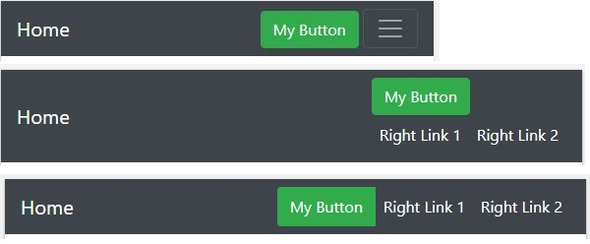

As we see in image in the mobile device we have menu tab, but in tablet and in pc this not exists

We can also say as a main feature carousel, modal, alerts, button, forms, dropdowns and so on. We will talk about them later.

Container and Grid System

We have learned what the grid system is, and now let’s learn how to use it.

Bootstrap’s grid system uses a series of containers, rows, and columns to layout and align content. It’s built with [flexbox](https://developer.mozilla.org/en-US/docs/Web/CSS/CSS_Flexible_Box_Layout/Using_CSS_flexible_boxes) and is fully responsive. Below is an example and an in-depth look at how the grid comes together.

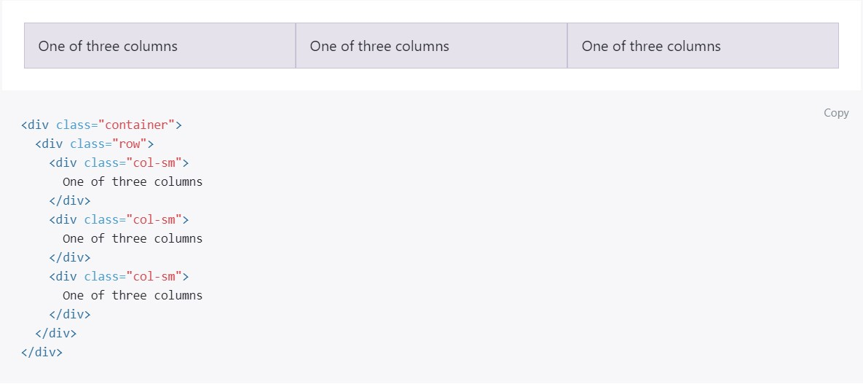

The above example creates three equal-width columns on small, medium, large, and extra-large devices using our predefined grid classes. Those columns are centered in the page with the parent .container.

Breaking it down, here’s how it works:

* Containers provide a means to center and horizontally pad your site’s contents. Use .container for a responsive pixel width or .container-fluid for width: 100% across all viewport and device sizes.
* Rows are wrappers for columns. Each column has horizontal padding (called a gutter) for controlling the space between them. This padding is then counteracted on the rows with negative margins. This way, all the content in your columns is visually aligned down the left side.
* In a grid layout, content must be placed within columns and only columns may be immediate children of rows.
* Thanks to flexbox, grid columns without a specified width will automatically layout as equal width columns. For example, four instances of .col-sm will each automatically be 25% wide from the small breakpoint and up.
* Column classes indicate the number of columns you’d like to use out of the possible 12 per row. So, if you want three equal-width columns across, you can use .col-4.
* Column widths are set in percentages, so they’re always fluid and sized relative to their parent element.
* Columns have horizontal padding to create the gutters between individual columns, however, you can remove the margin from rows and padding from columns with .no-gutters on the .row.
* To make the grid responsive, there are five grid breakpoints, one for each [responsive breakpoint](https://getbootstrap.com/docs/4.0/layout/overview/#responsive-breakpoints): all breakpoints (extra small), small, medium, large, and extra-large.
* Grid breakpoints are based on minimum width media queries, meaning **they apply to that one breakpoint and all those above it** (e.g., .col-sm-4 applies to small, medium, large, and extra-large devices, but not the first xs breakpoint).

Grid Options:

While Bootstrap uses ems or rems for defining most sizes, pxs are used for grid breakpoints and container widths. This is because the viewport width is in pixels and does not change with the [font size](https://drafts.csswg.org/mediaqueries-3/#units).

See how aspects of the Bootstrap grid system work across multiple devices with a handy table.

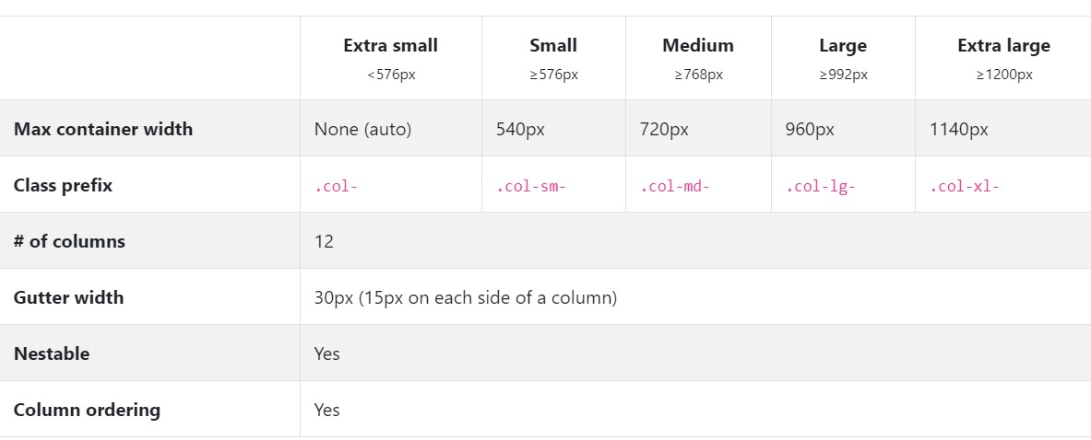

Now let’s see some grid examples:

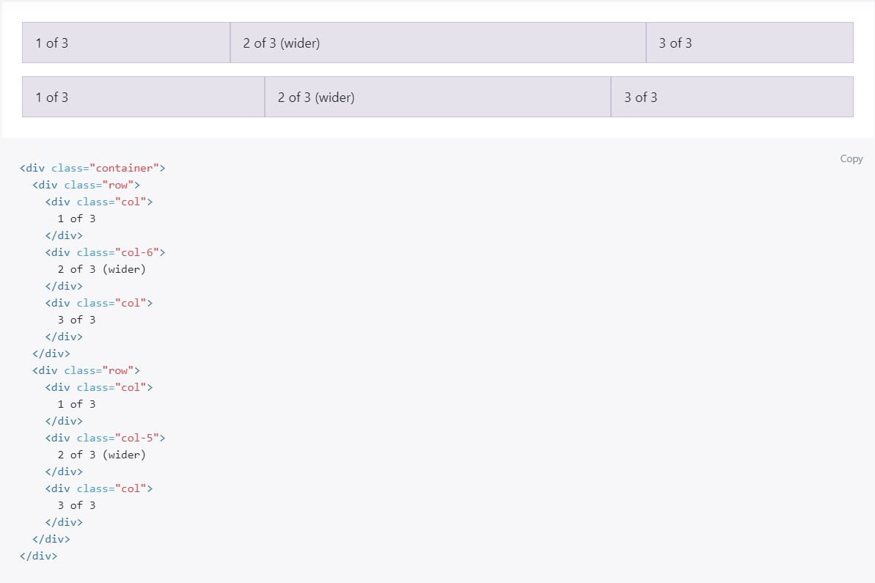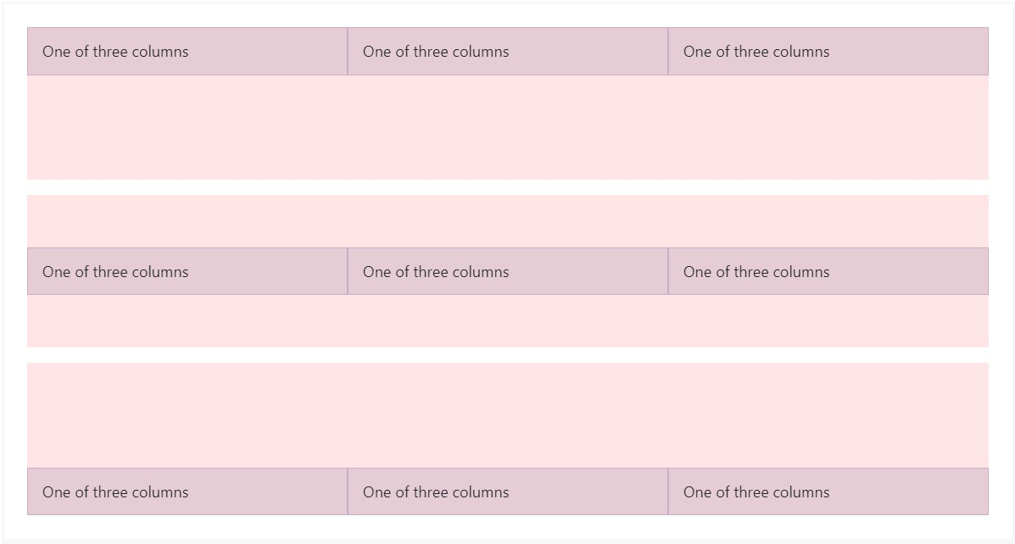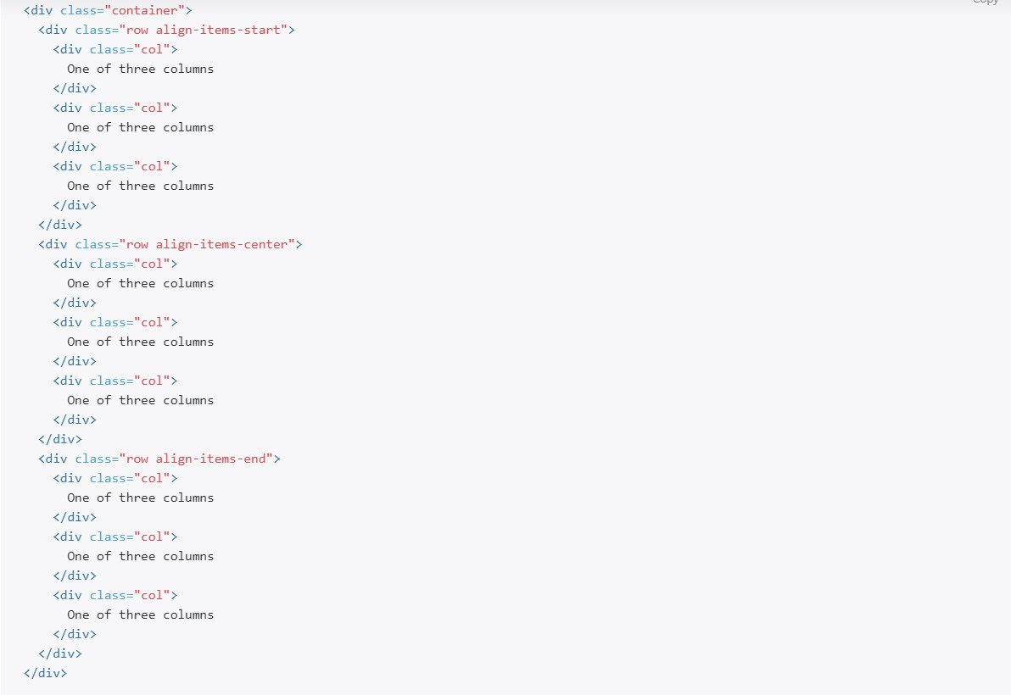

We really can Talk about so much about grid system, for more information you can visit getbootstrap.com or w3schools.com and other sources

Bootstrap Typography

Bootstrap has some classes which can make our text look better, let’s see some of them. Bootstrap use 16px font-size, and its line-height is 1.5. The default font-family is "Helvetica Neue", Helvetica, Arial, sans-serif.

display-1, display-2, display-3, display-4

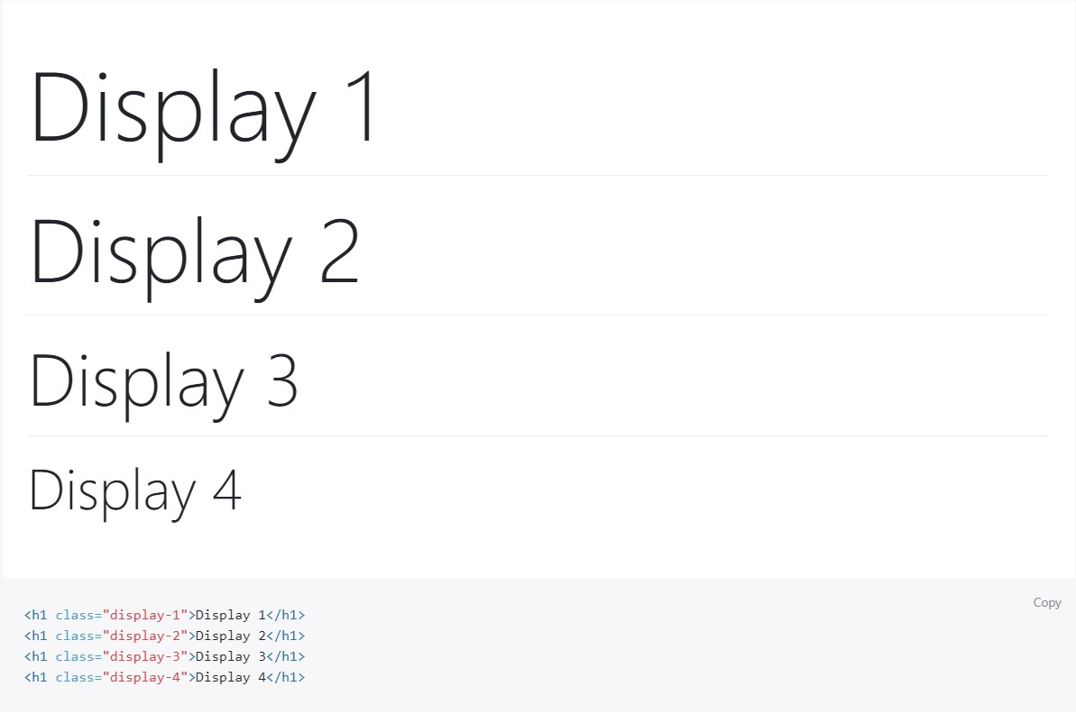

lead – usually using for the p element:

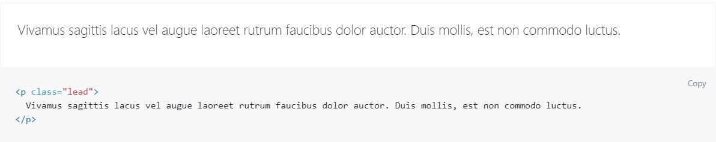

blockquote - For quoting blocks of content from another source within your document. Wrap <blockquote class="blockquote"> around any HTML as the quote.

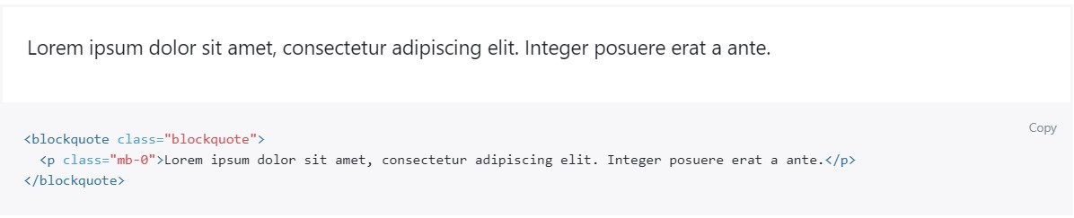

blockquote-footer

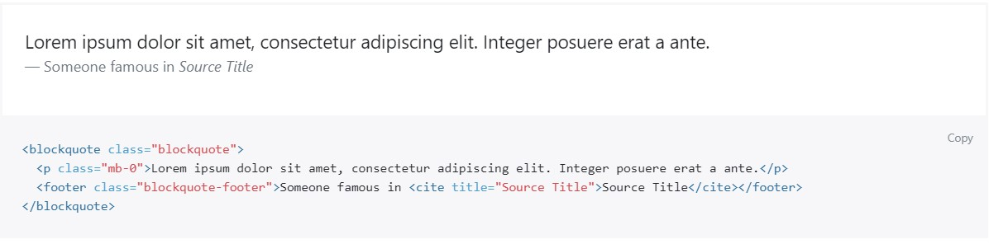

Alignment

For alignment we have 4 class:

text-center – text-align: center for this class

text-justify – text-align: justify for this class

text-left – text – align: left

text-right – text-align: right for these elements

Text colors:

Bootstrap has text-color classes:

These are: text-light – white text, text – dark – black text, text-danger – red text, text-success – green text, text-warning – yellow text, text-secondary – gray text, text-muted – bold gray text

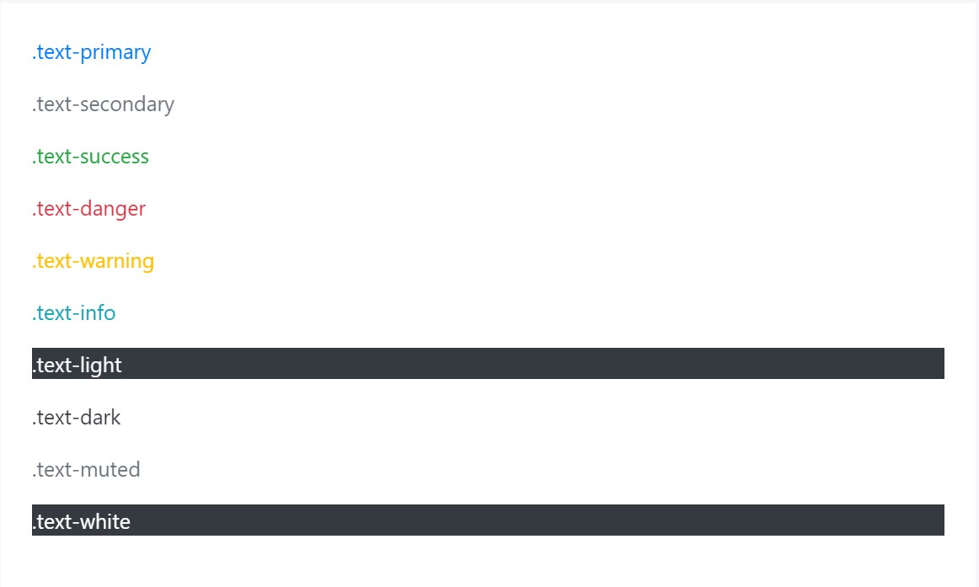

Bootstrap colors

Bootstrap has 7 main color which named by primary, info, light, dark, secondary, danger, warning, we can use in so many place text – colors in the above, for these colors Bootstrap have buttons, colorful texts and others, but we can also use these colors as background color for this we just write bg – (one of above colors) , for example bg – danger, gives div background color #dc3545, or bg-primary gives to the div #107bff background hex color 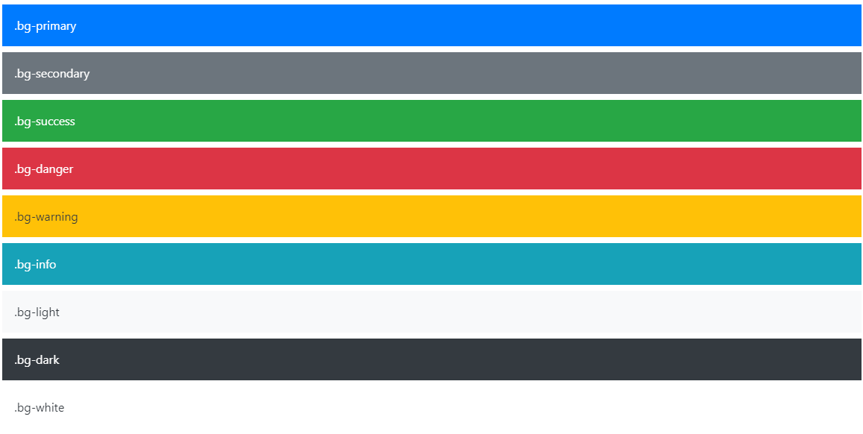

Bootstrap Tables

One of the easiest ways to create beautiful table is using bootstrap table class

For using we just create table and gives it table class

<table class = ‘table’></table>

This creates simple table, there are other class that we can use, first table-responsive, we use this class for div element and we write our table inside of this div, if our table need more place there creating scroll in the bottom and information can be more readable and more beautiful

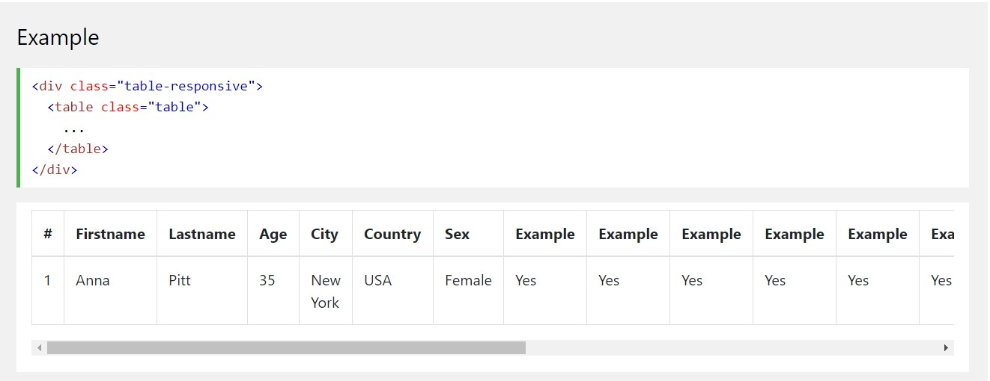

Table striped

The. table-striped class adds zebra-stripes to a table:

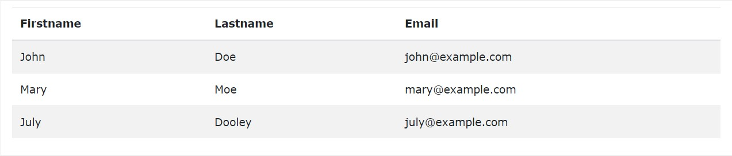

We can give table different color, for using we just use table – ( here one of the color name such as info, primary or else )

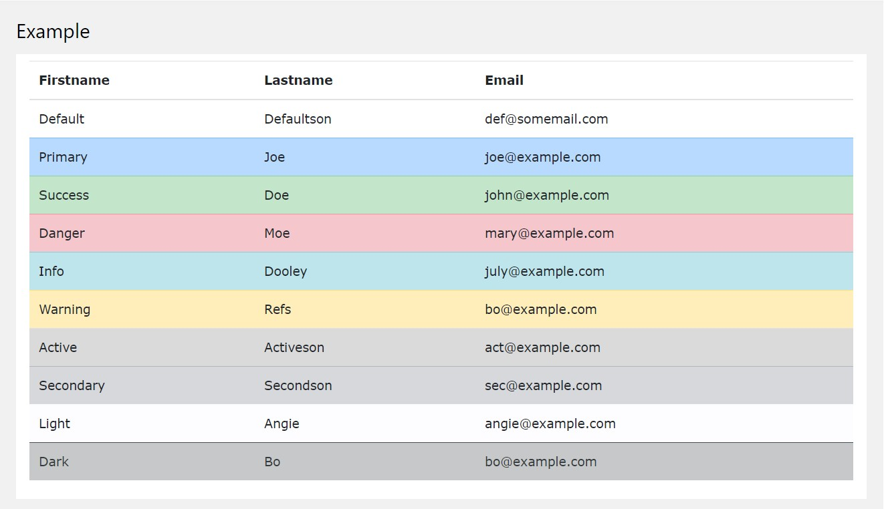

Bootstrap Alerts

Bootstrap 4 provides an easy way to create predefined alert messages:

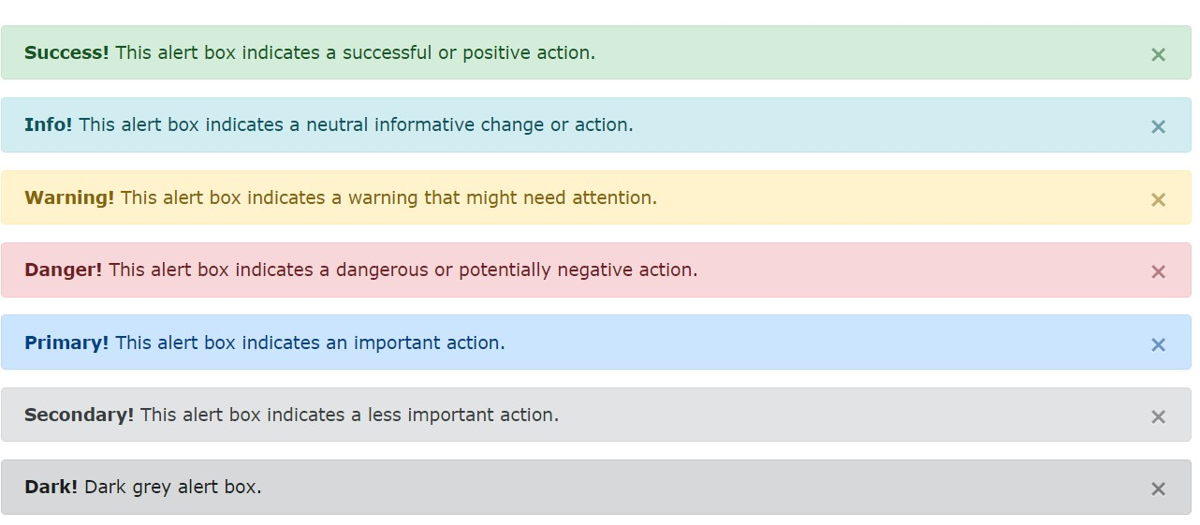

To create alert, we just give to the tag alert class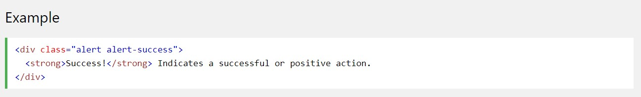

and to give background-color we add one more color class such as alert – danger, alert – success or else, in the image we also have, dismiss button to create this we just do below code:

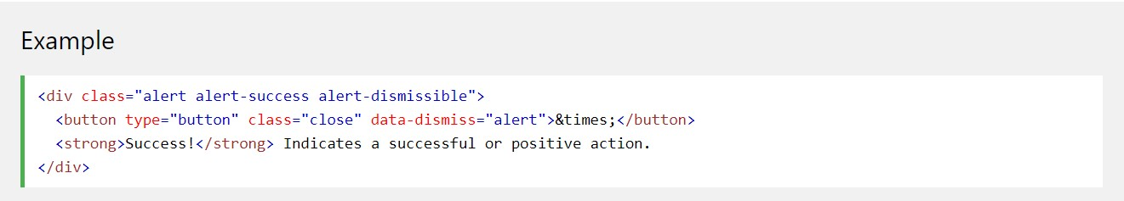

Buttons

One of the most useful part of Bootstrap is buttons, we every time give button class btn and then we just need one thing do to and it is to give background color for this we just give btn – color name let’s see example:

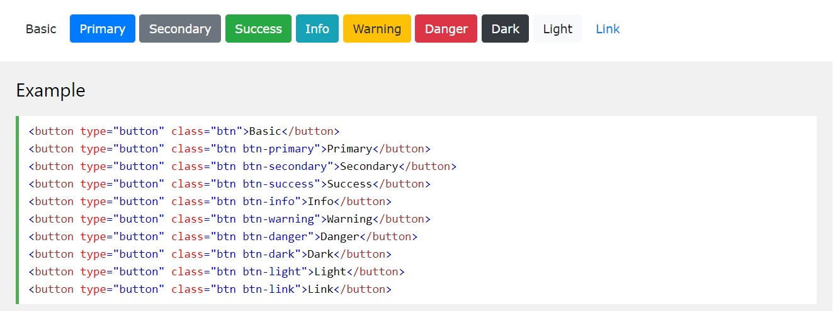

Bootstrap also have outline buttons and they have special hover effect, when we hover over them they became full color as border

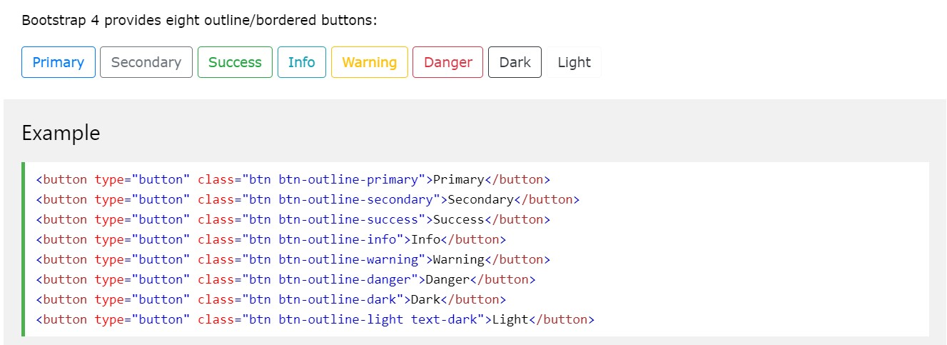

Bootstrap also have button – groups which using to create side – to - side buttons, and for usage we just need to wrap all buttons with one div which has class btn-group

An example of button group

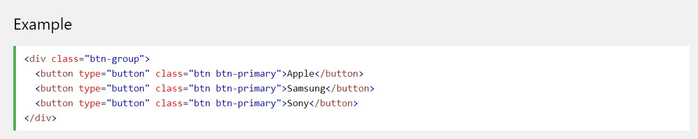

Cards

A card in BS4 is a bordered box with special padding, header, body, special image, colors and etc.

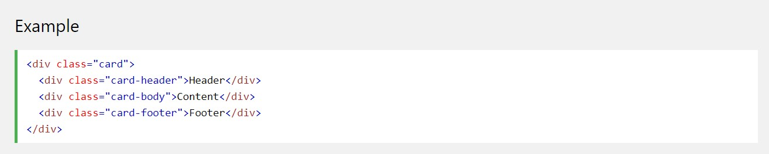

card class is always be wrapper for cards, card-header class creates header, and others creates body and footer.

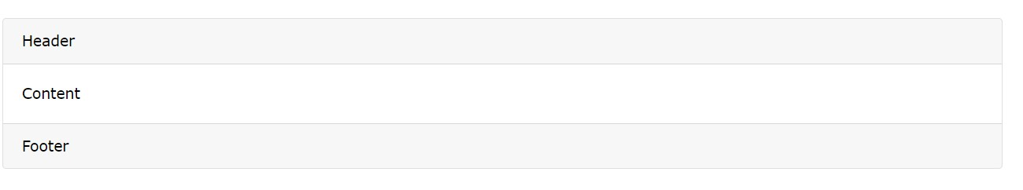

The codes above give us layout like this.

For colors in card we just use bg – color name schema. For example bg – primary give blue card

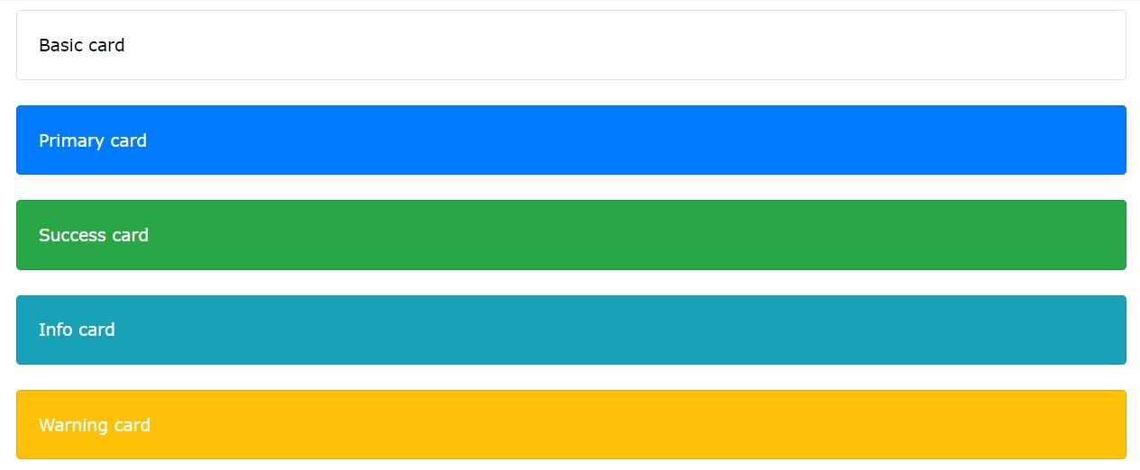

And others continuing in the same way

Images in card:

We can use images in the card with special class,

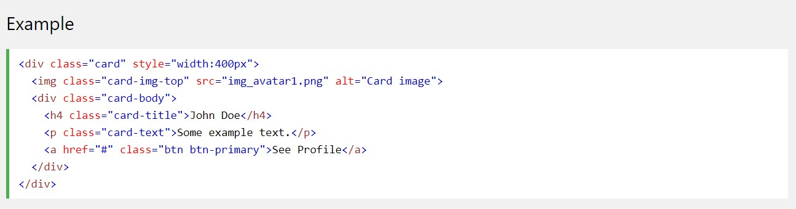

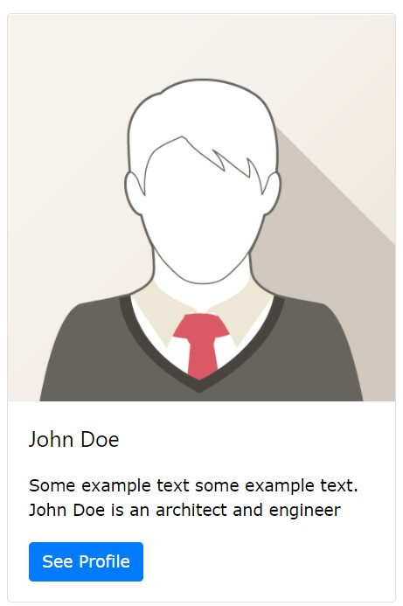 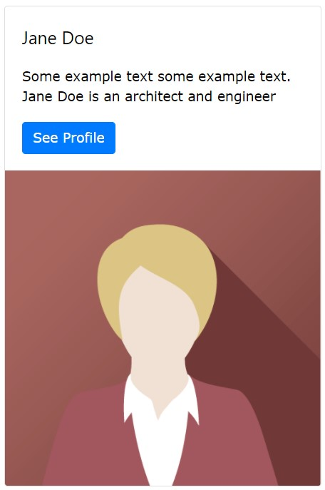

We see top and bottom image, in the code above our code give us 1st layout for getting 2nd layout we just need to car-img-top class to card-img-bottom class

Card also have many different options they can find official site of Bootstrap

Forms

Forms is useful also in the bootstrap. Bootstrap 2 different form layout:

1. Stacked – full width form
2. Inline form

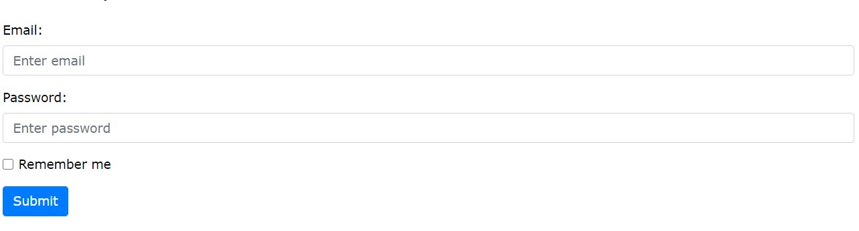

The following example creates a stacked form with two input fields, one checkbox, and a submit button. Add a wrapper element with .form-group, around each form control, to ensure proper margins:

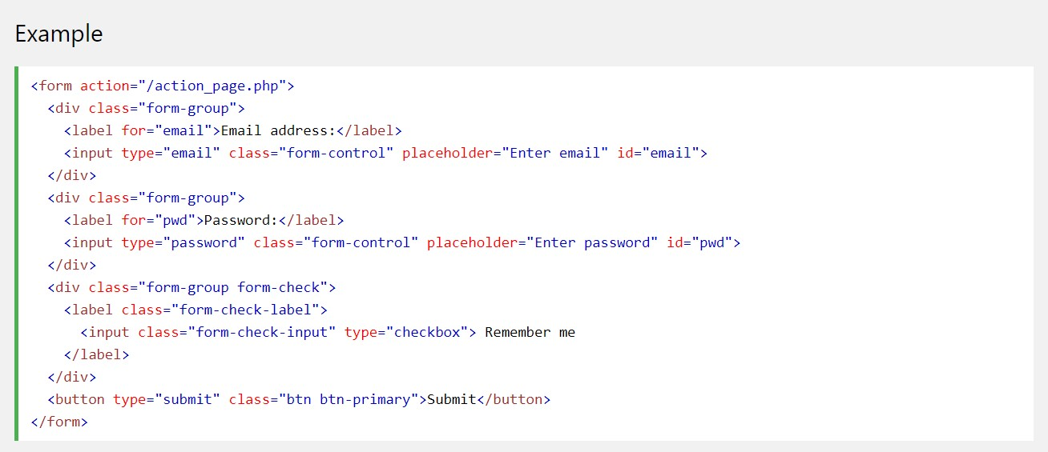

Inline Forms:



In an inline form, all of the elements are inline and left-aligned.

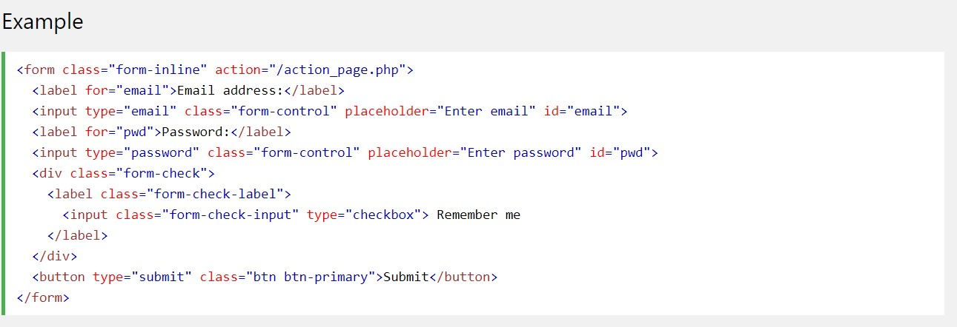

Conclusion

Bootstrap also have different options such as modals, carousel, tooltips, popover, icons and others. In the web application Bootstrap help us very much, but Bootstrap is not only web framework, we can talk about Materialize CSS and Tailwind. All of them has some useful functions that in others is not exists. Among them Bootstrap is easiest to learn and to use, therefore it is very popular. For these reasons, when our page use Bootstrap it very easy to understand that this page using Bootstrap, but We can’t say the same words for others. For these and some others reasons, sometimes it would be more recommended rule to use other framework or not using framework.

Sources

1. <https://www.w3schools.com/bootstrap4>
2. https://getbootstrap.com/