Ansible

App deployment, configuration management, and orchestration — all from one system. Ansible is simple, agentless automation that anyone can use.
Ansible can be run directly from the command line without setting up any configuration files. You only need to install Ansible on the control server or node. It communicates and performs the required tasks using SSH. No other installation is required. This is different from other orchestration tools like Chef and Puppet where you have to install software both on the control and client nodes.
Ansible uses configuration files called playbooks for a series of tasks. The playbooks are written in YAML syntax.Written in Python ,OpenSource,Red Hat acquired Ansible in 2015.Due to the ease of use, Ansible is rising in popularity as an IT automation tool.

How Ansible Works?
The picture given below shows the working of Ansible.
Ansible works by connecting to your nodes and pushing out small programs, called "Ansible modules" to them. Ansible then executes these modules (over SSH by default), and removes them when finished. Your library of modules can reside on any machine, and there are no servers, daemons, or databases required.
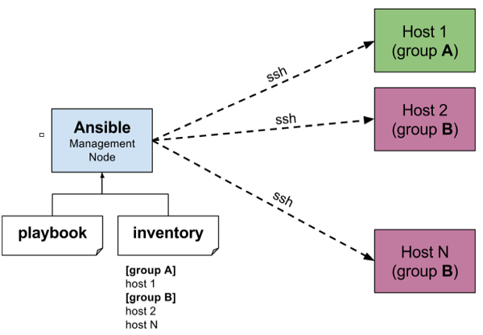
Beauty of Ansible is that it removes the modules once those are installed so effectively it connects to host machine , executes the instructions and if it’s successfully installed removes the code which was copied on the host machine which was executed.

Ansible uses YAML because it is very easy for humans to understand, read and write when compared to other data formats like XML and JSON.

Ad hoc Commands

Ad hoc commands are commands which can be run individually to perform quick functions.These ad-hoc commands are not used for configuration management and deployment, because these commands are of one time usage.

Parallelism and Shell Commands
Reboot your company server in 12 parallel forks at time. For this, we need to set up SSHagent for connection.
$ ssh-agent bash
$ ssh-add ~/.ssh/id_rsa
To run reboot for all your company servers in a group, 'abc', in 12 parallel forks −
$ Ansible abc -a "/sbin/reboot" -f 12
By default, Ansible will run the above Ad-hoc commands form current user account. If you want to change this behavior, you will have to pass the username in Ad-hoc commands as follows −
$ Ansible abc -a "/sbin/reboot" -f 12 -u username

PlayBooks

Playbooks are the files where Ansible code is written. Playbooks are written in YAML format. YAML stands for Yet Another Markup Language. Playbooks are one of the core features of Ansible and tell Ansible what to execute. They are like a to-do list for Ansible that contains a list of tasks.

Create a Playbook
Let us start by writing a sample YAML file. We will walk through each section written in a yaml file.
---
name: install and configure DB
hosts: testServer
become: yes

vars:
oracle_db_port_value : 1521

tasks:
-name: Install the Oracle DB
yum: <code to install the DB>

-name: Ensure the installed service is enabled and running
service:
name: <your service name>

Generally Ansible task execution engine have three modes of operations

Linear : Tasks are executed linearly , first task one execute on host 1 and then host 2 and so on.
Rolling Updates: All tasks are executed on first host then moved to other hosts.
Free: Tasks executed in free form.

Arguably, the ability to manage remote systems is the most important aspect of Ansible. When combined with the ability to express the tasks to be performed in a simple to read text file,Ansible provides a reusable and repeatable system for managing a fleet of infrastructure.Ansible is designed to scale beyond a small handful of systems to manage. In order to efficiently address whole fleets of systems, Ansible must be able to work on multiple machines at the same time.
The default operation model allows Ansible to linearly execute a list of tasks on multiple machines at once. As the set of machines complete one task, they are given the next task to complete. This is the default, or linear strategy, and allows for data generated in an action on a particular machine to be used as input data for a later task on a different machine. There are however certain times when systems need to be worked on in smaller batches in a specific order.
This strategy is useful for rolling changes out in small batches into production, or minimizing the impact of an upgrade by disrupting only small portions of a service at any one time. This is the serial strategy. Instead of linearly walking through the task list, one or more hosts in batches are walked through the task list before looping back to the beginning for the next set of hosts. A third operation strategy was introduced with Ansible 2.0, in which machinescomplete tasks as fast as they individually can, without waiting for the rest of the hosts to complete a given task.
This is known as the free strategy, and is used mostly to reduce interruption of a specific machine or service, rather than the fleet as a whole. When using the strategy, it is not possiblefor one host to depend on task-generated data from a different host. The Ansible project manages code contribution and software releases. It is a very popular open source project.The Ansible company was created to fund development, which was later acquired by Red Hat.

References:

https://www.ansible.com/
https://www.lynda.com/Ansible-tutorials/

