Before managing complete applications with Kubernetes and Container Engine,
you'll want to know how containers work and what advantages they provide.

Introduction to containers and docker

What are Containers?

A container is a standard unit of software that packages up code and all its dependencies so the application runs quickly and reliably from one computing environment to another.

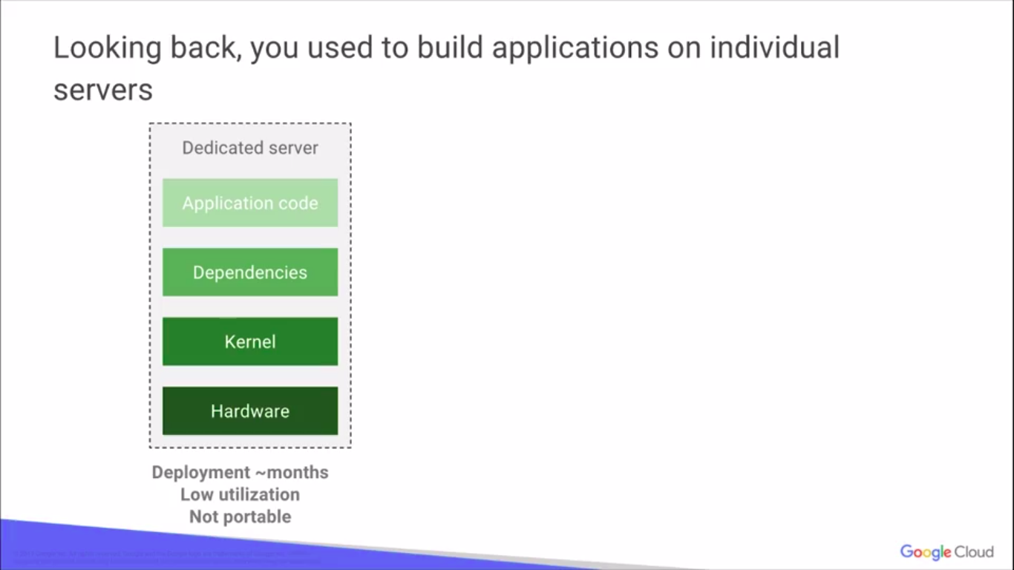
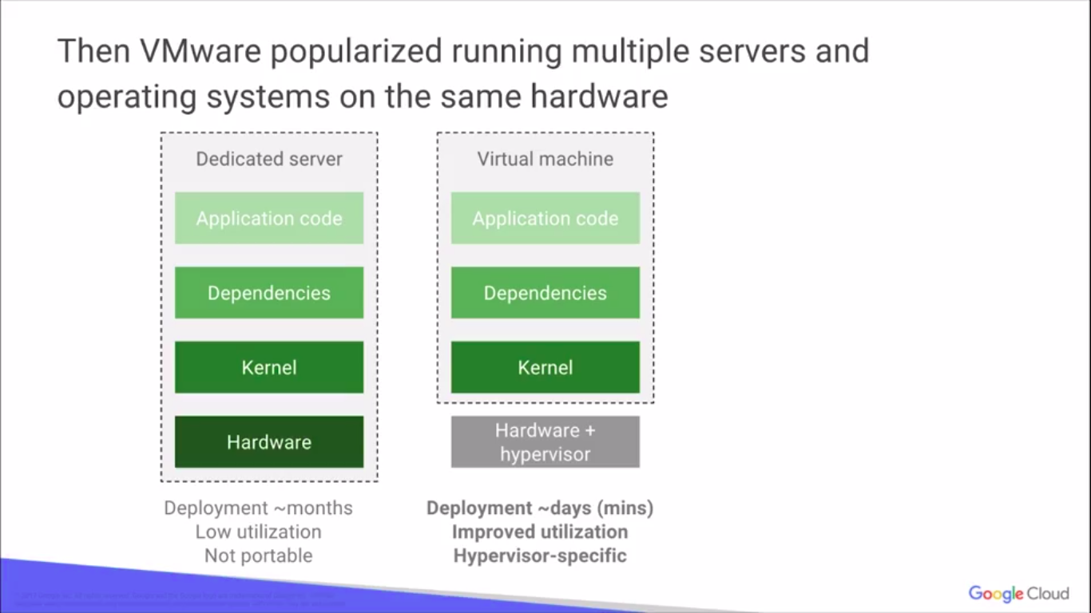
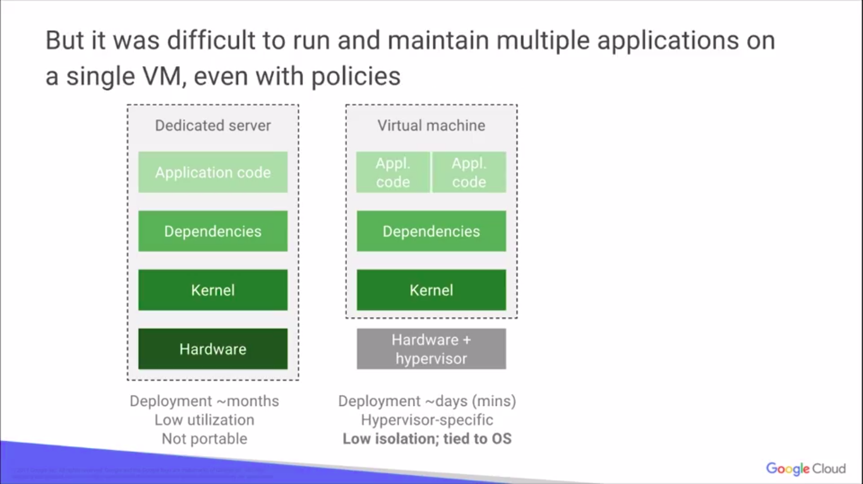
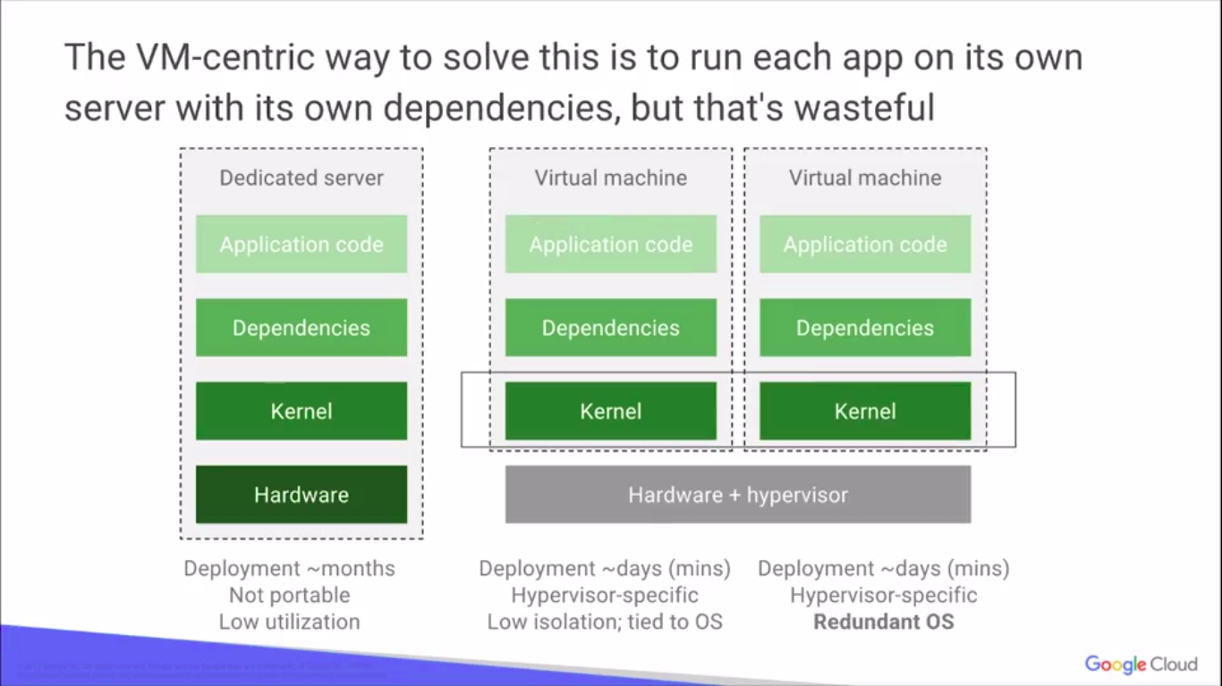
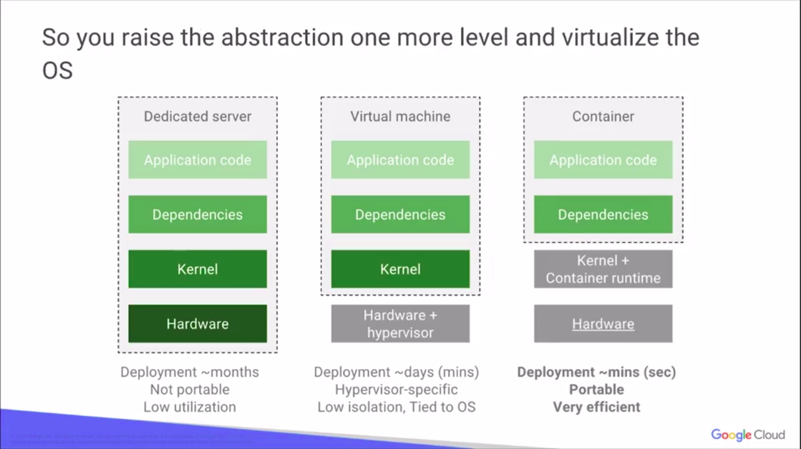
What is Docker?

A Docker container image is a lightweight, standalone, executable package of software that includes everything needed to run an application: code, runtime, system tools, system libraries and settings.
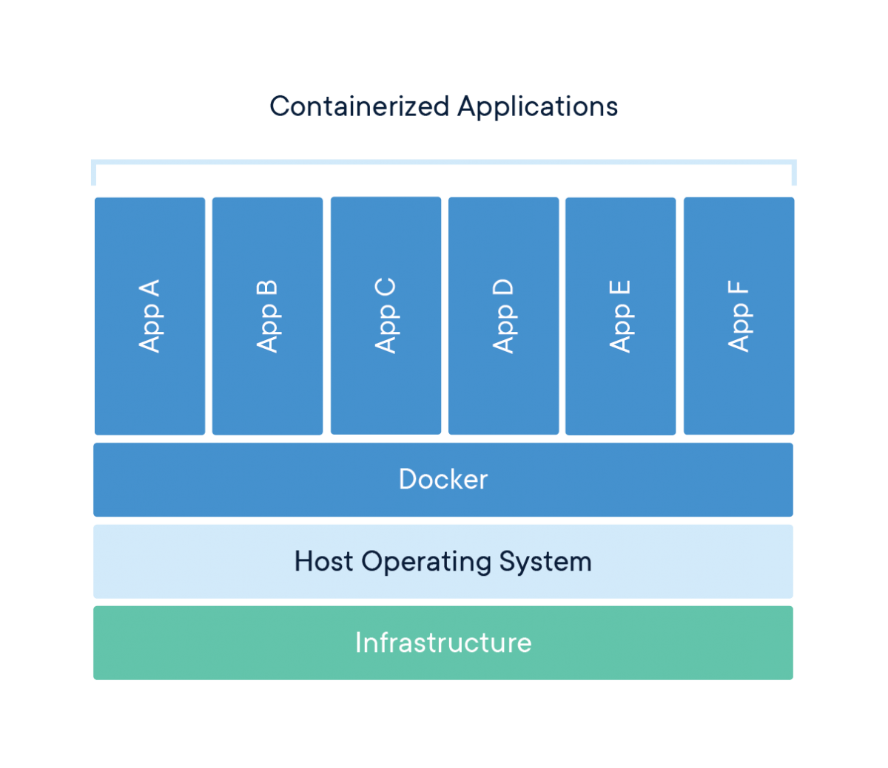

Docker Containers Are Everywhere: Linux, Windows, Data center, Cloud, Serverless, etc.
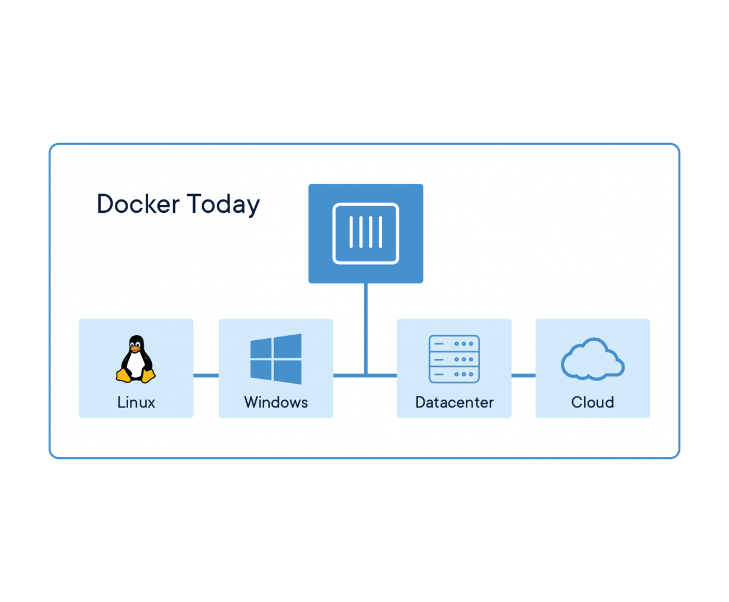

Comparing Containers and Virtual Machines

Containers and virtual machines have similar resource isolation and allocation benefits, but function differently because containers virtualize the operating system instead of hardware. Containers are more portable and efficient.
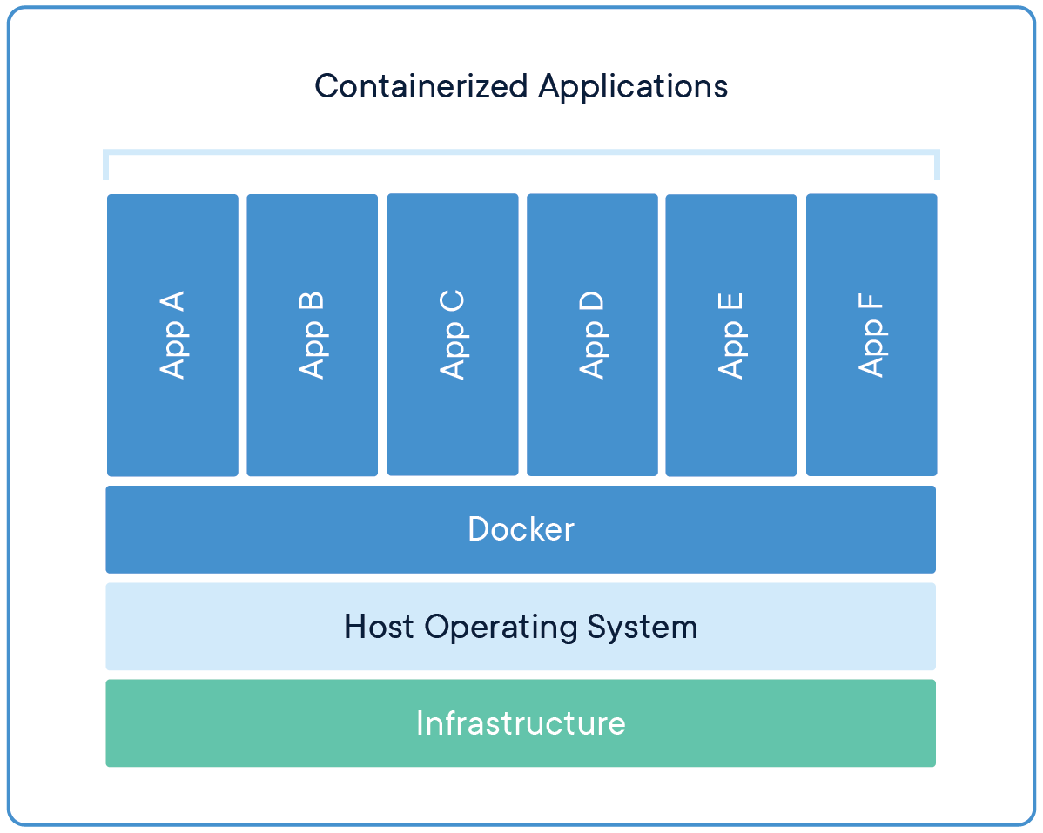
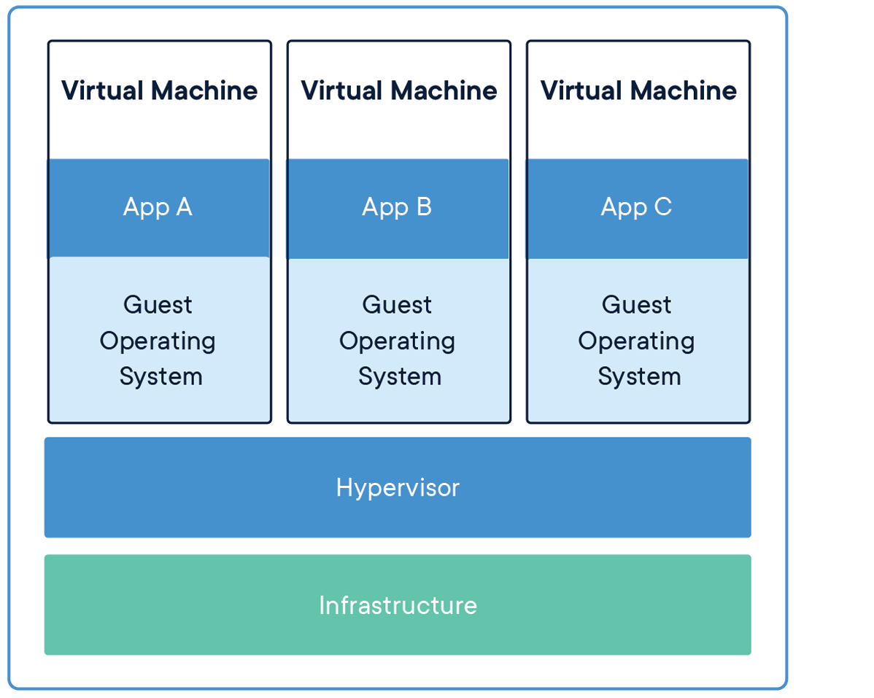

Docker is a platform for developers and sysadmins to develop, deploy, and run applications with containers. The use of Linux containers to deploy applications is called containerization. Containers are not new, but their use for easily deploying applications is.
Containerization is increasingly popular because containers are:
- Flexible: Even the most complex applications can be containerized.
- Lightweight: Containers leverage and share the host kernel.
- Interchangeable: You can deploy updates and upgrades on-the-fly.
- Portable: You can build locally, deploy to the cloud, and run anywhere.
- Scalable: You can increase and automatically distribute container replicas.
- Stackable: You can stack services vertically and on-the-fly.

Docker History
Docker adoption has gone sky high.Basically, they've gone, it's a line straight up from when they released in around 2013.It's a massive adoption in the market today.
It's up to about 40% in one year Docked adoption itself. Written in: Go
Developed by: Docker, Inc.

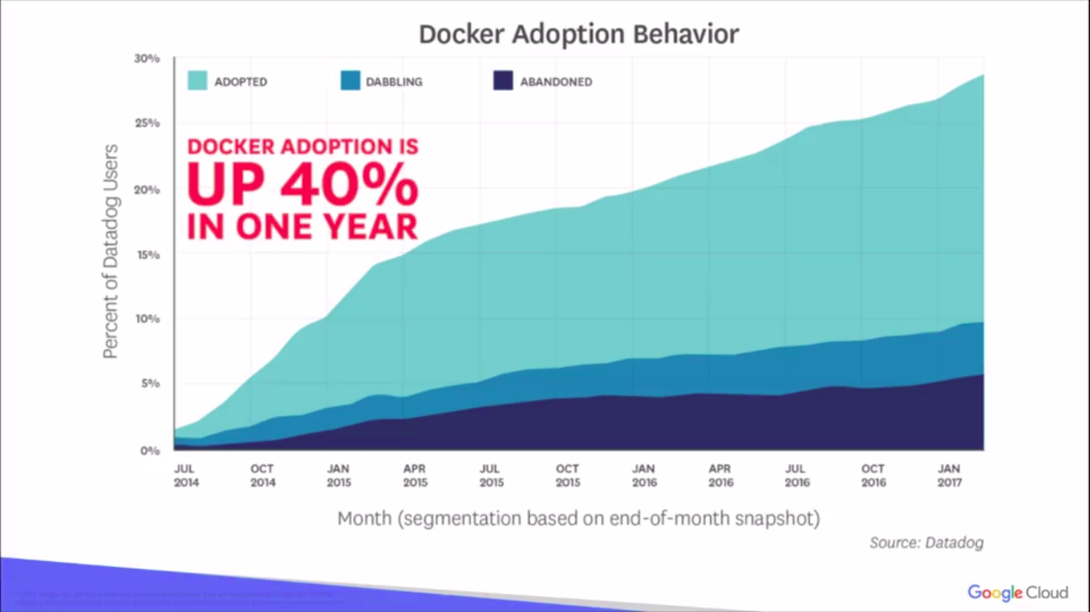

Images and containers
A container is launched by running an image. An image is an executable package that includes everything needed to run an application--the code, a runtime, libraries, environment variables, and configuration files.

These portable images are defined by something called a Dockerfile

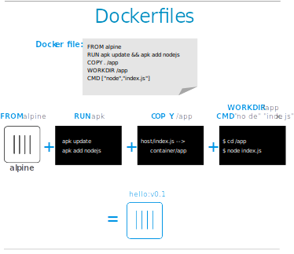

A container is a runtime instance of an image--what the image becomes in memory when executed (that is, an image with state, or a user process). You can see a list of your running containers with the command, docker ps, just as you would in Linux.

Docker Engine+Docker hub = Docker Platform

Docker Engine

- Docker Daemon
- Docker CLI

Docker Daemon

- Builds Images
- Runs and Manages Containers

Docker CLI

• docker build # Build an image from a Dockerfile
• docker images # List all images on a Docker host
• docker run # Run an image
• docker ps # List all running and stopped instances
• docker stop # Stop a running instances
• docker rm # Remove an instance
• docker rmi # Remove an imageDocker

Docker Architecture

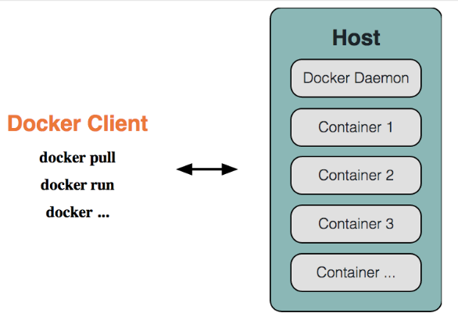
Docker Hub

• Provides Docker Services
• Library of public images
• Storage for your images
• free for public images
• cost for private images
•Automated builds(link github/bitbucket repo; trigger
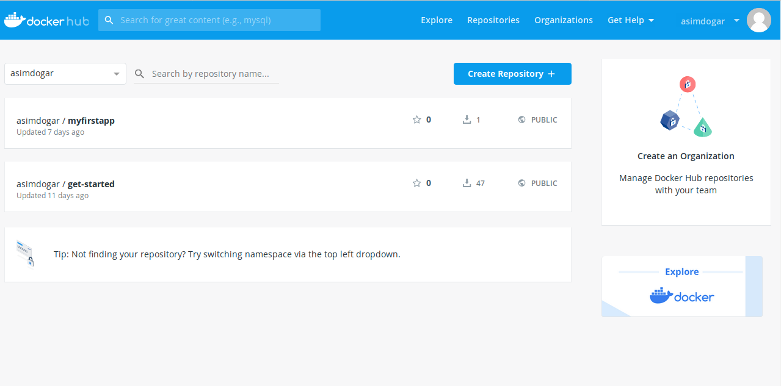
build on commit)Docker Hub

## Execute Docker image
docker run hello-world

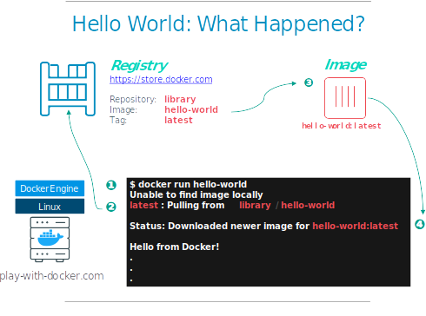
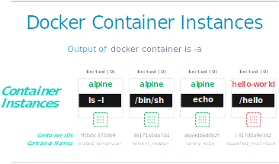

Container Isolation
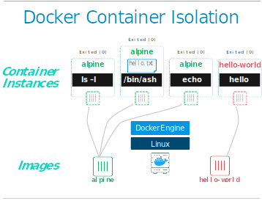

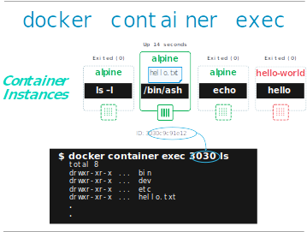

Container Orchestration:
As you saw earlier,containers allow you to break up applications into modules with hardware,software, and operating system requirements.You can run them on the same or even different machines and start and stop them quickly,but you can't specify how many machines or containers to keep running,what to do if they fail,or how to connect them to other containers and persistent storage?For that, you need a container orchestration system like Kubernetes.Kubernetes adds the ability to define how many machines to run,how many containers to deploy,how to scale them,where persistent disks reside,and how to deploy a group of containers as a unit.

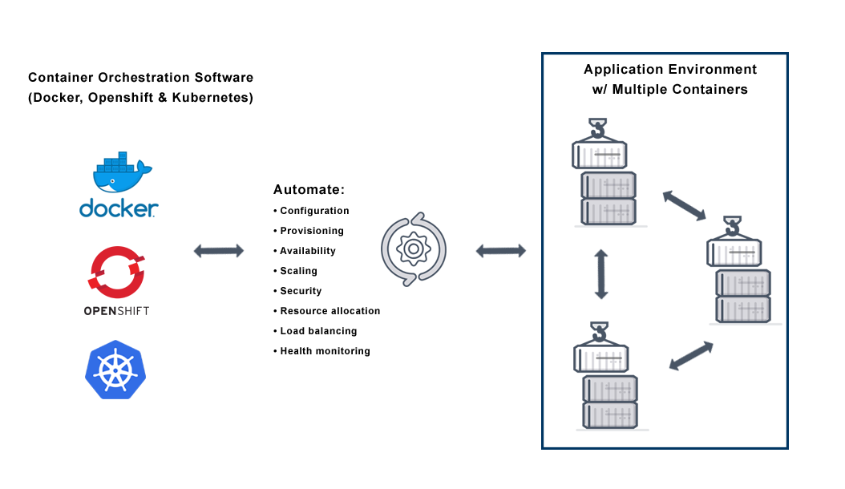

Kubernetes (K8s)

Kubernetes (K8s) is an open-source system for automating deployment, scaling, and management of containerized applications.
It was originally designed by Google, and is now maintained by the Cloud Native Computing Foundation.Initial release: 7 June 2014; Written in: Go

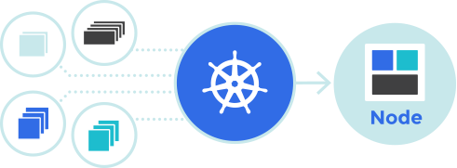

Kubernetes Clusters
A Kubernetes cluster consists of two types of resources:
- The Master coordinates the cluster
- Nodes are the workers that run applications
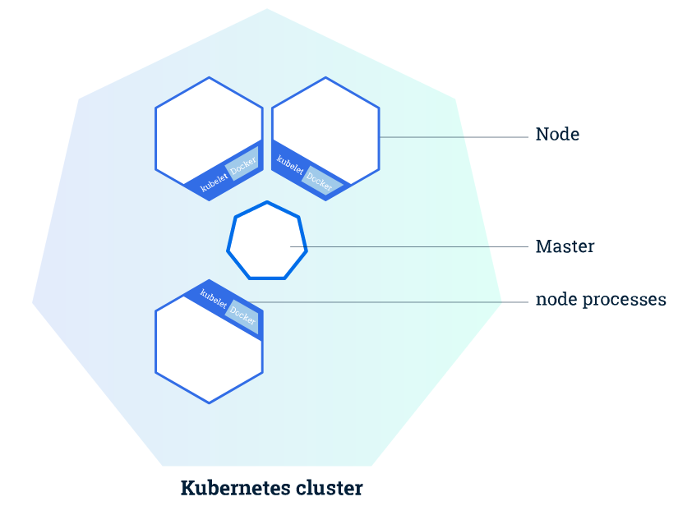
The Master is responsible for managing the cluster.such as scheduling applications, maintaining applications' desired state, scaling applications, and rolling out new updates.
A node is a VM or a physical computer that serves as a worker machine in a Kubernetes cluster.
The nodes communicate with the master using the Kubernetes API, which the master exposes. End users can also use the Kubernetes API directly to interact with the cluster.
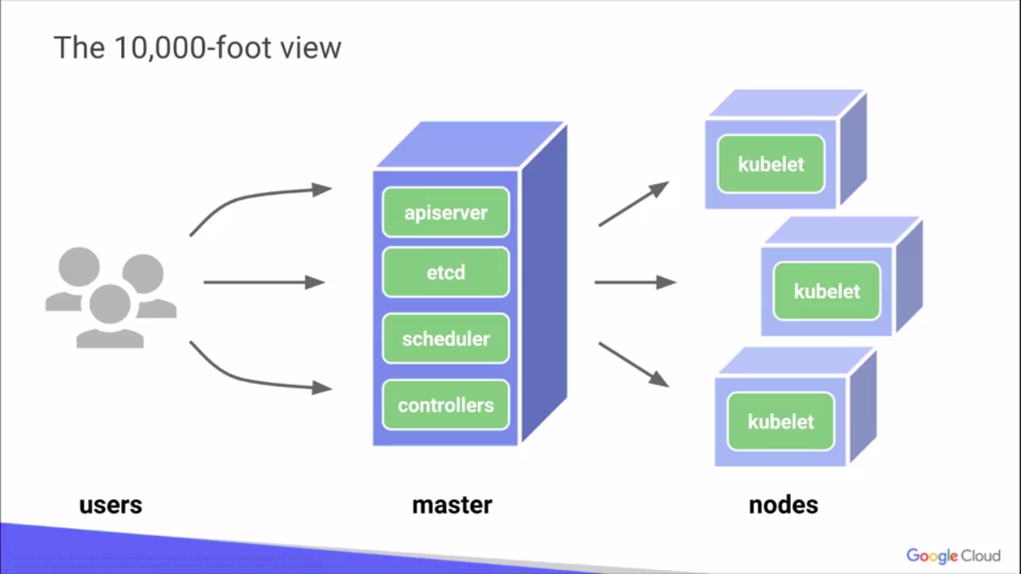
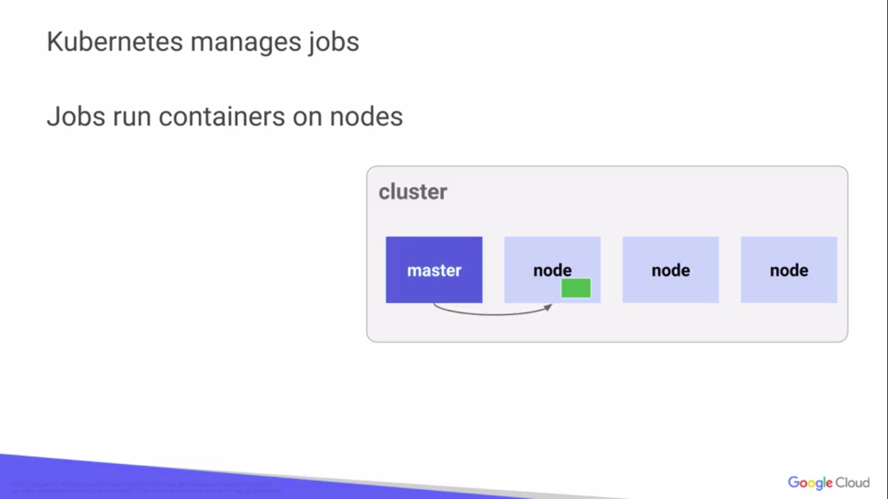
A Kubernetes cluster that handles production traffic should have a minimum of three nodes.

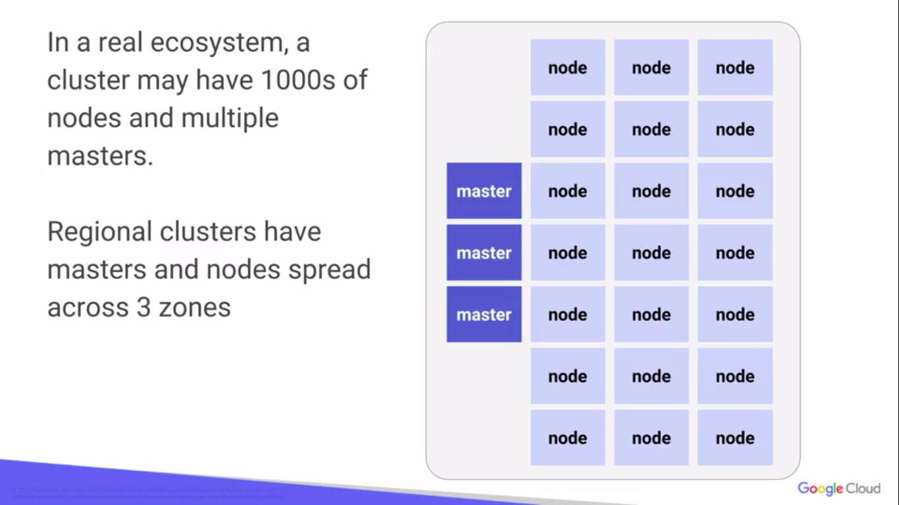

Deploying your first app on Kubernetes
You can create and manage a Deployment by using the Kubernetes command line interface,Kubectl. Kubectl uses the Kubernetes API to interact with the cluster.
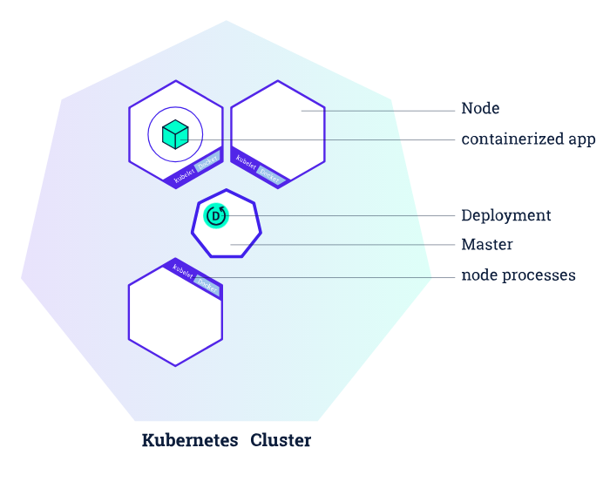

When you created a Deployment, Kubernetes created a Pod to host your application instance. A Pod is a Kubernetes abstraction that represents a group of one or more application containers (such as Docker or rkt), and some shared resources for those containers. Those resources include:
- Shared storage, as Volumes
- Networking, as a unique cluster IP address
- Information about how to run each container, such as the container image version or specific ports to use
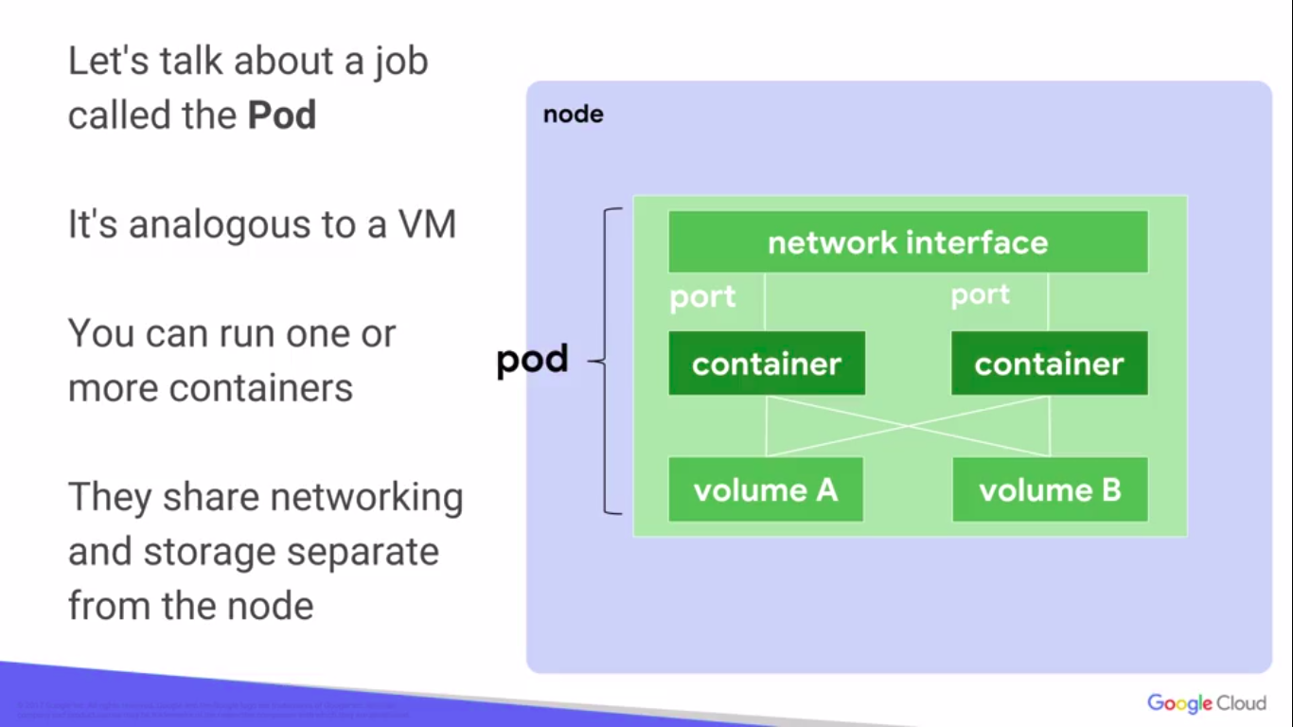
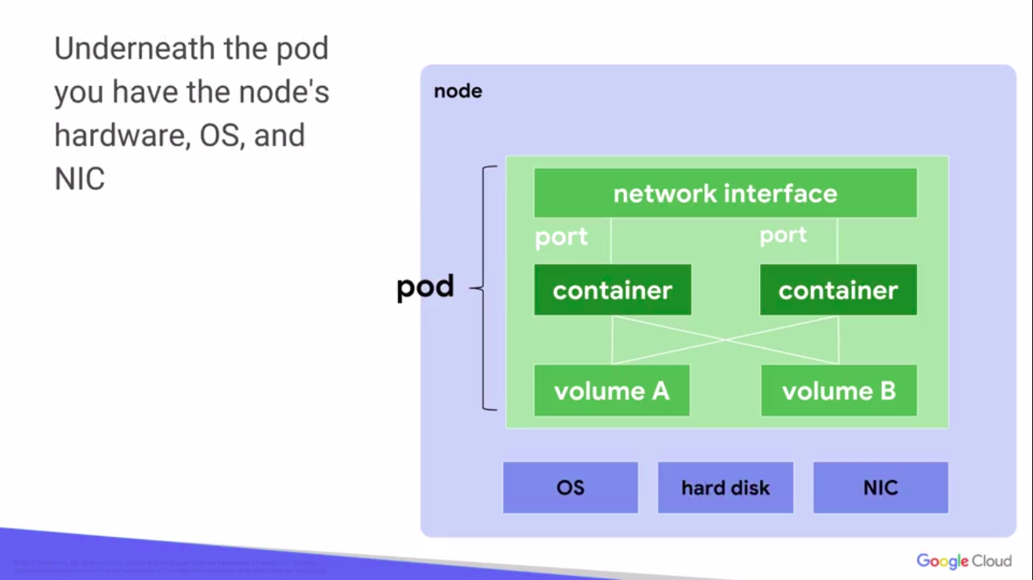
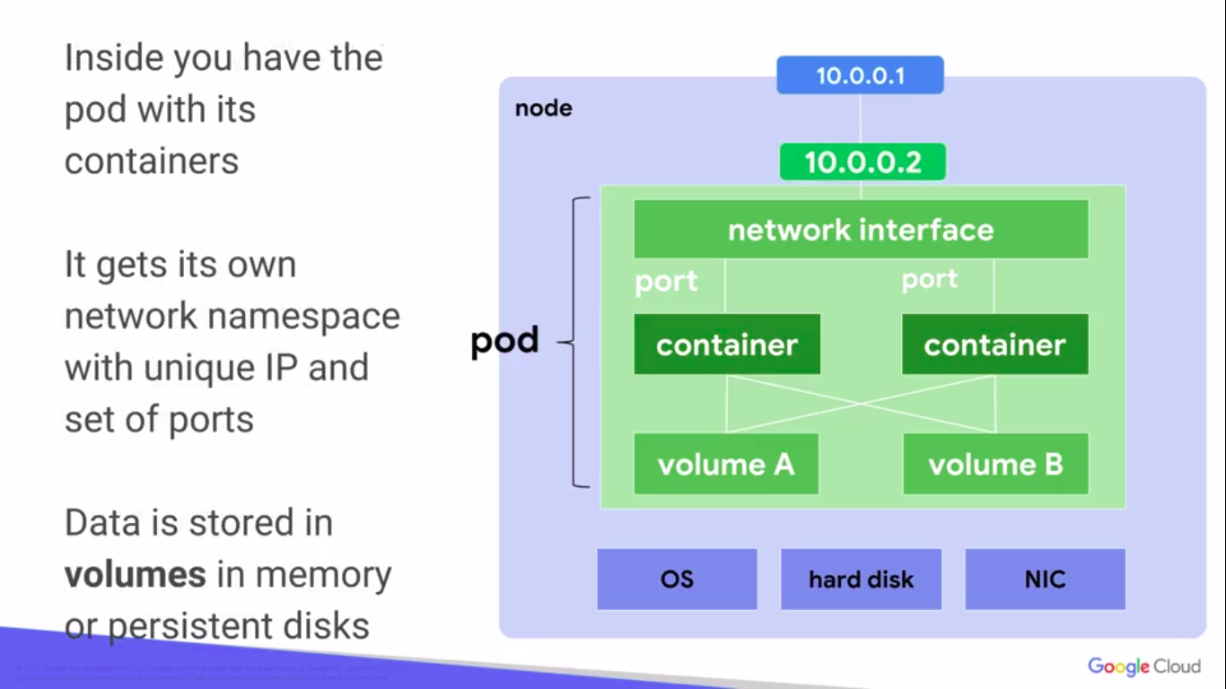
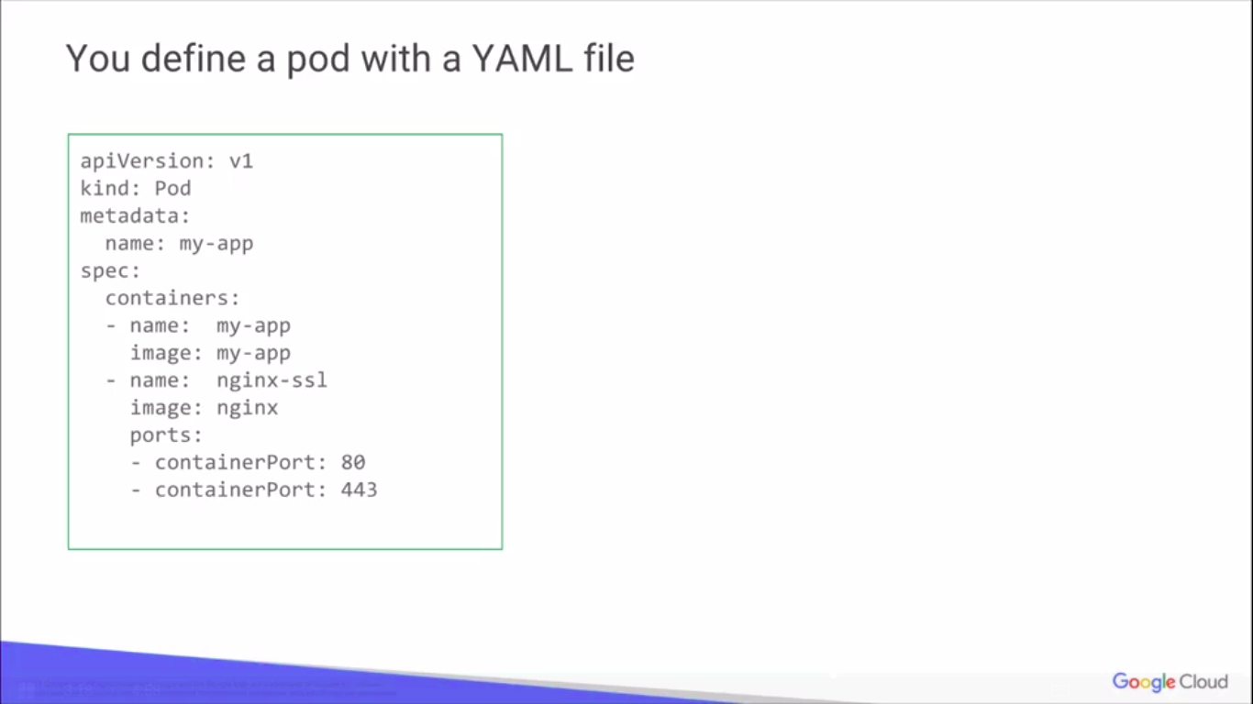
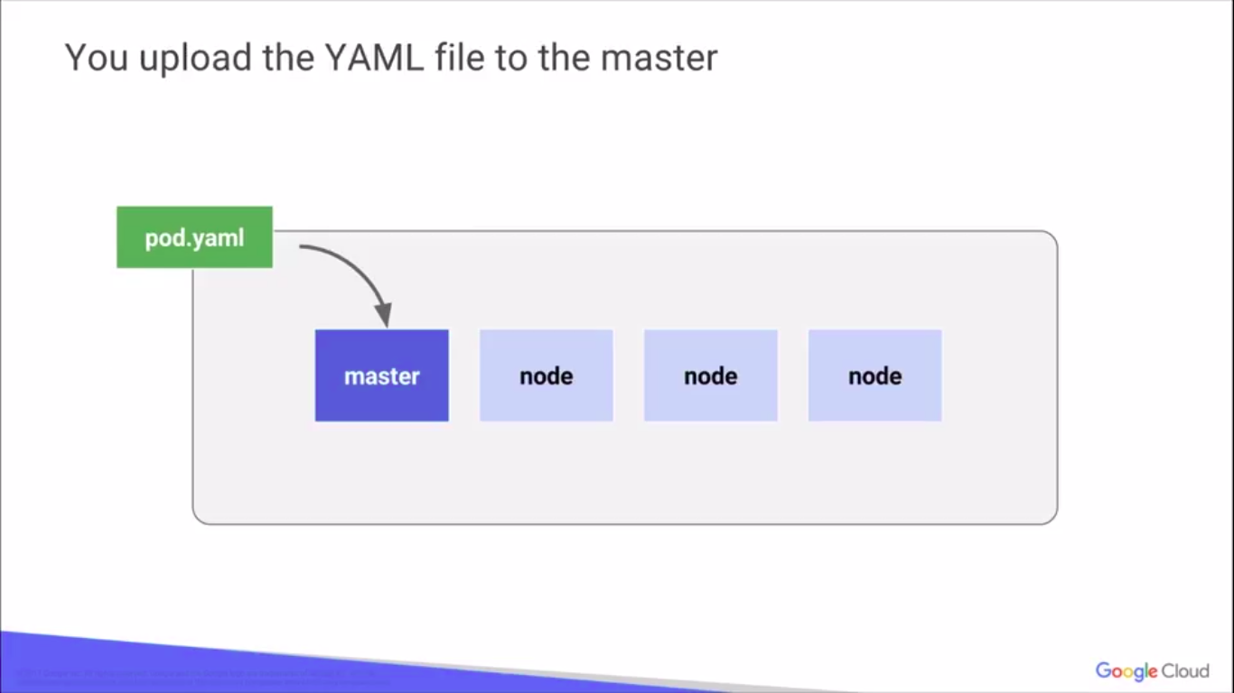
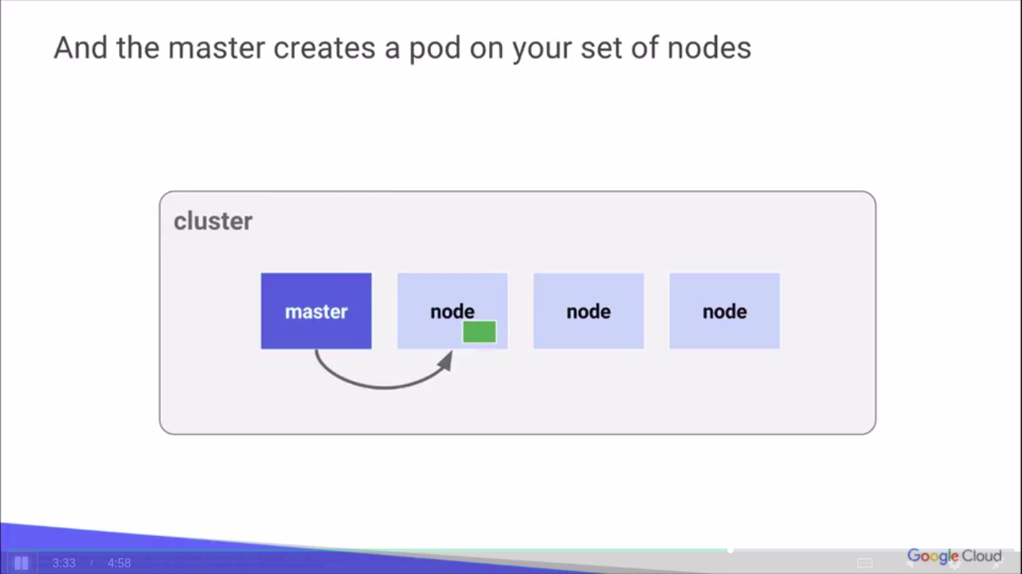
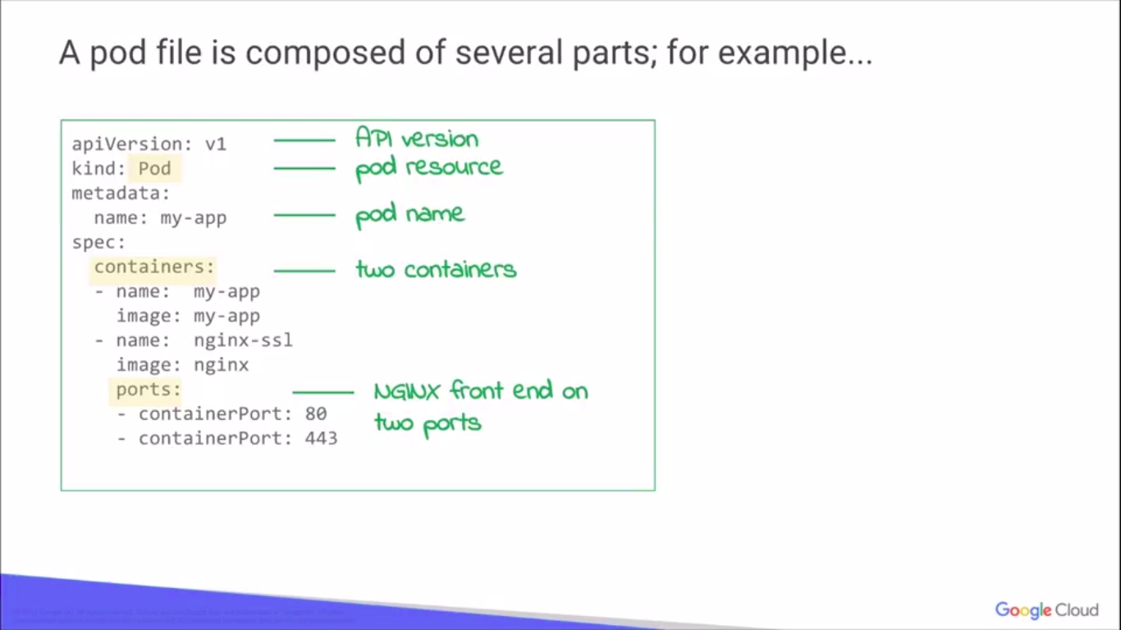
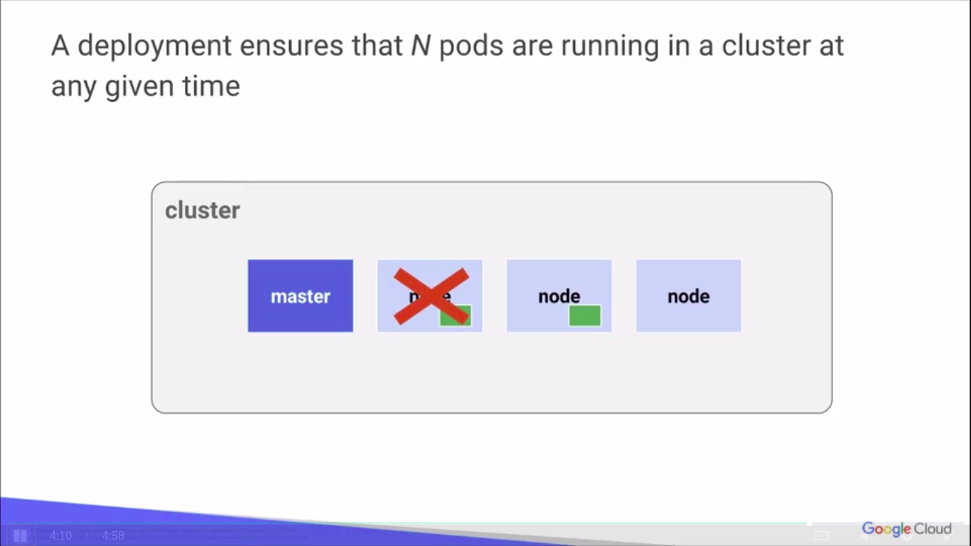

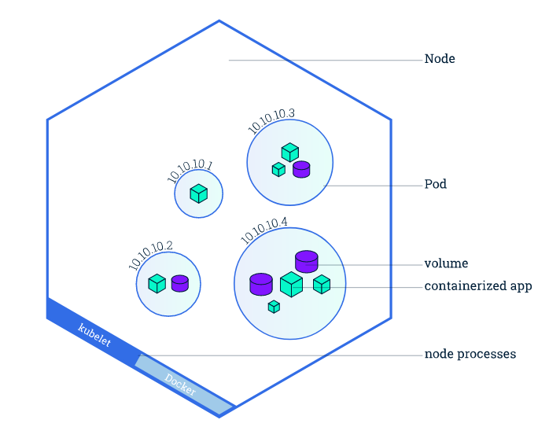

kubectl get - list resources
- kubectl describe - show detailed information about a resource
- kubectl logs - print the logs from a container in a pod
- kubectl exec - execute a command on a container in a pod

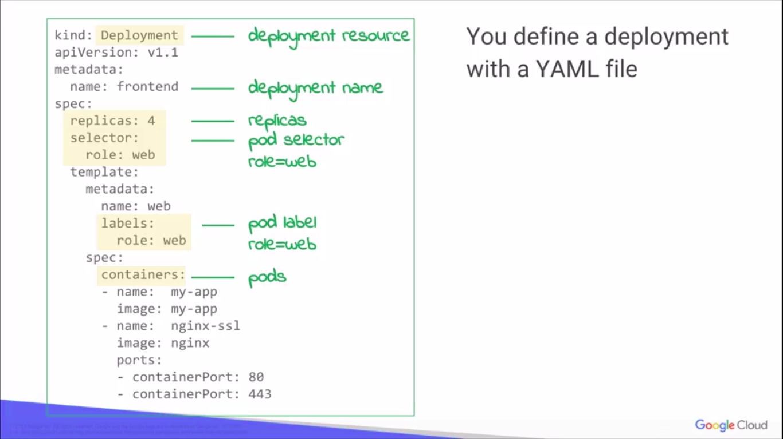

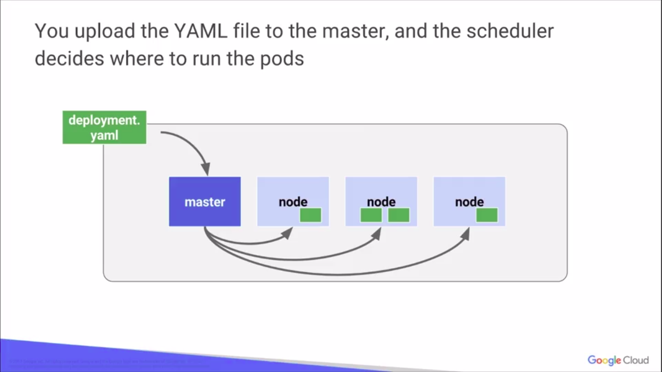

Using a Service to Expose Your App

A Service in Kubernetes is an abstraction which defines a logical set of Pods and a policy by which to access them. Services enable a loose coupling between dependent Pods. A Service is defined using YAML (preferred) or JSON, like all Kubernetes objects.


