Multi-element dataset of soil profiles across climatic zones in China’s mountains
Yuying Wu ^{a, b}, Haijian Bing ª, Yuhan Wang ^{a, c}, Wenzheng Yang ª, Jie Zhang ª, Yanhong Wu ª, Jun Li ^{d}, Gan Zhang ^{d}
ª Institute of Mountain Hazards and Environment, Chinese Academy of Sciences, Chengdu 610213, China
^{b} University of Chinese Academy of b`1qSciences, Beijing 10049, China
^{c} Key Laboratory of Green Utilization of Critical Non-metallic Mineral Resources, Ministry of Education, Wuhan University of Technology, Wuhan 430070, China
^{d} State Key Laboratory of Organic Geochemistry, Guangzhou Institute of Geochemistry, Chinese Academy of Sciences, Guangzhou 510640, China

* Corresponding author:
Haijian Bing (PhD), E-mail: hjbing@imde.ac.cn

1 Description
Mountain ecosystems, as global biodiversity hotspots and critical regulators of biogeochemical cycles, are increasingly vulnerable to accelerating global changes. Despite their ecological significance, the lack of large-scale, comprehensive datasets on soil element distributions has hindered our understanding of how multiple soil elements interact and regulate ecosystem functions under rapid environmental shifts. To address this critical knowledge gap, we present a continental-scale dataset of soil element concentrations from 30 mountain ecosystems across China, spanning five major climatic zones (tropical, subtropical, warm temperate, temperate, and cold temperate regions) and three pedogenetically distinct soil horizons (organic (O), surface mineral (A), and parent material (C) horizons). This dataset encompasses quantitative measurements of 24 elements, including major nutrients (e.g., phosphorus, potassium, calcium, magnesium), trace metals (e.g., iron, molybdenum, copper, zinc), and toxic elements (e.g., cadmium, chromium, lead, antimony). To support integrated Earth system analyses, the dataset is accompanied by key site-specific environmental variables, including climate parameters (temperature, precipitation, aridity index), normalized difference vegetation index, soil physicochemical properties (pH, moisture, bulk density), soil type, parent rock type, atmospheric nitrogen deposition, and chemical weathering index. The dataset reveals significant vertical stratification in element distributions, with organic horizon enriched in biogenic elements, and deeper horizons dominated by lithogenic components. Spatial patterns along latitudinal, longitudinal, and altitudinal gradients underscore the influence of climate and geology on soil chemistry. This dataset offers a unique, continental-scale characterization of soil elemental distribution with integrated spatial and vertical dimensions, providing a holistic view of soil biogeochemistry in mountain environments. It serves as an invaluable resource for disentangling the complex interplay of climatic, edaphic, and biological factors regulating soil element cycling. Researchers can utilize this dataset to: improve biogeochemical models, assess soil quality and ecosystem health under rapid environmental change, investigate elemental stoichiometry across environmental gradients, and identify the sources and fates of nutrients and pollutants in vulnerable mountain systems. By enabling cross-disciplinary investigations at an unparalleled scale, this dataset advances our fundamental understanding of mountain ecosystem resilience and provides a robust baseline for future environmental monitoring.

2 Study area
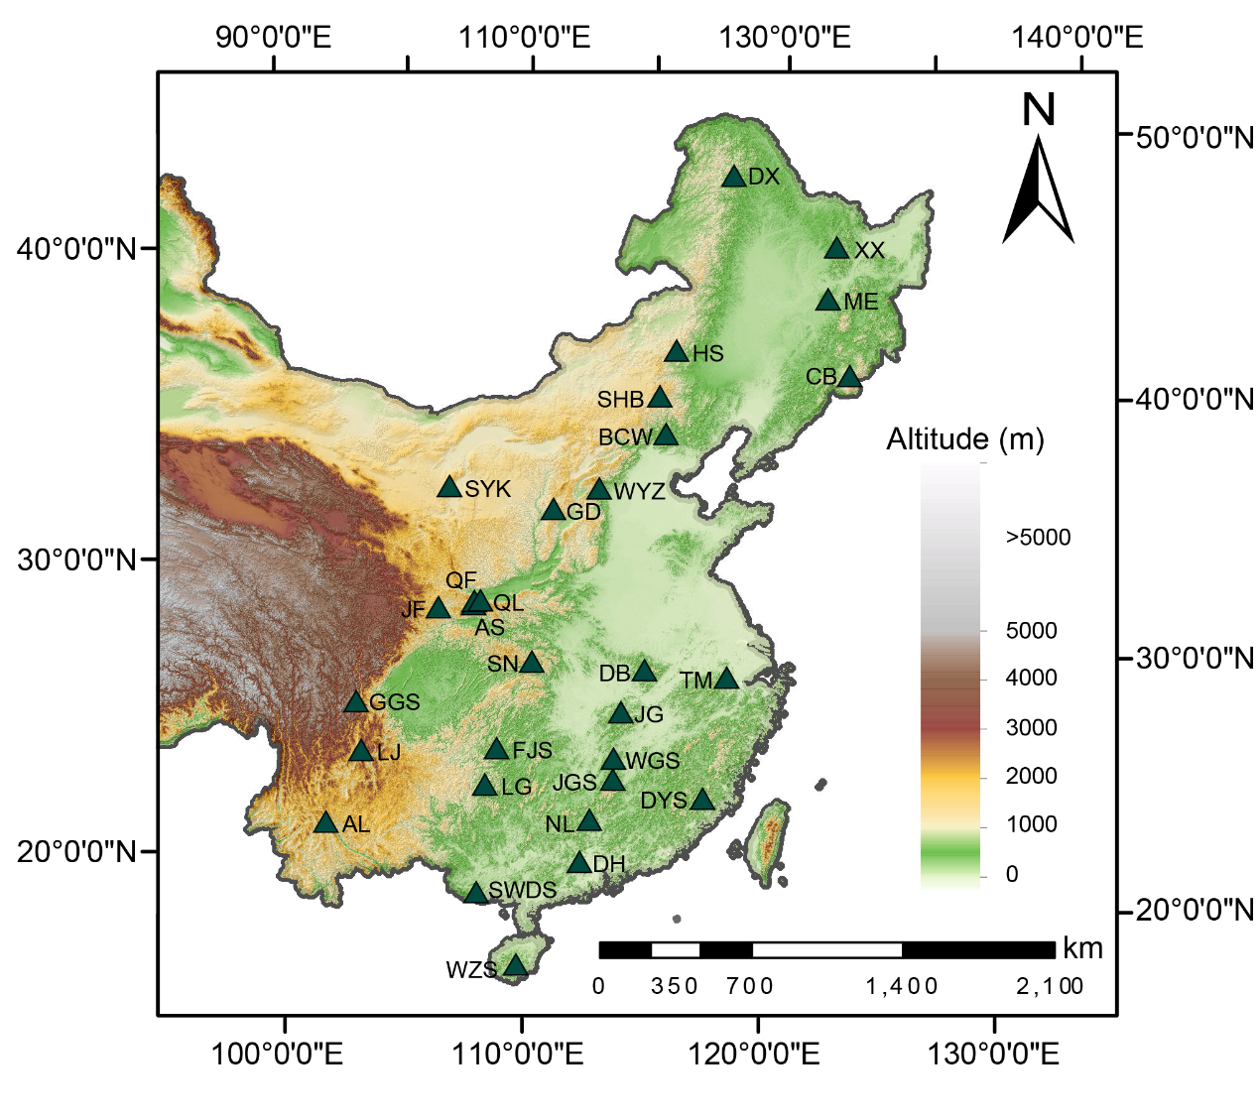
Fig. 1 Geographic distribution of the 30 China’s mountains. AL, Mt. Ailao; AS, Mt. Ao; BCW, Mt. Baicaowa; CB, Mt. Changbai; DB, Mt. Dabie; DH, Mt. Dinghu; DX, Mt. Daxinganling; DYS, Mt. Daiyun; FJS, Mt. Fanjing; GD, Mt. Guandi; GGS, Mt. Gongga; HS, Mt. Han; JF, Mt. Jifeng; JG, Mt. Jiugong; JGS, Mt. Jinggang; LJ, Mt. Luoji; LG, Mt. Leigong; LJ, Mt. Luoji; ME, Mt. Maoer; NL, Mt. Nanling; QF, Mt. Qingfengxia; QL, Mt. Qinling; SHB, Mt. Saihanba; SN, Mt. Shennongjia; SWDS, Mt. Shiwandashan; SYK, Mt. Suyukou; TM, Mt. Tianmu; WGS, Mt. Wugong; WYZ, Mt. Wuyuezhai; WZS, Mt. Wuzhi; XX, Mt. Xiaoxinganling.

3 Abbreviations
Abbreviations | Full name | Unit
O | Organic horizon | -
A | Surface mineral horizon | -
C | Parent material horizon | -
BF | Broadleaf forest | -
CBF | Coniferous-broadleaf mixed forest | -
CF | Coniferous forest | -
MAP | Mean annual precipitation | mm
MAT | Mean annual temperature | °C
AI | Aridity index | -
Thickness | Soil thickness | cm
N deposition | Atmospheric nitrogen deposition | kg N ha⁻¹ yr⁻¹
NDVI | Normalized difference vegetation index | -
Thickness | Thickness of soil | cm
BD | Soil bulk density | g cm⁻³
CIA | Chemical alteration index | -
SOC | Soil organic carbon | mg kg⁻¹
Al | Aluminum | mg kg⁻¹
Ba | Barium | mg kg⁻¹
Be | Beryllium | mg kg⁻¹
Ca | Calcium | mg kg⁻¹
Fe | Iron | mg kg⁻¹
K | Potassium | mg kg⁻¹
Mg | Magnesium | mg kg⁻¹
Mn | Manganese | mg kg⁻¹
Na | Sodium | mg kg⁻¹
Sr | Strontium | mg kg⁻¹
Ti | Titanium | mg kg⁻¹
V | Vanadium | mg kg⁻¹
Zn | Zinc | mg kg⁻¹
P | Phosphorus | mg kg⁻¹
Cr | Chromium | mg kg⁻¹
Co | Cobalt | mg kg⁻¹
Ni | Nickel | mg kg⁻¹
Cu | Copper | mg kg⁻¹
Mo | Molybdenum | mg kg⁻¹
Cd | Cadmium | mg kg⁻¹
Sb | Antimony | mg kg⁻¹
Tl | Thallium | mg kg⁻¹
Pb | Lead | mg kg⁻¹

