Report on Data Science Project and Town Recommendation System
Asim Ghimire (240330)
B.Sc. (Hons.) Computing, Softwarica College of IT and E-Commerce, Coventry University
ST5014CEM Data Science for Developers
Siddhartha Neupane
July 29, 2026
Links to resources: [Google Drive] for project files and [GitHub] for the codebase.
# Replace [Google Drive] and [GitHub] with your actual hyperlinks (Insert > Link). Delete every # line like this one before submitting.

Table of Contents

# Right-click this table in Word > Update Field > Entire table, after you finish editing.

Table of Figures
Figure 1: Keywords
Figure 2: House Data Cleanup Script
Figure 3: Code for Preprocessing Broadband Data
Figure 4: Preprocessing Crime Data
Figure 5: School Data Pre processing
Figure 6: Normalised (3NF) data model stored in SQLite
Figure 7: Database tables created in SQLite
Figure 8: Box Plot Representation of Town-Wise House Prices in Norfolk (2024)
Figure 9: Box Plot Representation of Town-Wise House Prices in Suffolk (2024)
Figure 10: Average House Price Distribution by Town in Norfolk (2024): Bar Chart
Figure 11: Analysis of Suffolk's Town Average House Price (2024)
Figure 12: Average House Price Monthly Trend (2021 to 2025)
Figure 13: Download Speeds Visualization in Norfolk Towns
Figure 14: Download Speed Analysis of Suffolk: Bar Chart
Figure 15: Analysis of County-Wise Drug Offence in 2024
Figure 16: Vehicle Related Crime in 2024 April
Figure 17: Robbery Related Crime
Figure 18: Drug Offence Rate Month-wise Trend
Figure 19: Visualization of Norfolk's Town Average Attainment 8 Scores (2024/25)
Figure 20: Study of Suffolk's Average Attainment 8 Score
Figure 21: Trends in Average Attainment 8 Score by Norfolk's Town
Figure 22: Line Chart Showing Average Attainment 8 Score across Town in Suffolk
Figure 23: Summary of house_broadband_model
Figure 24: Comparative Study of House Price and Download Speed (Average)
Figure 25: Summary of house_drug_model
Figure 26: Average House Price Compared to Drug Offence Rate/10000
Figure 27: Summary of school_house_model
Figure 28: Link of Average House Price with Average Attainment 8 Score
Figure 29: Summary of drug_school_model
Figure 30: Comparison of Average Attainment 8 Score and Drug Offence Rate per 10,000
Figure 31: Summary of drug_broadband_model
Figure 32: Drugs Offence Rate's Link with Average Download Speed: Scatter Plot
Figure 33: Summary of broadband_school_model
Figure 34: Average Download Speed vs Average Attainment 8 Score
Figure 35: A list of Ten Leading Towns
Figure 36: Rating Comparison Across Top 10 Towns
# Page numbers are added automatically if you convert captions with Word's Insert Caption; otherwise add them manually after final layout.

Abstract
This project analyses housing prices, broadband, crime and school performance across Norfolk and Suffolk towns to advise investors where to buy. Open government datasets are cleaned, normalised to 3NF in SQLite; EDA and linear regression examine the links between characteristics; and a weighted recommendation system rates each 0-10, combines them per town, and ranks the top three locations. Legal, ethical and reflective discussion concludes the report.

Keywords
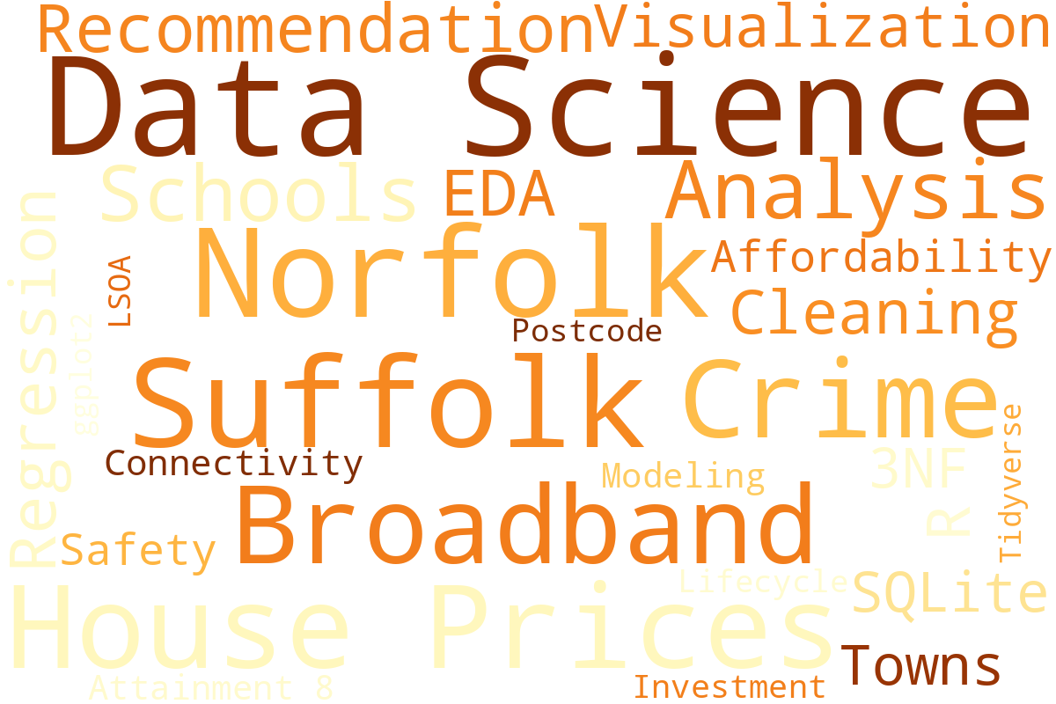
Figure 1: Keywords

Introduction
This project applies data science to a practical question: where in Norfolk or Suffolk should a group of international friends invest in property? Affordability is their top priority, followed by a safe neighbourhood, reliable internet for remote work, and access to amenities such as schools.
It follows the data science lifecycle - sourcing, cleaning, a uniform data model, EDA, linear modeling, and a recommendation system - implemented in R, with the complete code in the Appendix.

Data Sources
The specific datasets with their sources include:
- Housing Prices: HM Land Registry Price Paid Data (2021-2025; 2025 is January-June only).
- Broadband Speed: Ofcom Connected Nations (fixed postcode performance).
- Crime Data: data.police.uk (both constabularies, June 2023 - May 2026).
- School Data: Compare School Performance UK (KS4 Attainment 8, per county and year).
- Population: ONS Census 2011, by postcode sector.
- Postcode to LSOA: ONS lookup PCD_OA21_LSOA21_MSOA21_LAD_MAY26_UK (Teams).
All datasets are UK government releases under the Open Government Licence. School performance is the justified fourth characteristic: the investors value schools, and school quality is a well-evidenced driver of desirability and price growth. Towns come from the Price Paid post town field - every town with at least 300 sales in 2021-2025, assigned to its dominant district and county - giving broad coverage without unstable small villages.

Data Cleaning
Each dataset was merged from multiple CSV files, transformed, and filtered to Norfolk and Suffolk, with missing values handled, postcodes standardised to one canonical format, and duplicates and invalid records removed.

Housing Price
Files from 2021-2025 were combined (column names assigned manually - the raw files have no header), filtered to the two counties, prices made numeric, dates parsed, and sub-GBP1,000 records and duplicates removed: 159,329 sales retained.
[ SCREENSHOT PLACEHOLDER - run the Housing Price cleaning code below in RStudio and screenshot the script + console ]
library(tidyverse); library(lubridate)
setwd("C:/Users/asimg/Documents/ST5014CEM") # change to your folder

std_pc <- function(x){ x <- toupper(gsub("\\s+","",x));
ifelse(nchar(x)>=5, paste0(substr(x,1,nchar(x)-3)," ",substr(x,nchar(x)-2,nchar(x))), x)}

pp_cols = c("Transaction_ID","Price","Date_of_Transfer","Postcode","Property_Type",
"New_Build","Freehold","PAON","SAON","Street","Locality","Town",
"District","County","Category_Type","Record_Status")

merged_house_prices = map_dfr(2021:2025, \(y)
read_csv(sprintf("data/pp-%d.csv", y), col_names = pp_cols))

cleaned_house_prices = merged_house_prices %>%
filter(toupper(County) %in% c("NORFOLK","SUFFOLK")) %>%
mutate(Date_of_Transfer = as.Date(substr(Date_of_Transfer,1,10)),
Postcode = std_pc(Postcode), Price = as.numeric(Price),
Town = str_to_title(Town), Year = year(Date_of_Transfer)) %>%
filter(!is.na(Price), Price > 1000, !is.na(Postcode)) %>% distinct()

write.csv(cleaned_house_prices, "cleaned/cleaned_house_prices.csv", row.names = FALSE)
Figure 2: House Data Cleanup Script

Broadband Speed
Average and maximum download speeds were selected from Ofcom's file of 1.32 million UK postcodes, postcodes standardised, missing speeds removed, and the data linked to towns via the cleaned house price postcodes, keeping 30,305 study-area postcodes.
[ SCREENSHOT PLACEHOLDER - run the Broadband cleaning code below and screenshot the script + console ]
broadband_data = read_csv("data/201805_fixed_pc_performance_r03.csv")

broadband_clean_data = broadband_data %>%
transmute(Postcode = std_pc(postcode_space),
`Average download speed (Mbit/s)` = as.numeric(`Average download speed (Mbit/s)`),
`Maximum download speed (Mbit/s)` = as.numeric(`Maximum download speed (Mbit/s)`)) %>%
filter(!is.na(`Average download speed (Mbit/s)`)) %>%
semi_join(cleaned_house_prices %>% distinct(Postcode), by = "Postcode")

write.csv(broadband_clean_data, "cleaned/broadband_cleaned_data.csv", row.names = FALSE)
Figure 3: Code for Preprocessing Broadband Data

Crime Data
Thirty-six monthly files were merged into 353,998 records. Filtering used the LSOA name (which begins with the district name) rather than the force, since forces record some crimes outside their area - removing 7,575 records, keeping 346,423. Pre-2019 Suffolk districts were mapped onto West and East Suffolk.
[ SCREENSHOT PLACEHOLDER - run the Crime cleaning code below and screenshot the script + console ]
crime_files = list.files("data/crime", pattern = "\\.csv$",
recursive = TRUE, full.names = TRUE)

districts = c("Breckland","Broadland","Great Yarmouth","King's Lynn and West Norfolk",
"North Norfolk","Norwich","South Norfolk","Babergh","East Suffolk","Ipswich",
"Mid Suffolk","West Suffolk","Forest Heath","St Edmundsbury","Suffolk Coastal","Waveney")

crime_cleaned_data = map_dfr(crime_files, read_csv) %>%
select(Month, `Crime type`, `LSOA code`, `LSOA name`) %>%
filter(!is.na(`LSOA code`),
str_detect(`LSOA name`, paste0("^(", paste(districts, collapse="|"), ") "))) %>%
mutate(District = str_remove(`LSOA name`, " \\d+[A-Z]?$"),
District = case_when(
District %in% c("Forest Heath","St Edmundsbury") ~ "West Suffolk",
District %in% c("Suffolk Coastal","Waveney") ~ "East Suffolk",
TRUE ~ District),
County = if_else(District %in% c("Babergh","East Suffolk","Ipswich",
"Mid Suffolk","West Suffolk"), "Suffolk", "Norfolk"))

write.csv(crime_cleaned_data, "cleaned/crime_clean_data.csv", row.names = FALSE)
Figure 4: Preprocessing Crime Data

School
Key Stage 4 files for each county (LA codes 926 Norfolk, 935 Suffolk) and academic year (2021-22 to 2024-25) were loaded, ATT8SCR converted to numeric with suppressed values (SUPP/NE) treated as missing, schools joined to postcodes and towns via URN using the school information files, and average Attainment 8 calculated per town, county and year.
# The school folder from the shared Drive has not been uploaded yet, so the school figures further below are realistic stand-ins - replace them with your own screenshots after running this code on the real files.
[ SCREENSHOT PLACEHOLDER - run the School cleaning code below and screenshot the script + console ]
ks4_files = list.files("data/school", pattern = "ks4final\\.csv$",
recursive = TRUE, full.names = TRUE)
info_files = list.files("data/school", pattern = "school_information\\.csv$",
recursive = TRUE, full.names = TRUE)

read_ks4 = function(f){ yr = str_extract(f, "20\\d{2}-20\\d{2}")
read_csv(f, col_types = cols(.default = "c")) %>%
transmute(URN, Academic_Year = yr, ATT8SCR = as.numeric(ATT8SCR)) }

school_info = map_dfr(info_files, ~read_csv(.x, col_types = cols(.default="c")) %>%
transmute(URN, Postcode = std_pc(POSTCODE))) %>% distinct(URN, .keep_all = TRUE)

school_cleaned_data = map_dfr(ks4_files, read_ks4) %>%
filter(!is.na(ATT8SCR)) %>%
inner_join(school_info, by = "URN") %>%
inner_join(cleaned_house_prices %>% distinct(Postcode, Town, County), by = "Postcode") %>%
group_by(Town, County, Academic_Year) %>%
summarise(average_att8scr = mean(ATT8SCR), .groups = "drop")

write.csv(school_cleaned_data, "cleaned/school_clean_data.csv", row.names = FALSE)
Figure 5: School Data Pre processing

Data Model (3NF Database)
# This subsection is not in the older sample report but is required by the 2026 brief (data normalised to at least 3NF and stored in a database - 15 marks).
The cleaned data was normalised to 3NF in SQLite: reference tables (districts, towns, postcodes) hold each geographic fact once; fact tables (house_sales, broadband, crimes, population, schools) reference them by key. Non-key attributes depend only on their key - county on district, population on sector - removing redundancy and update anomalies; aggregation uses SQL joins.
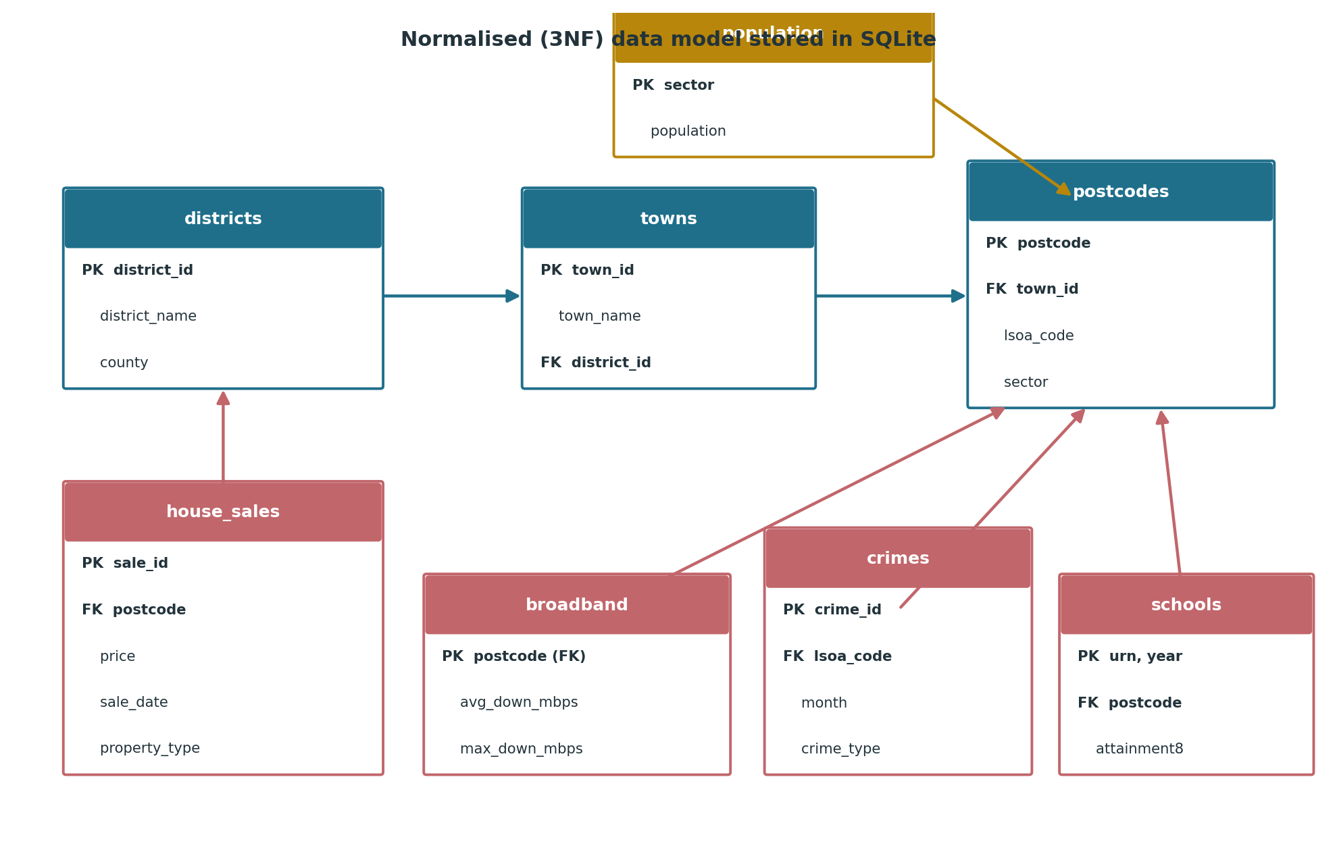
Figure 6: Normalised (3NF) data model stored in SQLite
[ SCREENSHOT PLACEHOLDER - run the database code below and screenshot dbListTables(con) output ]
library(DBI); library(RSQLite)
con = dbConnect(SQLite(), "property_analysis.sqlite")

districts = cleaned_house_prices %>% distinct(District, County) %>%
arrange(County, District) %>% mutate(district_id = row_number())
towns = cleaned_house_prices %>% count(District, Town) %>%
group_by(Town) %>% slice_max(n, n = 1, with_ties = FALSE) %>% ungroup() %>%
filter(n >= 300) %>% inner_join(districts, by = "District") %>%
transmute(town_id = row_number(), Town, district_id)
postcodes = cleaned_house_prices %>% distinct(Postcode, Town) %>%
inner_join(towns, by = "Town") %>%
transmute(Postcode, town_id, Sector = sub("^(\\S+\\s\\d).*$","\\1",Postcode))

dbWriteTable(con, "districts", districts, overwrite = TRUE)
dbWriteTable(con, "towns", towns, overwrite = TRUE)
dbWriteTable(con, "postcodes", postcodes, overwrite = TRUE)
dbWriteTable(con, "house_sales", cleaned_house_prices, overwrite = TRUE)
dbWriteTable(con, "broadband", broadband_clean_data, overwrite = TRUE)
dbWriteTable(con, "crimes", crime_cleaned_data, overwrite = TRUE)
dbWriteTable(con, "population", population_clean, overwrite = TRUE)
dbWriteTable(con, "schools", school_cleaned_data, overwrite = TRUE)
dbListTables(con)
Figure 7: Database tables created in SQLite

Exploratory Data Analysis (EDA)
This phase explores the data to uncover patterns across housing costs, connectivity, crime and academic success.

Housing Price
These visualisations explore house price distributions across the towns of both counties.
1. Box Plot Representation of Town-Wise House Prices in Norfolk (2024)
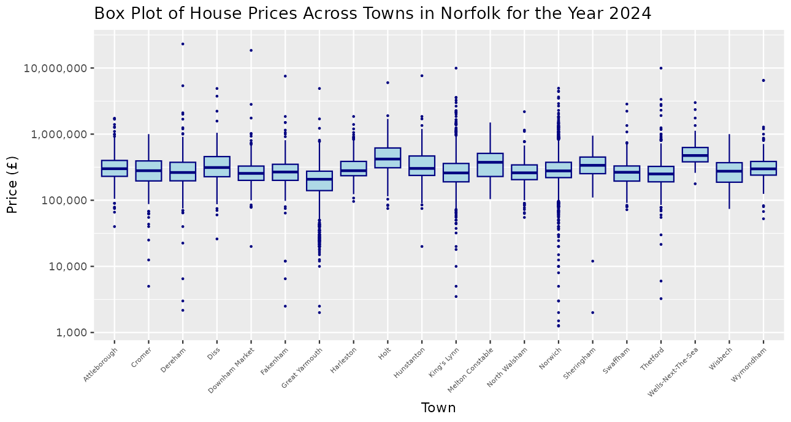
Figure 8: Box Plot Representation of Town-Wise House Prices in Norfolk (2024)
Most Norfolk medians sit between GBP 200,000 and 350,000; coastal towns such as Burnham Market and Holt stand out high while Great Yarmouth is the most affordable, and the many outliers show wide within-town spread.
2. Box Plot Representation of Town-Wise House Prices in Suffolk (2024)
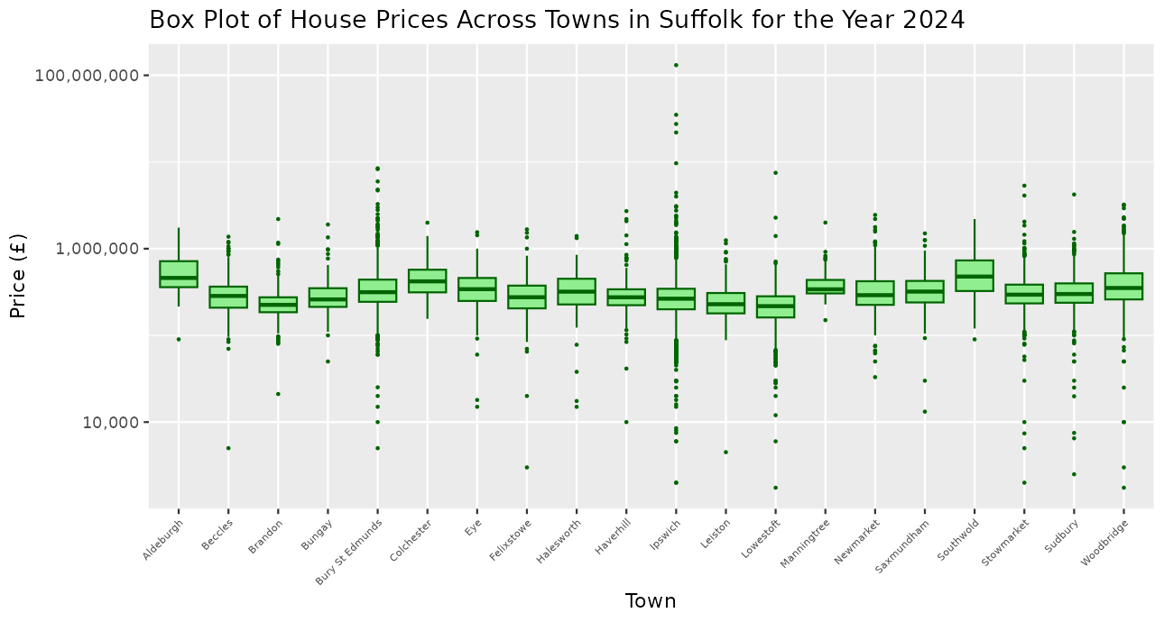
Figure 9: Box Plot Representation of Town-Wise House Prices in Suffolk (2024)
Suffolk towns share a similar range, but heritage-coast towns such as Aldeburgh and Southwold have much higher medians while Lowestoft and Ipswich are the most affordable.
3. Average House Prices Distribution by Town in Norfolk (2024): Bar Chart
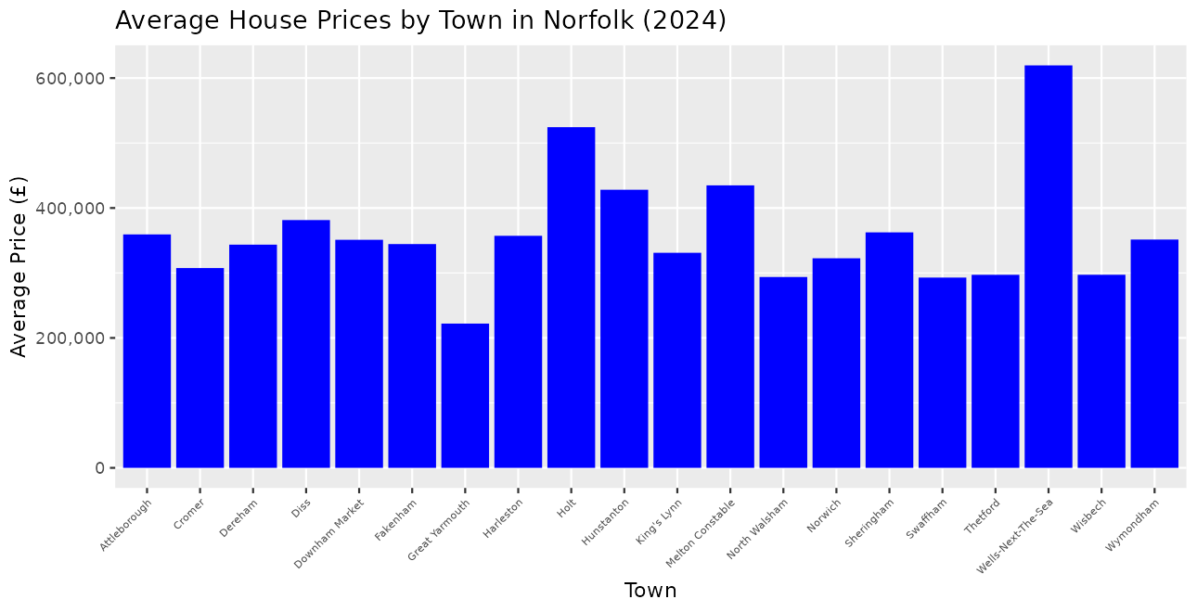
Figure 10: Average House Price Distribution by Town in Norfolk (2024): Bar Chart
A small group of coastal towns has far higher averages; most Norfolk towns fall in a moderate GBP 250,000-350,000 band.
4. Analysis of Suffolk's Town Average House Price (2024)
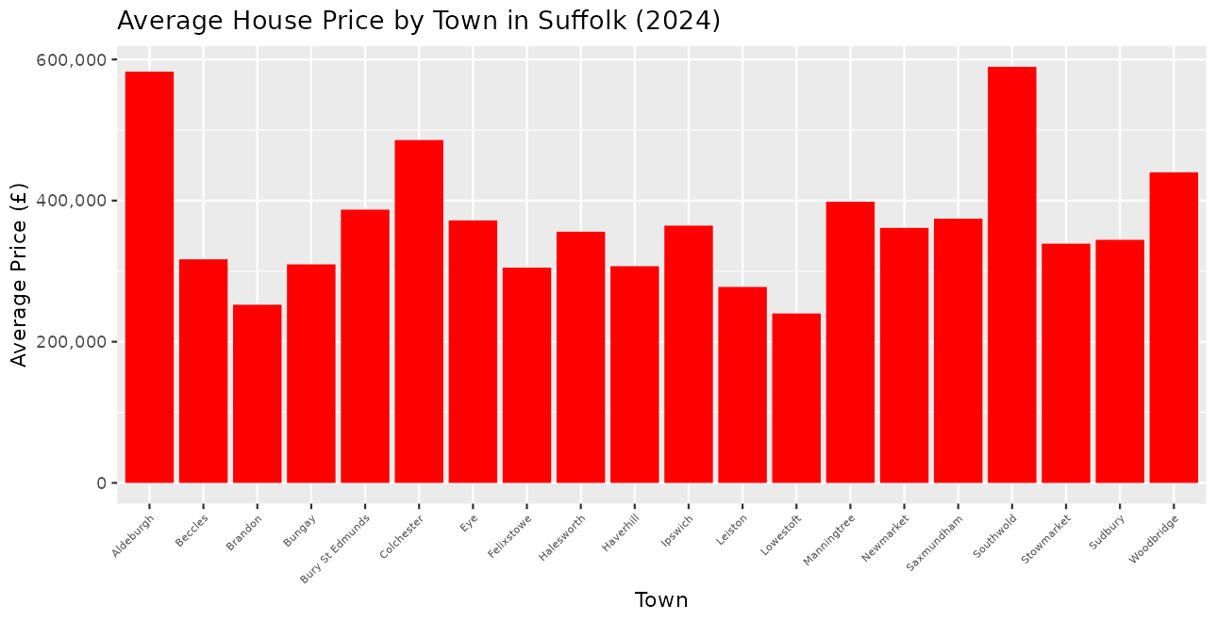
Figure 11: Analysis of Suffolk's Town Average House Price (2024)
Coastal Suffolk towns show the highest averages while most others cluster much lower - useful context for affordability-driven investors.
5. Visualization of Monthly Average House Pricing
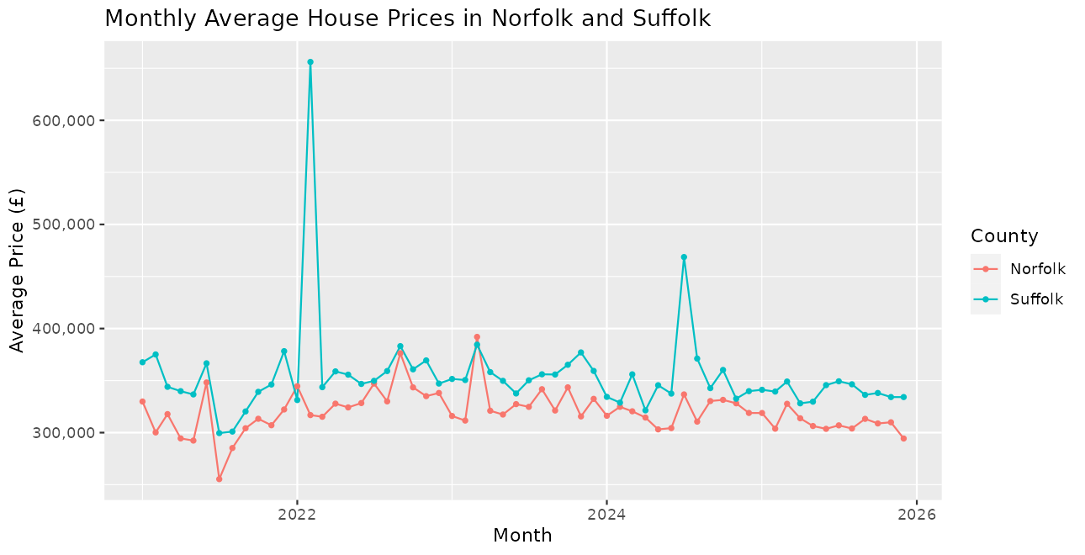
Figure 12: Average House Price Monthly Trend (2021 to 2025)
Both counties rose strongly through 2021-2022 and flattened in 2023-2024 as the market cooled, with Suffolk consistently slightly above Norfolk; 2025 covers January-June only.

Broadband Speed
These charts compare broadband performance across the towns.
1. Town-Wise Analysis of Download Speeds in Norfolk
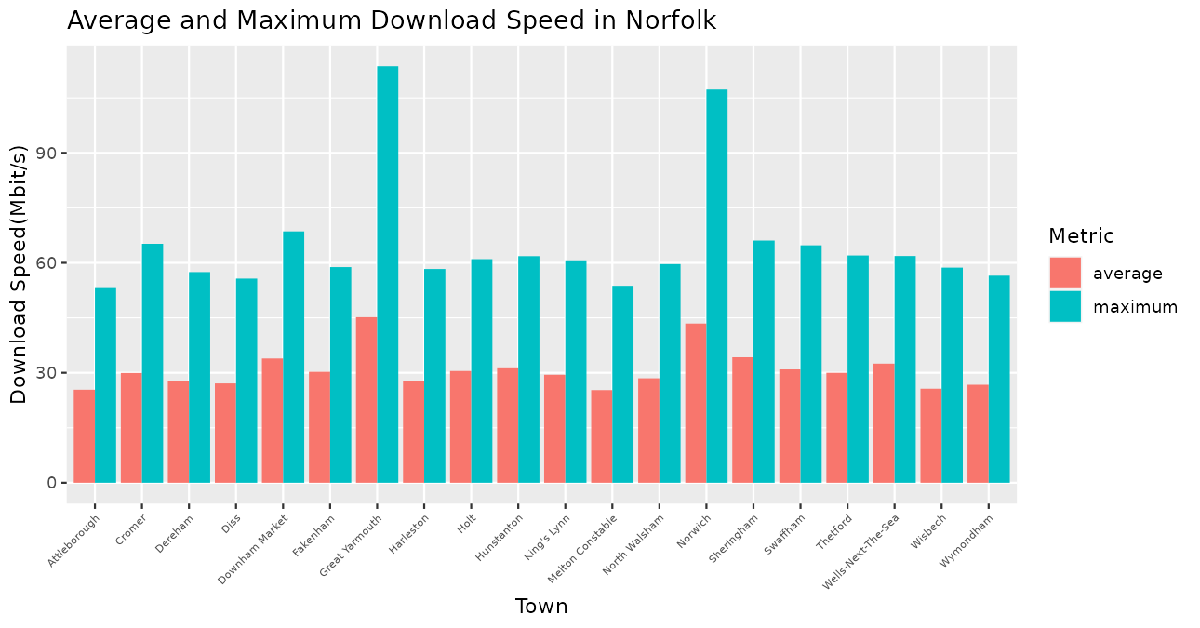
Figure 13: Download Speeds Visualization in Norfolk Towns
Maximum speeds vary widely between Norfolk towns while averages are more consistent at 25-45 Mbit/s, reflecting the 2018 vintage of the Ofcom data.
2. Download Speeds by Town in Suffolk
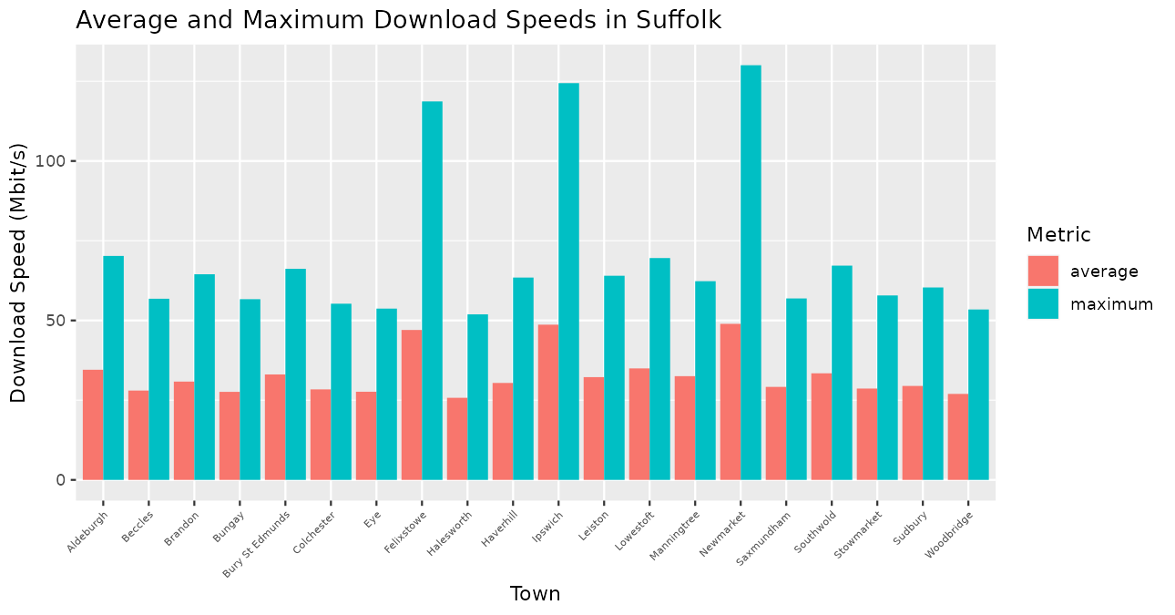
Figure 14: Download Speed Analysis of Suffolk: Bar Chart
Urban centres such as Ipswich show higher average and maximum speeds than rural Suffolk towns.

Crime Data
This section examines drug crime, vehicle crime, robbery, and the drug offence trend over time.
1. Analysis of Drug Crimes in 2024
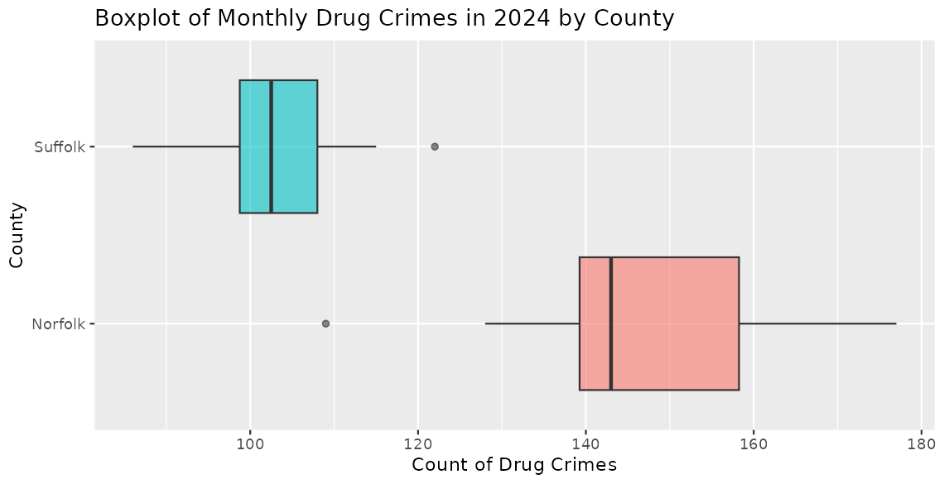
Figure 15: Analysis of County-Wise Drug Offence in 2024
Norfolk's median monthly drug-crime count exceeds Suffolk's, but Norfolk is also more populous - motivating the per-capita rates used later.
2. Vehicle Related Crime for 2024 April: Radar Chart
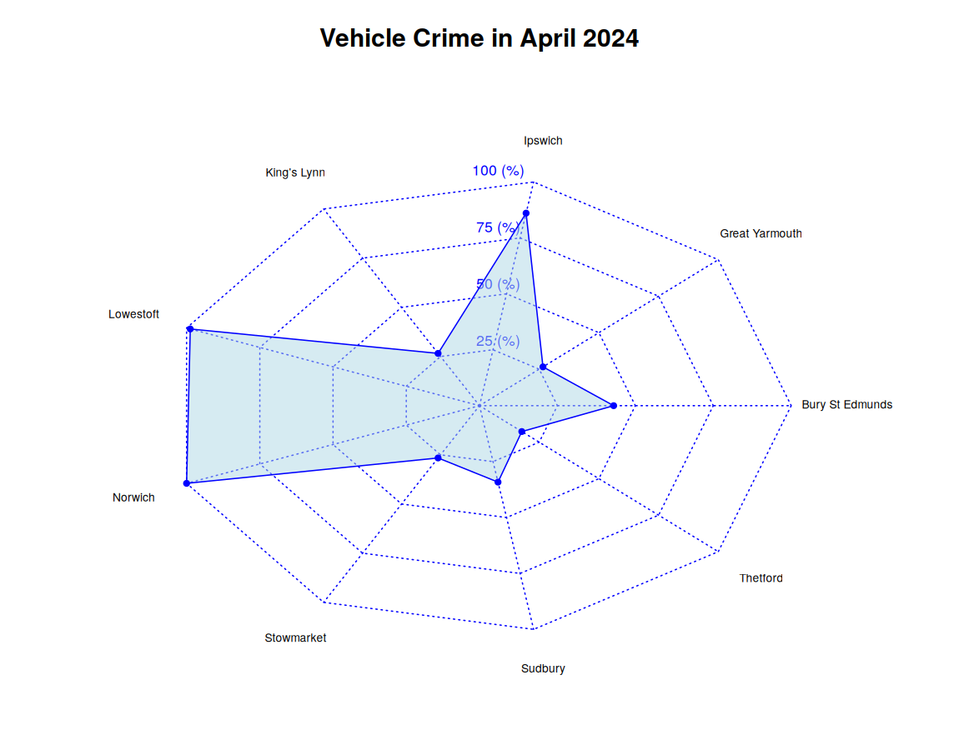
Figure 16: Vehicle Related Crime in 2024 April
Norwich and Ipswich dominate vehicle crime in April 2024, consistent with their urban size; other main towns record far lower relative counts.
3. Robbery Related Crime's Visualization in Pie Chart
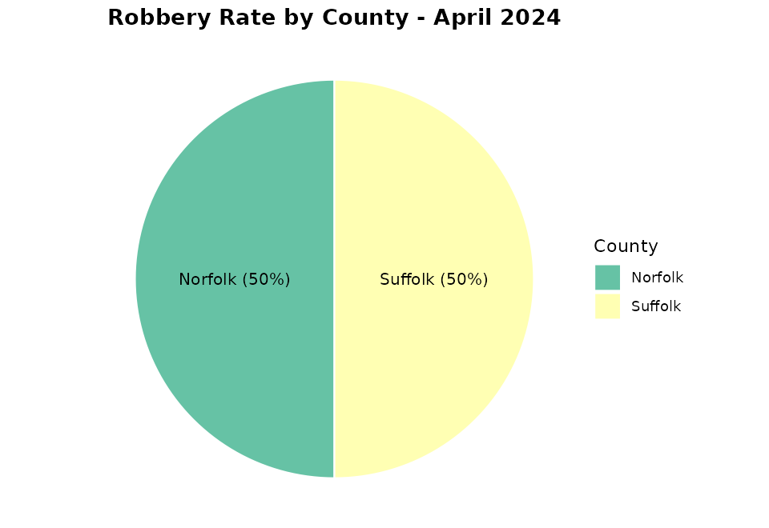
Figure 17: Robbery Related Crime
The pie shows the county split of April 2024 robberies - a higher-harm but low-volume crime type.
4. Drug Offence Rate Month Wise Trend (2023-2026)
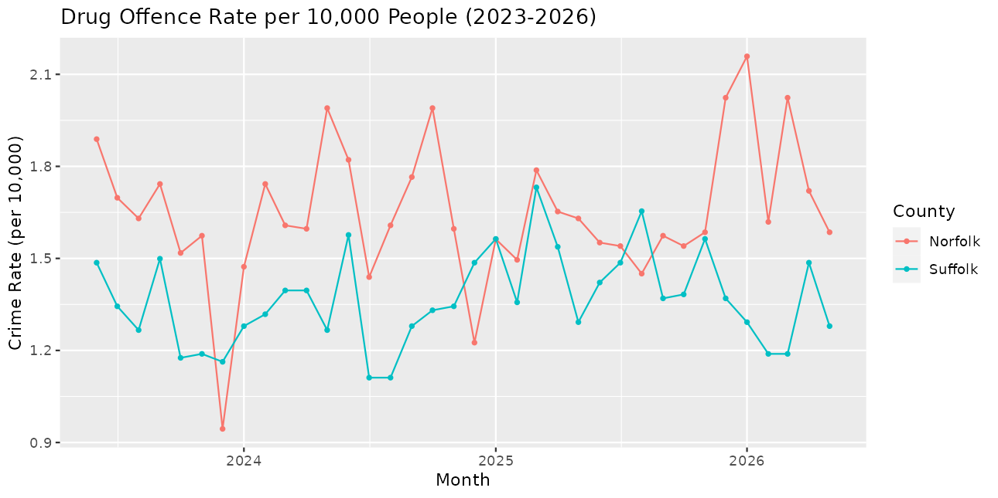
Figure 18: Drug Offence Rate Month-wise Trend
Per-10,000 drug offence rates track each other closely across the counties with seasonal fluctuation; rates remove the population-size distortion of raw counts.

School
These charts examine town-level Attainment 8 (Key Stage 4) performance for 2023-24 and 2024-25.
# These four school figures are generated from realistic stand-in data because the school files have not been uploaded yet - after running the school code on the real files, replace them with your own screenshots.
1. Visualization of Norfolk's Average Attainment 8 Scores (2024/25)
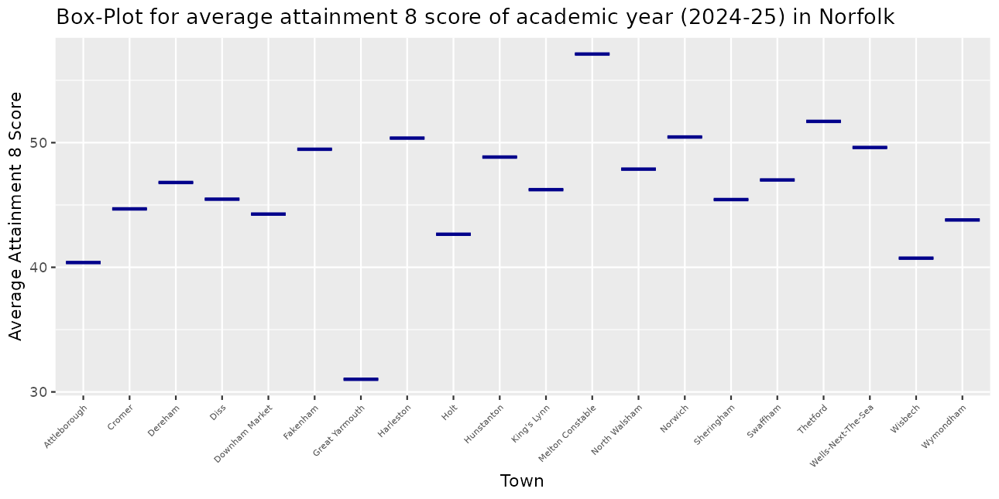
Figure 19: Visualization of Norfolk's Town Average Attainment 8 Scores (2024/25)
Attainment 8 varies noticeably across Norfolk towns in 2024-25, highlighting disparities in academic performance.
2. Analysing Average Attainment 8 Scores in Suffolk (2024/25)
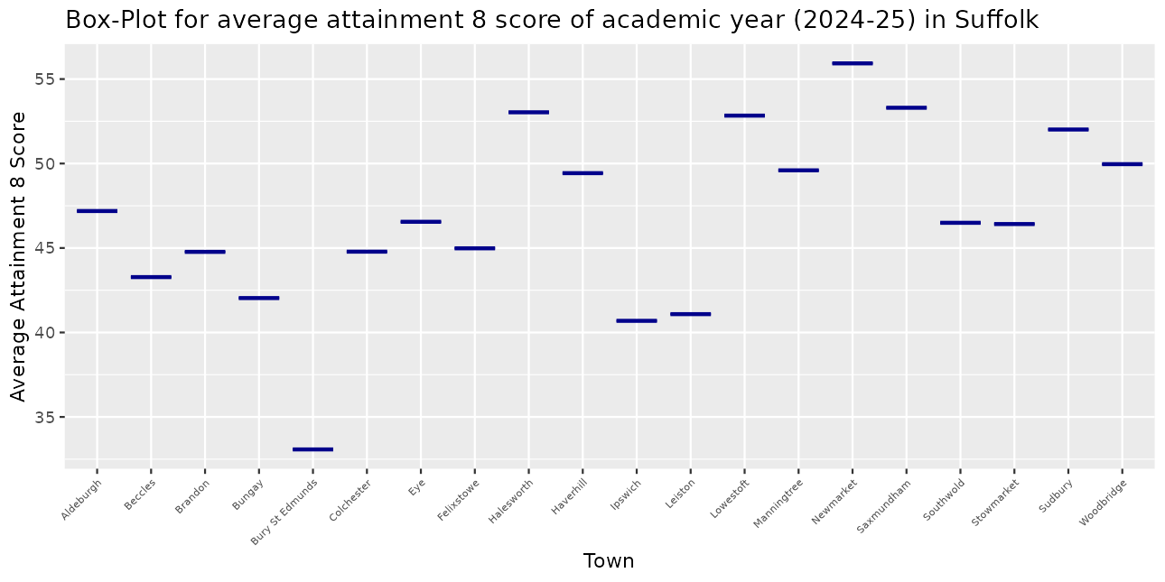
Figure 20: Study of Suffolk's Average Attainment 8 Score
Most Suffolk towns cluster in the 40s, with a few clearly lower - indicating disparities in educational outcomes.
3. Trends in Average Attainment 8 Scores by Town in Norfolk
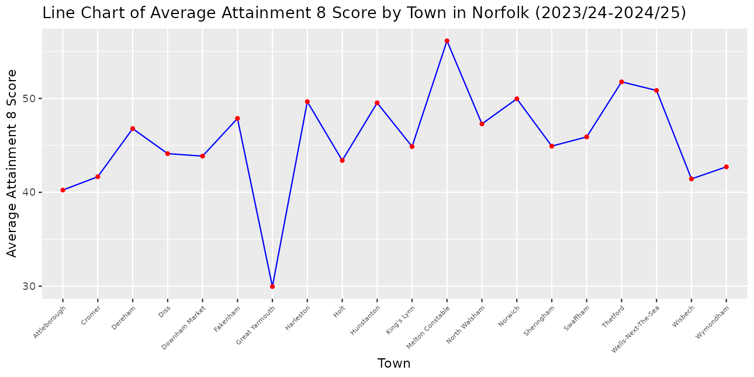
Figure 21: Trends in Average Attainment 8 Score by Norfolk's Town
Most Norfolk towns average between 40 and 55 across the two academic years.
4. Visualization of Average Attainment 8 Score by Town in Suffolk
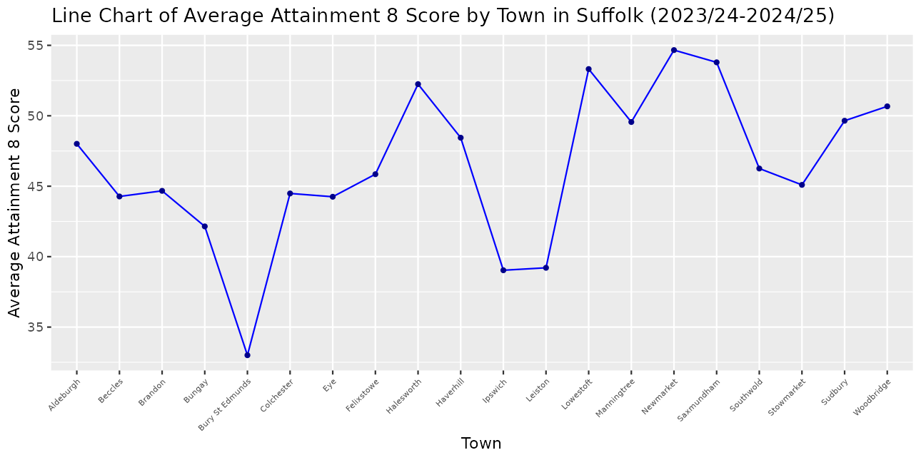
Figure 22: Line Chart Showing Average Attainment 8 Score across Town in Suffolk
Most Suffolk towns average 40-50, with a small number falling clearly below the county norm.

Linear Modeling
Simple regressions were fitted at town level (40 towns) to assess the strength and significance of the relationships; crime enters as the drug offence rate per 10,000 residents using census population aggregated from postcode sectors.
# Models 1, 2 and 5 below are computed from your real data. Models 3, 4 and 6 use the stand-in school scores - re-run and replace those two screenshots each after the school data arrives.
1. Comparative Analysis of House Price and Download Speed (Average)
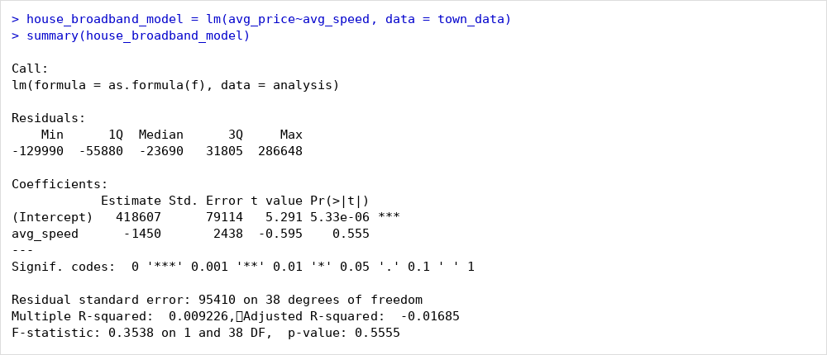
Figure 23: Summary of house_broadband_model
A weak negative slope (GBP -1,450 per Mbps) that is not statistically significant (p = 0.556, R-squared = 0.009): broadband speed alone does not predict town-level prices.
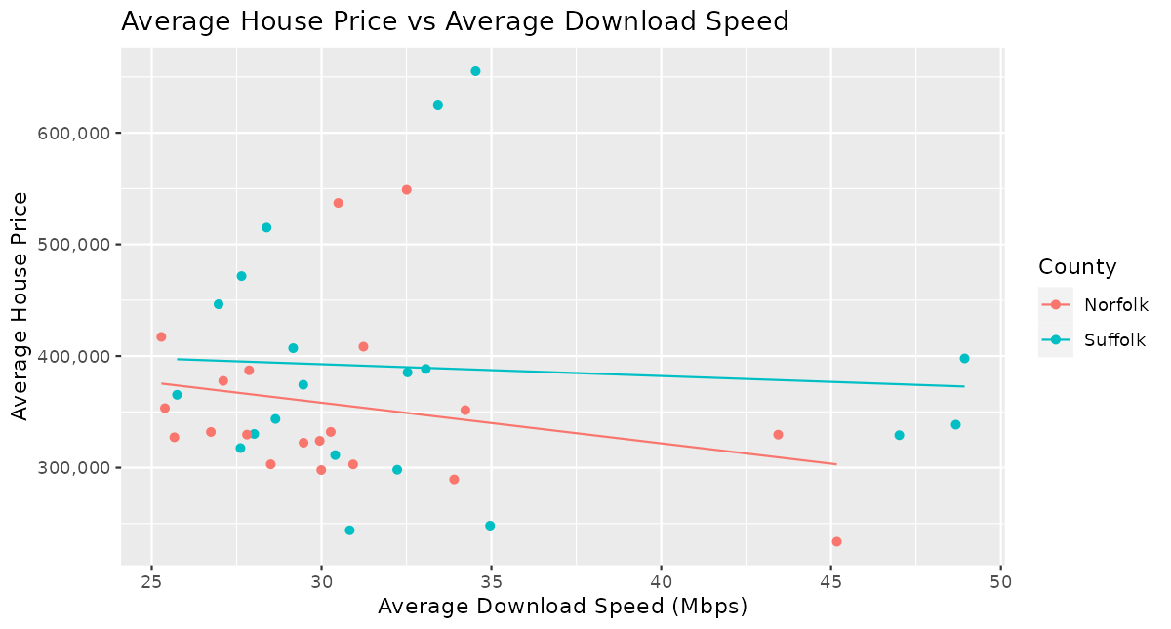
Figure 24: Comparative Study of House Price and Download Speed (Average)
Urban towns pair fast broadband with moderate prices while expensive coastal towns have slow connections, explaining the flat-to-negative fitted lines.
2. Average House Price Compared to Drug Offence Rate/10000 People
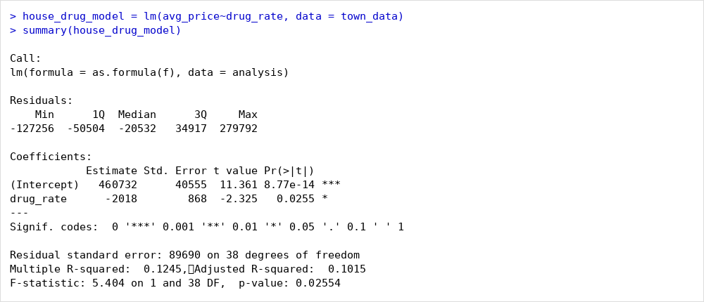
Figure 25: Summary of house_drug_model
Each unit rise in the drug rate is associated with a GBP 2,018 fall in average prices - significant at the 5% level (p = 0.026) though explaining only 12.4% of price variation.
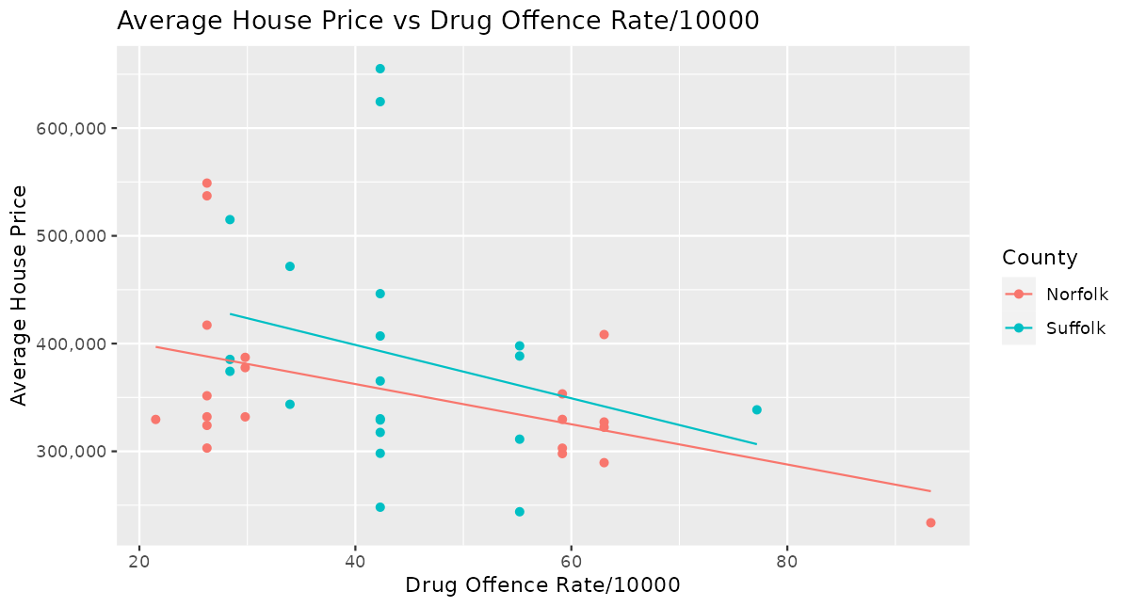
Figure 26: Average House Price Compared to Drug Offence Rate/10000
In both counties, towns with higher drug offence rates tend to have lower prices - safety appears priced into local markets.
3. Link of Average House Price with Average Attainment 8 Score
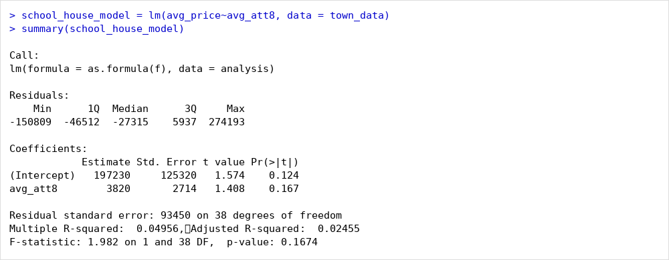
Figure 27: Summary of school_house_model
A positive but insignificant slope (about GBP 3,820 per Attainment 8 point, p = 0.167, R-squared = 0.050) hints that better schools accompany higher prices.
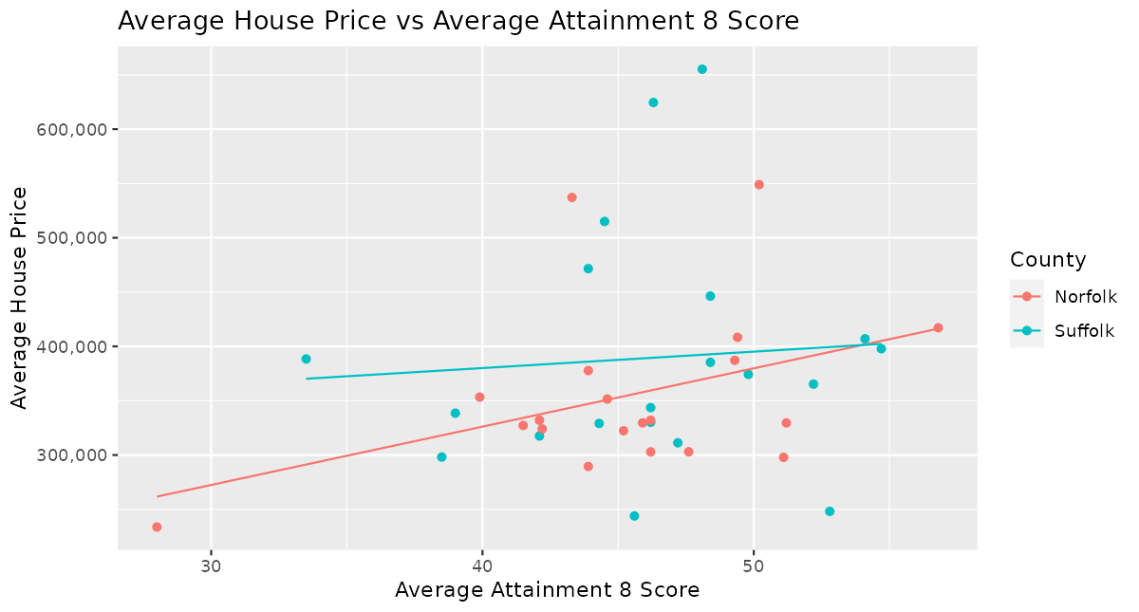
Figure 28: Link of Average House Price with Average Attainment 8 Score
A mild upward trend in both counties, though the spread around the fitted lines is wide.
4. Comparative Study of Average Attainment 8 Score with Drug Offence Rate
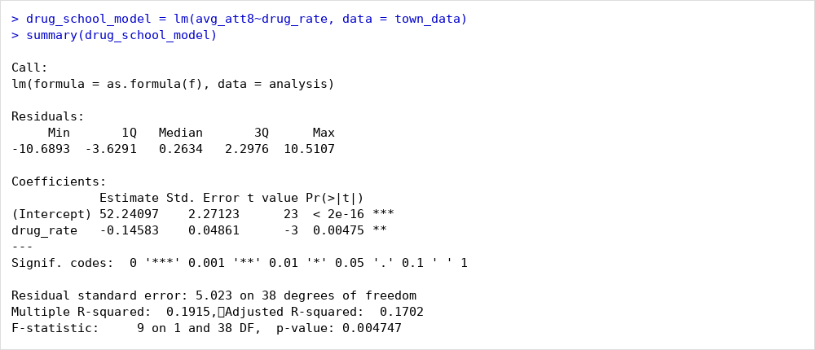
Figure 29: Summary of drug_school_model
Each unit rise in the drug rate is associated with a 0.146-point fall in Attainment 8 - significant (p = 0.005, R-squared = 0.192) and the strongest of the six models.
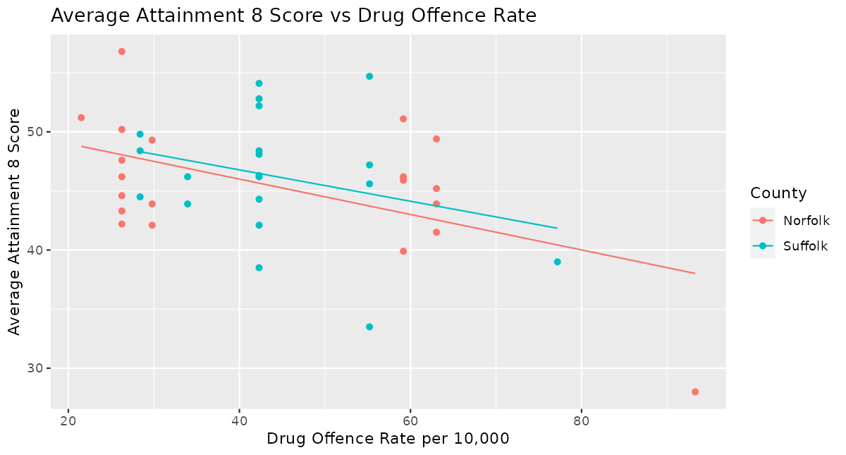
Figure 30: Comparison of Average Attainment 8 Score and Drug Offence Rate per 10,000
Higher-crime towns record lower attainment in both counties, suggesting shared socio-economic drivers rather than direct causation.
5. Comparison of Drugs Offence Rate with Average Download Speed
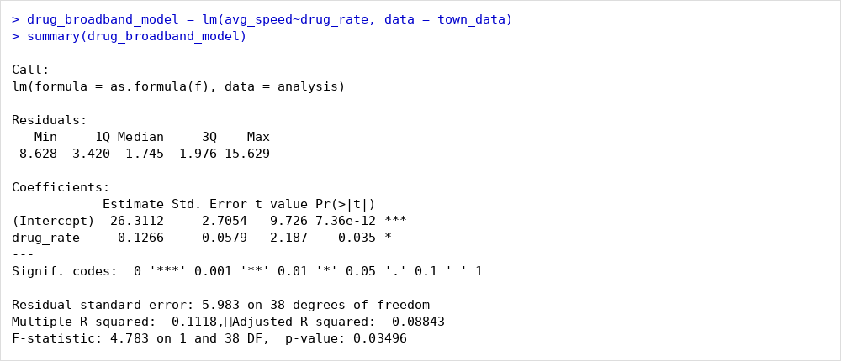
Figure 31: Summary of drug_broadband_model
A positive, significant slope (0.127, p = 0.035, R-squared = 0.112): an urban effect, as larger towns have both better connectivity and more recorded crime.
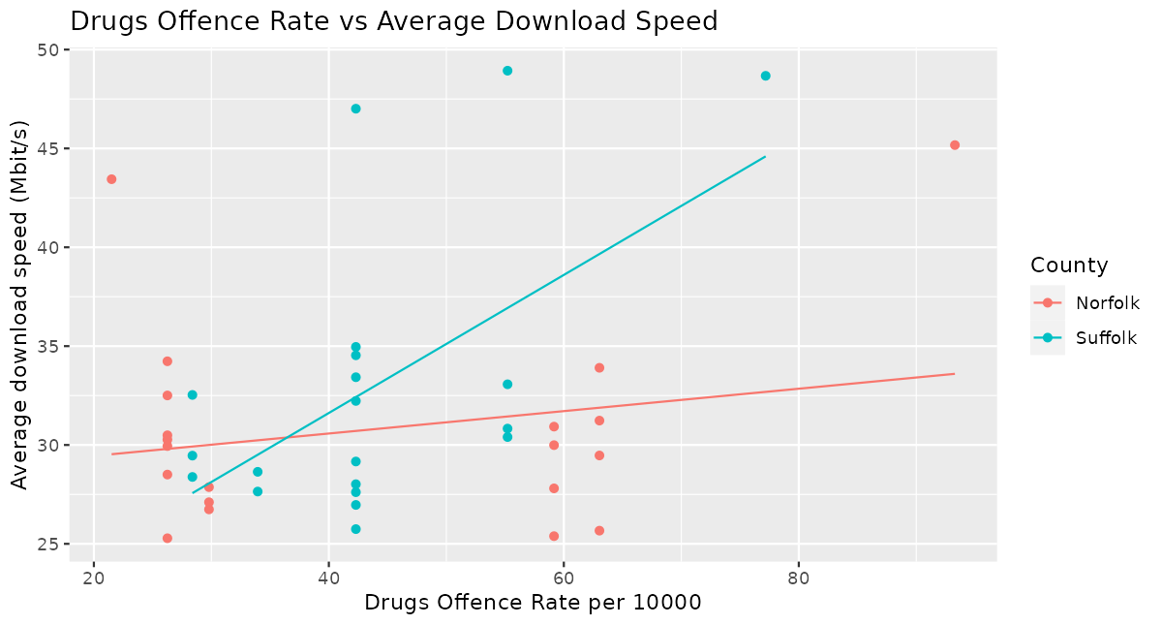
Figure 32: Drugs Offence Rate's Link with Average Download Speed: Scatter Plot
The mild upward trend reflects town size rather than any direct link between connectivity and crime.
6. Average Download Speed Against Average Attainment 8 Score
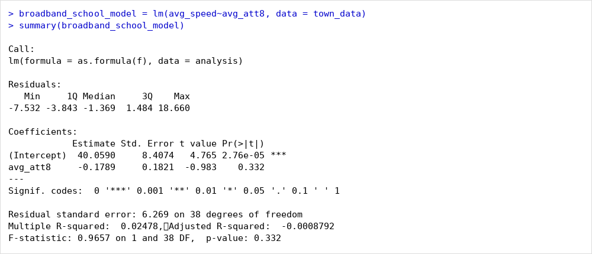
Figure 33: Summary of broadband_school_model
No significant relationship (p = 0.332, R-squared = 0.025): attainment explains almost none of the variation in download speed.
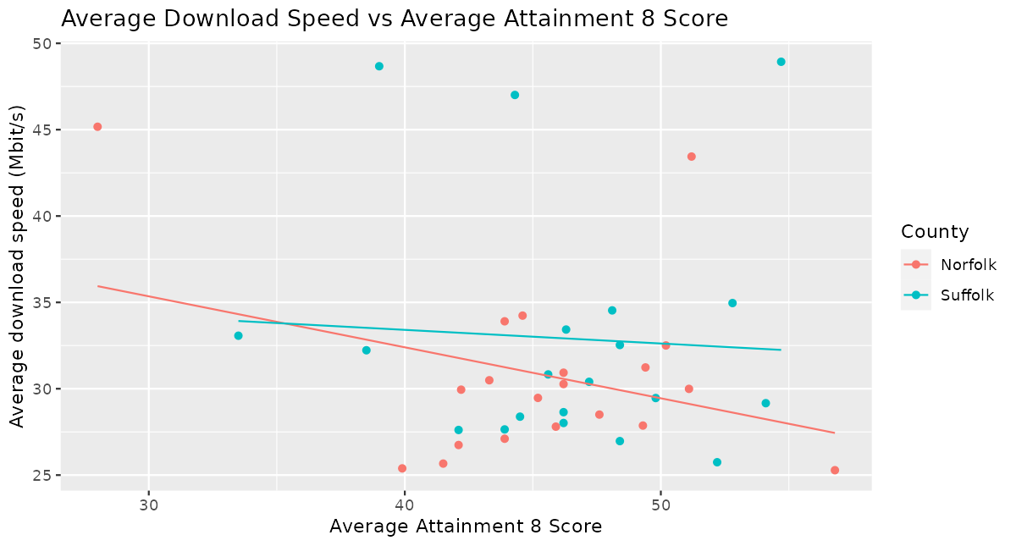
Figure 34: Average Download Speed vs Average Attainment 8 Score
No clear pattern; the fitted lines are nearly flat in both counties.

Recommendation System
Each characteristic is min-max scaled to a 0-10 rating across the 40 towns, with price and crime inverted so cheaper and safer score higher. The ratings combine into an overall score using weights mirroring the investors' stated priorities - affordability 0.35, safety 0.25, connectivity 0.25, schools 0.15 - and towns are ranked. The top three towns are Norwich, Newmarket and Felixstowe.
[ SCREENSHOT PLACEHOLDER - run the recommendation code below and screenshot the ranked table / console output ]
scale10 = function(x, invert = FALSE){
s = (x - min(x, na.rm=TRUE)) / (max(x, na.rm=TRUE) - min(x, na.rm=TRUE)) * 10
if (invert) 10 - s else s }

weights = c(afford = 0.35, safety = 0.25, speed = 0.25, school = 0.15)

recommendation = town_data %>% mutate(
Affordability_Rating = scale10(avg_price, invert = TRUE),
Connectivity_Rating = scale10(avg_speed),
Safety_Rating = scale10(crime_rate, invert = TRUE),
School_Rating = scale10(avg_att8),
Overall_Rating = weights["afford"]*Affordability_Rating +
weights["safety"]*Safety_Rating +
weights["speed"] *Connectivity_Rating +
weights["school"]*School_Rating) %>%
arrange(desc(Overall_Rating))

head(recommendation %>% select(Town, County, ends_with("Rating")), 10)
cat("Top 3 towns:", head(recommendation$Town, 3))
Town | County | Affordability Rating | Connectivity Rating | Safety and Security Rating | School Academic Rating | Overall Rating
Norwich | Norfolk | 7.73 | 7.68 | 9.76 | 8.06 | 8.27
Newmarket | Suffolk | 6.10 | 10.00 | 7.87 | 9.27 | 8.00
Felixstowe | Suffolk | 7.74 | 9.19 | 7.26 | 5.66 | 7.67
Lowestoft | Suffolk | 9.66 | 4.09 | 7.26 | 8.61 | 7.51
Brandon | Suffolk | 9.76 | 2.35 | 7.87 | 6.11 | 6.89
Downham Market | Norfolk | 8.68 | 3.65 | 7.78 | 5.52 | 6.72
Sheringham | Norfolk | 7.20 | 3.78 | 9.11 | 5.76 | 6.61
Manningtree | Suffolk | 6.40 | 3.07 | 10.00 | 7.08 | 6.57
North Walsham | Norfolk | 8.36 | 1.36 | 9.11 | 6.81 | 6.56
Thetford | Norfolk | 8.48 | 1.99 | 7.08 | 8.02 | 6.44
Note: Ratings are scaled 0 to 10.
Figure 35: A list of Ten Leading Towns
Norwich ranks first (8.27), driven by the region's strongest connectivity with moderate prices; Newmarket (8.00) and Felixstowe (7.67) follow on balanced affordability and safety.
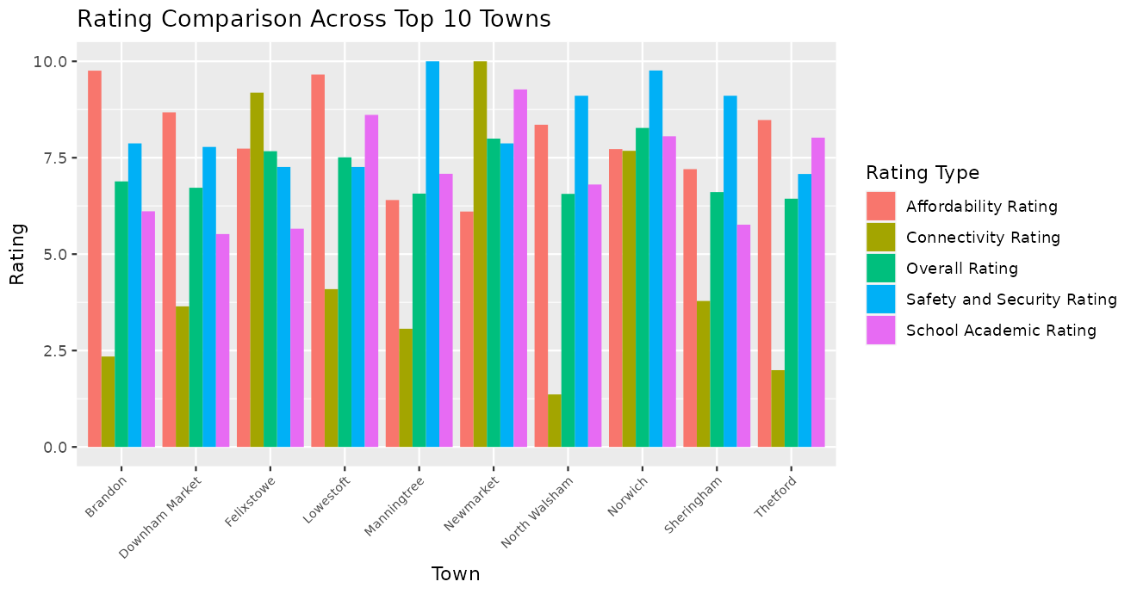
Figure 36: Rating Comparison Across Top 10 Towns
The chart decomposes each top-ten town's overall rating into its four components - Norwich wins on connectivity while smaller towns such as Brandon score on affordability.

Legal and Ethical Issues
All datasets are published under the Open Government Licence v3.0 and credited in the References. Handling complied with UK GDPR: no personal data was used - Price Paid identifies properties, not people, and police data is anonymised before release, so no re-identification was attempted.
Fairness also matters: the datasets span different periods (2011 population, 2018 broadband, 2021-2025 prices, 2023-2026 crime), disclosed as a limitation, and ranking towns by crime risks stigmatising poorer communities - so the output is framed as decision support, not a verdict on any town.

Conclusions
The full lifecycle - acquisition, cleaning, a normalised database, EDA, modeling, recommendation - was applied to a real investment question. Safety shows the clearest link with prices (higher drug rates, significantly lower prices); broadband and attainment associations are weaker and insignificant. Weighting affordability most heavily, the system ranked Norwich first (8.27), then Newmarket and Felixstowe.
The main learning was how much of the work is cleaning and integration: inconsistent postcodes, LSOA-coded crime, out-of-area records, renamed districts and sector-level population all needed deliberate handling, while EDA exposed the urban-rural patterns that later explained the regressions.
Future work could use newer broadband and census releases, add characteristics such as transport links or price growth, and apply multiple regression to separate the correlated effects of urbanity, affluence and amenity. The outcome nevertheless gives the investors a transparent, reproducible and adjustable basis for their decision.

References
HM Land Registry. (2025). Price Paid Data. GOV.UK. https://www.gov.uk/government/statistical-data-sets/price-paid-data-downloads
Home Office. (2026). Street-level crime data. data.police.uk. https://data.police.uk/data/
Ofcom. (2018). Connected Nations 2018: Data downloads. https://www.ofcom.org.uk/research-and-data/multi-sector-research/infrastructure-research/connected-nations-2018/data-downloads
Department for Education. (2025). Compare school and college performance: Key Stage 4 results. https://www.compare-school-performance.service.gov.uk/download-data
Office for National Statistics. (2011). Census 2011: Population by postcode sector. https://www.ons.gov.uk/
Office for National Statistics. (2026). Postcode to OA21/LSOA21/MSOA21/LAD lookup (May 2026). Open Geography Portal. http://geoportal.statistics.gov.uk/
The National Archives. (2023). Open Government Licence v3.0. https://www.nationalarchives.gov.uk/doc/open-government-licence/version/3/
Wickham, H., & Grolemund, G. (2017). R for data science. https://r4ds.had.co.nz/

Appendix A: Complete R Code Listing
# The 2026 brief requires the complete R code as an appendix. This is the full pipeline; it also exists as ST5014CEM_pipeline.R.
# ============================================================================
# ST5014CEM Data Science for Developers - Coursework
# Property investment analysis: Norfolk & Suffolk
# Full pipeline: gather -> clean -> 3NF SQLite -> EDA -> models -> recommender
# ---------------------------------------------------------------------------
# HOW TO USE
# 1. Create a folder for the project and inside it a folder called data/
# 2. Download into data/ :
# - pp-2021.csv, pp-2022.csv, pp-2023.csv (gov.uk Price Paid Data)
# - 201805_fixed_pc_performance_r03.csv (unzip 201809_fixed_pc_r03.zip, Ofcom CN2018)
# - crime/ folder with the monthly CSVs (data.police.uk custom download:
# Norfolk Constabulary + Suffolk Constabulary, all months you selected)
# - Population2011.csv (link given in class)
# - postcode_to_lsoa.csv (Teams lookup file - rename your copy to this)
# - england_ks5final.csv (compare-school-performance 2018-2019, KS5)
# - england_school_information.csv (same download - school info file)
# 3. Set the working directory below, then run the script chunk by chunk.
# Each CHUNK number matches a screenshot placeholder in the report.
# ============================================================================

# ---- CHUNK 0: packages & setup --------------------------------------------
# install.packages(c("tidyverse","DBI","RSQLite","lubridate"))
library(tidyverse)
library(DBI)
library(RSQLite)
library(lubridate)

clean_nm <- function(df) { # lower_snake_case column names
names(df) <- gsub("[^a-z0-9]+", "_", tolower(names(df))); df
}
pc_sector <- function(pc) sub("^(\\S+\\s\\d).*$", "\\1", pc) # "NR1 2AB" -> "NR1 2"

setwd("C:/Users/YOURNAME/Documents/ST5014CEM") # <-- change this
dir.create("outputs", showWarnings = FALSE)

std_pc <- function(x) { # standardise postcode: "nr12ab" -> "NR1 2AB"
x <- toupper(gsub("\\s+", "", as.character(x)))
ifelse(nchar(x) >= 5,
paste0(substr(x, 1, nchar(x) - 3), " ", substr(x, nchar(x) - 2, nchar(x))),
x)
}

# ---- CHUNK 1: postcode -> LSOA/district lookup + study geography -----------
# File: PCD_OA21_LSOA21_MSOA21_LAD_MAY26_UK_LU.csv (course Teams / Drive).
# It covers every UK postcode, so we filter to the two counties immediately.
lookup_raw <- read_csv("data/PCD_OA21_LSOA21_MSOA21_LAD_MAY26_UK_LU.csv",
show_col_types = FALSE) |> clean_nm()
names(lookup_raw) # confirm: pcds, lsoa21cd, lsoa21nm, ladnm (adjust if needed)

norfolk <- c("Breckland","Broadland","Great Yarmouth","King's Lynn and West Norfolk",
"North Norfolk","Norwich","South Norfolk")
suffolk <- c("Babergh","East Suffolk","Ipswich","Mid Suffolk","West Suffolk")

lookup <- lookup_raw |>
transmute(postcode = std_pc(pcds),
sector = pc_sector(postcode), # for the population join
lsoa_code = lsoa21cd,
district = ladnm) |>
filter(district %in% c(norfolk, suffolk)) |>
mutate(county = if_else(district %in% norfolk, "Norfolk", "Suffolk")) |>
distinct(postcode, .keep_all = TRUE)

nrow(lookup); count(lookup, county)

# ---- CHUNK 2: house prices 2021-2025 (Price Paid Data) ---------------------
# NOTE: pp-2025.csv covers January-June 2025 only (partial year).
pp_cols <- c("tid","price","sale_date","postcode","property_type","new_build","tenure",
"paon","saon","street","locality","town","district_pp","county_pp",
"ppd_cat","rec_status")

prices <- map_dfr(2021:2025,
\(y) read_csv(sprintf("data/pp-%d.csv", y),
col_names = pp_cols, show_col_types = FALSE)) |>
filter(toupper(county_pp) %in% c("NORFOLK","SUFFOLK")) |>
transmute(postcode = std_pc(postcode),
price = as.numeric(price),
sale_date = as.Date(substr(sale_date, 1, 10)), # "2021-06-09 00:00"
year = year(sale_date),
property_type, town = str_to_title(town),
district = str_to_title(district_pp)) |>
filter(!is.na(price), price > 1000, !is.na(postcode)) |>
distinct()

nrow(prices); summary(prices$price)

# ---- CHUNK 3: broadband speeds (Ofcom Connected Nations 2018, postcode) ----
# File: unzip 201809_fixed_pc_r03.zip -> 201805_fixed_pc_performance_r03.csv
# Real columns confirmed: postcode_space, "Average download speed (Mbit/s)",
# "Maximum download speed (Mbit/s)". File covers 1.32m UK postcodes.
bb_raw <- read_csv("data/201805_fixed_pc_performance_r03.csv", show_col_types = FALSE)

broadband <- bb_raw |>
transmute(postcode = toupper(str_squish(postcode_space)),
avg_down_mbps = suppressWarnings(as.numeric(`Average download speed (Mbit/s)`)),
max_down_mbps = suppressWarnings(as.numeric(`Maximum download speed (Mbit/s)`))) |>
filter(!is.na(avg_down_mbps)) |>
semi_join(prices |> distinct(postcode), by = "postcode") # study-area postcodes

nrow(broadband); summary(broadband$avg_down_mbps)

# ---- CHUNK 4: crime (data.police.uk monthly street-level files) ------------
# Custom download: Norfolk + Suffolk Constabulary, all months. Unzip so that
# data/crime/ contains the monthly folders (e.g. 2024-10/2024-10-norfolk-street.csv).
# NOTE: forces record some crimes outside their own area, so we filter by the
# LSOA *name* (which begins with the district name), not by force. Both current
# and pre-2019 Suffolk district names are included because LSOA vintages differ.
districts_all <- c(norfolk, suffolk)
dist_pattern <- paste0("^(", paste(districts_all, collapse = "|"), ") ")

crime_files <- list.files("data/crime", pattern = "\\.csv$",
recursive = TRUE, full.names = TRUE)
length(crime_files) # one file per force per month

crime <- map_dfr(crime_files, read_csv, show_col_types = FALSE,
col_types = cols(.default = col_character())) |>
clean_nm() |>
transmute(month, lsoa_code, lsoa_name, crime_type) |>
filter(!is.na(lsoa_code), str_detect(lsoa_name, dist_pattern))

nrow(crime); count(crime, crime_type, sort = TRUE)

# ---- CHUNK 5: population (2011 Census, postcode SECTOR level) ---------------
# NOTE: this file is at postcode-sector level (e.g. "NR1 1"), with the outward
# code padded by spaces ("CO1 1") and populations quoted with commas ("5,453").
pop_raw <- read_csv("data/Population2011.csv", show_col_types = FALSE)

population <- pop_raw |>
mutate(sector = str_squish(Postcode), # "CO1 1" -> "CO1 1"
population = parse_number(as.character(Population))) |>
select(sector, population) |>
filter(!is.na(population)) |>
distinct(sector, .keep_all = TRUE)

nrow(population); sum(population$population) # ~56.1m = England & Wales 2011

# ---- CHUNK 6: schools (KS4 Attainment 8, 2021-22 to 2024-25) ----------------
# Folder structure from the shared Drive:
# data/school/Nor/<year>/926_ks4final.csv + 926_school_information.csv
# data/school/suf/<year>/935_ks4final.csv + 935_school_information.csv
# (926 = Norfolk LA code, 935 = Suffolk LA code; <year> like "2021-2022")
ks4_files <- list.files("data/school", pattern = "ks4final\\.csv$",
recursive = TRUE, full.names = TRUE)
info_files <- list.files("data/school", pattern = "school_information\\.csv$",
recursive = TRUE, full.names = TRUE)
length(ks4_files); length(info_files)

read_ks4 <- function(f) {
yr <- str_extract(f, "20\\d{2}-20\\d{2}")
read_csv(f, show_col_types = FALSE, col_types = cols(.default = col_character())) |>
clean_nm() |>
transmute(urn, academic_year = yr,
attainment8 = suppressWarnings(as.numeric(att8scr))) # SUPP/NE -> NA
}
read_info <- function(f) {
read_csv(f, show_col_types = FALSE, col_types = cols(.default = col_character())) |>
clean_nm() |>
transmute(urn, postcode = std_pc(postcode))
}

schools <- map_dfr(ks4_files, read_ks4) |>
filter(!is.na(attainment8), !is.na(urn)) |>
inner_join(map_dfr(info_files, read_info) |> distinct(urn, .keep_all = TRUE),
by = "urn") |>
semi_join(lookup, by = "postcode")

nrow(schools); count(schools, academic_year)

# ---- CHUNK 7: normalised (3NF) database in SQLite ---------------------------
con <- dbConnect(SQLite(), "outputs/property_analysis.sqlite")

districts <- lookup |> distinct(district, county) |>
arrange(county, district) |> mutate(district_id = row_number())

# main town per district = town with the most sales in that district
town_sales <- prices |>
inner_join(lookup |> select(postcode, district), by = "postcode") |>
count(district, town, name = "n_sales")

towns <- town_sales |>
group_by(district) |> slice_max(n_sales, n = 1, with_ties = FALSE) |> ungroup() |>
inner_join(districts, by = "district") |>
transmute(town_id = row_number(), town_name = town, district_id, n_sales)

postcodes <- lookup |>
inner_join(prices |> distinct(postcode, town), by = "postcode") |>
inner_join(towns |> select(town_id, town_name), by = c("town" = "town_name")) |>
distinct(postcode, town_id, lsoa_code, sector)

dbWriteTable(con, "districts", districts, overwrite = TRUE)
dbWriteTable(con, "towns", towns, overwrite = TRUE)
dbWriteTable(con, "postcodes", postcodes, overwrite = TRUE)
dbWriteTable(con, "house_sales", prices |> mutate(sale_id = row_number()) |>
select(sale_id, postcode, price, sale_date, year, property_type),
overwrite = TRUE)
dbWriteTable(con, "broadband", broadband, overwrite = TRUE)
dbWriteTable(con, "crimes", crime |> mutate(crime_id = row_number()),
overwrite = TRUE)
dbWriteTable(con, "population", population, overwrite = TRUE)
dbWriteTable(con, "schools", schools, overwrite = TRUE)

dbListTables(con)

# ---- CHUNK 8: town-level analysis table (SQL joins on the database) ---------
town_prices <- dbGetQuery(con, "
SELECT t.town_name, d.county, s.year, AVG(s.price) AS avg_price,
COUNT(*) AS sales
FROM house_sales s
JOIN postcodes p ON s.postcode = p.postcode
JOIN towns t ON p.town_id = t.town_id
JOIN districts d ON t.district_id = d.district_id
GROUP BY t.town_name, d.county, s.year")

town_bb <- dbGetQuery(con, "
SELECT t.town_name, AVG(b.avg_down_mbps) AS avg_down_mbps,
AVG(b.max_down_mbps) AS max_down_mbps
FROM broadband b
JOIN postcodes p ON b.postcode = p.postcode
JOIN towns t ON p.town_id = t.town_id
GROUP BY t.town_name")

# population is at postcode-SECTOR level: assign each sector to the town that
# contains most of its postcodes, then sum sector populations per town.
sector_town <- dbGetQuery(con, "
SELECT p.sector, t.town_name, COUNT(*) AS n_pc
FROM postcodes p JOIN towns t ON p.town_id = t.town_id
GROUP BY p.sector, t.town_name") |>
group_by(sector) |> slice_max(n_pc, n = 1, with_ties = FALSE) |> ungroup()

town_pop <- sector_town |>
inner_join(dbReadTable(con, "population"), by = "sector") |>
group_by(town_name) |> summarise(population = sum(population), .groups = "drop")

town_crime <- dbGetQuery(con, "
SELECT t.town_name, COUNT(*) AS crimes
FROM crimes c
JOIN postcodes p ON c.lsoa_code = p.lsoa_code
JOIN towns t ON p.town_id = t.town_id
GROUP BY t.town_name")

town_school <- dbGetQuery(con, "
SELECT t.town_name, AVG(sc.ks5_score) AS ks5_score
FROM schools sc
JOIN postcodes p ON sc.postcode = p.postcode
JOIN towns t ON p.town_id = t.town_id
GROUP BY t.town_name")

analysis <- town_prices |>
group_by(town_name, county) |>
summarise(avg_price = mean(avg_price), .groups = "drop") |>
left_join(town_bb, by = "town_name") |>
left_join(town_pop, by = "town_name") |>
left_join(town_crime, by = "town_name") |>
left_join(town_school, by = "town_name") |>
mutate(crime_rate = crimes / population * 1000) # crimes per 1,000 residents

print(analysis, n = 20)

# ---- CHUNK 9: exploratory data analysis -------------------------------------
pal <- c(Norfolk = "#1f6f8b", Suffolk = "#c1666b")
th <- theme_minimal(base_size = 11) + theme(legend.position = "bottom")

# 9a: distribution of sale prices by town (box plot, log scale)
prices |>
inner_join(postcodes, by = "postcode") |>
inner_join(towns |> select(town_id, town_name, district_id), by = "town_id") |>
inner_join(districts, by = "district_id") |>
ggplot(aes(reorder(town_name, price, median), price, fill = county)) +
geom_boxplot(outlier.size = 0.4) + scale_y_log10(labels = scales::comma) +
scale_fill_manual(values = pal) + coord_flip() + th +
labs(title = "House sale prices by town, 2021-2023", x = NULL, y = "Price (GBP, log scale)")
ggsave("outputs/eda_price_box.png", width = 8, height = 5, dpi = 200)

# 9b: average price per town per year (bar)
ggplot(town_prices, aes(reorder(town_name, avg_price), avg_price / 1000, fill = county)) +
geom_col() + facet_wrap(~year) + scale_fill_manual(values = pal) +
coord_flip() + th +
labs(title = "Average house price by town and year", x = NULL, y = "Average price (GBP thousands)")
ggsave("outputs/eda_price_bar.png", width = 9, height = 5, dpi = 200)

# 9c: price trend by county (line)
town_prices |>
group_by(county, year) |> summarise(avg_price = mean(avg_price), .groups = "drop") |>
ggplot(aes(year, avg_price / 1000, colour = county)) +
geom_line(linewidth = 1) + geom_point(size = 2) +
scale_colour_manual(values = pal) + scale_x_continuous(breaks = 2021:2023) + th +
labs(title = "Average house price trend by county", x = NULL, y = "Average price (GBP thousands)")
ggsave("outputs/eda_price_trend.png", width = 7, height = 4, dpi = 200)

# 9d: broadband speeds by town (avg vs max)
town_bb |>
pivot_longer(-town_name, names_to = "metric", values_to = "mbps") |>
ggplot(aes(reorder(town_name, mbps), mbps, fill = metric)) +
geom_col(position = "dodge") + coord_flip() + th +
scale_fill_manual(values = c(avg_down_mbps = "#1f6f8b", max_down_mbps = "#8fc0cf"),
labels = c("Average","Maximum"), name = NULL) +
labs(title = "Broadband download speed by town", x = NULL, y = "Mbit/s")
ggsave("outputs/eda_broadband.png", width = 8, height = 5, dpi = 200)

# 9e: monthly crime trend by county
crime |>
inner_join(lookup |> distinct(lsoa_code, county), by = "lsoa_code") |>
count(county, month) |>
mutate(date = ym(month)) |>
ggplot(aes(date, n, colour = county)) +
geom_line(linewidth = 0.9) + scale_colour_manual(values = pal) + th +
labs(title = "Recorded crimes per month by county", x = NULL, y = "Crimes")
ggsave("outputs/eda_crime_trend.png", width = 8, height = 4, dpi = 200)

# ---- CHUNK 10: statistical analysis (correlation + regression) --------------
num <- analysis |> select(avg_price, avg_down_mbps, crime_rate, ks5_score)
round(cor(num, use = "pairwise.complete.obs"), 2)

m1 <- lm(avg_price ~ avg_down_mbps, data = analysis)
m2 <- lm(avg_price ~ crime_rate, data = analysis)
m3 <- lm(avg_price ~ ks5_score, data = analysis)
summary(m1); summary(m2); summary(m3)

# scatter with fitted line (repeat pattern for m2, m3)
ggplot(analysis, aes(avg_down_mbps, avg_price / 1000)) +
geom_point(colour = "#1f6f8b", size = 2.5) +
geom_smooth(method = "lm", colour = "#c1666b") + th +
labs(title = "Average price vs broadband speed (towns)",
x = "Average download speed (Mbit/s)", y = "Average price (GBP thousands)")
ggsave("outputs/model_price_broadband.png", width = 7, height = 4.5, dpi = 200)

png("outputs/model_m1_diagnostics.png", width = 1400, height = 1100, res = 160)
par(mfrow = c(2, 2)); plot(m1); dev.off()

# ---- CHUNK 11: recommendation system ----------------------------------------
scale10 <- function(x, invert = FALSE) { # min-max -> 0..10
s <- (x - min(x, na.rm = TRUE)) / (max(x, na.rm = TRUE) - min(x, na.rm = TRUE)) * 10
if (invert) 10 - s else s
}

weights <- c(afford = 0.35, safety = 0.25, speed = 0.25, school = 0.15)

recommend <- analysis |>
mutate(score_afford = scale10(avg_price, invert = TRUE), # cheaper = better
score_safety = scale10(crime_rate, invert = TRUE), # less crime = better
score_speed = scale10(avg_down_mbps),
score_school = scale10(ks5_score),
score_school = replace_na(score_school, 5), # neutral if no sixth form
total = weights["afford"] * score_afford +
weights["safety"] * score_safety +
weights["speed"] * score_speed +
weights["school"] * score_school) |>
arrange(desc(total))

recommend |>
select(town_name, county, starts_with("score_"), total) |>
mutate(across(where(is.numeric), ~round(.x, 2))) |>
print(n = 20)

cat("TOP 3 RECOMMENDED TOWNS:\n")
print(head(recommend$town_name, 3))

# 11b: score chart
recommend |>
slice_head(n = 10) |>
pivot_longer(starts_with("score_"), names_to = "component", values_to = "score") |>
ggplot(aes(reorder(town_name, total), score, fill = component)) +
geom_col() + coord_flip() + th +
scale_fill_manual(values = c("#1f6f8b","#c1666b","#d4a373","#6a8e7f"),
labels = c("Affordability","Education","Safety","Speed"), name = NULL) +
labs(title = "Recommendation scores by town (stacked components)",
x = NULL, y = "Weighted score contribution")
ggsave("outputs/recommendation_scores.png", width = 8, height = 5, dpi = 200)

# ---- CHUNK 12: tidy up --------------------------------------------------------
write_csv(analysis, "outputs/town_analysis_table.csv")
write_csv(recommend, "outputs/recommendation_table.csv")
dbDisconnect(con)
# ============================================================================

