Evaluation of accelerated weathering test for fired clay bricks using study of NaCl and Na₂SO₄
Muhammad Asim Kamran^{*1}, Muhammad Shoaib², Muhammad Younis³,
^{*1}Department of Physics, University of Agriculture, Faisalabad 38040, Pakistan.
²Department of Physics, Khwaja Fareed University of Engineering & Information Technology (KFUEIT), Rahim Yar Khan 64200, Pakistan.
³Institute of Physics, Gomal University 29220, Dera Ismail Khan, KPK, Pakistan.
*Correspondence: Muhammad Asim Kamran (kamran.m58@yahoo.com)

Highlights
- Na₂SO₄ creates high crystallization pressure, while NaCl mostly deposits inside pores.
- UPV detects masonry degradation only after major cracks form, missing early microcracks.
- Compares the damage mechanisms of NaCl and Na₂SO₄ on fired clay bricks.
- Long-term damage patterns are similar, allowing identical restoration strategies for both salts.
- Acrylic-siloxane coatings protect bricks well, whereas silicone coatings block pores and worsen damage.

Abstract
Salts are among the most significant agents responsible for the deterioration of porous construction materials, particularly fired-clay bricks. Due to their ability to penetrate pore networks and crystallize within the material, salts can generate internal stresses that gradually weaken masonry and reduce the service life of buildings. Although considerable research has been conducted on salt crystallization in construction materials such as natural stone, mortar, concrete, and clay bricks, limited attention has been given to the specific mechanisms through which different salts affect the structural integrity of bricks. This study was designed to evaluate the influence of two commonly encountered salts, sodium chloride (NaCl) and sodium sulfate (Na₂SO₄), on the weathering behavior of brick specimens. Accelerated salt weathering tests were performed to investigate the crystallization process and its impact on the physical and mechanical properties of the bricks. Following the completion of the weathering cycles, the specimens were evaluated by measuring tensile strength and weight loss (w/w₀), and the results were compared with untreated reference samples. The findings provide valuable insight into the deterioration mechanisms associated with each salt and contribute to a better understanding of salt-induced damage in brick masonry exposed to aggressive environmental conditions.
Graphical Abstract

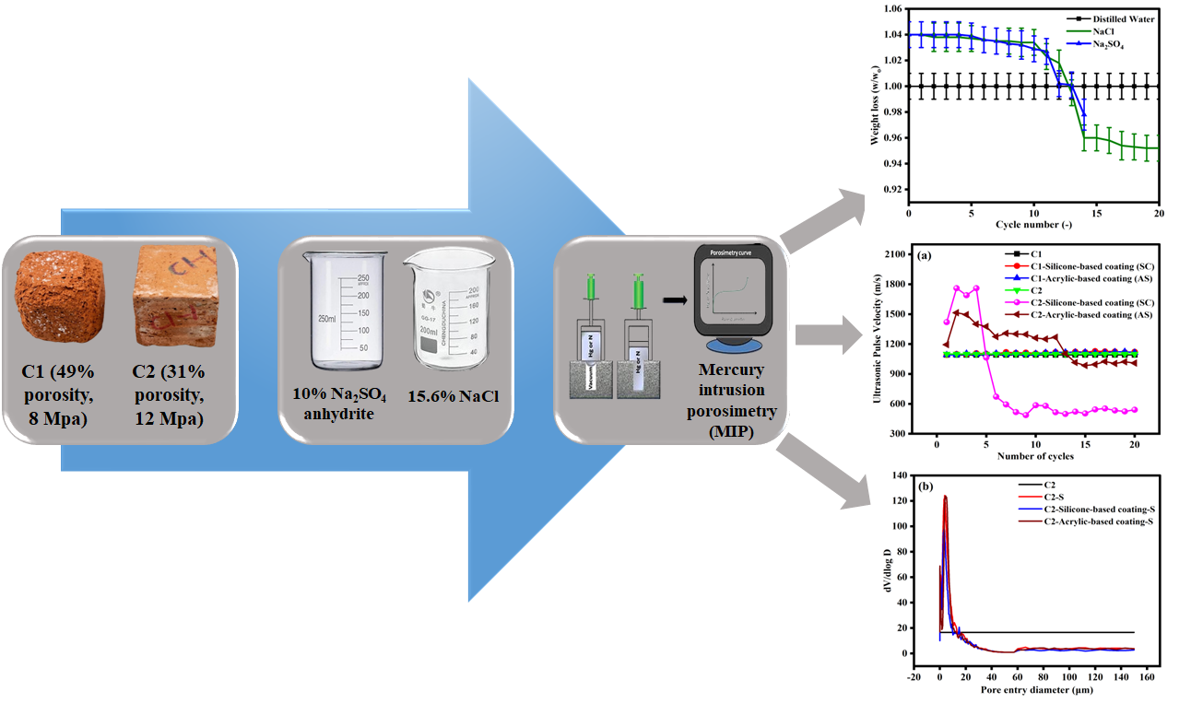
Keywords: Sodium chloride, Salt crystallization, Sodium sulfate, Masonry structures
1 Introduction
Environmental weathering of old and modern masonry buildings is a constant threat to the preservation of the architectural heritage built in these materials and one of the most important degradation mechanisms is the salt crystallization inflicted on the works, also known as physical salt attack [1,2]. Of all the chemical agents causing the phenomenon, the one that is better known for having a very high damage potential is sodium sulfate (Na₂SO₄) in relation to porous masonry materials [3]. This material failure is mainly caused by the build-up of so-called internal crystallisation pressure [4]. Salts dissolve in water and when added to the inter-connecting pore system of a material such as brick or stone, it is not inert for very long [5]. Instead, the environment is altered, and the salt is made to crystallise from the solution [6]. During this process, these crystals develop inside the limited volume of the matrix and apply a local mechanical stress on the sides of the pores [7]. Two factors play a critical role in the formation of solid crystals from the infiltrating solution the degree of supersaturation of the infiltrating solution, that is, the chemical driving force required to cause the dissolved ions to come out of the solution and to form solid crystals, and the intrinsic pore geometry of the host material, which is the exact size, volume, and geometric configuration of the pores or voids within it that directly influence the precipitating process [8,9]. Severe crystallization damage has been attributed mostly to high supersaturation which arises upon deviation from the equilibrium of the solution-pore system [10]. Rapid evaporation of the water, dissolution processes-induced phase changes (including fast interchanging between various hydration states of the minerals) or quick changes in local climate/relative humidity occur in real microclimate and cause this crucial destabilization [11–13]. These environmental changes then cause the dissolved salt to change from a liquid back to a very disruptive crystalline state in a much shorter time than the material can keep up with the volume change [14]. Due to its aggressive properties and well-established ability of material destruction, sodium sulfate is universally used as a standard deteriorating agent in accelerated laboratory salt weathering experiments and has been well documented and validated by pioneering researchers such as Rodriguez-Navarro and Doehne [15]. However, when sodium sulfate is compared with other salts that occur in the environment, an intriguing paradox emerges which has been a chemical enigma of conservation science for decades.
According to the literature, at any fixed value of supersaturation, sodium chloride (NaCl) exerts a much larger thermodynamic crystallization pressure than sodium sulfate (sodium sulfate follows the following law) [16]. But in real world lab tests and field investigations, the sodium sulfate is invariably much harsher physically and in terms of macro-structural failure of the masonry units. This significant difference is due to the special thermodynamic characteristics of the sodium sulfate, water system [17,18]. In contrast to the relatively flat solubility curve of sodium chloride, the solubility curve of sodium sulfate is very sensitive to temperature and will very quickly cause a massive supersaturation event to occur on a small change of ambient temperature [19–21]. In addition, a phase change occurs in sodium sulfate that is mediated by dissolution: the transition between thenardite and mirabilite, the anhydrous and decahydrate forms, respectively [22–24]. This supersaturation will be very high and be limited in size as thenardite will quickly dissolve and mirabilite will immediately precipitate, which easily can overcome tensile strength of most fired clay brick [25,26]. By contrast, although sodium chloride is a ubiquitous environmental contaminant often derived from marine aerosol, from de-icing salts or from rising damp caused by ground water, no clear opinion yet exists on the specific ways that it causes damage or on its long-term effects on the durability of masonry [27–29]. Unlike Na₂SO₄, NaCl does not exhibit any dramatic solubility changes or complicated hydration states dependent on temperature and thus it rarely reaches the high supersaturation levels needed to fracture thick, strong pore walls in a short period of time; hence, there remains a controversy in the literature on the extent of the hazard it poses. For instance, Ishaq et al. also studied desalination of fired-clay bricks (with NaCl pollution of 15 g kg⁻¹) using kaolin-based electrode compartments/boxes of CaCO₃ at the anode and CH₃COOH at the cathode. At a field strength of 1 V cm⁻¹, 84% of Clˉ ions and 76% of Na⁺ ions were removed after a 24h treatment with an energy consumption of 301 Wh [30]. In a similar electrokinetic method, Rorig-Dalgaard et al. studied brick samples which were polluted with 1wt% chloride (in form of NaCl). The use of kaolin clay matrix buffered at the positive electrode with CaCO₃ and at the negative electrode with CH₃COOH has effectively neutralized the localized pH changes and has been able to extract 97% of the desired Clˉ ions in 6 weeks of remediation [31]. Saidov et al. analyzed that sodium sulfate is recognized as a salt with probably the most damaging capabilities when crystallizing in porous media. From these three main crystalline phases that can be formed, the thermodynamically stable anhydrous salt (Na₂SO₄), decahydrate (Na₂SO₄.10H₂O) and the thermodynamically metastable heptahydrate (Na₂SO₄.7H₂O) [32]. Saidov et al. elaborated that Na₂SO_{4 is} recognized as typical damaging weather salt. Several operations showed that the major weathering effects of saline polluted pores are influenced by drying and wetting cycles. In this studio, in ordinary constructing materials we carried out accelerated sodium sulfate aging tests i.e. fired clay brick calculating the concentration with their stretches [33]. Gentilini et al. stated that in this article, preliminary findings of an investigative campaign conducted on three masonry combinations exposed to weathering rounds in salted solution are described [34]. Weathering cycles consist of a wetting stage by capillary growth of a NaCl solution as well as a drying stage in an oven. The impacts of salts transparently on their mechanical performance is scanned on the end of the last conditioned cycle by examining triaxial tests, in particular the relationship of Mohr-Coulomb.
It is very important to acknowledge that the rate, pattern and ultimate severity of the decay is not solely determined by the profile of the salt, but also by the microstructural, physical and mechanical characteristics of the particular masonry units involved; these are equally important to determine whether the material will survive the salt exposure or crumble to dust [35]. Inside the brick, salt weathering takes place as the initial starting point, while other properties like total open porosity and distribution of pores provide a favorable environment [36]. In general, small pore materials with a predominance of sub-micron size pores are very susceptible to crystallization pressure because the diameter of the pores makes it much more difficult for the crystals to grow, so the driving force of supersaturation of the system must be increased above that of the bulk solution to induce crystallization in the pore. On the other hand, the large macropores result in "open relief zones" where crystals would first form in the void without immediately coming into contact with the structure walls. Within the pore network, the degree of interconnectivity can increase the velocity of the passage of solutions and cause deep subflorescence, whereas the mechanical tensile strength may cause some materials to withstand the outward pressure of expanding crystals, which delays the fracturing of the structure. In light of this, it would be desirable to make a comprehensive comparative study that allows distinguishing, mapping and understanding these different degradation mechanisms; this is the objective of the current research. The various commercial bricks and historic ones having widely contrasting microstructural matrices are subjected to these two types of salt solutions, NaCl and Na₂SO₄, to identify the exact limit of interaction between chemical salt characteristics and the physical material characteristics, thereby to get a clearer picture of a targeted approach in preservation and treatment of historic masonry.
The originality of the present research is in its direct tackling of the oversimplified assumptions in the standard masonry durability test. NaCl has been misrepresented considering its slower degradation rates, while Na₂SO₄ is a universal salt used in the research community for salt attack. This paper is a step forward in that it explains the thermodynamic paradox that NaCl (in theory) has a higher crystallization pressure than Na₂SO₄, but has less macro-damage. Lastly, this study provides a new diagnostic matrix for considering preventive options for salt exposure based on mapping the relationship between the development of the salt precipitation front and the internal microstructure.
2 Experiments
2.1 Materials
All the materials used for the contamination and electrokinetic desalination of fired-clay bricks were sodium sulfate (Na₂SO₄, 99%), sodium chloride (NaCl, 99.5%), Aluminum phosphate (AlPO₄, 98%), and muscovite mica (Kal₂.AlSi₃O₁₀.OH₂, 97%), which were purchased from Sigma-Aldrich. All reagents were utilized as received for the multi-ion transport and salt weathering experiments, while distilled (DI) water was employed throughout the experimental process.
2.2 Methodology
For this investigation, two brick types were chosen which were both commercially available, being termed C1 and C2 respectively. Initially, Brick C1 showed porosity value of 49% and its compressive strength was 8MPa, while Brick C2 showed porosity value of 31% and compressive strength 12MPa. Irregular block specimens with dimensions 4 × 4 × 4 cm were made of both brick types (both coated and uncoated) to assess the effects of the two protective surface treatment regimens on the extent of salt induced deterioration. Different (acrylic siloxane-based) AS and (silicone-based) SC water-repellents coating was applied. Mechanical properties of the samples such as compressive strength and tensile strength were tested in materials testing lab. The Universal Testing Machine (UTM) was used for the testing. This setup allows several standardized mechanical tests to be conducted and was used to test the load-bearing capacity of the bricks both in compression and in tension. The salt crystallization resistance was tested by an accelerated weathering test as per RILEM V1b. A total of 112 cycles were applied with 10% sodium sulfate (Na₂SO₄) anhydrite and 15.6% sodium chloride (NaCl) solutions. A cycle was composed of 2h of salt immersion, 19 hours of drying in an oven at 60 °C and 3h of cooling at room temperature. In terms of their condition, after each cycle changes in mass were noted and other physical signs of deterioration recorded. The changes in the inner structures were monitored by ultrasonic pulse velocity (UPV) tests daily for 15 days with the help of 54 kHz transducers as per ASTM C597-2016. Furthermore, mercury intrusion porosimetry (MIP) was used to investigate changes in the distribution of pore size, pore structure and total porosity due to salt crystallization and various applied treatments on the surface.
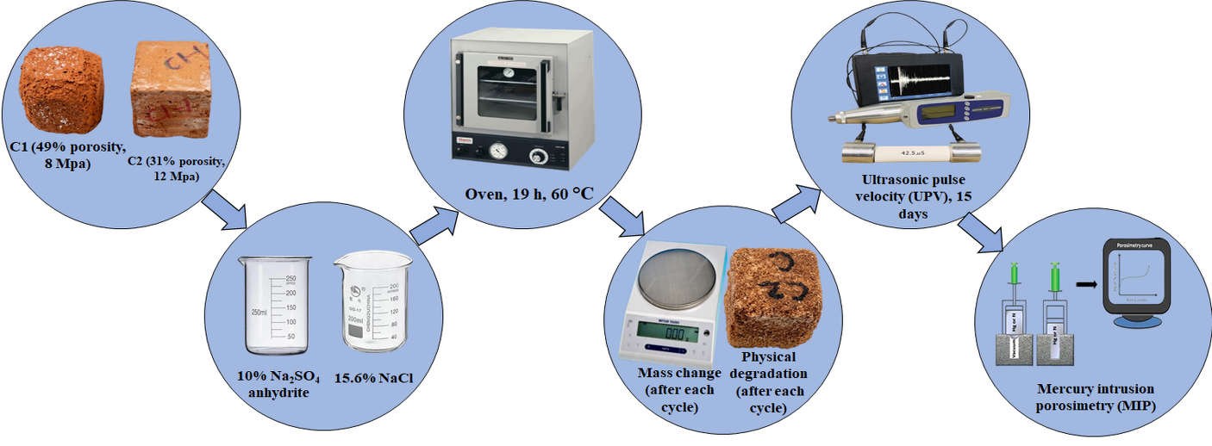

Scheme: A graph shows two types of commercial bricks, Na₂SO₄ and NaCl.
3 Results and Discussions
3.1 Mass Changes
The mass differences among the three types and variations of bricks C1 and C2 are plotted in Fig. 1, and the individual type and variation classes are as follows: Uncoated controls, silicone-based coated (SC), and acrylic siloxane-based coated (AS) [37]. Fig. 1 (a-b) compares the sodium sulfate weathering (S) processes and Fig. 1 (c-d) shows the sodium chloride weathering (C) process. The C1 bricks were subjected to sulfate environment, over time gaining some mass, but in small increments, as C1-AS and C1-SC bricks lost very little mass. The mass loss for untreated C2 bricks happened much more quickly and the AS coating for C2 bricks (C2-AS) hindered the mass loss greatly. But at the 15th cycle, the silicone-coated C2-SC bricks suddenly underwent a mass drop on a large scale, showing a less durable result in comparison to the untreated bricks. The chloride weathering samples (unshielded C1 and C2) actually had weight gains until 60th cycles, even though there was obvious weathering. C1-SC did not sustain any damage, C2-SC experienced the same spike of mass loss that was seen during the sulfate test. In contrast, no significant difference was observed between the mass of the specimens in the acrylic siloxane treatment (AS) for the two brick types during the course of the experiment.

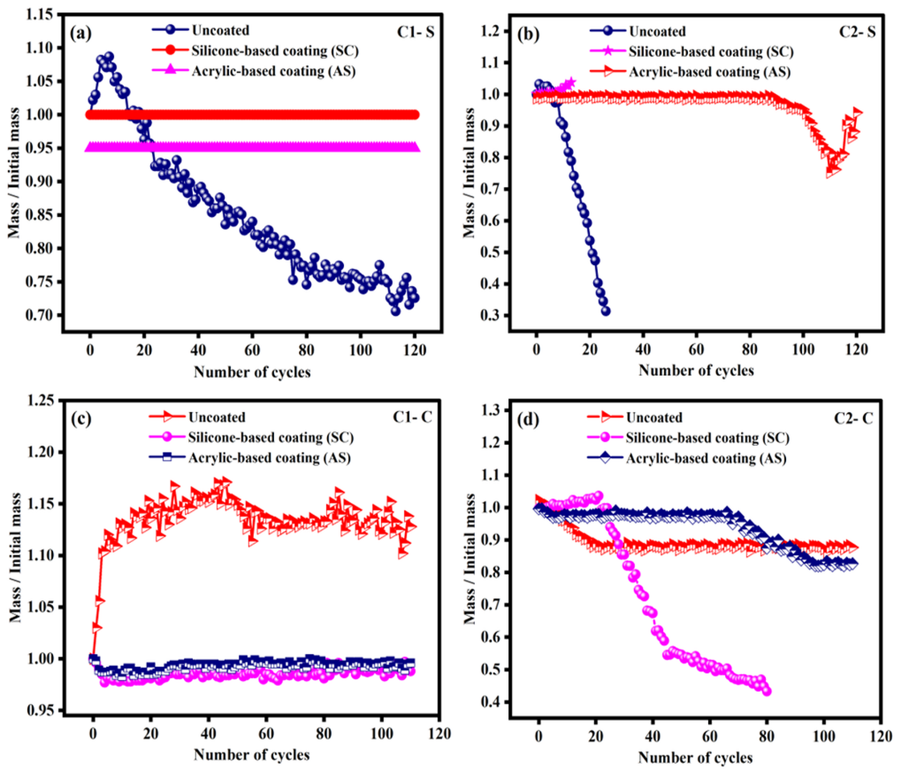
Fig. 1. Mass fluctuations during accelerated salt weathering cycles: (a) sulfate-exposed C1, (b) sulfate-exposed C2, (c) chloride-exposed C1, and (d) chloride-exposed C2 specimens.
3.2 Visual Damages
Contrasting patterns of damage were observed between two types of bricks, the low-temperature fired C1 bricks and the modern kiln-fired, wire-cut C2 bricks [38]. These structural changes are recorded in Fig 2(a-b) after 20th weathering cycles. Early signs of decay, surface roughening and fine powder, were observed before any weight loss was recorded. The C1 specimens made with no reinforcement degraded uniformly, with no flaking or spalling occurring. By contrast the C2 specimens experienced the greatest damage with deep, irregular cracks and high mass loss being apparent from cycle 6th onwards. The positioning of silicone-based water repellent (SC) was only dependent on brick type, with excellent results for preserving the lower-temperature fired C1 brick but resulting in serious and early failure for the wire cut C2 brick types. Fig 2(c-d) reports the physical trends of the brick samples both before and after 90 days in NaCl weathering conditions. Both untreated C1 and C2 bricks were found to undergo uniform degradation with granular crumbling, while the untreated C2 bricks had an overall damaged appearance with rounded corners and powdering on surfaces. A large amount of efflorescence formed on all of the uncoated samples, evenly on C1 and in patches on C2. The Silicone Water Repellent (SC), which was used on the C1 bricks (C1-SC), kept the bricks free from any appreciable damage up to cycle 60th. In contrast, the wire-cut C2-SC bricks cracked and failed suddenly, which is the same phenomenon as in sulfate test, and it brought about rapid weight loss. In summary, both brick types treated with the acrylic-siloxane treatment (AS) were found to be more durable against sodium chloride weathering.
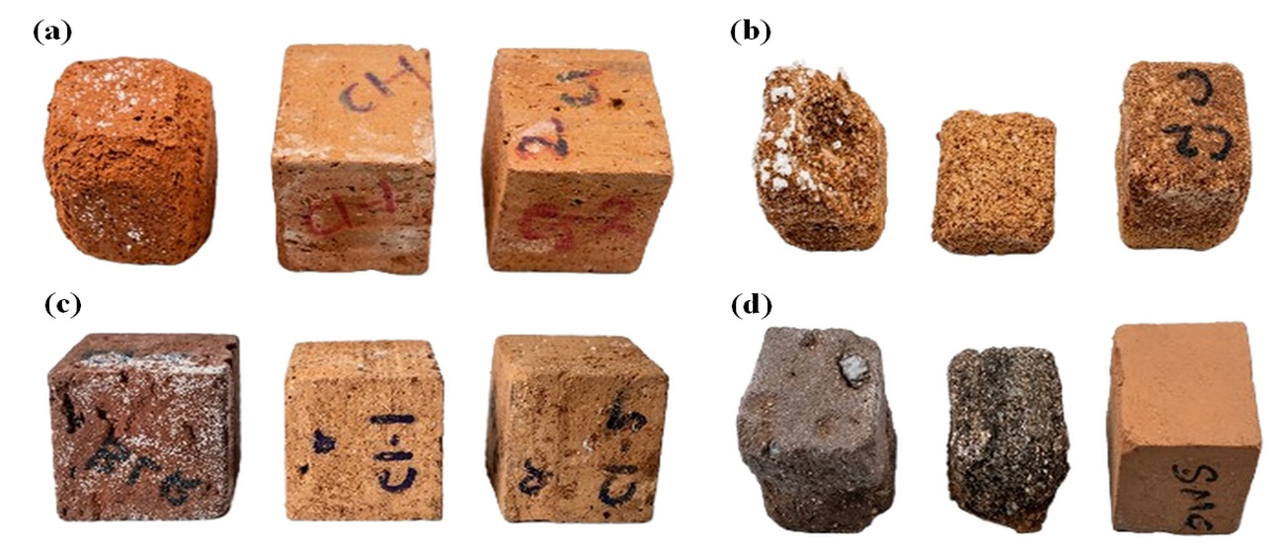
Fig. 2. (a) Physical degradation of C1, C1-SC, and C1-AS specimens following 30 accelerated weathering cycles, (b) Comparative damage state of untreated and treated C2 brick variants after 30 rounds of weathering, (c) Visible weathering and material integrity of the various C1 brick configurations following 90th test cycles, and (d) Visible weathering and material integrity of the various C2 brick configurations following 90th test cycles.
3.3 Weight loss
The treated bricks C1 and C2 with NaCl (sample two) were created with a massive superficial efflorescence emerging in the edges followed by the top face which showed that the Na⁺ and Clˉ ions were highly mobile [39]. At the same time the specimens exposed to Na₂SO₄ (sample three) showed heavy crystallization strictly at surface and outside boundaries of the specimens, as shown by heavier. In both saline groups, salt accumulation showed an increase from the 14th to the 20th cycle and in the latter the amount increased considerably, both in total volume and thickness, on the lateral surfaces. Significantly, no physical damage was done to the DI water. In contrast with such behavior, the salt crystallization in the NaCl and Na₂SO₄ groups caused progressive spalling and drastic mass loss of the materials as shown in Fig. 3. Weight changes were measured as the ratio of w-to-w₀ (w being the dry weight after a given cycle and W₀ the initial baseline weight) and were observed to decrease fast after the 14th cycle. The damage caused by Na₂SO₄ is very serious because the salt solution can enter extensively in the porous brick network when the salt is wetted. This sub-superficial crystallization causes disruption in the internal pore structure thus contributing towards flaking and further structural disintegration, in addition to causing heavy surface efflorescence. The results highlight the importance of characterizing the degradation pathways of solute-specific systems in masonry materials under cyclical environmental moisture exposure.
Table 1: Weight calculation after each cycle of cubes of bricks C1 and C2.
No. of cycles (counts) | DI water Specimen (grams) | Sodium chloride Specimen (grams) | Sodium sulfate Specimen (grams)
1 | 115.483 | 1.04 | 1.05
5 | 115.481 | 1.03 | 1.04
10 | 115.480 | 1.02 | 1.03
15 | 115.480 | 0.96
20 | 115.4801 | 0.95
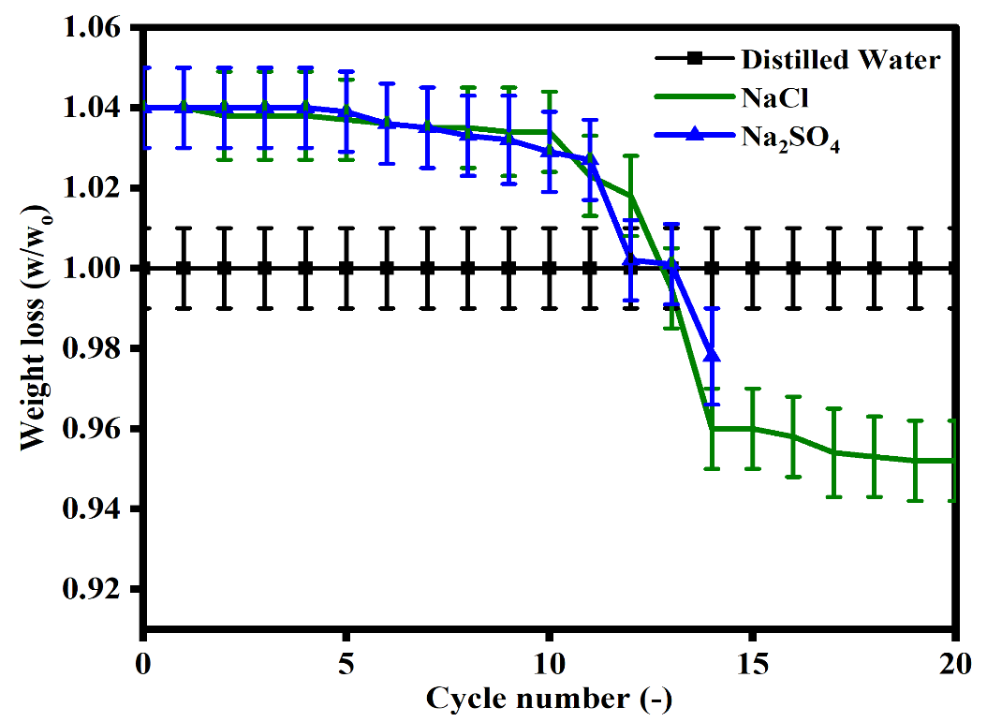

Fig. 3. Weight loss profiles of fired-clay brick samples subjected to 20 wet-dry weathering cycles during immersion in DI water, 10% NaCl, and saturated Na₂SO₄ solutions.
3.4 Ultrasonic Pulse Velocity Test
The results of the ultrasonic pulse velocity (UPV) test conducted on the uncoated and coated C1 and C2 bricks after sulphate and chloride exposure, respectively are given in Fig. 4(a-b) [40]. Physical attrition made it impractical to continue collecting data after 15 days of weathering, when several specimens experienced major damage or full fragmentation of their surfaces. These data demonstrate that velocities approach a plateau when the salt deposits are uniformly packed in the internal pore structure. The stabilization period is only until the development of macro-cracking, however. Precipitating salts constantly fill the pores and micro-cracks in the material, so UPVs are not representative of the decay in the early stages of the micro-structure until macro fissures appear. This diagnostic restriction was consistently found both in NaCl and Na₂SO₄ environments.

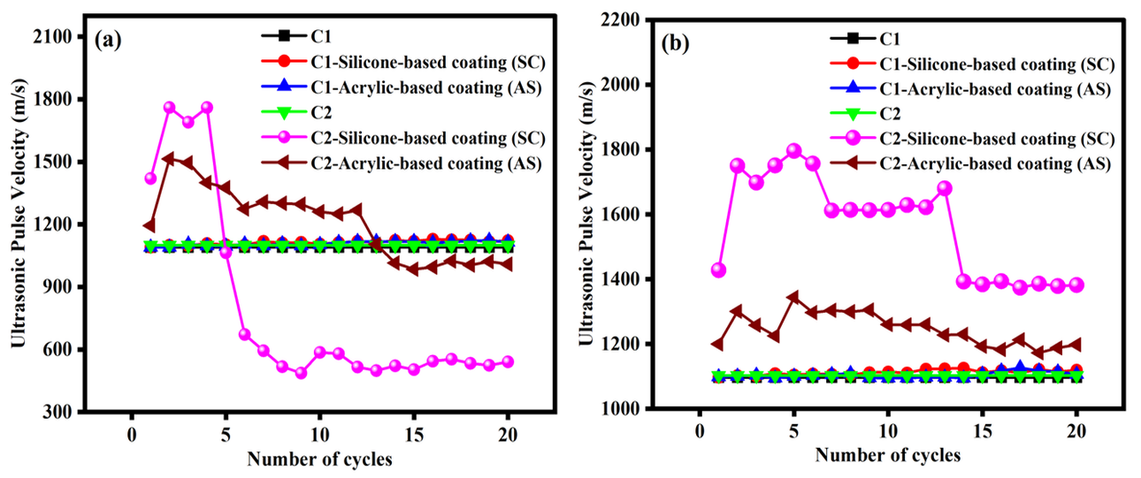
Fig. 4. UPV variations across successive weathering cycles for samples exposed to: (a) sulfate salt and (b) chloride salt solutions.
3.5 Porosity
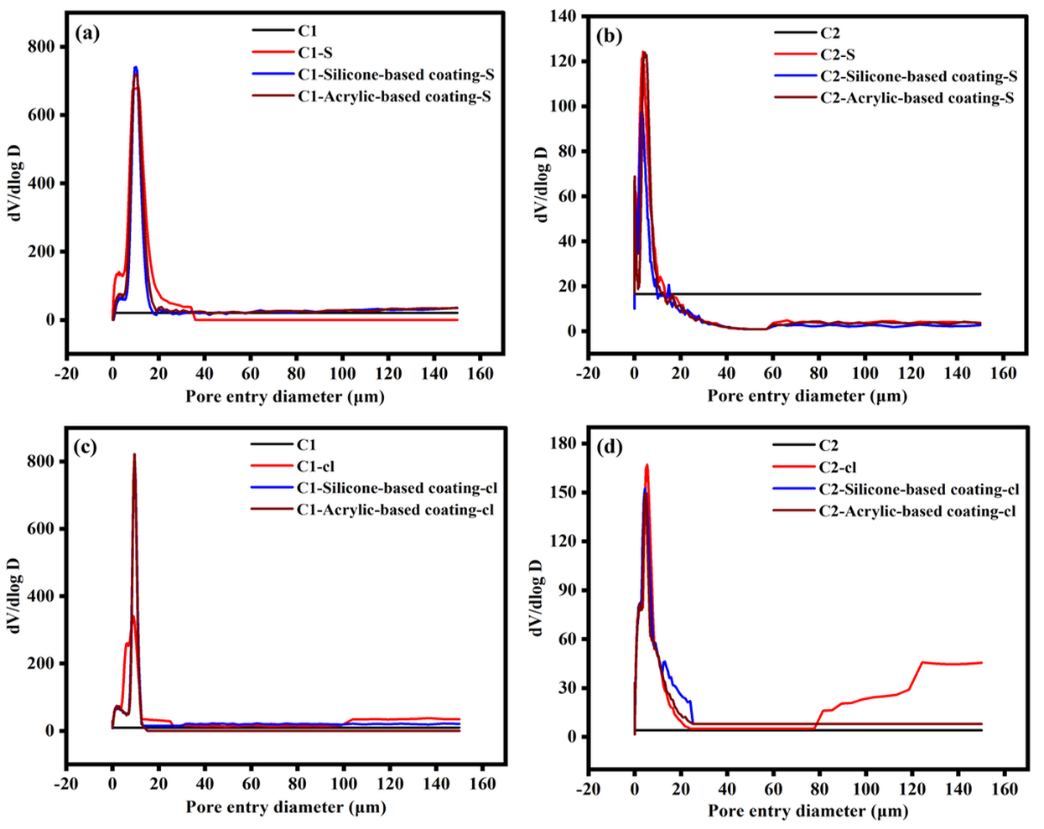
Weight loss is not adequate for material damage monitoring, as it is only measurable when the material is lost, and does not measure internal damage associated with cracking without loss of material [41]. To overcome this limitation, we used MIP to study internal pore structural modifications. Fig. 5(a-b) shows comparison between the DI curve of pristine and weathered samples (weathered samples are coated and uncoated in each case). The naming system adopted for the samples is simple, such as C1-S – C1 brick, without sulfate (weathering), C1-silicone based coating (SC)-S – C1 brick with silicone coating after sulfate (weathering); C1-acrylic siloxane-based coating (AS)-S – C1 brick with acrylic-siloxane coating after sulfate weathering (where "cl" represent chloride weathering). When the weathered differential intrusion graphs are compared to the unweathered control graphs, the resulting difference in pore space fills will be an accurate number that represents the pore space filled by the salt crystals. This number was very high in the C2 bricks and was almost absent in C1. Moreover, there were virtually no changes in the critical pore diameters from fresh and deteriorated samples. A small decrease in the critical pore size of C2 was observed, which suggested that a small fraction of its predominant pore channels was bridged by the growth of sodium sulfate crystals. Like sulfate exposure, high similarity was found in the physical degradation processes of the C1 bricks and hence their porosimetry profiles are quite similar when exposed to sodium chloride weathering. The differential intrusion curves of both treatment variants (C1-SC cl and C1-AS cl) directly overlaid the baseline curve of the pristine C1 control as presented in Fig. 6(a, b). The result shows perfect match-up in that both water repellents have 100% isolated the brick backing from salt attack when fully subjected to salt attack conditions, and no perceptible difference in the effectiveness of the coating was found after 100 days of rigorous testing. But the C1 without Sulfate exposure showed a lot less variation, internal salt distribution, which again was prominently reflected in the change of the "C1-cl" curve. The pore size critical point for the acrylic-siloxane treated sample (C2-AS cl) was exactly in the middle for the C2 brick series. This particular trend highlights the higher protection in the AS formulation as compared to the silicone formula. However, weight loss is not adequate for material damage monitoring, as it is only measurable when the material is lost, and does not measure internal damage associated with cracking without loss of material [30]. To overcome this limitation, we used MIP to study internal pore structural modifications. Fig. 5(a-b) shows comparison between the DI curve of pristine and weathered samples (weathered samples are coated and uncoated in each case). The naming system adopted for the samples is simple, such as C1 S – C1 brick, without sulfate (weathering), C1-SC S – C1 brick with silicone coating after sulfate (weathering); C1-AS S – C1 brick with acrylic-siloxane coating after sulfate weathering (where "cl" represent chloride weathering). When the weathered differential intrusion graphs are compared to the unweathered control graphs, the resulting difference in pore space fills will be an accurate number that represents the pore space filled by the salt crystals. This number was very high in the C2 bricks and was almost absent in C1. Moreover, there were virtually no changes in the critical pore diameters from fresh and deteriorated samples. A small decrease in the critical pore size of C2 was observed, which suggested that a small fraction of its predominant pore channels was bridged by the growth of sodium sulfate crystals. Like sulfate exposure, high similarity was found in the physical degradation processes of the C1 bricks and hence their porosimetry profiles are quite similar when exposed to sodium chloride weathering. The differential intrusion curves of both treatment variants (C1-SC cl and C1-AS cl) directly overlaid the baseline curve of the pristine C1 control as presented in Fig. 6(a, b). The result shows perfect match-up in that both water repellents have 100% isolated the brick backing from salt attack when fully subjected to salt attack conditions, and no perceptible difference in the effectiveness of the coating was found after 100 days of rigorous testing. But the C1 without Sulfate exposure showed a lot less variation, internal salt distribution, which again was prominently reflected in the change of the "C1-cl" curve. The pore size critical point for the acrylic-siloxane treated sample (C2-AS cl) was exactly in the middle for the C2 brick series. This particular trend highlights the higher protection in the AS formulation as compared to the silicone formula.

Fig. 5. Differential mercury intrusion curves comparing unweathered baseline samples with coated specimens subjected to accelerated NaCl weathering: (a) C1 substrate, (b) C2 substrate, (c) C1 brick profiles, and (d) C2 brick profiles.
4 Conclusion
The aim of this study was to analyze the damage caused by accelerated salt weathering on different brick blocks with various types of pores by using sodium sulfate (Na₂SO₄) and sodium chloride (NaCl) solutions and to expose the brick samples to the cyclic wetting-drying test as per the RILEM V 1.b standard with and without coating. The parameters observed during weathering were: number of cycles, exposure time, weight, weight loss (w/w₀), temperature, compressive strength, and tensile strength. In sample 1, immersed in distilled water, no significant changes in weight and weight loss were observed during this study. The curves of the samples exposed to the salt solutions, on the other hand, showed a more or less linear curve at the start, followed by a higher rate of deterioration after two to three cycles. The acrylic-siloxane coating, which also had some microcracks, was more durable in the long term as it helps to relieve internal salt pressure. The silicone-based coating, on the other hand, covered the pores on the surface, leading to higher crystallization stress and accelerated delamination. The primary damage mechanism was suggestively through crystallization pressure and crack formation by sodium sulfate while sodium chloride initially infiltrated pore spaces leading to short-term densification and minor early damage. Eventually, exposures to NaCl also began to develop degradation patterns as had been observed with Na₂SO₄ exposures, however, so that the same conservation and restoration program were required for masonry exposed to either of those two salts.

Author Contributions
Muhammad Asim Kamran: conceptualization (lead); methodology (equal); funding acquisition (equal); supervision (lead); writing– review & editing (equal). Muhammad Shoaib: formal analysis (equal); resources (equal); validation (lead); writing– review & editing (equal). Muhammad Younis: data curation (lead); formal analysis (equal); visualization (equal); validation (equal); writing– original draft (equal).
Conflicts of Interest
The authors declare no conflicts of interest.
Data Availability Statement
The data that support the findings of this study are available from the corresponding author upon reasonable request.

References
[1] E. Afif-Khouri, A. Lozano-Martínez, J.I.L. de Rego, B. López-Gallego, R. Forjan-Castro, Capillary Rise and Salt Weathering in Spain: Impacts on the Degradation of Calcareous Materials in Historic Monuments, Build. 2025, Vol. 15, Page 2285 15 (2025) 2285. https://doi.org/10.3390/BUILDINGS15132285.
[2] E.I. Nadelman, K.E. Kurtis, Durability of Portland-limestone cement-based materials to physical salt attack, Cem. Concr. Res. 125 (2019). https://doi.org/10.1016/j.cemconres.2019.105859.
[3] M. Steiger, S. Asmussen, Crystallization of sodium sulfate phases in porous materials: The phase diagram Na2SO4-H2O and the generation of stress, Geochim. Cosmochim. Acta 72 (2008) 4291–4306. https://doi.org/10.1016/j.gca.2008.05.053.
[4] F.C. Meldrum, C. O’Shaughnessy, Crystallization in Confinement, Adv. Mater. 32 (2020) 2001068. https://doi.org/10.1002/ADMA.202001068;REQUESTEDJOURNAL:JOURNAL:15214095;WGROUP:STRING:PUBLICATION.
[5] G. Abrey, STONE, Wind. Hist. Repair Conserv. (2025) 476–534. https://doi.org/10.4324/9781003139379-16/STONE-GRAHAM-ABREY.
[6] D.A. Weingaertner, S. Lynn, D.N. Hanson, Extractive crystallization of salts from concentrated aqueous solution, Ind. Eng. Chem. Res. 30 (2002) 490–501. https://doi.org/10.1021/IE00051A009.
[7] R.M. Espinosa, L. Franke, G. Deckelmann, Model for the mechanical stress due to the salt crystallization in porous materials, Constr. Build. Mater. 22 (2008) 1350–1367. https://doi.org/10.1016/J.CONBUILDMAT.2007.04.013.
[8] J. Zhang, H. Li, Q. Kuang, Z. Xie, Toward Rationally Designing Surface Structures of Micro- and Nanocrystallites: Role of Supersaturation, Acc. Chem. Res. 51 (2018) 2880–2887. https://doi.org/10.1021/ACS.ACCOUNTS.8B00344.
[9] C.M. Pina, M. Enders, A. Putnis, The composition of solid solutions crystallising from aqueous solutions: The influence of supersaturation and growth mechanisms, Chem. Geol. 168 (2000) 195–210. https://doi.org/10.1016/S0009-2541(00)00227-8.
[10] J.S.J. van Deventer, C.E. White, R.J. Myers, A Roadmap for Production of Cement and Concrete with Low-CO2 Emissions, Waste Biomass Valorization 2020 129 12 (2020) 4745–4775. https://doi.org/10.1007/S12649-020-01180-5.
[11] D. Fanourakis, G. Tsaniklidis, T. Makraki, N. Nikoloudakis, T. Bartzanas, L. Sabatino, H. Fatnassi, G. Ntatsi, Climate Change Impacts on Greenhouse Horticulture in the Mediterranean Basin: Challenges and Adaptation Strategies, Plants 14 (2025) 3390. https://doi.org/10.3390/PLANTS14213390/S1.
[12] X. Liu, Y. Bao, L. Yuan, H. Zhao, W. Tian, J. Ji, From activity to stability: dissolution-mediated surface reconstruction and redeposition in transition metal-based electrocatalysts, J. Mater. Chem. A 13 (2025) 35024–35053. https://doi.org/10.1039/D5TA05671C.
[13] T. Kim, N.D. Nguyen, Y. Kim, S. Yu, Experimental investigation of time-dependent electrical load effects through multipoints in-situ measurement of temperature and relative humidity of PEMFC bipolar plate under transient operation, Appl. Therm. Eng. 247 (2024). https://doi.org/10.1016/j.applthermaleng.2024.123049.
[14] C.T. Oguchi, S. Yu, A review of theoretical salt weathering studies for stone heritage, Prog. Earth Planet. Sci. 2021 81 8 (2021) 32-. https://doi.org/10.1186/S40645-021-00414-X.
[15] A. Rodríguez-Navarro, Distinct citation distributions complicate research evaluations. A single indicator that universally reveals research efficiency cannot be formulated, (2024).
[16] A. Ouda, Y. Bajón-Fernández, E. McAdam, Methods to modify supersaturation rate in membrane distillation crystallisation: Control of nucleation and crystal growth kinetics (including scaling), J. Memb. Sci. 691 (2024). https://doi.org/10.1016/j.memsci.2023.122249.
[17] R.T. Pabalan, K.S. Pitzer, Heat capacity and other thermodynamic properties of Na2SO4(aq) in hydrothermal solutions and the solubilities of sodium sulfate minerals in the system Na-Cl-SO4-OH-H2O to 300°C, Geochim. Cosmochim. Acta 52 (1988) 2393–2404. https://doi.org/10.1016/0016-7037(88)90296-7.
[18] E. Wernersson, P. Jungwirth, Effect of Water Polarizability on the Properties of Solutions of Polyvalent Ions: Simulations of Aqueous Sodium Sulfate with Different Force Fields, J. Chem. Theory Comput. 6 (2010) 3233–3240. https://doi.org/10.1021/CT100465G.
[19] B. Liu, X. Ding, Z. Jiang, B. Wang, T. Fang, Research on the Solubilities of Sodium Chloride and Sodium Sulfate Under Hydrothermal Conditions, J. Solut. Chem. 2020 499 49 (2020) 1186–1207. https://doi.org/10.1007/S10953-020-01020-Z.
[20] F.J. Armellini, J.W. Tester, Solubility of sodium chloride and sulfate in sub- and supercritical water vapor from 450-550°C and 100-250 bar, Fluid Phase Equilib. 84 (1993) 123–142. https://doi.org/10.1016/0378-3812(93)85120-B.
[21] S. Genkinger, A. Putnis, Crystallisation of sodium sulfate: supersaturation and metastable phases, Environ. Geol. 2006 522 52 (2006) 329–337. https://doi.org/10.1007/S00254-006-0565-X.
[22] H.E.A. Brand, A.D. Fortes, I.G. Wood, K.S. Knight, L. Vočadlo, The thermal expansion and crystal structure of mirabilite (Na2SO4·10D2O) from 4.2 to 300 K, determined by time-of-flight neutron powder diffraction, Phys. Chem. Miner. 2008 361 36 (2008) 29–46. https://doi.org/10.1007/S00269-008-0256-0.
[23] R.M. Espinosa Marzal, G.W. Scherer, Crystallization of sodium sulfate salts in limestone, Environ. Geol. 2008 563 56 (2008) 605–621. https://doi.org/10.1007/S00254-008-1441-7.
[24] H. Derluyn, M. Prat, Salt crystallization in porous media, (2024) 263.
[25] Z. Chen, H. Zou, Y. Liu, J. Gai, F. Basquiroto De Souzae, K. Sagoe-Crentsil, A. Neild, W. Duan, Crystallization of sodium sulfate in two-dimensional interconnected pore system: Insights into localized, transient, and anisotropic stress generation and material deterioration, Phys. Rev. Appl. 22 (2024) 034065. https://doi.org/10.1103/PhysRevApplied.22.034065.
[26] S. Mancigotti, An experimental method to measure crystal growth rate in porous materials and quantity deformation developed during crystal growth, (2020). https://doi.org/10.48730/8NPP-QM71.
[27] H. Wang, X. Wang, X. Yang, W. Li, L. Xue, T. Wang, J. Chen, W. Wang, Mixed chloride aerosols and their atmospheric implications: A review, Aerosol Air Qual. Res. 17 (2017) 878–887. https://doi.org/10.4209/AAQR.2016.09.0383/METRICS.
[28] H.A. Dugan, S.E. Arnott, The ecosystem implications of road salt as a pollutant of freshwaters, Wiley Interdiscip. Rev. Water 10 (2023). https://doi.org/10.1002/WAT2.1629.
[29] M.A. Dawoud, W.A. Al Hassan, Groundwater Management and Treatment: A Resilient Source for Environmental Protection, Sustain. Remediat. Pollut. Clim. Resil. (2025) 661–693. https://doi.org/10.1007/978-981-96-5674-5_24/SAVE-RESEARCH.
[30] M. Ishaq, K. Kamran, Y. Jamil, R.A. Sarfraz, Electric potential and current distribution in contaminated porous building materials under electrokinetic desalination, Mater. Struct. 2021 544 54 (2021) 175-. https://doi.org/10.1617/S11527-021-01770-2.
[31] I. Rörig-Dalgaard, Further developments of a poultice for electrochemical desalination of porous building materials: minimization of side effects, Mater. Struct. 2014 486 48 (2014) 1901–1917. https://doi.org/10.1617/S11527-014-0282-Y.
[32] T.A. Saidov, N. Shahidzadeh, L. Pel, Crystallization of sodium sulfate on hydrophilic/hydrophobic surfaces during drying: An NMR study, Europhys. Lett. 102 (2013) 28003. https://doi.org/10.1209/0295-5075/102/28003.
[33] T.A. Saidov, L. Pel, K. Kopinga, Sodium sulfate salt weathering of porous building materials studied by NMR, Mater. Struct. 2017 502 50 (2017) 145-. https://doi.org/10.1617/S11527-017-1007-9.
[34] O.D. Gentilini, M.J. Cardoso, P. Poortmans, Less is more. Breast conservation might be even better than mastectomy in early breast cancer patients, The Breast 35 (2017) 32–33. https://doi.org/10.1016/J.BREAST.2017.06.004.
[35] Z. Wang, Y. Wang, Y. Zhao, C. Ma, J. Tang, M. Hu, X. Li, S. Yin, K. Ren, Multi-modal NMR-SEM approach for deciphering salt crystallization-freeze-thaw synergistic damage in limestone, Npj Herit. Sci. 2026 141 14 (2026) 280-. https://doi.org/10.1038/s40494-026-02485-9.
[36] S. Manohar, M. Santhanam, Correlation between Physical-mineralogical Properties and Weathering Resistance Using Characterisation Case Studies in Historic Indian Bricks, Int. J. Archit. Herit. 16 (2022) 667–680. https://doi.org/10.1080/15583058.2020.1833108.
[37] S. Manohar, M. Santhanam, N. Chockalingam, Performance and microstructure of bricks with protective coatings subjected to salt weathering, Constr. Build. Mater. 226 (2019) 94–105. https://doi.org/10.1016/J.CONBUILDMAT.2019.07.180.
[38] C. Zhang, J. Li, M. Yu, Y. Lu, S. Liu, Mechanism and Performance Control Methods of Sulfate Attack on Concrete: A Review, Mater. 2024, Vol. 17, Page 4836 17 (2024) 4836. https://doi.org/10.3390/MA17194836.
[39] J. Obert, M. Pearlman, L. Obert, S. Chapin, Popular Weight Loss Strategies: a Review of Four Weight Loss Techniques, Curr. Gastroenterol. Rep. 19 (2017) 61-. https://doi.org/10.1007/S11894-017-0603-8/METRICS.
[40] I.A.N. Omrani, M. Koniorczyk, The non-destructive evaluation of the salt crystals content in building materials: ultrasonic technique plus differential scanning calorimetry, Mater. Struct. 2026 592 59 (2026) 56-. https://doi.org/10.1617/S11527-026-02958-0.
[41] Y. Jia, Y. Wang, L. Tang, C. Wang, Review of Identification Methods for Early-Stage Cracking in Solids, J. Test. Eval. 52 (2024) 3123–3148. https://doi.org/10.1520/JTE20230733.

