Computing Coursework 2 – Solving engineering problems with a programming language
Name: Asim Khan
Student ID: 20805656

Add the relevant parts to the various sections below. Once complete, add this document to the .git repository and submit it together with your code, text files and functions.

Task 1 – read temperature data, plot, and write to a log file
- Include a photograph of the implementation here.
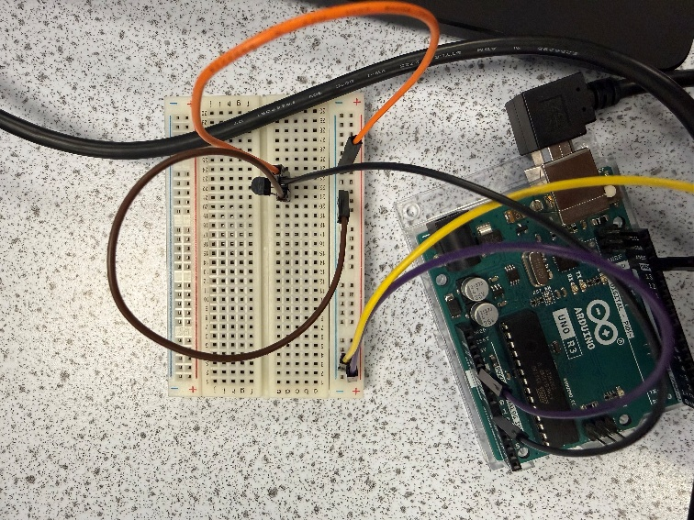
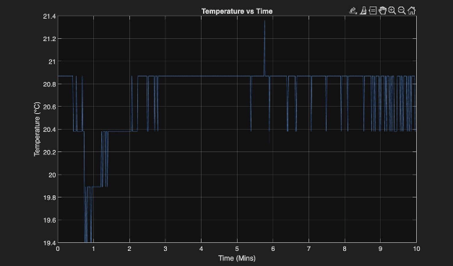
- Include the plot as an image here.

TASK 2 – LED temperature monitoring device implementation
- Include a photograph of the implementation here.
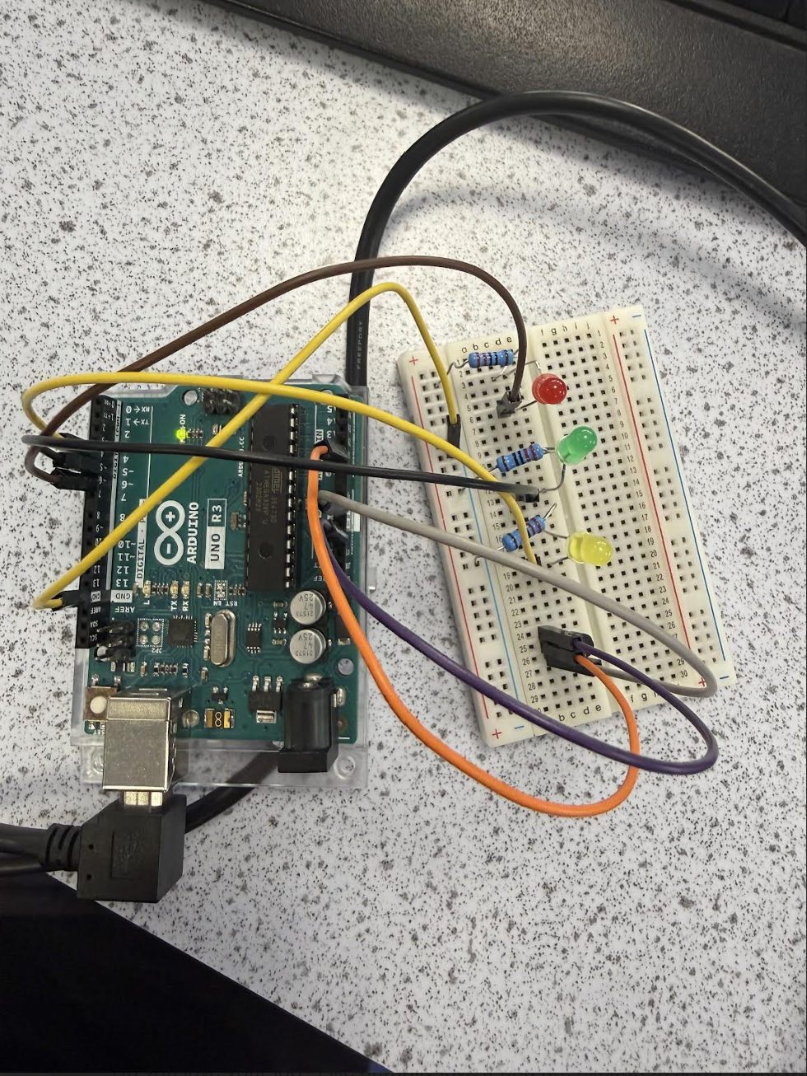
- Include your initial flowchart here.
- 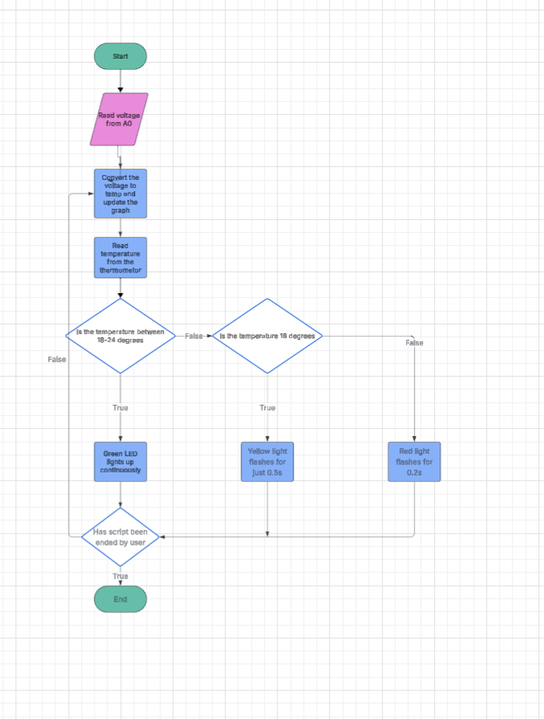

- Include the plot as an image here. 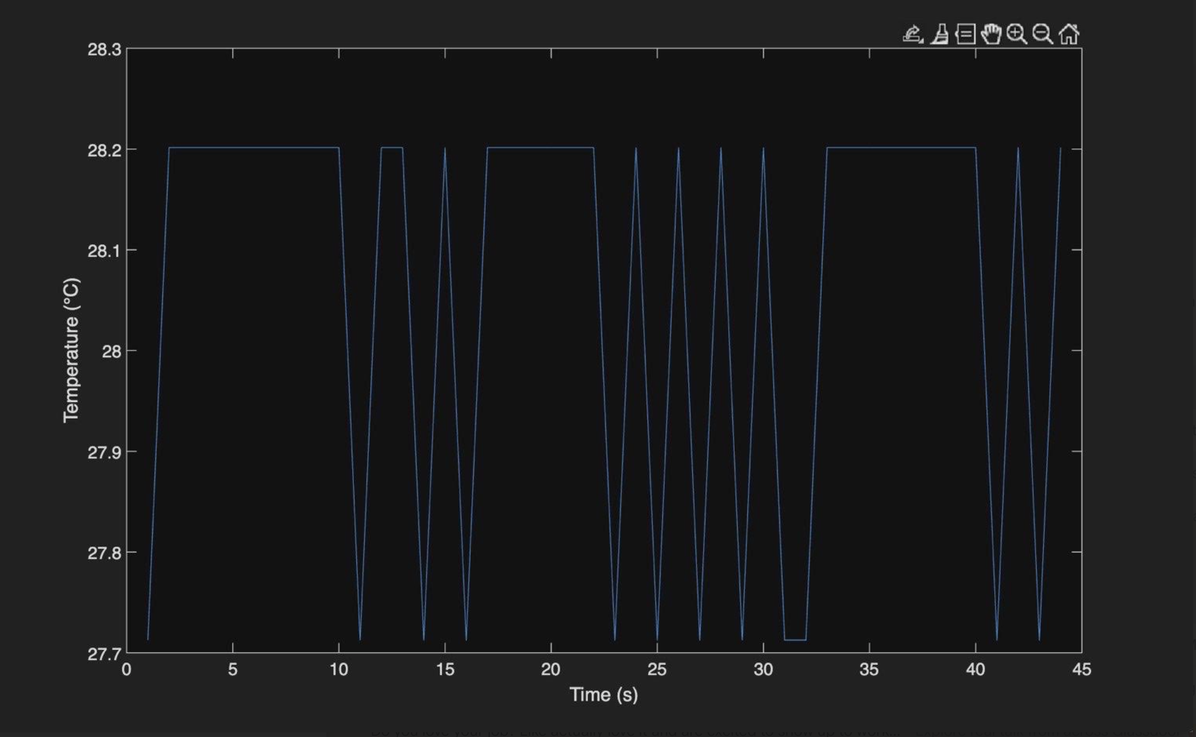

- Include your final flowchart here. 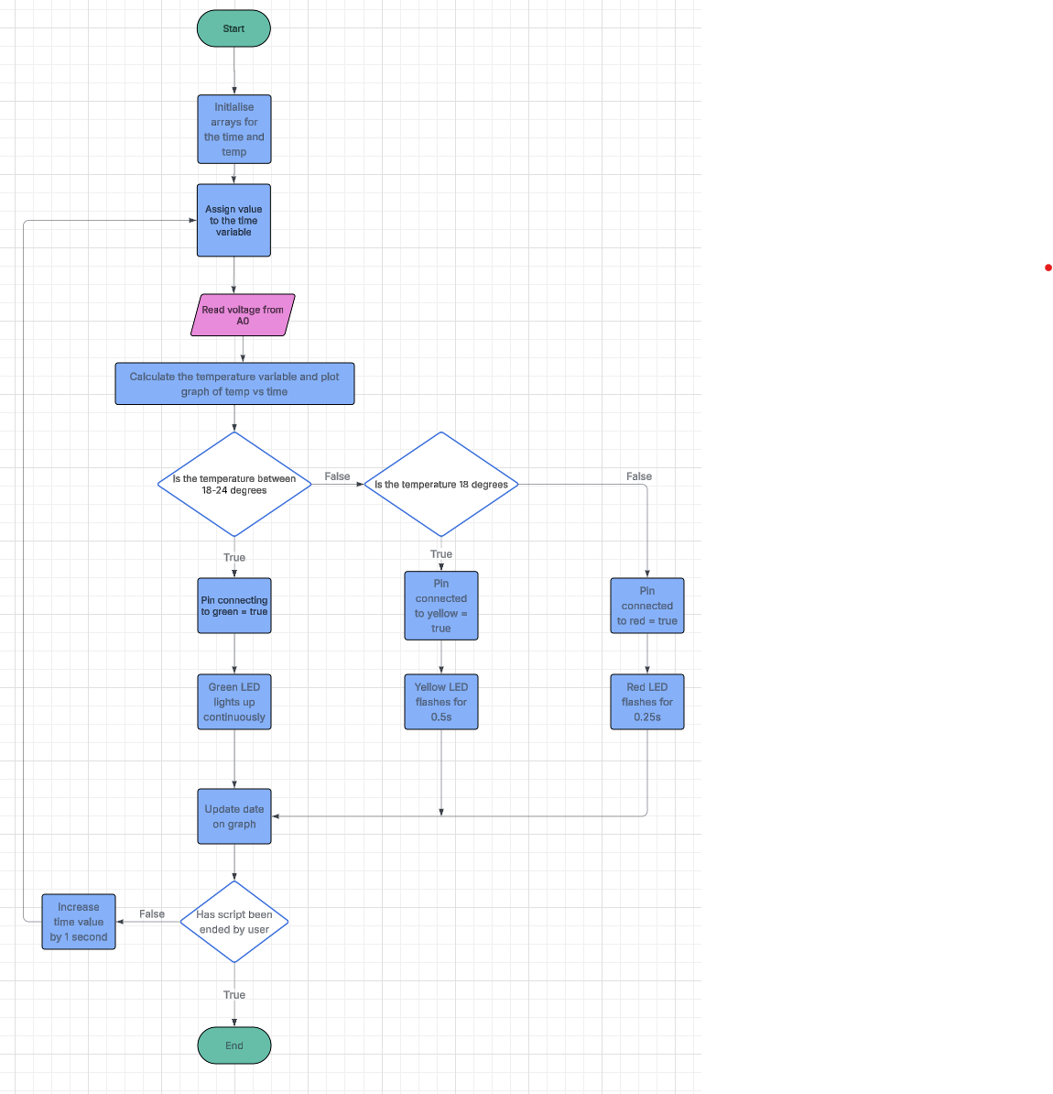

TASK 3 – ALGORITHMS – TEMPERATURE PREDICTION
- Include your initial flowchart here.
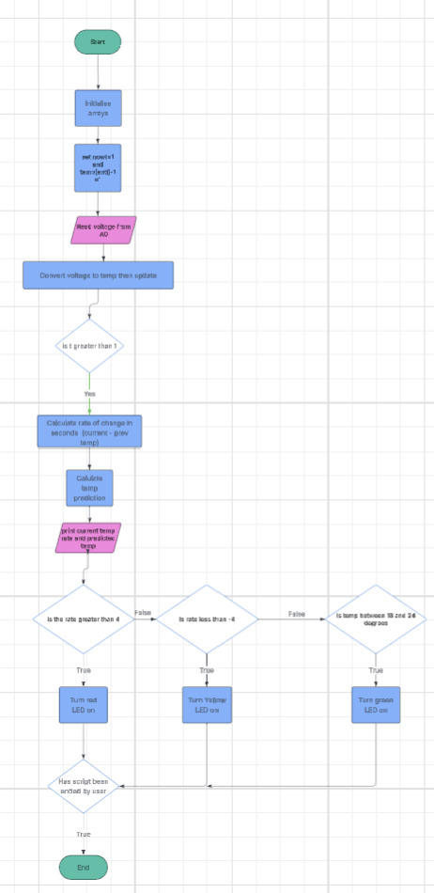

Task 4 – reflective statement
During the project I was tasked with developing a temperature prediction as well as monitoring system using Arduino. A huge challenge I had faced initially was setting up my Arduino and properly connecting it to the MATLAB. Huge fluctuations in my temperature could be initially seen as a result of the voltage readings which weren’t very consistent and occasionally giving non realistic values. I had t pay attention to the wires within my breadboard making sure that everything was well placed and connected properly noticing when wires may be loose which explained the huge fluctuations and unnatural reading in my voltages.

A huge strength of my project is that I was able to successfully complete all three tasks I had been assigned with monitoring the temperature as well as predicting future ones using formulas I had created using the MATLAB code. I used arrays which allowed me to store data and implemented loops to allow continuous data collection as well as updating. These allowed me to gain a much better understanding in the fundamentals of coding. I enjoyed using the Arduino kits as it allowed me to see how my coding had immediate feedback making the assignment more realistic and practical.

One of the limitations that I have noticed particularly in my task 2 graphs were the many fluctuations within my readings this could have been due to like I had previously mentioned possibly loose or faulty wiring withing my circuit which heavily impacted the way in which my data was then collated. Another limitation within the model itself would be its lack of realism this can be demonstrated in real world applications where the temperature can drop suddenly whereas ijn the model we had created it always assumed a constant temperature change which wouldn’t always be realistic.

To improve in the future I would like to use wires that would function correctly or that I ensure I place them correctly into the breadboard because when I initially did the assignment I carried out a lot of time trying to figure out where the large unrealistic values of temperature were coming from spending large amounts of time looking into my code attempting to see where I had made any errors, however it was mainly due to loose wiring. I would also like to improve the structure of my code and attempt to neaten it.

