**1. SQL installation:-**

<https://go.microsoft.com/fwlink/p/?linkid=2216019&clcid=0x4009&culture=en-in&country=in>

1. Install BASIC Version.



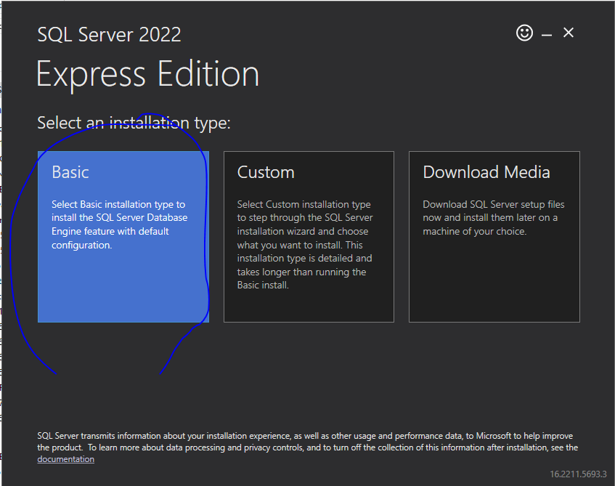

**2. SQL SSMS Installation(400mb)**

<https://aka.ms/ssmsfullsetup>

