IST 263

Lab 09

This lab covers:
- Flexbox
- Centering
- Advanced Flexbox Layout

SETUP
Create a folder in your GitHub repository called lab09. Place a copy of your latest contact page, skills page, and stylesheet in the new folder. Please make sure to keep the same file names in the new folder or your navigation will not work on later labs.

part 1 - Flexbox
Flexbox is a one-dimensional layout method for laying out items in rows or columns. Items flex to fill additional space and shrink to fit into smaller spaces. Download and open the practice file (flexbox.html) in VS Code and you will see an H2 element called "The Flexbox Part".
We are going to position those boxes side by side using flex and ratios. Flex uses a parent and children relationship. What does this mean? If you declare an element to be flex in CSS then its immediate children elements will display side by side. In our case we are going to declare the div container with a class of part2 to be the parent. That means the 3 article tags are that element’s immediate children.

Practice
- Add a style to the embedded style sheet to make the part2 div flex.
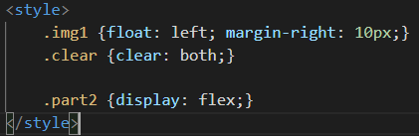
Reload the page and you should see that all the articles are side by side.
- Let's assume that the first article is the most important and you would like it to take up more space. We are going to assign a ratio for the size of the three boxes. This is done by using class selectors for each box and using the flex property with an integer for the ratio. In this case I'm going to make the first article double the size of the other two. Add the styles below and refresh to see what happens.
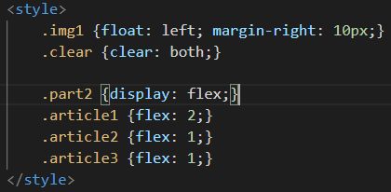
- One of the cool things about flex is that you can change the order of the items that layout without moving the content around. In our case we are going to reverse the order of the boxes in the layout with the order property. The value will be what place in the layout you want your box to occupy.
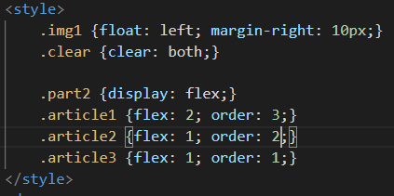
- All the text is squished together in our layout so let's add some space between the article elements. You can do this with simple margins and a grouped selector.
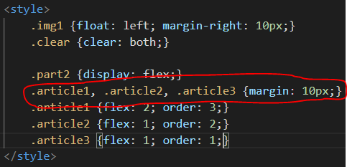
- This is the perfect time to show you the non-flex layout trick of rounding corners. We're going to apply it to the first article in the Flex part (which is actually displaying as our last because of order). Start by putting a background-color on article1. Rounded corners are accomplished using the border-radius property. The number after describes how rounded you want the edge.
I'm also adding some padding with a descendant selector so that there is white space around the box with this article.
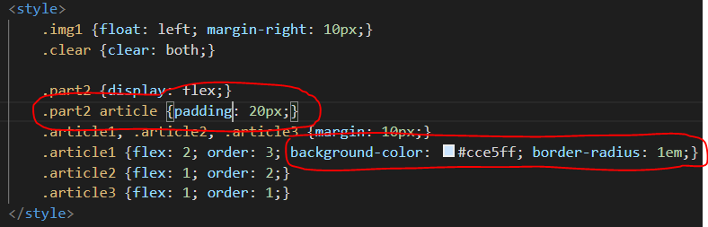

Now you try it
You are going to do an organized layout of your contact page. This is what mine looks like:
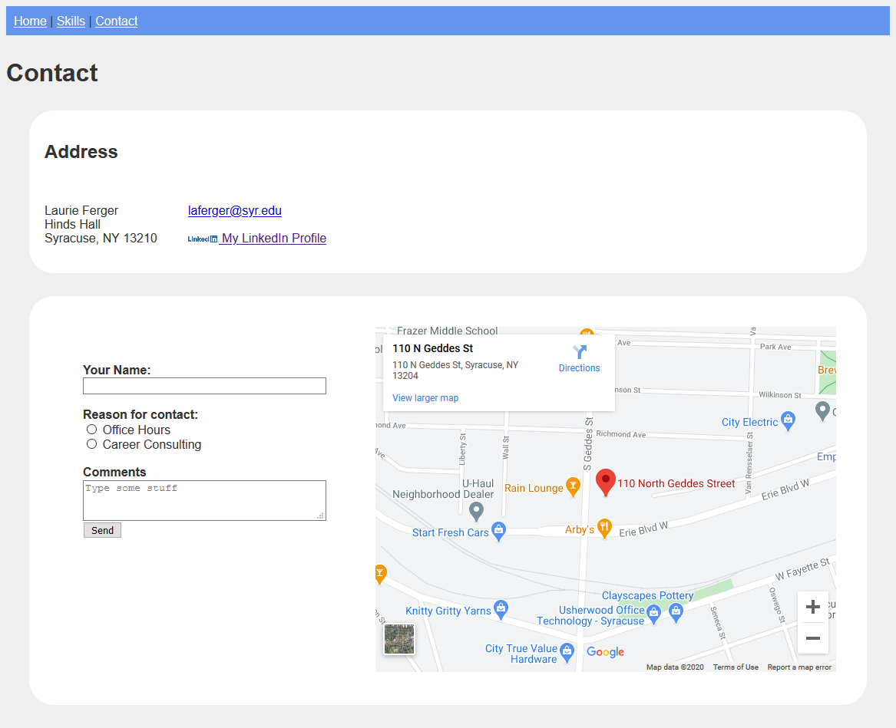
- We are not changing anything about the nav or page header (contact heading) layout so we’re don’t need to do anything with them for this part.
If you look at the rest of the page above you can convert it into two rows with two columns. Here’s how I’m thinking about it. I’ve outlined the first row and columns in red and the second row and columns in green.
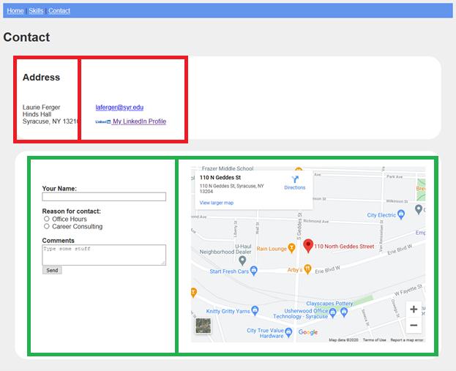
- We will be using flexbox to lay this out so start by typing all the div tags you need to make these rows and columns. You should have this:
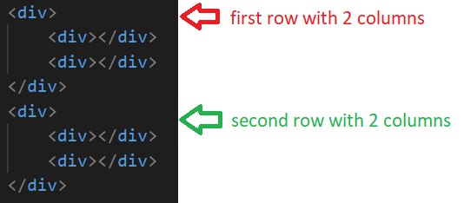
- We have 4 pieces of content that we need to move into the div tags we made above.
Row 1 is: address in the first column / email and linked in links in the second column
Row 2 is: form in the first column / map in the second column
Move the content into the div tags in the correct location and be careful. For example, make sure you get the form tags and everything inside them when you move the form into row 2 column 1.
- Using flexbox position the first row's content (address and links) side by side. If you need to look back at examples of the properties, look at the practice at the beginning of this lab or notes from class.
Layout for this part will use the CSS properties flex and display.
- What flex properties are needed to make the content appear side by side?
- Make sure you do not have tags overlapping incorrectly.
- Where do you need to add class attributes and values so you can apply styles?
- Where do you need to add padding or margins to allow for whitespace?
- Using flexbox position the second row's content (form and map) side by side.
- Your layout must contain the following:
  - Background colors on both boxes
  - Space between edge of the page and flexboxes.
  - Rounded corners
  - Space between top and bottom containers. (Your two rows shouldn’t look squished together)
  - Space inside the containers.
  - Form and map should not look like it's squished to the left. Allow it to fill the space.
  - Everything must have adequate whitespace.
  - Work on the appearance of your form. Now is the time to make sure it looks good.

part 2 – Centering & More Flexbox
Now we are going to change our layout on the skills page. Here’s what our page is going to look like when we are done.
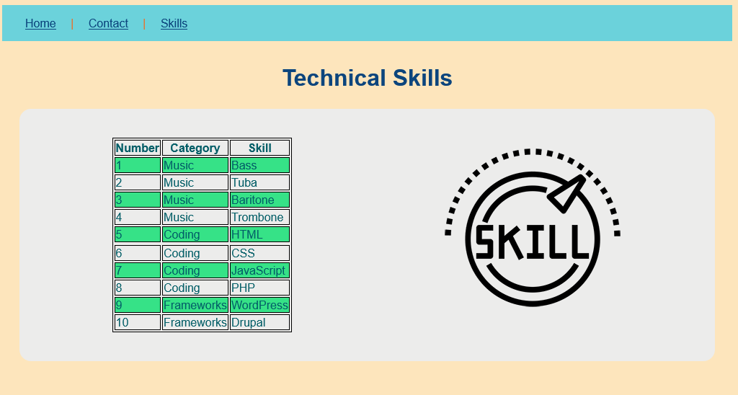
Spend some time thinking through where the rows and columns are in this design. Scroll down when you want to look at the solution I came up with.
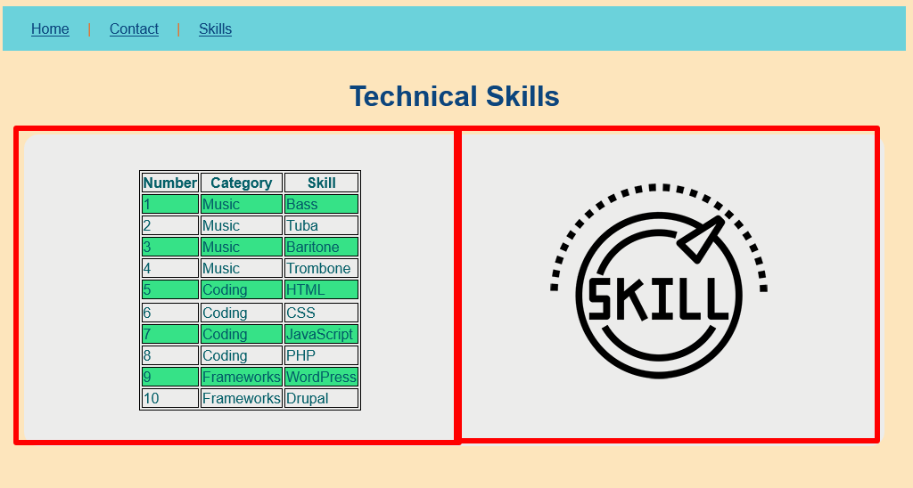
The red is a flexbox with two columns. Let’s go through the steps to create this entire page.

Centering
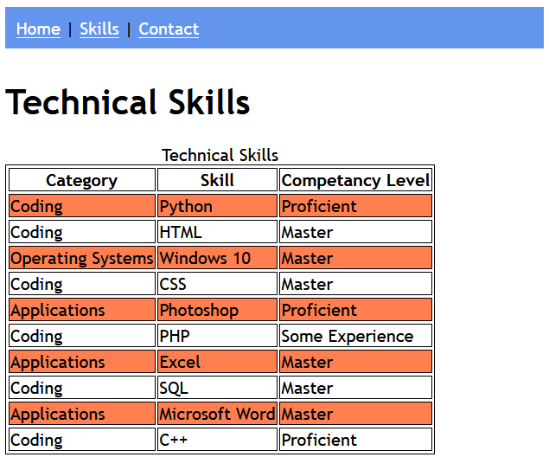
Let’s start with our existing skills page.
We talked about three ways to center horizontally based on the item you are trying to center.
Inline - Is your item inline? Then you use the text-align property.
Block - Is your item block? Then you can center with margins or flexbox.
- Add a main heading to the skills page with appropriate text. I called mine Technical Skills. Here’s what my page looks like after I add the heading.
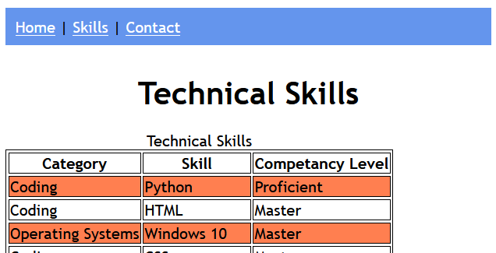
- Center that heading over the page using one of the techniques we discussed. Note: I want you to practice the techniques we learned in lecture so points will only be allotted for this section if you use one of the techniques. Here’s what my heading looks like after the header is centered.

More flexbox

- Below your “Technical Skills” heading and before your table, create a flexbox that uses some of the same elements from our Contact page. It will have two containers named “skillstable” and “skillsimage” inside the flexbox.
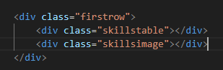
- Move your entire table into the “skillstable” div. Be careful to move the enter table, from <table> tag to </table> tag, inclusive.
- In the “skillsimage” div, add this image (you’ve added images in previous lessons):
https://peopel-su.github.io/ist263/images/skill_3775447.png
My page now looks like this:
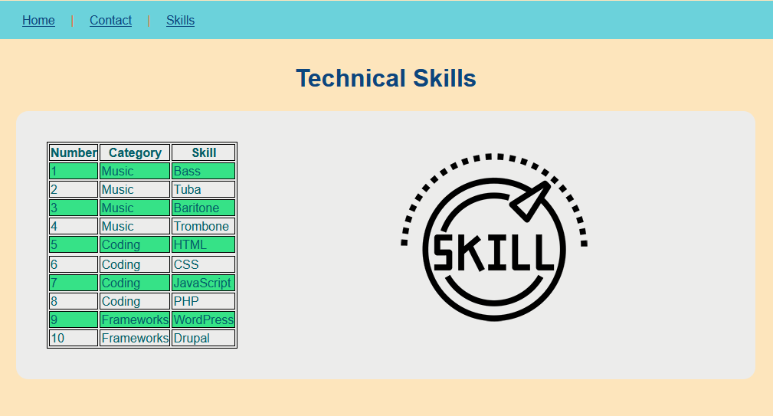

- Next let’s center the table in its container. In your styles.css, add a rule with the selector as “.skillstable table”, property of “margin” and value of “0 auto”. This was one of the centering methods we discussed in the lecture.
- The last step is to center the image in its container. Add a rule with the selector as “.skillsimage”, property of “text-align” and value of “center”. This was another of the centering methods we discussed in the lecture.
- As we also discussed in the lecture, use the “flex-basis” property for both .skillstable and .skillsimage, setting them both at 50%.
- Save, commit, and push origin for all your files.

What will You hand IN?
Create a word document, pdf or use the "write submission" option in blackboard to provide the following:
- Submit the URL for your contact page.
- Validate the contact page and submit the validation link.
- Submit the URL for your skills page.
- Validate the skills page and submit the validation link.
- Submit answers to the following:
  - What questions did you have about the lab? What didn't you fully understand?
  - What was the hardest part of the lab?
  - Rate your comfort level with this week's topics.
1 ==> I can do this on my own and explain how to do it.
2 ==> I can do this on my own without any help.
3 ==> I can do this with help or guidance from others.
If you choose this level, please indicate HOW this person helped you.
4 ==> I don't understand this at all yet and need extra help.

