IST 263 Project Milestone 3 – Site Media
Name: Amanda Simone
Description:
I am going to make a photography portfolio with my work from the past couple of years. I intend to add my favorite/best pictures and a description of my creative process with each one. I may also add my graphic design projects from last semester and a description of each of those, as well. My intention is to have a professional portfolio of my photography because I have done it as a job and as volunteer work for a number of years.

3 Pages: Include some information about what will be on each of the three pages in your website.

- What will be on the home page?
  - about me page
  - photography experience and style
  - overview of what else is on the page
- What will be on the 2nd page?
  - photography work
  - descriptions of each
- What will be on the 3rd page?
  - graphic design projects
  - descriptions of each

URL to Images on Github:
Login to github.com and navigate to your images folder for the project. Copy the url and paste it here. | https://github.com/asimon15-su/ist263/tree/main/images

Example Site Media Entries
Media Thumbnails | Page | Usage Rights | Citation (if applicable)
 | Home Page | Creative Commons License
Video: https://youtu.be/pQN-pnXPaVg | About Page | NA
 | Home Page | I own this image

NOTE: You need to legally use all your images. The options for usage writes should be: I own this, creative commons, free stock, or some other way you legally use the image. Embedded content gets the NA (not applicable).

Your turn! Enter your images below. FYI – the images you find need to be quite large to look good on your website. If the image you find is tiny, keep looking.
Media Thumbnails | Page | Usage Rights | Citation (if applicable)
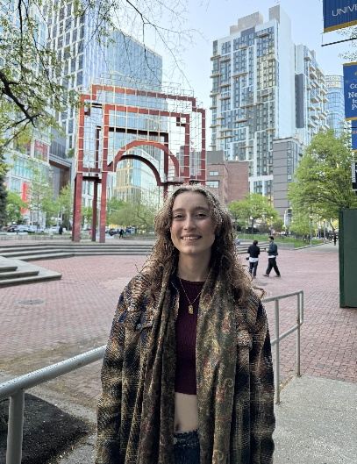 | 1 | I own this photo
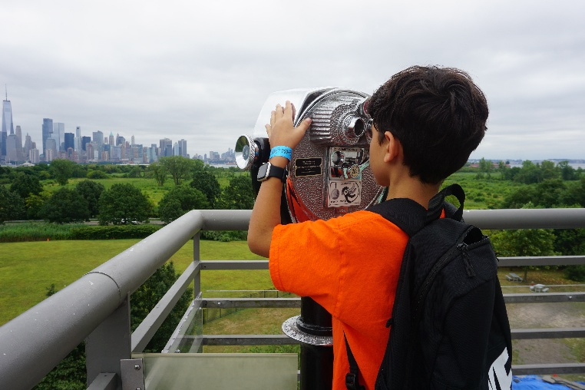 | 2 | I own this photo
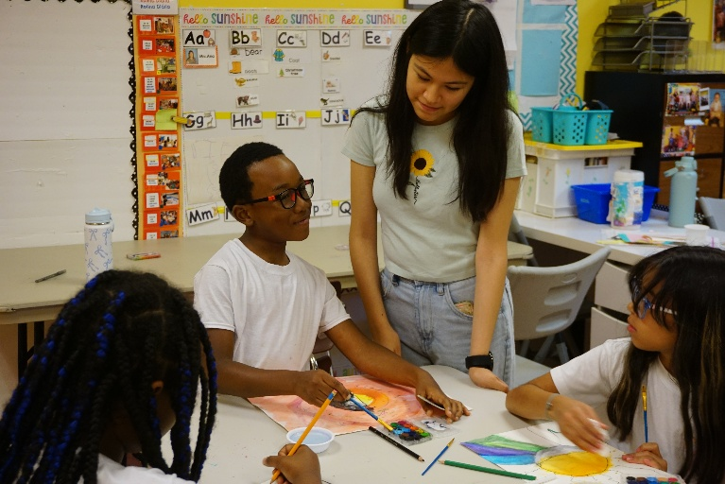 | 2 | I own this image
 | 2 | I own this image
 | 2 | I own this image
 | 2 | I own this image
 | 2 | I own this image
 | 3 | I own this graphic
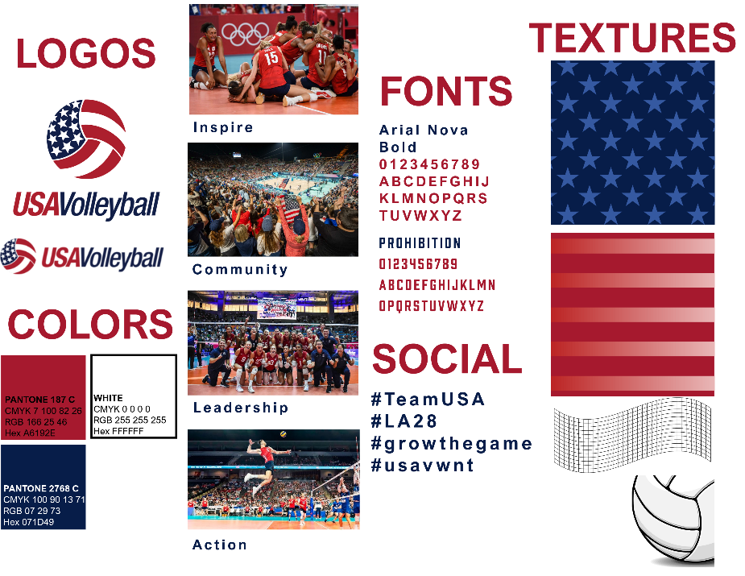 | 3 | I own this graphic.  Details found on public USAV EPK.

