Assignment 1
Vikas Kurapati
130010058

Question 1:

The streamlines of the flow given with freestream velocity and a source and a sink (rankine oval) is given by :
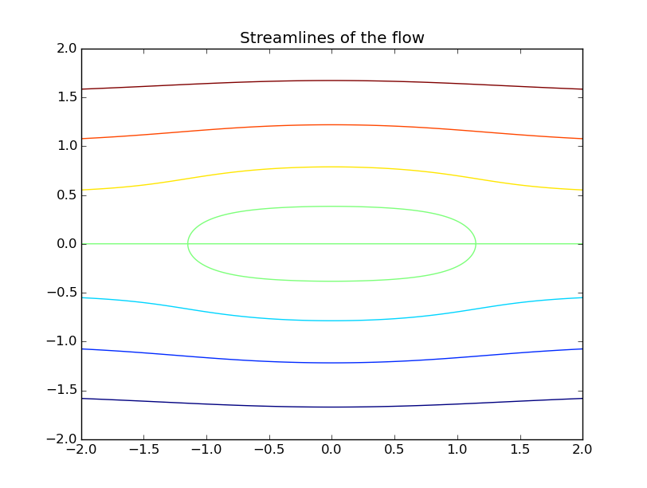

The potential lines of the same flow are given by:
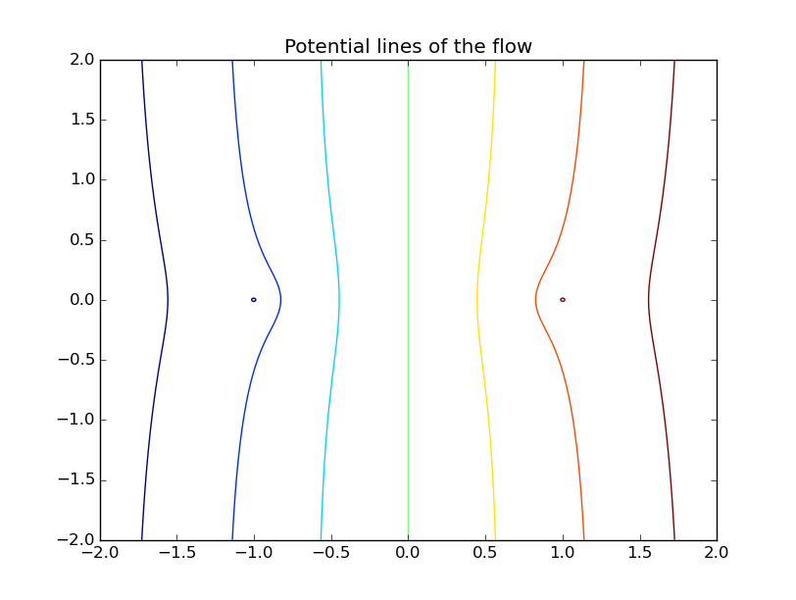
Question 2:
The trajectories of the tracer particles by Euler and Runge – Kutta(second order) schemes are given below:
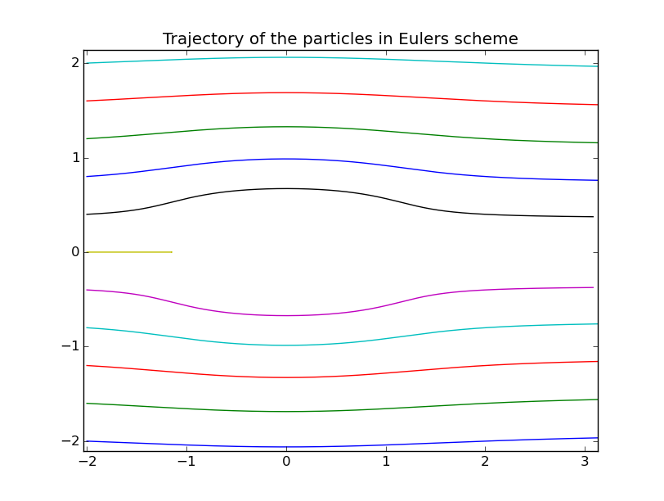
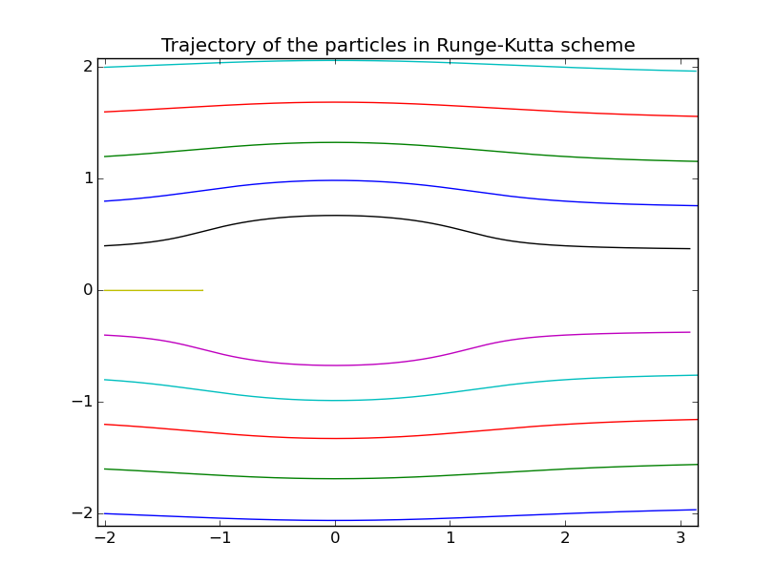
Both the schemes show the trajectories to be close to the streamlines of the flow and also, the the particle along the x-axis stops when it gets close to the source.

Question 3:

Two point vortices in isolation in motion under the influence of eath other is shown below and is compared with the actual solution (which is a circle)

In all the cases the total time of simulation is kept to be constant of 10

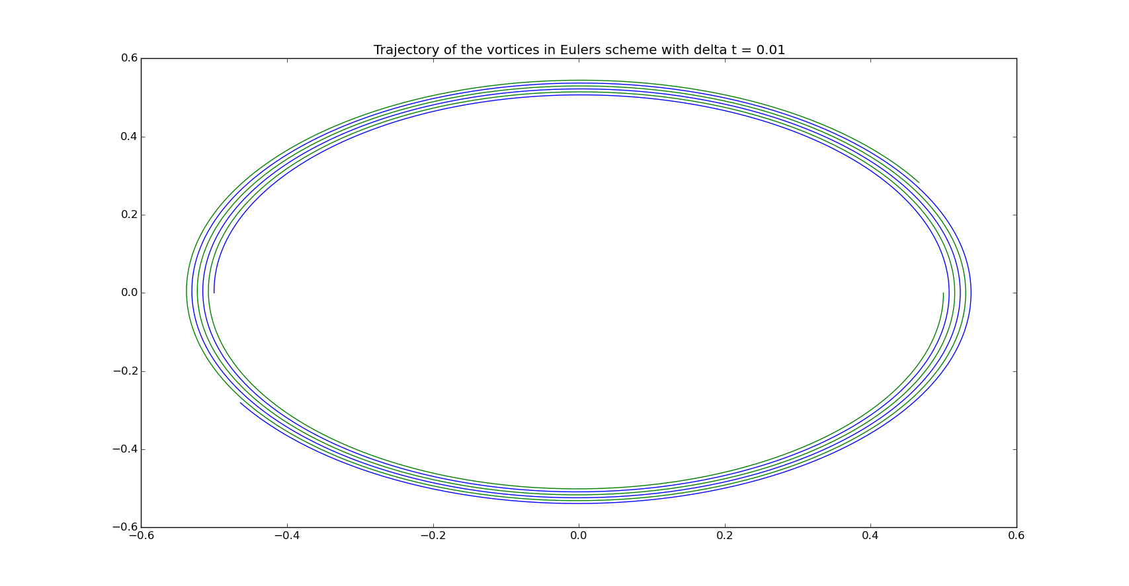
Euler schemes with different size of time step:
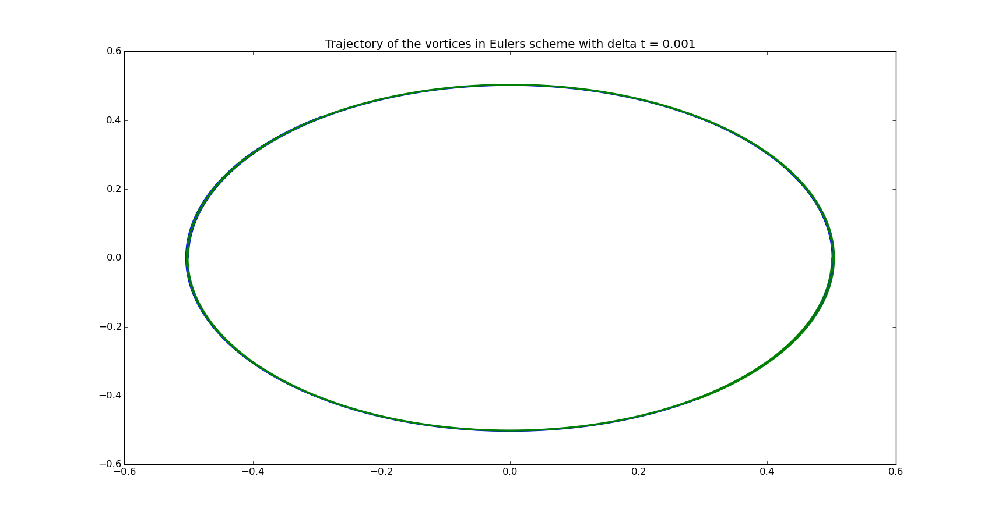
Here, it shows that in Euler's scheme, the flow solution goes closer to the actual solution as the size of the time step is decreased.

Runge-Kutta scheme solutions with the same step sizes and total time :
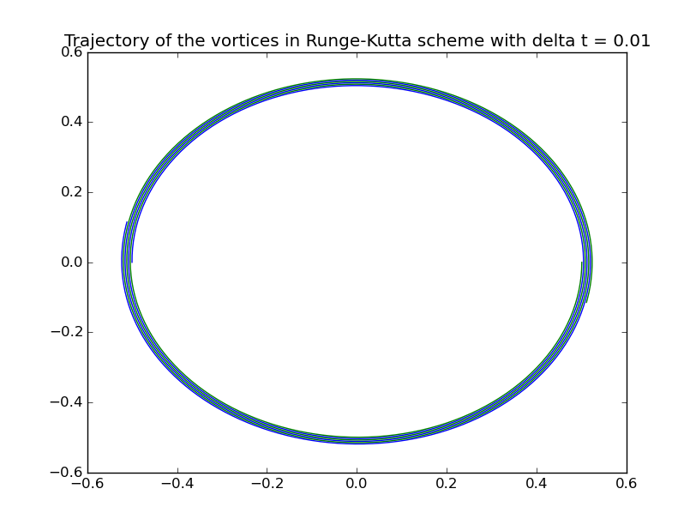

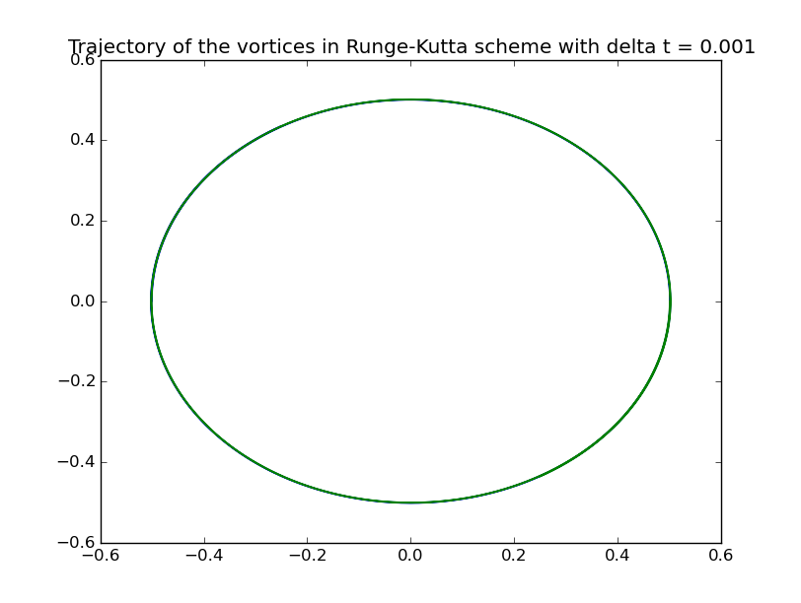
Here, it can be clearly seen that the solution gets better i.e., approaches closer to the integral solution as the time step is decreased.

And also when two schemes are considered, for a constant step size, it can be clearly seen that Runge-Kutta scheme is better than Euler Scheme.

