Team E Pecunia

WEB API DEPLOYMENT

ON AZURE

Preface

Web API is a set of subroutine definitions, protocols, and tools for building software and applications so by using web API any third party can consume a service just by calling that API and use those service. So this document is about how to deploy a Web API on a cloud and consume those services. We have deployed our Pecunia project in on cloud using PecuniaBankingTeam web app and then consumed that service using Html.

Step1

To deploy Web Api project on we need to create web app. To create Web App we have to select app service on Azure portal.

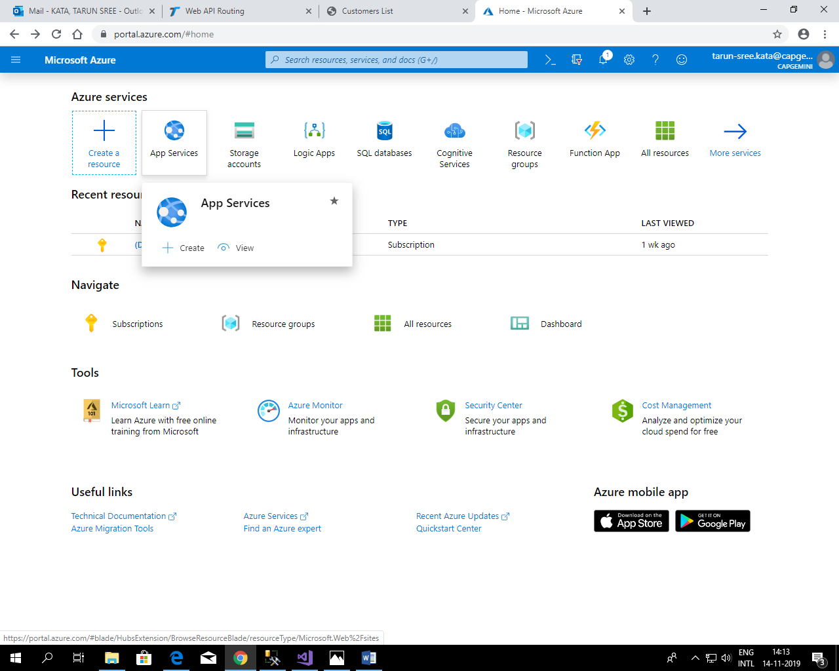

Step 2

Next we have to create new Web App by selecting on Add button

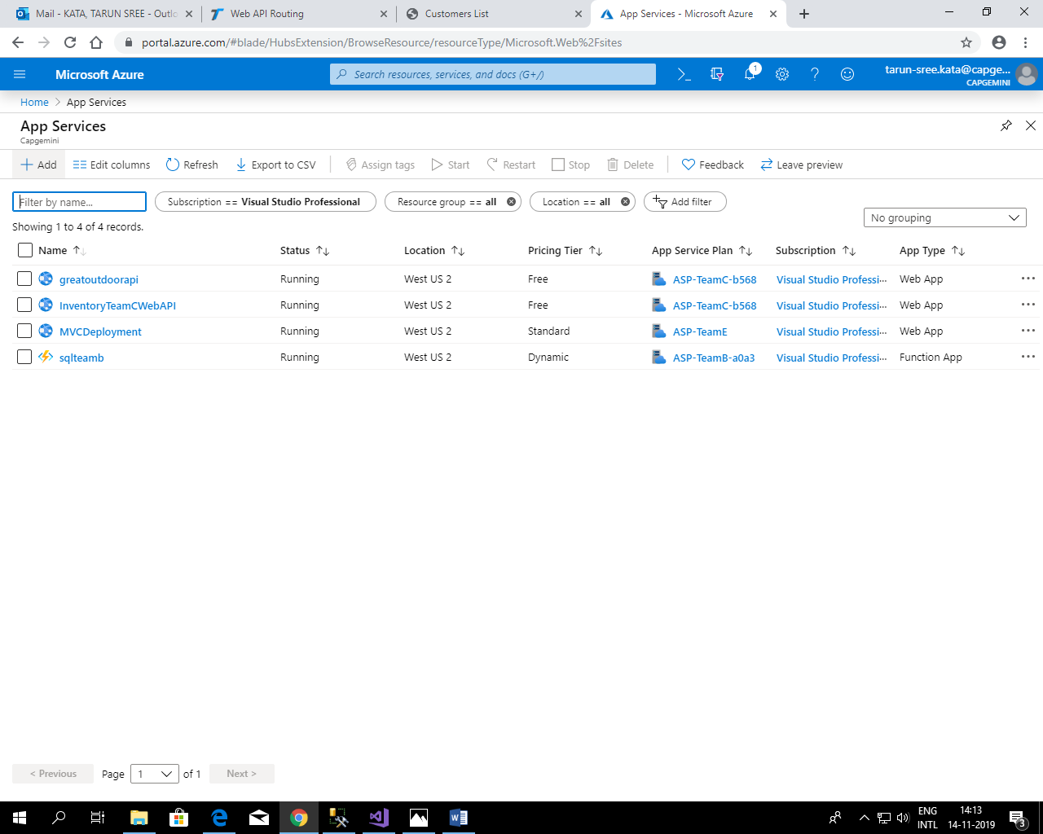

Step 3

After adding new web app we have to configure our app 1st we have to add new resource group define app name set runtime stack as ASP.Net with version similar to in which you devloped Web Api , select region according your convineance.

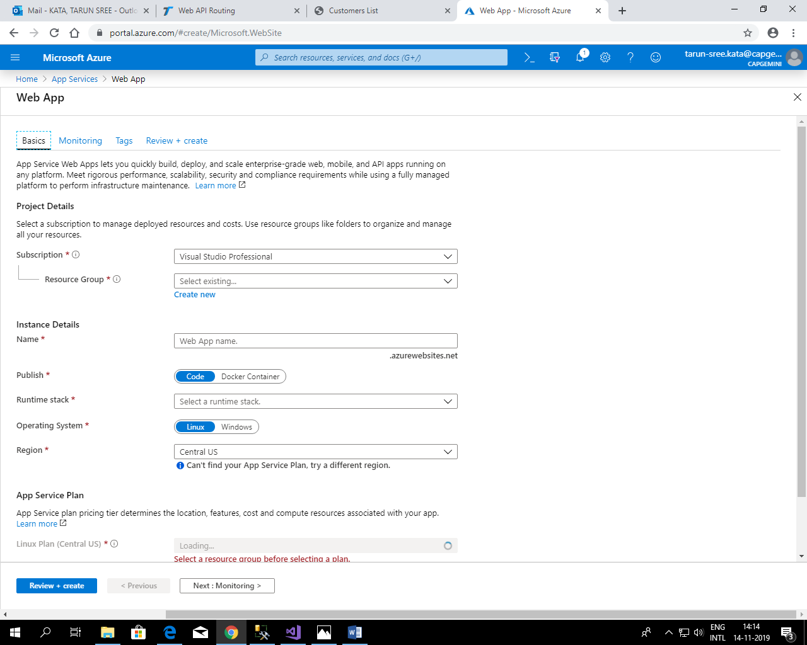

Step 4

We have to enable pplication insights for monitoring and pplication insights will be automatically selected.

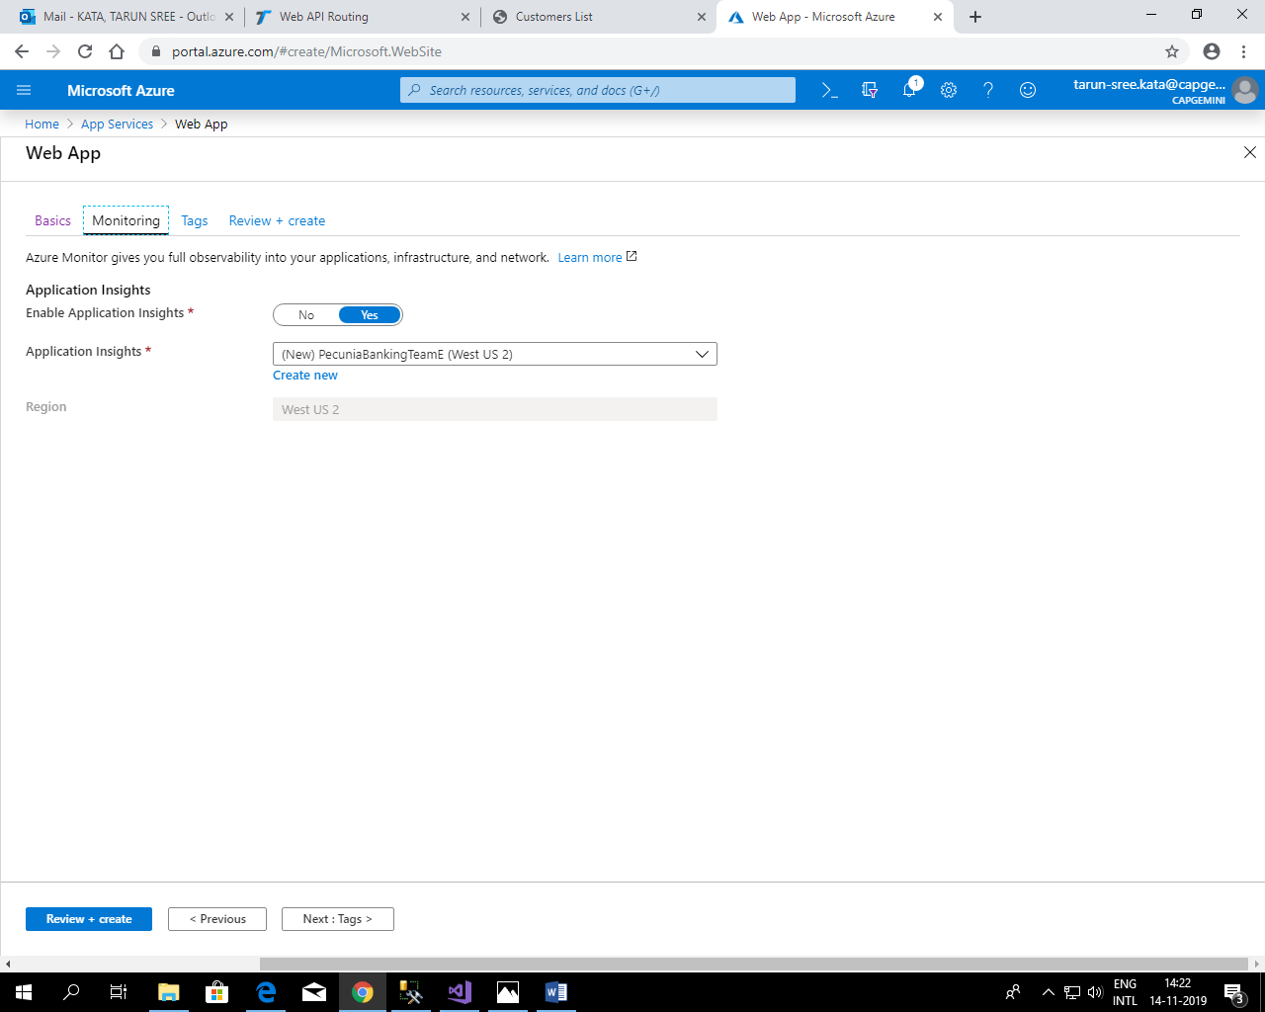

Step 5

After configuring we have to review and create our web app setting and then we have to start deployment after deployment our web app will be created.

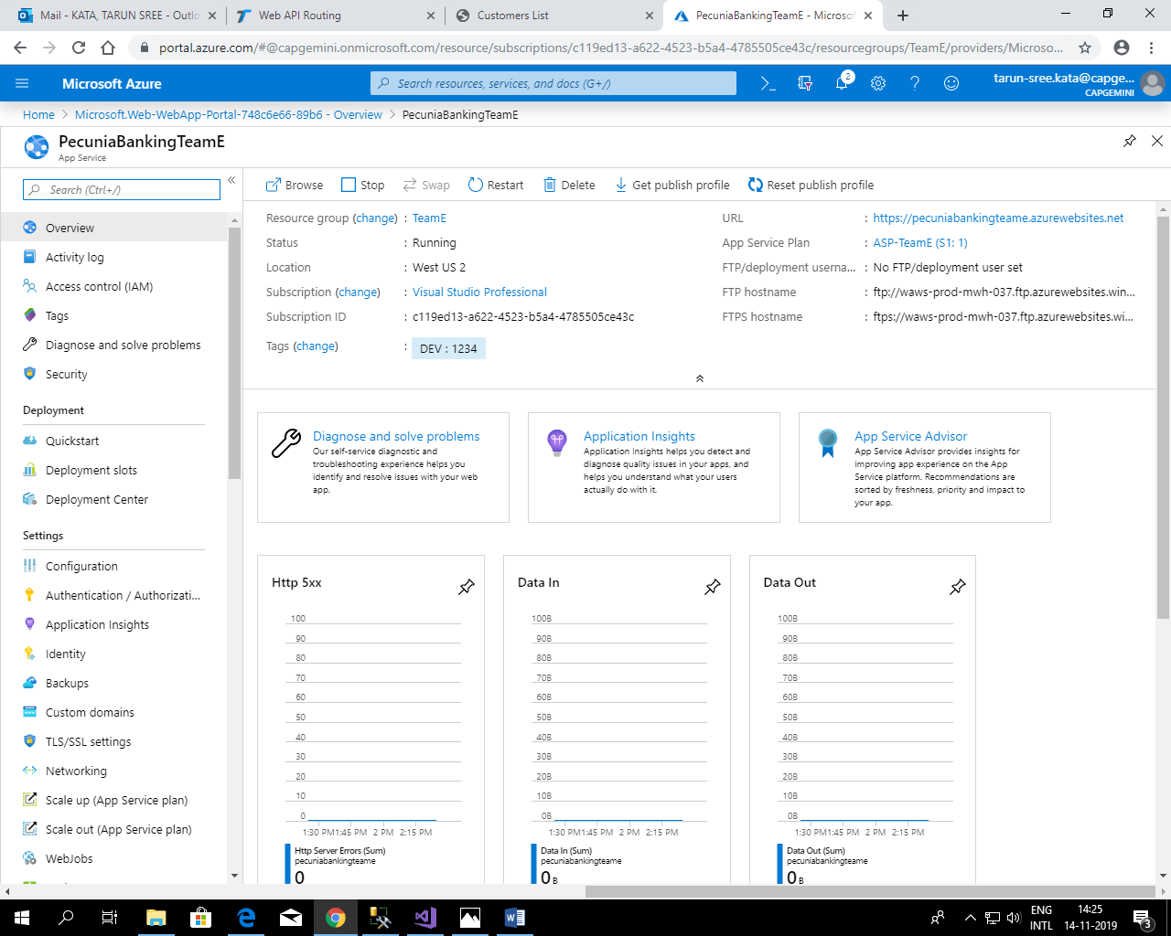

Step 6

After sucessfully deploying the web app now we have to publish our Web Api in our web app. We will publish our solution after selecting publish.

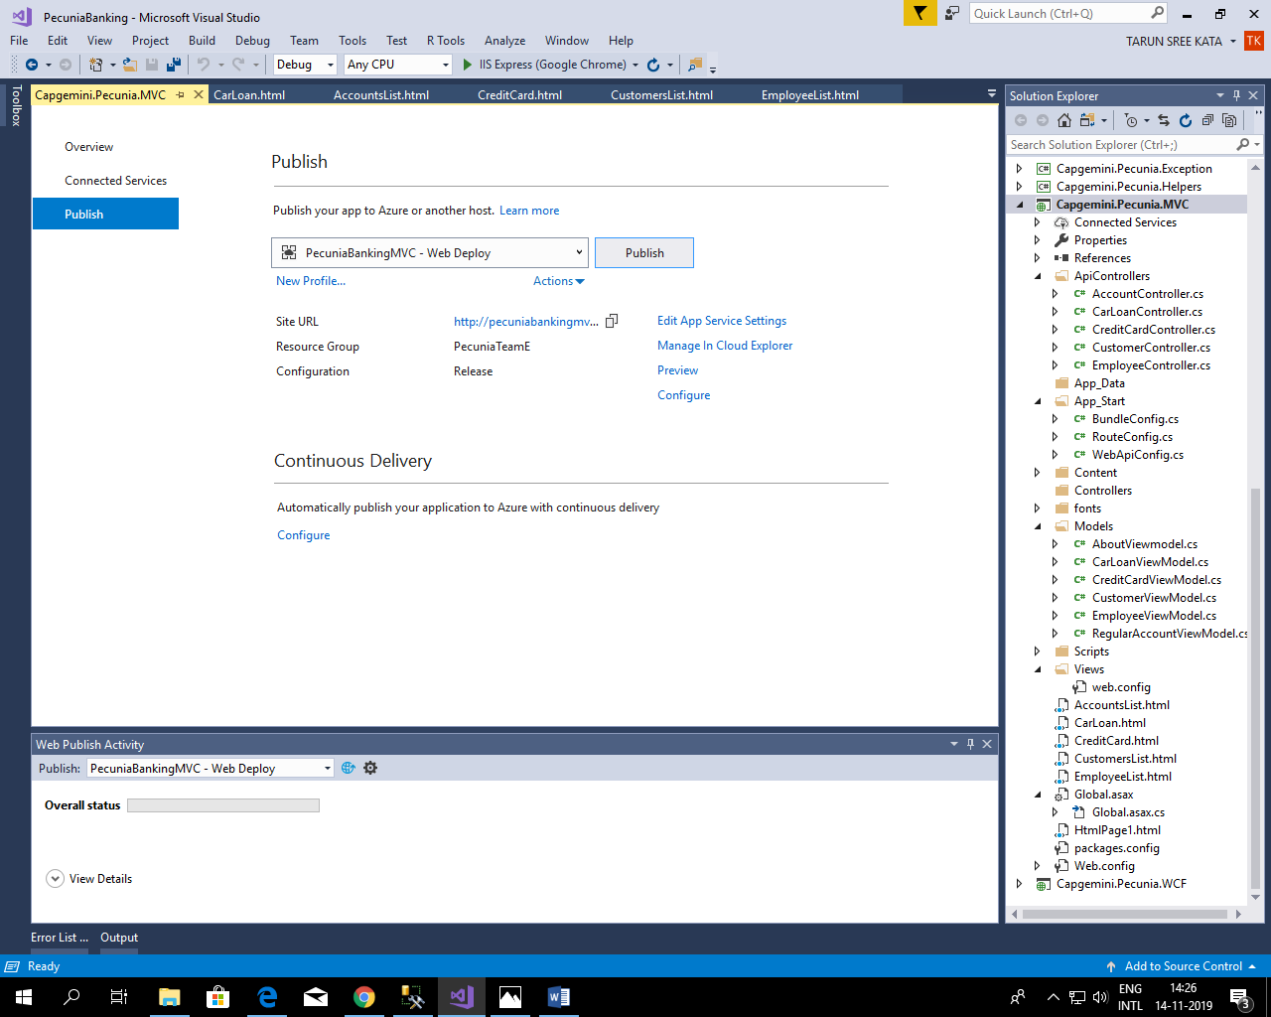

Step 7

After selecting we have to publish in already deployed web app so we have to select existing.

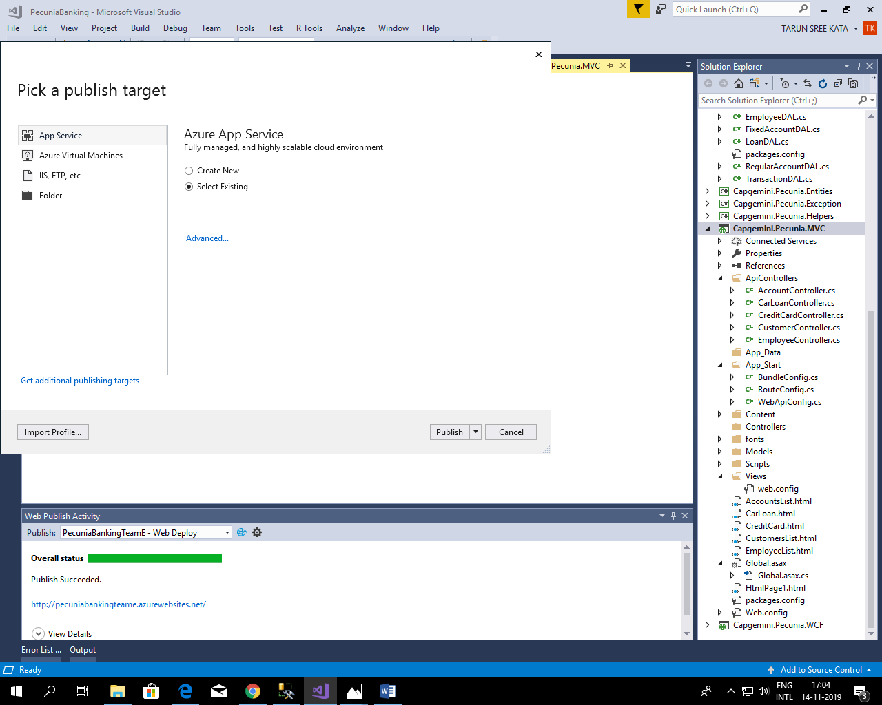

Step 8

After selecting existing web app we have to configure our publish setting , we have to select precompile before publishing.

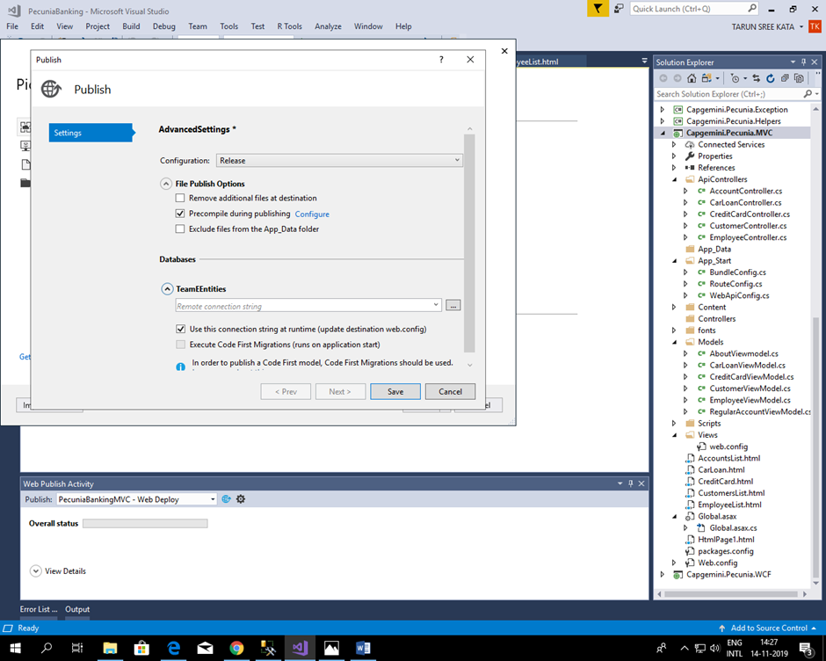

Step 9

After selecting existing web app we have to configure our publish setting , we have to select do not merge and create a separate assembly for each page and control.

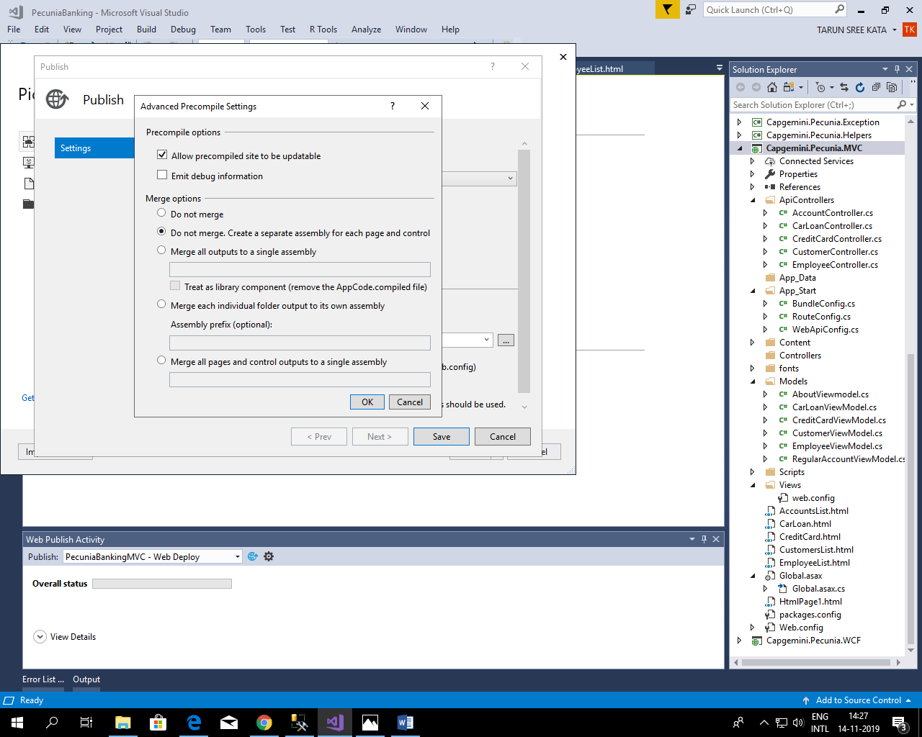

Step 10

After selecting existing web app we have to configure our publish setting , we have to create a connection string to link our azure database with Web api.

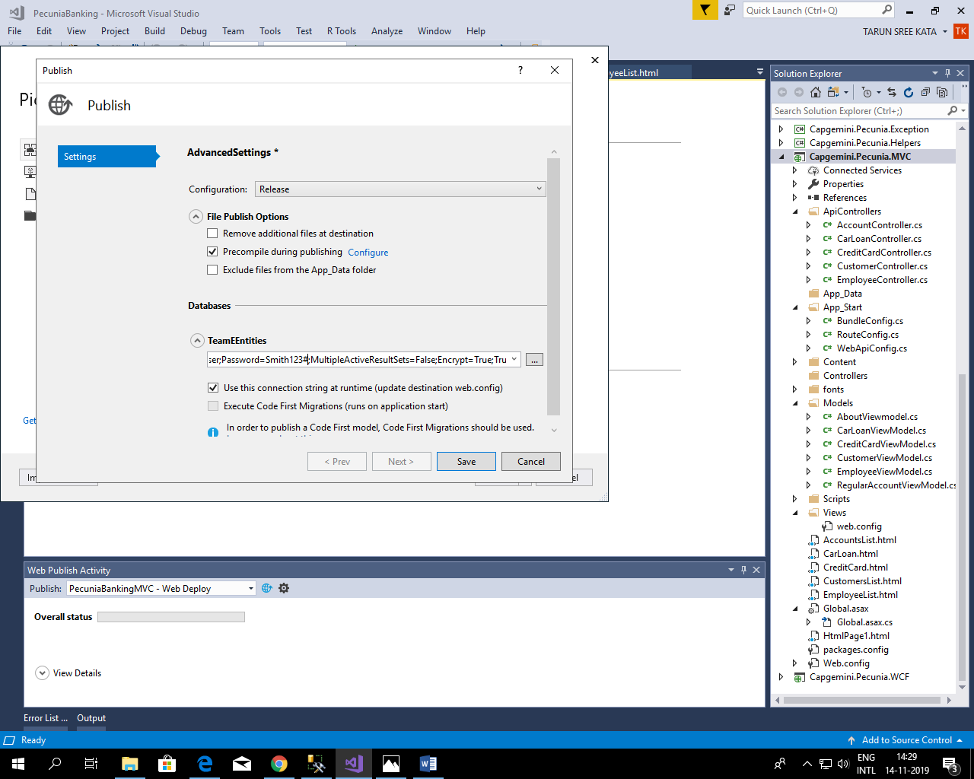

Step 11

After connecting with database we have to link with which web app we have to select for deployment.

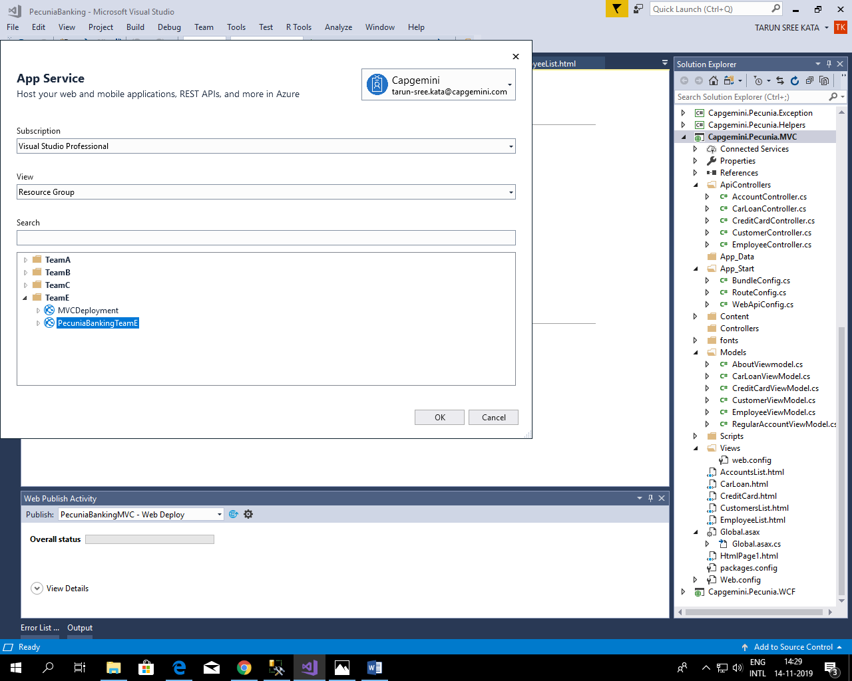

Step 12

After sucessfully establishing database connection we have to configure web api by selecting App service editor.

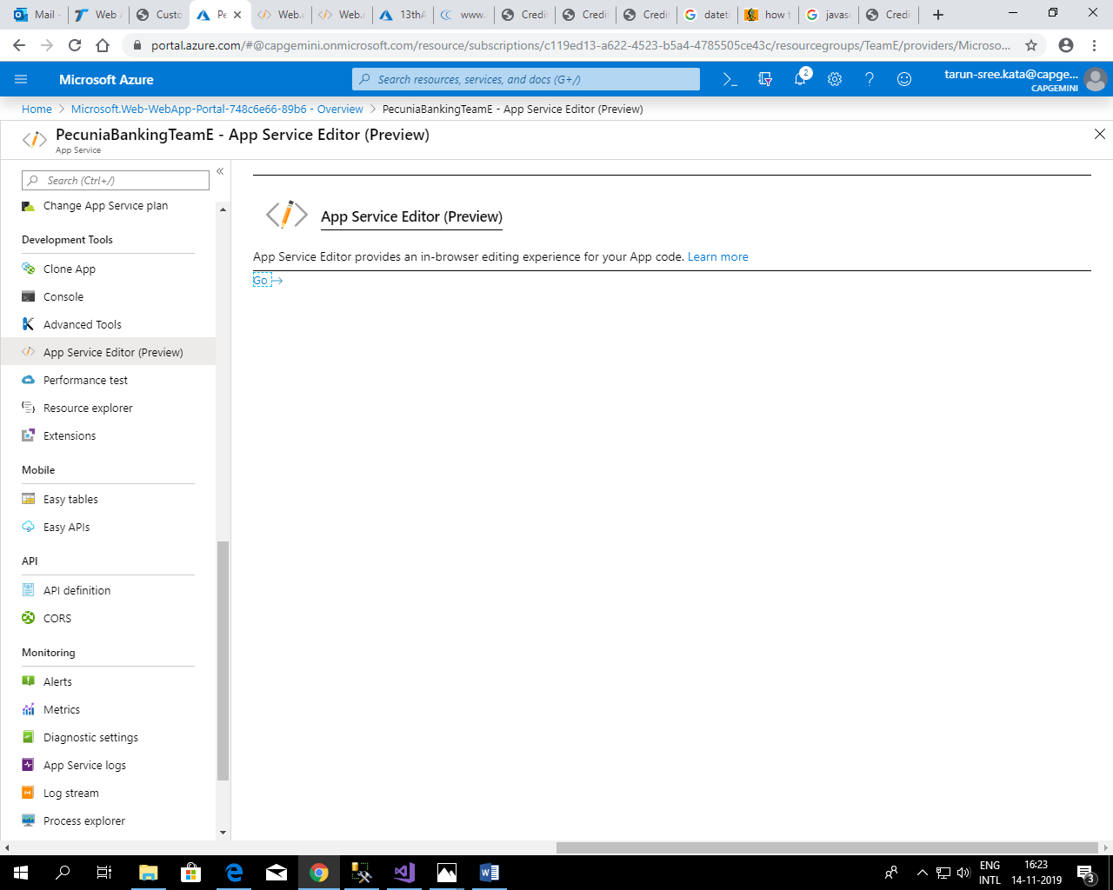

Step 13

We have to now connect it with our web app with our data base using data connection.

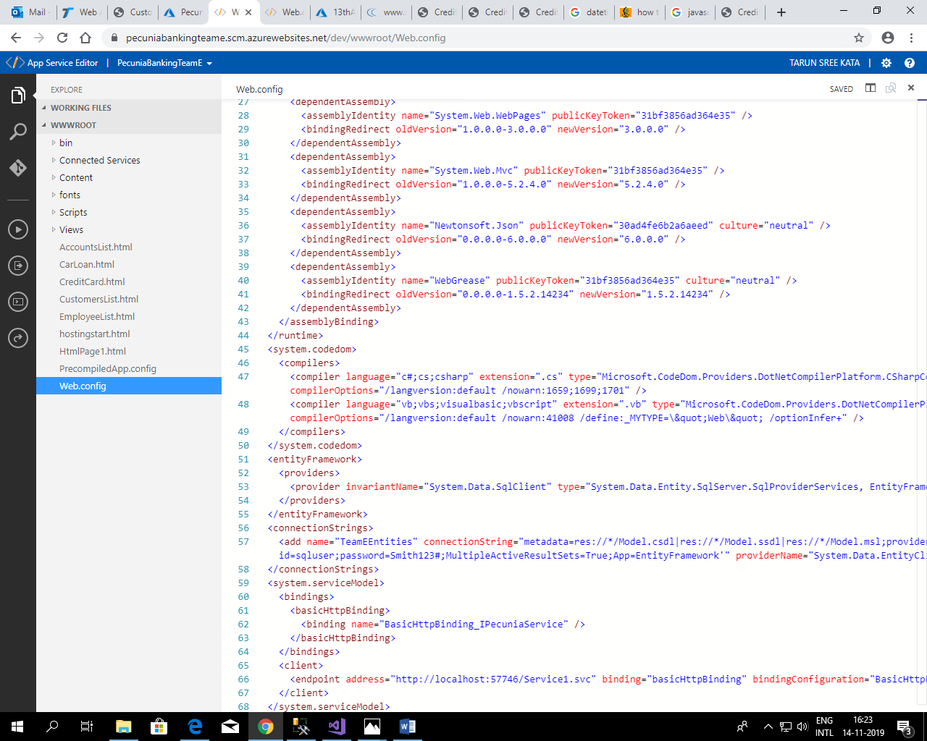

Step 14

After connecting app service with data base now we will publish our solution.

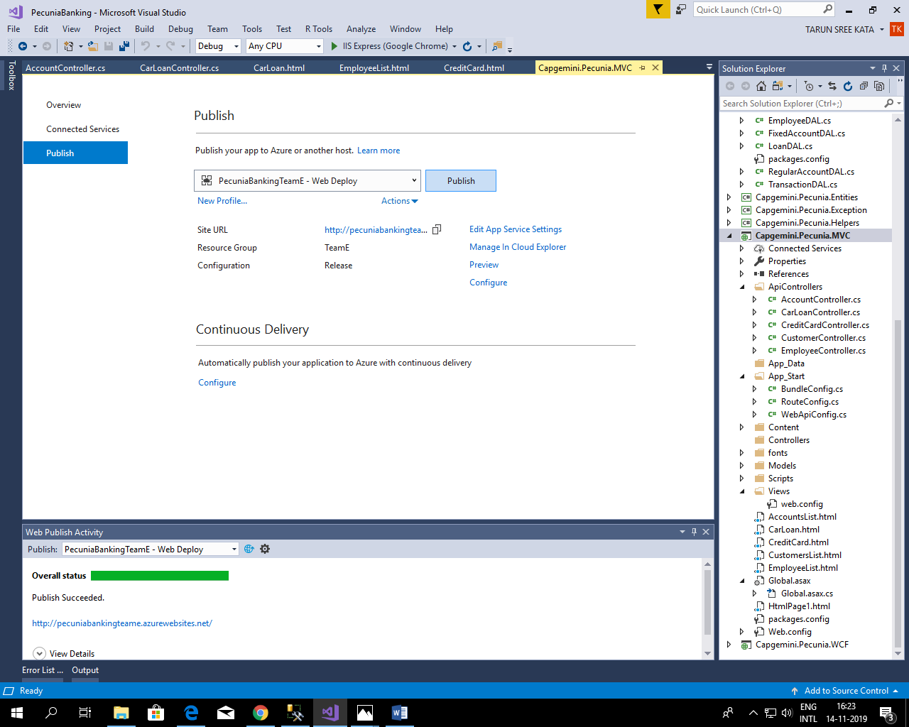

Step 15

Employee List.

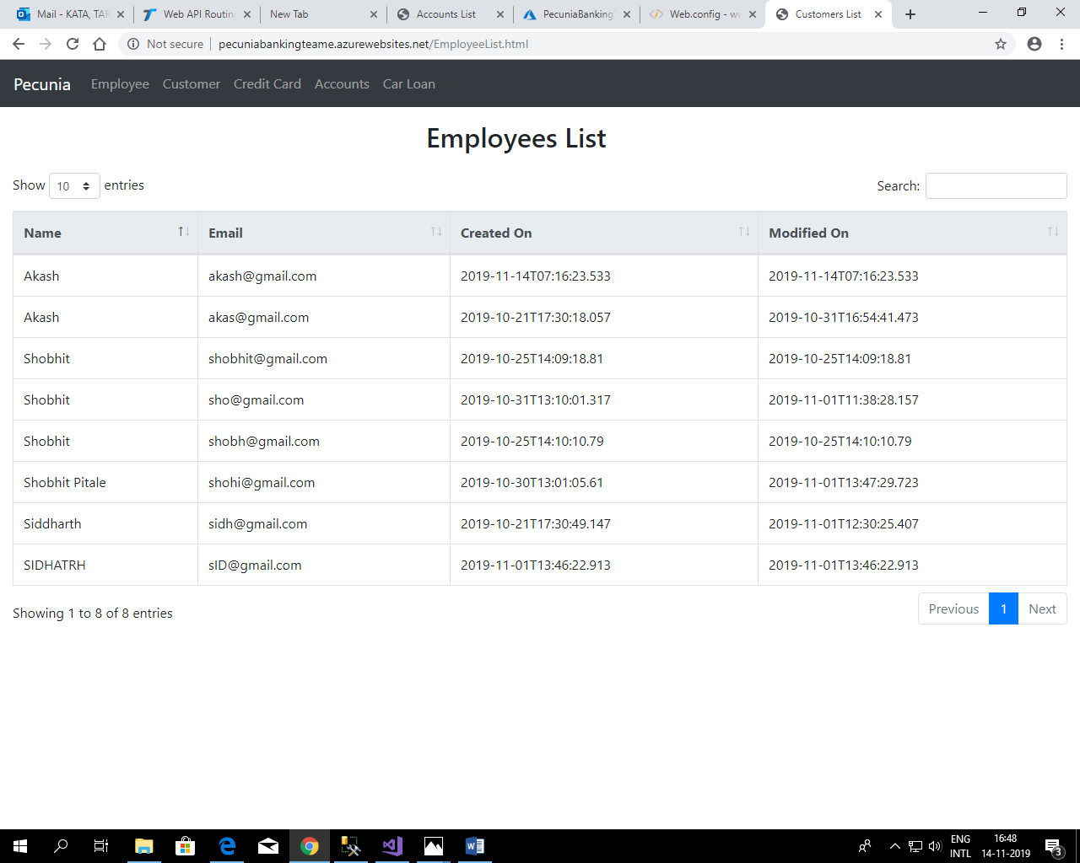

Step 16

Customer List.

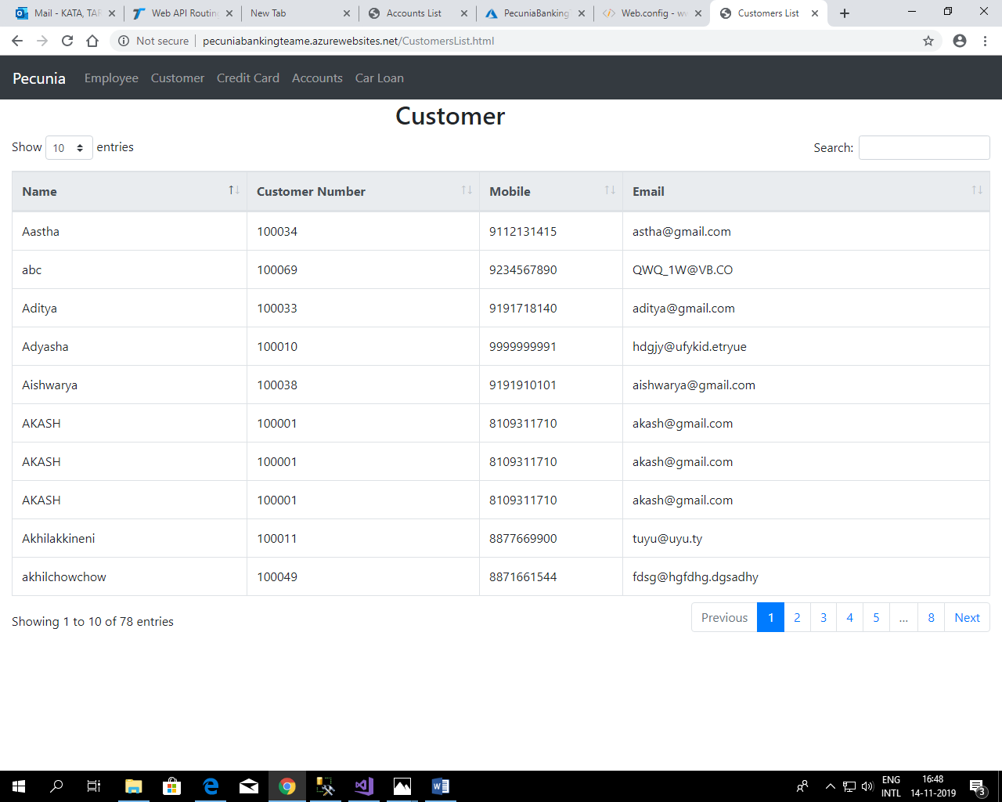

Step 17

Credit Card List.

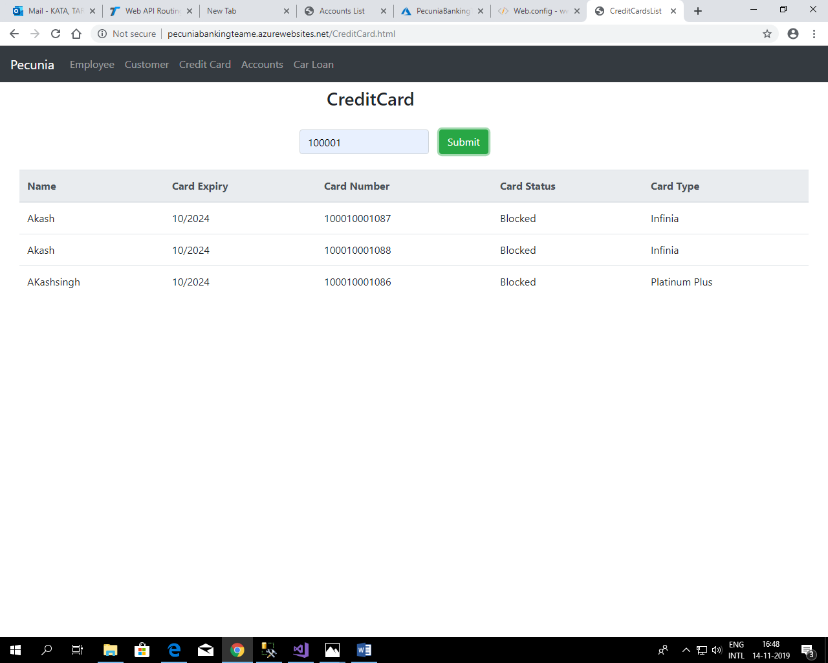

Step 18

Accounts List.

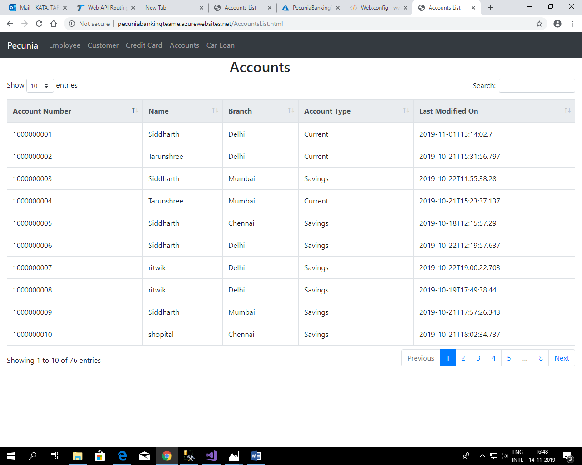

Step 19

Car Loan List.

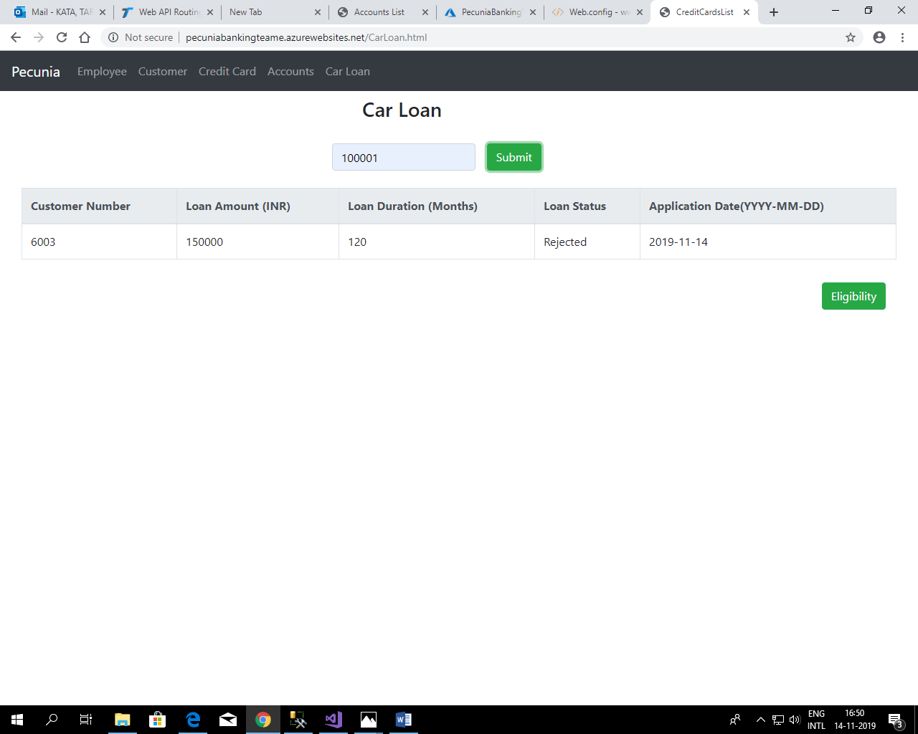

Now our web app is sucessfully deployed and web api project is sucessfully published