**Midterm: (100 pts)**

**Student Name:** Amrit Singh

**KSU ID:** 001237880

**1. (20pts)**

1. Define the Cartesian product of two sets and explain its properties.

Given sets *A* and B, the Cartesian product of *A* and *B*, $A×B$, is the set of all ordered pairs of real numbers $(x,y)$ where *x* is an element of *A* and *y* is an element of *B*.

This can be denoted formally as the following:

$$A×B=\{\left(a,b\right): a∈A∧b∈B\}$$

Let $A=\{a_{1},a_{2},a_{3},…,a_{m}\}$ and $B=\{b_{1},b_{2},b_{3},…,b_{n}\}$

$$A×B=\{\left(a_{1},b_{1}\right),\left(a_{1},b_{2}\right),\left(a_{1},b_{3}\right),….\left(a_{1},b_{n}\right),$$

$$\left(a_{2},b_{1}\right),\left(a_{2},b_{2}\right),\left(a_{2},b_{3}\right),….\left(a_{2},b_{n}\right),$$

$$\left(a_{3},b_{1}\right),\left(a_{3},b_{2}\right),\left(a_{3},b_{3}\right),….\left(a_{3},b_{n}\right),$$

$$….$$

$$\left(a_{m},b_{1}\right),\left(a_{m},b_{2}\right),\left(a_{m},b_{3}\right),….\left(a_{m},b_{n}\right),\}$$

There are *m* rows of *n* pairs, for a total of *m * n* pairs. Each row here is $\left\{a_{i}\right\}×B$ for some $a_{i}∈A$ which we can write as:

$$A×B=\left(\left\{a_{1}\right\}×B\right)∪\left(\left\{a_{2}\right\}×B\right)∪\left(\left\{a_{2}\right\}×B\right)∪…(\{a_{m}\}×B)$$

This is a union of *m* disjoint sets, where each set has *n* elements in them. The total can be added together using the additive principle: *n* + *n* + *n* + …. + *n* = *m * n*.

We can then conclude that the cardinality of a cartesian product between two sets *A* and *B* is the product of the cardinality of set *A* and the cardinality set *B*:

$$\left|A×B\right|=\left|A\right|*|B|$$

which is the multiplicative principle.

Example: Suppose $A = \{1,2,3\}$ and $B = \{x,y\}$

$$A×B=\{1x,1y,2x,2y,3x,3y\}$$

$$\left|A\right|=3$$

$$\left|B\right|=2$$

$$\left|A×B\right|=6$$

1. Provide an example of a binary relation and discuss how it can be represented both as pairs and a rule.

A binary relation is a relation *R* from set *X* to *Y* is a subset of the Cartesian product $X×Y$ denoted as $\left(x,y\right)∈R$ and by $xRy$.

Example:

Suppose $X=\{0,1,2\}$ and $Y=\{1,2,3,4\}$ and a relation *xRy* such that *x < y*. We can find that the relation *xRy* can be written as pairs:

$$xRy = \{\left(0,1\right),\left(0,2\right),\left(0,3\right),\left(0,4\right),\left(1,2\right),\left(1,3\right),\left(1,4\right),\left(2,3\right),\left(2,4\right),(3,4)\}$$

and as a rule:

$$xRy=\{(x,y)∈X×Y:x<y\}$$

**2. (20pts)**

* 1. Describe what a function is, including the terms domain, codomain, and range.

A function is as mapping, or relation/rule, that assigns each input exactly one output. The set of all inputs for a function is known as the domain, and the set of allowable outputs is known as the codomain. The range (or image) is the set of actual output values produced by the function, a subset of the codomain. A function *f* is defined by:

$$f:X →Y$$

where set *X* is the domain and set *Y* is the codomain.

Example:

$$f: N→N, f\left(x\right)=x+1$$

* The domain is the set of all natural numbers, $N$
* The codomain is the set of all natural numbers, $N$
* The range is $f\left(x\right)$ or {1, 2, 3, 4, ,5, 6,…}, basically $N$ but excluding 0, hence a subset of the codomain.
  1. Explain the difference between partial and total functions.

A partial function is a function that does not have an output value for a given input value, meaning its not defined for all possible inputs in its domain. A total function has an output value for a given input value, meaning it has outputs defined for all of it’s domain.

Example: Consider the following functions:

$$f: R→R, f\left(x\right)=\frac{1}{x}$$

$$g: R→R, g\left(x\right)=x+1$$

We can see that *f* is a partial function, since $f\left(0\right)=\frac{1}{0}$ is undefined. The function *g* however, is a total function since it has defined outputs for all inputs.

* 1. Give examples of injective, surjective, and bijective functions.

Injective means that each element of the codomain is the image of at most one element of the domain, aka one-to-one.

* + - 1 $→$ 2
    - 2 $→$ 3
    - 3 $→$ 4
    - 4 $→$ 5
    - 5 $→$ 6

The input 1 maps to 1, 2 maps to 2, 3 maps to 3, 4 maps to 4, and 5 maps to 5, etc. Each output is mapped to at most one element of the domain, however 1 is never hit for the codomain, making this function only injective.

Subjective means that everything in the codomain is in the range, or outputs, aka onto.

Example:

* + - 1,2 $→$ 1
    - 3 $→$ 2

The inputs 1 and 2 map to 1, 3 maps to 2, etc. All of the outputs of the codomain, aka the range, are mapped. Multiple inputs are mapped to the same output. This means we can say that this function is not one-to-one, but it is onto, hence this function is surjective.

Bijective means both, one-to-one and onto.

Example:

* + - 1 $→$ 1
    - 2 $→$ 2
    - 3 $→$ 3
    - 4 $→$ 4
    - 5 $→$ 5

The input 1 maps to 1, 2 maps to 2, 3 maps to 3, 4 maps to 4, and 5 maps to 5, etc. Each output is mapped to at most one element of the domain, meaning one-to-one. Each output is also in the codomain, hence it is also onto, making it bijective.

**3. (30pts)**

a. Permutation with Repetition

A password consists of 5 characters, where each character can be any digit from 0 to 9.

* How many different possible passwords can be formed?

Order matters, and repeats are allowed so then the answer must look like $P\left(n,k\right)= n^{k}$ where n is the number of possibilities and k is the length, hence $P\left(n,k\right)= n^{k}=P\left(10,5\right)={10}^{5}= 100,000$ possible passwords.

* If the first character of the password must be an odd digit (1, 3, 5, 7, or 9), how many different possible passwords can be formed?

For our password, we have 5 characters. The first character is limited to 5 choices (i.e 1, 3, 5, 7, or 9), and the second, third, fourth, and fifth characters have 10 choices (0-9). Hence, we can say that we have $5*{10}^{4}=50,000$ possible passwords.

b. Combination with Repetition

A fruit shop offers 4 different types of fruits: apples, bananas, cherries, and dates. A customer wants to buy 7 fruits, and the selection can include any combination of these 4 types of fruits.

* How many different combinations of 7 fruits can the customer choose?

We 4 different types of fruits and want to give any combination of 7 to a customer. An example with fruits A, B, C, D could be:

A B C D

**|**|**|*

This means we have $C(10,3)$ combinations, so therefore:

$$C\left(n,k\right)=\frac{n!}{\left(n-k\right)!k!}= C\left(10, 3\right)= \frac{10!}{\left(10-3\right)!3!}=\frac{10*9*8*…*3*2*1}{(7*6*5*4*3*2*1)(3*2*1)}=\frac{10*9*8}{3*2*1}=120$$

* If the customer must buy at least 2 apples, how many different combinations of 7 fruits can the customer choose?

If the customer must get at least 2 A’s, then the remaining 5 fruit choices need to be divided among the 4 types of fruits, so our star and bars chart could look like

A B C D

*|*|**|*

This means that we have C(8,3) ways to distribute the fruit.

$$C\left(n,k\right)=\frac{n!}{\left(n-k\right)!k!}= C\left(8, 3\right)= \frac{8!}{\left(8-3\right)!3!}=\frac{8*7*6*…*3*2*1}{(5*4*3*2*1)(3*2*1)}=\frac{8*7*6}{3*2*1}=56$$

**4. (30pts):**

Consider the binomial expansion of (1+x)10..

1. Find the binomial coefficient of the term containing x4 .
2. Express the general term of the expansion of (1+x)10 using binomial coefficients.

Using Pascal’s triangle, we can determine the coefficient values of the expansion (1+x)10

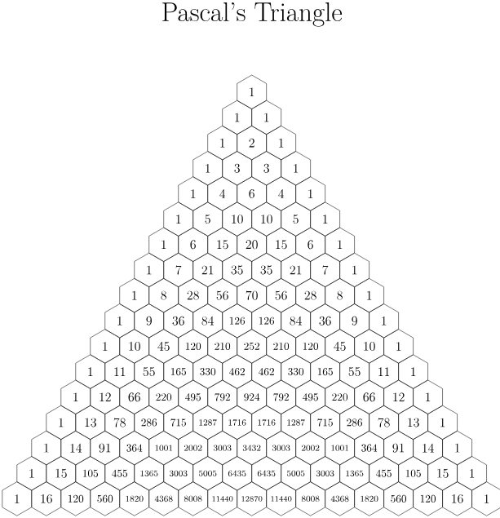



Here we can deduce,

$${\left(1+x\right)}^{10}={\left({10 \atop 0}\right)x}^{10}{\left(1\right)}^{0}+ \left({10 \atop 1}\right)x^{9}\left(1\right)+\left({10 \atop 2}\right)x^{8}{\left(1\right)}^{2}+\left({10 \atop 3}\right)x^{7}{\left(1\right)}^{3}+\left({10 \atop 4}\right)x^{6}{\left(1\right)}^{4}+\left({10 \atop 5}\right)x^{5}{\left(1\right)}^{5}+\left({10 \atop 6}\right)x^{4}{\left(1\right)}^{6}+\left({10 \atop 7}\right)x^{3}{\left(1\right)}^{7}+\left({10 \atop 8}\right)x^{2}{\left(1\right)}^{8}+\left({10 \atop 9}\right)x^{1}{\left(1\right)}^{9}+{\left({10 \atop 10}\right)x}^{0}1^{10}$$

$${\left(1+x\right)}^{10}={1x}^{10}{\left(1\right)}^{0}+ 10x^{9}\left(1\right)+45x^{8}{\left(1\right)}^{2}+120x^{7}{\left(1\right)}^{3}+210x^{6}{\left(1\right)}^{4}+252x^{5}{\left(1\right)}^{5}+210x^{4}{\left(1\right)}^{6}+120x^{3}{\left(1\right)}^{7}+45x^{2}{\left(1\right)}^{8}+10x^{1}{\left(1\right)}^{9}+{1x}^{0}1^{10}$$

${\left(1+x\right)}^{10}=x^{10}+ 10x^{9}+45x^{8}+120x^{7}+210x^{6}+252x^{5}+210x^{4}+120x^{3}+45x^{2}+10x^{1}+1$

1. Using your result from part b, determine the value of x for which the coefficient of x4 in the expansion of (1+x)10 is equal to 210.

The coefficient of $x^{4}$ in the expansion that is equal to 210 is $\left({10 \atop 6}\right)$.

1. Verify if the value of x obtained in part c is correct by substituting it back into the binomial coefficient expression.

$$\left({10 \atop 6}\right)= \frac{n!}{\left(n-k\right)!k!}= \frac{10!}{\left(10-6\right)!*6!}=\frac{10*9*8*…*3*2*1}{(4* 3*2*1)(6*5*4*3*2*1)}=\frac{10*9*8*6}{4* 3*2*1}=210$$