Day#01
Test case generating Langflow Prompt template
Font I have Used :
IBM Plex Sans Variable
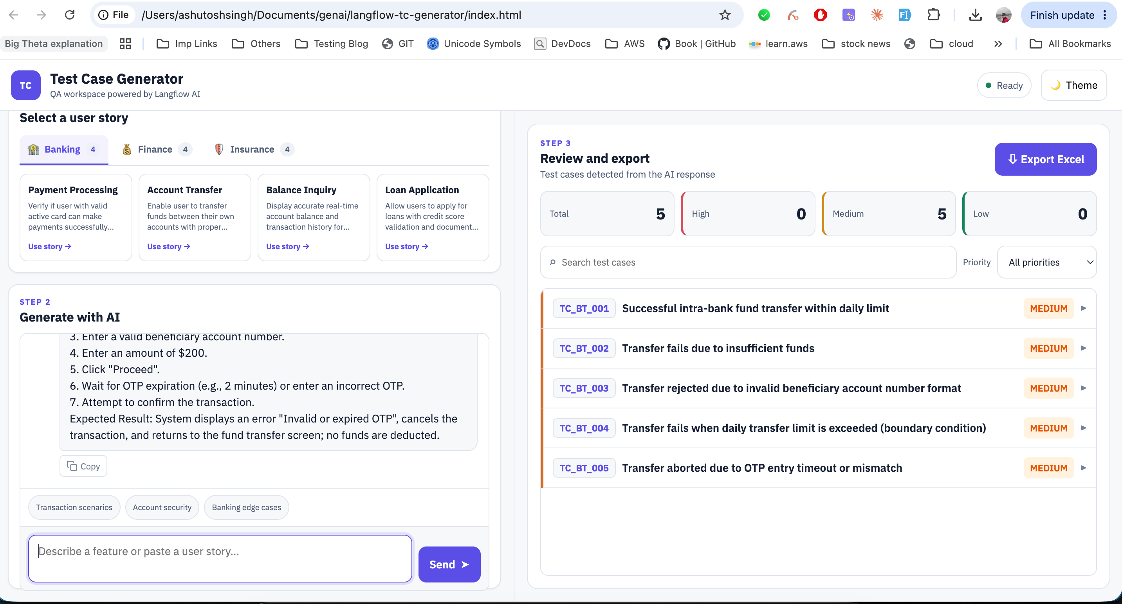
Langflow
