Test Case Generated
Langflow Workflow
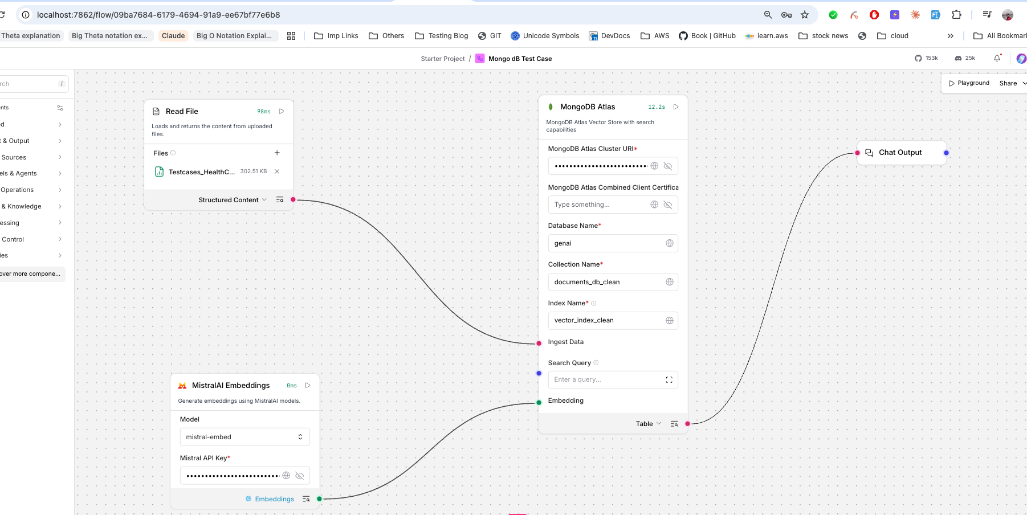
Module Wise Ascending Order Test Case Populated
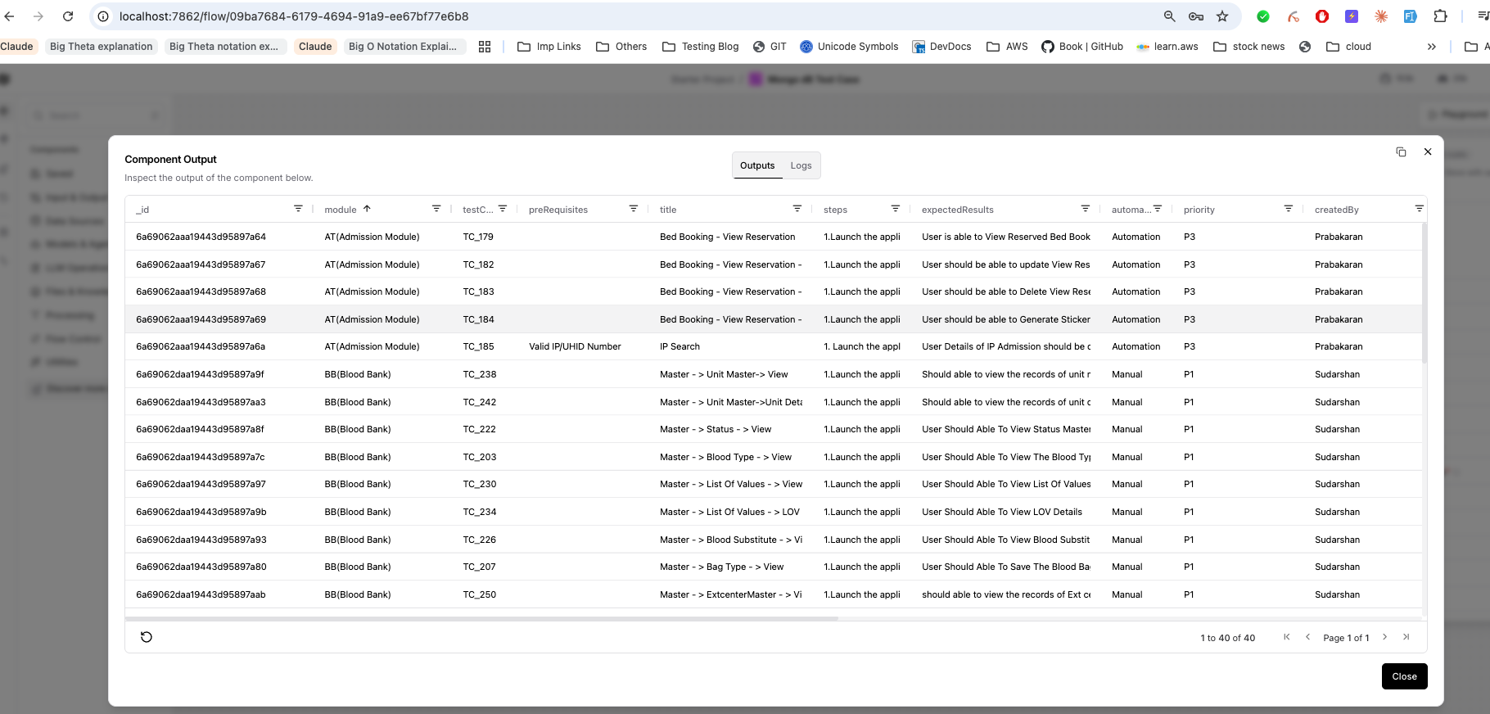
Mongo dB
Module: { "module": "AT(Admission Module)" }
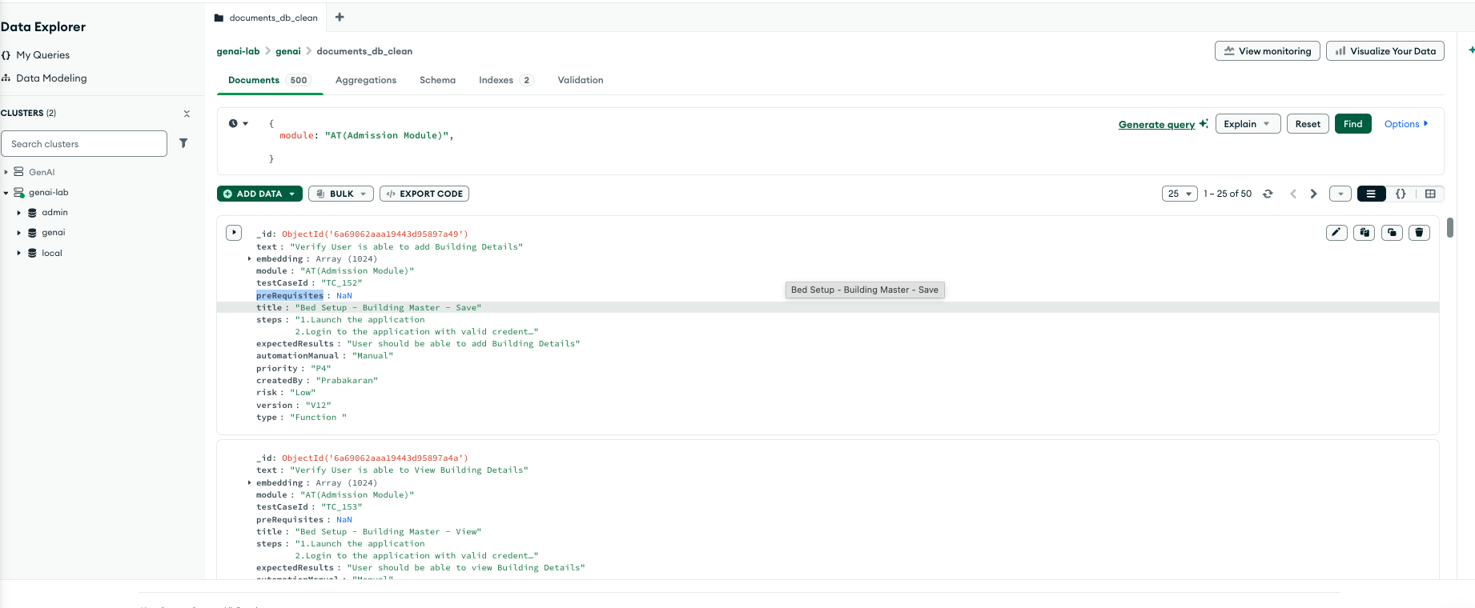
Fetching the same output from Postman
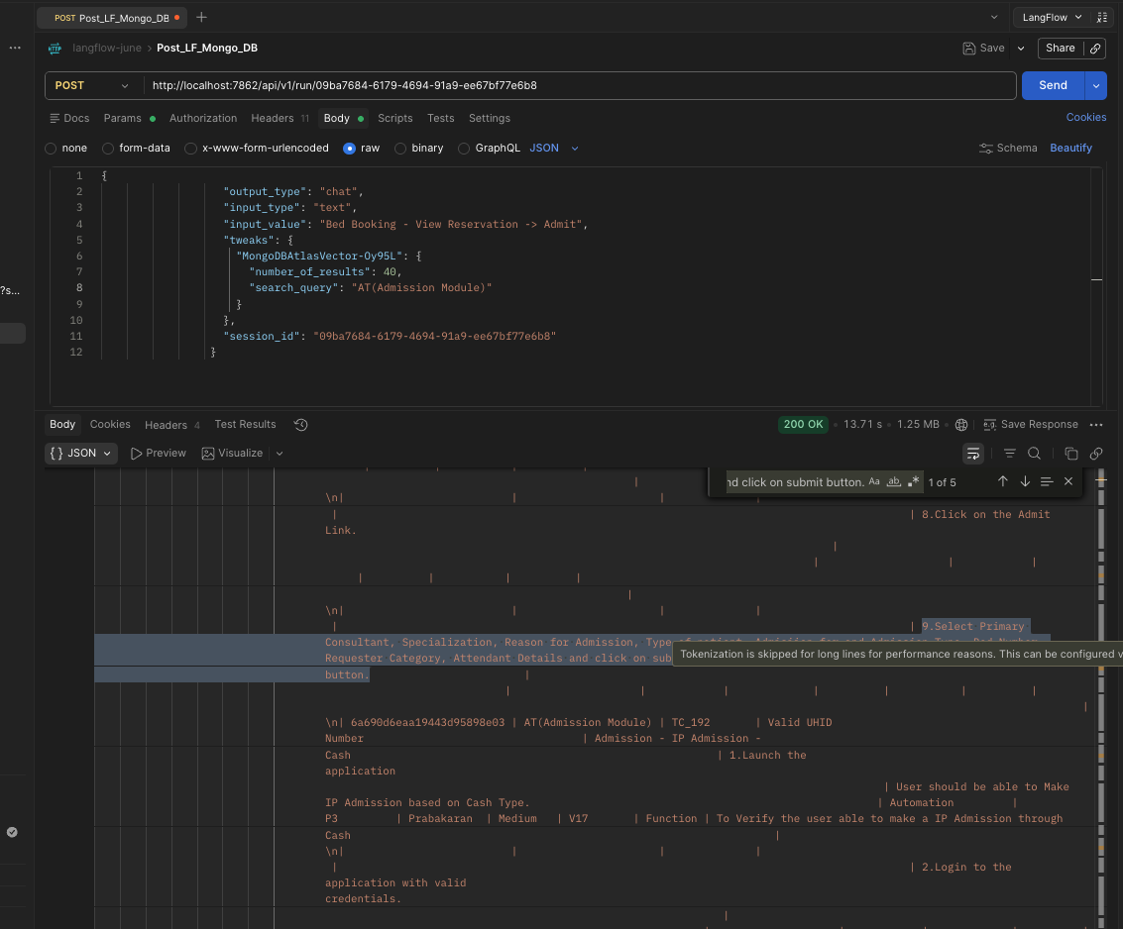
Langflow
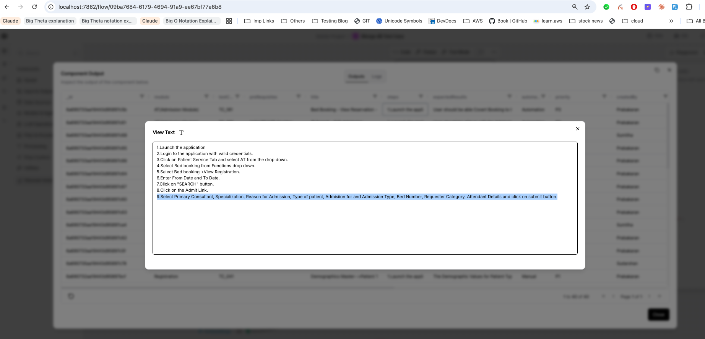
Result: Postman and Langflow both are showing same result

