Welcome to NBA Feeds! This is an application that allows you to get the latest statistical information about the NBA.

**Login**:

If you’re an existing user enter your username and password and click sign in to continue. If you’re a new user, click the new account button to continue to create a new user account that we will store in our user database.

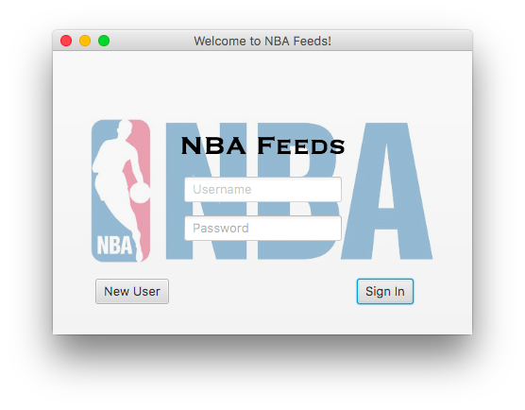

On the create account screen, enter you’ll type in your preferred username and password. Note that if your username already exists in the database the system will prompt you to log in with that username or to continue with a new username. To enter your favorite team, simply type your teams name excluding the city with the first letter capitalized. For example, the “Miami Heat” would be entered as “Heat”. For your favorite player, the system expects the first and last name, with appropriate capitalization, of any current player.

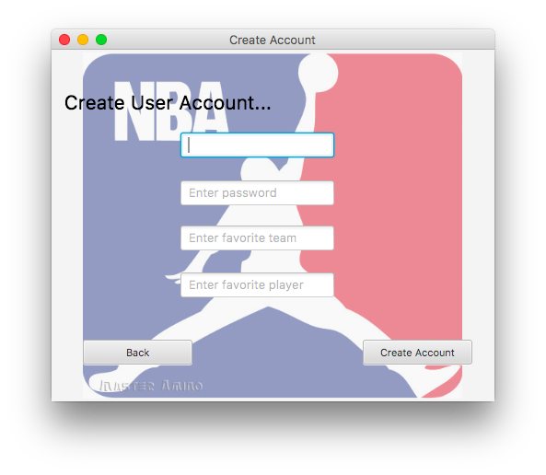

**Select Category**:

After logging in you’ll be presented with the select category screen where you’ll be able to choose from among six categories – Daily Player Stats, Cumulative Player Stats, Player Injuries, Full Game Schedule, Team Standings, Team Stats. If you’d like to log out of the system, simply click on the log out button.

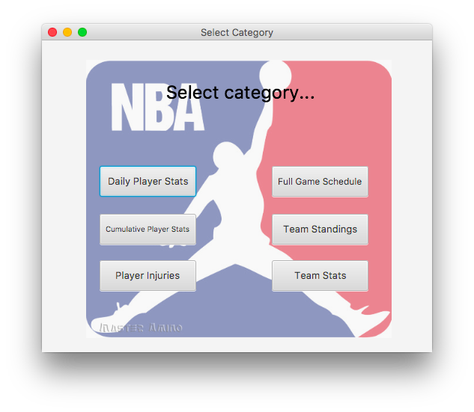

**Daily Player Stats**:

This screen displays the key statistics for your favorite player. It makes it easy to see how your favorite player performed today.

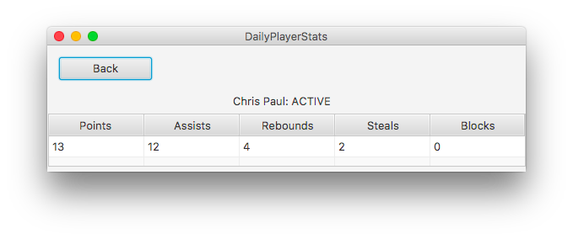

**Cumulative Player Stats**:

This screen displays the cumulative player stats for all players in the league. It is default sorted by player name, but can be sorted by the average field. To sort click on the column header, either name or avg. You have 5 statistical categories to choose from— points, rebounds, assists, blocks, and steals. All of which are calculated on a per game basis. To select a category, click on the relevant button.

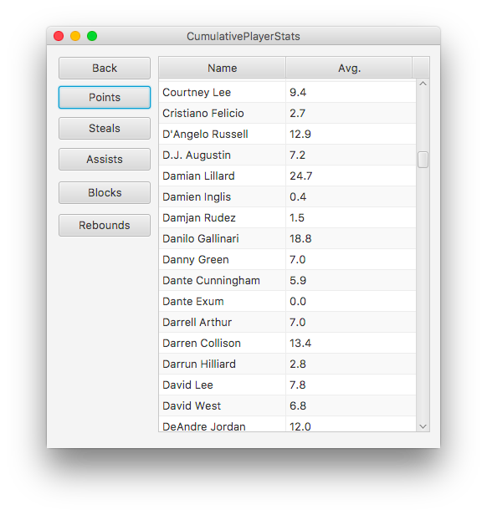

**Full Game Schedule**:

This screen presents your favorite team’s matchup for today as well as their logo and their opponents logo dynamically. To view your teams full schedule, click the button labeled “click here”

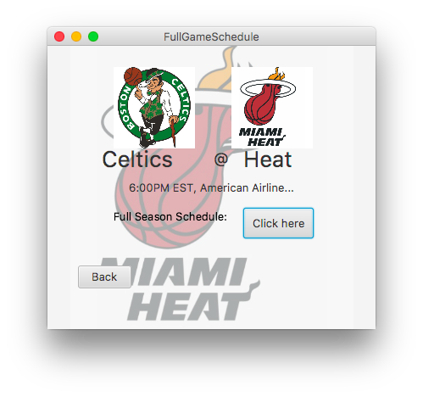

The full season’s games is listed chronologically.

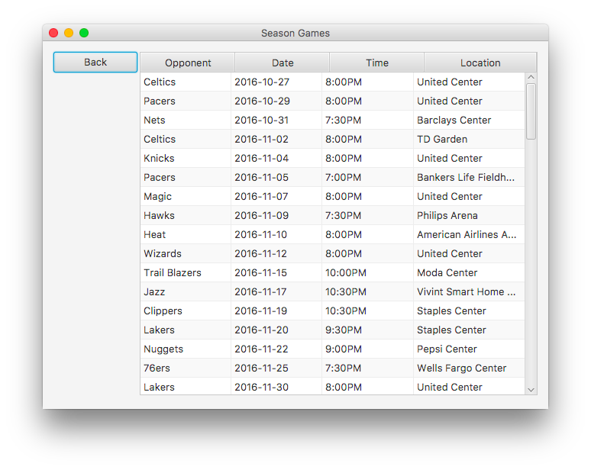

**Team Stats**:

This screen displays the top five players across five statistical categories for your favorite team. To select a different statistical category, click on the button labeled with that categories name.

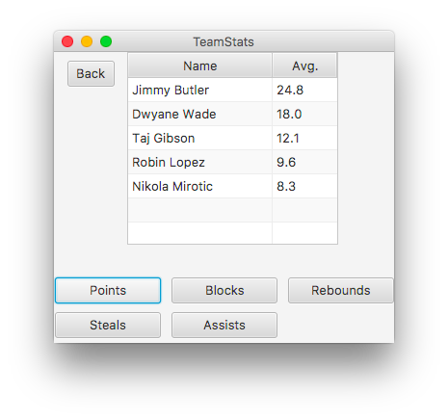

**Team Standings**:

This screen presents the overall league standings for all 30 NBA teams. The list presents the teams in rank order of their standings with the current win-loss record and the team name.

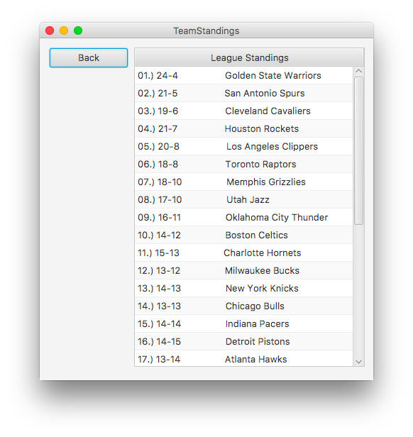

**Player Injury**:

This screen presents relevant injury information about your favorite player as well as your favorite team.

